Bone Diseases: Part 2

Part 1: Fibro-Osseous Lesions of the Jaws
- Lesions characterized by replacement of normal bone by fibrous tissue.
- The term fibro-osseous lesion is not specific diagnosis it just describes the process, i.e. we need to know the exact diagnosis because each type will have specific and different management.

Fibrous Dysplasia
- Developmental tumor like condition
- Benign
- Replacement of normal bone by excessive proliferation of fibrous connective tissue mixed with bone trabeculae.
- Result from mutation in gene GNAS 1
- The severity varies it can affect single bone, multiple bones, or multiple bones+ cutaneous involvement+ endocrine abnormalities. [The severity will depend on the time during embryologic life that GNAS 1 gene had been mutated].
  - If mutation occurs early embryologic life during stem cell differentiation that will cause multiple bones abnormalities+ cutaneous pigmentation+ endocrine problems [Mccune – Albright syndrome].
  - If mutation occurred during late embryologic life there will be multiple bone involvement without pigmentation or endocrine abnormalities [Polystotic fibrous dysplasia].
  - If mutation occurred during postnatal life there will be only single bone involvement [Monostotic fibrous dysplasia].

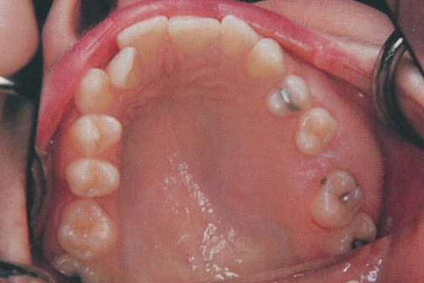

Monostotic: 80-85% of fibrous dysplasia, usually 2nd decade of life, jaws commonly affected sites. Male=female.
Presentation:
- Painless swelling of the affected area.
- Maxilla more than mandible
- Radiographically: “ground glass appearance” fine opacification due to poorly calcified bone and the margins blends with the surrounding normal bone.

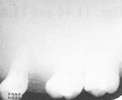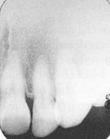

Polystotic: uncommon, multiple bone involvement.

Jaffe-Lichtenstien syndrome: polystotic fibrous dysplasia+ café au lait (coffee with milk) pigmentation of the skin.

Mccune- Albright syndrome: polystotic fibrous dysplasia+ café au lait spots+ multiple endocrinopathies.

Note: polystotic unlike monostotic it involves long bones, associated with pain and leg length discrepancies is common.

Treatment:
- Sometimes they are stabilized and do not require intervention if no discomfort or cosmetic problems is present.
- If they keep growing and/or create cosmetic problems then surgery can be an option.
- In mandible when small region of the bone is affected, resection can be done to remove the mutated segment of bone.
- Generally speaking fibrous dysplasia is a tumor that tends to recur after reduction in about 50% of the cases, because reduction (shaving of bone not resection) will not remove the mutated bone; we do shaving when complex area affected or large bone segment, so reduction can a treatment option to provide better cosmetic results with preservation of the affected bone.
- Radiotherapy SHOULD never be used with fibrous dysplasia because that carry the risk of malignant transformation into osteosarcoma.

Cemento-osseous dysplasia

Cemento-osseous dysplasia is a benign condition of the jaws that may arise from the fibroblasts of the periodontal ligaments. It is most common in African-American females. The three types are periapical cemental dysplasia (common in blacks), focal cemento-osseous dysplasia (caucasians), and florid cemento-osseous dysplasia (blacks). periapical occurs most commonly in the mandibular anterior teeth while focal appears predominantly in the mandibular posterior teeth and florid in both maxilla and mandible in multiple quadrants. (Wikipedia).
- Occurs in the teeth bearing area of the Jaws.
- Common.
- Appears in close proximity to the periodontal ligaments.
- It can be subdivided into 3 subtypes according to the clinical and radiographical appearance:
  - Type 1: Focal cement-osseous dysplasia
    - It had been recognized in 1990s before it was misdiagnosed as ossifying fibroma.
    - Affect females in about 90% of the cases.3rd to 6th decade of life.
    - Posterior region of the jaw
    - Single site involvement
    - Asymptomatic
    - Radiopaque patteren

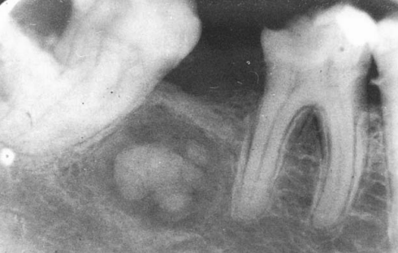
Focal cement-osseous dysplasia

- Type II: periapical cement-osseous dysplasia
  - Affect periapical region of the anterior mandible
  - Multiple lesions occur more common than single lesion.
  - Female to male ratio 14:1. Most patients diagnosed between the ages of 30-50 years. Black people usually more affected.
  - Teeth associated with the lesion are vital
  - Asymptomatic
  - Radiographically: early stage the lesion is radiolucent and it cannot be differentiated from periapical granuloma or periapical cyst. When the lesion starts to mature it will change into mixed radiolucent and radiopaque. The end stage it becomes radiopaque.

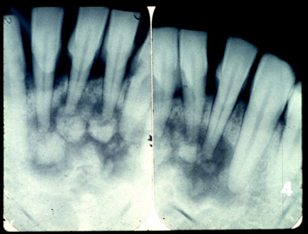
Periapical cement-osseous dysplasia

- Type III: Florid cement-osseous dysplasia
  - Multifocal involvement that can affect any site of the jaw.
  - Affect mainly middle aged black women.
  - It can occur bilaterally or even affect the 4 quadrants of the jaw.
  - Usually it is asymptomatic but some patients complain from dull pain, with exposed yellowish avascular bone.
  - Radiographically it follows the same patteren as periapical cement-osseous dysplasia.
Treatment:
- During early stage when the lesion is radiolucent it cause few problems.
- Once sclerosis occurred the lesion becomes hypovascular and it is at risk of necrosis.
- Surgery or extraction of teeth better to be avoided due to the risk of necrosis during the sclerotic phase, so the best treatment is prophylaxis and good home hygiene care to control periodontal diseases and prevent teeth loss.
- Management of patient with symptoms due to sclerosis after surgery or extraction can be difficult:
  - They are at high risk of osteomyelitis.
  - We need to cut not currete the affected bone that will give better results.
  - The idea is to remove bone until we reach healthy bone.
  - Antibiotics must be prescribed but it is not effective without surgery.

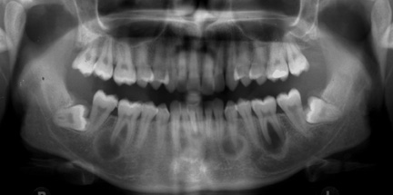
Early stage cement-osseous dysplasia. Few problomes can occur, however, the condition become complicated when it is sclerotic due hypovascularity of bone

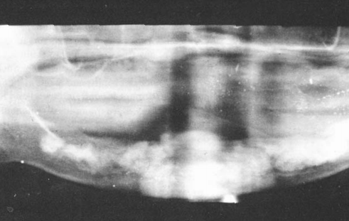
Severe case of florid cement-osseous dysplasia, severe sclerosis affecting the mandible due to multiple foci of florid type.

Ossifying Fibroma

- True neoplasm with growth potential
- Before the discovery of the focal cement osseous dysplasia too many cases were misdiagnosed as ossifying fibroma. Nowadays ossifying fibroma is considered as rare tumor.
- This neoplasm composed of fibrous tissue mixed with bone and cementum like materials.
- Female affected more than male. Usually appear during the 3rd or 4th decade.
- Small lesions with no swelling so they are asymptomatic, while large lesions present as painless swelling.
- Radiographically: Unilocualr well defined. The degree of radiolucency or opacity depends on the amount of the calcified materials (bone & cementum) within the lesion; it can be completely radiolucent or completely radiopaque or mixed.
- Treatment: the circumscribed nature of this lesions permits enucleation of the tumor with ease. Large tumor may require resection. Low recurrence rate and surgery shows good prognosis.
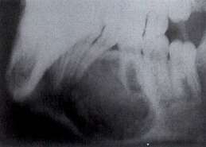
Ossifying fibroma affecting the region between the premolar and molar teeth. Notice that this lesion doesn’t contain too much calcified materials and it is mixed lesion.

Part II: Benign tumors of the Jaws

Osteoma

Osteomas are benign lesions composed of mature compact and/or cancellous bone that grow continuously.
Osteomas of the jaws may arise on the surface of the bone as a polypoid or sessile mass (periosteal osteoma), in the medullary bone (endosteal osteoma) or in the soft tissue (extraskeletal osteoma).
- Benign tumor composed of mature compact and cancellous bone.
- Osteoma can arise on the surface of the bone (Periosteal osteoma) or located in the medullary bone (Endosteal osteoma).
- Most commonly affect young adults, asymptomatic, affecting most commonly the angle of the mandible or the condyle.
- Radiographically: circumscribed sclerotic mass.
- Treatment: large osteoma of the mandibular body causing symptoms and deformity treated by conservative surgical excision. Small osteoma may require observation only. Unlike osteoma of the body of the mandible osteoma of the condyle must be treated when they are small because if they become large then condylectomy must be done.
Gardner Syndrome

- Rare disorder due to genetic mutation.
- Characterized by osteoma+ intestinal polyp+ epidermoid cysts.
- It is a serious syndrome because the intestinal polyp can transfer into adenocarcinoma.
- Most common sites that osteoma may affect are the skull, paranasal sinuses, and the mandible.
- When mandible is affected it is usually associated with facial deformity.
- Most of the patient affected in the second decade of life.
- Usually they have 3-6 osteomas, and they occur before the intestinal polyps appear.
- Treatment: The main concern will be the risk of malignant transformation of the intestinal polyp, so prophylactic colectomy with removal of osteomas and epidermoid cysts.

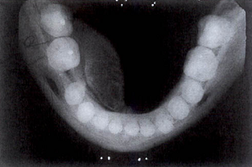
Osteoma arises on the lingual side of the posterior mandible.

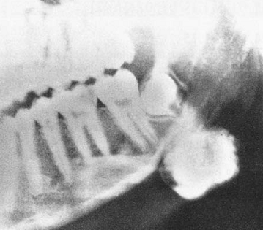
Osteoma arises at the angle of the mandible

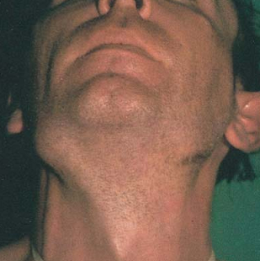
Multiple epidermoid cysts in Gardner syndrome.

Osteoblastoma

- Rare Benign neoplasm of bone arises from osteoblasts.
- If occurred within the jaws the mandible is affected more than maxilla. Posterior more than anterior region.
- Size usually 2-4 cm, but they may as large as 10 cm.
- Treatment: Local excision or curettage, good prognosis, few lesions show recurrence. In rare occasions they may transform into osteosarcoma.

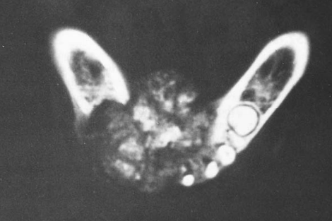
Severe oosteoblastoma of the mandible

Cementoblastoma

- Odontogenic neoplasm of cementoblasts.
- 75% of the cases affect the mandible.
- 90% of the cases will be in the molar and premolar teeth.
- Affect mainly children and young adults
- 2/3 of the patient will have pain and swelling.
- Radiographically: will appear as radiopaque mass fused to one or more tooth roots.
- Treatment: Surgical extraction of the tooth with the attached calcified mass. If the mass was small, surgical exposure can be done + resection of the root with the calcified mass and then endodontic treatment.

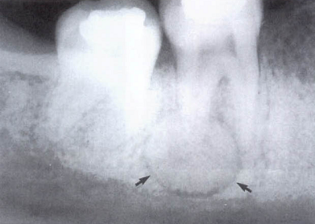
Cementoblastoma
Chondroma

- Benign tumor composed of hyaline cartilage components.
- When occur within the jaw they either affect the condyle or the maxilla.
- Painless, slowly growing tumor
- Can be associated with teeth mobility and root resorption.
- Chondroma of the jaw has potential for malignant transformation into chnondrosarcoma.
- Treatment: Chondroma of the jaw should be completely removed due to the risk of malignant transformation. If the chondroma affecting the condyle then condylectomy must be performed.

Torus Mandibularis
- etiology Torus mandibularis is a developmental malformation of unknown etiology.
- Clinical features It presents as an asymptomatic bony swelling, covered by normal mucosa. The lesion displays slow growth during the second and third decades of life. Characteristically, the lesions appear bilaterally on the lingual surface of the mandible, usually in the area adjacent to the bicuspids. The diagnosis is based on clinical criteria.
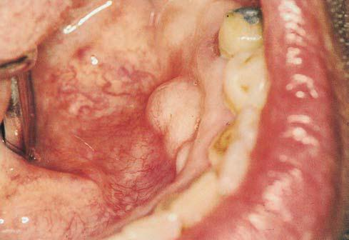
Torus mandibularis
- Treatment Unnecessary unless full denture construction is required.

Torus Palatinus

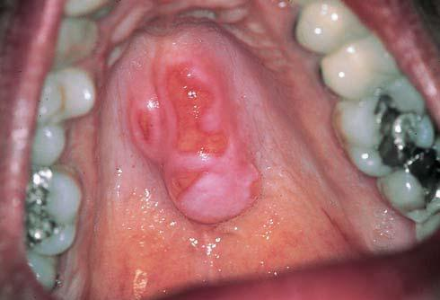
Torus palatinus at the midline of the hard palate
- etiology Torus palatinus is a developmental malformation of unknown etiology.
- Clinical features It presents as a slow-growing, nodular, lobular or spindled, asymptomatic bony swelling covered by normal mucosa. Characteristically, the lesion appears along the midline of the hard palate.It occurs more often in women, and usually appears during the third decade of life. The diagnosis is based on the clinical findings.
- Treatment Unnecessary unless full denture construction is required.

Multiple Exostoses
- Multiple exostoses may occur on the buccal surface of the maxilla, and rarely on the mandible. Clinically, the lesions appear as multiple asymptomatic bony swellings. The diagnosis is based on the clinical findings.
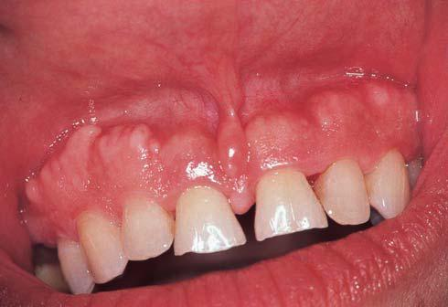
Multiple exostoses on the maxilla.
- Treatment Unnecessary unless full denture preparation is required.

Part III: Malignant tumors of the Jaws

Osteosarcoma

- Highly malignant
- Many occur without specific reason; sometimes they can occur after irradiation of some diseases such as Paget’s disease of bone or fibrous dysplasia [that is why radiotherapy is contraindicated with these conditions].
- Most commonly occur between the ages of 30 and 40.
- Body of the mandible is the most commonly affected site.
- Clinical course: firm swelling grows over few months and become painful. Teeth may be loosened and parasthesia or anesthesia of the mental nerve may occur. The lungs are the most common site where osteosarcoma metastasizes.
- Radiographiaclly: irregular bone destruction over bone formation. Bone formation within soft tissue masses, which gives what, is called “sun ray appearance”.
- Treatment: It is highly and rapidly invasive and can metastasise early. Treatment is mandibulectomy or maxillectomy with wide excision of any soft tissue extension combined with radio or chemotherapy.
- The prognosis depends on the extent of the tumor, soft tissue involvement, lymph nodes or/and base of the skull involvement.

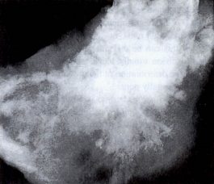
Sun ray appearance of an osteosarcoma affecting the angle of the mandible

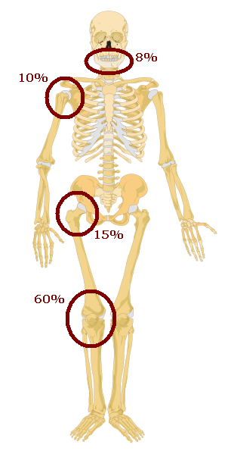
Ratio of the sites that affected by osteosarcoma in the body and predilection of the condition

Chondrosarcoma

- cancer composed of cells derived from transformed cells that produce cartilage.
- Affects adults
- Maxilla in 70% of the cases
- Pain, swelling, and loosening of teeth.
- Treatment: wide excision, if it is inadequate recurrence will occur.

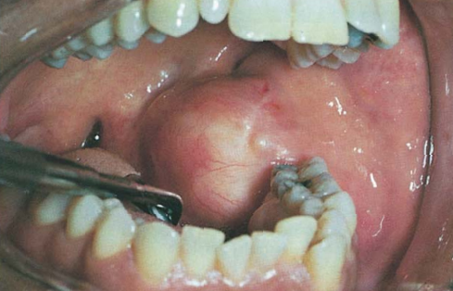
Chondrosarcoma affecting posterior mandible
Chondrosarcoma
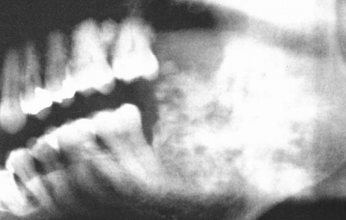

Ewing’s Sarcoma
Ewing's sarcoma (ES) is a rare malignant small round cell tumor that primarily affects the skeletal system. It accounts for 4 to 10% of all types of bone cancer, with long bones and pelvis being the most common locations. It affects mainly adolescents and young adults and is rarely seen before the age of 5 and after age of 30. Clinically, this tumor has an aggressive behaviour characterized by rapid growth and high probability of micrometastasis at diagnosis

- Primary malignant tumor of bone from neuroectodermal origin.
- Ewing's sarcoma is a malignant small, round, blue cell tumour (SRBCT). In histopathology, a small-, round-, blue-cell tumor (abbreviated SRBCT), also known as a small-blue-round-cell tumour (SBRCT) or a small-round-cell tumour (SRCT), is any one of a group of malignant neoplasms that have a characteristic appearance under the microscope, i.e. consisting of small round cells that stain blue on routine H&E stained sections. (SRBCT: can include different malignant diseases that share this feature, such as neuroblastoma, ewing’s sarcoma, rhabdomysarcome…etc.)
- The body of the mandible is the most commonly affected site within the head and neck.
- 80% of the patients are younger than 20 years of age.
- Pain associated with swelling.
- Fever, leukocytosis, increase ESR, which can be misdiagnosed with osteomyelitis.
- Penetrate the cortex of bone and may present as soft tissue mass within the jaw.
- Parasthesia and loosening of teeth are common
- Treatment: Surgery+ radiotherapy+ chemotherapy. Show good prognosis.

Multiple Myeloma
- a relatively rare malignant plasma-cell disorder.
- Etiology is Unknown.
- Clinical features the malignancy is more common in men over 50 years of age, and the jaws are affected in about 30% of cases.
- Clinically, it presents with bone swelling, tooth mobility, pain, and paresthesia.
- A painless soft swelling, usually on the alveolar mucosa and gingiva, may develop as part of the overall disease spectrum.
- Laboratory tests Bone-marrow biopsy, radiography, serum and urine protein electrophoresis.
- Differential diagnosis Plasmacytoma, non-Hodgkin lymphoma, Ewing sarcoma, leukemia, Langerhans cell histiocytosis.
- Treatment Chemotherapy, radiotherapy.

LANGERHANS CELL HISTIOCYTOSIS

Langerhans cell histiocytosis is a group of tumours or tumour-like lesions of Langerhans cells, antigen-presenting counterparts of macrophages. In 1953, Lichtenstein observed cytoplasmic bodies, known as X bodies, within histiocytes from tissues of patients suffering from what were previously considered distinct clinical disorders: eosinophilic granuloma, Hand-Schüller-Christian disease and Abt-Letterer-Siwe disease. As a result of their common underlying histopathology, Lichtenstein grouped these diseases together under the name of histiocytosis X. With Nezelof’s discovery in 1973 that these histiocytes were in fact Langerhans cells, the disorder was renamed Langerhans cell histiocytosis.

There are 3 main types:

- Solitary eosinophilic granuloma: Eosinophilic granuloma is an osteolytic lesion of bone with a predilection for the mandible. The main clinical features are, Adults mainly are affected. Typical symptoms are pain, tenderness, swelling or bone destruction.
General management: Radiographs show a tumour-like area of rarefaction. A bone scan should be carried out to ensure that the disease is not multifocal. Diagnosis is confirmed by biopsy typically showing foamy histiocytes and eosinophils with ill-defined, somewhat fibrillar background and areas of necrosis. Eosinophilic granuloma is relatively benign and sometimes resolves spontaneously. Otherwise it responds to curettage or, if recurrent, to modest doses of irradiation, or chemotherapy.
Dental Management: Eosinophilic granuloma is an osteolytic lesion of bone with a
predilection for the mandible. It can produce a characteristic form of periodontal destruction with gross gingival recession and alveolar bone loss typically involving a small group of teeth and often exposing the roots of the teeth, with a ‘teeth foating in air’ appearance on radiography. Eosinophilic granuloma can also affect the oral soft tissues, but less frequently than the mandible.

- Multifocal eosinophilic granuloma and Hand–Schuller–Christian disease: These lesions are the same histologically as the solitary eosinophilic granuloma and are sometimes referred to indifferently as Hand–Schuller–Christian disease. Clinical features Multifocal eosinophilic granuloma most frequently develops before the age of 5 years.
Hand–Schuller–Christian disease, strictly speaking, comprises osteolytic lesions of the skull, exophthalmos and diabetes insipidus; it is a variant of multifocal eosinophilic granuloma but develops in only 25%. General management Diagnosis is by biopsy, which shows essentially the same features as solitary eosinophilic granuloma. Skeletal radiography or bone scans show the extent of the disease. In approximately 50%, the lesions gradually resolve spontaneously over the course of years but can leave residual disabilities as a result of limb lesions or diabetes insipidus. To reduce such complications, or in refractory cases, chemotherapy in relatively modest doses may be given as for solitary lesions. The mortality may be 25–30%. The younger the patient and the more wide-spread the disease, the worse the prognosis. Dental aspects Complications can arise from radiotherapy to the oral or para-oral regions, or chemotherapy with corticosteroids or cytotoxic agents.
- Letterer–Siwe disease
General aspects
Letterer–Siwe disease typically affects children between the ages of 2 and 3 years.
Clinical features
The main features of Letterer–Siwe disease are lymphadenopathy, hepatosplenomegaly, and bone and skin lesions. Fever, infections and bleeding tendencies are secondary to pancytopenia, which results from marrow displacement by the histiocyte-like cells.It sometimes follows a rapidly fatal course. Rarely death follows within a week of diagnosis.
General management
Diagnosis is by biopsy, showing infiltration of the tissues by proliferating histiocyte-like cells. Treatment is with radiotherapy, corticosteroids and cytotoxic drugs, and may be successful. Occasionally the course of the disease is less acute and recoveries are possible.
Dental aspects
In view of the age group mainly affected and the rapidity of the course, patients are unlikely to be seen by dentists. In the few older patients with a more chronic form of the disease, the features relevant to dentistry are essentially those of severe types of multifocal eosinophilic granuloma. Corticosteroid or cytotoxic treatment may complicate dental management.

