Oral Histology Lect. ا.م.د عبد الكريم المحمداوي 2018
DENTIN
- Provides the bulk and general form of tooth.
- Determines the shape of the crown.
- Physically & chemically the dentin closely resembles the bone.
- The main morphologic difference between bone & dentin is that some of the osteoblasts that form bone marrow enclosed within its matrix substance as osteocytes, whereas the dentin contains only the processes of the cells that form it.
Both are considered vital tissue because they contain because they contain living protoplasm.

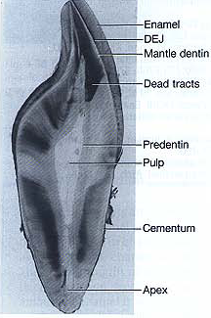

PHYSICAL PROPERTIES
- It is light yellowish in color, becoming darker with age.
- It is elastic and subject to slight deformation.
- Harder than bone but softer than enamel.
- Lower content of mineral salts in dentin renders it more radiolucent than enamel.

CHEMICAL PROPERTIES
- Consists of 35% organic matter and water & 65% inorganic material.
- The organic substance consists of collagenous fibrils and a ground substance of mucopolysaccharides .
- The inorganic component consists of hydroxyapetite as in bone, cementum & enamel.

Structure of Dentin
- The bodies of the odontoblasts are arranged in a layer on the pulpal surface of the dentin, and only their cytoplasmic processes are included in the tubules in the mineralized matrix.
- Each cell gives rise to one process, which traverses the predentin & calcified dentin within one tubule.
- Terminates in a branching network at the junction with enamel or cementum.
- Tubules are found throughout normal dentin & are therefore characteristic of it and form the basic unit.

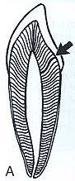
‘S’ CURVATURE OF DENTINAL TUBULES

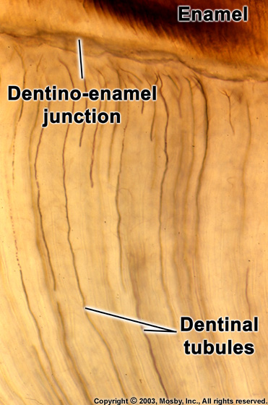
Dentinal tubules
- The ratio between the numbers of tubules per unit area on the pulpal and outer surfaces of dentin is about 4:1.
- There are more tubules per unit area in the crown than in the root.
- The dentinal tubules have lateral branches throughout dentin, which are termed canaliculi or microtubules.
- A few dentinal tubules extend through the dentinoenamel junction into the enamel. These are termed enamel spindles.

Types of Dentin
- Peritubular dentin
- The dentin that immediately surrounds the dentinal tubules.
- It is more highly mineralized than intertubular dentin.
- It is twice as thick in outer dentin (approx. 0.75um) than in inner dentin (0.4um).
2.Intertubular dentin
- Forms the main body of dentin.
- It is located between the dentinal tubules or, more specifically, between the zones of peritubular dentin.
- Its About one-half of its volume is organic matrix, specifically collagen fibers.

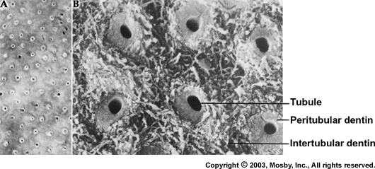

3.Predentin
- Is located adjacent to the pulp tissue.
- Is 2 to 6 um wide, depending on the activity of the odontoblast.
- It is the first formed dentin and is not mineralized.
- As the collagen fibers undergo mineralization at the predentin- dentin front, the predentin then becomes dentin and a new layer of predentin forms circumpulpally.
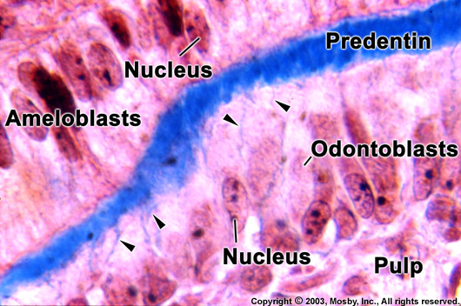
Odontoblastic process
- They are the cytoplasmic extensions of the odontoblasts.
- The odontoblasts reside in the peripheral pulp at the pulp- predentin border and their processes extend into the dentinal tubules.
- The processes are largest in diameter near the pulp and taper further into dentin.
- The odontoblast cell bodies are approximately 7um in diameter and 40um in length.

Types of dentin according to time and cause of its formation
- Primary dentin consist of :
a.Mantle dentin is the first formed dentin in the crown underlying the dentinoenamel junction.
- It is the outer or most peripheral part of the primary dentin & is about 20um thick.
- The fibrils found in this zone are perpendicular to the dentinoenamel junction.
b.Circumpulpal dentin forms the remaining primary dentin or bulk of the tooth.
- Represents all of the dentin formed prior to root completion.
- The fibrils are much smaller in diameter & are more closely packed together.
- Slightly more mineral content than mantle dentin

2.Secondary dentin
- A narrow band of dentin bordering the pulp and representing the dentin formed after root completion.
- Contains fewer tubules than primary dentin.
- There is usually a bend in the tubules where primary and secondary dentin interface.

3.Tertiary dentin(Reparative dentin)
• Its produced in reaction to various stimuli, such as attrition, caries, or a restorative dental procedure.
• Unlike primary or secondary D. that forms along the entire pulp-dentin border, tertiary D. is produced only by those cells directly affected by the stimulus.
• It may have tubules continuous with those of secondary D. tubules sparse in number and irregularly arranged, or no tubules at all.
• The cells forming tertiary D, line its surface or become included m the D, and so in this case is referred to as osteodentin,
• Stimuli of different nature not only induce additional formation of reparative D. but also lead to changes in the D, itself, calcium salts may be deposited in or around degenerated odontoblastic processes and may obliterate the tubules. This type of D. called transparent or sclerotic D. and can be observed in teeth of elderly people, especially in the roots. Transparent D. can be demonstrated only in ground sections. It appears light in transmitted and dark in reflected light, because the light passes through the transparent D. but reflected from the normal D.
• Dead tracts: In ground sections of D-, the odontoblastic processes disintegrated as a result of sever stimuli to the pulp like caries, attrition or abrasion, and the empty tubules are filled with air. They appear dark in transmitted and white in reflected light this type of D, called dead tracts and its area of decreased sensitivity. Reparative D. seals these dead tracts at their pulpal end.

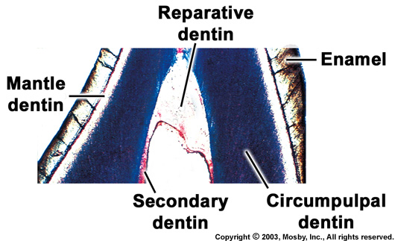
Some abnormalities in dentin
- Interglobular dentin
- Sometimes mineralization of dentin begins in small globular areas that fail to fuse into a homogenous mass. This results in zones of hypomineralization between the globules. These zones are called interglobular dentin.
- Forms in crowns of teeth in the circumpulpal dentin just below the mantle dentin.
2.Tomes'granular layer
- There is a zone adjacent to the cementum that appears granular. This is known as Tomes’ granular layer.
- Caused by coalescing and looping of the terminal portions of the dentinal tubules.
