Lec2 Transcription and RNA Processing د.اسامة الموسوي

The first stage in the expression of genetic information is transcription of the information in the base sequence of a double-stranded DNA molecule to form the base sequence of a single-stranded molecule of RNA. For any particular gene, only one strand of the DNA molecule, called the template strand, is copied by RNA polymerase as it synthesizes RNA in the 5' to 3' direction. Because RNA polymerase moves in the 3' to 5' direction along the template strand of DNA, the RNA product is antiparallel and complementary to the template. RNA polymerase recognizes start signals (promoters) and stop signals (terminators) for each of the thousands of transcription units in the genome of an organism. Figure below illustrates the arrangement and direction of transcription for several genes on a DNA molecule.

**RNA Structure**

The main differences between DNA and RNA **( Ribonucleic acid** ) illustrated in (table : 1)

|  |  |  |
| --- | --- | --- |
| **Table 1 : The main differences between DNA and RNA** | | |
| **RNA** | **DNA** |
| 1-Usually single stranded  2-**U**racil as a base ( figure 2 )    3-Ribose as the sugar  4- Functionally : carries protein encoding information and controls how information is used .    5- Transient : the presence of the –OH of the ribose makes RNA much less stable than DNA , which is critical in its function as a short-lived carrier of genetic information . | 1-Usually double stranded  2-**T**hymine as a base  3- Deoxyribose as the sugar  4- functionally : stores RNA and protein encoding information, and transfers information to daughter cells  5- Persists |

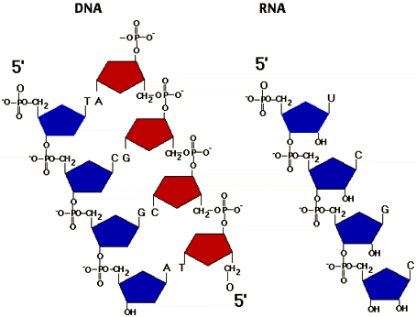

TYPES OF RNA

RNA molecules play a variety of roles in the cell. The major types of RNA are:

• Ribosomal RNA (rRNA), which is the most abundant type of RNA in the cell. It is used as a structural component of the ribosome. Ribosomal RNA associates with ribosomal proteins to form the complete, functional ribosome.

• Transfer RNA (tRNA), which is the second most abundant type of RNA. Its function is to carry amino acids to the ribosome, where they will be linked together during protein synthesis.

• Messenger RNA (mRNA), which carries the information specifying the amino acid sequence of a protein to the ribosome. Messenger RNA is the only type of RNA that is translated. The mRNA population in a cell is very heterogeneous in size and base sequence, as the cell has essentially a different mRNA molecule for each of the thousands of different proteins made by that cell.

• Heterogeneous nuclear RNA (hnRNA or pre-mRNA), which is found only in the nucleus of eukaryotic cells. It represents precursors of mRNA, formed during its post transcriptional processing.

• Small nuclear RNA (snRNA), which is also only found in the nucleus of eukaryotes. One of its major functions is to participate in splicing (removal of introns) mRNA.

RNA POLYMERASES

There is a single prokaryotic RNA polymerase that synthesizes all types of RNA in the cell. A protein factor called sigma (𝛔) is required for the initiation of transcription at a promoter. Sigma factor is released immediately after initiation of transcription. Termination of transcription sometimes requires a protein called rho (𝛒) factor. The prokaryotic RNA polymerase is inhibited by rifampin. Actinomycin D binds to the DNA, preventing transcription. There are three eukaryotic RNA polymerases, distinguished by the particular types of RNA they produce.

• RNA polymerase I is located in the nucleolus and synthesizes 28 S, 18 S, and 5.8 S rRNAs.

• RNA polymerase II is located in the nucleoplasm and synthesizes hnRNA ,mRNA and some snRNA.

• RNA polymerase III is located in the nucleoplasm and synthesizes tRNA, some snRNA, and 5 S rRNA.

Transcription factors (such as TFIID for RNA polymerase II) help to initiate transcription. The requirements for termination of transcription in eukaryotes are not well understood. All transcription can be inhibited by actinomycin D. In addition, RNA polymerase II is inhibited by a-amanitin (a toxin from certain mushrooms).

**Transcription (RNA synthesis):**

Transfer of genetic information from DNA by the synthesis of a complementary RNA molecule under the direction of RNA polymerase.

Transcription occurs in three stages:

**1- Initiation:**

Transcription begins when transcription factors help RNA polymerase bind to the promoter (which is a special sequence that signals the start of the gene). Transcription factor regulate which genes are transcriped in a particular cell type.

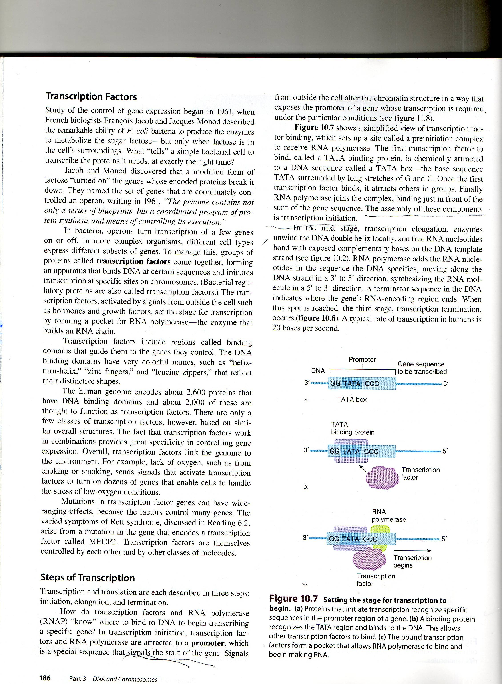

Figure: Setting the stage for transcription to begin: a- Proteins that initiate recognize specific sequences in the promoter region of a gene. b-A binding protein recognizes the TATA region and binds to the DNA. This allows other transcription factors to bind. c- The bound transcription factors form a pocket that allows RNA-polymerase to bind and begin making RNA.

**2- Elongation :**

RNA polymerase unwind the DNA double helix locally, RNA polymerase then adds RNA nucleotides to a growing chain, in a sequence complementary to the DNA template strand . RNA is transcribed from the template strand of DNA. The other DNA strand is called the coding strand.

**3- Termination:**

A termination sequence in the gene signals the end of transcription.

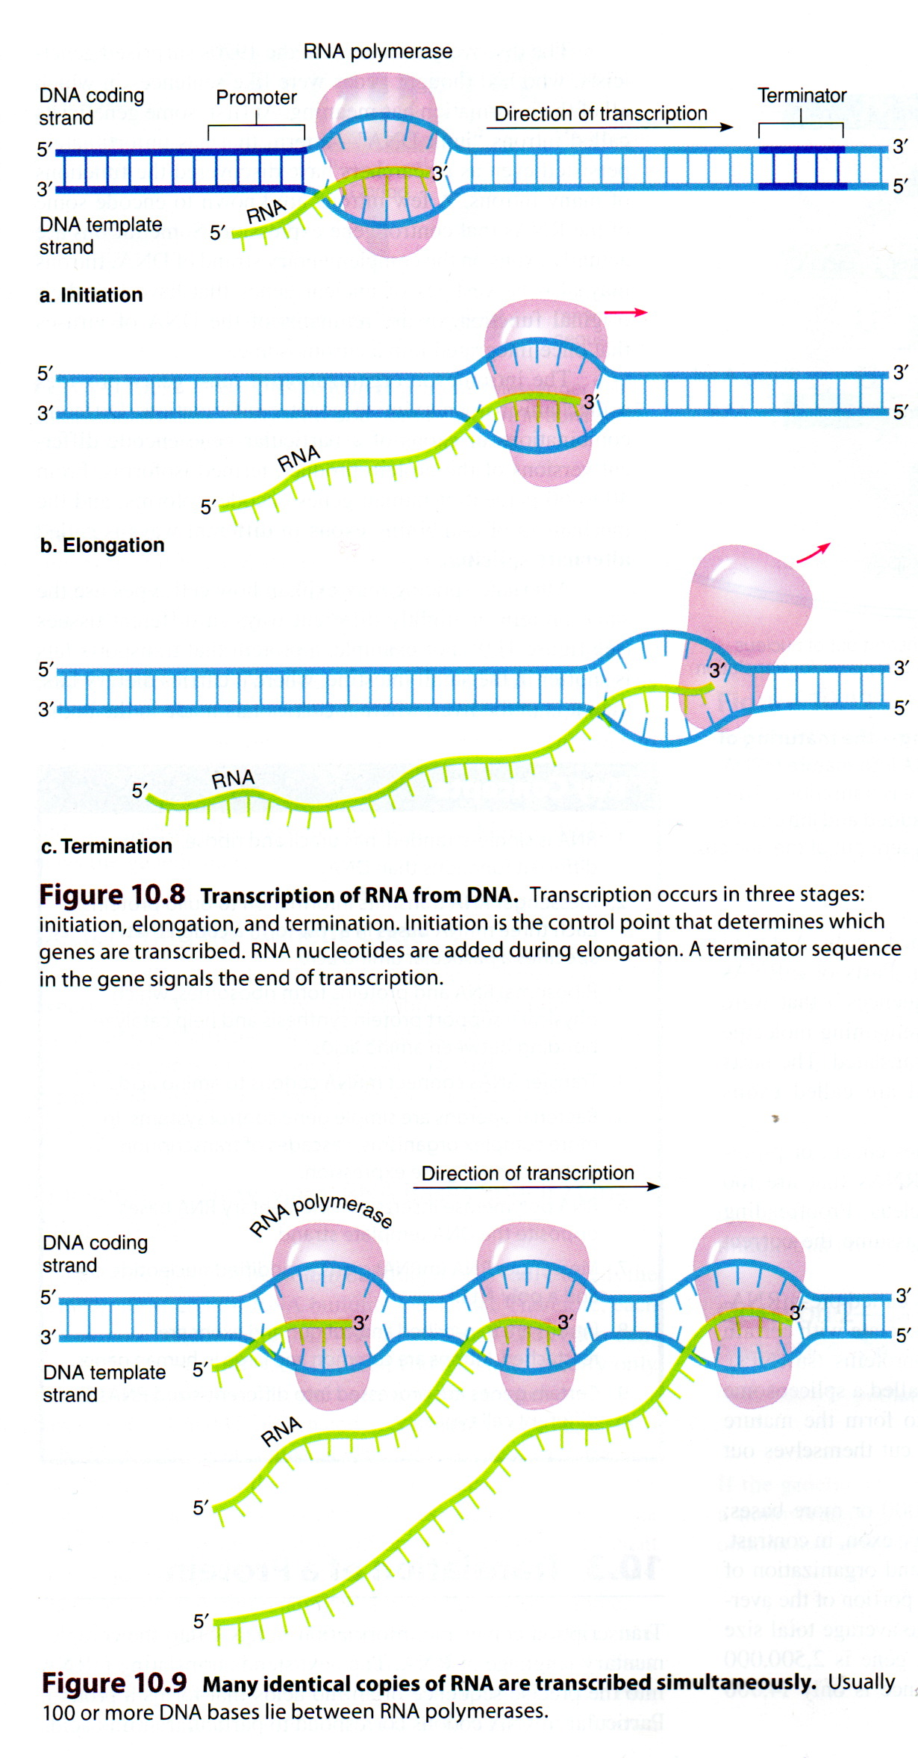

**mRNA Processing in Eukaryotes**

In the nucleus, a gene composed of **Exons** (coding sequences) and **Introns**

(noncoding sequences). Both of these are transcriped to pre- mRNA or primary

transcripts (primary mRNA). Pre mRNA undergoes 3 major modifications prior to

their transport to the cytoplasm for translation:

**1) 7-Methyl guanosine caps** are added to the 5' ends of the primary transcripts. **2) Poly (A) tails** (a series of adenine molecules) are added to the 3 ends of the

transcripts. It is important for RNA stability and translation of polypeptide.

**3)** Processing involves **spliceosomes** consist of snRNAs and protein subunits in the

nucleus to remove the intron and **splice together the exon into mRNA.** Mature

mRNA transmits to the cytoplasm where it directs protein synthesis. Transcription

and RNA processing occur in the nucleus while translation occurs in the cytoplasm

(in Eukaryote).

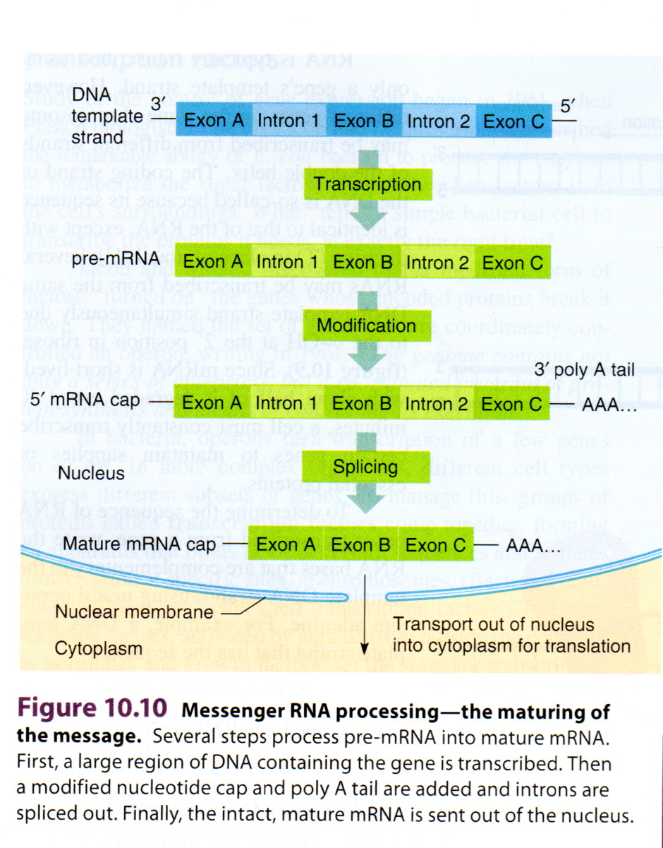

**Translation (Protein Synthesis)**

The Process which the genetic information (which is stored in the sequence of

nucleotides in an mRNA molecule ) is translated , according to the specification of the genetic code into the sequence of amino acids in the polypeptide gene product. Aribosome has two subunits (each composed of rRNA and various proteins) small

subunit and large subunit. Eukaryotic ribosome (80 S) has small subunit (40 S) and

large subunit (60 S).

**Protein synthesis consists of 3 phases:**

**1- Initiation Phase:**

A small ribosomal subunit binds to mRNA: an initiator tRNA with the

anticodon UAC pairs with the start codon AUG.

The large ribosomal subunit completes the ribosome; initiator tRNA carry

methionine occupies the P-site. The A-site is ready for the second tRNA

The small and large subunit together form two tRNA binding sites P (Peptidyl)

site and A (Aminoacyl ) site .



**2- Elongation Phase**: Elongation consists of 3 steps:

**1st** A second charged tRNA with an anticodon complementary to the second

codon on mRNA binds to A-site.

**2nd- Peptide bond formation: Peptidyltransferase** (part of the large ribosomal

subunit) can catalyze formation of peptide bond between the amino acids

carried by the two tRNAs . This bond forming reaction connects the methionine at the P-site to the amino acid carried by the tRNA at the A-site. It also disconnects

methionine from the initiation tRNA as a result the tRNA at the A-site now carries

two amino acids.

**3rd- Translocation:**

Three concerted movements occur, collectively called translocation.

1- Uncharged -tRNA leaves the P-site.

2- The dipeptide-tRNA in the A-site moves to the P-site.

3- The ribosome moves a long the mRNA by three nucleotides (codon) to place the

next codon in the A-site.

The empty A-site now receives another tRNA whose identity is determined by the

next codon in the mRNA and the (peptide bond formation and translocation) occurs once again.

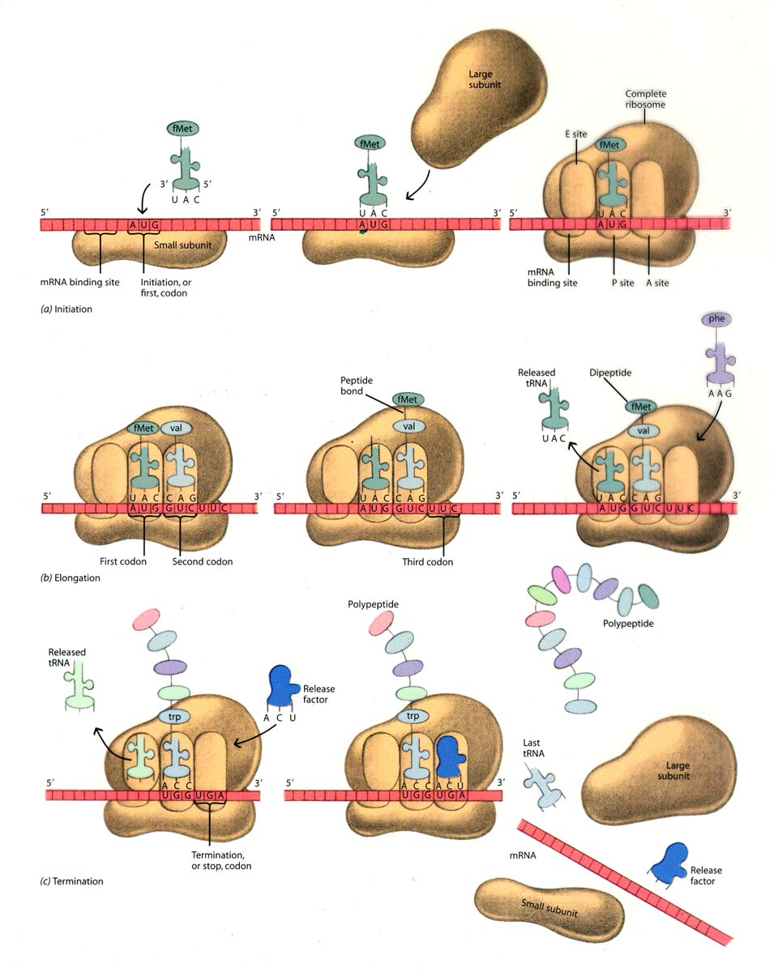

**3- Termination Phase:**

Termination of protein synthesis occurs when one of 3 stop codons (UAG,

UAA, and UGA) appears in A-site of the ribosome. A protein called release factor

recognizes stop codons and hydrolysis the bond between the last tRNA at the P-site

and the **polypeptide** releasing them. The ribosomal subunits dissociate.

The resultant **polypeptide chain** may be enzyme, hormone, antibody, or

structural proteins.



**Genetic Code:**

The linear sequences of 3 Nucleotides in mRNA that Code for a sequence of amino acids in Polypeptide chain during the Process of Translation at the Ribosome . 64 Codons more than enough to Code for 20 different amino acids found in Proteins

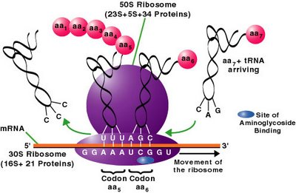

**Features of The Genetic Code :**

1- Genetic Code is **Triplet** : AAA Code for Lysine .

2- **Unambiguous** : each Triplet Codon has only one meaning .

3- The Genetic Code has start and stop signals . There is one **start signals** ( **AUG** ) . and there is 3 **stop signals** ( **UAA** , **UAG** , **UGA** ) .

4- **Universal** : the Code is same and stable in all living organisms .