**The characteristic of a junction diode Introduction**

**Diode** is the simplest type of semiconductor device. In general, it is a two-terminal electronic device that permits current flow predominantly in only one direction.

* The current that pass **depends** upon the voltage between the leads.
* They do not obey **Ohm's law**.

It is **unidirectional**, i.e. current flows in only one direction (**anode to cathode internally**). When a **forward voltage** is applied, the diode conducts; and when a **reverse voltage** is applied, there is no conduction.

**Diodes** are a **rectifying** device, in other words a device that converts the flow of **AC** to **DC** power. The diode itself is not a new device; its original form was in a **vacuum tube**, which in itself is a device with a venerable history.

An ideal **diode** is like a light switch in your home. When the switch is **closed**, the circuit is completed; and the light turns on. When the switch is **open**, there is no current and the light is off.

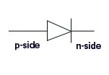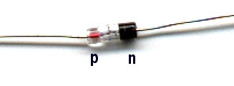A semiconductor **diode** consists of a **PN** junction and has two terminals, an anode (**+**) and a cathode (**-**). Current flows from anode to cathode within the diode.

**The p-n Junction Diode**

When a **p-type** semiconductor is brought in contact with an **n-type** semiconductor, a **p-n junction** is formed and the diffusion process begins. Owing to the force of attraction between the unlike charges on either side of the junction, the **holes**, majority carries on the **p-side**, begin to diffuse into the **n-type** and at the same time, the **electrons**, the majority carries on the **n-side**, diffuse into the **p-side**. The movement of these charges gives rise to the **diffusion current**. Following the passive convention for the current, the diffusion current is from the **p-side** into the **n-side**.

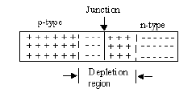

**Biasing the Junction Diode**

* **A forward biased p-n junction: -**

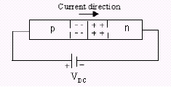Occur when the **positive** terminal of a battery is connected to the **p-side** and the **negative** terminal of a battery is connected to the **n-side**.

The **positive** terminal of the battery removes the free electrons from the **p-side** and forces the holes to move toward the **depletion region**. As soon as the holes enter the **depletion region**, they end up neutralizing the negative charge.

The reduction in the negative charge causes a decrease in the **depletion region** on the **p-side**. A similar phenomenon occurs on the **n-side** where the negative terminal of the battery removes the holes from the **n-side** and pushes the free electrons toward the **depletion region**. As the electrons migrate into the **depletion region**, they neutralize the positive charges (**holes**) causing a **reduction** in the **depletion region**.

* **A reverse biased p-n junction: -**

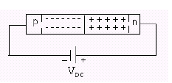Occur when the **positive** terminal of a battery is connected to the **n-side** and the **negative** terminal of a battery is connected to the **p-side**.

The **positive** end of the battery removes electrons from the **n-side** and forces holes to move toward its **depletion region**. Likewise, the negative end of the battery removes the holes from the **p-side** and makes the electrons to move toward its **depletion region**. As the **depletion region** widens on both sides of the junction, it further restricts any diffusion activity that might be taking place due to the thermal energy. Thus, in a reverse biased **p-n** junction, the current is essentially **zero**. Keep in mind that the reverse current in a reverse biased  **p-n** junction can never be zero **because** of the thermally produced free electrons and holes in the intrinsic semiconductor.

The voltage at which the **p-n** junction diode begins to conduct in the reverse direction is defined as the **breakdown voltage**, **zener voltage**, or the **peak-inverse voltage**.

The most important point to remember about the **p-n** junction diode is its ability to offer very **little** resistance to current flow in the **forward bias** direction but **maximum** resistance to current flow when **reverse biased**.

**Characteristic Curve**

This is the "**characteristic**" curve of a **p-n** junction diode. It shows the slow, then abrupt rise of current as the voltage is raised. Under reverse bias, even very large voltages will cause only very small currents, essentially constant reverse bias currents. The reverse bias current **depends** mainly on the rate of thermal generation of the electron-hole pairs.

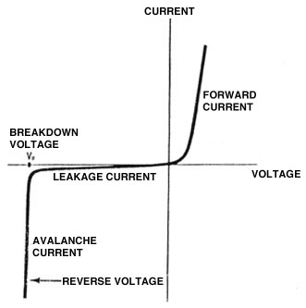If the **p-n** junction is operated in the fourth quadrant, the product of a negative current and a positive voltage will yield a negative power. Physically, this corresponds to a source of power. Consequently, a **p-n** junction operated in the fourth quadrant can be used as a source of power; this is the principle behind the **solar cell**. However, a typical diode characteristic is more like the following.

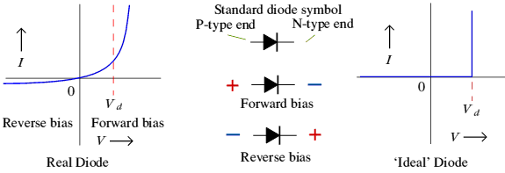

***The Medical Applications of Diode***

1. The Diode is unidirectional (current flows in only one direction), this work is similar to: -
   1. In cardiovascular system: - the **valve** of the heart permits the blood to flow in only one direction.
   2. In nervous system: - the **synapse** that connects the neuron to the other neuron only permits the action potential to move along the axon away from its own cell body.
2. In bone growth: -

Bone contains **collagen**, which behaves like an **N type** semiconductor, that is, it conducts current mainly by **negative** charges, and **mineral crystals**, which behaves like a **P type** semiconductor, that is, they conduct current mainly by **positive** charges.

1. The Diode use to produce LASER in semiconductor LASER.
2. In Dentistry: -
   1. Some light cures work like the diode.
   2. All power supplies of dental chairs depend on diode in their work.