Management of Children with Systemic Diseases

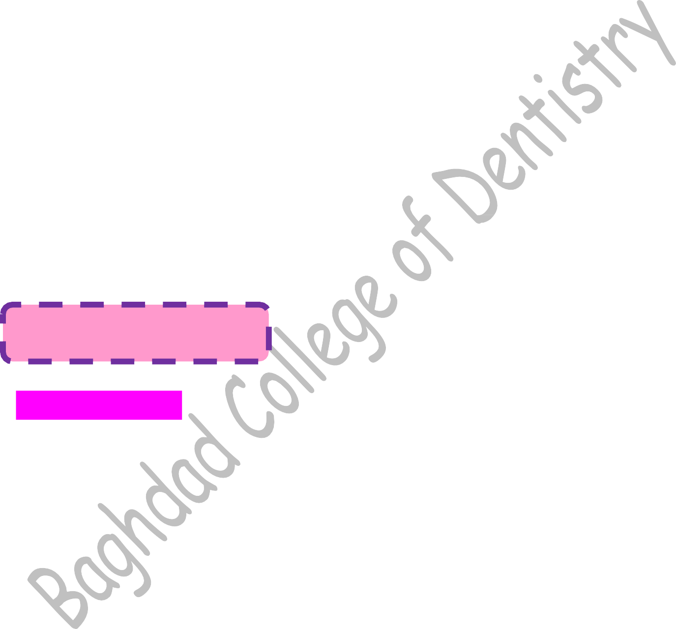
Management of Children with Systemic Diseases
Systemic disease in children cover a wide range of conditions, which include diseases involving one or more organs or systems of the body, thereby affecting the general health of the child.
A number of systemic conditions affect the oral tissues and require modifications during routine dental treatment. The systemic disease may have a profound effect on the health of the oral tissue and vice versa. For examples:
- Oral manifestation of systemic disease( glossitis seen in anemia)
- Systemic condition might increase the risk of oral disease (dental erosion seen in a child with anorexia nervosa).
- Medication used for the treatment of the systemic disease might increase the risk of oral disease (gingival hyperplasia on administration of Dilantin).
- Oral disease may pose a greater risk for the child to develop systemic disease (bacteremia from odontogenic infection in bacterial endocarditis).

ENDOCRINOPATHIES

Hyperthyroidism
Patients with Hyperthyroidism are of a great concern to the dental surgeon. In children with untreated or poorly treated thyrotoxicosis, dental treatment, infections or trauma can precipitate an acute emergency called thyroid crisis or thyroid storm.
Causes of thyrotoxicosis
Ectopic thyroid tissues
Graves’ disease (Appears to be due to an autoimmune disorder in which a substance is produced that abnormally stimulates the thyroid gland)
Multinodular goiter Thyroid adenoma Pituitary gland disease
Note: Thyroid hormones are important for metabolic functions that are involved with utilization.
Thyrotoxicosis means increased amount of thyroid hormones, thyroxine and
triiodothronine in blood.

Oral manifestations in children
Premature loss of primary teeth and early eruption of permanent teeth.
Early development of the jaw bones. Increased periodontal disease.

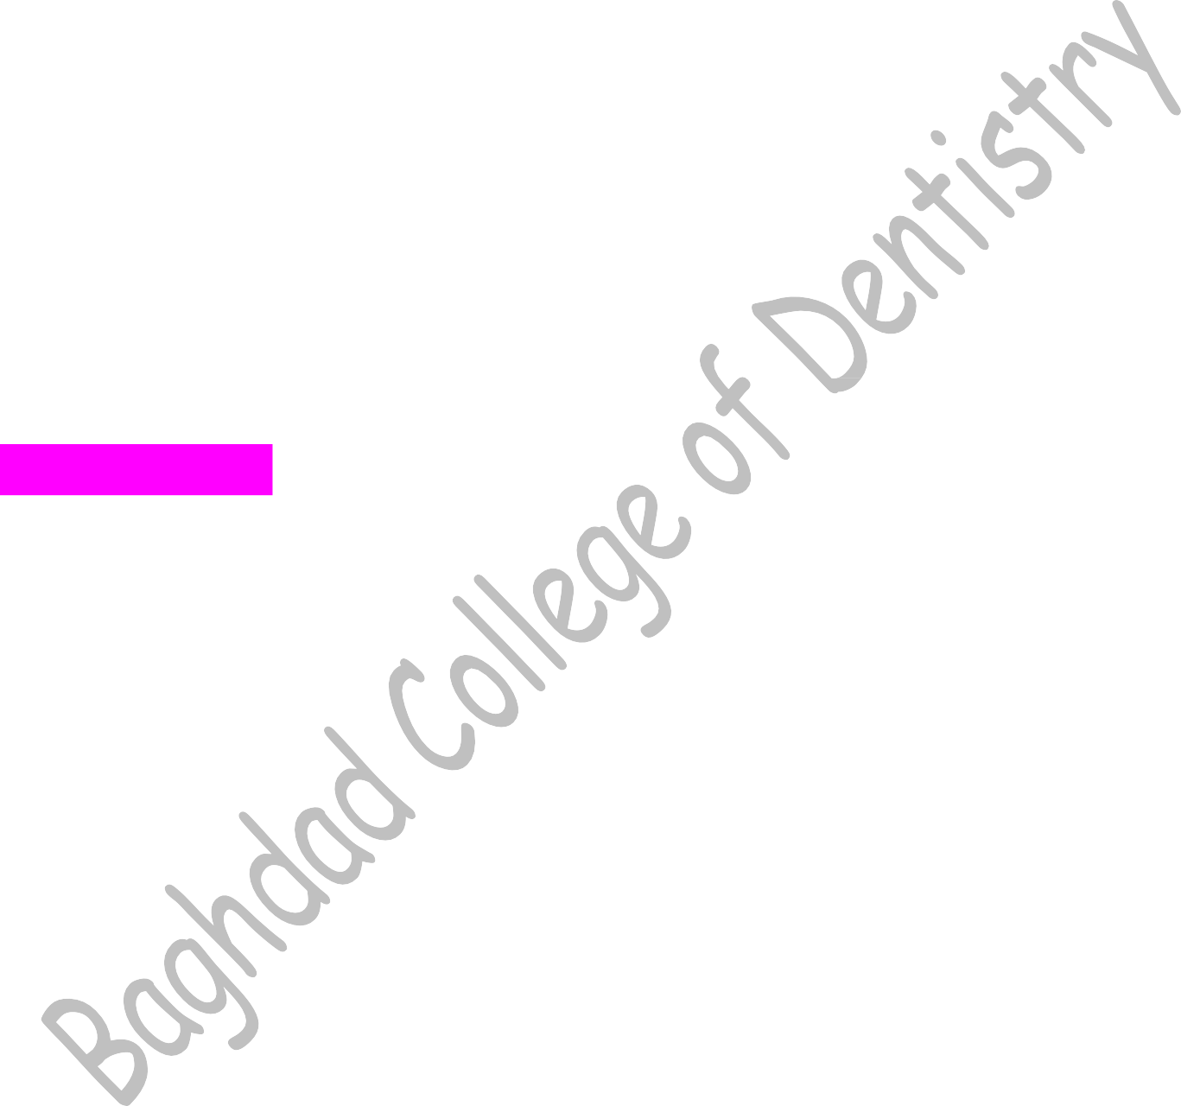
Management in the dental clinic
  - Consultation with child’s physician.
  - Avoid elective dental treatment until thyrotoxicosis is under control.
  - Acute infections must be dealt with antibiotic therapy to prevent thyroid crisis.
  - Avoid use of adrenaline and other vasoconstrictors.
  - Thyroid storm may be precipitated due to trauma, surgery, stress, or infections. Early recognition and management is important. It includes ice applied on skin, intravenous administration of hydrocortisone, glucose, etc. and cardiopulmonary resuscitation, if required.
  - Patients under good medical control can be managed as normal.

Hypothyroidism
It does not manifested as sever, life-threating condition and in children it is called
Cretinism.

Oral manifestations
Delayed eruption of teeth
Malocclusion Enlarged tongue

Hyperparathyroidism
A lower level of calcium level stimulates release of parathyroid hormone which: Increase bone resorption.
Retains calcium by reabsorption in the kidneys. Favors absorption of calcium in the intestine.
The net effect is increased serum calcium level which inhibits further parathyroid hormone secretion.

Oral manifestations
  - Drifting and loosening of teeth
  - Malocclusion
  - Pathological fracture of jaw bones
  - Radioluscencies representing bone cysts (osteitis fibrosa cystica), loss of lamina dura

  - A generalized ground glass or moth eaten appearance of bone may be seen.

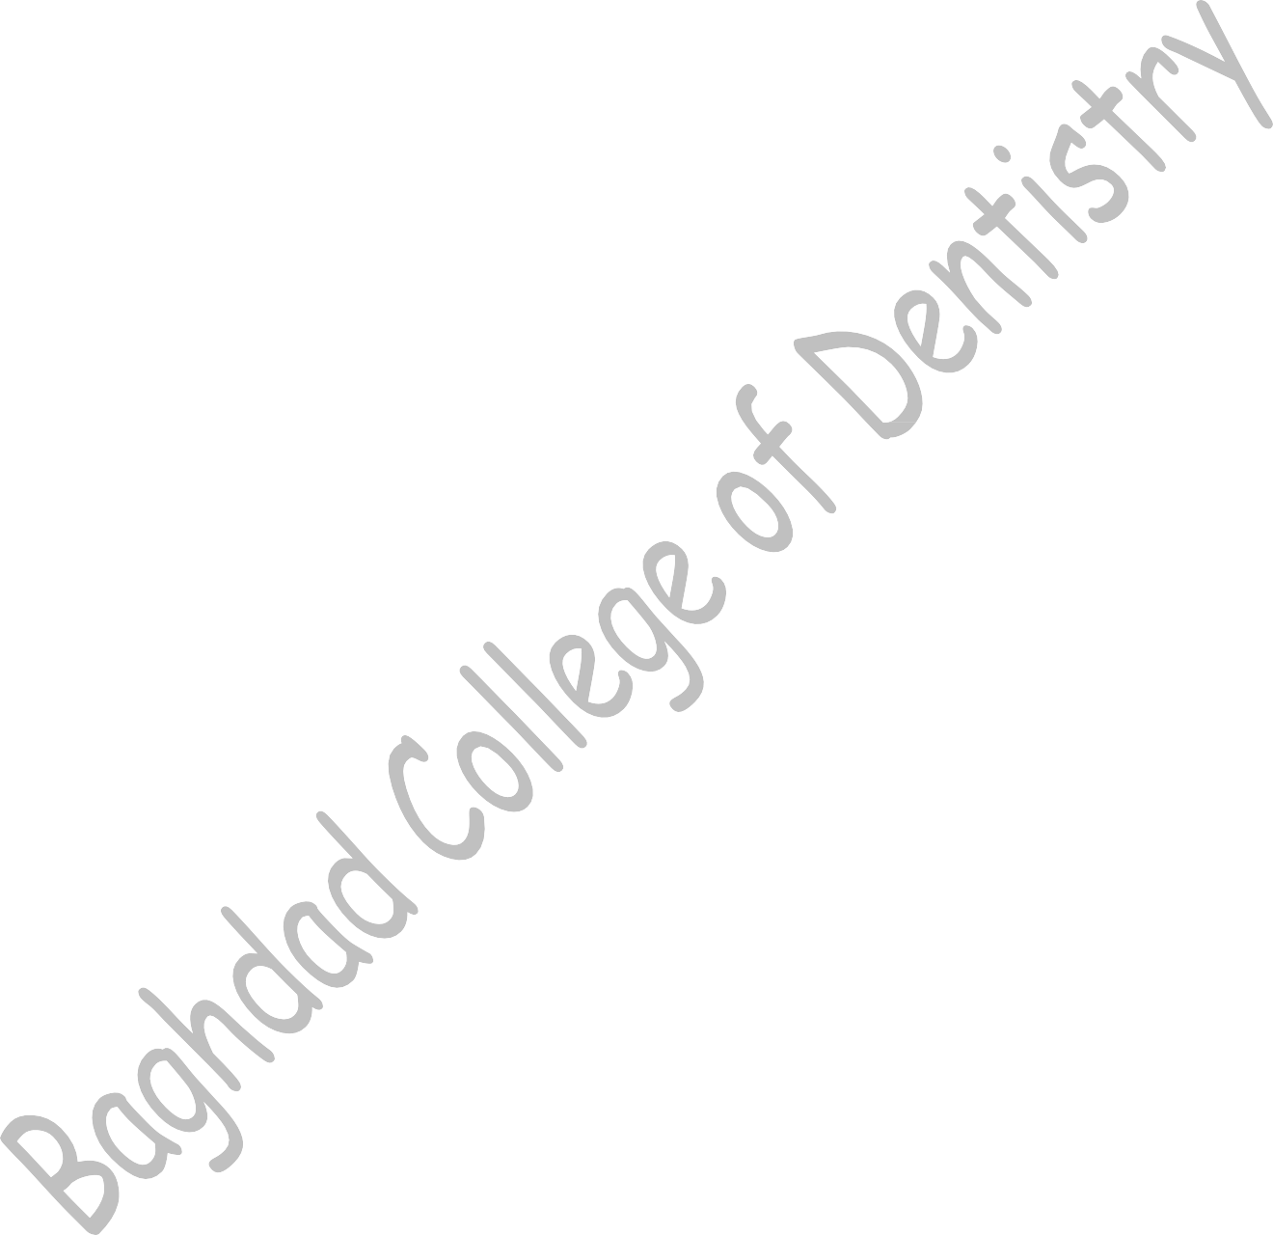
Management in the dental clinic
  - Consultation with child’s physician.
  - Determine serum calcium, phosphate and alkaline phosphatase level.
  - Avoid routine dental treatment in patients with severe renal failure. Emergency dental treatment must be provided with proper medical advice.
  - Dental treatment of malocclusion, missing teeth... etc. should be done after the treatment of the cause of hyperparathyroidism.

Hypoparathyroidism
Commonly seen following surgical procedures involving thyroid gland and inadvertent excision of parathyroid gland (damage to the gland during surgery). Severe cases of hypoparathyroidism may lead to tetany.

Oral manifestations
Hypoplasia of teeth
Blunting of molar roots
A sharp tap over the facial nerve in front of the ear causes twitching of facial muscles around the mouth (Chvostek sign).

Management in the dental clinic
  - Consultation with child’s physician.
  - Avoid elective treatment in case of severe hypocalcemia with serious cardiac problems.

Diabetes Mellitus
It is a disease complex of disordered metabolism characterized by hyperglycemia, altered protein and lipid metabolism as a result of absolute or relative deficiency of insulin. Clinically it can be classified as:
Insulin dependent mellitus
Non-Insulin dependent mellitus

Symptoms of Diabetes Mellitus:
- patients may drink huge volumes of fluid
- cause more urine will be produced and making the person thirstier as a result.

Excessive thirst
- Because of imbalance of sugar level in blood.

Fatigue and tiredness
- urinating a lot
- losing weight
- having blurried vision
Others general symptoms

Other symptoms include:
Recurrent bed wetting, Repeated skin infections, Marked irritability, Headache, Drowsiness, Malaise, Dry mouth

Oral manifestation:
- Gingivitis, increased severity of periodontitis, bone loss, periodontal abscess, etc.
- Xerostomia
- Delayed wound healing
- Pulpitis in non-carious tooth
- Burning sensation in tongue
- Acetone smell in breath
- Oral ulcers
- Oral candidiasis
- Increase the susceptibility to dental caries (due to xerostomia and increase saliva glucose)
- Miscellaneous conditions such as: Neuropathies: may affect cranial nerves (facial).
Drug side-effects: lichenoid reaction may be associated with sulphonylureas (chlopropamide)
Ulcers

Management in the dental clinic
To minimize the risk of an operative emergency, clinicians need to consider some issues
before initiating dental treatment:
  - Medical history: Take history and assess glycemic control at initial appointment, that’s by:
- Glucose levels
- Frequency of hypoglycemic episodes
- Medication, dosage and times.
- Consultation

  - Scheduling of visits: Morning appointment
Do not coincide with peak activity.

Diet:
Ensure that the patient has eaten normally and taken medications as usual
  - Blood glucose monitoring: Measured before beginning. (<70 mg/dL)
  - Prophylactic antibiotics: To get rid of the establishment of infection.
  - During treatment: The most common complication of DM occur is: Hypoglycemic episode.
Hyperglycemia
  - After treatment: Dietary intake
Medications: salicylates increase insulin secretion and sensitivity ➔ avoid aspirin

MANAGEMENT OF SYNCOPE:
Treat the underlying cause
Immediate symptomatic therapy includes: Recognition of unconsciousness “Shake & shout”
Check for protective reflexes

Management
Position victim-supination
Assess & open airway-head tilt, chin lift
Airway patency, breathing, circulation-look, listen & feel
Artificial ventilation & cardiac massage-cardiopulmonary resuscitation

