Respiratory diseases

RESPIRATORY DISEASES

ASTHMA (REACTIVE AIRWAY DISEASE)
Asthma is a common childhood disease, affecting 1 in 10 children. It is a chronic diffuse obstructive airway disease characterized by inflammation, increased mucus production, and bronchial constriction, caused by edema of the mucous membranes, increased mucous secretions, and spasm of smooth muscle.
Before initiating dental treatment, the dentist should know what are the frequency and severity of the attacks, what are the triggering agents, when the patient was hospitalized and/or in the emergency department, when the last attack occurred, what medications the patient takes, and what limitations on activity the patient may have. Patients taking systemic corticosteroids and those who were hospitalized or in the emergency department in the preceding year should be treated with caution because they are at higher risk of morbidity and mortality.
Patients who use bronchodilators should take a dose before their appointment, and they should bring their inhalers or nebulizers into the dental office in case trouble arises. Behavioral methods are used to reduce anxiety and the child may need to be positioned in an upright position for the dental procedure, and nitrous oxide–oxygen analgesia may be helpful. Hydroxyzine hydrochloride (Vistaril) and diazepam (Valium) have been successful in alleviating anxiety. Barbiturates and narcotics are not indicated because of their potential for histamine release, leading to a bronchospasm. Aspirin compounds
and nonsteroidal anti-inflammatory agents are contraindicated because about 4% of patients experience wheezing after taking these drugs.
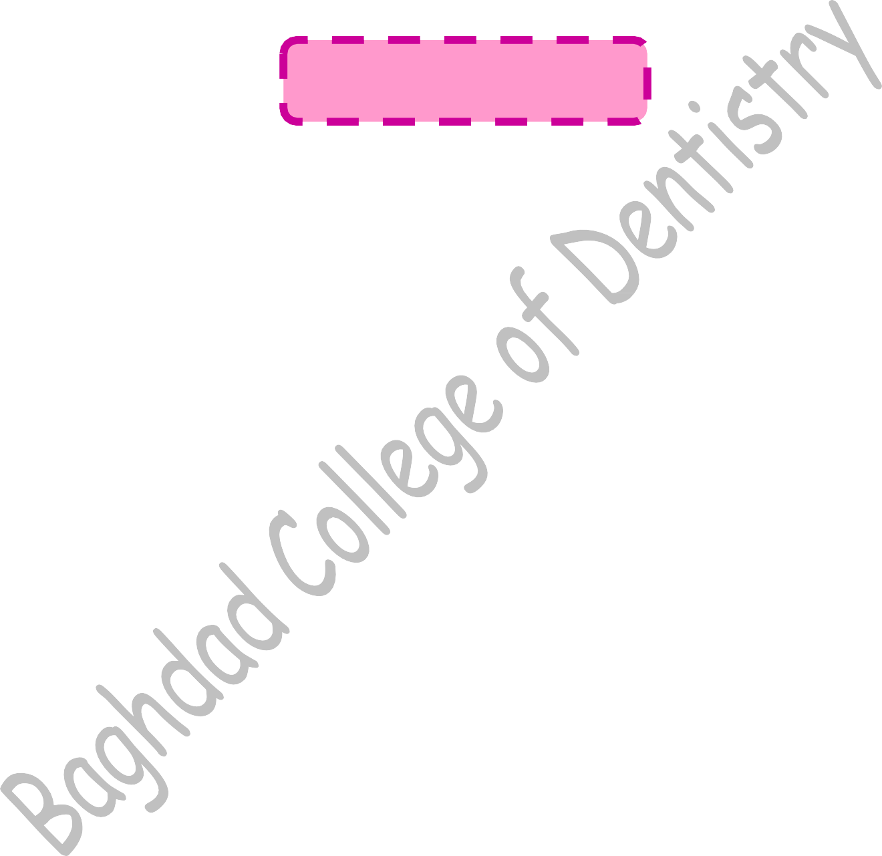Oral findings of children with moderate to severe asthma include higher caries rates, decreased salivary rates, increased prevalence of oral mucosal changes characteristic of chronic mouth breathers, and increased levels of gingivitis. Increased incidence of orofacial abnormalities such as high palatal vault, more posterior crossbites, greater overjets, and increased facial height is also seen.

HEART DISEASE
Heart disease can be divided into two general types: congenital and acquired. Because individuals with heart disease may require special precautions during dental treatment, such as antibiotic coverage for prevention of infective endocarditis (IE), a dentist should closely evaluate the medical histories of all patients to ascertain their cardiovascular status. The dentist should obtain a thorough medical and dental history, perform a physical examination, formulate a complete treatment plan, and discuss the treatment with the child’s physician or cardiologist. Behavior management techniques are useful, and conscious sedation and nitrous oxide–oxygen analgesia have also been proven beneficial in reducing anxiety in such patients. Conscious sedation monitoring and cardiopulmonary resuscitation equipment should be readily available during the appointment. If general anesthesia is indicated, the dental procedures should be completed in a hospital setting,
where adequate supportive care is available if needed.
Other considerations are especially important in treating patients who are susceptible to IE:
- Pulp therapy is not recommended for primary teeth with a poor prognosis because of the high incidence of associated chronic infection. Extraction of such teeth with appropriate fixed-space maintenance is preferred.
- Endodontic therapy in the permanent dentition can usually be accomplished successfully if the teeth to be treated are carefully selected and the endodontic therapy is adequately performed.
- A dentist who feels uncomfortable in treating patients who are susceptible to IE has a responsibility to refer them to someone who will adequately care for them.

Conditions at risk of infective Endocarditis during dental care:
Prophylactic antibiotic is necessary for invasive dental treatment:
  - Dental procedures likely to induce gingival or mucosal bleeding, including professional cleaning.
  - Surgical operations.
  - Incisions and drainage of infected tissues and endodontic treatment.
  - Intraligmentary injections.
  - Distal shoe space maintainer.

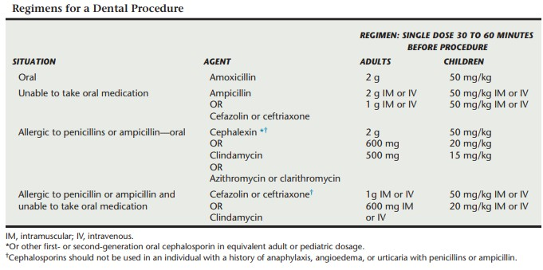Any dental patient who has a history of congenital heart disease or rheumatic heart disease or who has a prosthetic heart valve should be considered susceptible. The American Heart Association’s antibiotic recommendations for the prevention of bacterial endocarditis are presented as followed:

HEMOPHILIA (DISORDERS OF HEMOSTASIS)

The hemophilia are disorders of hemostasis, resulting from a deficiency of a clotting factor that promotes formation of a fibrin clot, termed procoagulants. Hemophilia is an inherited bleeding disorder affecting approximately 1in 5000 males.
Hemophilia A, or classic hemophilia, is a deficiency of factor VIII, also known as antihemophilic factor. It is the most common form of hemophilia and is inherited as an X- linked recessive trait. Therefore males are affected, females are carriers, and there is no male-to-male transmission.
Hemophilia B, or Christmas disease which is factor XI (plasma thromboplastin antecedent) deficiency, it is caused by a deficiency of factor IX (plasma thromboplastin component) and it is also inherited as an X-linked recessive trait. Factor IX deficiency is one fourth as prevalent as factor VIII deficiency.

Hemophilia C or Rosenthal’s disease, it is inherited as an autosomal-recessive trait, with male and female offspring equally affected. This disorder is most frequently observed in those of Ashkenazi Jewish descent, but it is found in many other populations.
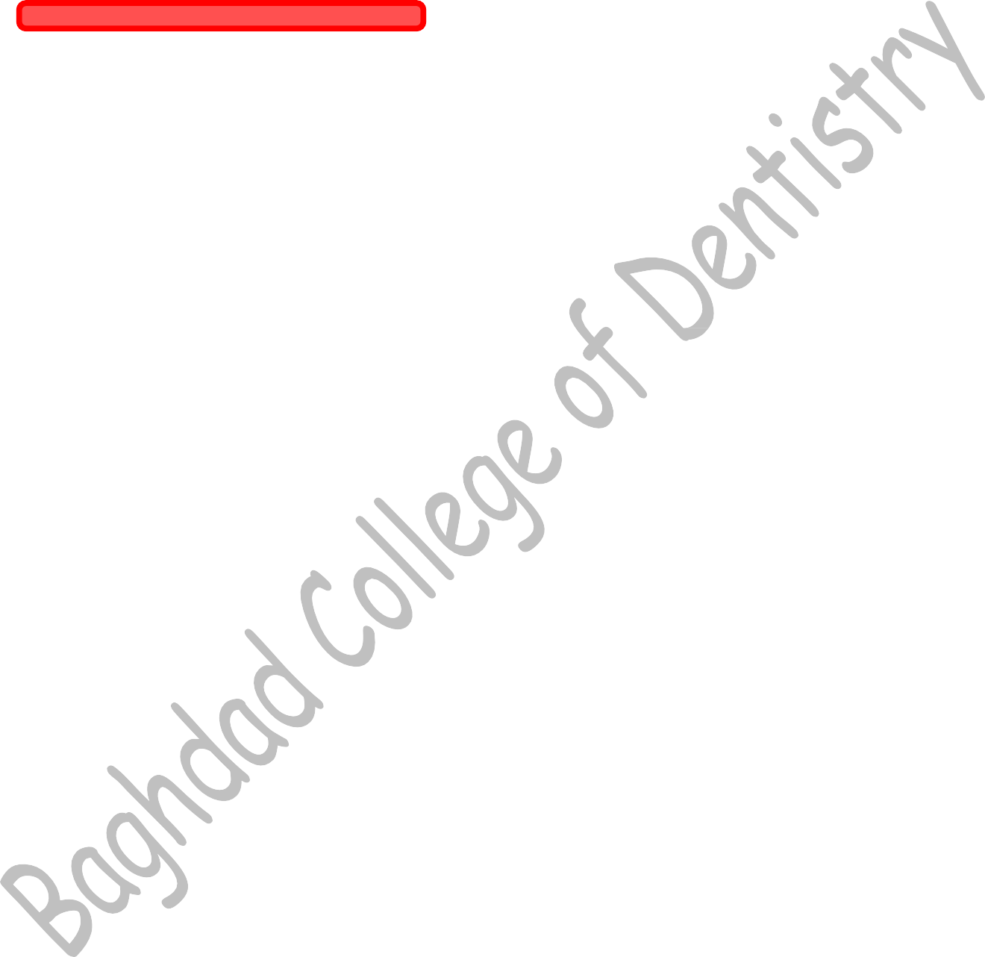
Other factor deficiencies, such as factors II, V, and XIII and factor are rare and are inherited as autosomal-recessive traits.
Von Willebrand disease (VWD) is a hereditary bleeding disorder resulting from an abnormality of the von Willebrand factor (VWF) found in plasma, platelets, megakaryocytes, and endothelial cells. VWF circulates in conjunction with factor VIII, protecting it from proteolytic degradation, and is important in platelet adhesion to the subendothelium via collagen and therefore the formation of the primary platelet plug.
The mainstay of therapy for hemophilia is replacement of the deficient coagulation factor through the use of purified concentrates either manufactured through recombinant technology or from pooled plasma. In the past, whole blood, plasma, or cryoprecipitate was used; but at present, genetically engineered products represent the main source of replacement therapy.
Based on the level of the procoagulant present, hemophilia can be classified into three groups:
- Severe deficiency: levels less than 1%
- Moderate deficiency: levels between 1% and 5%
- Mild deficiency: levels greater than or equal to 5% to less than 50%
For mild factor VIII deficiency, DDAVP (1-deamino-8-d-arginine vasopressin) may be used for minor hemorrhagic episodes to achieve hemostasis. This drug, when given intravenously, subcutaneously, or intranasally causes a rise in activities of factor VIII and VWF.

USE OF ANTIFIBRINOLYTIC AGENTS
Antifibrinolytic agents are an adjunctive therapy for dental management of patients with bleeding disorders and are important for the prevention or treatment of oral bleeding. These agents include ε-aminocaproic acid (its advantage for children is that it is available in both tablet and liquid form.) and tranexamic acid.
Hemophilic patients form loose, friable clots that are easily dislodged or rapidly dissolved, especially in the oral cavity, where local fibrinolysis is increased. Antifibrinolytics prevent clot lysis within the oral cavity and are often used as an adjunctive therapy to factor concentrates. For some dental procedures in which minimal bleeding is anticipated, antifibrinolytics may be recommended as the sole hemostatic agent. It should not be used when renal or urinary tract bleeding is present or when there is evidence of disseminated intravascular coagulation.

RISKS TO DENTAL STAFF
The risk for acquiring hepatitis B (HBV), hepatitis C (HCV), or human
immunodeficiency (HIV) virus infections following an accidental needle stick are 30%, 3%, and 0.3%, respectively. Although there is now evidence for the transmission of HIV when infected mothers premasticate food for their children, the quantifiable risk of HIV transmission via saliva alone is lower than that from a needle-stick injury.

DEVELOPMENT OF A TREATMENT PLAN
With recent advances in treatment, most patients with bleeding disorders receive
outpatient dental care routinely. With a thorough understanding of the patient’s hemostatic disorder, the dentist, in conjunction with the hematologist, is able to make safe and appropriate treatment decisions.
The dentist must be aware of the procedures that can be safely performed and those in which complications may arise. The dentist should confer with the patient’s physician and hematologist to formulate an appropriate treatment plan. The dentist should know the specific type of bleeding disorder, severity, frequency of and treatment for bleeding episodes, as well as the patient’s inhibitor status. Many individuals with hemophilia self- administer infusion products at home and are therefore able to treat themselves as required. The dentist should be prepared to discuss with the hematologist the type of anesthetic anticipated to be administered, invasiveness of the dental procedure, amount of bleeding anticipated, and time involved in oral wound-healing in order to help establish an appropriate treatment plan, including the need for replacement and adjunctive therapies.

PAIN CONTROL

Analgesia
If patient apprehension is significant, sedation or nitrous oxide–oxygen inhalation analgesia may be considered. Hypnosis has also proved beneficial for some individuals. Intramuscular injections of hypnotic, tranquilizing, or analgesic agents are contraindicated especially in patients who have not received replacement therapy or in patients with inhibitors, due to the risk of hematoma formation.
Analgesics containing aspirin or anti-inflammatory agents (e.g., ibuprofen) may affect platelet function and should be avoided. Acute pain of moderate intensity is frequently managed with acetaminophen (Tylenol, Temprat). For severe pain, narcotic analgesics may be required and are not contraindicated in the patient with a bleeding disorder.

Local Anesthesia
In the absence of factor replacement, periodontal ligament (PDL) injections may be used. The anesthetic is administered along the four axial surfaces of the tooth by placement of the needle into the gingival sulcus and the PDL space.
Infiltration anesthesia can generally be administered without pretreatment with either ε-aminocaproic acid or replacement therapy. However, if the infiltration injection is into

loose connective tissue or a highly vascularized area, then factor concentrate replacement to achieve a level of approximately 30% to 40% activity is required (bleeding in pterygomandibular region may result in Asphyxia).
One must proceed with caution when considering block anesthesia. The loose, connective, non-fibrous and highly vascularized tissue at the sites of inferior alveolar nerve injection and posterior superior alveolar injections is predisposed to development of a dissecting hematoma, which may cause airway obstruction and result in a life-threatening bleeding episode.
The dentist must carefully aspirate to ensure that the needle has not entered a blood vessel. If bloody aspirate is present, further factor replacement may be required, and the attending hematologist should be notified immediately following the operative procedure.
All patients should be observed for development of a hematoma and immediately referred for treatment in cases where hematomas develop after the administration of local anesthesia.

DENTAL MANAGEMENT
Most patients with bleeding disorders are recommended to receive routine regular outpatient dental care. Appointments should be arranged so that maximum treatment is accomplished per visit in order to minimize the need for unscheduled factor infusions and resultant increased cost. Patients with inhibitors are best treated at a center with experience in dealing with this complication. Dental procedures utilized to treat a patient with a bleeding disorder do not differ significantly from those used for unaffected individuals.

Conservative Dentistry and Prosthodontic
Rubber dam is used to minimize trauma to the tissues, saliva ejector should be avoided to avoid suction Hematomas. Wedges or matrices are used to avoid laceration to the papilla. In routine crown preparation retraction is used to expose marginal areas. Impression trays are trimmed and edges are coated with soft wax to minimize trauma. A rubber dam should be used to isolate the operating field and retract and protect the cheeks, lips, and tongue. These soft tissues are highly vascular and accidental laceration may present a difficult management problem. A thin rubber dam is preferred, since there is a decreased tendency to torque the rubber dam retainer and cause gingival tissue abrasion. The retainer should be placed carefully so that it is stable. If a retainer slips, it may lacerate the gingival papilla. Retainers with subgingival extensions should be avoided. Wedges and matrices can be used conventionally. During proximal preparation, the wedge retracts the papilla, thus protecting it. A properly placed matrix should not cause bleeding.
High-speed vacuum and saliva ejectors must be used with caution to prevent sublingual hematomas. Care must also be used in the placement of intraoral radiographic films, particularly in highly vascular sublingual tissues.
A pulpotomy or pulpectomy is preferable to extraction. The extraction of a tooth in an individual with a bleeding disorder involves more complicated treatment and expense. Most vital pulpotomy and pulpectomy procedures can be successfully completed with local

infiltration anesthesia. If the pulp of a vital tooth is exposed, an intrapulpal injection may be used safely to control pain. Bleeding from the pulp chamber does not present a significant problem, in that it is readily controlled with pressure from cotton pellets. If pulp tissue is necrotic, local anesthetic is usually unnecessary. Primary teeth when shed in normal way cause little or no hemorrhage, however, if very mobile, extraction may be necessary.

Surgical Complications
Despite all precautions, bleeding may occur 3 to 4 days postoperatively when the clot begins to resorb. Both systemic and local treatment should be used for hemostatic control when bleeding occurs. Sufficient replacement factor should be administered to control recurrent bleeding.

Dental Emergencies
Oral trauma is a common occurrence during childhood. Management of bleeding injuries, including hematomas, in the oral cavity of the patient with a bleeding disorder may require a combination of factor replacement and antifibrinolytic therapy, as well as treatment with local hemostatic agents. Blood loss from the oral cavity is easily underestimated or overestimated. The patient’s hemoglobin should be checked to ensure that anemia has not developed in these circumstances.
sing area.

SICKLE CELL ANEMIA
Sickle cell anemia (SCA) is composed of sickle cell trait, which is benign and does not restrict medical or dental treatment, and sickle cell disease (SCD). Patients with SCD have an autosomal-recessive hemolytic disorder that occurs predominantly in persons of African descent but it also can be found among Italian, Arabian, Greek, and Indian people.
Patients with SCD produce hemoglobin S instead of the normal hemoglobin A. Hemoglobin S has a decreased oxygen-carrying capacity. Decreased oxygen tension causes sickling of cells. Those patients are susceptible to recurrent acute infections, which result in an “aplastic crisis” caused by decreased red blood cell production and in subsequent joint and abdominal pain with fever. Over time, there is a progressive deterioration of cardiac, pulmonary, and renal function.
Many factors can precipitate a sickle cell crisis, including acidosis, hypoxia, hypothermia, hypotension, stress, hypovolemia, dehydration, fever, and infection. Patients with SCD have hemoglobin levels of 6 to 9 g/dL (normal, 12 to 18 g/dL).
Dental appointments should be short to reduce potential stress on the patient. The preventive program should have the goal of maintaining excellent oral health and decreasing the possibility of oral infection. Dental treatment should not be initiated during a sickle cell crisis. If emergency treatment is necessary during a crisis, only treatment that will make the patient more comfortable should be provided. Patients with SCD may have skeletal changes that make orthodontic treatment beneficial. Special care must be taken to

avoid tissue irritation, which may induce bacteremias, and the disease process may compromise the proposed treatment. Careful monitoring is a necessity when elective orthodontic treatment is proposed for patients with SCD.
The use of local anesthetics with a vasoconstrictor is not contraindicated in patients with SCD. In addition, the use of nitrous oxide is not contraindicated in these patients. Care must be taken in treating patients with SCD to avoid diffusion hypoxia at the completion of the dental procedure.
The restoration of teeth, including pulpotomies, is preferable to extraction. Pulpectomy in a non-vital tooth is reasonable if the practitioner is confident that the tooth can remain non- infected. If the tooth is likely to persist as a focus of infection, then extraction is indicated. The level of Hemoglobin S should investigated before extraction it should be less than 30%. Poor healing may occur after surgical dental treatment so prophylactic antibiotic may be needed.
The use of general anesthesia for dental procedures must be approached cautiously in consultation with the hematologist and anesthesiologist.

