*CELL PHYSIOLOGY
*CELLS ARE THE BASIC UNIT OF LIFE

**Functional Organization of the Human Body and Control of the “Internal Environment”
The goal of physiology is to explain the physical and chemical factors that are responsible for the origin, development, and progression of life.
In human physiology, we attempt to explain the specific characteristics and mechanisms of the human body that make it a living being.
The basic living unit of the body is the cell. Each organ is an aggregate of many different cells held together by intercellular supporting structures.
Each type of cell is specially adapted to perform one or a few particular functions.
Although the many cells of the body often differ markedly from one another, all of them have certain basic characteristics that are alike.
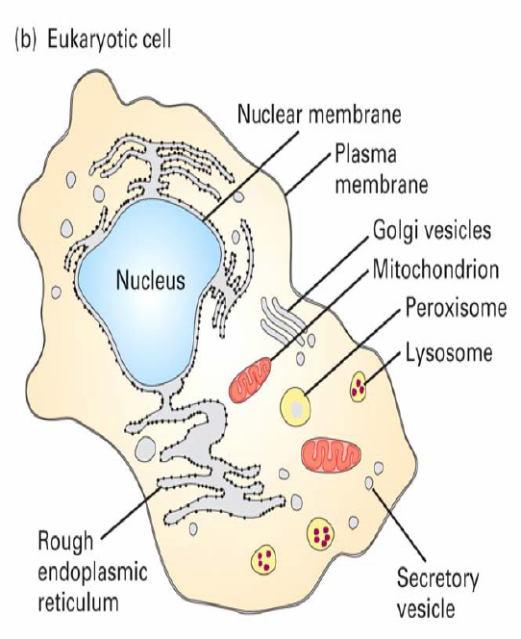

Further, the general chemical mechanisms for changing nutrients into energy are basically the same in all cells, and all cells deliver end products of their chemical reactions into the surrounding fluids.
Almost all cells also have the ability to reproduce additional cells of their own kind.

*Extracellular Fluid, The “Internal Environment”

About 60% of the adult human body is fluid, mainly a water solution of ions and other substances.
Although most of this fluid is inside the cells and is called intracellular fluid, about one third is in the spaces outside the cells and is called extracellular fluid. This ECF is in constant motion throughout the body.
It is transported rapidly in the circulating blood and then mixed between the blood and the tissue fluids by diffusion through the capillary walls.
In ECF, the ions and nutrients needed by the cells to maintain cell life.
Thus, all cells live in essentially the same environment- the ECF. For this reason, the ECF is also called the internal environment of the body.
Cells are capable of living, growing, and performing their special functions as long as the proper concentrations of oxygen, glucose, different ions, amino acids, fatty substances, and other constituents are available in this internal environment.

**Differences Between ECF and ICF
The ECF contains large amounts of sodium, chloride, and bicarbonate ions plus nutrients for the cells, such as oxygen, glucose, fatty acids, and amino acids. It also contains carbon dioxide that is being transported from the cells to the lungs to be excreted, plus other cellular waste products that are being transported to the kidneys for excretion.
The ICF differs significantly from the ECF; specifically, it contains large amounts of potassium, magnesium, and phosphate ions instead of the sodium and chloride ions found in the ECF.

**“Homeostatic” Mechanisms of the Major Functional Systems
Homeostasis:
The term homeostasis is used by physiologists to mean maintenance of nearly constant conditions in the internal environment.
Essentially all organs and tissues of the body perform functions that help maintain these constant conditions.

*ECF Transport and Mixing System - The Blood Circulatory System
ECF is transported through all parts of the body in two stages:
The first stage is movement of blood through the body in the blood vessels.
The second is movement of fluid between the blood capillaries and the intercellular spaces between the tissue cells.
The walls of the capillaries are permeable to most molecules in the plasma of the blood, with the exception of the large plasma protein molecules.
Therefore, large amounts of fluid and its dissolved constituents diffuse back and forth between the blood and the tissue spaces. This process of diffusion is caused by kinetic motion of the molecules in both the plasma and the interstitial fluid.

**Origin of Nutrients in the ECF
*Respiratory System:
Each time the blood passes through the body, it also flows through the lungs.
The blood picks up oxygen in the alveoli. The membrane between the alveoli and the lumen of the pulmonary capillaries, the alveolar membrane, is only 0.4 to 2.0 micrometers thick, and oxygen diffuses by molecular motion through the pores of this membrane into the blood in the same manner that water and ions diffuse through walls of the tissue capillaries.
*Gastrointestinal Tract:
A large portion of the blood pumped by the heart also passes through the walls of the GIT.
Here different dissolved nutrients, including carbohydrates, fatty acids, and amino acids, are absorbed from the ingested food into the ECF of the blood.
*Liver and Other Organs That Perform Primarily Metabolic Functions:
Not all substances absorbed from the GIT can be used in their absorbed form by the cells. The liver changes the chemical compositions of many of these substances to more usable forms, and other tissues of the body such as fat cells, GIT mucosa, kidneys, and endocrine glands helps modify the absorbed substances or store them until they are needed.
*Musculoskeletal System:
Sometimes the question is asked, how does the musculoskeletal system fit into the homeostatic functions of the body? The answer is obvious and simple: Were it not for the muscles, the body could not move to the appropriate place at the appropriate time to obtain the foods required for nutrition. The musculoskeletal system also provides motility for protection against adverse surroundings, without which the entire body, along with its homeostatic mechanisms, could be destroyed instantaneously.

Removal of Metabolic End Products
*Removal of Carbon Dioxide by the Lungs:
At the same time that blood picks up oxygen in the lungs, carbon dioxide is released from the blood into the lung alveoli; the respiratory movement of air into and out of the lungs carries the carbon dioxide to the atmosphere.
Carbon dioxide is the most abundant of all the end products of metabolism.
*Kidneys:
Passage of the blood through the kidneys removes from the plasma most of the other substances besides carbon dioxide that are not needed by the cells. These substances include different end products of cellular metabolism, such as urea and uric acid; they also include excesses of ions and water from the food that might have accumulated in the ECF.
The kidneys perform their function by:
1-Filtering large quantities of plasma through the glomeruli into the tubules.
2-Reabsorbing into the blood those substances needed by the body, such as glucose, amino acids, appropriate amounts of water, and many of the ions. Most of the other substances that are not needed by the body, especially the metabolic end products such as urea, are reabsorbed poorly and pass through the renal tubules into the urine.
Regulation of Body Functions
**Nervous System:
The nervous system is composed of three major parts:
1 - The sensory input portion.
2 - The central nervous system (or integrative portion).
3 - The motor output portion.
Sensory receptors detect the state of the body or the state of the surroundings. For instance, receptors in the skin apprise one whenever an object touches the skin at any point.

The CNS is composed of the brain and spinal cord. The brain can store information, generate thoughts, create ambition, and determine reactions that the body performs in response to the sensations. Appropriate signals are then transmitted through the motor output portion of the nervous system to carry out one’s desires.
A large segment of the NS is called the autonomic system. It operates at a subconscious level and controls many functions of the internal organs.
**Hormonal System of Regulation:
There are eight major endocrine glands that secrete chemical substances called hormones. Hormones are transported in the ECF to all parts of the body to help regulate cellular function. For instance, thyroid hormone increases the rates of most chemical reactions in all cells, thus helping to set the tempo of bodily activity. Insulin controls glucose metabolism; adrenocortical hormones control sodium ion, potassium ion, and protein metabolism; and parathyroid hormone controls bone calcium and phosphate.
Thus, the hormones are a system of regulation that complements the NS. The NS regulates mainly muscular and secretory activities of the body, whereas the hormonal system regulates many metabolic functions.
Thus, the hormones are a system of regulation that complements the NS. The NS regulates mainly muscular and secretory activities of the body, whereas the hormonal system regulates many metabolic functions.
**Reproduction:
Sometimes reproduction is not considered a homeostatic function. It does, however, help maintain homeostasis by generating new beings to take the place of those that are dying.
Control Systems of the Body
The human body has thousands of control systems in it. The most intricate of these are the genetic control systems that operate in all cells to help control intracellular function as well as extracellular function.
Many other control systems operate within the organs to control functions of the individual parts of the organs; others operate throughout the entire body to control the interrelations between the organs.
Characteristics of Control Systems
*Negative Feedback Nature of Most Control Systems:
Most control systems of the body act by negative feedback. In the regulation of Co₂ concentration, a high concentration of Co₂ in the ECF increases pulmonary ventilation. This, in turn, decreases the ECF Co₂ concentration because the lungs expire greater amounts of Co₂ from the body.
In other words, the high concentration of Co₂ initiates events that decrease the concentration toward normal, which is negative to the initiating stimulus.

Conversely, if the Co₂ concentration falls too low, this causes feedback to increase the concentration. This response also is negative to the initiating stimulus.
Therefore, in general, if some factor becomes excessive or deficient, a control system initiates negative feedback, which consists of a series of changes that return the factor toward a certain mean value, thus maintaining homeostasis.

((Gain)) of a Control System

The gain of the negative feedback is the degree of effectiveness with which a control system maintains constant conditions.
For instance, let us assume that a large volume of blood is transfused into a person whose baroreceptor pressure control system is not functioning, and the arterial pressure rises from the normal level of 100 mm Hg up to 175 mm Hg.
Then, let us assume that the same volume of blood is injected into the same person when the baroreceptor system is functioning, and this time the pressure increases only 25 mm Hg.

Thus, the feedback control system has caused a “correction” of –50 mm Hg—that is, from 175 mm Hg to 125 mm Hg. There remains an increase in pressure of +25 mm Hg, called the “error,” which means that the control system is not 100% effective in preventing change. The gain of the system is then calculated by the following formula:
Correction
Gain = ---------------- Error

Thus, in the baroreceptor system example, the correction is –50 mm Hg and the error persisting is +25 mm Hg. Therefore, the gain of the person’s baroreceptor system for control of arterial pressure is –50 divided by +25, or –2. That is, a disturbance that increases or decreases the arterial pressure does so only one third as much as would occur if this control system were not present.

The gains of some other physiologic control systems are much greater than that of the baroreceptor system. For instance, the gain of the system controlling internal body temp when a person is exposed to moderately cold weather is about –33.

**Positive Feedback Can Sometimes Cause Vicious Cycles and Death
One might ask the question, why do essentially all control systems of the body operate by negative feedback rather than positive feedback? If one considers the nature of positive feedback, one immediately sees that positive feedback does not lead to stability but to instability and often death.
Figure 1–3 shows an example in which death can ensue from positive feedback.
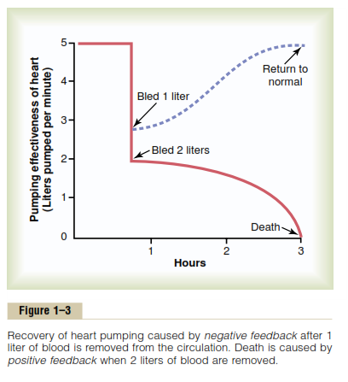

This figure depicts the pumping effectiveness of the heart, showing that the heart of a healthy human being pumps about 5 liters of blood per minute. If the person is suddenly bled 2 liters, the amount of blood in the body is decreased to such a low level that not enough blood is available for the heart to pump effectively.
As a result, the arterial pressure falls, and the flow of blood to the heart muscle through the coronary vessels diminishes. This result in weakening of the heart, further diminished pumping, a further decrease in coronary blood flow, and still more weakness of the heart; the cycle repeats itself again and again until death occurs.
Note that each cycle in the feedback results in further weakening of the heart. In other words, the initiating stimulus causes more of the same, which is positive feedback.
Positive feedback is better known as a (vicious cycle), but a mild degree of positive feedback can be overcome by the negative feedback control mechanisms of the body, and the vicious cycle fails to develop.
For instance, if the person in the same example were bled only 1 liter instead of 2 liters, the normal negative feedback mechanisms for controlling cardiac output and arterial pressure would overbalance the positive feedback and the person would recover, as shown by the dashed curve of Figure 1–3.

Positive Feedback: Positive Feedback Can Sometimes Be Useful. For examples:
Blood clotting is an example of a valuable use of positive feedback. When a blood vessel is ruptured and a clot begins to form.
Childbirth is another instance in which positive feedback plays a valuable role. When uterine contractions become strong enough for the baby’s head to begin pushing through the cervix, stretch of the cervix sends signals through the uterine muscle back to the body of the uterus, causing even more powerful contractions.
Another important use of positive feedback is for the generation of nerve signals. When the membrane of a nerve fiber is stimulated, this causes slight leakage of sodium ions through Na channels in the nerve membrane to the fiber’s interior. Na ions entering the fiber then change the membrane potential, which in turn causes more opening of channels, more change of potential, still more opening of channels, and so forth.
Thus, a slight leak becomes an explosion of sodium entering the interior of the nerve fiber, which creates the nerve action potential. This action potential in turn causes electrical current to flow along both the outside and the inside of the fiber and initiates additional action potentials. This process continues again and again until the nerve signal goes all the way to the end of the fiber.
In each case in which positive feedback is useful, the positive feedback itself is part of an overall negative feedback process.
For example, in the case of blood clotting, the positive feedback clotting process is a negative feedback process for maintenance of normal blood volume.

**More Complex Types of Control Systems (Adaptive Control):

The nervous system contains great numbers of interconnected control mechanisms. Some are simple feedback systems similar to those already discussed. Many are not. For instance, some movements of the body occur so rapidly that there is not enough time for nerve signals to travel from the peripheral parts of the body all the way to the brain and then back to the periphery again to control the movement.
Therefore, the brain uses a principle called feed-forward control to cause required muscle contractions. That is, sensory nerve signals from the moving parts apprise the brain whether the movement is performed correctly. If not, the brain corrects the feed-forward signals that it sends to the muscles the next time the movement is required. Then, if still further correction is needed, this will be done again for subsequent movements. This is called adaptive control. Adaptive control, in a sense, is delayed negative feedback.

