The Cell and Its Functions
Organization of the Cell
A typical cell, as seen by the light microscope has two major parts, the nucleus and the cytoplasm. The nucleus is separated from the cytoplasm by a nuclear membrane, and the cytoplasm is separated from the surrounding fluids by a cell membrane, also called the plasma membrane.
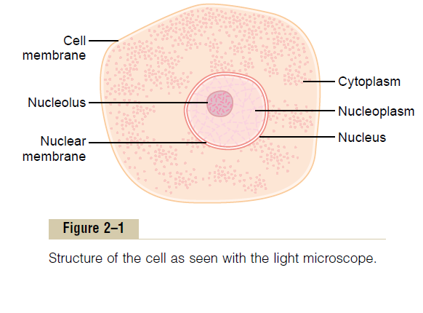
The different substances that make up the cell are collectively called protoplasm.
Protoplasm is composed mainly of five basic substances: water, electrolytes, proteins, lipids, and carbohydrates.
Water: The principal fluid medium of the cell is water, which is present in most cells, except for fat cells, in a concentration of 70 to 85 per cent. Many cellular chemicals are dissolved in the water. Others are suspended in the water as solid particulates.
Ions: The most important ions in the cell are potassium, magnesium, phosphate, sulfate, bicarbonate, and smaller quantities of sodium, chloride, and calcium.The ions provide inorganic chemicals for cellular reactions. Also, they are necessary for operation of some of the cellular control mechanisms For instance, ions acting at the cell membrane are required for transmission of electrochemical
impulses in nerve and muscle fibers.
Proteins: After water, the most abundant substances in most cells are proteins, which normally constitute 10 to 20 % of the cell mass.
These can bedivided into two types: structural proteins and functional proteins.
Structural proteins are present in the cell mainly in the form of long filaments that themselves are polymers of many individual protein molecules.
The functional proteins are an entirely different type of protein, usually composed of combinations of a few molecules in tubular-globular form.
Lipids: Lipids are several types of substances that are grouped together because of their common property of being soluble in fat solvents. Especially important lipids are phospholipids and cholesterol, which together constitute only about 2 %of the total cell mass. In addition to phospholipids and cholesterol, some cells contain large quantities of triglycerides, also called neutral fat. In the fat cells, triglycerides often account for as much as 95 %of the cell mass.
The significance of phospholipids and cholesterol is that they are mainly insoluble in water and therefore, are used to form the cell membrane and intracellular membrane barriers that separate the different cell compartments.
Carbohydrates: Carbohydrates have little structural function in the cell except as parts of glycoprotein molecules, but they play a major role in nutrition of the cell.
However, carbohydrate in the form of dissolved glucose is always present in surrounding extracellular fluid so that it is readily available to the cell. Also, a small amount of carbohydrate is stored in the cells in the form of glycogen, which is an insoluble polymer of glucose that can be depolymerized and used rapidly to supply the cells’ energy needs
Physical Structure of the Cell
The cell is not only contain fluid, enzymes, and chemicals; it also contains highly organized physical structures, called intracellular organelles. The physical nature of each organelle is as important as the cell’s chemical constituents for cell function. For instance, without one of the organelles, the mitochondria, more than 95 per cent of the cell’s energy release from nutrients would cease immediately.
Membranous Structures of the Cell
Most organelles of the cell are covered by membranes composed primarily of lipids and proteins.
These membranes include the cell membrane, nuclear membrane, membrane of the endoplasmic reticulum, and membranes of the mitochondria, lysosomes, and Golgi apparatus.
The lipids of the membranes provide a barrier that impedes the movement of water and water-soluble substances from one cell compartment to another because water is not soluble in lipids. However, protein molecules in the membrane often do penetrate all the way through the membrane, thus providing specialized pathways, often organized into actual pores, for passage of specific substances through the membrane.
Cell Membrane
The cell membrane (also called the plasma membrane), which envelops the cell, is a thin, pliable, elastic structure only 7.5 to 10 nanometers thick. It is composed almost entirely of proteins and lipids.The approximate composition is proteins, 55 %; phospholipids, 25 %; cholesterol, 13 %; other lipids, 4 %; and carbohydrates, 3 %.

Lipid Barrier of the Cell Membrane Impedes Water Penetration
The basic lipid bilayer is composed of phospholipid molecules. One end of each phospholipid molecule is soluble in water; that is, it is hydrophilic. The other end is soluble only in fats; that is, it is hydrophobic
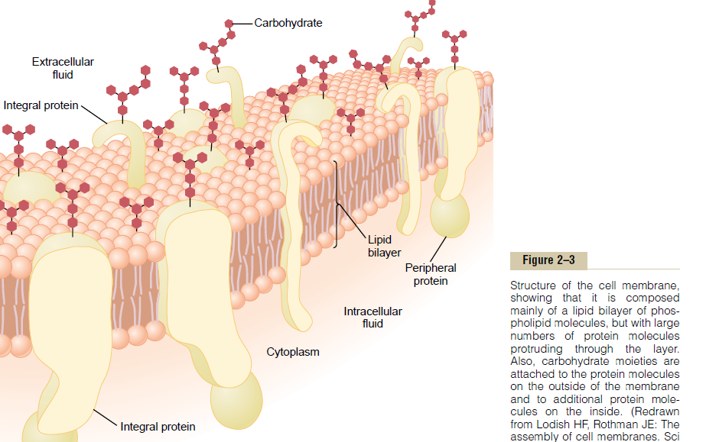
The phosphate end of the phospholipid is hydrophilic, and the fatty acid portion is hydrophobic.
The lipid layer in the middle of the membrane is impermeable to the usual water-soluble substances, such as ions, glucose, and urea. Conversely, fat-soluble substances, such as oxygen, carbon dioxide, and alcohol, can penetrate this portion of the membrane with ease.
The cholesterol molecules in the membrane are also lipid in nature because their steroid nucleus is highly fat soluble. These molecules, in a sense, are dissolved in the bilayer of the membrane.
They mainly help determine the degree of permeability (or impermeability) of the bilayer to water-soluble constituents of body fluids. Cholesterol controls much of the fluidity of the membrane as well.
Cell Membrane Proteins.:
These are membrane proteins, most of which are glycoproteins. Two types of proteins occur: integral proteins that protrude all the way through the membrane, and peripheral proteins that are attached only to one surface of the membrane and do not penetrate all the way through.
Many of the integral proteins provide structural channels (or pores) through which water molecules and water-soluble substances, especially ions, can diffuse between the extracellular and intracellular fluids.
Other integral proteins act as carrier proteins for transporting substances that otherwise could not penetrate the lipid bilayer.
Sometimes these even transport substances in the direction opposite to their natural direction of diffusion, which is called “active transport” Still others act as enzymes.
Integral membrane proteins can also serve as receptors for water-soluble chemicals, such as peptide hormones, that do not easily penetrate the cell membrane.
Interaction of cell membrane receptors with specific ligands that bind to the receptor causes conformational changes in the receptor protein. This, in turn, enzymatically activates the intracellular part of the protein or induces interactions between the receptor and proteins in the cytoplasm that act as second messengers, thereby relaying the signal from the extracellular part of the receptor to the interior of the cell.
Peripheral protein molecules are often attached to the integral proteins. These peripheral proteins function almost entirely as enzymes or as controllers of transport of substances through the cell membrane “pores.”
Membrane Carbohydrates—The Cell “Glycocalyx.”
Membrane carbohydrates occur almost invariably in combination with proteins or lipids in the form of glycoproteins or glycolipids.
In fact, most of the integral proteins are glycoproteins, and about one tenth of the membrane lipid molecules are glycolipids. Many other carbohydrate compounds, called proteoglycans—which are mainly carbohydrate substances bound to small protein cores—are loosely attached to the outer surface of the cell as well. Thus, the entire outside surface of the cell often has a loose carbohydrate coat called the glycocalyx.
The carbohydrate moieties attached to the outer surface of the cell have several important functions:
Many of them have a negative electrical charge,which gives most cells an overall negative surface charge that repels other negative objects.
The glycocalyx of some cells attaches to the glycocalyx of other cells, thus attaching cells to one another.
(3)Many of the carbohydrates act as receptor substances for binding hormones, such as insulin; when bound, this combination activates attached internal proteins that, in turn, activate a cascade of intracellular enzymes.
Some carbohydrate moieties enter into immune reactions,
Cytoplasm and Its Organelles
The cytoplasm is filled with both minute and large dispersed particles and organelles. The clear fluid portion of the cytoplasm in which the particles are dispersed is called cytosol; this contains mainly dissolved proteins, electrolytes, and glucose.
Dispersed in the cytoplasm are neutral fat globules, glycogen granules, ribosomes, secretory vesicles, and five especially important organelles: the endoplasmic reticulum, the Golgi apparatus, mitochondria, lysosomes, and peroxisomes.
Endoplasmic Reticulum: network of tubular and flat vesicular structures in the cytoplasm. The space inside the tubules and vesicles is filled with endoplasmic matrix, a watery medium that is different from the fluid in the cytosol outside the endoplasmic reticulum
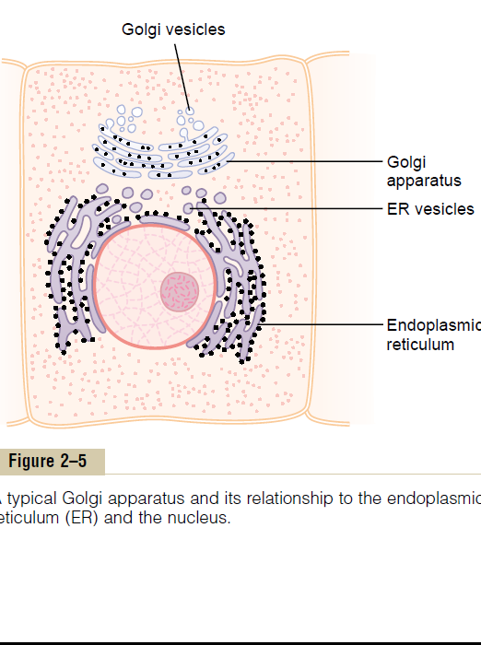

Ribosomes and the Granular Endoplasmic Reticulum
Attached to the outer surfaces of many parts of the endoplasmic reticulum are large numbers of minute granular particles called ribosomes. Where these are present, the reticulum is called the granular endoplasmic reticulum. The ribosomes are composed of mixture of RNA and proteins, and they function to synthesize new protein molecules in the cell.

Agranular Endoplasmic Reticulum
Part of the endoplasmic reticulum has no attached ribosomes. This part is called the agranular, or smooth, endoplasmic reticulum.
The agranular reticulum functions for the synthesis of lipid substances and for other processes of the cells promoted by intrareticular enzymes.
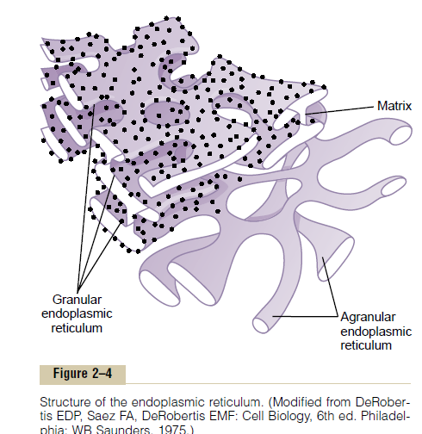
Golgi Apparatus
The Golgi apparatus, is closely related to the endoplasmic reticulum. It has membranes similar to those of the agranular endoplasmic reticulum. This apparatus is prominent in secretory cells, where it is located on the side of the cell from which the secretory substances are extruded.
The Golgi apparatus functions in association with the endoplasmic reticulum. In this way, substances entrapped in the endoplasmic reticulum (ER) vesicles are transported from the endoplasmic reticulum to the Golgi apparatus. The transported substances are then processed in the Golgi apparatus to form lysosomes, secretory vesicles, and other cytoplasmic components
Lysosomes:, are vesicular organelles that form by breaking off from the Golgi apparatus and then dispersing throughout the cytoplasm.
The lysosomes provide an intracellular digestive system that allows the cell to digest damaged cellular structures,food particles that have been ingested by the cell, and unwanted matter such as bacteria.
It is surrounded by a typical lipid bilayer membrane and is filled with large numbers of small granules, which are protein aggregates of as many as 40 different hydrolase (digestive) enzymes. A hydrolytic enzyme is capable of splitting an organic compound into two or more parts by combining hydrogen from a water molecule with one part of the compound and combining the hydroxyl portion of the water molecule with the other part of the compound.
For instance, proteinis hydrolyzed to form amino acids, glycogen is hydrolyzed to form glucose, and lipids are hydrolyzed to form fatty acids and glycerol.
Peroxisomes
Peroxisomes are similar physically to lysosomes, but they are different in two important ways. First, they are believed to be formed by self-replication (or perhaps
by budding off from the smooth endoplasmic reticulum) rather than from the Golgi apparatus. Second, they contain oxidases rather than hydrolases.
Several of the oxidases are capable of combining oxygen with hydrogen ions derived from different intracellular chemicals to form hydrogen peroxide (H2O2). Hydrogen peroxide is a highly oxidizing substance and is used in association with catalase, another oxidase enzyme present in large quantities in peroxisomes, to oxidize many substances that might otherwise be poisonous to the cell. For instance, about half the alcohol person drinks is detoxified by the peroxisomes of the liver cells in this manner.
Secretory Vesicles
One of the important functions of many cells is secretion of special chemical substances. Almost all such secretory substances are formed by the endoplasmic reticulum–Golgi apparatus system and are then released from the Golgi apparatus into the cytoplasm in the form of storage vesicles called secretory vesicles or secretory granules.
Mitochondria
The mitochondria, are called the “powerhouses” of the cell. Without them, cells would be unable to extract enough energy from the nutrients, and essentially all cellular functions would cease. Mitochondria are present in all areas of each cell’s cytoplasm, mitochondria are concentrated in the portions of cell that are responsible for the major share of its energy metabolism.
The basic structure of the mitochondrion, is composed mainly of two lipid bilayer–protein membranes: an outer membrane and an inner membrane.
Many infoldings of the inner membrane form shelves onto which oxidative enzymes are attached. In addition, the inner cavity of the mitochondrion is filled with a matrix that contains large quantities of dissolved enzymes that are necessary for extracting energy from nutrients.
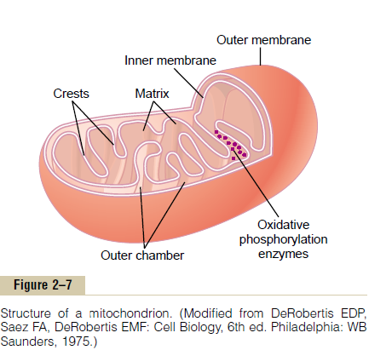
These enzymes operate in association with the oxidative enzymes on the shelves to cause oxidation of the nutrients, thereby forming carbon dioxide and water and at the same time releasing energy.
The liberated energy is used to synthesize a “high-energy” substance called adenosine triphosphate (ATP). ATP is then transported out of the mitochondrion, and it diffuses throughout the cell to release its own energy wherever it is needed for performing cellular functions.
Mitochondria are self-replicative, which means that one mitochondrion can form a second one, a third one, and so on, whenever there is a need in the cell for increased amounts of ATP. Indeed, the mitochondria contain DNA similar to that found in the cell nucleus.
Nucleus
The nucleus is the control center of the cell. Briefly, the nucleus contains large quantities of DNA, which are the genes. The genes determine the characteristics of the cell’s proteins, including the structural proteins, as well as the intracellular enzymes that control cytoplasmic and nuclear activities.
The genes also control and promote reproduction of the cell itself. The genes first reproduce to give two identical sets of genes; then the cell splits by a special process called mitosis to form two daughter cells, each of which receives one of the two sets of DNA genes.
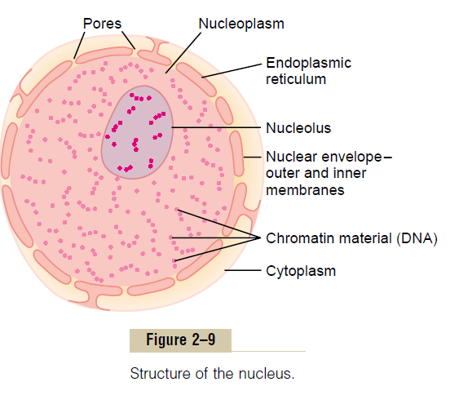
Nuclear Membrane
The nuclear membrane, also called the nuclear envelope, is actually two separate bilayer membranes, one inside the other. The outer membrane is continuous with the endoplasmic reticulum of the cell cytoplasm,and the space between the two nuclear membranes is also continuous with the space inside the endoplasmic reticulum
The nuclear membrane is penetrated by several thousand nuclear pores. Large complexes of protein molecules are attached at the edges of the pores. Even this size is large enough to allow molecules up to 44,000 molecular weight to pass through with reasonable ease.
Nucleoli and Formation of Ribosomes
The nuclei of most cells contain one or more highly staining structures called nucleoli.
The nucleolus, unlike most other organelles, does not have a limiting membrane. Instead, it is simply an accumulation of large amounts of RNA and proteins of the types found in ribosomes. The nucleolus becomes considerably enlarged when the cell is actively synthesizing
proteins.
First, specific DNA genes in the chromosomes cause RNA to be synthesized. Some of this is store in the nucleoli, but most of it is transported outward through the nuclear pores into cytoplasm. Here, it is used in conjunction with specific proteins to assemble “mature” ribosomes that play an essential role in forming cytoplasmic proteins.
Functional Systems of the Cell
Ingestion by the Cell—Endocytosis
If a cell is to live and grow and reproduce, it must obtain nutrients and other substances from the surrounding fluids. Most substances pass through the cell membrane by diffusion and active transport.
Diffusion involves simple movement through the membrane caused by the random motion of the molecules of the substance; substances move either through cell membrane pores or, in the case of lipid soluble substances, through the lipid matrix of the membrane.
Active transport involves the actual carrying of a substance through the membrane by a physical protein structure that penetrates all the way through the membrane. These active transport mechanisms are so important to cell function
Very large particles enter the cell by a specialized function of the cell membrane called endocytosis. The principal forms of endocytosis are pinocytosis and phagocytosis.
Pinocytosis means ingestion of minute particles that form vesicles of extracellular fluid and particulate constituents inside the cell cytoplasm.
Phagocytosis means ingestion of large particles, such as bacteria, whole cells, or portions of degenerating tissue. Phagocytosis occurs in the following steps:
1-The cell membrane receptors attach to the surface ligands of the particle.
2-The edges of the membrane around the points of attachment evaginate outward within a fraction of a second to surround the entire particle; then, progressively attach to the particle ligands. All this occurs suddenly in a zipper-like manner to form a closed phagocytic vesicle.
3-Actin and other contractile fibrils in the cytoplasm surround the phagocytic vesicle and contract around its outer edge, pushing the vesicle to theInterior
4-The contractile proteins then pinch the stem of the vesicle so completely that the vesicle separates from the cell membrane, leaving the vesicle in the cell interior in the same way that
pinocytotic vesicles are formed
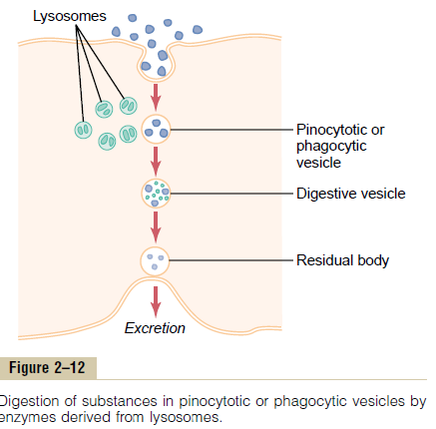
Pinocytosis is the only means by which most large macromolecules, such as most protein molecules, can enter cells. In fact, the rate at which pinocytotic vesicles form is usually enhanced when such macromolecules attach to the cell membrane.
Synthesis and Formation of Cellular Structures by Endoplasmic Reticulum and Golgi Apparatus Specific Functions of the Endoplasmic Reticulum:
ER structures are formed primarily of lipid bilayer membranes similar to the cell membrane, and their walls are loaded with protein enzymes that catalyze the synthesis of many substances required by the cell.
Most synthesis begins in the endoplasmic reticulum. The products formed there are then passed on to the Golgi apparatus, where they are further processed before being released into the cytoplasm.

Proteins Are Formed by the Granular Endoplasmic Reticulum.
The granular portion of the endoplasmic reticulum is characterized by large numbers of ribosomes attached to the outer surfaces of the endoplasmic reticulum membrane. protein molecules are synthesized within the structures of the ribosomes..
The endoplasmic reticulum also synthesizes lipids, especially phospholipids and cholesterol. These are rapidly incorporated into the lipid bilayer of the endoplasmic reticulum itself, thus causing the endoplasmic reticulum to grow more extensive. This occurs mainly in the smooth portion of the endoplasmic reticulum.
Other Functions of the Endoplasmic Reticulum(especially the smooth reticulum).
It provides the enzymes that control glycogen breakdown when glycogen is to be used for energy.
It provides number of enzymes that are capable of detoxifying substances, such as drugs, that might damage the cell. It achieves detoxification by coagulation, oxidation, hydrolysis, conjugation with glycuronic acid, and in other ways.
Specific Functions of the Golgi Apparatus
Synthetic Functions of the Golgi Apparatus.
Although the major function of the Golgi apparatus is to provide additional processing of substances already formed in the endoplasmic reticulum, it also has the capability of synthesizing certain carbohydrates that cannot be formed in the endoplasmic reticulum. This is especially true for the formation of large saccharide polymers bound with small amounts of protein; the most important of these are hyaluronic acid and chondroitin sulfate.
Types of Vesicles Formed by the Golgi Apparatus—Secretory Vesicles and Lysosomes.
In a highly secretory cell, the vesicles formed by the Golgi apparatus are mainly secretory vesicles containing protein substances that are to be secreted through the surface of the cell membrane.
These secretory vesicles first diffuse to the cell membrane, then fuse with it and empty their substances to the exterior by the mechanism called exocytosis.
Exocytosis, in most cases, is stimulated by the entry of calcium ions into the cell; calcium ions interact with the vesicular membrane and cause its fusion with the cell membrane, followed by exocytosis—that is, opening of the membrane’s outer surface and extrusion of its contents outside the cell.
Chemical Processes in the Formation of ATP—Role of the Mitochondria:
As glucose entire into the cells, glucose is subjected to enzymes in the cytoplasm that convert it into pyruvic acid (a process called glycolysis). A small amount of ADP is changed into ATP by the energy released during this conversion.
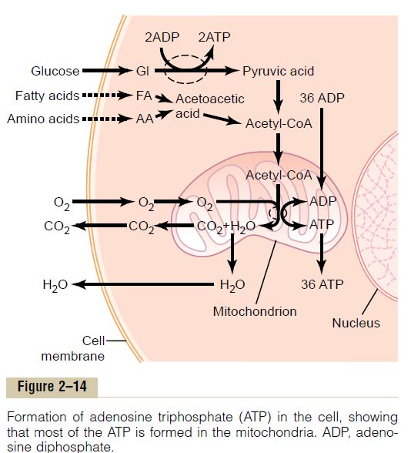
The pyruvic acid derived from carbohydrates, fatty acids from lipids, and amino acids from proteins are eventually converted into the compound acetyl-CoA in the matrix of the mitochondrion.
This substance, in turn, is further dissoluted (for the purpose of extracting its energy) by another series of enzymes in the
mitochondrion matrix, undergoing dissolution in a sequence of chemical reactions called the citric acid cycle, or Krebs cycle.
In this citric acid cycle, acetyl-CoA is split into its component parts, hydrogen atoms and carbon dioxide. The carbon dioxide diffuses out of the mitochondria and eventually out of the cell; finally, it is excreted from the body through the lungs.
The hydrogen atoms, conversely, are highly reactive, and they combine instantly with oxygen that has also diffused into the mitochondria. This releases amount of energy, which is used by the mitochondria to convert very large amounts of ADP to ATP, called ATP synthetase
Finally, the enzyme ATP synthetase uses the energy from the hydrogen ions to cause the conversion of ADP to ATP. The newly formed ATP is transported out of the mitochondria into all parts of the cell cytoplasm and nucleoplasm, where its energy is used to energize multiple cell functions.
Uses of ATP for Cellular Function.
Energy from ATP is used to promote three major categories of cellular functions: (1) transport of substances through multiple membranes in the cell, (2) synthesis of chemical compounds throughout the cell, and (3) supply energy for special cells to perform mechanical work.
These uses of ATP are:
to supply energy for the transport of sodium through the cell membrane, to promote protein synthesis by the ribosomes, and (3) to supply the energy needed during muscle contraction.
Ameboid Movement
Ameboid movement is movement of an entire cell in relation to its surroundings, such as movement of white blood cells through tissues. It receives its name from the fact that amebae move in this manner and have provided an excellent tool for studying the phenomenon.
The most common cells to exhibit ameboid locomotion in the human body are the white blood cells when they move out of the blood into the tissues in the form of tissue macrophages.
Other types of cells, fibroblasts move into a damaged area to help repair the damage, and even the germinal cells of the skin, move toward a cut area to repair the rent.
Finally, cell locomotion is especially important in development of the embryo and fetus after fertilization of an ovum.

