Pharmacognosy
Lec. 7 2017-2018 Assistant Lecturer
2nd stage 2nd semester Zahraa A.E. Al-Naqqash

SEPARATION AND ISOLATION OF CONSTITUENTS
Extraction techniques of Medicinal plants
Extraction, as the term is used pharmaceutically, involves the separation of medicinally active portions of plant or animal tissues from the inactive or inert components by using selective solvents in standard extraction procedures. The products so obtained from plants are relatively impure liquids, semisolids or powders intended only for oral or external use.
The extract thus obtained may be ready for use as a medicinal agent in the form of tinctures and fluid extracts, it may be further processed to be incorporated in any dosage form such as tablets or capsules, or it may be fractionated to isolate individual chemical entities such as ajmalicine, hyoscine and vincristine, which are modern drugs. Thus, standardization of extraction procedures contributes significantly to the final quality of the herbal drug.
Techniques commonly used in the field of phytochemistry are:-
- Extraction of plant materials.
- Isolation and separation of constituents.
- Chromatography techniques.

Extraction of plant materials.
Maceration
In this process, the whole or coarsely powdered crude drug is placed in a stoppered container with the solvent and allowed to stand at room temperature for a period of at least 3 days with frequent agitation until the soluble matter has dissolved. The mixture then is strained, the marc (the damp solid material) is pressed, and the combined liquids are clarified by filtration or decantation after standing.

Infusion
Fresh infusions are prepared by macerating the crude drug for a short period of time with cold or boiling water. These are dilute solutions of the readily soluble constituents of crude drugs.

Digestion
This is a form of maceration in which gentle heat is used during the process of extraction. It is used when moderately elevated temperature is not objectionable. The solvent efficiency of the menstrum is thereby increased.

Decoction
In this process, the crude drug is boiled in a specified volume of water for a defined time; it is then cooled and strained or filtered. This procedure is suitable for extracting water-soluble, heat- stable constituents. The starting ratio of crude drug to water is fixed, e.g. 1:4 or 1:16; the volume is then brought down to one-fourth its original volume by boiling during the extraction procedure. Then, the concentrated extract is filtered and used as such or processed further.

Percolation
This is the procedure used most frequently to extract active ingredients in the preparation of tinctures and fluid extracts. A percolator (a narrow, cone-shaped vessel open at both ends) is generally used. The solid ingredients are moistened with an appropriate amount of the specified menstruum and allowed to stand for approximately 4 h in a well closed container, after which the mass is packed and the top of the percolator is closed. Additional menstruum is added to form a shallow layer above the mass, and the mixture is allowed to macerate in the closed percolator for 24 h. The outlet of the percolator then is opened and the liquid contained therein is allowed to drip slowly. Additional menstruum is added as required, until the percolate measures about three-quarters of the required volume of the finished product. The marc is then pressed and the expressed liquid is added to the percolate. Sufficient menstruum is added to produce the required volume, and the mixed liquid is clarified by filtration or by standing followed by decanting.
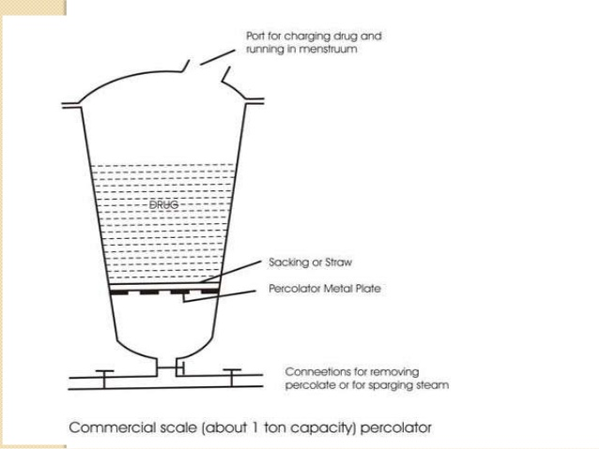

Sublimation
Sublimation may sometimes be possible on the whole drug, as in the isolation of caffeine from tea or for the purification of materials present in a crude extract. Modern equipment employs low pressures with a strict control of temperature.

Fractional liberation
Some groups of compounds lend themselves to fractional liberation from a mixture. As an example, a mixture of alkaloid salts in aqueous solution, when treated with alkali, will give first the weakest base in the free state followed by base liberation in ascending order of basicity. If the mixture is shaken with an organic solvent after each addition, then a fractionated series of bases will be obtained. A similar scheme can be used for organic acids soluble in water-immiscible solvents; in this case, starting with a mixture of the acid salts, it is possible to fractionally liberate the acids by addition of mineral acids.

Distillation
Fractional distillation has been traditionally used for the separation of the components of volatile mixtures; in phytochemistry it has been widely used for the isolation of the components of volatile oils. On a laboratory scale it is not easy by this method to separate minor components of a mixture in a pure state and gas chromatography is now routinely used.
Steam distillation is much used to isolate volatile oils and hydrocyanic acid from plant material.

Simple Distillation
In simple distillation, all the hot vapours produced are immediately channelled into a condenser which cools and condenses the vapours. Thus, the distillate will not be pure - its composition will be identical to the composition of the vapours at the given temperature and pressure.
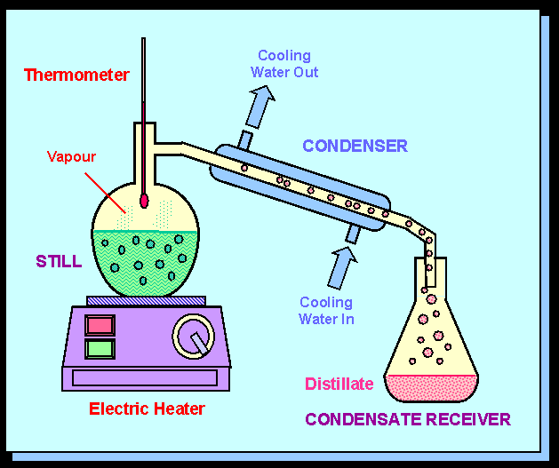
Simple distillation therefore usually used only to separate liquids whose boiling points differ greatly (rule of thumb is 25 °C) or to separate liquids from non volatile solids or oils.

Fractional Distillation
For many cases, the boiling points of the components in the mixture will be too close. In this case fractional distillation is used in order to separate the components well by repeated vaporization-condensation cycles within a packed fractionating column.
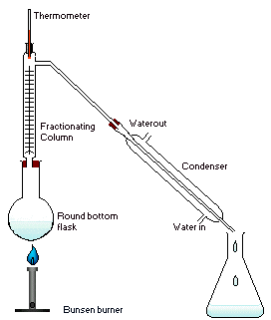
More theoretical plates lead to better separations. A spinning band distillation system uses a spinning band of Teflon or metal to force the rising vapours into close contact with the descending condensate, increasing the number of theoretical plates.
Hot Continuous Extraction
A/ Soxhlet extraction
In soxhlet extraction, organic components in solid samples are extracted from the matrix by continuously washing the solid with a volatile solvent in a specialised piece of glassware (soxhlet extraction apparatus). This is the most common method for extraction of organic compounds from solid samples, and is used as an extraction rate standard for the newly developed extraction method known as supercritical fluid extraction. Non-polar solvents such as benzene or dichloromethane, polar solvents such as methanol, or mixtures of polar and non-polar solvents whose boiling points are close to those of ethanol / benzene, or acetone / hexane are used. Benzene is known to be an especially efficient extraction solvent for Poly cyclic aromatic hydrocarbons PAHs, and acetone for sulphur-containing compounds. However, soxhlet extraction takes long time to get high extraction efficiency, and is not suitable for organic compounds which are thermally unstable.
In this method, the finely ground crude drug is placed in a porous bag or “thimble” made of strong filter paper, which is placed in chamber of the Soxhlet apparatus. The extracting solvent in flask is heated, and its vapors condense in condenser. The condensed extractant drips into the thimble containing the crude drug, and extracts it by contact. When the level of liquid in chamber rises to the top of siphon tube, the liquid contents of chamber siphon into flask. This process is continuous and is carried out until a drop of solvent from the siphon tube does not leave residue when evaporated. The advantage of this method, compared to previously described methods, is that large amounts of drug can be extracted with a much smaller quantity of solvent. This effects tremendous economy in terms of time, energy and consequently financial inputs. At small scale, it is employed as a batch process only, but it becomes much more economical and viable when converted into a continuous extraction procedure on medium or large scale.
During each cycle, a portion of the non-volatile compound dissolves in the solvent. After many cycles the desired compound is concentrated in the distillation flask. The advantage of this system is that instead of many portions of warm solvent being passed through the sample, just one batch of solvent is recycled.
After extraction the solvent is removed, typically by means of a rotary evaporator, yielding the extracted compound. The non-soluble portion of the extracted solid remains in the thimble, and is usually discarded.

Advantages and Disadvantages of Soxhlet Extraction
Advantages:
1. The displacement of transfer equilibrium by repeatedly bringing fresh solvent into contact with the solid matrix.
2. Maintaining a relatively high extraction temperature with heat from the distillation flask.
3. No filtration of the extract is required.
Disadvantages:
1. Agitation is not possible in the Soxhlet device.
2. The possibility of thermal decomposition of the target compounds cannot be ignored as the extraction usually occurs at the boiling point of the solvent for a long time
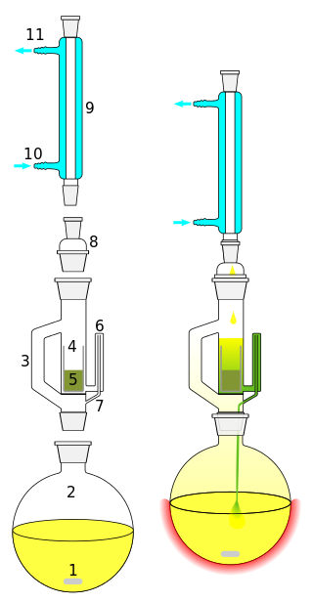
B/ Ordinary reflux condenser.
We place the plant material in round bottom flask with solvent and the round bottom flask is surrounded by a source of heat. The round bottom flask is attached to a condenser. We start to heat the flask and when the solvent reach its boiling point it will evaporate to the condenser were it condenses a return back to the flask.

Advantages:
1- Small amount of solvent is used.
2- Used for toxic reagent which cannot be used in open-air system.
3- Continuous extraction method (good extraction).
Hydro distillation
In order to isolate essential oils by hydro distillation, the aromatic plant material is packed in a still and a sufficient quantity of water is added and brought to a boil; alternatively, live steam is injected into the plant charge. Due to the influence of hot water and steam, the essential oil is freed from the oil glands in the plant tissue. The vapor mixture of water and oil is condensed by indirect cooling with water. From the condenser, distillate flows into a separator, where oil separates automatically from the distillate water.
There are three types of Hydro distillation for isolating essential oils from plant materials:
1. Water distillation
2. Water and steam distillation
3. Direct steam distillation
In this method we use a special apparatus which is called Clavenger it is used
For determination of percentage of volatile oils in the plant material
There are two types of clavenger traps:
A. For oils lighter than water.
B. For oils heavier than water.
These two types differ only in the mechanism of the return of the aqueous layer of the distillation flask and keeping the volatile oil in its position
Specific gravity of volatile oil varies between 0.84 to 1.2.
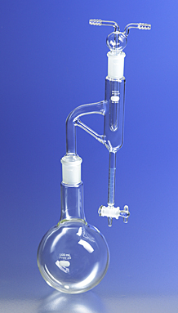
e.g. orange peels has been used for the extraction of orange oil (sp.gr.>water) and clove has been used for the extraction of clove oil (sp.gr.<water).

Vacuum Distillation
Steam distillation useful for compounds which boil beyond their decomposition temperature at atmospheric pressure and which would therefore be decomposed by any attempt to boil them under atmospheric pressure.
Some compounds have very high boiling points. To boil such compounds, it is often better to lower the pressure at which such compounds are boiled instead of increasing the temperature. Once the pressure is lowered to the vapour pressure of the compound (at the given temperature), boiling and the rest of the distillation process can commence. This technique is referred to as vacuum distillation and it is commonly found in the laboratory in the form of the rotary evaporator.

Solvent Extraction (Liquid- liquid extraction)
Liquid- liquid extraction also known as solvent extraction and partitioning, is a method to separate compounds based on their relative solubility in two different immiscible liquids, usually water and an organic solvent. It is an extraction of a substance from one liquid phase into another liquid phase. In this technique a solution ( usually aqueous) containing a solute or solutes is brought into contact with a second solvent ( usually organic) with the aim of transferring one or more of the solutes from the solution to the second solvent. The solution is vigorously shaken to make intimate contact with the solvent. The apparatus is allowed to stand to allow phases to separate.

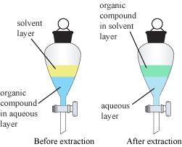

Choice of Solvent
If an organic product is to be purified by dissolution in an organic solvent followed by extraction of the solution with two or more portions of aqueous solution, the whole process will be much faster and easier, and will involve less loss, if the organic solution is less dense than water. In this case, the water layer can be drawn off through the stopcock, and the organic solution is retained in the funnel, ready for the next extraction. If the organic phase is heavier than water, it will have to be drawn off through the stopcock, the aqueous layer poured out, and the organic layer returned to the separatory funnel for the next extraction. Each such transfer will take time and may involve a loss of material. Conversely, if it is necessary to extract an aqueous solution with several portions of solvent in order to achieve the maximum recovery of a substance, it will be more convenient to extract with a solvent heavier than water so that the solvent can simply be drawn off each time through the stopcock without removal of the water layer first.
Solvent | Density (g/cm³)
Petroleum ether | Typically ~ 0.640
Diethyl ether | 0.714
Toluene | 0.867
Ethyl acetate | 0.900
Water | 1.000
Dichloromethane | 1.327

General roles for extraction (like dissolve like )
Solvents with increasing polarity
Hexane or pet. ether
Ether
Chloroform and ethyl acetate
Ethanol
Methanol
Water

Screening a plant (unknown chemical constituents)
Powdered plant
Hexane or pet. ether
Filtered

Marc Extract contains non polar ex: Fat, oil, chlorophyll

Chloroform

Intermediate polarity
e.x: Alkaloids , lignans
Marc

Ethanol or methanol
Polar compounds like glycosides

