**Therapeutics II**

**Thyroid & Parathyroid disorders**

* The thyroid gland consists of two lobes and is situated in the lower neck.
* The gland synthesizes, stores and releases two active hormones: Tetra-iodothyronine (Thyroxine, T4) and tri-iodothyronine (T3).
* Regulation of hormone synthesis and release:

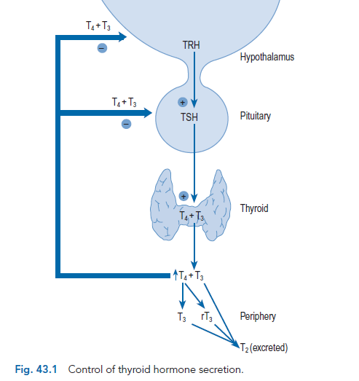

**Figure (1): Hypothalamic-anterior pituitary-thyroid axis**

**Hypothyroidism**

* Hypothyroidism is the **clinical** status resulting from **decreased** production of thyroid hormones or very rarely from tissue resistance.
* ***Subclinical*** *hypothyroidism* is defined by an **elevated TSH** with **normal** thyroid hormone levels.

The vast **majority** of patients have **primary hypothyroidism** which is due to failure of thyroid gland itself to produce sufficient hormones due to:

1- Most commonly ***chronic autoimmune thyroiditis* (Hashimoto’s disease)**.

2-Iatrogenic hypothyroidism because of:

a) Exposure to **destructive** amounts of thyroid gland or neck radiation.

b) After total thyroidectomy.

c) With **excessive** thionamide (thioamide) doses already used to treat hyperthyroidism.

d) Amiodarone & lithium may induce hypothyroidism in up to 10% of patients.

3- Other causes of primary hypothyroidism include iodine deficiency & thyroid hypoplasia.

**Secondary** disease (reduced TSH levels) is due to **hypopituitarism** which may be due to destruction of thyrotrophs (TSH secreting cells) by pituitary **tumors**, **pituitary surgery** or **radiation**, while **tertiary** disease due to failure of the hypothalamus.

**Peripheral hypothyroidism** is due to tissue insensitivity or resistance to the action of often **higher** levels of thyroid hormones.

**Clinical presentation**

* Symptoms of hypothyroidism include dry skin, cold intolerance, weight gain, constipation, lethargy &loss of energy.
* In children, thyroid hormone deficiency may manifest as growth or intellectual retardation.
* Physical signs include coarse skin and hair, brittle nails, bradycardia, and slowed or hoarse speech.
* Most patients with ***secondary hypothyroidism*** have other clinical signs of generalized pituitary insufficiency, such as abnormal menses & decreased libido (from low LH & FSH), or additional evidence of pressuring effect of pituitary tumor, such as visual field defects.
* **Myxedema coma** is a rare consequence of decompensated hypothyroidism manifested by **hypothermia**, **advanced** stages of hypothyroid symptoms, and altered sensor ranging from **delirium to coma**. Mortality rates of 60% to 70% necessitate immediate and aggressive therapy of myxedema coma.

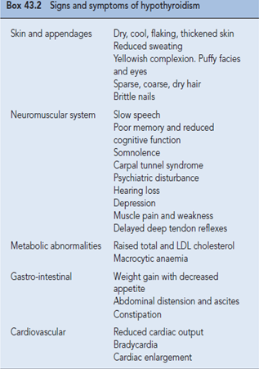

**Diagnosis**

* A rise in TSH level is the first evidence of **primary** hypothyroidism (reduced negative feedback).
* Many patients have a free T4 level within the normal range (**compensated** hypothyroidism).
* As the disease progresses, the free T4 drops below normal, while T3 concentration is often maintained in the normal range despite low T4.
* Antithyroid peroxidase antibodies and antithyroglobulin antibodies are usually elevated in case of autoimmune etiology.
* **Secondary** hypothyroidism should be suspected in patients with decreased T4 levels and inappropriately normal or low TSH levels.

**Treatment**

**Goals of Treatment**: Restore thyroid hormone concentrations in tissue, provide symptomatic relief, prevent neurologic deficits in newborns and children, and reverse the biochemical abnormalities of hypothyroidism.

* **Levothyroxine** (L-thyroxine, T4) is the drug of choice for thyroid hormone replacement because it is chemically stable, relatively inexpensive & free of antigenicity.
* Because T3 (and not T4) is the biologically active form, levothyroxine administration results in a pool of thyroid hormone that is readily and consistently converted to T3.
* In patients with **long-standing** disease and older individuals **without** known cardiac disease start therapy with levothyroxine 50 mcg daily and increase after **one** month. The recommended initial dose for older patients with known **cardiac disease** is 25 mcg/ day titrated upward in increments of 25 mcg at **monthly** intervals to prevent stress on the cardiovascular system.
* Levothyroxine is the drug of choice for pregnant women, and the goal is to decrease TSH to the normal reference range for pregnancy.

**Treatment of myxedema coma**

* Immediate and aggressive therapy with **IV bolus** levothyroxine, 300 to 500 mcg.
* Initial treatment with IV **liothyronine (synthetic T3)** or a combination of both hormones is advocated because of impaired conversion of T4 to T3.
* Glucocorticoid therapy with IV **hydrocortisone** 100 mg every 8 hours is recommended until coexisting adrenal suppression is excluded.
* Maintenance levothyroxine doses are typically 75 to 100 mcg IV until the patient stabilizes and oral therapy is begun.
* Supportive therapy is very important to maintain adequate ventilation, euglycemia, adequate BP, and body temperature.

**Hyperthyroidism**

Thyrotoxicosis results when tissues are exposed to excessive levels of T4, T3, or both. The causes include:

* TSH-secreting **pituitary tumors** release biologically active hormone that is unresponsive to normal feedback control (secondary cause). These tumors may additionally **secrete** prolactin or growth hormone; therefore, patients may present with **amenorrhea**, **galactorrhea** , or signs of **acromegaly**.
* In **Graves disease**, hyperthyroidism results from autoimmune disorder due to the action of thyroid-stimulating antibodies (TSAb). These immunoglobulins bind to TSH receptor and activate the thyroid gland in the same manner as TSH.
* An autonomous thyroid nodule (**toxic adenoma**) is a thyroid mass whose function is independent of pituitary control. Hyperthyroidism usually occurs with larger nodules (>3 cm in diameter).
* In **multinodular goiter**, follicles with autonomous function coexist with normal follicles. Thyrotoxicosis occurs when autonomous follicles generate more thyroid hormone than is required.
* Thyrotoxicosis factitia is produced by ingestion of exogenous thyroid hormone. This may occur when thyroid hormone is used for inappropriate indications, excessive doses, or ingested accidently.
* Amiodarone may induce thyrotoxicosis, but at much lower rate than its ability to induce hypothyroidism.

**Clinical presentation**

* Symptoms of thyrotoxicosis include nervousness, palpitations, fatigue, heat intolerance, weight loss concurrent with increased appetite, increased frequency of bowel movements, and scanty menses in women.
* Physical signs include warm, smooth, moist skin and unusually fine hair; separation of the ends of the fingernails from the nail beds (onycholysis), tachycardia at rest, and fine tremor of the protruded tongue and outstretched hands.

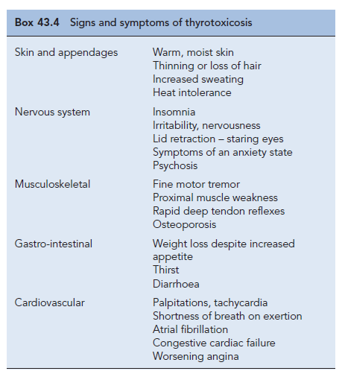

* **Thyroid storm** is a **life-threatening** medical emergency characterized by decompensated thyrotoxicosis, high fever (often >39.4°C [103°F]), diarrhea, vomiting, dehydration, tachycardia, tachypnea, delirium and coma. Precipitating factors include infection, trauma, surgery, radioactive iodine (RAI) treatment, and withdrawal from antithyroid drugs.

**Diagnosis**

* ***Elevated 24-hour radioactive iodine uptake* (RAIU)** indicates true hyperthyroidism (The patient’s thyroid gland is overproducing T 4, T 3 or both (normal RAIU 10% to 30%). Conversely, a low RAIU indicates that the excess thyroid hormone is not a consequence of thyroid gland hyper function but is likely caused by thyroiditis or hormone ingestion.
* TSH-induced hyperthyroidism is diagnosed by elevated free thyroid hormone levels, and elevated serum TSH concentrations.
* TSH-secreting **pituitary adenomas** are diagnosed by demonstrating **lack** of TSH response to TRH stimulation

**Treatment**

**Goals of Treatment**: Eliminate excess thyroid hormone; minimize symptoms and long-term consequences & reduce or eliminate the potential for side effects.

**Non-pharmacologic Therapy**

* Surgical removal of the thyroid gland should be considered in patients with a large gland (>80 g), severe ophthalmopathy (exophthalmos), or lack of remission on antithyroid drugs.
* If thyroidectomy is planned, **propylthiouracil** (PTU) or **methimazole** is usually given until the patient is **biochemically euthyroid** (usually 6–8 weeks), followed by addition of **iodides** (500 mg/day) for **7–14 days** before surgery to decrease vascularity of the gland. **Propranolol** has been used for several weeks preoperatively and 7 to 10 days after surgery to maintain pulse rate less than 90 beats/min.

**Pharmacotherapy**

**1-Thioureas (Thionamides or thioamides)**

* **PTU** and **methimazole** block thyroid hormone synthesis by **inhibiting** the **peroxidase** enzyme system of the thyroid, so inhibiting incorporation of iodide into iodotyrosines.
* Improvement in **symptoms** and **laboratory** abnormalities should occur within 4 to 8weeks, at which time a tapering regimen to maintenance doses can be started. Dosage change **monthly** because the endogenously produced T4 will reach a **new steady-state** concentration in this interval.
* Major adverse effects include **agranulocytosis** (with fever, oropharyngeal infection, and granulocyte count <250/mm3), **aplastic anemia**, and **hypoprothrombinemia**. If it occurs, agranulocytosis usually develops in the first 3 months of therapy; routine monitoring is not recommended because of its **sudden** onset.

**2- Iodides**

* Iodide **acutely blocks** thyroid hormone release, inhibits thyroid hormone biosynthesis by **interfering** with intrathyroidal **iodide use**, and **decreases size** and **vascularity** of the gland.
* Symptom improvement occurs within **2 - 7 days** of initiating therapy, and serum T4and T3 concentrations may be reduced for a few weeks.
* Iodides are often used as **adjunctive** therapy to prepare a patient with Graves disease for surgery, and to acutely inhibit thyroid hormone release and quickly attain the euthyroid state in severely thyrotoxic patients.
* **Potassium iodide** is available as a saturated solution (**SSKI,** 38 mg iodide per drop) or as **Lugol solution,** containing 6.3 mg of iodide per drop. When used to prepare a patient for surgery, it should be administered 7 to 14 days preoperatively.

**3-Adrenergic blockers**

* β-Blockers are used to **ameliorate** thyrotoxic **symptoms** such as palpitations, anxiety, tremor, and heat intolerance.
* Propranolol and nadolol partially block the conversion of T4 to T3, but this contribution to the overall therapeutic effect is small.
* β- blockers are usually used as **adjunctive** therapy with antithyroid drugs, RAI, or iodides when treating Graves’ disease or toxic nodules; in preparation for surgery; or in thyroid storm
* Initial dose of propranolol of 20 to 40 mg orally four times daily is effective for most patients (heart rate <90 beats/min). Younger or more severely toxic patients may require 240 to 480 mg/day.
* Centrally acting sympatholytics (eg, **clonidine**) and calcium channel antagonists (eg,**diltiazem**) may be useful for symptom control when **contraindications** to β-blockade exist.

4- **Radioactive iodine**

* **Sodium iodide–I131** is an **oral liquid** that concentrates in the thyroid and initially disrupts hormone synthesis by incorporating into thyroid hormones and thyroglobulin.
* Over a period of weeks, follicles that have taken up RAI and surrounding follicles develop evidence of **cellular necrosis** and **fibrosis** of **interstitial tissue**.
* RAI is the **agent of choice** for Graves disease, toxic autonomous nodules, and toxic multinodular goiters.
* **Pregnancy is an absolute contraindication** to use of RAI.
* Antithyroid drugs **are not** routinely used after RAI because their use is associated with a higher incidence of **post-treatment recurrence** or **persistent hyperthyroidism.**
* A single dose of 4000 to 8000 rad results in a euthyroid state in 60% of patients at **6 months** or sooner. A second dose of RAI should be given **6 months** after the first RAI treatment if the patient remains hyperthyroid.

**Parathyroid gland**

**Physiology**

* Most individuals possess **four** parathyroid glands situated posterior to the upper and lower lobes of the thyroid. These glands secrete parathyroid hormone (PTH).
* The unbound ionised plasma **calcium levels** regulate the secretion of PTH, increased calcium concentration suppressing PTH secretion and low levels stimulating it.
* PTH acts on the renal tubular transport of calcium and phosphate and also stimulates the renal synthesis of 1,25-dihydroxycolecalciferol (active vitamin D).
* PTH and active vitamin D act to maintain plasma calcium levels within the normal range.
* PTH increases distal tubular reabsorption of calcium and decreases proximal and distal tubular reabsorption of phosphate.
* PTH stimulates osteoclast-mediated bone resorption but, in addition, has an anabolic effect on bone, with an increase in osteoblast number and function.

**Hypoparathyroidism/hypocalcaemia**

Hypoparathyroidism is the clinical state which may arise either from failure of the parathyroid glands to secrete PTH or from failure of its action at the tissue level.

**Etiology**

Hypoparathyroidism most commonly occurs as a result of **surgery** for **thyroid disease** or after neck exploration and **resection** of adenoma causing hyperparathyroidism. Other causes include **autoimmune** parathyroid destruction.

**Clinical manifestations**

Most of the clinical features of hypoparathyroidism are due to **hypocalcaemia**. The decrease in **ionized** plasma calcium levels leads to increased **neuromuscular excitability**. The major signs and symptoms are shown in the box 1.



**Treatment**

* Severe, acute hypocalcaemia **with tetany** should be treated with intravenous calcium gluconate. **Initially**, **10 mL** of 10% calcium gluconate is given by **slow** intravenous injection, preferably with ECG monitoring. If **further** parenteral therapy is required, **20 mL** of 10% injection should be added to each **500 mL** of **intravenous fluid** and given **over 6hr**.
* The plasma magnesium level should always be measured in patients with hypocalcaemia, and if low, magnesium therapy instituted.
* For **chronic** treatment, PTH therapy is **not** currently a practical option as the hormone has to be administered parenterally, and the current high cost is prohibitive. Maintenance treatment for hypoparathyroidism is easily achieved with a **vitamin D** preparation to increase intestinal calcium absorption, often in conjunction **with calcium** supplementation.

**Hyperparathyroidism/hypercalcaemia**

* Hyperparathyroidism occurs when there is increased production of PTH by the parathyroid gland.
* **Primary** hyperparathyroidism causes **hypercalcaemia**. While **secondary** hyperparathyroidism reflects a physiological response to **hypocalcaemia** or **hyperphosphataemia**.
* Primary hyperparathyroidism is due to the development of either single parathyroid adenomas or rarely (<5%) hyperplasia of all four glands.
* There are several conditions associated with secondary hyperparathyroidism, including **chronic renal failure** and **vitamin D deficiency**.

**Clinical manifestations**

The clinical features of hyperparathyroidism are shown in box 2. These are related to the effects of **hypercalcaemia (if primary disease)** itself, or the effects of **mobilization** of calcium from the skeleton and **excretion** in the urine.



**Treatment**

* Surgical **removal** of the adenoma or removal of all hyperplastic tissue is the **only curative** treatment for **primary** hyperparathyroidism.
* The main indications for surgical treatment are persistent hypercalcaemia > 2.85 mmol/L, symptomatic hypercalcaemia, and progression of osteoporosis. Postoperatively, **temporary hypocalcaemia** is common.
* In patients with bone disease, treatment with alfacalcidol (vitamin D analog) and calcium supplements should be started on the day before the operation.
* Approximately10% of surgically treated patients develops permanent hyperparathyroidism.