**CHRONIC HEART FAILURE**

**KEY CONCEPTS**

1. The most common causes of heart failure are coronary artery disease (CAD), hypertension, and dilated cardiomyopathy.
2. Development and progression of heart failure involves activation of neurohormonal pathways, including the sympathetic nervous system and the renin-angiotensinaldosterone system (RAAS).
3. The clinician must identify potential reversible causes of heart failure exacerbations, including prescription and nonprescription drug therapies, dietary indiscretions, and medication nonadherence.
4. Symptoms of left-sided heart failure include dyspnea, orthopnea, and paroxysmal nocturnal dyspnea (PND), whereas symptoms of right-sided heart failure include fluid retention, GI bloating, and fatigue.
5. General therapeutic management goals for chronic heart failure focus on preventing onset of clinical symptoms or reducing symptoms, preventing or reducing hospitalizations, slowing or preventing disease progression, improving quality of life, and prolonging patient survival.
6. Nonpharmacologic treatment involves dietary modifications such as sodium and fluid restriction, risk factor reduction including smoking cessation, timely immunizations, and supervised regular physical activity.
7. Diuretics are used for relief of acute symptoms of congestion and maintenance of euvolemia.
8. Agents with proven benefits in improving symptoms, slowing disease progression, and improving survival in chronic heart failure target neurohormonal blockade; these include angiotensin-converting enzyme (ACE) inhibitors or angiotensin receptor blockers (ARBs), β adrenergic blockers, and aldosterone antagonists.
9. Combination therapy with hydralazine and isosorbide dinitrate is an appropriate substitute for angiotensin II antagonism in those unable to tolerate an ACE inhibitor or ARB or as add-on therapy in African Americans.
10. Treatment of acute heart failure targets relief of congestion and optimization of cardiac output utilizing oral or IV diuretics, IV vasodilators, and when appropriate, inotropes. Current treatment strategies in acute heart failure target improving hemodynamics while preserving organ function.



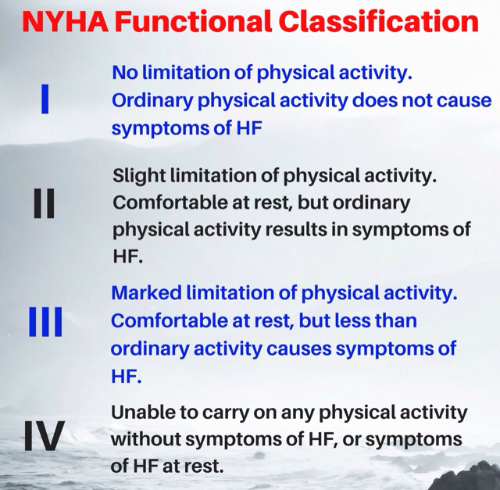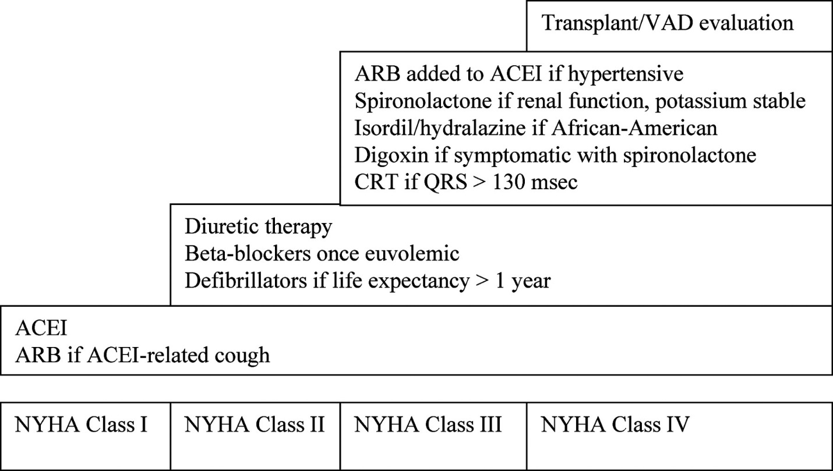

**Treatment of chronic heart failure according to the stage**

**TREATMENT OF CHRONIC HEART FAILURE**

**Desired Therapeutic Outcomes**

There is no cure for HF. The general therapeutic management goals for chronic HF include preventing the onset of clinical symptoms or reducing symptoms, preventing or reducing hospitalizations, slowing progression of the disease, improving quality of life, and prolonging survival.

**Nonpharmacologic Interventions**

Non pharmacologic treatment involves dietary modifications such as sodium and fluid restriction, risk factor reduction including smoking cessation, timely immunizations, and supervised regular physical activity.

* Patient education regarding monitoring symptoms, dietary and medication adherence, exercise and physical fitness, risk factor reduction, and immunizations are important for the prevention of AHF exacerbations Home monitoring should include daily assessment of weight and exercise tolerance. Daily weights should be done first thing in the morning upon arising and before any food intake to maintain consistency.
* Nonadherence is an important issue because it relates to acute exacerbations of HF. Ensuring an understanding of the importance of each medication used to treat HF, proper administration, and potential adverse effects may improve adherence. Stressing the rationale for each medication is important, especially for NYHA FC I or ACC/AHA stage B patients who are asymptomatic yet started on drugs that may worsen symptoms initially.
* Dietary modifications in HF consist of initiation of an AHA step II diet as part of cardiac risk factor reduction, sodium restriction, and sometimes fluid restriction Exercise, although discouraged when the patient is acutely decompensated to ease cardiac workload, and is recommended when patients are stable.
* Modification of classic risk factors, such as tobacco alcohol consumption, is important to minimize the potential for further aggravation of heart function. Patients with HF should be counseled to receive yearly influenza vaccinations. Additionally, a pneumococcal vaccine is recommended.

**Pharmacologic Treatment**

***Diuretics***

Diuretics have been the mainstay for HF symptom management for many years. Diuretics are used for relief of acute symptoms of congestion and maintenance of euvolemia. In more milder HF, diuretics may be used on an as-needed basis. However, once the development of edema is persistent, regularly scheduled doses will be required.

**Therapeutic options**

Two types of diuretics are used for volume management in HF: thiazides and loop diuretics. Thiazide diuretics such as hydrochlorothiazide, chlorthalidone, and metolazone block sodium and chloride reabsorption in the distal convoluted tubule. Thiazides are weaker than loop diuretics in terms of effecting an increase in urine output and therefore are not utilized frequently as monotherapy in HF. They are optimally suited for patients with hypertension who have mild congestion. Additionally, the action of thiazides is limited in patients with renal insufficiency (creatinine clearance less than 30 mL/min [0.50 mL/s]) due to reduced secretion into their site of action. An exception is metolazone, which retains its potent action in patients with renal dysfunction. Metolazone is often used in combination with loop diuretics when patients exhibit diuretic resistance, defined as edema unresponsive to loop diuretics alone. Oral torsemide can be considered an alternative to the IV route of administration for patients who do not respond to oral furosemide in the setting of profound edema

**Home monitoring**

Once diuretic therapy is initiated, dosage adjustments are based on symptomatic improvement and daily body weight. Because body weight changes are a sensitive marker of fluid retention or loss, patients should continue to weigh themselves daily. Once a patient reaches a euvolemic state, diuretics may be cautiously tapered and then withdrawn in appropriate patients. In stable, educated, and adherent patients, another option is self-adjusted diuretic dosing. Based on daily body weight, patients may temporarily increase their diuretic regimen to reduce the incidence of overt edema. This also avoids overuse of diuretics and possible complications of overdiuresis such as hypotension, fatigue, and renal impairment.

**Mechanism of diuretic resistance**

The maximal response to diuretics is reduced in HF, creating a “ceiling dose” above which there is limited added benefit. This diuretic resistance is due to a compensatory increase in sodium reabsorption in the distal tubules, which decreases the effect of blocking sodium reabsorption in the loop of Henle. Apart from increasing diuretic doses, strategies to improve diuretic efficacy include increasing the frequency of dosing to two or three times daily, utilizing a continuous infusion of a loop diuretic, and/or combining a loop diuretic with a thiazide diuretic. The latter strategy theoretically prevents sodium and water reabsorption at both the loop of Henle and the compensating distal convoluted tubule. Metolazone is used most often for this purpose because it retains its activity in settings of a low creatinine clearance. Metolazone can be dosed daily or as little as once weekly. This combination is usually maintained until the patient reaches his or her baseline weight. The clinician must use metolazone cautiously because its potent activity predisposes a patient to metabolic abnormalities as outlined next.

**Diuretics side effects**

Diuretics cause numerous adverse effects and metabolic abnormalities, with severity linked to diuretic potency. A particularly worrisome adverse effect in the setting of HF is hypokalemia. Low serum potassium can predispose patients to arrhythmias and sudden death. Hypomagnesemia often occurs concomitantly with diuretic-induced hypokalemia, and therefore both should be assessed and replaced in patients needing correction of hypokalemia. Magnesium is an essential cofactor for movement of potassium intracellularly to restore body stores. Patients taking diuretics are also at risk for renal insufficiency due to overdiuresis and reflex activation of the renin-angiotensin system. The potential reduction in renal blood flow and glomerular pressure.

***Neurohormonal Blocking Agents***

***ACE inhibitors***

Numerous clinical studies show ACE inhibitor therapy is associated with improvements in clinical symptoms, exercise tolerance, NYHA FC, LV size and function, and quality of life as compared with placebo. ACE inhibitors significantly reduce hospitalization rates and mortality regardless of underlying disease severity or etiology.

**Role in MI**

ACE inhibitors are also effective in preventing HF development in high-risk patients. Studies in acute MI patients show a reduction in new-onset HF and death with ACE inhibitors whether they are initiated early (within 36 hours) or started later. In addition, ACE inhibition decreases the risk of HF hospitalization and death in patients with asymptomatic LV dysfunction. All patients with documented LV systolic dysfunction, regardless of existing HF symptoms, should receive ACE inhibitors unless a contraindication or intolerance is present.

**Contraindications**

Despite their clear benefits, ACE inhibitors are still underutilized in HF. One reason is undue concern or confusion regarding absolute versus relative contraindications for their use. Absolute contraindications include a history of angioedema, bilateral renal artery stenosis, and pregnancy.

Relative contraindications include unilateral renal artery stenosis, renal insufficiency, hypotension, hyperkalemia, and cough. Relative contraindications provide a warning that close monitoring is required, but they do not necessarily preclude their use.

**Use in renal impairment**

In general, ACE inhibitors can be used in patients with serum creatinine less than 2.5 to 3 mg/dL (221 to 265 μmol/L). In HF, their addition can result in improved renal function through an increase in CO and renal perfusion. Although a small increase in serum creatinine (less than 0.5 mg/dL [44 μmol/L]) is possible with the addition of an ACE inhibitor, it is usually transient or becomes the patient’s new serum creatinine baseline level.

However, ACE inhibition can also worsen renal function because glomerular filtration is maintained in the setting of reduced CO through angiotensin II’s constriction of the efferent arteriole. Patients most dependent on angiotensin II for maintenance of glomerular filtration pressure, and hence most susceptible to ACE inhibitor worsening of renal function, include those with hyponatremia, severely depressed LV function, or dehydration. The most common reason for creatinine elevation in a patient without a history of renal dysfunction is overdiuresis. Therefore, clinicians should consider decreasing or holding diuretic doses if an elevation in serum creatinine occurs concomitantly with a rise in blood urea nitrogen.

**Side effects: (hypotension, cough)**

Hypotension occurs commonly at the initiation of therapy or with dosage increases but may happen anytime Therefore, in euvolemic patients, diuretic doses may often be decreased or withheld during ACE inhibitor dose titration. Initiating at a low dose and titrating slowly can also minimize hypotension. It may be advisable to initiate therapy with a short-acting ACE inhibitor, such as captopril, and subsequently switch to a longer-acting agent, such as lisinopril or enalapril, once the patient is stabilized.

It can be challenging to distinguish an ACE inhibitor– induced cough from cough caused by pulmonary congestion. A productive or wet cough usually signifies congestion, whereas a dry, hacking cough is more indicative of a drugrelated etiology. If a cough is determined to be ACE inhibitor– induced, its severity should be evaluated before deciding on a course of action. If the cough is truly bothersome, a trial with a different ACE inhibitor or switching to an ARB is warranted.

**Angiotensin Receptor Blockers**

Angiotensin receptor blockers are considered an equally effective replacement for ACE inhibitors in patients who are intolerant or have a contraindication to an ACE inhibitor.

The addition of an ARB to ACE inhibitor therapy can be considered in patients with evidence of disease progression despite optimal ACE inhibitor therapy. Many of the other considerations for the use of ARBs are similar to those of ACE inhibitors, including the need for monitoring renal function, blood pressure, and potassium. Contraindications are similar to those of ACE inhibitors. In patients truly intolerant or contraindicated to ACE inhibitors or ARBs, the combination of hydralazine and isosorbide dinitrate should be considered.

**Hydralazine and Isosorbide Dinitrate**

The combination of hydralazine and isosorbide dinitrate was the first therapy shown to improve long-term survival in patients with systolic HF, but it has largely been supplanted by angiotensin II antagonist therapy (ACE inhibitors and ARBs). Therefore, until recently, this combination therapy was reserved for patients intolerant to ACE inhibitors or ARBs secondary to renal impairment, angioedema, or hyperkalemia.

***β*-Adrenergic Antagonists**

**value in HF**

Chronic *β*-blockade reduces ventricular mass, improves ventricularshape, and reduces LV end-systolic and diastolic volumes. *β*-Blockers also exhibit antiarrhythmic effects, slow or reverse catecholamine-induced ventricular remodeling, decrease myocyte death from catecholamine-induced necrosis or apoptosis, and prevent myocardial fetal gene expression. Consequently, *β*-blockers improve EF, reduce all-cause and HF-related hospitalizations, and decrease all-cause mortality in patients with systolic HF.

**Introduction** **of beta blockers**

The key to utilizing *β*-blockers in systolic HF is initiation with low doses and slow titration to target doses over weeks to months. It is important that the *β*-blocker be initiated when a patient is clinically stable and euvolemic. Volume overload at the time of *β*-blocker initiation increases the risk for worsening symptoms. *β*-Blockade should begin with the lowest possible dose after which the dose may be doubled every 2 to 4 weeks depending on patient tolerability.

**Side effects**

*β*-Blockers may cause an acute decrease in left ventricular ejection fraction (LVEF) and short-term worsening of HF symptoms upon initiation and at each dosage titration. After each dose titration, if the patient experiences symptomatic hypotension, bradycardia, orthostasis, or worsening symptoms, further increases in dose should be withheld until the patient stabilizes. After stabilization, attempts to increase the dose should be reinstituted. If mild congestion ensues as a result of the *β*-blocker, an increase in diuretic dose may be warranted. If moderate or severe symptoms of congestion occur, a reduction in *β*-blocker dose should be considered along with an increase in diuretic dose.

Dose titration should continue until target clinical trial doses are achieved (Table 6–7) or until limited by repeated hemodynamic or symptomatic intolerance. Patient education regarding the possibility of acutely worsening symptoms but improved long-term function and survival is essential to ensure adherence.

**Selection of B blockers**

Apart from possible clinical differences between the *β*-blockers approved for HF, selection of a *β*-blocker may also be affected by pharmacologic differences. **Carvedilol** exhibits a more pronounced blood pressure lowering effect, and thus causes more frequent dizziness and hypotension as a consequence of its *β*1 and *α*1-receptor blocking activities.

Therefore, in patients predisposed to symptomatic hypotension, such as those with advanced LV dysfunction (LVEF less than 20% [0.20]) who normally exhibit low systolic blood pressures, **metoprolol succinate** may be the more desirable first-line *β*-blocker. In patients with uncontrolled hypertension, carvedilol may provide additional antihypertensive efficacy.

*Β-Blockers* may be used by those with reactive airway disease or peripheral vascular disease but should be used with considerable caution or avoided if patients display active respiratory symptoms. Care must also be used in interpreting shortness of breath in these patients because the etiology could be either cardiac or pulmonary. A selective *β*1-blocker such as metoprolol is a reasonable option for patients with reactive airway disease. The risk versus benefit of using any *β*-blocker in peripheral vascular disease must be weighed based on the severity of the peripheral disease, and a selective *β*1-blocker is preferred. During acute heart failure admission, the dose of B-Blocker should be haved.

**Aldosterone Antagonists**

**Value**

Currently, the aldosterone antagonists available are spironolactone and eplerenone. Each agent (spironolactone and eplerenone) has been studied in a defined population of patients with HF. Both Effective in reducing HF hospitalizations, improving functional class, reducing sudden cardiac death, and improving all-cause mortality.

**Introduction, dosing and monitoring**

The major risk related to aldosterone antagonists is hyperkalemia. Before and within 1 week of initiating therapy, two parameters must be assessed: serum potassium and creatinine clearance (or serum creatinine).

Aldosterone antagonists should not be initiated in patients with potassium concentrations greater than 5.5 mEq/L (5.5 mmol/L). Likewise, these agents should not be given when creatinine clearance is less than 30 mL/minute (0.50 mL/s) or serum creatinine is greater than 2.5 mg/dL (221 μmol/L).

In patients without contraindications, spironolactone is initiated at a dose of 12.5 to 25 mg daily, or occasionally on alternate days for patients with baseline renal insufficiency.

Eplerenone is used at a dose of 25 mg daily, with the option to titrate up to 50 mg daily. Doses should be halved or switched to alternate-day dosing if creatinine clearance falls below 50 mL/min (0.83 mL/s).

Potassium supplementation is often decreased or stopped after aldosterone antagonists are initiated, and patients should be counseled to avoid high potassium foods. At any time after initiation of therapy, if potassium concentrations exceed 5.5 mEq/L (5.5 mmol/L), the dose of the aldosterone antagonist should be reduced or discontinued. In addition, worsening renal function dictates consideration for stopping the aldosterone antagonist.

**Adverse effects**

Other adverse effects observed mainly with spironolactone include gynecomastia for men and breast tenderness and menstrual irregularities for women. Gynecomastia leads to discontinuation in up to 10% of patients on spironolactone. Eplerenone is a CYP3 A4 substrate and should not be used concomitantly with strong inhibitors of 3A4.

***Digoxin***

**Value**

The exact role of digoxin in therapy remains controversial largely due to disagreement on the risk versus benefit of routinely using this drug in patients with systolic HF. Digoxin was shown to decrease HF-related hospitalizations but did not decrease HF progression or improve survival. Moreover, digoxin was associated with an increased risk for concentration-related toxicity and numerous adverse effects.

Current recommendations are for the addition of digoxin for patients who remain symptomatic despite an optimal HF regimen consisting of an ACE inhibitor or ARB, *β*-blocker, and diuretic. In patients with concomitant atrial fibrillation, digoxin may be added to slow ventricular rate regardless of HF symptomatology.

**Dosing**

Digoxin is initiated at a dose of 0.125 mg to 0.25 mg daily depending on age, renal function, weight, and risk for toxicity. The lower dose should be used if the patient satisfies any of the following criteria: older than 65 years, creatinine clearance less than 60 mL/min (1.0 mL/s), or ideal body weight less than 70 kg (154 lb). The 0.125-mg daily dose is adequate in most patients.

***Antiplatelets and Anticoagulation***

***Indication***

Aspirin is generally used in HF patients with an underlying ischemic etiology, a history of ischemic heart disease, or other compelling indications such as history of embolic stroke. If aspirin is indicated, the preference is to use a low dose (81 mg daily).

Current consensus recommendations support the use of warfarin in patients with reduced LV systolic dysfunction and a compelling indication such as atrial fibrillation or prosthetic heart valves. In addition, warfarin is empirically used in patients with echocardiographic evidence of a mural thrombus or severely depressed (LVEF less than 20% [0.20]) LV function.

**Heart Failure with Preserved Left Ventricular Ejection Fraction**

**Treatment goal**

(a) Correction or control of underlying etiologies (including optimal treatment of hypertension and CAD and maintenance of normal sinus rhythm).

(b) Reduction of cardiac filling pressures at rest and during exertion.

(c) Increased diastolic filling time. Diuretics are frequently used to control congestion.

**Therapeutic options**

Recent studies failed to show significant reductions in mortality or hospitalizations with the use of ARBs. *Β-Blockers* and calcium channel blockers can theoretically improve ventricular relaxation through negative inotropic and chronotropic effects. Unlike in systolic HF, nondihydropyridine calcium channel blockers (diltiazem and verapamil) may be especially useful in improving diastolic function by limiting the availability of calcium that mediates contractility.

**Outcome Evaluation of Chronic Heart Failure**

1. If diuretic therapy is warranted, monitor for therapeutic response by assessing weight loss and improvement of fluid retention, as well as exercise tolerance and presence of fatigue.
2. Once therapy for preventing disease progression is initiated, monitoring for symptomatic improvement continues.
3. It is important to keep in mind that patients’ symptoms of HF can worsen with *β*-blockers, and it may take weeks or months before patients notice improvement
4. Monitor blood pressure to evaluate for hypotension caused by drug therapy.

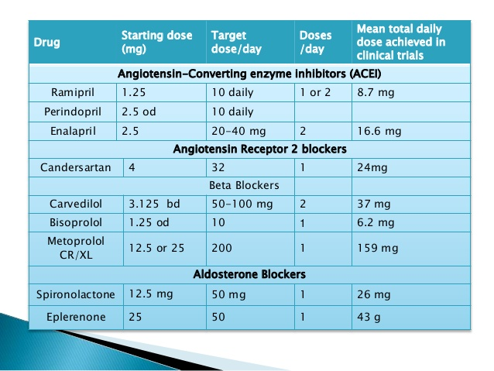

**Patient Care and Monitoring**

1. Educate the patient on lifestyle modifications such as salt restriction (maximum 2 to 4 g/day), fluid restriction if appropriate, limitation of alcohol, tobacco cessation, participation in a cardiac rehabilitation and exercise program, and proper immunizations such as the pneumococcal vaccine and yearly influenza vaccine.

2. Develop a treatment plan to alleviate symptoms and maintain euvolemia with diuretics. Daily weights to assess fluid retention are recommended.

3. Develop a medication regimen to slow the progression of HF with the use of neurohormonal blockers such as vasodilators (ACE inhibitors, ARBs, or hydralazine/ isosorbide dinitrate), β-blockers, and aldosterone antagonists. Utilize digoxin if the patient remains symptomatic despite optimization of the therapies just described.

4 Is the patient at goal or maximally tolerated doses of vasodilator and β-blocker therapy?

5. Are aldosterone antagonists utilized in appropriate patients with proper electrolyte and renal function monitoring?

6. Stress the importance of adherence to the therapeutic regimen and lifestyle changes for maintenance of a compensated state and slowing of disease progression.

7. Evaluate the patient for presence of adverse drug reactions, drug allergies, and drug interactions.

8. Provide patient education with regard to disease state and drug therapy, and reinforce self-monitoring for symptoms of HF that necessitate follow-up with a healthcare practitioner.