***Patient Data sheet***

Patient Name Age: Sex: date of admission

Weight: Height: BMI :

* Chief Compliant (CC):
* History Of Present Illness (HOPI):
* Past Medical History(PMH):
* Past Surgical History(PSH):
* Medication history:
* Drug Allergy:
* Review of other system
* CNS
* CVS
* GIS
* RS
* GUT
* Vital Signs: BP(blood pressure) PR(pulse rate)

RR(respiratory rate) Temp.(temprture)

* Investigation:
* -Lab. Data :
* U/S(ultrasound):
* Morning Tour Treatment
* Night Tour Treatment

**Principles of wound healing**

A wound is a disruption of the normal structure and function of the skin and underlying soft tissue. Wounds may be caused by a variety of mechanisms, including acute traumatic injury to the skin (abrasion, puncture, crush, burns, gunshot, animal bite, surgery) and other etiologies that cause initially intact skin to break down. Any mechanism that decreases blood flow in the skin for a prolonged period of time has the potential to cause ischemic breakdown of the skin. Skin perfusion may be impaired due to proximal arterial obstruction (eg, peripheral artery disease), vascular compression (eg, hematoma, immobility causing focal pressure), or microvascular occlusion or thrombosis (eg, vasculitis, cholesterol crystals).

Surgical wounds are a controlled form of acute wound that is created in the operating room environment. Surgical wounds are classified according to the degree of bacterial load or contamination of the surgical wound and are used to predict the risk of surgical wound infection that can impact wound healing. The four categories are clean, clean-contaminated, contaminated, and dirty. The majority of clean and clean-contaminated wounds are closed primarily at the completion of the surgery; contaminated and dirty wounds as well as surgical wounds requiring removal of staples or sutures due to postoperative wound infection are left open and require wound care.

Wound healing is a complex and dynamic process, with the wound environment changing with the shifting health status of an individual.

**Four phases of wound healing**

|  |  |  |  |
| --- | --- | --- | --- |
| Phase of healing | Time  post injury | Cells involved in  Phase | Function or activity |
| Hemostasis | Immediate | Platelets | Clotting |
| Inflammation | Day 1–4 | Neutrophils  Macrophages | Phagocytosis |
| Proliferation  (granulation  and contraction) | Day 4-21 | Macrophages  Lymphocytes  Angiocytes Neurocytes  Fibroblasts  Keratinocytes | Re-establish skin function closure |
| Remodeling (maturation) | Day 21-2 years | Fibrocytes | Develop tensile strength |

**Pre-operative care**

**1.1 Pre-operative assessment in the elective patient**

* The aim of pre-operative assessment is to maximise patient safety andminimise the complications of surgery by identifying potential problemsand optimising patients before surgery.
* The extent of pre-operative preparation depends on several factors, mainly:
* the timing of surgery (i.e. how urgent it is);
* the nature of surgery (i.e. minor or major procedure);
* the patient’s past medical history and current status.

**1.1.1 History and examination**

* All patients should have a thorough history taken. Many units now havespecially designed forms to ensure all areas are adequately explored. It isimportant to remember that the junior doctor who undertakes thepre-operative assessment may be the only person to take a detailed historyand will often uncover important factors regarding the patient’speri-operative care.
* It is important that if such a critical factor is identified or an abnormal resultis found, it is communicated to the consultants' team before surgery, as thismay avoid preventable complications or cancellation of the operation.
* For example, identification that a patient is on clopidogrel, whichmust be stopped before elective surgery to reduce the risk ofhaemorrhage, or identification of undiagnosed aortic stenosis.
* Pre-operative assessment is therefore a very responsible role.
* A detailed, systematic history covering all areas is required.

**Past medical history**

* In particular focusing on cardiovascular disease (including hypertension),respiratory disease, renal disease, diabetes and significant obesity.
* If a disease is identified, it should be optimally managed pre-operatively, so itis not enough to simply document ‘hypertension’.
* The level of control should be checked and if sub-optimal, steps takento improve it. This may necessitate liaison with the GP or hospitalspecialist responsible for the care of this illness and delaying theplanned surgery by contacting the consultant’s team.

**Drug history**

* Particular care is needed to ensure this is accurate with correct drug names,doses and administration times. If necessary, contact the GP for verification.
* Certain drugs should be flagged up to the consultant’s team, as they mayhave a significant impact on the surgery. These include:
* anticoagulants (see Section 1.3.6);
* steroids (see Section 1.3.9);
* anti-diabetic medication (see Section 1.3.10);
* chemotherapeutic agents: blood counts need to be carefullymonitored;
* ACE-inhibitors (e.g. ramipril) and angiotensin II receptor antagonists(e.g. losartan), which should be omitted on the morning of surgery.
* The following medications should **not** be stopped prior to surgery:
* antihypertensives, especially beta-blockers (e.g. atenolol);
* other cardiac medications (e.g. digoxin);
* inhalers, especially steroid inhalers (e.g. beclomethasone);
* analgesics;
* Proton pump inhibitors (PPIs) (e.g. omeprazole).

**Allergies**

* These should be documented and described in terms of severity.
* In latex allergy the surgical team should be informed, as these patientsshould be first on the operating list and may require special equipment.

**Social history**

* Important issues include:
* Jehovah’s Witnesses who refuse blood products;
* patients who have inadequate support on discharge where timelyinput from social services may ensure smooth discharge planning;
* smoking and illicit substance abuse.

**Family history**

* A family history of cardiovascular disease or hyperlipidaemia may triggermore detailed assessments.

**Previous anaesthetic problems**

* Previous reactions, airway problems or post-operative nausea or vomitingshould be noted.

**Examination**

* A full physical examination is required for all patients.

**1.1.2 Relevant investigations**

* Not all investigations are necessary for all patients. Assess the age andcomorbidities of the patient, as well as the type of procedure planned.

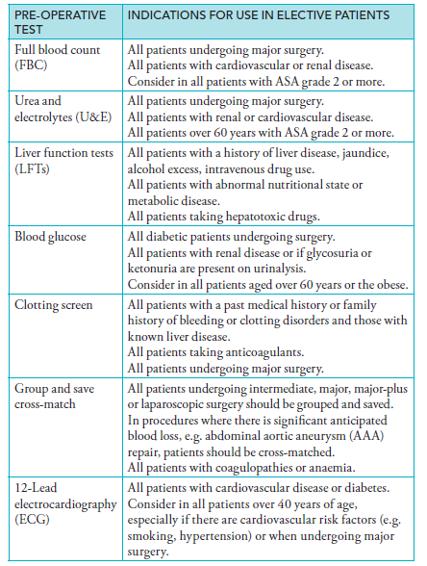

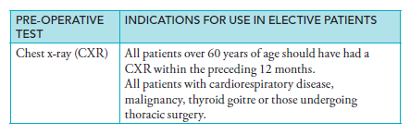

**1.1.3 Specific investigations**

* The following are not routinely required but may be required in certainpatients.

Table.Indications for specific pre-operative investigations in elective patients.

Pre-operative

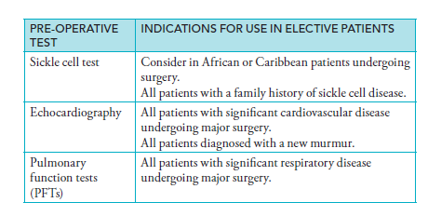

**1.2 Pre-operative assessment in the emergency surgical patient**

* In the emergency setting, preparation for theatre is about optimisation togive the patient the best possible chance of a good surgical outcome.
* In patients with severe comorbidity, NCEPOD recommends:
* communication between surgeon and anaesthetist pre-operatively;
* adequate pre-operative investigation;
* appropriate grade of surgeon (minimising operating time and bloodloss);
* adequate resuscitation;
* availability of critical care bed.
* It should not be forgotten that emergency admissions may require urgentsurgery, and so a thorough history and examination should be performed by the admitting doctor.

**1.2.1 Pre-operative investigations in emergency patients**

* All emergency general surgical patients should have an appropriate set ofblood test results available prior to surgery, including FBC, U&E, LFTs,glucose, clotting screen, group and save or cross-match depending on thetype of surgery, their comorbid conditions and the underlying acuteillness.
* All sexually active women of child-bearing age should have a pregnancy test.
* Patients admitted with an acute abdomen, where perforation of a viscous ispart of the differential diagnosis, should have an erect chest x-ray.
* Any patients with tachycardia and all adults aged 40 over years should have abaseline ECG, as should anyone with a cardiac, hypertensive or respiratoryhistory.
* All patients should have a simple urinalysis.
* An ABG may be relevant in patients with significant respiratory disease andthose with acute sepsis, pancreatitis or suspected intestinal ischaemia wherea metabolic acidosis may develop.

**1.3 How to manage conditions of special relevance:**

**1.3.1 Recent myocardial infarction (MI)**

* Avoid elective surgery [unless urgent or coronary artery bypass grafting(CABG)] for >6 months as risk of re-infarction is elevated.
* Specific relevant investigations:
* up-to-date ECG and echocardiogram.
* Continue all normal cardiovascular medications.
* Consider stopping anti-platelets 10 days prior to surgery.

**1.3.2 Aortic stenosis (AS)**

* Patients with severe AS should not undergo elective surgery without priorconsideration of valvular replacement.
* Specific relevant investigations:
* echo to assess the pressure gradient across the valve and its area—thenormal gradient is only a few mmHg.
* Prophylactic antibiotics may be required, although the indications for thishave recently been substantially reduced.
* Patients may be on anticoagulants.
* Avoid tachycardia and hypotension as patients are at risk of MI.
* Diastolic filling is reduced due to left ventricular hypertrophy.

**1.3.3 Atrial fibrillation (AF)**

* Can precipitate cardiac failure if inadequately rate-controlledperi-operatively.
* May be on warfarin (see Section 1.3.6).
* Specific relevant investigations:
* ECG to assess rate and rhythm (if paroxysmal);
* INR if on warfarin.

**1.3.4 Cardiac failure**

* Postpone surgery until stable and optimised on medication.
* Important to carefully control fluid balance to avoid overload.
* Specific relevant investigations:
* U&Es as diuretics and ACE-inhibitors can cause renal impairment.
* CXR to assess for disease severity and fluid overload.
* ECG and echocardiogram to assess LV function.

**1.3.5 Patients taking anticoagulants**

* If on warfarin, it is important to weigh the risk of stopping the medicationagainst the risk of bleeding intra-operatively, and this risk varies with theindication for therapy.
* Patients on warfarin for AF, for example, are not at great risk if theystop taking it and so may simply omit the drug for 5–7 dayspre-operatively.
* Patients on warfarin for metallic heart valves, however, are at highrisk of thromboembolism if the INR is normalised and so shouldhave cover with low molecular weight heparin (LMWH) or IVheparin.
* In the emergency setting, reversal of warfarin may be required quickly andso drugs such as vitamin K, fresh frozen plasma (FFP) or prothrombincomplex concentrate may be used.
* Anti-platelet medications should be omitted pre-operatively.
* Stop clopidogrel 7–10 days pre-operatively.
* Stop dipyridamole 7 days pre-operatively.
* Omit aspirin on the day of surgery.

**1.3.6 Recent cerebrovascular accident (CVA)**

* Avoid elective surgery (unless urgent or carotid endarterectomy) for>6 weeks.
* This is because autoregulation of cerebral blood pressure is disruptedfollowing a CVA, and normal ability to cope with fluctuations ofcerebral blood pressure caused by anaesthetic agents is impaired. Thisincreases the risk of a further peri-operative CVA.

**1.3.7 Hyperthyroidism**

* Patients with hyperthyroidism are at risk of thyrotoxic crisis, AF andbleeding.
* Efforts should be made to make the patient euthyroid prior to surgery.
* Specific relevant investigations:
* Thyroid function tests (TFTs), ECG, CXR.
* AF may resolve on treating the underlying thyroid disease, but patientsmay require rate control with beta-blockers, digoxin, verapamil oramiodarone.
* Anti-thyroid drugs may increase bleeding in thyroid surgery, and are oftenstopped 10–14 days prior to surgery.

**1.3.8 Immunosuppression**

* Surgical patients on long-term steroid therapy are at risk of Addisoniancrisis.
* These should be continued throughout surgery, as their use results inadrenal suppression leading to an impaired stress response.
* Patients unable to take their oral steroids will require IV hydrocortisone.
* If patients are taking <10 mg of prednisolone daily (or equivalent dose ofother steroid), they need no additional steroid cover.
* If taking >10 mg daily, patients will need 25 mg IV hydrocortisone atinduction of anaesthesia and additional cover post-op dependent on the typeof surgery.

**1.3.9 Diabetes mellitus**

* Diabetic patients who undergo surgery are at risk of multiple complications(see Figure 1.1).
* Ensure the patient is first on the operating list to optimiseglycaemic control.
* Specific relevant investigations:
* U&E, blood glucose, ECG.
* Adjust medication according to the timing and extent of surgery and inconsultation with the anaesthetist (see Table 1.3).
* Patients may require a variable rate insulin infusion (VRII), particularly ifstarved for a substantial period or if they have decompensated diabetes (e.g.in the presence of sepsis).
* BMs should be monitored regularly to ensure good control.

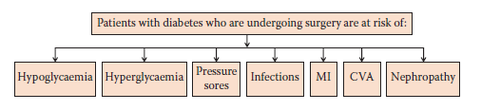

Figure 1.1 Specific risks in diabetic surgical patients.

Table 1.3 Alterations in diabetic medication before surgery taken from NH S

diabetes summary.

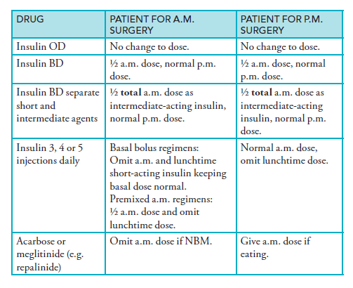

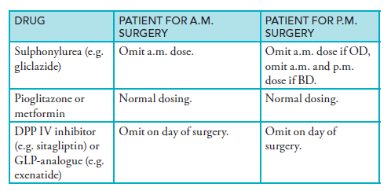

**1.3.10 Morbid obesity**

* Operations are made more complicated due to:
* Harder to manually handle larger patients.
* Special equipment may be required, such as larger operating tables, beds andspecial hoists. Not every hospital will have these.
* Increased prevalence of comorbidities, e.g. IHD, DM, gallstones, etc.
* Poor airway for anaesthetic intubation.
* Obesity may predispose to multiple complications (see Figure 1.2).
* Specific relevant investigations:
* ECG, blood glucose, respiratory function tests, including spirometry,ABG and CXR.

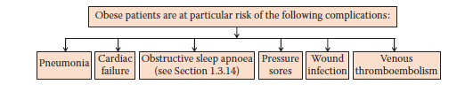

Figure 1.2 Complications specific to obese patients undergoing surgery.

**1.3.11 Renal failure**

* Manage all renal failure patients jointly with a nephrologist.
* Mild chronic renal failure is common in the elderly surgical patient.
* Delay elective surgery to allow optimisation and stabilisation of thecondition.
* Avoid nephrotoxic drugs, e.g. gentamicin.
* Make sure hydration is maintained pre-operatively.
* Severe renal failure.
* Risk of fluid overload, electrolyte imbalances, metabolic acidosis andanaemia of renal failure.
* Uraemia is immunosuppressant so ensure prophylactic antibiotics.
* Monitor urine output, plasma electrolytes, creatinine, urea and bicarbonate.
* Check potassium regularly, as having a general anaesthetic (GA)increases the risk of hyperkalaemia.
* Haemodialysis patients should have dialysis more than 24 hourspre-operatively to allow the effects of heparin to wear off.
* Patients using peritoneal dialysis having abdominal surgery may need to beconverted to haemodialysis pre- and post-operatively.

**1.3.12 COPD**

* Lung function decreases with the use of GA, so alternatives, such as regionalanaesthesia, may be considered.
* Optimise medical therapy with nebulisers, oxygen and steroids as required.
* Advise smoking cessation 4–8 weeks prior to surgery.
* Use of chest physiotherapy at least twice a day:
* passive, e.g. breathing exercises;
* active, e.g. postural drainage.
* May need to book a bed on HDU for post-operative non-invasiveventilation.
* Specific relevant investigations:
* Assess lung function using spirometry, ABG and CXR.

**1.3.13 Liver disease**

Patients with liver disease are at risk of several complications (see Figure 1.3).

* Patients with liver disease may be classified using the Child–Pugh criteria(Table 1.4).

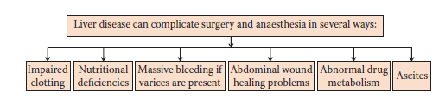

Figure 1.3 Complications specific to patients with liver disease undergoing surgery.

Table 1.4 Components of the Child–Pugh scoring system for liver disease.

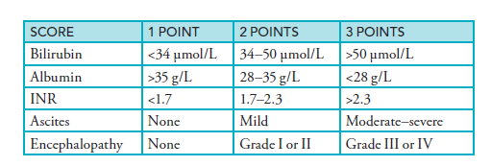

* Surgical risks vary with the score, and in those with a high score all but themost critical, life-saving surgery are contraindicated.
* Specific relevant investigations:
* FBC, clotting screen, U&E, LFT and bone profile.
* Patients should have close monitoring of blood sugar, as they have defectiveglycolysis and gluconeogenesis.
* Patients with deranged clotting may need vitamin K pre-operatively forseveral days or require fresh frozen plasma (FFP) peri-operatively.
* Prophylactic antibiotics are indicated.

**1.3.14 Infection**

Surgical antibiotic prophylaxis is the appropriate use of preoperative and postoperative antibiotics to decrease the incidence of postoperative wound infections.

**Treatment Goals**

Surgical Antibiotic Prophylaxis aims to:

* Decrease the incidence of postoperative wound infections.
* Decrease the incidence of adverse drug effects in patients undergoing surgery.
* Decrease the cost of care for surgical patients.
* Minimize the adverse effects of prophylactic antibiotics on the microflora of the patient and the overall bacterial resistance patterns in a particular institution.

**Pathophysiology**

Surgical wound infection does not necessarily follow bacterial contamination. The predominant organisms involved are the endogenous microflora at the surgical site. The development of a surgical wound infection is dependent on a complex interaction between the patient's host-defense response, intrinsic bacterial factors, and local tissue factors. Factors which increase the risk of surgical wound infection are as follows:

* Host-Defense Response Factors: Patients with an underlying host-defense deficit are at increased risk of surgical wound infection (extremes of age, malnutrition, diabetes, corticosteroid therapy, other immunologic deficiency)
* Bacterial Factors:
  + - Degree of wound contamination
    - Bacterial virulence
    - Microbial resistance to prophylactic antibiotics
* Local Tissue Factors:
  + - Blood supply and tissue hypoxia
    - Presence of necrotic material
    - Presence of hematoma
    - Presence of a foreign body

Infectious complications may arise in the surgical wound itself or in other organ systems. They may be initiated by changes in the physiologic state of the respiratory, genitourinary, or immune systems associated with surgery.

**Antimicrobial Spectrum**

The antimicrobial agent chosen for an individual patient should have activity against the most common pathogens which cause surgical wound infections.The agent does not need to possess antibacterial activity against all of the endogenous microbial flora at the surgical site; the use of agents with an excessively broad spectrum of activity increases the risk of microbial resistance and superinfection without an improvement in effectiveness. Third- generation cephalosporins exemplify this point. Despite their increased antimicrobial activity, these agents have not proven superior to first-generation cephalosporins in any operative procedure.

**Timing of Antibiotic Administration**

The most common error encountered in surgical prophylaxis is in the timing of antibiotic administration. Antibiotic prophylaxis has contributed to a reduction in superficial wound infection rates. Coverage should be initiated not more than 2 hours ( oral route) or 30 min.(IM,IV) before the skin incision is made and, in the absence of gross contamination or overt infection, should not be given beyond 24-48 hrs. after surgery.

**Duration of Prophylaxis**

Antibiotic administration should be continued for the shortest duration established to decrease the risk of postoperative infections. Antibiotic administration continued beyond 24 hours has not been shown to be superior to shorter duration antibiotic prophylaxis in most surgical procedures. Antibiotic prophylaxis continued beyond 24 hours increases cost, alters the patient's microflora, and adversely affects the bacterial resistance patterns of the institution. Single-dose antibiotic prophylaxis provides the optimal balance of reducing wound infections in most operative procedures while decreasing adverse drug effects.

**Postoperative Care**

**Routine postoperative care include**

* **Intravenous fluids:** The intravascular volume of surgical patients is depleted by both insensible fluid losses and redistribution into the third space. As a general rule, patients should be maintained on IV fluids until they are tolerating oral intake. Extensive abdominal procedures require aggressive fluid resuscitation. Insensible fluid losses associated with an open abdomen can reach 500-1000 ml/hr.
* **Deep venous thrombosis prophylaxis:** Many postoperative patients are not immediately ambulatory. In those, it is important to provide prophylactic therapy to reduce the risk of DVT and PE. Prophylaxis should be started postoperatively in patients undergoing major procedures because venous stasis and relative hypercoagulability occur during the operation.
* **Medications**
* Antiemetics
* Ulcer prophylaxis
* Pain control
* Antibiotics
* **Laboratory tests:**
* A complete blood count: should be obtained in the immediate postoperative period and on subsequent postoperative days in any procedure in which significant blood loss occurred.
* Serum electrolytes, BUN, and creatinine: are important postoperatively in patients on NPO status or who are receiving large volumes o IV fluids, TPN, or transfusions. In patients with large transfusions requirements, it is important to keep track of calcium and magnesium levels.
* Coagulation studies: are important in patients who have had insults to the liver or large transfusion requirements.
* ECG on daily basis and a series of three troponin I levels 12 hrs apart are appropriate ways to monitor for MI in patients with significant cardiac risk factors.
* Chest X-rays: Is necessity after any procedure in which the thoracic cavity is entered or when central venous access is attempted. CXRs on subsequent postoperative days should be considered on an individual basis if significant pulmonary or CV disease is present.

**Postoperative complications**

Postoperative complication is classified into:

* Local or general complications:
* Local- involving the operation site itself
* General-affecting any of the other systems of the body as respiratory, urological, or cardiovascular complications.
  + - 1. Neurologic complications

1. Perioperative stroke
2. Seizures
3. Delirium
   * + 1. Cardiovascular complications
4. Myocardial ischemia and infarction
5. CHF
6. Hypertension
   * + 1. Pulmonary complications
       2. Renal complications: acute renal failure occurs postoperatively can be divided into prerenal, intrinsic renal, and post renal.
7. Prerenal ARF: results from decreased renal perfusion that might be secondary to hypotension, intravascular volume contraction, or decreased effective renal perfusion.
8. Renal ARF: the causes include drug-induced acute tubular necrosis, pigment-induced renal injury, radio contrast dye administration, acute interstitial nephritis, and prolonged ischemia from suprarenal aortic cross-clamping.
9. Post renal ARF : results from obstruction of the urters or bladder. Operations that involve dissection near the urters, such as colostomy closure, or total abdominal hysterectomy, have a higher incidence of ureteral injures. In addition, obstruction of the bladder from an enlarged prostate, postoperative pain and medication administration, or obstructed urinary catheter can occur.
   * + 1. Infectious complications

* Evaluation of fever should take into context the time after operation in which the fever occurs.

1. Intra-operative fever: may be secondary to malignant hyperthermia, a transfusion reaction, or a preexisting infection.
2. High fever(>39 C) in the first 24 hrs. is commonly the result of a streptococcal or clostridial wound infection, aspiration pneumonitis, or a preexisting infection. Streptococcal wound infections present with severe local erythema and incisional pain. Penicillin G( 2 million units IV every 6 hours) or ampicillin (1-2 g IV every 6 hours) is effective therapy. Patients with a severe necrotizing closteridial infection present with systemic toxemia, pain, and crepitus near the incision. Treatment includes emergent operative debridement and metronidazole(500 mg IV every 6 hours) or clindamycin(600-900mg IV every 8 hours).
3. Fever that occurs more than 72 hours after surgery has a broad differential diagnosis, including pneumonia, UTI, thrombophlebitis, wound infection, intra-abdominal abscess, and drug allergy.
   * + 1. DVT and PE
       2. DM complications**:** as DKA and nonketotic hyperosmolar syndrome.

**Complications of general anesthesia**

1. *Malignant hyperthermia:* is a hyper metabolic disorder of skeletal muscle that is characterized by intracellular by hypercalcemia and rapid adenosinetriphosphate consumption. This condition is initiated by exposure to one or more ansthetic-triggering agents, including desflurane , halothane, isoflurane, sevoflurane, and succinylcholine.

Signs and symptoms may occur in the operating room or more than 24 hours postoperatively and include tachycardia, tachypena, hypertension, hypercapnia, hyperthermia, acidosis, and skeletal muscle rigidity.

Treatment involves immediate administration of dantrolene(1mg/kg IV up to a cumulative dose of 10 mg/kg). This attenuates the rise in intracellular calcium. Repeat doses are given as needed if symptoms persist with care monitoring for 24-72 hours.

1. *Laryngospasm:* during emergence from anesthesia, noxious stimulation of the vocal cords can occur at light phases of anesthesia. In addition, blood or other oral secretions can irritate the larynx. As a result, the vocal cords may be brought into forceful apposition, and the flow of gas through the larynx may then be restricted or prevented completely. This alone may cause airway compromise or may lead to negative-pressure pulmonary edema.Treatment involves the use of positive-pressure ventilation by mask to break the spasm. Such therapy usually is sufficient. Succinylcholine may be required in refractory cases to allow successful ventilation.
2. *Nausea and vomiting*
3. *Urinary retention:* although very common with spinal anesthesia, occurs after pelvic operations and in conjunction with benign prostatic hypertrophy. Treatment ranges from conservative (early ambulation, having patient sit or stand while attempting to micturate) to aggressive (bladder catheterization).
4. *Hypothermia:* general anesthesia induction causes peripheral vasodilatation*,* which leads to internal redistribution of heat, resulting in an increase in peripheral temp. at the expense of the core temp. The core temp. then decreases in a linear manner until a plateau is reached. Such hypothermia is more pronounced in the elderly. Hypothermia may provoke cardiac arrhythmia. Treatment includes passive warming during an operation by insulation of all exposed surfaces. In addition, active warming with forced-air convective warmers is effective, but care should be taken in using warmers with patients with vascular insufficiency.
5. *Nerve injury:* can occur secondary to improper positioning of the patient on the operating table or insufficient padding of dependent regions. Such palsies can be long lasting and debilitating.

**Parenteral fluid therapy**

1. Crystalloids: are solutions that contain sodium as the major osmotically active particle. Crystalloids are relatively inexpensive and are useful for volume expansion, maintenance infusion, and correction of electrolyte disturbances.
2. Isotonic crystalloids: as lactated Ringers solution, 0.9% NaCl distribute uniformly throughout the extracellular fluid compartment so that after 1 hr. only 25% of the total volume infused remains in the intravascular space. Lactated Ringers solution is designed to mimic extracellular fluid and is considered a balanced salt solution. This solution provides a HCO3 precursor and is useful for replacing GI losses and extracellular fluid volume deficits. In general, lactated Ringers solution and 0.9% NaCl solution can be used interchangeably. However, the last is preferred in the presence of hyperkalemia, hypercalecmia, hyponatermia, hypochloremia, or metabolic alkalosis.
3. Hypertonic saline solutions: alone and in combination with colloids, such as dextran, have generated interest as a resuscitation fluid for patients with shock or burns. These fluids are appealing because, relative to isotonic crystalloids, smaller quantities are required initially for resuscitation. This immunomodulatory effect of hypertonic saline plus dextran may help to prevent widespread tissue damage and multiorgan dysfunction seen after traumatic injury. The possible side effects of hypertonic solutions include hypernatermia, hyperosmolarity, hyperchloremia, hypokalemia.
4. Hypotonic solutions: as D5W, 0.45% NaCl distribute throughout the total body water compartment, expanding the intravascular compartment by as little as 10% volume expansion. They are used to replace free water deficits.
5. Colloid solutions: contain high-molecular weight substances that remain in the intravascular space. Early use of colloids in the resucscitation regimen may result in more prompt restoration of tissue perfusion and may lessen the total volume of fluid required for resucscitation. The use of colloids is indicated when crystalloids fail to sustain plasma volume because of low colloid osmotic pressure( as increased protein loss from the vascular space, as in burns and peritonitis).
6. Albumin preparations: ultimately distribute throughout the extracellular space, although the initial location of distribution is the vascular compartment. Preparations of 25% albumin and 5% albumin expand the intravascular volume by an equivalent amount. Albumin 25% is indicated in the edematous patient to mobilize interstitial fluid into the intravascular space.
7. Dextran: is a synthetic glucose polymer that undergoes predominantly renal elimination. In addition to its indication for volume expansion, it is also used for thromboembolism prophylaxis and promotion of peripheral perfusion. Dextran solutions expand the intravascular volume by an amount equal to the volume infused.

**Principles of fluid management**

A normal individual consumes an average of 2000-2500 ml of water daily. Daily water losses include approximately 1000-1500 ml in urine and 250 ml in stool. The minimum amount of urinary output that is required to excrete the catabolic end products of metabolism is approximately 800ml. An additional 750 ml of insensible water loss occurs daily via the skin and respiratory tract. Insensible losses increase with hypermetabolism, fever and hyperventilation. Contraindications to fluid management include volume overload, pulmonary edema, acid-base disturbances, fever if pyrogenic and electrolyte disturbances.

1. Maintenance: maintenance fluids should be administered at a rate that is sufficient to maintain a urine output of 0.5-1 ml/kg/hr. Maintenance fluid requirements can be approximated on the basis of body weight as follws:

100 mL/kg/day for the first 10 kg.

50 mL/kg/day for the second 10 kg.

20 mL/kg/day for each subsequent 10 kg.

Maintenance fluids should contain Na+ (1-2 mmol/kg/day) and K+(0.51 mmol/kg/day) (e.g., D5/0.45% NaCl+20-30 mmolK+/L).

1. Intraoperative fluid management: requires replacement of preoperative deficit as well as ongoing losses. Intaoperative loses include maintenance fluids for the duration of the case, hemorrhage, and third-space losses. The maintenance fluid requirements are calculated as detailed above. Acute blood loss can be replaced with a volume of crystalloid that is 3-4 times the blood loss or an equal volume of colloid or blood. Intaoperative insensible and third-space fluid losses depend on the size of the incision and the extent of tissue trauma and dissection and can be replaced with an appropriate volume of lactated Ringers solution.
2. Postoperative fluid management: sequestration of extracellular fluid into the sites or operative trauma can continues for 12 or more hours after operation. ADH is released in response to surgery, conserving water. Hypovolaemia will cause aldosterone secretion and salt retention by the kidney. Potassium is released by damaged tissues, and the potassium level may be further increased by blood transfusion, each unit containing in excess of 20 mmol/L. If renal perfusion is poor, and urine output sparse, this potassium will not excreted and accumulates, causing life-threatening arrhythmias. This is the basis of the recommendation that supplementary potassium may not be necessary in the first 48 hours following surgery or trauma. Urine output should be monitored closely and intravascular volume repleted to maintain a urine output of 0.5-1mL/kg/hr.

**Postoperative nausea and vomiting**

Postoperative nausea and vomiting(PONV) is one of the most common side effects associated with surgical procedures. It can be very distressing for patients, can lead to medical complication and imposes an economic burden. The medical complications of PONV include possible wound disruption, esophageal tears, gastric herniation, muscular fatigue, dehydration and electrolyte imbalance. There is also an increased risk of pulmonary aspiration of vomitus. Aside from the medical complications, PONV can have psychological effects that may result in patients experiencing anxiety about further surgery.

**Risk factors associated with PONV**

Patient risk factors

1. Gender: the prevalence of PONV is 3 times higher in women than in men. This gender difference is not evident in pre-pubertal children or in the elderly, which indicates that there may be hormonal involvement.
2. Age: children are 2 times more likely to develop PONV than adults PONV is low in very young children, increases up to the age of 5 and is highest in children between the ages of 6 and 16 years.
3. Obesity: fat-soluble anesthetics may accumulate in adipose tissue and continue to be released for an extended period resulting in prolonged side effects, including PONV.
4. Migraine: patients with a history of migraine are more likely to experience PONV.
5. Pre-operative eating patterns: adequate preoperative fasting reduces the risk of PONV, whereas excessive starvation appears to increase the risk. In emergency surgery where there has not been an adequate fast the risk is increased.
6. History of PONV or motion sickness: such patients may have a lower threshold to nausea and vomiting than the rest of the population. Anxiety, due to a previous experience of PONV may lead to the risk.
7. Gastro paresis: patients with delayed gastric emptying secondary to an underlying disease may be at increased risk of PONV.

**Procedural risk factors**

The type and duration of surgery is a major factor in PONV. Extended surgical procedures are more likely to lead to PONV than shorter operations, and Gynecological, abdominal especially gastrointestinal, laproscopic, ear-nose and throat, ophthalmic surgical procedures predispose to a higher incidence of PONV

**Anesthetic risk factors**

Certain anesthetic agents have been associated with a higher incidence of PONV than others.

Use of opioid analgesics, use of nitrous oxide, use of some inhalation agents and longer procedures and greater depth of anesthesia.

**Postoperative risk factors**

1. Pain: relief of pain is associated with the relief of nausea, though the use of opioid analgesics may exacerbate the risk because of their known emetic potential.
2. Dizziness; PONV is increased in patients who experience dizziness.
3. Early ambulation: early or sudden movement can increase the risk of PONV, especially if the patients have received opioids.
4. Hypotension: postoperative hypotension is common and can trigger PONV.
5. Premature oral intake: it is generally considered wise to restrict oral intake, and then to recommended small sips of water to minimize the risk of PONV.

**Management of PONV**

* Benzamide( metoclopramide): 0.1-0.2 mg/kg IV over 1-2 min.
* Phenothiazines(prochlorperazine): 12.5 mg IM.
* Antiserotonine( ondanesterone) :4 mg by slow 1v infusion and can be repeated every 6-8 hours, or tropisterone 2 mg by slow IV infusion.

**Postoperative analgesia**

Pain is defined as an unpleasant sensory and emotional experience associated with actual or potential tissue damage. It is a complex process influenced by both physiological and psychological factors.

**Effects of postoperative pain**

Postoperative pain can affect all organ systems and includes

* Respiratory: reduced cough, atelectasis, sputum retention and hypoxemia.
* Cardiovascular: increased myocardial oxygen consumption and ischemia.
* Gastrointestinal: decreased gastric emptying reduced gut motility and constipation.
* Genitourinary: urinary retention.
* Neuroendocrine: hyperglycemia, protein catabolism and sodium retention.
* Musculoskeletal: reduced mobility, pressure sores and increased risk of DVT.
* Psychological: anxiety and fatigue.

**Analgesic drugs**

Many patients are unable to tolerate oral medications immediately after postoperative period.

1. Narcotics: the intermittent administration of IV or IM narcotics has the disadvantage that the narcotics may be given too infrequently, too late, and in insufficient amounts to provide adequate pain control. This may the only choice in patients who are functionally unable to operate a patient-controlled analgesia device.

* Morphine, 2-4 mg IV every 30-60 min., or meperidine 50 -100 mg IV every 30-60 min.
* Tramadol, 100 mg then 50 mg every 10-20 min. during the first hour to total max.250 mg then 50-100mg every 4-6 hours; max.600mg daily.

1. NSAIDs:as diclofenac sodium.25-50 mg after surgery; further doses given after 4-6 hrs. if necessary;max.150 mg in 24 hrs. for 2 days.

**Diabetic foot**

Diabetic foot is a common chronic foot problems cause great disability within the diabetic patients. 10-15% of diabetic patients develop foot ulcers and foot related problems are responsible for up to 50% of diabetes related hospital admission.

**Precipitating factors of foot ulceration**

1. Friction in ill-fitting or new shoes.
2. Ulcerated callus.
3. Self-treated callus.
4. Foot injures (unnoticed trauma in shoes).
5. Burns.
6. Corn plaster.
7. Nail infection.
8. Foot deformities.

**Causes of foot ulceration**

1. Neuropathy:
2. Peripheral neuropathy: is believed to be the most significant contributor to the development of lower extremity ulcers in diabetic patients through impaired detection of injury from poorly fitting shoes or trauma. Diabetic motor neuropathy is also associated with abnormal weight bearing. The motor neuropathy results in abnormalities such as hummer toes which shifts weight bearing more proximally than normal on the metatarsal heads. Additionally, the dorsum of the toes at the posterior interphalangeal joints is often traumatized by ill-fitting shoes in patients with hummer toes.
3. Autonomic neuropathy: leads to failure of sweating and inadequate lubrication of the skin. Dry skin leads to mechanical breakdown that initiates ulcer formation. Autonomic neuropathy also contributes to failure of auto regulation in the microcirculation; therefore, arterial blood will shunt past capillaries into the venous blood flow. This reduces the nutritive blood flow to the skin and predispose to ulcer formation.
4. Ischemia: the microvascular disease seen in diabetic patients also contributes to the development and progression of lower-extermity. These patients should be evaluated for proximal atherosclerotic disease, which may be amenable to intervention, thus improving the chances of healing of the ulcer or healing of an amputation.

**Types of foot ulceration**

1. Neuropathic : clinical features are

* Warm with intact pulses
* Diminished sensation
* Ulceration(usually on tips of toes and plantar surfaces under metatarsal heads).
* Sepsis.
* Local necrosis
* Edema

1. Ischemic(neuroishemic) clinical features:

* Pulses less, not warm.
* Usually diminished sensation.
* Ulceration (often on margins of foot, tips of toes, heels).
* Sepsis.
* Necrosis or gangrene.
* Critical ischemia (urgent attention foot pink, painful, pulse less, and often cold).

Despite preventive measures, foot ulceration and infection are common and represent a potentially serious problem and ulcers can be secondarily infected by staphylococci, streptococci, Gram-ve bacteria and anaerobic bacteria; infection can quickly lead to cellulitis, abscess formation, and osteomyelitis. The reasons for this include incompletely defined abnormalities in cell-mediated immunity and phagocyte function associated with hyperglycemia, as well as diminished vascularization. Hyperglycemia aids the colonization and growth of a variety of organism.

Sepsis complicating toe ulcers can lead to in situ thrombosis of the digital arteries, resulting in gangrene of the toe.

**Treatment**

1. Clean wounds: are treated with conservative debridement and dressing changes, with careful trimming of the calluses and nails.
2. Infected wounds: are diagnosed clinically; excess keratin should be pared away to expose the floor of the ulcer and allow efficient drainage of the lesion. A bacterial swab should be taken from the floor of the ulcer after the callus has been removed. Plain X-rays may show osteomyelitis or gas in the soft tissues when lesions fail to heal or continue to recur. The patient should be instructed to dress the ulcer daily. A simple non-adherent dressing should be applied after cleaning the ulcer with normal saline solution. Patients with superficial ulcers can be treated as outpatients and prescribed appropriate oral antibiotics until the ulcer has healed.
3. Urgent treatment: patients with the danger signs listed below:

* Redness and swelling of a foot; this often indicates a developing abscess.
* Cellulites, discoloration, and crepitus.

Those patients need to be admitted to the hospital immediately for urgent therapy. They should have bed rest and be started on IV antibiotics. An IV insulin pump may be needed to control blood glucose level. In the 1st 24 hours before bacteriological cultures available, a wide spectrum of antibiotics cover is needed.

Therapy consisting of antibiotics covering aerobic and anaerobic organisms according to culture and sensitivity test may be necessary. This treatment may be adapted when the results of bacteriological culture are available.

**Prevention**

Prevention remains one of the most important elements in the management of the diabetic foot.

1. Careful selection of footwear.
2. Daily inspection of the feet to detect early signs of poor-fitting footwear or minor trauma.
3. Daily foot hygiene to keep the kin clean and moist.
4. Avoidance of self-treatment of foot abnormalities and high-risk behavior.
5. Promote consultation with a health care provider if an abnormality arises.

**Appendicitis**

**Epidemiology**

* Commonest cause of an acute abdomen and surgical admission in the UK.
* Approximately one in seven people will have an appendicectomy.
* It most commonly occurs between 10 and 20 years; it is rare under 3 yearsof age.

**Pathophysiology**

It usually occurs when the appendix is obstructed by a faecolith or foreign body in the lumen, by a fibrous stricture in its wall from previous inflammation or by enlargement of lymphoid follicles in its wall secondary to a catarrhal inflammation of its mucosa; rarely it is associated by a carcinoid tumor near its base. The obstructed appendix acts as a closed loop; bacteria proliferate in the lumen and invade the appendix wall, which is damaged by pressure necrosis. The vascular supply to the appendix is made up of end-arteries, which are branches of the appendicular branch of the ileocolic artery. Once these are thrombosed, gangrene is inevitable and is followed by perforation. An appendix may perforate in under 12 hrs., but conversely it is not rare to see an acutely inflamed but not perforated appendix after 3-4 days

**Clinical features**

**Abdominal pain**

* Initially vague, colicky central abdominal pain.
* Visceral pain caused by luminal obstruction of the appendix andstretch of the visceral peritoneum.
* Localising to the right iliac fossa and becoming constant.
* The pain changes as the parietal peritoneum becomes involved.
* Usually accompanied by a low-grade fever, nausea, vomiting and anorexia.
* The appendix position varies and can result in different symptoms; forexample a pelvic appendix may cause urinary symptoms or diarrhoea.
* On examination there may be general signs of sepsis:
* Usually a low-grade pyrexia initially, which may spike up to 38–39°Cin the presence of perforation or abscess formation.
* There may be tachycardia, flushing and evidence of dehydration.

**Abdominal examination**

* Tenderness over McBurney’s point is the usual feature.
* There may also be signs of peritoneal inflammation, including:
* Guarding, tenderness on percussion, pain on coughing or othermovement.
* Signs of generalised peritonitis may develop as the illness progresses with abdominal rigidity.
* Rovsing’s sign: Pain is felt in the RIF when pressure is applied to the LIF.
* There must also be RIF tenderness for this sign to be positive.
* Psoas sign: The patient keeps his or her hip in flexion to relieve his or herpain.
* The appendix is anatomically adjacent to the psoas muscle, which isinvolved in hip flexion.
* PR examination may reveal tenderness anterolaterally on the right.

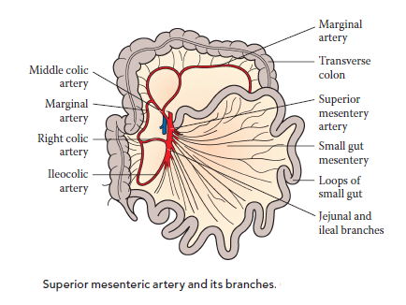

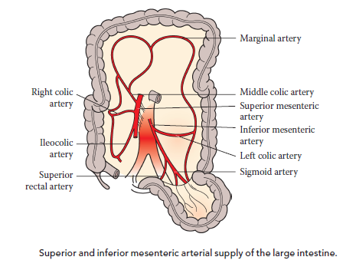

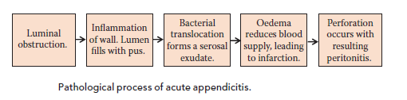

**Diagnosis**

* The diagnosis of appendicitis is a clinical one; however there are some teststhat may be useful, particularly where the diagnosis is not clear-cut. Theseinclude:
* The performance of a full blood count (FBC) can be useful todetermine whether or not the patient has a leucocytosis.
* A urinalysis to exclude urinary tract infection.
* Although appendicitis may cause a haematuria or pyuria withassociated urinary symptoms.
* A pregnancy test in women of child-bearing age is mandatory to ruleout an ectopic pregnancy.
* An ultrasound scan (USS) in women can be useful where thediagnosis of appendicitis is in doubt to exclude tubo-ovarianpathology as the cause of RIF pain
* A computed tomography (CT) scan can be useful to confirm thediagnosis, especially in the elderly where a caecaltumour may becausative, or in the obese where examination is difficult.
* Diagnostic laparoscopy allows immediate treatment if appendicitis isconfirmed.
* Urea and electrolytes (U&E) should also be performed to assesshydration status.
* Remember to ask about previous abdominal surgeries (including righthemicolectomy), as it is embarrassing to quote appendicitis as a cause of RIFpain if the patient has already had the appendix removed!

**Management**

* Patients are often dehydrated at presentation and so require fluidresuscitation. IV fluids should be continued whilst the patient remainsstarved for theatre.

**Open appendicectomy**

* Usually performed in children.
* A Lanz incision (centred on McBurney’s point; see Figure 1.5) is used for thebest cosmetic result.
* If the appendix is found to be perforated or gangrenous, then peritoneallavage is performed to remove any pus or contamination.
* Most patients can be discharged on the second or third day post-operatively.

**Laparoscopic appendicectomy**

* Improves diagnostic accuracy and minimises negative appendicectomy rates.
* It is indicated in patients who are unwell but there is question as to thediagnosis, and is particularly indicated in young women.
* It is useful in the obese where wound infections are more commonand laparoscopic procedures have lower wound infection rates.
* There is now evidence to suggest that laparoscopic appendicectomy shouldbe performed where expertise is available for this to be done.
* Laparoscopy has decreased length of stay in hospital, faster return to normaldiet and activities and better post-operative pain.
* If the patient presents late (usually after several days of symptoms) with apalpable appendix mass, he or she requires CT scanning to determinewhether there is an associated appendix abscess or a perforated caecaltumour.
* The initial management of an appendix abscess is conservative withIV fluids, antibiotics and observation. They may require radiologicaldrainage.
* If there is deterioration, or frank perforation, surgery may still berequired.

**Complications**

* Abscess formation; peri-appendicular, pelvic or sub-hepatic.
* Post-operative collection or abscess.
* Appendix stump blowout, leading to peritonitis.
* Wound problems, including infection or haematoma.
* Intestinal obstruction due to adhesion formation within the abdomen.
* Patients with a perforated appendix may occasionally need admission tointensive treatment unit (ITU).

**Pregnancy**

* Appendicitis is the most common non-gynecologic surgical emergency during pregnancy.
* It must be suspected in any pregnant woman with abdominal pain.
* Operation is indicated in pregnant patient as soon as the diagnosis of appendicitis is suspected. A negative laparotomy carries a risk of fetal loss of up to 3% .

**Deep Venous Thrombosis**

Deep venous thrombosis (DVT) is a common cause of death. The true incidenceof DVT difficult to determine because its clinical diagnosis can be inaccurate and often occurring in the setting of other critical illness.

**Pathophysiology**

DVT starts as platelet nidus, usually in the venous valves of the calf. The thrombogenic nature of the nidus activates the clotting cascade, leading to platelet and fibrin accumulation. The fibrinolytic system is subsequently activated, with thrombus growth if thrombogenesis predominates over thrombolysis. A thrombus can detach from the endothelium and migrate into the pulmonary system, becoming a PE; alternatively, it can also organize and grow into the endothelium, resulting in venous incompetency and phlebitis. Thrombi localized into the endothelium, resulting in embloize than thrombi that extend to the thigh veins. Approximately 20% of cases of calf DVT propagate to the thigh, and 50% of cases of thigh or proximal DVT embolize.

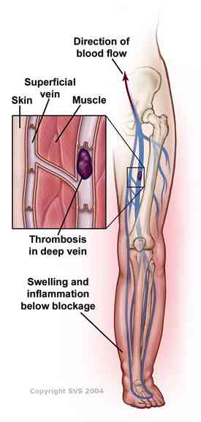

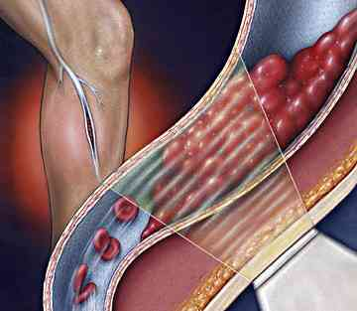

**Risk factors for DVT**

* Endothelial injury by malignancy:
* Adhesion of tumor cells to endothelium can lead to disruption of endothelial intracellular junctions and expose the highly thrombogenicsubendothelial surface.
* Chemotherapeutic drugs, such as bleomycin, carmustine, vincristine and doxorubicin can also cause vascular endothelial cell damage.
* Venous stasis:
* This is caused by immobility, venous obstruction, increased venous pressure, and increased blood viscosity.
* Venous stasis promotes thrombus formation by reducing clearance of activated coagulation factors and by causing endothelial hypoxia, leading to reduced levels of surface-bound thrombomodulin and increased expression of TF.
* Surgery and critical illness. Major chest surgery, abdominal/ pelvic surgery, and lower extremity surgery have all been associated with increased risk of DVT development. Similarly, a prolonged non-ambulatory state, such as fracture of the hip, pelvis, or leg; multisystem trauma; neurologic injury; or other critical injury requiring bed rest can increase DVT risk.
* Oral contraceptives (OCPs) and estrogen hormone replacement therapy:These have been linked to increased risk of venous thrombus formation.
* Hypercoagulable states:
* Primary hypercoagulable states are inherited conditions that can lead to abnormal endothelial cell thromboregulation.
* Decreased thrombomodulin-dependent activation of protein C
* Impaired heparin binding of antithrombin III.
* Downregulation of membrane-associated plasmin production.
* Increased serum prothrombin levels.
* Decreased thrombogenic inhibitors.
* Secondary hypercoagulable states are states in which endothelial activation
* Antiphospholipid syndrome.
* Venous trauma.
* Surgery.
* Hyperhomocysteninemia
* Heparin-induced thrombopathy.
* Myloprolerative syndromes.
* Cancer.
* Chemotherapy agents: cyclophosphamide, MTX, and 5-flurouracil, cause a decrease in the plasma levels of proteins C and S.

**Clinical features**

DVT can be silent but typically symptoms and signs occur during the second postoperative week, although they may came earlier or later. The patient complains of pain in the calf, and on examination there is tenderness of the calf and swelling of the foot, often with edema, raised skin temp., and dilation of the superficial veins of the leg. This is accompanied by a mild pyrexia. If the pelvic veins or the femoral vein are affected, there is massive swelling of the whole lower limb.

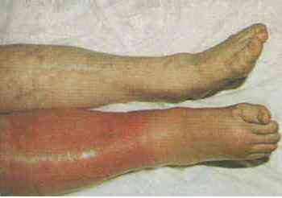

**Investigations**

* Venography: it is an invasive procedure.
* Duplex scanning: it can detect thrombi in all major veins at and above the knee. It is simple and noninvasive.
* Compression ultrasonogrphy: is highly sensitive in detecting thrombosis of the proximal veins but less sensitive in detecting calf vein thrombosis.

**Management**

**A. Prophylaxis**

* Treat avoidable risk factors.
* Active mobilization: stimulation of blood flow by encouraging early mobilization reduces the risks.
* Intermittent calf compression: using inflatable cushions wrapped around the lower legs may be used intra-operatively to reduce the incidence of thrombosis.
* Graded compression stockings and elevation of the legs to increase venous return are simple and effective.
* Low-dose unfractionated heparin: this is given SC at 5000 units 2 hrs. before surgery every 8 or12 hrs. Postoperatively. It should not be used for patients undergoing cerebral, ocular or spinal surgery.
* Low- molecular weight heparins: such as enoxaparin.
* Newer medications: such as the direct thrombin inhibitors represent a possible alternative to the unfractionated and LMWHs in the prevention of thromboembolic disease.

**B. Treatment**

When the diagnosis of DVT is made postoperatively, begin full-dose heparinization(bolus of 5000-10000IU, followed by continuous infusion of 1000-1500IU/hr) if surgical hemostasis is achieved. Once on therapeutic heparin(aPPT of 1.5-2), warfarin should be initiated and the dose adjusted to maintain an appropriate INR (ie, 2-3). Heparin and a therapeutic level of warfarin should overlap for at least 48 hrs. before discontinuing heparin. If edema is present, the patient should remain on bed rest with the affected limb elevated above the level of the heart for several days. The patient should remain on bed rest for 2-3 days even if no pain or edema is present and even if the aPPT is at a therapeutic range to allow fixation of the clot to the vessel wall. Administer 3-6 months of therapy in the case of proximal DVT, assuming that surgery was the only predisposing risk factor.

* Daltapain sodium is administered at 200 IU/kg/day SC. With a single dose not to exceed 18000 IU.
* Enoxaparin sodium is administered at 1mg/kg q12 hrs. SC. Or at 1.5mg/kg/day SC. The single daily dose should not exceed 150 mg.

**Gallstones**

**Epidemiology**

* Gallstones are common:
* 10% of people over 50 years have gallstones.
* Incidence increases with age.
* Affects more women than men 2F:1M.

**Aetiology**

* Three types of gallstones:
* Cholesterol stones (20%).
* Bile pigment stones (5%).
* Mixed stones (75%).

**Clinical features**

* 80% are asymptomatic.
* There are several clinical presentations associated with gallstones (see Figure)

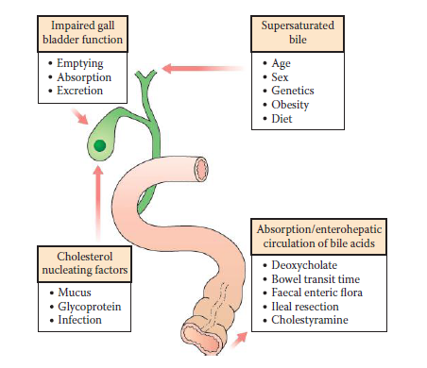

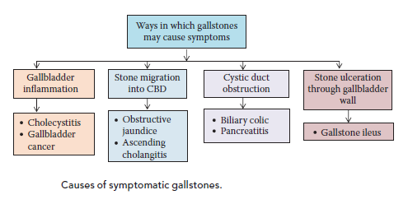

**Biliary colic**

* Pain occurring when the gallbladder contracts against an obstruction(e.g. a stone in Hartmann’s pouch or the cystic duct).
* Severe right upper quadrant (RUQ)/epigastric pain, lasting for a few hours.
* Usually precipitated by eating (often fatty foods).
* May be associated with nausea &/ or vomiting.
* Patient is usually systemically well (in contrast to acute cholecystitis)

**Acute cholecystitis**

* Prolonged gallbladder outlet obstruction, resulting in inflammation due toconcentrated bile, initially resulting in chemical cholecystitis.
* May subsequently be complicated by infection, pus (empyema) ormucus (mucocele).
* Often a history of previous biliary colic.
* RUQ/epigastric pain that becomes more severe, constant and localised aftera day or two.
* Associated fever, ↑ WCC, may be rigors and other features of sepsis.
* On examination there will be tenderness and guarding in the RUQ.
* Murphy’s sign positive.

**Chronic cholecystitis**

* Repeated episodes of inflammation resulting in chronic fibrosis andthickening of the entire gallbladder wall.
* Recurrent episodes of pain with or without fever.

**Diagnosis**

* Inflammatory markers (WCC, CRP) will usually be elevated in acutecholecystitis, cholangitis and pancreatitis.
* LFTs may show an obstructed picture. Serial measurements should be takenif obstructive jaundice is present to ensure its resolution or prompt furthertreatment if it remains elevated.
* Ultrasound scan (USS) is used to visualise the gallbladder and biliary tree,allowing diagnosis of stones, inflammation and duct dilatation.
* Plain abdominal x-ray is useful in gallstone ileus, as there will be evidence ofsmall bowel obstruction, often with pneumobilia.
* MRCP allows better visualisation of the biliary tree and will demonstrateany gallstones within the CBD that may be causing obstruction (Figure 5.7),which will require removal (e.g. with ERCP or at surgery).
* ERCP is diagnostic for biliary tree dilatation and CBD stones, and is usedtherapeutically to remove obstructing CBD stones, insert stents and performsphincterotomy (sphincter of Oddi).

**Treatment**

**Supportive measures**

* Intravenous fluids and analgesia.
* Antibiotics are required in patients with acute cholecystitis, cholangitis andacute severe pancreatitis.
* Vitamin K is used to correct coagulopathy caused by obstructive jaundice.ERCP may be used therapeutically in the presence of CBD obstruction
* Trawling of the duct to remove stones.
* Sphincterotomy to prevent further obstructive episodes.
* Insertion of stents to allow bile drainage in difficult cases.
* Percutaneous transhepatic cholangiography (PTC) is used in patients withsevere biliary obstruction and sepsis who are unsuitable for ERCP or where ithas been unsuccessful.
* Insertion of a percutaneous stent may relieve obstruction until sepsissubsides and the patient is well enough for alternative management.
* Complications include:
* Bleeding, infection (cholangitis), pancreatitis, perforation.

**Cholecystectomy**

* Indications:
* Acute or chronic cholecystitis, recurrent biliary colic, gallstoneinducedpancreatitis, biliary peritonitis due to perforation of thegallbladder or previous CBD obstruction.
* Usually performed laparoscopically.
* Conversion to open procedure is rare and should occur in <5% of electivecases and <10% of emergency cases.
* May be a day-case procedure in simple elective cases.
* There is evidence to suggest that index admission laparoscopiccholecystectomy (i.e. on the patient’s first admission with symptoms) is safe,prevents readmission and shortens overall hospital stay.
* On-table cholangiogram and duct exploration may be performed duringlaparoscopic cholecystectomy to identify and remove any stones.

**Burns**

**Definition**

* Damage to skin and subcutaneous tissue in response to thermal, electrical,chemical, frictional, cold or radiation injury.
* By far the commonest type in the UK is a thermal burn, caused mostly bydry burn, e.g. flame, but can be from a wet burn, e.g. scalding.

**Assessment of extent of burn**

**Size of burn**

* The patient’s palm is ~1% of his or her total body surface area (TBSA) andcan be useful to determine extent of small or very large burns.
* Wallace’s rule of 9’s is useful in initial assessment (see Figure).
* It is important to use the appropriate chart for the patient’s age.

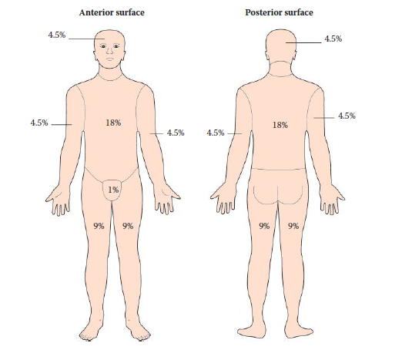

Figure.The ‘rule of 9’s’ method for calculating the proportion of the total body Surface area that has been burnt.

**Depth of burn** (see Table)

* Difficult to assess accurately since burns tend to be dynamic and evolve overtime.
* Figures show the characteristics of different burn depths.

Table. Difference between different depths of burns.

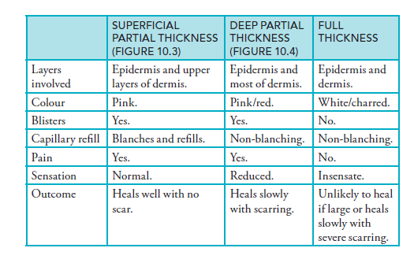



Figure. Superficial burns.



Figure. A mixture of partial-thickness and full-thickness burns.

**Initial management of acute burn**

* Like any emergency, management should take the ABC approach.

*MICRO-facts*

Signs of potential inhalation injury:

* Burns on neck, around mouth, on palate or nasal passages.
* Soot in oropharynx or nostrils.
* Hoarse voice.
* Hypoxia.
* Carboxyhaemoglobin.
* Stridor, tachypnoea and dyspnoea are late signs.

**Airway and breathing**

* If suspected smoke inhalation, early intubation is indicated to preventairway obstruction and death.
* If severe airway obstruction, a tracheostomy may be needed.
* High-flow oxygen through non-rebreathing mask.
* Perform ABG and check carbon monoxide levels.

**Fluid resuscitation**

* Burn injuries lead to large inflammatory exudation of proteins and solutesinto the extravascular space.
* This occurs within the first 6–12 hours post-injury (not post-arrival into theemergency department!) and starts to slow by 36 hours
* Fluid loss is dependent on size of burn:
* ≥15% total body surface area (TBSA) in adults and ≥10% in childrenwill lead to circulatory shock.
* Insert a large-bore cannula and catheterize (to monitor output; keep urineoutput 0.5–1 mL/hour in adults, 1–2 mL/hour in children).
* Use the Parkland formula to calculate the fluid requirements (usuallyHartmann’s solution).
* Give half in the first 8 hours (from the time of injury), and half in thenext 16 hours.

**Analgesia**

* Cool wound with running water for 10 minutes.
* Temporary use of cling-film as dressing reduces evaporation and pain.
* If small burn, simple oral analgesia may be sufficient.
* If large burn, IV opiate analgesia will be needed (do not use IM route).

**Nutrition**

* Burn injuries lead to a highly catabolic state.
* If burns >20% TBSA, insert a nasogastric (NG) tube within 6 hours toprevent stress ulceration of the stomach (Curling’s ulcers).

**Management of the burn wound**

* Depends on burn depth (Figure 10.5).
* Assess if an escharotomy is needed:
* An escharotomy is an incision along the full length of the burn torelieve compression due to oedema in circumferential full-thicknessburns.
* The incision is in the mid-axial line and extends down to the fascia.
* Necessary if blood flow to a limb is occluded or respiratory movementrestricted.
* Escharotomies should be performed in an operating theatre by a burnsspecialist if at all possible.
* If assessment indicates that escharotomy may be required, discuss **urgently**with the local burns unit and arrange transfer.
* After escharotomy the principles of management are the same regardless ofthe size of the burn.

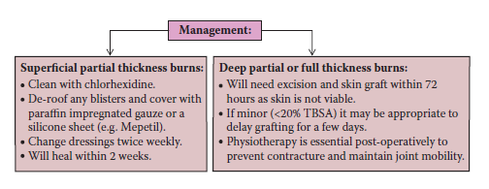

Figure 10.5 General management plans for burns.

***Appendix***

***Table I : Perioperative drug management for patients with hypertension***

|  |  |  |  |  |
| --- | --- | --- | --- | --- |
| **Drug** | **Day before surgery** | **Day of surgery** | **During surgery** | **After procedure** |
| *Β-blockers* | Usual dose | Usual dose on morning of surgery with sip of water | IV bolus or infusion | Continue IV dose until medication can be taken PO |
| *Calcium channel blockers* | Usual dose | Usual dose on morning of surgery with sip of water | IV bolus or infusion | Continue IV dose until medication can be taken PO |
| *ACE-inhibitors* | Usual dose | Usual dose on morning of surgery with sip of water | IV formulations | Continue IV dose until medication can be taken PO |
| *Diuretics* | Stop day before |  | IV Β-blockers/IV Calcium channel blockers | Restart when patient on oral liquids |
| *Potassium supplements* | Stop day before; consider checking potassium level |  |  | Restart when patient on oral liquids |
| *Central-acting sympatholytics* | Usual dose | Usual dose on morning of surgery with sip of water | Transdermal clonidine/IV methyl dopa | Restart when patient on oral liquids |
| *Peripheral sympatholytics* | Usual dose | Usual dose on morning of surgery with sip of water | Any IV formulation | Restart when patient on oral liquids |
| *Α-blockers* | Usual dose | Usual dose on morning of surgery with sip of water | Any IV formulation | Restart when patient on oral liquids |
| *vasodilators* | Usual dose | Usual dose on morning of surgery with sip of water | Any IV formulation | Continue IV dose until medication can be taken PO |

***Table II : Perioperative drug management for patients with CAD***

|  |  |  |  |  |
| --- | --- | --- | --- | --- |
| **After procedure** | **During surgery** | **After procedure** | **Day before surgery** | **Drug** |
| Continue IV dose if needed or until medication can be taken PO | IV infusion if frank ischemia | Usual dose | Usual dose | *Nitroglycerin* |
| Usual dose + B-blockers | Usual dose + B-blockers | Usual dose + B-blockers | Usual dose | *Beta-blockers* |
| Continue IV dose if needed or until medication can be taken PO | Usual dose morning of surgery | Usual dose morning of surgery | Usual dose | *Calcium channel blockers* |
| Restart postoperatively at discretion of surgeon |  |  | Discontinue 1 week before surgery | *Aspirin* |
| Restart postoperatively at discretion of surgeon |  |  | Discontinue 1 week before surgery | *Ticlopidine* |

|  |  |  |  |  |  |
| --- | --- | --- | --- | --- | --- |
| **Substitute drug if needed** | **After surgery** | **During surgery** | **Day of surgery** | **Day before surgery** | **Drug** |
|  | Continue IV dose until medication can be taken PO | IV phenytoin | Usual dose on morning of surgery with sip of water | Usual dose | *Phenytoin* |
|  | Continue IV dose until medication can be taken PO | IV phenobarbital | Usual dose on morning of surgery with sip of wate | Usual dose | *Phenobarbital* |
|  | Continue IV dose until medication can be taken PO | IV phenobarbital | Usual dose on morning of surgery with sip of wate | Usual dose | *Phenobarbital* | |
| phenytoin or phenobarbital | Continue IV dose until medication can be taken PO | IV phenytoin or IV phenobarbital | PO phenytoin or phenobarbital | PO loading dose of phenytoin or phenobarbital | *Carbamazapine* | |
| phenytoin or phenobarbital | Continue IV dose until medication can be taken P | PO phenytoin or phenobarbital | PO phenytoin or phenobarbital | PO loading dose of phenytoin or phenobarbital | *Valproic acid* | |

***Table III : Perioperative drug management for patients with epilpsey.***

***Table IV : Perioperative drug management for patients on NSAIDs***

|  |  |  |  |  |  |
| --- | --- | --- | --- | --- | --- |
| ***Substitute drug if needed*** | ***After procedure*** | ***During surgery*** | ***Day of surgery*** | ***Day before surgery*** | ***Drug*** |
| Low dose steroids | IM prepration until patient is on oral liquids |  |  | Discontinue 1 week before surgery | NSAIDs with long half-life |
| Low dose steroids | IM prepration until patient is on oral liquids |  |  | Discontinue 2-3 days before surgery | NSAIDs with short half-life |

***Table V: Classification of surgical wounds***

|  |  |  |  |  |
| --- | --- | --- | --- | --- |
| **Usual organism** | **Wound infection rate(%)** | **Example of typical procedures** | **Definition** | **Wound class** |
| S. aureus | 2 | Wide local excision of breast mass | Nontraumatic, elective surgery; no entry of GI, biliary, tracheobronchial, respiratory, or GU tracts | *Clean* |
| Related to the viscus entered | <10 | Gastroctomy, hysterectomy | Respiratory, genitourinary, GI tract entered but minimal contamination | *Clean-containtated* |
| Depends on underlying disease | 20 | Ruptured appendix; resection of unprepared bowel | Open, fresh, traumatic wounds; uncontrolled spillage from an unprepared hollow viscus; minor break in sterile technique | *Contaminated* |
| Depends on underlying disease | 28-70 | Intestinal fistula resection | Open, traumatic, dirty wounds; traumatic perforated viscus; pus in the operative field | *Dirty* |

***Table VI : Recommendations for antibiotic prophylaxis***

|  |  |  |  |
| --- | --- | --- | --- |
| **Adult dose before surgery** | **Recommended antibiotics** | **Likely pathogens** | **Nature of operation** |
| 1-2 g IV  1 g IV  1.5 g IV | Cefazolin  Vancomycin  cefuroxime | Staphylococci, conynbacteria, enteric Gram-ve bacilli | *Cardiac; prosthetic valve and other procedures* |
| 1-2 g IV  1-2 g IV  1-2 g IV | Cefazolin  Vancomycin  Cefoxitin | Staphylococci, streptococci, enteric Gram-ve bacilli, clostridia | *Vascular: peripheral bypass or aortic surgery with prosthetic graft* |
| 1-2 g IV  1-2 g IV | Cefazolin  Vancomycin | Staphylococci | *Orthopedic: total joint replacement or internal fixation of fractures* |
| 1-2 g IV  1.5-3 g IV  600-900 mg/ IV  1.5mg/kg IV | Cefazolin  Amipcillin-sulbactam  Clindamycin  Gentamycin | Oral anaerobes, enteric Gram-ve bacilli, staphylococci | *Head and neck, entering oral cavity or pharynx* |
| 1-2 g IV | Cefazolin | Enteric Gram-ve bacilli, Gram+ve cocci | *Gasrtoduodenal(high-risk patient)* |
| 1-2 g IV  1-2 g IV  1-2 g IV | Cefazolin  Cefoxitin  Cefotatan | Enteric Gram-ve bacilli, enterococci, clostridia | *Biliary* |
| 1 g of each at 1 PM, 2PM, AND 11 PM the day before an 8AM operation | Oral: neomycin+erythromycin base | Enteric Gram-ve bacilli,, anaerobes, enterococci | *Colorectal* |
| 1-2 g IV  1-2 g IV | Cefoxitin  Cefotatan | Enteric Gram-ve bacilli,, anaerobes, enterococci | *Appendectomy (no perforation* |
| 1-2 g IV  1-2 g IV  1-2 g IV | Cefazolin  Cefoxitin  Cefotatan | Enteric Gram-ve bacilli ,group B streptocooci, anaerobes, enterococci | *Vaginal or abdominal hysterectomy* |
| 1g IV after cord clamped | Cefazolin | Same as for hysterectomy | *Cesarean section(high risk patient)* |
| 1g IV q8h  1.5-3 g IV q 6h | Cefazolin or  Amipcillin-sulbactam | Staphylococci, group A streptococci, clostridia | *Traumatic wound* |

***Table VII: Recommendations for preoperative and postoperative anticoagulation in patients taking oral anticoagulants***

|  |  |  |
| --- | --- | --- |
| ***Postoperative*** | ***Preoperative*** | ***Indications*** |
|  | IV heparin  No therapy | *Acute venous thromboembolism*  *Within 1 mo of surgery*  *Within 3 mo of surgery* |
|  | No therapy | *Recurrent venous thromboembolism* |
|  | IV heparin | *Acute arterial embolism (within 30 days)* |
|  | No therapy | *Mechanical heart valve* |
|  | No therapy | *Nonvalvular atrial fibrillation* |

***Table VIII: Prophylaxis for DVT and pulmonary embolism***

|  |  |  |
| --- | --- | --- |
| Prophylaxis | Surgery type | *Patient group* |
| None | Minor | *Low risk* |
| GCS, SC every -12, IPC | Major | *Low or moderate risk* |
| SC every-7 o LMWH | Major | *High risk* |
| SCevery-8/12 or LMWH +IPC | Major | *Highest risk* |

*GCS:* graded compression stockings*.*

*IPC:* intermittent pneumatic compression.

*Low risk:* age less than 40 years and no risk factors*.*

*Moderate risk:* major surgery and age less than 40 years minor procedure with risk factors or between 40 and 60 years of age.

*High risk:* major procedure over 40 years, multiple risk factors present, major procedure.

***Table IX: Estimation of intraoperative fluid loss and guide for replacement***

|  |  |
| --- | --- |
| Maintenance IVF× hr NPO + preexisting deficit related to disease state | *Preoperative deficit* |
| Maintenance IVF× duration of case | *Maintenance fluids* |
| 1-3 mL/kg/hr for minor procedure(small incision)  3-7 mL/kg/hr for moderate procedure(medium incision)  9-11mL/kg/hr for mextensive procedure(large incision) | *Third space and insensible losses* |
| 1 ml blood or colloid per 1mlblood loss, or 3 ml crystalloid per 1ml blood loss. | *Blood loss* |

***Refrences***

* ***Jenna Morgan,Harriet Walker, Andrew Viggars, :Surgery on the Move-CRC Press (2014)***
* ***Mary E. Klingensmith, Li Ern Chen, Sean C. Glasgow, etal. In: The Washington Manual Of Surgery. 5th Ed, Wolters Kluwer/Lippincott Williams & Wilkins.USA.2008.***
* ***Dennis L.Kasper, Eugene Braunwald, Anthony S. Fauci,etal. In: Principls of Internal Medicine. 16th Ed,Mc Graw-Hill.USA.2005***
* ***Anmar Hassan Kashkool, Al-Sabbagh May, Al-Rawaq Kh. The Possible Protective Effects of Antioxidant Drugs (Vitamin E and C) Against The Toxicity of Doxurubicin in Breast Cancer Patients.MS.c.2008.***
* ***Harlod Ellis,Sir Roy Calne, Christopher Waston.In: General Surgery.11th Ed, Blackwell Publishing,UK.2006.***
* ***Preoperative care .*** [***www.surgeryencyclopedia.com***](http://www.surgeryencyclopedia.com)
* ***Quinn AC, Brown JH, Wallace PG, Asbury AJ. Studies in postoperative sequelae. Nausea and vomiting-still a problem. Anaesthesia 49, 62-65 (1994).***
* ***Kenny GN. Risk factors for postoperative nausea and vomiting. Anaesthesia, 49, suppl 6-10 (1994).***
* ***Watcha MF, White PF. Postoperative nausea and vomiting. Its etiology, treatment and prevention. Anesthesiology 78, 403-406 (1993).***
* ***Benton IB, Sneyd JR.  Epidemiological aspects of PONV and assessment of risk.  In: The effective management of post-operative nausea and vomiting.  Eds Strunin, L Rowbotham, DJ and Miles A.  Aesculapius Medical Press, 3-12 (1999)***
* ***Jolley S.  Managing post-operative nausea and vomiting.  Nursing Standard 15 (No 40), 47-54 (2001)***
* ***Perioperative Management of the Geriatric Patient.*** *Author: Tulay Ersan, MD,* ***Chief of Geriatrics, Department of Internal Medicine, Division of Geriatrics, MonmouthMedicalCenter.***[***Contributor Information and Disclosures***](javascript:showcontent('active','authordisclosures');)***.Updated: Feb 3, 2010.***
* ***Perioperative Medication Management.****Author: Nafisa K Kuwajerwala, MD,* ***Staff Surgeon, Breast Oncology, WilliamBeaumontHospital. PLLC.***[***Contributor Information and Disclosures***](javascript:showcontent('active','authordisclosures');)***.Updated: Aug 19, 2008***