Lec.2 Pathophysiology Dr.Nadia Hameed

Inflammation:
is a response of living tissues to a harmful insult or agents. Its purpose is to localize, eliminate the injurious agent, remove damaged tissue and replace it with healthy new tissue (repair).
The causes of inflammation are many and varied:
  - Exogenous causes:
    - Physical agents
      - Mechanic agents: fractures, foreign corps, sand, etc.
      - Thermal agents: burns, freezing
    - Chemical agents: toxic gases, acids, bases
    - Biological agents: bacteria, viruses, parasites
  - Endogenous causes:
    - Circulation disorders: thrombosis, infarction, hemorrhage
    - Enzymes activation – e.g. acute pancreatitis
    - Metabolic products deposals – uric acid, urea
    - Immunological : hypersensitivity reactions
Types of inflammation:
I//Acute inflammation II//Chronic inflammation

Acute inflammation: An inflammatory response that:
- Lasts only for short period.
- Characterized by the exudation of fluid and plasma protiens
- Emigration of leukocytes predominantly neutrophiles.

Signs of acute inflammation
Redness (rubor)
Heat (calor)
Pain (dolor)
Swelling (tumor)
Loss of function (function lazy
The basis of the five cardinal signs
- Increased blood flow due to vascular dilatation gives redness and heat.
- Increased vascular permeability gives oedema causing tissue swelling.
- Certain chemical mediators stimulate sensory nerve endings giving pain. Nerves also stimulated by stretching from oedema.
- Pain and swelling result in loss of function

Events of acute inflammation
1- Changes in vascular flow and caliber.
2- Increase vascular permeability.
3- Cellular events.

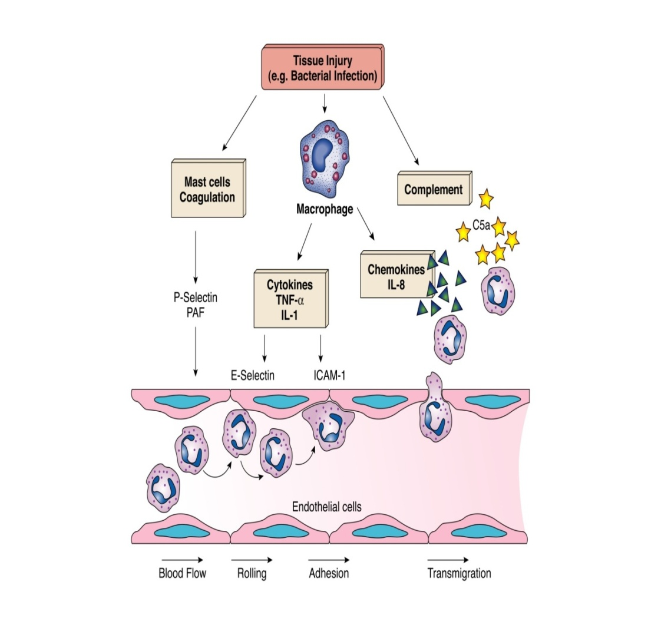
Pathogenesis of acute inflammation:
- First there is vascular dilatation and increase blood flow
This is due to vasodilators released locally (especially histamine) and autonomic impulses that relax the smooth muscles of the arteriolar wall.
- Second increase vascular permeability and decrease blood flow: this lead to the escape of exudates into the extravascular tissue. This is due to release of histamine, leukotrienes, kinines and complement products. binding of these mediators to receptors on endothelial cells lead to stimulation of contractile protein (myosin) with endothelial cell gap formation.

Fluid escapes from vessels because of endothelial cell (EC)retraction, opening up gap-junctions. The vessels which are normally involved are the post-capillary venules where the EC have high affinity receptors for histamine. Severe EC injury leads to leakiness of all vessels capillaries, venules and arterioles - giving acute local oedema, e.g. blister formation after a burn.

Exudation of protein-rich fluid (exudate) which floods the area has the following functions:
- dilutes toxins,
- allows immunoglobulins to opsonise bacteria and other injurious agents
- provides substrate (fibrinogen) for fibrin scaffold.

The above (first and second ) represent also the vascular changes or response in inflammation

- Third: Cellular Response
THERE IS ACTIVE EMIGRATION OF POLYMORPHS through vessel wall and along the chemotactic gradient to the site of injury
The sequence of events in the cellular response to inflammation includes:
  - pavementing
  - emigration
  - chemotaxis
  - phagocytosis
- Pavementing
The release of chemical mediators (i.e., histamine, leukotrienes and kinins) and cytokines affects the endothelial cells of the capillaries and causes the leukocytes to increase their expression of adhesion molecules.
As this occurs, the leukocytes slow their migration and begin to marginate, or move to and along the periphery of the blood vessels

- Emigration and chemotaxis
Emigration is a mechanism by which the leukocytes extend pseudopodia, pass through the capillary walls by ameboid movement, and migrate into the tissue spaces.
The emigration of leukocytes also may be accompanied by an escape of red blood cells.
Once they have exited the capillary, the leukocytes move through the tissue guided by secreted cytokines, bacterial and cellular debris, and complement fragments (C3a, C5a).
The process by which leukocytes migrate in response to a chemical signal is called chemotaxis.

- Chemotaxins
After extravasation from the blood , leukocytes migrate toward sites of injury under the effect of certain substances which is called chemotaxins , these substances are able to attract leukocyte toward them , these chemotaxins include:
1-bacterial products.
2-complement system particularly C5a .
3- products of lipoxygenase pathway of arachidonic acid metabolism particularly leukotrienes B4 (LTB4) .
4-Cytokines , especially these of the chemokine family .

- Phagocytosis:

is the process of engulfment and internalization of particulate material (e.g. microorganism ,damaged cells, tissue debris ) by specialized cells called phagocyte which include :polymorph neutrophil &monocyte
Phagocytosis consist of 3 steps:
1-recognition &attachment of the particle to the ingesting leukocyte and this process is facilitated by opsonins which bind specific molecules on microbial surface with a specific receptor on leukocyte. The opsonins are immunoglobulin G ( IgG) and C3b fragment of complement system .
2-Engulfment with subsequent formation of a phagocytic vacuole.
Once attached to cell membrane, the particle is engulfed by pseudopods and enclosed in a membrane bound vesicle called "phagosome" or "phagocytic vesicle".
Fusion between phagosome and lysosome leads to formation of "phagolysosome", where exposure of the particle to lysosomal enzymes occurs.
3-killing and degredation of the ingested material.microbial killing is achieved by 2 mechanisms:-
a- Oxygen independent mechanism: mediated by some of bactericidal proteolytic enzymes the already present in lysosomal granules.
b- Oxygen dependent mechanism: due to generation of oxygen free radicles H2O2 hydrogen peroxide ,O2⁻ superoxide, OH. Hydroxyl radical.
Oxygen free radicals caused damage of the cell membrane so act as a bactericidal agents.

Mediators of acute inflammation
Chemical mediators of inflammation:
They are the chemical mediators that direct the vascular and cellular events in acute inflammation.
Sources :
1- cells: neutrophils, macrophage, basophils, lymphocyte, mast cell, endothelium and platelets .
2- plasma protein.
Mediators derived from cells :
1- Vasoactive amines : histamine and serotonine
Sources ; mast cells ,basophils and plaeletes .
Effects : vasodilation and increase vascular permeability .

2-Arachidonic acid metabolites A.A
A.A is a poly unsaturated fatty acid present in large amount in cell membrane.
There are two pathways for A.A metabolism
Cell membrane phospholipids
↓phospholipase
prostaglandins←----------------- A.A ---------------------------→leukotriene
vasodilatation cycloxygenase Lipoxygenase vascular permeability

3-Cytokines:
Sources: lymphocyte and MQ .
Effects : they are important in normal immune reaction in inflammation ,healing and repair .
Tumor Necrosis Factor (TNF) and interleukine -1(IL-1) have many functions like:
a-promote adhesion between leukocyte and endothelium.
b-they induce systemic acute phase response (fever, and decrease in appetite.
3-stimulat fibroblast proliferation.
IL-8 is chemotactic factor .

4-Platelet activation factor :
Sources :neutrophils ,monocytes ,basophils ,endothelium and platelets .
Effects :
1-vasodilation.
2-increase vascular permeability .
3-induce leukocyte adhesion to endothelium.
4-chemotaxin .
5-stimulate synthesis of other mediators
Plasma mediators:
These mediators are synthesized by the liver or may be produced locally by cells at the site of inflammation , they circulate as inactive precursors that must undergo proteolytic cleavage to acquire their biological properties .
There are three systems :
1- complement system :consist of cascade of plasma proteins that play an important role in both immunity and inflammation activation of this system is done by two pathways classic and alternative pathways leading to formation of :
C3a ,C5a →anaphylatoxin (vasodialtion ,increase VP )
C5a → also chemotaxis and adhesion
C3b →opsonin .

2- kinin system : activation of this system lead to formation of bradykinin.
Effects :increase VP ,arteriolar dilation ,bronchial smooth muscle contraction and pain .
3-coagulation/fibrinolytic system .activation of this system result in thrombin activation which in turn cleaves circulating soluble fibrinogen to generate an insoluble fibrin clot.
Effects : increase VP ,leukocyte emigration and chemotaxis .

Outcome of Acute Inflammation
Resolution
Healing by fibrosis
Abscess formation
Progression to chronic inflammation
Outcome of acute inflammation :
1- resolution :complete restoration of the normal structure and function of the injured tissue .this the usual outcome when the injury is limited for short duration with minimum tissue damage and the tissue capable of replacing any irreversibly injured cells . this involves :
a- neutralization or removal of various chemical mediators
b-normalization of VP
c-cessation of leukocyte emigration with subsequent death (by apoptosis )of extravasated neutrophils

d-removal of inflammatory exudates mainly by lymphatic and small fraction is reabsorbed into venules of microcirculation and removal of fibrin by fibrinolytic system →FDP (fibrin degradation product )which removed by lymphatics and small amount is engulfed by MQ .

e-Replacement of any specialized cells lost as a result of injury .
Resolution is achieved only if the injurious agent is removed and when there has been minimal necrosis of specialized cells

2-scarring or fibrosis:-this results after:-
a-sever tissue destruction.
b-if the inflammation occurs in tissues that do not regenerate.
c- if there is extensive fibrinous exudates(due to increase VP)may not be completely removed by fibrinolytic enz. ,so fibrin which is not removed undergo a process called "organization": MQ .migrate into fibrin, followed by in growth of new capillaries and fibroblasts leading to formation of granulation tissue which will be mature into a dense fibrous tissue.
Organization of fibrin is a common sequeale to acute inflammation of serous membrane & synovial membrane

3- Suppuration (abscess formation):-it is a common sequale of acute inflammation characterized by formation of pus.
Pus:-it is a thick ,creamy ,yellowish or blood stained inflammatory exudates containing a large number of living, disintegrated &dead neutrophil in addition to micro- organisms, dead cells &tissue debris.
Usually it is due to infection by pyogenic "pus forming" bacteria like Staph.aureus&Strep.pyogens
4-Progression to chronic inflammation :
may follow acute inflammation if there is continuous tissue injury (e.g. persistence of m.o. ).
Chronic inflammation may be followed by restoration of normal structure and function or may lead to scarring.

