EXP.1
Aldol Condensation - Synthesis of Dibenzalacetone

Purpose - The objectives of this experiment are to learn aldol condensation mixture of aldehydes and ketones, which used extensively in organic synthesis to form C-C bonds and make bigger molecules.

Introduction

Like the Grignard reaction, the Aldol Condensation is an extremely useful carbon-carbon bond-forming reaction in organic chemistry. Under the reaction conditions in the experiment, two equivalents of aldehyde will react.

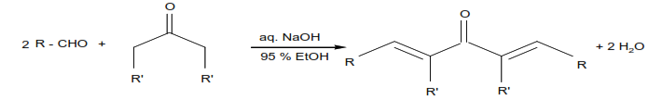

The aldol condensation is a reaction that is named based on the type of product formed when two aldehydes (or ketones), in the presence of dilute base, yields a molecule having both alcohol and aldehyde functional groups. An example of the type of base-catalyzed aldol condensation that you will perform is shown below.
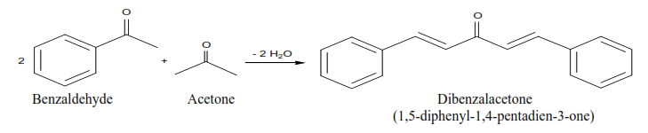

These products are a ß-hydroxyaldehyde (or a ß-hydroxyketone). This reaction is used extensively in organic synthesis to form C-C bonds and make bigger molecules. In every case, the product results from the addition of one molecule of an aldehyde (or ketone) to a second molecule in such a way that the a-carbon of the first becomes attached to the carbonyl carbon of the second.

MECHANISM OF THE ALDOL CONDENSATION

The acidity of the alpha-carbon makes beta-dehydration of aldols an easy reaction. (This is of course quite different than the chemistry of normal alcohols.) This conjugated enone synthesis is catalyzed by both acids and bases. This shows the mechanism of the experiment performed. The reaction proceeds by an aldol condensation.

Step 1:
First, an acid-base reaction. Hydroxide functions as a base and removes the acidic α-hydrogen giving the reactive enolate.

Step 2:
The nucleophilic enolate attacks the aldehyde at the electrophilic carbonyl C in a nucleophilic addition type process giving an intermediate alkoxide.

Step 3:
An acid-base reaction. The alkoxide deprotonates a water molecule creating hydroxide and the β−hydroxyaldehydes or aldol product.

MECHANISM OF THE DEHYDRATION OF AN ALDOL PRODUCT

Step 1:
First, an acid-base reaction. Hydroxide functions as a base and removes an acidic α-hydrogen giving the reactive enolate.

Step 2:
The electrons associated with the negative charge of the enolate are used to form the C=C and displace the leaving group, regenerating hydroxide giving the conjugated aldehyde.

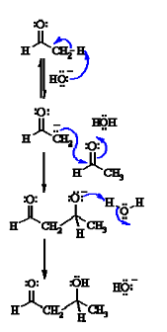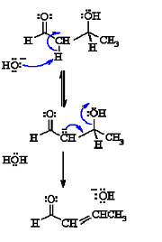
Dehydration generally occurs under slightly more vigorous conditions, such as higher temperature, than the condensation reaction. Thus at higher temperature in base the aldol reaction will go directly to the conjugated enone without any isolation of the aldol intermediate.

In the present case, the reaction—a mixed, or crossed aldol condensation involving an aromatic aldehyde—is referred to as a Claisen-Schmidt condensation. The Claisen-Schmidt condensation always involves dehydration of the product of the mixed addition to yield a product in which the double bond (produced during dehydration) is conjugated to both the aromatic ring and the carbonyl group. Because this aromatic aldehyde lacks α- hydrogens, only one product is formed, rather than a mixture of four different compounds, as long as the concentration of the second aldehyde is carefully controlled. In this experiment we will prepare the dibenzalacetone: 1,5-diphenyl-1,4-pentadien-3-one. The equilibrium is shifted toward the product because the compound precipitates from the reaction mixture as it is formed.
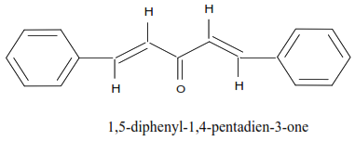
In this experiment, you will run an aldol condensation between an aldehyde and a ketone and then the product of the reaction precipitates out of solution and can be collected by filtration. The crude product is normally purified by recrystallization. Weigh your product and determine percent yield. What reactant is your percent yield based on? Determine the melting point and compare to the literature value. (Table 1)
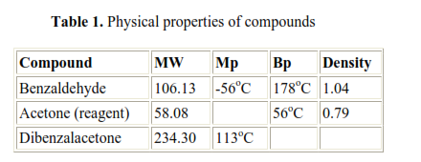
Safety Note

a) NaOH in aqueous ethanol is corrosive and particularly dangerous to the eyes. If contacted, remove with plenty of water.
b) Acetone is highly flammable.
c) Benzaldehyde is listed as moderately toxic (but contributes to the flavor of
almonds)

Experimental:

Chemicals:

Methanol, CH3OH
Acetone, CH3COCH3
10% NaOH
Benzaldehyde, C6H5-CHO
95% Ethanol, C2H5OH

Materials:

125 mL Erlenmeyer flask
25 mL graduated cylinder
thermometer
funnel
filter paper
ice bath

Procedure:

- Transfer 15mL of ethanol into a 125-mL Erlenmeyer flask and add 20mL of 10% NaOH to it. Using a thermometer, cool the solution to 20ºC.

- In a medium size tube, mix 2mL of benzaldehyde with 15 drops of acetone, and leave it at room temperature for 5 minutes. Then, add the mixture to the ethanol-NaOH solution in small portions and stir with magnetic stirrer (if available) for 30 minutes. Chill the solution in an ice-water bath. Collect the yellow crystals by suction filtration and hand-dry them by pressing them between dry paper towels.

- Determine the weight of the dibenzalacetone product, its melting point, and the percent yield. Return the product to your instructor.

