EXP.4

Cross aldol condensation
Peparation of 1-(4-methoxyphenyl)-3-phenylprop-2-en-1-one

Introduction

Aldol condensations represent an important class of carbon ‐carbon bond formation
reactions both in nature and in synthetic chemistry. Compounds called chalcones
(or chalconoids) can be prepared by the cross aldol condensation of an aromatic ketone
and an aldehyde.

In this experiment 1-(4-methoxyphenyl)-3-phenylprop-2-en-1-one, obtained through a cross aldol condensation of 4-Methoxybenzaldehyde and Acetophenone, will be synthesized in a one pot reaction.

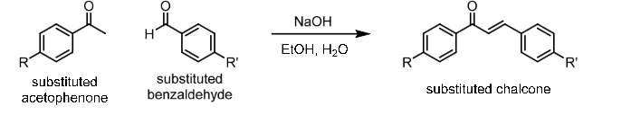

Experimental:

Chemicals:

Acetophenone
Anisaldehyde
50% NaOH
95% Ethanol, C2H5OH

Materials:

25 mL Round bottle flask
10 mL graduated cylinder
thermometer
funnel
filter paper
ice bath

Procedure

- Acetophenon (1mL) and anisaldehyde (1mL) were added to 5 mL 95%ethanol.
- Add 5 drops sodium hydroxide (50%) solution to mixture for 2 min.
- The mixture was irradiated by an ultrasonic generator in a water bath at 30-35 ºC for (25 min.) turbidity appeared in the mixture.
- Neutralized with 2N HCl. The solid product formed was filtered, washed with cold water and recrystallized by ethanol.

