EXP.3
Synthesis of p-nitroaniline from aniline based on protection/deprotection of amine group

The nitration of aniline is difficult to carry out with nitrating mixture (a mixture of cone. H₂SO₄ ,and cone. HN0₃) since —NH₂ group gets oxidized which is not required. So the amino group is first protected by acylation to form acetanilide which is then nitrated to give p-nitroacetanilide as a major product and o-nitroacetanilide as a minor product. Recrystallization from ethanol readily removes the more soluble ortho-compound and the pure p-nitroacetanilide is obtained. The chemical equation can be written as:

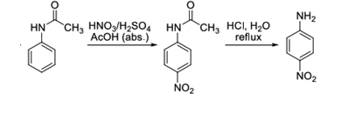
Deprotection of amine group procedure:

- In a 50 mL Erlenmeyer flask mix the moist, crude p-nitroacetanilide with 3 mL of water and 4 mL of concentrated hydrochloric acid. Reflux the mixture gently for 15–20 minutes. The material gradually dissolves and an orange-colored solution is formed.
- When the hydrolysis is completed add 6 mL of cold water and cool the mixture to room temperature. Crystals of the product may separate.
- Pour the p-nitroaniline hydrochloride slowly, stirring thoroughly, into a mixture of 4 mL of concentrated aqueous ammonia, 15 mL of water, and 5–6 g of chipped ice. The mixture must be distinctly alkaline at the time of the mixing; test with indicator papers, and add a little more ammonia if necessary.
- Collect the orange-yellow precipitate of p-nitroaniline with suction and wash it with cold water. Recrystallize the product from a large volume of hot water; about 30 mL of water will be required per gram of material.
- The yield is 0.5–0.8 g. Prepare a sample of the purified product.

