CONTENTS

page

Section 1

The SCOPE OF PHARMACOGNOSY …………………………….…….….. 2

Section 2

MICROSCOPICAL IDENTIFICATION OF CRUDE DRUGS AND CELL CONTENTS

1. Organised drugs ………………………………………………….. 13
2. Non-organised drugs……..……………………………….……… 13
3. Cell differentiation………………………………………...……... 13
4. Microscopic slides……………………………..…………..….….. 19
5. Cell contents ………………………………………………..…...…22
6. Microscopic slides ………………………..….……….……….…..23

Section 3

EXTRACTION METHODS

1. Cold methods ………………………………………….………………….…..…26

2. Hot methods …………………………..……..…………………..….27

Section 4

CHROMATOGRAPHY

1. Introduction …………………………………………………30
2. Definition ………………………………...…………………30
3. Classification …………………………...…………………..31

Section 5

PAPER CHROMATOGRAPH Y

Introduction …………………………………………………………………32

1. Detection methods …………………………………………..32
2. Experiment no. 1 (Circular filter paper chromatography) …33
3. Experiment no.2 (Paper chromatography for the separation of natural products)……………………………………………………….. .34

Section 6

THIN LAYER CHROMATOGRAPHY

Introduction ………………………………………………………….…………..36

1. Preparing TLC plates ……………………….…………..….……….36
2. Advantages of TLC over PC ……………………….……….36
3. Development technique ………………………..…….……………..37
4. Detection methods………………………….………………. 37
5. Experiment no.3 (TLC on microscopic slides) ……………….38
6. Experiment no.4 (Effect of solvent polarity up on Revalues of alkaloids) ………………………………………………………………..41

Section 7

SEPARATION OF A MIXTURE OF DYES USING COLUMN CHROMATOGRAPHY Introduction ………………………..……….….43

1. Mechanism of separation in column chromatography …....43
2. Packing of column ………………………………………………....44
3. Detection methods ……..………………………………….44

Section 8

QUIZ QUESTIONS …………………………………………………………45

**The SCOPE OF PHARMACOGNOSY**

* The word **Pharmacognosy** formed from two Greek words , pharmakon which means drug and gnosis which means acquire knowledge.
* **Pharmacognosy** covering all information on medicine from natural sources (plants, animals, and microorganisms)
* **Pharmacognosy** is closely related to both botany and plant chemistry.
* The classification of drugs for study: vegetable drugs are usually arranged for study in one or other of the following five ways:

1- **Alphabetical**: using either Latin or English names

2- **Taxonomic**: families, genera and species

3**- Morphological**: either organized drugs (leaves, flowers, seed, herbs……..etc) or unorganized (extracts, gums, resins, oils …etc.)

4- **Pharmacological or therapeutic uses**

5- **Chemical** e.g. alkaloids, glycosides, volatile oils ……etc.

There are a number of cards or sheets you have to recognize the botanical name; family name local name part used active compound, basic structure, dosage form and therapeutic use.

1- **Cinchona**

* Botanical name**: *Cinchona succirubra***
* Family name: Rubiaceae
* Local name: الكنينة
* Active compound: Alkaloid quinine



Basic structure :

* Dosage form: tablets
* Therapeutic use: malaria

**2-DIGITALIS**

* Botanical name: ***Digitalis lanata***
* Family name: Scrophulariaceae
* Part used: Dried leaves
* Local name: زهرة الكشتبان Active compound : Cardio tonic glycoside
* Basic structure :



Digoxin

* Dosage form: tab., drops, injection.
* Therapeutic use:cardio tonic glycoside (increase the tone of heart muscle)

**3- FENNEL**

* Botanical name: ***Foeniculum vulgarae***
* Family name: Umbelliferae
* Part used: Fruit, seeds
* Local name: حبة حلوة
* Active compound: Volatile oil
* Basic structure :



* Dosage form: syrup
* Therapeutic use: Flavoring agent and carminative

**4- BLACK PEPPER**

* Botanical name: ***Piper nigrum***
* Family name: Piperaceae
* Part used: unripe fruit
* Local name: الفلفل الاسود
* Active compound: Volatile oil
* Basic structure :



* Dosage form: powder, ointment
* Therapeutic use: stimulant, irritation and febrifuge

**5- GLYCYRRHIZA**

* Botanical name: ***Glycyrrhiza glabra***Family name: Leguminosae
* Part used: ROOT
* Local name: السوس
* Active compound: saponin glycoside (glycyrrhizin)
* Basic structure :



* Therapeutic use: demulcent, expectorant, laxative

**6-COFFEE**

* Botanical name: ***Coffea arabica***
* Family name: Rubiaceae
* Part used: coffee seeds
* Local name : القهوة
* Active compound: caffeine
* Basic structure :



* Therapeutic use: CNS stimulant

**7- Cinnamon**

* Botanical name: ***Cinnamonum zeylanicum***
* Family name: Lauraceae
* Part used: bark
* Local name: الدارسين
* Active compound: aldehyde Volatile oil
* Basic structure :



* Dosage form: solution and ointment
* Therapeutic use: carminative

**8- SENNA**

* Botanical name: ***Cassia acutifolia***
* Family name: leguminosae
* Part used: leaf and pods
* Local name: السنا مكي
* Active compound: Anthraquinone glycoside
* Basic structure :



* Dosage form: tablet
* Therapeutic use: cathartic or laxative

**9- Cascara**

* Botanical name: ***Cascara sagrada***
* Family name: Rhamnaceae
* Part use: bark
* Active compound: Anthraquinone glycoside
* Basic structure :



* Dosage form: liquid extract, tab.
* Therapeutic use: laxative

**10-Papaver**

* Botanical name: ***Papaver somniferum***
* Family name: Papaveraceae
* Part used: ripe capsules
* Local name: الخشخاش
* Active compound: alkaloid e.g. morphine, papaverine, codeine
* Basic structure :



* Dosage form: tab, syrup.
* Therapeutic use: narcotic, analgesic, antitussive and antispasmodic

**11-Ephedra**

* Botanical name: ***Ephedra sinica***
* Family name: Gentaceae
* Part used: entire plant or overgrown portion
* Local name: عل الند
* Active compound: alkaloidal amine
* Basic structure :



* Dosage form: cap., Inj., Tab. And syrup
* Therapeutic use: bronchodilator, mydriatic

**12-MENTHA**

* Botanical name: ***Mentha piperita***
* Family name: Labiatae
* Part used: leaves
* Local name: النعناع
* Active compound: Volatile oil
* Basic structure :



* Dosage form: ointment, syrup.
* Therapeutic use: flavor, carminative, counter irritant

**13-CARAWAY**

* Botanical name: ***Carum carvi***
* Family name: Umbelliferae
* Part used: Fruit
* Local name: كراوية
* Active compound: Volatile oil
* Basic structure :



* Dosage form: solution
* Therapeutic use: carminative, antacids, digestive, antispasmodic

**14-Belladonna**

* Botanical name: ***Atropa belladonna***
* Family name: Solanaceae
* Part used: leaves
* Local name: ست الحسن
* Active compound: atropine, hyosine, hyoscyamine
* Basic structure :



* Dosage form: tab., Inj., drops, syrup.
* Therapeutic use: antispasmodic, mydriatic

**15-ERGOT**

* Scientific name: ***Claviceps purpurea***
* Family name: Claviceptaceae
* Part used: dried sclerotium
* Local name: المهماز
* Active compound: indole alkaloid
* Basic structure :



* Dosage form: tab., Inj.
* Therapeutic use: oxytocic, migraine treatment

**16- RAUWOLFIA**

* Botanical name: ***Rauwolfia serpentine***
* Family name: Apocynaceae
* Part used: ROOT
* Local name: راؤلفية
* Active compound: indole alkaloid
* Basic structure :



Reserpine

* Dosage form: tab.
* Therapeutic use: hypotensive, sedative

**17- HAMAMELIS (WILCH HAZEL)**

* Botanical name: ***Hamamelis virginiana***
* Family name: Hamamelidaceae
* Part used: leaves
* Active compound: tannins
* Basic structure :



* Dosage form: decoction or infusion
* Therapeutic use: astringent, homeostatic

**18- NUX VOMICA**

* Botanical name: ***Strychnos nuxvomica***
* Family name: Loganiaceae
* Part used: dried ripe seed
* Local name: جوز القيء
* Active compound: alkaloid (strychnine and brucine)
* Basic structure :



* Therapeutic use: central stimulant in physiology and neuroanatomical research

References:

1. Trase and Evans pharmacognosy .
2. Tyler pharmacobiotechnology and pharmacognosy.
3. Atlas .

MICROSCOPIGAL IDENTIFICATION OF CRUDE DRUGS AND CELL CONTENTS

For convenience of study , drugs may be arranged not only according to families and chemical constituents but into morphological groups as barks , roots , leaves, seeds or in another word drugs can be arranged into organized and non organized drugs .

A. ORGANISED DRUGS.

1) Leaves and tops (herbs)

May include leaves, flowers, and fruits.

2) Barks

All tissues outside the cambium from trunks, branches, or roots.

3) Woods

Secondary tissues produced by the cambium or it's inner surface.

4) Leaves or leaflets.

5) Inflorescence and flowers.

6) Fruits.

7) Seeds.

B. NON ORGANISED DRUGS

These includes: fixed oils, fats, waxes, volatile oil resins , oleoresins, oleogumresins, balsams, and gums, dried juices, lattices, extracts.

CELL DIFFERENTIATION

* The cell wall
* Parenchymatous tissue
* The epidermis
* Epidermal trichomes
* The endodermis
* Cork tissue
* Collenchyma
* Sclereids
* Fibers
* xylem .
* secretory tissue

(1) The cell wall

There are different types of cell wall :

1. Cellulose wall
2. Lignified wall
3. Chitinom wall
4. cutinized wall
5. Mucilaginum wall

(2) Parenchymatous tissue

(3) The epidermis

Single layer of cells covering the whole plant, the structure of the epidermis and stomata are of first important in the microscopically identification of leaves .e.g.

Straight-walled epidermis in senna leaves

Waxy walled in belladonna leaves

Beaded wall in digitalis

**Types of stomata**

1- **Anomocytic stomata**: cells resembling the other epidermal cells may surround stomata for example: Digitalis purpurea leaves.

2- **Anisocytic stomata**: with the stomata surrounded by 3or4 subsidiary cells one of which is markedly smaller than the other. For example: Hyoscymus niger and Atropa belladonna leaves.

3- **Paracytic stomata**: with 2 subsidiary cells with their long axis parallel to the pore for example: senna leaves

4- **Diacytic stomata**: with 2 subsidiary cells with their long axis at right angles to the pore of the stomata for example: Mentha piperita

5- **Actinocytic stomata**: subsidiary cells are arranged along the radii of the circle for example: Pilocarpus jaborandi leaves.

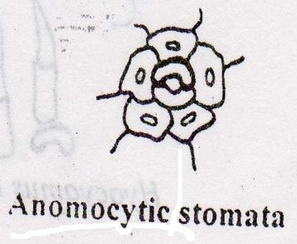 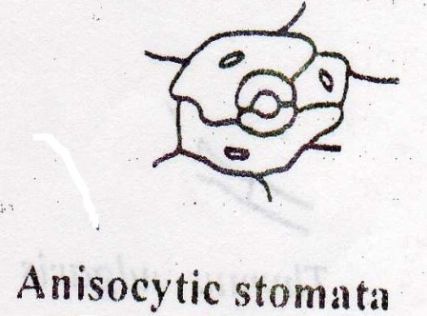

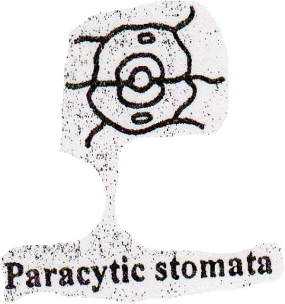 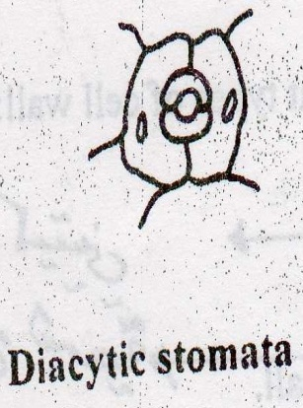 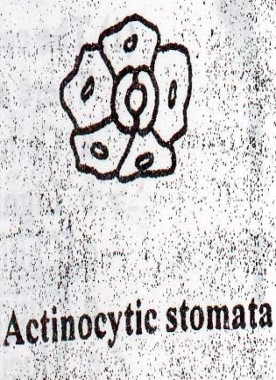

**Epidermal Trichomes**

Most leaves, stems, flowers, fruits and seeds possess Trichomes of one kind or another. Many show hairs of more than one type.

Hairs may be grouped into::

* Non glandular or clothing hairs.

a. Unicellular.

b. Multicellular .

* Glandular hairs.

Unicellular hairs vary from small papillose outgrowth to large robust structure e.g. Senna leaf.

Multicellular hairs may be Uni.-, Bi-, or multlseriate or complicated branch  
structures, e.g. Pyrethrum flowers and Hamamelis leaf

Glandular cells may have unicellular or multiseriate stalk and the glandular he may be unicellular or multicellular.

* Multicellular uniseriate clothing hairs

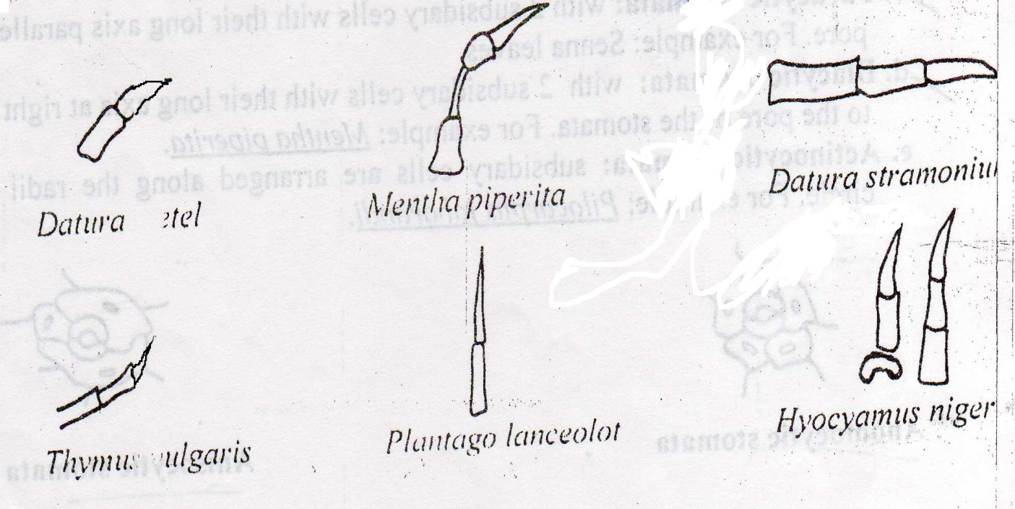

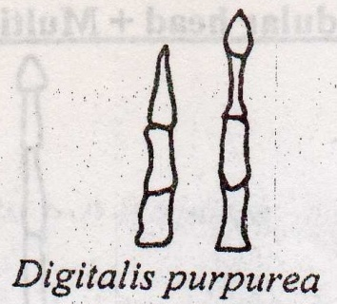

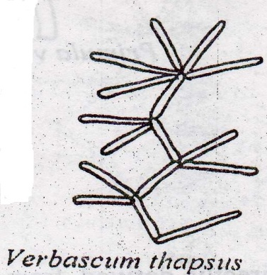

* Multicellular branched hair

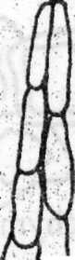

* Biseriate hair
* Glandular hairs

Multicellular glandular head

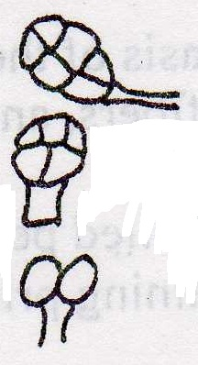

Atropa belladonna

Datura stramomium

Digitalis purpurea

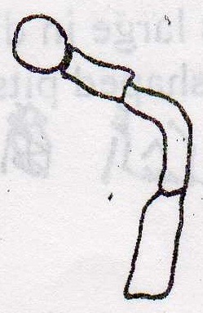

Multicellular stalk

Multicellular glandular head + Multicellular stalk

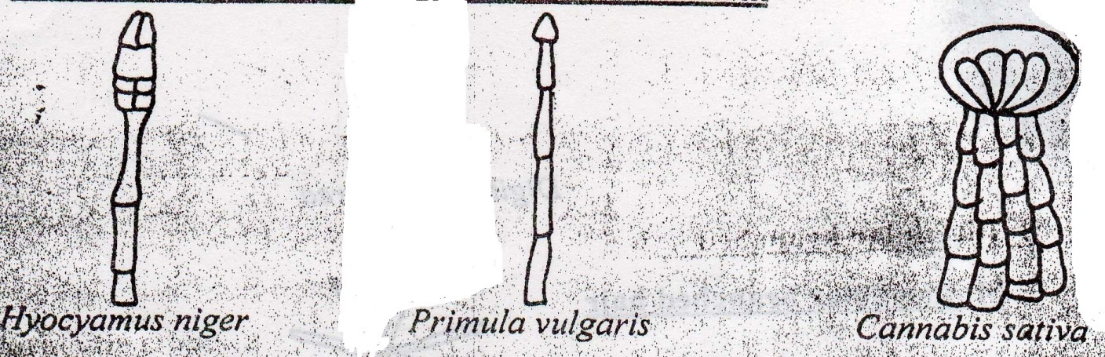

(5) Соrк tissue

(6) Collenchyma

living tissue directly derived from the parenchyma but have greater mechanical Strength. The walls are thickened by cellulose laid down in longitudinal strips, e.g. Digitalis purpurea**.**

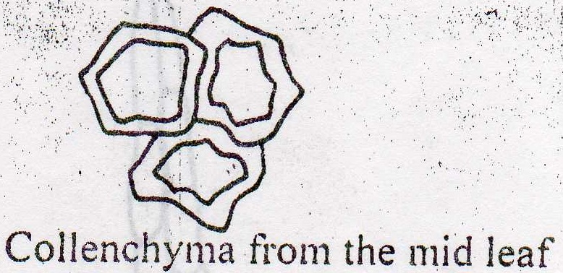

(7) Fibers

Tissue composed of spindle-shaped or elongated cells with pointed ends and thick walled. The cell wall may be composed of cellulose, liginification or sclerotic or scierenchymatous fibers. Most mature fibers are unicellular, but occasionally transverse septa develop, e.g. ginger.

Fibers are best differentiated on the basis of the tissue in which they occur, e.g. cortical fibers , pericyclic fibers , xylem fibers , and phloem fibers.

Lignified fibers are moderately thick walled pericyclic fibers, accompanied by a parenchymatous sheath of cells containing prisms of calcium oxalate, e.g. Senna leaf.

Phloem fibers occur isolated or in irregular rows in the barks of Cinnamon, Cassia and Cinchona. Cinchona fibers large in diameter , fusiform in shape, thick walls striated and traversed by funnel shaped pits.

(8) Xylem

Elongated water-conducting cell with Lignified and thickened-pitted cell wall.

(9)Vessels

Is the fundamental conducting elements of the xylem of the angiosperms . There are different types of vessels:

1. Spiral(senna and Belladonna)
2. Annular (Senna and Belladonna)
3. Reticulate (Gentian, Ginger, Rhubarb)
4. Pitted vessels

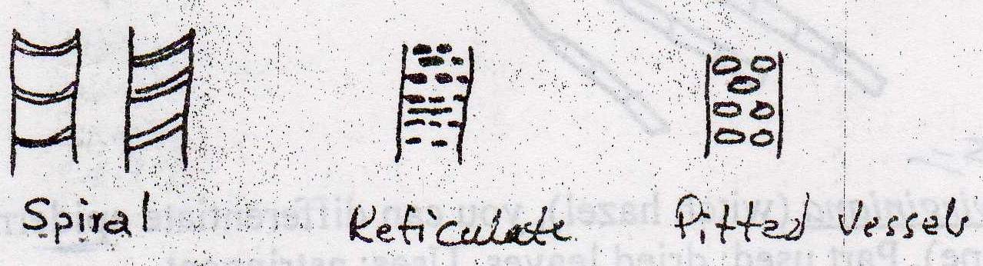

Microscopic slides

Slide no.l Zingiber officinale (Ginger), you can differentiate fibers, starch, and vessels. Part used: rhizome. Uses: carminative and stimulant.

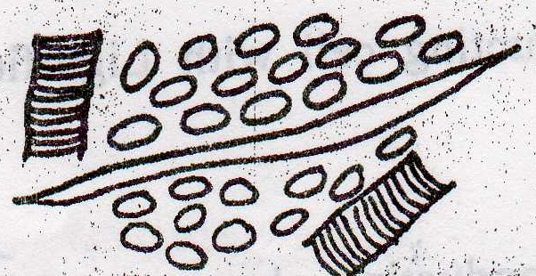

Slide no.2 Digitalis purpurea or Digitalis lanata of the fam. **Scrophullariaceae,** you can differentiate multicellular epidermal trichomes. Part used; leaves. Uses: cardiotonic glycoside.

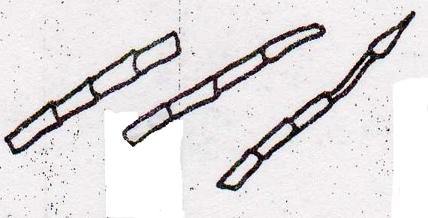

Slide no.3 Hamamelis virginiana (witch hazel), you can differentiate epidermal trichomes (stellate in shape). Part used: dried leaves. Uses: astringent.

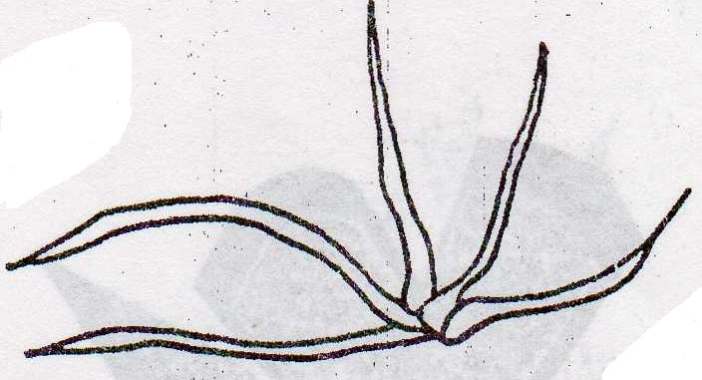

Slide no.4 Chrysanthemum cinerariaefolium (Pyrethrum), you can differentiate t-shape epidermal trichomes . Part used: dried flowers. Uses: insect flowers are a contact poison for insects and used in the form of powders, sprays, and shampoos,

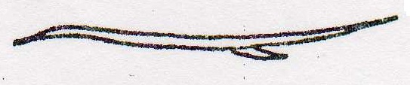

Slide no.5 Cassia angustifolia (Senna), you can differentiate a unicellular epidermal trichomes. Part used: dried leaflets. Uses: stimulant laxative

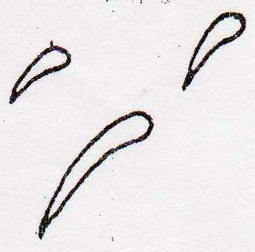

Slide no.6 Cinchona succirubra. you can differentiate the fibers.

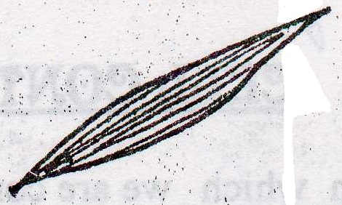

Slide no.7 Grass, you can differentiate paracytic stomata

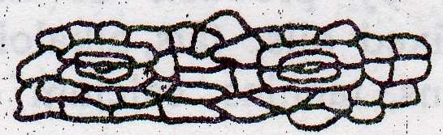

Slide no.8 Aloe , уou can differentiate anomocytic stomata.

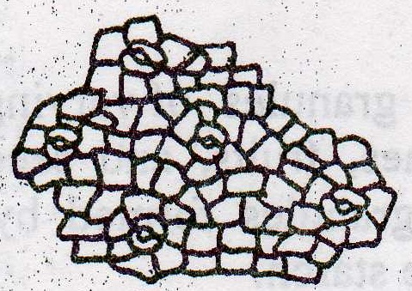

Slide no.9 Aloe, youcan differentiate anisocytic stomata.

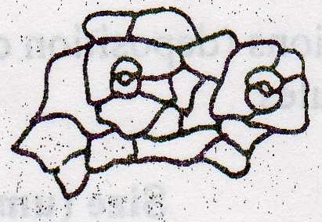

Slide no.10 Mentha piperita , you can differentiate diacytic stomata.

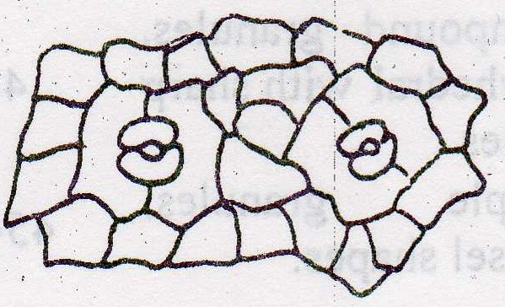

***Cell Contents***

Cell contents with which we are concerned in Pharmacognosy are those which can be identified in vegetable drug by microscopic examination or by chemical and physical tests. These cell contents represent either food storage products e.g. starch or by products of metabolism and these include carbohydrates , protein , fix oil , fats , alkaloids , glycosides , purines , volatile oil , gums , mucilage , tannins , calcium oxalate, calcium carbonate , and silica.

STARCH

Starch occurs in granules of varying size in almost all organs of plants, found in roots, fruits, rhizomes and seeds. Starch granules may simple or compound, compound granules formed by aggregation of a large numbers of simple granules, e.g. rice starch

**Hilum**: is the starting point of formation of starch granules, the position of the Hilum either central or eccentric. There are different shapes of Hilum (dot, curved, multiple clefts).

**Concentric rings or striations**: (deposition of successive layers around the Hilum) also appear in starch granules.

|  |  |  |
| --- | --- | --- |
| Hilum | Shape | Type of starch |
| Central triangles or 2-5 satellite cleft without striation | Simple, polyhedral or sub spherical | Maize starch |
| Central point without striations | Compound granules, polyhedral with sharp angles | Rice starch |
| Point, eccentric with well marked striations | Simple granules, mussel shapes | Potato starch |

***Calcium oxalate***

Calcium oxalate is a dimorphous salt and both types occur in plants , these are tetragonal or monoclinic system , these both types differ in the amount of water of crystallization

* Tetragonal system (CaC2O4.3H2O)

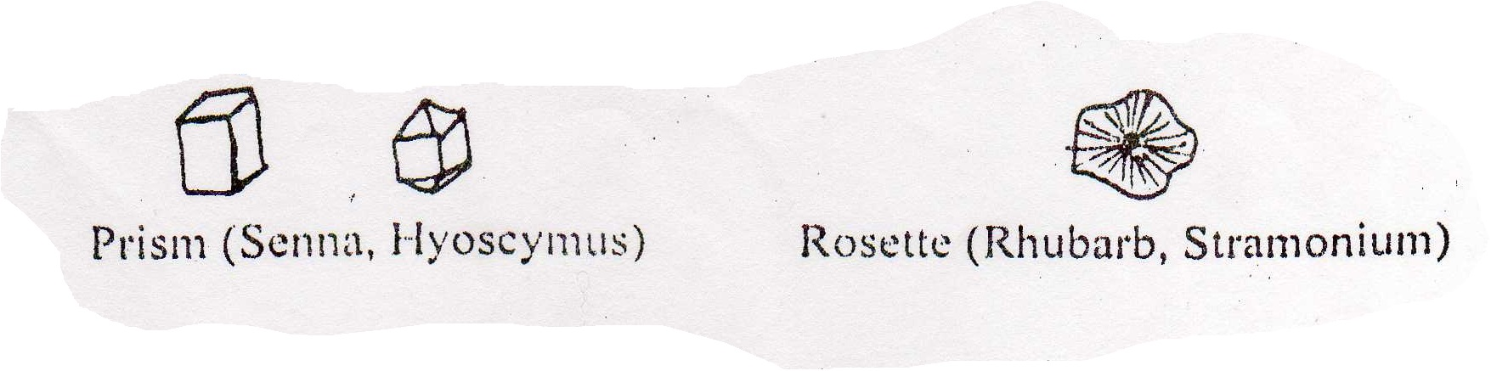

* Monoclinic system (CaC2O4.H2O)

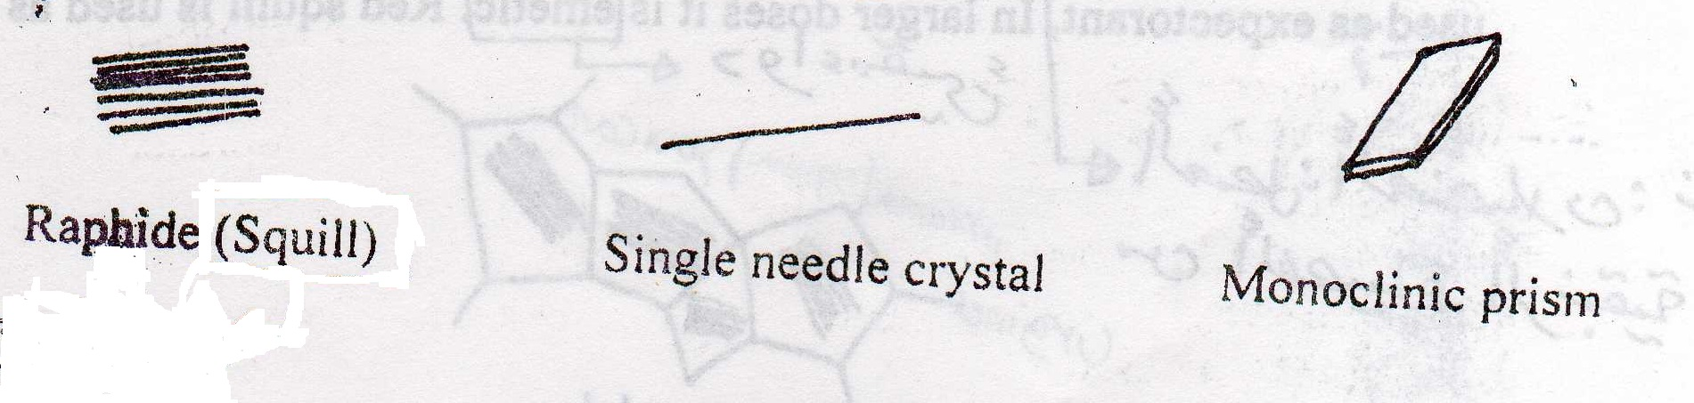

Microscopic slides

**Slide no. 1** potato starch (Solanum tuberosum) .you has to differentiate the size, shape, Hilum , striations and aggregation

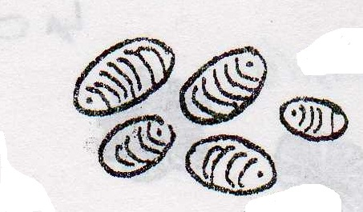

**Slide no. 2** Maize starch ( Zea mays )

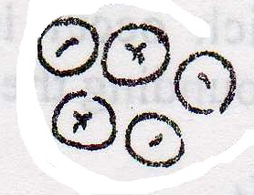

**Slide no. 3** Rice starch

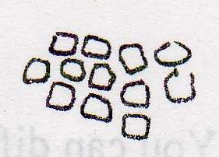

**Slide no. 4** potato starch and Iodine the later will stain the potato starch granules with dark blue color.

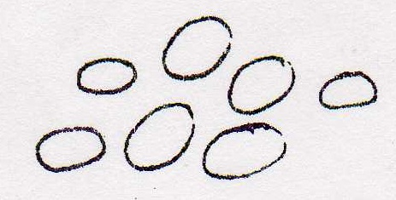

Slide no.5 Urginea maruma (squill) You can differentiate large poly many of which contain mucilage surrounding a bundle of many raphides of calcium oxalate . squill has a digitalis-like action onthe heart and in small doses used as expectorant. In larger doses it is emetic , Red squill is used as rat poison.

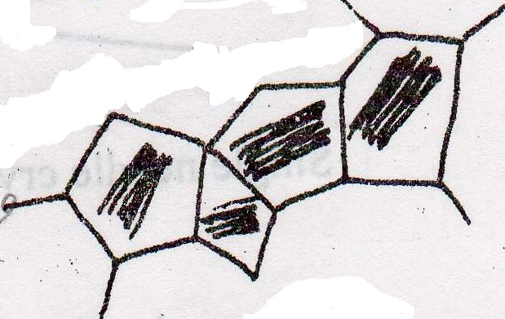

Slide no.6 Rheum palma turn (Rhubarb). Part used: rhizomes. You can differentiate rosette shape calcium oxalate crystals. Rhubarb is used as a bitter stomachic and the treatment of diarrhea, purgation being followed by an astringent effect.

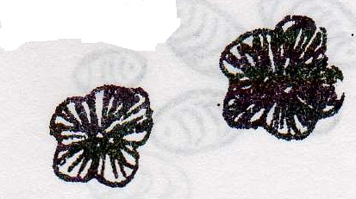

Slide no.7 Rhumnus purshiana (Cascara). Part used: dried bark. You can differentiate calcium oxalate crystals, which occur in monoclinic prisms and clusters. The prisms in crystal sheath surrounding the groups of stone cells and fibers**.**

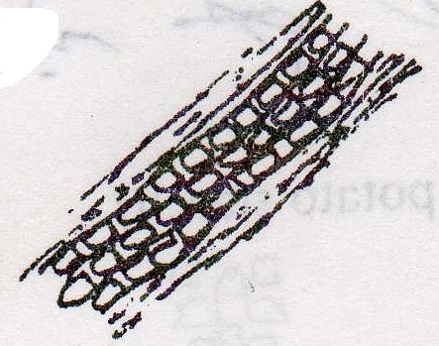

Slide no.8 Piper cubeba (Fructus cubebae). You can differentiate stone cells, which occur as a horse shoe shape.

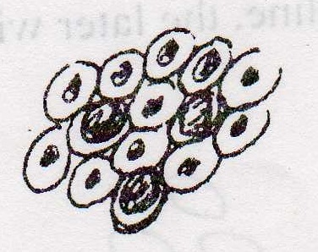

**Extraction Methods**

Extraction involves the separation of the medicinally active constituent of plants or animal tissues from the inactive or inert component by using solvent(s) and by using one of the standard extraction procedures

The products that obtained from plants are relatively impure liquids, semisolid or powders, intended only for oral or external use. These total extractive products are called Galenical, which came from the name Galen, the 2nd century Greek physician.

Methods of extraction can be divided into:

**Cold methods.**

**Hot methods.**

**Cold methods**

1-Maceration

Which include soaking of plant material with the solvent until penetration of cellular structures and the active constituent softened and dissolved in the solvent? The procedure include placing the plant material in a container and adding the solvent, cover the container and leave it for a time which differ from 2-4 days. After that pouring off the solvent, expressing the plant material and filter the solvent, the procedure carried out at room temperature (15-25) .due to the difficulty to get the active constituent in one maceration process, the procedure may be repeated many times and the solvent obtained then mixed together.

The solvent used in extraction is usually depend on the active constituent e.g. alkaloids and glycosides, by using alcohol and water in different proportion. Water is used because if the alkaloids present in a salt form, they will dissolve in water

Non-polar solvent like chloroform are used for the extraction of volatile oil and terpenes

Advantages:

1- Can be used for heat sensitive substances.

2- Easy and cheap.

Disadvantages:

1- Take a long time.

2- Non efficient.

3- Extract small quantities.

2**- Perculation**

In this method we are going to use a special apparatus which called perculator. The perculator has a porous diaphragm at the bottom. The procedure includes placing the powder plant material in the perculator and start adding the solvent from the upper end. While the solvent going downward to extract as much as possible the active constituent, then passing through the diaphragm. The plant material is much better to be soaked by the solvent about 1/2 hr. before starting the procedure.

The solvent used depends on the active constituent. The solvent called menstrum and the extract we get it called perculate and the plant material left is called mark material.

Advantages:

1- We can use different types of solvents with different polarities to extract the active constituent.

2- used for heat sensitive substances.

3- Easy and cheap.

Disadvantages:

1- Large quantity of solvent is used

2- Take along time.

3- Extracts small quantities and inefficient.

**Hot methods**

1- Infusion

In this method we have special container called infusion pot. This method also used for the extraction of volatile oil. The procedure involve placing the plant material in the infusion pot then we add the solvent which is boiling water and cover with heavy lid which contain sieves, after the addition of the solvent, left for awhile for the extraction of active constituent during that time the volatile oil evaporated with steam and deposited on the lid and condenses on the lid after that we take the solvent which contain the active constituent.

2- Decoction

In this method we place the powdered plant material in a container then add the solvent and place the container on the source of heat or direct flame then agitating until the active constituent will be dissolve in the solvent. This method is usually used for hard plant material like barks, stems and roots which contain a lot of fibers. Here the solvent used depend on the active constituent and source of heat e.g. chloroform and ether can't be used because we use a direct source of heat. In addition to that the active constituent should be heat stable

3- Digestion

In this method the plant materials is placed together with the solvent and by application of gentle heat, so that the solvent will increase its power for extraction and this method is used in cases were moderately elevated temperature is required.

4- Continuous hot extraction methods.

a) Ordinary reflux condenser.

We place the plant material in round bottom flask with solvent and the round bottom flask is surrounded by a source of heat. The round bottom flask is attached to a condenser. We start to heat the flask and when the solvent reach its boiling point it will evaporate to the condenser were it condenses a return back to the flask.

Advantages:

1- Small amount of solvent is used.

2- Used for toxic reagent, which cannot be used in open-air system?

3- Continuous extraction method (good extraction)

b) Soxhlet apparatus

Soxhlet consist of a round bottom flask, extracting chamber, condenser, and a thimble containing the powder plant material.

When a solvent starts to boil it will evaporate to the condenser and dropped down to a porous paper (thimble )which contain the plant material, the solvent then will extract some of the active constituent and then it will go back to the round bottom flask through a siphon tube.

Advantages:

1- We use a small amount of solvent

2- It is a closed apparatus so that it is used for dangerous organic solvents.

3- It can be used for the extraction of different active constituent by changing the polarity of the solvent.

4- It can be used for the extraction of active constituent decomposed by direct heat.

**A comparison between ordinary reflux and Soxhlet**

|  |  |
| --- | --- |
| **Soxhlet** | **Reflux** |
| Consisting from round bottom flask connected with extracting chamber containing thimble and the extracting chamber connected to a condenser. | Consisting from round bottom flask directly connected to a condenser. |
| The plant material is placed in the thimble separated from the solvent. | The plant material is placed together with the solvent in the round bottom flask. |
| The extract not requires filtration | The extract requires filtration |
| The plant material is not directly exposed to heat | The plant material is directly exposed to the heat |

5-Distillation

In this method we use a special apparatus which is called Clavenger it is used mainly for the extraction of volatile compound, e.g. orange peels has been used for the extraction of orange oil (sp.gr.>water) and clove has been used for the extraction of clove oil (sp.gr.<water).

Chromatography

**Introduction**

Chromatography means color writing it is used in many scientific fields, used in many subjects and applied in all analytical fields. Tswett originated this term in 1903, this scientist separated plant pigment on column of CaCo3 of solid adsorbent, then pass on solvent ( petroleum ether) tried to wash pigment. Then many rings or spots are separated into many different colors so the name came from this.

**Definition**

Chromatography is a method of analysis and separation technique of organic and inorganic compound. It is increasingly important for the evaluation of drugs and it is used for large and small quantities so it is used quantitatively and qualitatively and proved to be more effective from the other means of separation and identification.

The separation of mixture of compound in chromatography to it is components depend on the action of two forces:

1) Mobile force (driving force) that will try to move the components of mixture.

2) Opposing force (stationary or retardation force) that will try to keep components in it is place depending on many factors:

a) Solubility in mobile phase.

b) Adsorption ability of component to be separated.

c) Ionic forces.

**There are several important terms in chromatography:**

1) Stationary phase: also called column, adsorbent, bed, sorbent, opposing force, and retardation force.

2) Mobile phase: also called solvent, effluent, and eluent

3) Chromatographic system: means the whole conditions of chromatography e.g. stationary phase, mobile phase, temperature, dimension, method of detection…..etc.

4) Developing: means separating mechanism (addition of mobile phase that cause separation).

5) Chromatogram: the result of the separation procedure.

**The main uses of chromatography:**

1) Analytical procedures.

2) Scientific research.

3) Purification.

**Classification**:

There are different types of chromatography:

A) **According to mobile phase** (modern type of classification)

1) Liquid chromatography.

2) Gas chromatography.

**B) According to the mechanism of separation** (classical type)

1) Adsorption chromatography.

2) Partition chromatography.

3) ion-exchange chromatography.

4) Gel filtration

5) Affinity chromatography.

6) Electrophoresis

**PAPER CHROMATOGRAPHY**

In this case the stationary phase is solid stationary phase (cellulose paper) composed from cellulose which is a carbohydrate consists of about 1000 molecules of anhydrous glucose units connected by oxygen groups forming several chains, these chains links with each other forming cellulose net work.

The mobile phase either single liquid or mixture of liquids and the mechanism of separation depending mainly on partition in which the stationary phase is the hydration shell of cellulose fibers.

The separation of component of a mixture in partition chromatography dependent on differences in partition coefficient of the component between an aqueous and an immiscible organic liquid, the aqueous phase is usually the stationary phase. Strips of filter paper is used and as the solvent moves the component also move along the paper at varying rates, depending mainly on the differences in their partition coefficient between the aqueous and organic phase.

The paper may either be dipped in the solvent mixture so that the solvent front travels up the paper (ascending technique) or the trough of solvent may be supported At the top of the chamber in this case the solvent travels down the paper (descending technique)

Circular or Horizontal paper chromatography is another technique used, in which circular filter paper bearing a wick at the center of the paper is placed in a Petri dish and the solvent system supplementation is through the center wick. There is another technique, which is called two-dimensional technique.

Retardation factor can be defined as the distance moved or traveled by the compound to the distance moved by the solvent and it is constant for each compound when chromatography is carried out using the same technique, mobile phase, and the same conditions. Usually the Rf value is used for the identification of the separated compound by comparison with the Rf value of a standard. **The Rf value is going to change if we:**

**1) Change the solvent.**

**2) Aging.**

**3) Impurities.**

**4) Temperature.**

**5) Saturation.**

**6) Solvent front must be uniform.**

**DETECTION METHODS IN PAPER CHROMATOGRAPHY**

1) Chemical detection by using chemical reagents

2) Physical detection by using UV light.

3) Radioactive method: specific detection procedures when use to detect separated compound having some radioactivity or labeled compounds.

4) Biological methods by using certain microorganisms and are especially used for the detection of antibiotics.

**EXPERIMENT NO. 1**

**Circular filter paper chromatography**

**(Horizontal paper chromatography)**

**Method:**

1) Prepare a circular filter paper and insert a wick in the center of the paper.

Mark four pencil dots (starting points) approximately 1cm from the wick.

2) Apply the sample on pencil dot (3different magic colors and ink).

3) Place a chromatographic paper over the dish that contains the mobile phase in such a way that develops to about 4-5 cm

4) Remove the chromatogram, make the solvent front and dry at room temperature.

5) Examine the chromatogram by the daylight and calculate the Rf value for each separated spot.

6) Make full report.

NOTE: mobile phase is prepared by shaking n-butanol, acetic acid, and water (4:1:5) for 3 min. in a separatory funnel and collect the upper phase.

**EXPERIMENT NO.2**

**PAPER CHROMATOGRAPHY FOR THE SEPARATION OF NATURAL PRODUCTS**

METHOD:

Separation of a mixture of natural products (leucine and cysteine) uses ascending paper and their identification.

Technique: one way ascending.

Paper: whatman no.1.

Mobile phase (solvent): n- butanol: glacial acetic acid: water (4:1:5)

Temperature: at lab. Temperature.

Reference solution: 0.5% leucine and 1% cysteine in 10% aqueous isopropanol.





Examination: daylight after spraying and heating.

Spray: 0.1% Ninhydrin in n-butanol.

Requirement: calculate Rf values, note all colors and tabulate the results.

What conclusion may be drawn from these results?

The extracts provided contains amino acids, which are the building blocks for proteins and alkaloids, and which are readily separated by paper chromatography.

Note that amino acids and the spray reagent may produce different colors.

Draw the chemical reaction between Ninhydrin and amino acids.

+  

 +  + NH3 + CO2

Ninhydrin oxidation decarboxylate amino acids to CO2 and NH3 and an aldehyde with less carbon atom than the parent amino acids and reacted ninhydrin the react with liberated ammonia forming blue complex.

Note: cysteine is freely soluble in water, slightly soluble in alcohol, practically insoluble in either .while leucine sparingly soluble in water practically insoluble in alcohol and in either, it dissolves in dilute mineral acids and in dilute solutions of alkali hydroxide.

**ADSORPTION CHROMATOGRAPHY**

**It is a method of separati**ng and isolation plant constituent. The chromatographic procedure originated by Tswett, the idea originated from the fact that charcoal is used to decolorize and clarify solution; colored impurities are adsorbed by the charcoal and a colorless solution result after filtration.

All finely divided solids have the power to adsorb other sub stances on their surfaces to a greater or lesser extent. Similarly all substances are capable of being adsorbed; some much more readily than others are this phenomenon of selective adsorption is the fundamental principle of thin layer chromatography.

**THIN- LAYER- CHROMATOGRAPHY (T.L.C)**

**PREPARING T.L.C PLATES**

1) Preparing on a suitable glass plate, a thin layer of an adsorbent is placed over the glass plate by either dipping or spreading.

2) The mixture to be resolved is dissolved in a suitable solvent place as a series of spots on the film towards one end of the plate.

3) This end is then dipped in a suitable solvent mixture, enclosed in an airtight container

The solvent front travel up the film and a suitable time the plate is removed, the solvent front marked the solvent allowed evaporating and the position of the separated compounds determined by suitable means.

**ADVANTAGES OF TLC OVER PC**

1) Fractionations can be effected more rapidly with smaller quantities of a mixture.

2) The separated spots are usually more compact and clearly identified from one another.

3) The nature of the film is often such that drastic reagents such as H2SO4 which would destroy a paper chromatogram can be used for the location of separated substances.

The grain size of most TLC adsorbent lie between 5-50 µm. there are different types of adsorbents that have been used in TLC.

**SILICA GEL**

Silica gel is amorphous porous substances formed from polysilicic gel.

 +  + H2O

Monosilicic acid polymerization Di- or higher polysilicic acid



**ALUMINA**

Oxides used in chromatography containing either – AL2O3 or X AL2O3

**KIESELGUHR**

Naturally occurring amorphous silicic acid of fossil origin referred to as diatomaceous earth. It has a lot of impurities, water, and organic substances consist of small only slightly active surface and relatively large pore volume (used for partition chromatography).

**KIESELGUHG G**

Finely divided power of grain size less than 60µm used in TLC with gypsum used as a binder.

The stationary phase in TLC is a solid stationary phase, used as a thin film and we can use plastic or glass sheath as an inert support for coating material which does not involve in the separation technique.

We can use silica gel GF (G =Gypsum and F= fluorescence). In addition to that Alumina can be used as a coating material in TLC depending on the type of the chemical nature and the solubility of the separated compounds.

The mobile phase in TLC is a liquid and it could a mixture of liquids or a single liquid. We have to know the solubility of the compound and determine whether it is acidic or basic and the chemical nature or the functional groups present in order to know what type of stationary phase and mobile phase should be used.

We have different types of silica gel depending on the number of free hydroxyl groups left on the silica gel:

1) Activated.

2) Inactivated.

By the addition of water to silica gel we block the active sites of silica gel (deactivation) .if the silica gel have a large content of water, the water content is considered as a stationary phase and the mechanism of separation is partition.

**DEVELOPMENT TECHNIQUE IN TLC**

Usually the same technique used in PC can be used in TLC but mainly we are going to use ascending technique in which the TLC plate are in a chamber contains the mobile phase.

**DETECTION METHODS IN TLC**

The detection methods in TLC is the same in PC, these are:

1) **Physical detection**: we use UV light with certain wavelength.

2) **Chemical detection**: we use a chemical reagent either by spraying or dipping in both methods the chemical reagent will react with separated compound and give a color.

3) **Biological detection**: by using certain microorganisms to detect the separated compounds.

4) **Radioactive detection**: if the compound being separated have radioactivity, such compound can be detected by using special instrument.

**EXPERIMENT NO. 3**

**TLC ON MICROSCOPE SLIDES**

METHOD:

1) Preparation of slides for TLC.

Thin layer slides are prepared from slurry of the adsorbent which after separating and drying forms a powder film over the surface of glass slide. The slurry is prepared by mixing 35g of silica gel G with 100ml of acetone in ajar. Three clean slides are prepared by dipping in the slurry (make sure that the jar containing the slurry is well shaken before each dipping process to ensure homogenous coating of the slurry).

2) Drying of TLC slides.

Number your slides (using fine needle at the top corner) as 1, 2, and 3

a) Leave slide no, 1 to dry at room temperature.

b) Activation slide no. 2 by heating in an oven at110c at 10 min.

c) Hydrate slide no.3 by exposing it to water vapor (on a water bath) and allow it to dry at room temperature for 5 min.

3) Application of test mixture.

The test mixture consists of 3dyes (crystal violet, methyl red, and dimethyl yellow). Measure 1cm from the bottom of the slide. This is the base line of the chromatogram. Place the prepared slide on a piece of clean drawing paper. Spot the test dye mixture from a clean capillary to the base line at 1cm from the edge of the slide. Repeat the same spotting procedure on slide no. 2 and no. 3

4) Preparation of tanks.

One developing solvent is used placed in a small tank. The solvent used is chloroform. The developing solvent occupy about 0.5cm depth of the tanks provided, seal the tank containing solvent with aground glass lid, leave for 10min to ensure saturation of atmosphere, make the solvent front and place the slide in the developing solvent. Allow the solvent front to travel to the tank. Then remove from the tank and allow drying at room temperature.

5) Measurement of chromatographic data.

a) Making a permanent record: examine the slides, trace the chromatogram on the tracing paper and label the color of each spot.

b) Calculate the RF value of the colored spots

c) Make a conclusion drawn from these results, starting in it, which of the three sides give the best separation? Why?

d) Essential experimental details of the chromatographic procedure used should be recorded on the chromatogram, i.e.:

Title: thin layer chromatography.

Technique: one way ascending.

Adsorbent: silica gel G

Solvent system: chloroform.

Time: record the time required by the solvent to travel up the slide.

Temperature: record lab. Temperature.

Examination: e.g. in daylight or in UV light.

e) Draw the chemical structures of dimethyl yellow, methyl red, and crystal violet then give the physical and chemical properties of each.

 

Methyl red Dimethyl red



Crystal violet

**EXPERIMENT NO.4**

**EFFECT OF SOLVENT POLARIRTY UP ON RF VALUES OF ALKALOIDS**

Introduction:

Alkaloids are well-defined crystalline substances, which form salts with mineral acids. Precipitated from neutral or slightly acid solution by dragendroffs reagent (solution of potassium bismuth iodide). TLC separation of alkaloids can be performed on silica gel, alumina, cellulose power or kieselguhr. Silica gel is the most active stationary phase and alumina is less active.

The layer of silica gel is weakly acid; salts are the formed during TLC of strong bases on silica gel and remain at the start when neutral solvents are employed. The acid properties of silica gel must therefore often be mitigated.

It is advisable to use solvent contains ammonia or organic bases like pyridine, piperidine, diethyl amine; using silica gel G for analytic and preparation methods for alkaloid TLC.

The sample used in this experiment is composed from indole alkaloids (strychnine and brucine) extracted from the dried ripe seeds of Strychnos nux vomica of the family loganiaceae. Strychnine and Brucine are used as a circulatory stimulant in surgical shocks or respiratory stimulant in certain poisoning cases

METHOD:

Silica gel adsorbent-prepare microscope slides using silica gel G slurry in acetone. The slides should be air-dried at room temperature.

Samples: 0.5% solution of the following alkaloids provided in methanol:

A) Strychnine.

B) Brucine.

 

Solvent system: the following solvent systems are provided:

1) Chloroform.

2) Ethyl acetate: Isopropanol: conc. Ammonia (100:4:2)

3) Ethyl acetate: Isopropanol: conc. Ammonia (80: 15:5)

4) Ethyl acetate: Isopropanol: conc. Ammonia (60: 30: 10)

5) Ethyl acetate: Isopropanol: 5% Ammonia (45:35:20)

Run chromatograms of the alkaloids in solvent systems from 1-5.

Detection: spray with dragendroffs reagent.*

Note: ensure that ammonia is removed from a slide before spraying. Why?

Results:

1) Calculate the Rf values for each alkaloid in each solvent system.

2) Construct a graph for strychnine and Brucine alkaloids plotting Rf values against solvent system from 1-5.

Discussion:

Discuss the effect of solvent polarity up on Rf value.

* dragendroffs reagent is prepared by dissolving 0.85g basic bismuth nitrate in 40 ml water and 10 ml glacial acetic acid, followed by addition of 8g potassium iodide dissolved in 20 ml water.

SEPARATION OF MIXTURE OF DYES USING COLUMN CHROMATOGRAPH

**INTRODUCTION**

Column chromatography is process of separating and analyzing a group of substances.

**STATIONARY PGASE**:

The stationary phase is a solid adsorbent or stationary phase e.g. silica gel, alumina, Mg oxide. Usually the stationary phase in column chromatography present in the form of powder or granule with a particle size 100-200 mesh size (i.e. silica gel used in column chromatography with a particle size larger than that used in TLC).

**MOBILE PHASE:**

The mobile phase is liquid. Either single liquid or a mixture of liquids.

**INSTRUMENT:**

The instrument used consists of vertical glass tube, where the adsorbent is packed. A small plug of glass wool or sintered glass disc at the bottom of the tube supports the column.

MECHANISM OF SEPARATION IN COLUMN CHROMATOGRAPHY

There are two mechanisms of separation in column chromatography:

(1) **Adsorption mechanism**: in which the stationary phase is solid and the mobile phase is liquid.

(2) **Partition mechanism**: in this case the silica gel is exposed to water; water will surround the silica gel, here the silica gel acts as a support for water. Silica gel mixed with water then packed inside the column, then the column is eluted with the mobile phase which is water immiscible e.g. chloroform, n-butanol. Passing of the mobile phase through the column is known as ELUTION.

**There are different types of ELUTION:**

A) **Simple Elution**: one solvent or a mixture of the solvents is used from the beginning to the end of the procedure.

B) **fractional or step wise Elution**: by changing the mobile phase, during the procedure we can use another solvent for example more polar that will lead to further separation of the sample.

C) **Gradual Elution:** in this method we are not going to change the solvent completely but we are going to use a mixture of two solvents e.g. Ethyl acetate +5% Ethanol and then we can gradually increase the polarity of the mobile phase.

**Packing of column**

There are two methods of packing:

1. WET METHOD.

2. DRY METHOD.

The wet method is preferred over the dry method.

**PROCEDURE**

1. Place the small amount of the mobile phase in the column and allow the mobile phase to pass through the lower end of the column to remove the air bubbles that may be present in the column and which may be disturb the separation procedure.

2. Prepare the slurry by mixing Ethyl acetate and silica gel.

3. Pour the slurry in the column and allow setting down and removing the excess of the mobile phase. The mobile phase should always be above the silica gel to prevent the entry of air.

4. Place a small quantity of pure sand above the stationary phase to prevent the disruption of the stationary phase.

5. Place the sample (mix. Of dyes).

6. Open the lower end to start separation.

7. Add Ethyl acetate from the upper end to reconstitute the Ethyl acetate removed from the lower end. (Inlet = outlet).

8. Collect the separated compounds after detection.

**DETECTION METHODS**

1. By using Ultra violet lamp.

2. Physical method.

3. Chemical fractional collector.

QUIZ QUESTIONS

Quiz no.l

Q1/ Give the main use for each of the following plants

a) Belladonna.

b) Ergot

c) Aloe.

f)Opium

e) Peppermint.

f) Clove.

Q2/ Give the shape and plant source for each of thefollowings :

a) Raphide calcium oxalate crystals*.*

b) Rosette calcium oxalate crystals.

c) Stone cells.

d) Anomocytic stomata.

e) Unicellular trichomes .

Quiz no.2

Ql/ Show with diagrams how you can differentiate microscopically between the followings:

1. Rhubarb root and Ginger root.
2. Witch hazel leaf and digitalis leaf.
3. Anisocytic stomata and anomocytic stomata.
4. Cascara bark and cinchona barк.
5. Potato and maize starch.

Quiz no*.*3

Q1) Show with diagrams how you can differentiate microscopically between the followings:

1. Digitalis leaf and pyrethrum flower.
2. Ginger root and maize starch.

Q2) Mention the botanical name of two plants containing

a) Volatile oils.

b) CNS activity.

Quiz no.4

Q/ give the botanical name for each of the following uses:

1. Carminative
2. Cardio tonic
3. Cathartic
4. Antispasmodic
5. Antimalarial
6. hypotensive

Quiz no.5

Q/ Give the botanical name and draw the shape of the characteristic elements for each of the following plants:

a) witch-hazel

1. pyrethrum flower.
2. ginger root.
3. Digitalis leaf.

Quiz no.6

Q/ Aloe and Senna have the same therapeutic use. Give the botanical name, family name, and their therapeutic use. Give the method of differentiation by the microscope.

Quiz no.7

Q/ Give the botanical name, family name, active compound, therapeutic use, and the method of microscopically differentiation of both digitalis and belladonna leaves .

Quiz no.8

Q/ Fill in the blanks:

1) Rosette shape calcium oxalate is characteristic microscopical differentiation of ___________________________

2)Calcium oxalate crystals occur as a dimorphous salt _______________ or ______ .

3)The size of potato starch granules is ______________________.

4)The term extraction involves____________________.

Quiz no.9

Q1) give the advantages and disadvantages of Soxhlet .

Q2/ Fill in the blanks:

1) In percolation the solvent called________________ and the extract called _________________ and the plant material leaf is called ________.

2) hilum is _____________________________________________.

Quiz no . l0

Q1) Differentiate between potato and maize starch under the microscope

Q2) what are the advantages of Soxhlet

Quiz no.l1

Q1) Differentiate between maize and rice starch under the microscope.

Q2) Define maceration and explain its advantages and disadvantages.

Quiz no.12

Q1) Differentiate between squill and rhubarb cell contents microscopically.

Q2) Define percolation and explain it's advantages and disadvantages.

Quiz no. 13

Q1 ) Differentiate between infusion and maceration.

Q2/ Differentiate microscopically between rice and maize starch.

Quiz no.14

Q1) Fill in the blanks:

1)cell contents, which can be identified by microscopical examination , are either ________________or____________

2) Calcium oxalate is a salt.

Q2) Differentiate microscopically between cascara bark and rhubarb.

Quiz no.15

Ql/ Give the microscopical differentiation between potato starch and maize starch .

Q2/ Give the main differences between digestion and decoction.

Quiz no.16

Ql) Give the reason(s) behind the use of starch as a reference In the microscopical examination of crude drugs.

Q2) Give the main differences between ordinary reflux and soxhlet.

Quiz no. 17

Ql) Give the advantages of maceration.

Q2) How you can differentiate microscopically between squill bulb and rhubarb.

Quiz no.18

Ql) Give the advantages of soxhlet over reflux.

Q2) Give 3 plants containing calcium oxalate crystals with their types and shapes.

Quiz no. 19

Q1) Define the followings:

1. Chemical detection in paper chromatography,
2. Chromatogram.

Q2/ Fill in the blanks:

1. Stationary' phase also called _________ or __________ or_______ Mobile phase also called _________ or________ or________

Quiz no.20

Ql) 0.1% Ninhydrin in n-butanol is the reagent used in the detection method by spraying. What are the compounds that can be detected by this reagent? Give an example with the reaction.

Q2/ Briefly mention the fundamental principle of adsorption chromatography.

Quiz no.21

Q l) The separation of a mixture of compounds to their components in chromatography depending on the action of two forces, what are these forces and how can these forces affect on the separation?

Q2 ) Mention the detection methods used in column chromatography and what is the detection method that has been used in our experiment.

Quiz no.22

Ql) If you have a mixture of alkaloids in your sample and after running a TLC, these alkaloids are separated. Give the reagent of choice to detect the separated compounds with their composition and the color produced.

Q2) Place (T) in front of the true statement and (F) in front of the false statement and correct the false one.

1. Leucine is an amino acid sparingly soluble in water and containing sulfhydryl group in its structure.
2. The way of measurement of Rf values in circular paper chromatography is the same as in ascending paper chromatography.
3. The mobile phase that has been used in the experiment of paper  
   chromatography is chloroform and isopropanol .

Quiz no.23

Q1) give the reason(s) behind the use of pure sand in the packing of the column chromatography.

Q2) if you have a non-polar compound and you have two solvent systems the first one chloroform: methanol (75 : 25) and the second one is chloroform :methanol (25; : 75). After running a TLC by using the first solvent youhave got a separation of your sample. If you want to run a TLC using the second solvent, what do you expect about the Rf-value (remain the same, increase, ordecrease) and why?

Quiz no.24

Q1/ You have three mobile phases:

1) Chloroform : ethanol : water (20 : 30 : 50)

2) Chloroform : ethanol: water (10: 35 : 55).

3) Chloroform : ethanol : water (80 : 15 : 5).

Classify the above mobile phases in order of increasing polarity?

Q2/ Wet method is preferred over the dry method in the packing of the column chromatography, why?

Quiz no.25

Q1/ If your sample is a mixture of amino acids, give the reagent of choice to detect the separated compounds after running paper chromatography and draw the reaction?

Q2/ Give the botanical name, family name, and active principal and pharmacological activity of the Nux vomica

Quiz no.26

Q1) after running TLC for alkaloids( brucine and strychnine ) using activated silica gel and spraying with dragendroffs reagent , no spots were appeared , give the possible reasons

Q2) give the reagent of choice for detection of amino acid ( explaining the condition with chemical reactions )

Q3) explain a method by which partition mechanism is applied in column chromatography

Quiz no.27

Q1) give the advantages of:

1. TLC over PC
2. Chromatography
3. Activation of TLC slides
4. The sand placed over the stationary phase in column chromatography
5. The stationary phase in column chromatography is always covered by the mobile phase

Q2) compare between PC and column chromatography in instruments mechanism of separation , detection methods

Q3) what are the developing techniques used in PC