Univ. of Mustansiriya
College of Pharmacy
Branch of Clinical Laboratory Sciences
Human Biology
Lecturer Dr. Buthainah Ibrahem AL-Ezzi

Lec8 Glandular epithelium tissues

Glandular Specialized Epithelium

Specialized Epithelial Tissue are a class of epithelial tissues that have very specific and specialized functions and structures. This tissue is composed of cuboidal, columnar, ciliated columnar epithelial cells.

Glandular Specialized Epithelium

Contain cells of the glands are secretary in nature. Zymogen granules appear in the cytoplasm of secretary cells. A gland can be classified on the basis of presence and absence of ducts, number of cells and shape of secretary unit.

What is a Gland?
The gland is a specialized cell, group of cells, or organ of endothelial origin that selectively removes materials from the blood, concentrates or alters them, and secretes them for further use in the body or for elimination from the body. Most glands are formed during development by proliferation of epithelial cells so that they project into the underlying connective tissue.
It is classified:1- According to the duct. 2- According to the secretory part. 3- According to nature of secretion. 4- According to mode of secretion.
- According to the duct
Branching of the duct: A-Simple glands possess one unbranched duct e.g. intestinal, gastric glands. B-Compound glands have branched duct system • e.g. salivary glands.
II- According to the secretory part.
(A) Number of cells : Unicellular glands: formed of a single cell • e.g. goblet cells.
Multicellular glands: formed of numerous cells e.g. salivary gland.
(B)Shape of the secretory part:
The glands in our bodies come in three overarching shapes. Acinar, meaning 'grape,' are ducts that have a large, bulbous collection of secretory and excretory cells within a small lumen, or interior space. They look something like a cluster of grapes in the body, hence their name. Tubular glands have cells of a consistent shape that form a uniform tubular lumen, while alveolar glands have cells of a similarly uniform size within a large, sac-like lumen. Tubular and alveolar glands can be further subdivided by their shape into simple, or non-branching glands, and compound, or branching glands.

Simple Glands
Thankfully, the terminology for these glands is fairly self-explanatory, which should make them relatively easy to remember. Simple glands are exactly what you would think of in relation to shape: they have a simple straight duct, or opening, that connects the secretory and excretory cells, and where the exterior of the tissue is straight, without any complex branching systems. Tubular glands come in three simple shapes: simple tubular, simple coiled tubular, and simple branched tubular. Alveolar glands only have two simple shapes: simple alveolar and simple branched alveolar. Let's take a quick look at what these glands look like and where they might be found in the body.
Simple tubular glands are one of more uncommon shapes that, in a cross section, simply look like a straight test tube submerged in the tissue. These glands are found in the lining of the intestines, where they secrete mucous to help the byproducts of digestion pass through the intestinal tract.
Simple coiled tubular glands are like coiled tubes. They basically look like a garden hose tangled or coiled around itself at one end. The sweat glands in your skin are simple coiled tubular glands.
Simple branched tubular glands have a straight duct opening with branched clusters of secretory glands. They include the gastric glands of your stomach that produce acid, as well as the mucous secreting glands lining your esophagus, tongue, and duodenum of your small intestinesز

Type | Description | Location
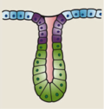 | simple tubular  or simple straight tubular  or straight tubular | the gland is a uniform tube | Small intestine (Crypts of Lieberkühn), uterine glands
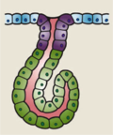 | coiled tubular  or simple coiled tubular | the gland is coiled without losing its tubular form | sweat glands
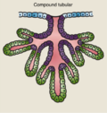 | simple branched tubular  or compound tubular | branching occurs in the tubes | pyloric glands of stomach

Alveolar glands: have alveolar (flask shaped) or acinar (grape like) secretory parts
Branched alveolar glands are classified as follows:
 | Type | Description | Location
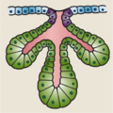 | simple branched acinar |  | thyroid glands
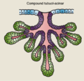 | tubuloalveolar  or tubulo-alveolar  or tubulo-acinar  or compound tubulo-acinar  or compound tubuloalveolar | glands that start out as simple branched tubular, and branch further to terminate in alveoli | salivary glands,  esophagus  mammary glands

Tubulo-alveolar glands: If glands are categorized by shape, alveolar glandscontrast with tubular glands. Alveolar glands have a saclike secretory portion, thus are also termed saccular glands. They typically have an enlarged lumen (cavity), hence the name similar to alveoli, the very small air sacs in the lungs.

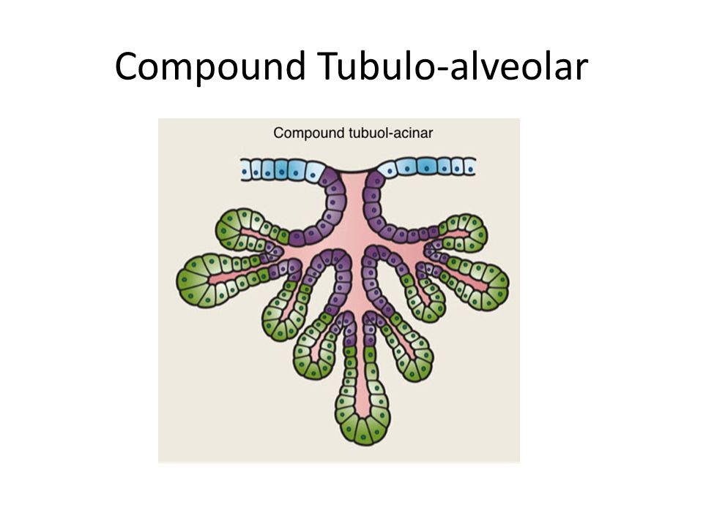

III- According to nature secretion
1- Mucous glands: produce viscid mucous poor in enzymes e.g. goblet cells and minor salivary glands.
2- Serous glands: produce watery solution rich in enzymes e.g. Parotid glands and pancreas.
3- Mucoserous glands: produce both types of secretions e.g. submandibular and sublingual glands.
• Sweat glands ;of skin produce watery secretion containing some enzymes and waste products
• Oily glands: secrete fatty secretion e.g. sebaceous and tarsal glands
• Waxy glands: secret waxy secretion e.g. ceruminous glands of the external canal.
• Cellular glands: produce cells e.g testis and ovary
III- According to method (mode) of secretion:
1-Exocrine glands have ducts - and they secrete onto a surface: examples of exocrine glands are: sebaceous and sweat glands (in the skin), salivary glands (oral), Brunner's glands. So, we have covered their basic structure and function in tissue types, and we have looked at several examples of exocrine glands in other topics.
Exocrine glands can be Unicellular - Goblet cells, or Multicellular - and the basis of their classification was covered in the topic on epithelia. Exocrine can be classify depended of the way that secretion is : 1-Merocrine glands : (or eccrine) is a term used to classify exocrine glands and their secretions in the study of histology. A cell is classified as merocrine if the secretions of that cell are excreted via exocytosis from secretory cells into an epithelial-walled duct or ducts and then onto a bodily surface or into the lumen. the secretory cells are not destroyed during secretion e.g. salivary glands.
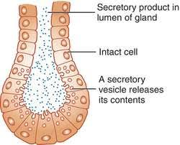
2-Apocrine glands: The apocrine gland is a type of gland that is found in the skin, breast, eyelid, and ear. Apocrine glands in the breast secrete fat droplets into breast milk and those in the ear help form earwax. Apocrine glands in the skin and eyelid are sweat glands. the apical part of the cells is destroyed during secretion e.g. mammary glands. 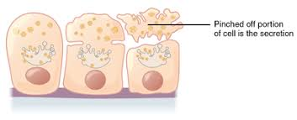

3-Holocrine glands: is a term used to classify the mode of secretion in exocrine glands in the study of histology. Holocrine secretions are produced in the cytoplasm of the cell and released by the rupture of the plasma membrane, which destroys the cell and results in the secretion of the product into the lumen, the whole cell is destroyed during secretion e.g. sebaceous glands.
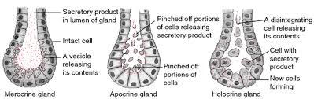

There is also cytocrine glands which transfer of secretory material from one cell to another, such as the transfer of melanosomes from melanocytes to epidermal cells.
2-Endocrine Glands
Endocrine glands do not have ducts. Their secretions (hormones) are secreted into the blood stream. Because of this, the hormones can act over long distances, and reach any organ in the body to coordinate activity. Often there is a specific 'target' organ that the hormone acts on. This long range activity is also often called neuroendocrine - as it is somewhat analogous to the coordinating activity of neurons. Some short range endocrine activity also occurs in the digestive system - and this is known as paracrine activity - for example enter endocrine cells of the gut respond to activity by secreting peptides of monoamines that act locally.
The secretory cells of endocrine glands are therefore always found in close proximity to a capillary bed, and have a rich network of blood vessels.
The signaling molecules released - hormones, are usually released by exocytosis, by the secretory cells, into the interstitial spaces and pass through fenestrated capillaries to enter the blood stream and move to target organs. The target organs will have specific receptors for the hormone, and can respond when the hormone binds. This means you should know the gland, hormone, target organ/cells and response to the hormone. The major glands of the endocrine system include the pineal gland, pituitary gland, pancreas, ovaries, testes, thyroid gland, parathyroid gland, hypothalamus and adrenal glands.
To simplify, there's a small and main difference between exocrine and endocrine glands. Exocrine gland have duct to let their secretion out like sweat glands. ... Endocrine glands are ductless glands meaning their secretions are directly poured into the bloodstream.
3-Mixed glands: have the two types: 1) A gland that contains both serous and mucous secretory units. 2) A gland that is both exocrine and endocrine for example:
The liver is largest mixed gland and internal organ in of the human body. A gland is more like a group of cells that makes and releases substance that is used elsewhere in the body.
The pancreas gland works both as endocrine and exocrine gland, because it is a glandular organ in the upper abdomen, but really it serves as two glands in one: a digestive exocrine gland and hormone - producing endocrine gland functioning as an exocrine gland , the pancreas excretes enzymes to breakdown the proteins.

