Anatomy of Renal System (RS)
RS is one of the excretory body systems (Respiratory system, Integumentary system, Digestive system and Urinary system) >
Renal system consist of the following organs:
- Kidneys (2)
- Ureters (2)
- Urinary bladder
- Urethra
General Functions of Urinary System: RS is responsible for
- Control blood volume and composition by reabsorption of body need and excretion of excess water and electrolytes
- Filter blood plasma, detoxify and eliminate wastes (toxic substances, free radicles, drugs)
- Regulate blood pressure
- Regulate fluid osmolality
- Secrete renin
- Regulate Plasma CO2 and Acid-Base balance
- Hormone production:
- Calcitriol is the active form of vitamin D in the body. Tubule cells of the proximal convoluted tubule produce calcitriol from inactive vitamin D molecules.
- Erythropoietin (EPO) is a hormone produced in response to hypoxia (a low level of oxygen in the blood). EPO stimulates the cells bone marrow to increase their output of red blood cells.
Kidney:
The kidneys are a pair of organs found along the posterior muscular wall of the abdominal cavity at the level between T12-L3. The kidneys are bean-shaped with the convex side of each organ located laterally and the concave side medially. Adult kidney weighs 120 to 170 gram and is 12cm long, 6cm width and 2.5cm thickness. The left kidney is located slightly more superior than the right kidney due to the larger size of the liver on the right side of the body. Unlike the other abdominal organs, the kidneys are retroperitoneal organs. The ribs and muscles of the back protect the kidneys from external damage.
Each kidney consists of the following anatomical parts:
Kidney
Protective layers Hilum (sinus)
Parenchyma

Cortex medulla
- Hilum (or sinus). The concave side of the kidney. It provides a space for the renal artery, renal vein, and ureter to enter and exit the kidney.
- A protective layers that surround the kidneys are include:
- Renal fascia (gerotas fascia) attaches the kidney to abdominal wall.
- Renal fat.
- Renal capsule: directly cover the kidney outer surface.
- Parenchyma which include soft, densely vascular renal cortex. And seven cone-shaped renal pyramids form the renal medulla deep to the renal cortex. The renal pyramids are aligned with their bases facing outward toward the renal cortex and their apexes point inward toward the center of the kidney.
Each apex connects to a minor calyx, a small hollow tube that collects urine. The minor calyces merge to form 3 larger major calyces, which further merge to form the hollow renal pelvis at the center of the kidney. The renal pelvis exits the kidney at the renal hilum, where urine drained into the ureter.

Nephrons (functional unit)
Nephrons are the kidneys’ functional units that filter blood to produce urine. Each kidney contains around 1 million individual nephrons. The nephron is made of 3 main parts: the renal blood vessels, renal corpuscle (capillaries and capsule) and the renal tubule.
Nephrons are responsible for blood filtration.
- Renal blood vessels are afferent and efferent arterioles, renal venioles.
- Renal corpuscle (glomeruli) is formed by the capillaries of the glomerulus and the glomerular capsule (also known as Bowman’s capsule). The blood is filtered and the filtrate (urine) drained to the renal tubule.
- Renal tubules concentrate urine and carry the urine from the glomerular capsule to the renal pelvis. Renal tubular system includes:
- The curvy first section of the renal tubule is known as the proximal convoluted tubule. The tubule cells that line the proximal convoluted tubule reabsorb much of the water and nutrients initially filtered into the urine.
- Urine next passes through the descending loop, loop of Henle, and ascending loop these loops carry urine into the renal medulla before returning to the renal cortex.
- Following the ascending loop the distal convoluted tubule.
- Finally, urine from the distal convoluted tubules of several nephrons enters the collecting duct, which carries the concentrated urine through the renal medulla forming renal pyramids.
- Renal pyramids empty the urine in minor calyces.
- minor calyces merge together to form 3 major calyces.
- Major calyces flow the urine toward renal pelvis, then urine passes out of the kidneys through the ureter.

Urine formation: (filtration, reabsorption, secretion)
- Glomerular filtration: create a filtrate fluid
- Tubular reabsorption: reabsorb the useful solutes from the filtrate and return them to the blood.
- Tubular secretion: removes additional wastes from the blood adding them to filtrate.
- Water conservation (water saving): removes water from the urine and returns it to the blood again and concentrates the wastes.
Ureter
The ureters are paired muscular ducts with narrow lumen that carry urine from the kidneys to the bladder aided by the rhythmic contraction of smooth muscle of the wall of the ureter. The ureter is roughly 25-30 cm long in adults, it is a retroperitoneal structure. At the proximal end of the ureter is the renal pelvis and at the distal end is the bladder.
Urinary bladder:
The bladder is a hollow muscular organ situated at the base of the pelvis. Urine collects in the bladder from the two ureters, which open into the bladder at its posterior wall. Urine leaves the bladder via the urethra, a single muscular tube which ends in the urethral orifice.
The bladder is a retroperitoneal organ. In men, it lies in front of the rectum. In women, it lies in front of the uterus. Adult bladder capacity is about 300 to 600 mL of urine.
Urethra:
The urethra is a thin, fibromuscular tube that begins at the lower opening of the bladder (internal urethral orifice) and extends through the pelvis to the outside of the body which called the external urethral orifice. The urethra is the passageway between the bladder and the external part of the body, which allows urine to be excreted from the body. It is significantly longer in males than females. It is approximately 4 cm in length for females, whereas it is about 20 cm in the male body.
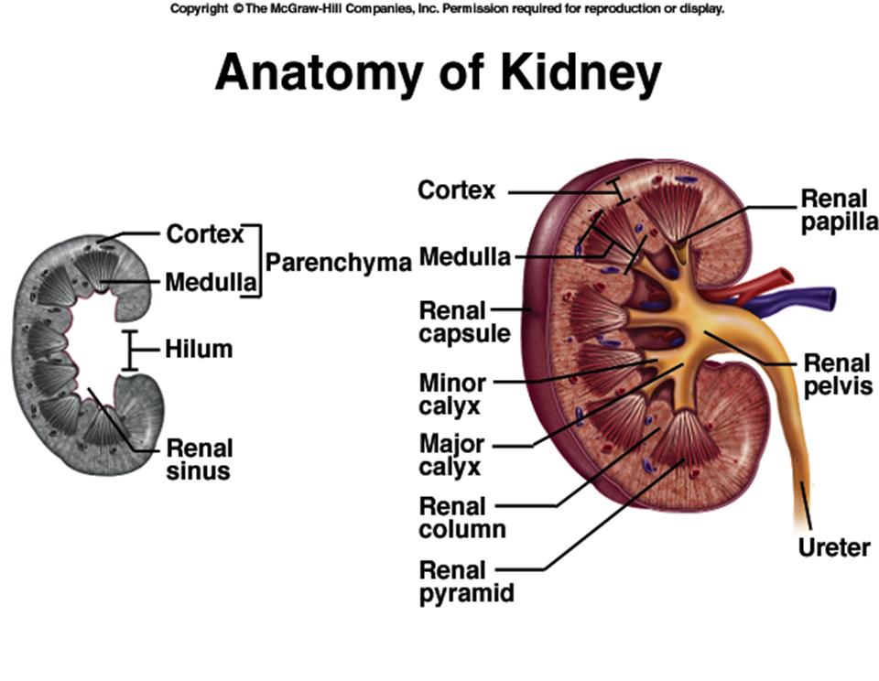
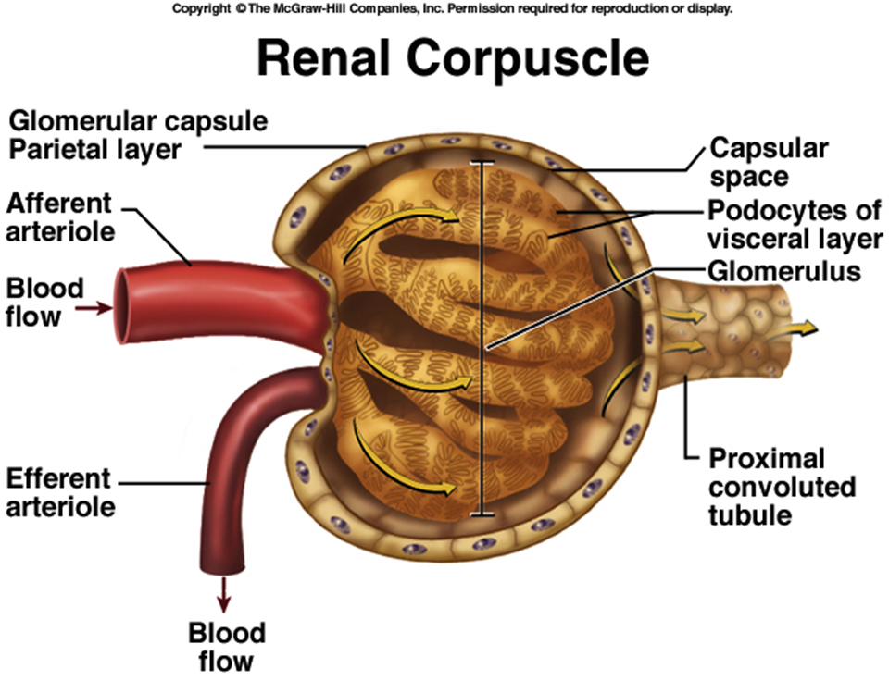
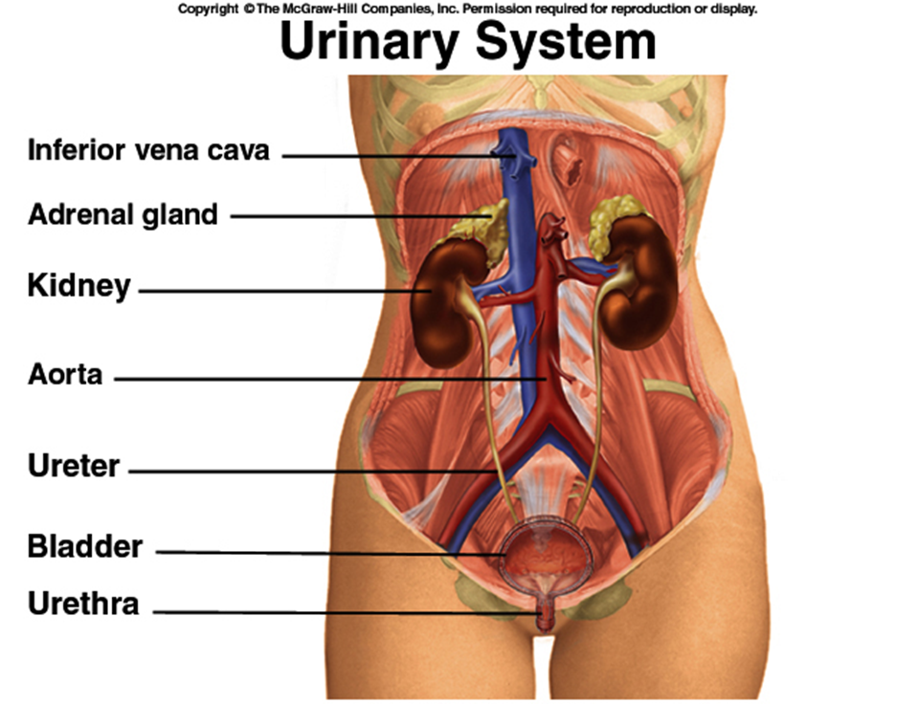

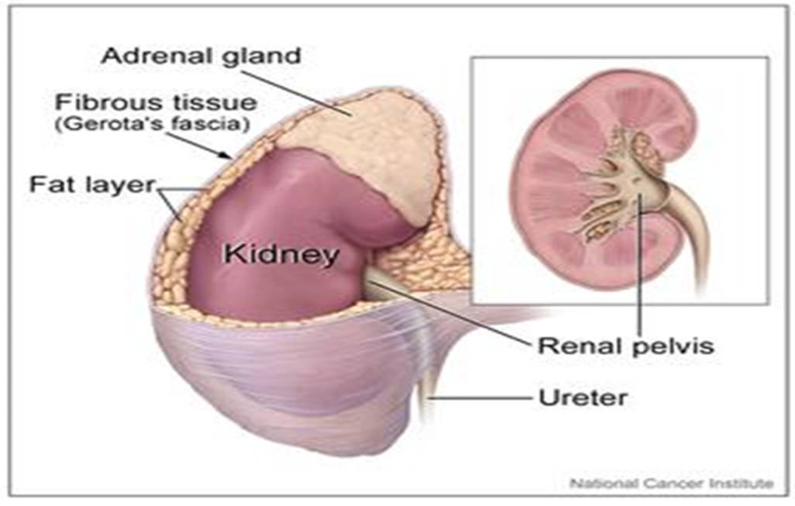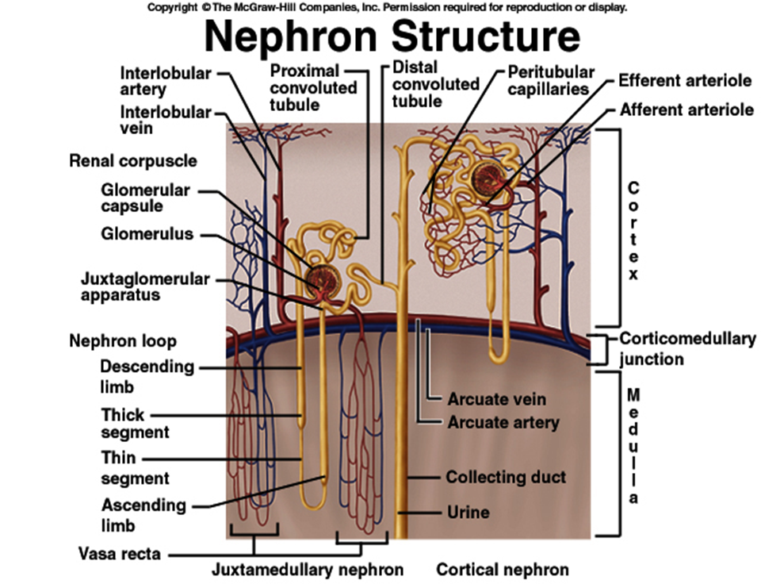
capsule

