The easiest method for detection of cancer tumor is by nanoparticles releasing biomarkers called peptides, which are molecules located between carboxyl group of amino acid and amino group of another amino acid molecule, when meeting cancer tumor at its earliest stages.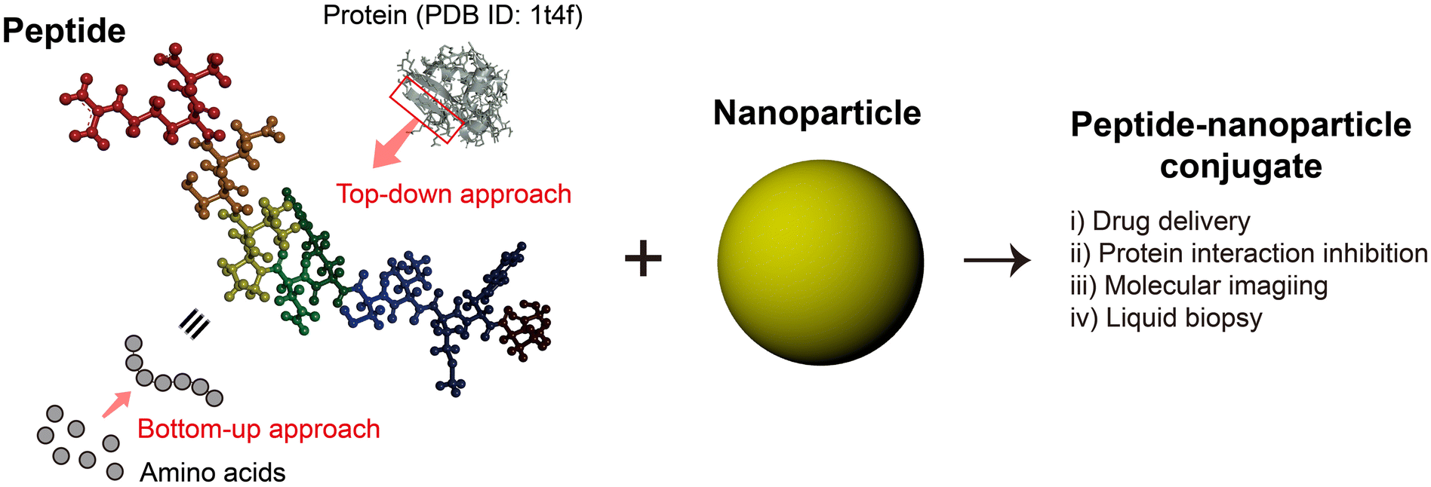

Magnetic nanoparticles, which compose of magnatic material like iron and its chemical compound, are used with nuclear magnetic resonance (NMR) to detect cancer tumor in brain. Magnetic nanoparticles stick to molecules in blood stream called micro vesicles available in brain cancer. NMR detect magnetic nanoparticles when they are stuck with micro vesicles. This is an earlier method to detect brain cancer.
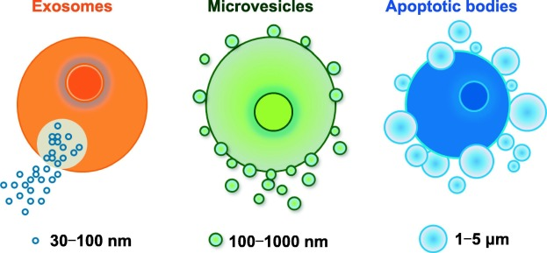
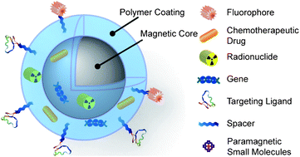

Researchers found a method to capture individual cancer cells that circulate in blood stream by injecting nanofibers coated with antibodies that catch to cancer cells making Cancer cells in trap, and then blood can be analyzed [9].
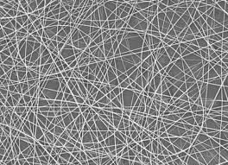
Nano fiber

Gold nanoparticles attached to antibodies can detect in early stages flu virus particles. When light is directed on nanoparticle cluster, the reflected light intensity is increased. So, reflected light from blood sample containing virus particle attached with cluster of nanogold particles will increased. [9]
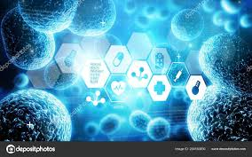
Reflected light from Viruses attached with gold nanoparticles.

Some diseases eject protein and some molecules when happened. Some nanoparticles attach to protein or these molecules and clump around them. If the disease is exist the nanoparticles clump around protein and shoot red color, but if there is no disease, blue color will appear.

References:
- https://www.understandingnano.com/medicine.html.
- https://www.understandingnano.com/nanotechnology-drug-delivery.html.
- https://www.understandingnano.com/nanoparticles-insulin-release.html.
- https://www.understandingnano.com/mesoporous-nanoparticles-target-senescent-cells.html.
- https://www.google.com/search?q=leposom&oq=leposom&aqs=chrome..69i57j69i60&sourceid=chrome&ie=UTF-8.
- https://www.elprocus.com/nanorobots-and-its-application-in-medicine/
- Robert, A. and Freitas, Jr. The Ideal Gene Delivery Vector: Chromallocytes, Cell Repair Nanorobots for Chromosome Replacement Therapy. Journal of evolution technology, 16(1), pp. 1-97. 2007.
- https://www.alarabiya.net/ar/medicine-and-health/2014/10/31/.
- https://www.understandingnano.com/nanotechnology-medical-diagnosis.html.

