Pharmacognosy II 3rd year Dr. Rasha A. Eldalawy
Glycosides

Glycosides are compounds that yield one or more sugars upon hydrolysis. The term glycoside is a generic term for natural product that is chemically bound to a sugar. Thus the glycoside composes of two parts: the sugar and the aglycone. The aglycon may be a terpene , a flavonoid, a coumarine or any other natural product. Glycoside showed extra chemical diversity. Among the sugars found in natural glycosides, D-glucose is the most abundant one, L rhamnose and L-fructose also occur quite ferequently. Of the pentoses : L-arabinose is more common than D-xylose. The sugar part can be disaccharide.
Because of the cyclic structure of the sugar, two diastereoisomers of the glycoside exist depending on the configuration of the anomeric carbon. These diastereoisomers are called anomers and are designated as α and β. This classification depends on the glycosidic linkage (above the linkage is β), below the linkage is α.

Chemically, glycosides are usually mixed acetals in which the hydroxyl group on the anomeric carbon is replaced by a moiety possessing a nucleophilic atom. Thus the
sugar moiety of a glycoside can be joined to the aglycone via
- Oxygen atom (O-glycosides)
- Carbon atom (C-glycosides)
- Nitrogen atom (N-glycosides)
- Sulfur atom (S-glycosides)

Nomenclature of glycosides
In the nomenclature of glycosides the trivial names have an “in” ending, and the names indicate the source of glycoside, for example, digitoxin from Digitalis, salicin from Salix, and prunasin from Prunus. The systematic names are usually formed by replacing the “ose” suffix of the parent sugar with “oside”. The anomeric prefix (α- or β-) and the configurationally prefix (D or L) immediately precede the sugar stem name, and the chemical name of the aglycone precedes the name of the sugar. For example the name of salicin is o-hydroxy-methylphenyl β-D-glycopyranoside.

o-hydroxy-methylphenyl β-D-glycopyranoside

Classification of glycosides
The classification of glycosides is a difficult matter.
If the classification is based on the sugar group, a number of rare sugars are involved; for example glucosides and rhamnosides,
if the aglycone group is used as a basis of classification , all class of natural product will involved example lignan glycosides, alkaloidal glycosides etc.
  - A therapeutic classification, although excellent from a pharmaceutical viewpoint, omits many glycosides of pharmacognostic interst.example cardiac glycosides.
Based on properties or function.
Glycosides that have soap like properties are called saponin. Similarly, glycosides that liberate hydrocyanic acid (HCN) on hydrolysis are known as cyanogenic glycosides.
Acorrdingly the types of glycosides are
Cardiac glycosides
Cyanogenic glycosides
Phenolic glycosides (flavonoids, lignans and other phenolic compounds)
Aldehyde glycosides
Anthraquinone glycosides
Saponine glycosides [terpene (triterpenoid) and sterol unit]

Hydrolysis of glycosides
All natural glycosides are hydrolyzed into a sugar and another organic compound by boiling with mineral acids; but differ in the in the ease with which this hydrolysis is performed.
Enzymatic hydrolysis is more specific. Many of the enzymes hydrolyzed only a single glycoside; however two enzymes, namely emulsin of almond and myrosinase of black mustard seeds, each hydrolyze a considerable number of glycosides. Rhamnase is the enzymes that hydrolyze rhamnoside glycosides.
Biosynthesis of glycosides
The biosynthetic pathways are widely variable depending on the type of aglycone as well as the glycone units. The aglycone and the sugar parts are biosynthesized separately, and then coupled to form a glycoside. The coupling of the two parts occurs via phosphorylation of a sugar to yields a sugar 1- phosphate which reacts with a uridine (uracil nucleo base and ribose) triphosphate to form a uridine diphosphate sugar (UDP-sugar) and inorganic phosphate. This UDP sugar reacts with the aglycone to form the glycoside and a free UDP

Cyanogenic glycosides
Cyanogenic glycosides names come from (yield HCN on hydrolysis)

Biosynthesis of these glycosides begin with L-phenylalanine
Amygdalin found in almond (prunus amygdalus) Fam: Rosaceae.
Linseed (linum sativum) Fam: Linaceae contain the glycoside linamarin.
HCN liberated on hydrolysis can be determined by a simple color test using sodium picrate (yellow) which turns red in contact with HCN.

Uses and side effects
The extracts of plants that contain the cyanogenic glycoside are used as flavoring agents in many pharmaceutical preparations. Amygdalin has been used for treatment for cancer and as cough suppressant.
Excessive ingestion of this glycoside can be fatal. Some foodstuffs containing cyanogenic glycosides can cause severe gastric irritation and damage if not properly handled.
Anthraquinone glycosides
These glycosides are anthracene derivatives most of them contain anthraquinone skeleton such as cascara sagrada, frangula, aloe, rhubarb and senna.
These drugs are used as cathartics. The glycosides, upon hydrolysis, yield aglycones that are di-, tri-, or tetrahydroxyanthraquinones or modifications of these compounds. Atypical example is frangulin A, which hydrolyses to form emodin (1,6,8-trihydroxy-3-methylanthraquinone) and rhamnose. The structural relationships of emodin are shown in the following figure.

Glycosides of anthranols, dianthrones, and oxanthrones have significant therapeutic action. They employed as cathartic which exert their action by increasing the tone of the smooth muscle in the wall of the colon and stimulate the secretion of water and electrolytes into the large intestine (bulk laxatives).Glycosides of anthranols and anthrone (Aloe and Rhubarb) elicit a more drastic action than other anthraquinone leading to discomforting gripping action. The drug of choice is cascara and senna. Aloe is used for treatment of minor burns. The action is due to presences of aloin A and Aloin B. Action of senna due to presence of the glycosides (sinnoside A and B).

Biosynthesis of anthraquinone glycosides
Feeding of labeled acetate to organisms produce anthraquinone glycosides have revealed that the distribution of radioactivy in these compounds is consistent with formation via a head to tail condensation of acetate units. Anthranols and anthrone are likely to be intermediates in the formation of anthraquinone compounds.

Test for anthraquinone glycosides
Powdered plant material is mixed with organic solvent and filtered. Aqueous base (NaOH or NH₄OH) is added to it. A pink or violet color in the base layer indicates the presence of anthraquinone nucleus. This test is specific for aglycone, therefore hydrolysis with HCl in case of O-glycosides and ferric chloride/HCl for C-glycosides must be performed.

Isoprenoids glycosides
The aglycone of this type of glycosides is biosynthetically derived from isoprene units. There are three types of isoprenoid glycosides: diterpene, saponins and cardiac glycosides
- Steviol glycosides are high intensity sweeteners, 250-300 times sweeter than sucrose.
- They are isolated and purified from the leaves of the stevia plant (Stevia rebaudiana Bertoni), where it is present at levels up to 13%.
Saponine glycosides
Saponins form colloidal solutions in water that foam upon shaking. They have a bitter acrid taste and have irritation action to mucous membrane. They destroyed red blood corpuscles by hemolysis and are toxic. Upon hydrolysis they yield an aglycone known as a sapogenin which can be one of two possible chemical classes either steroid (cyclopentaphenanthrene) or triterpenoid (pentacyclic structures)
The two major types of steroidal sapogenin are diosgenin and hecogenin. Sapogenin are used in the commercial production of sex hormones for clinical use, for example, progesterone’s derived from diosgenin (from the plant Dioscorea from Mexico)

Other steroidal hormone like cortisone can be prepared from hecogenin which can be isolated from Sisal leaves found extensively in East Africa.

In triterpenoid saponins, the aglycone is a triterpene C-30, for example ginsenosides which is found in many plants example liquorice and ginseng roots. Liquorices contains glycyrrhetic acid is used as expectorants and flavoring for gum, while ginseng is used as tonic.

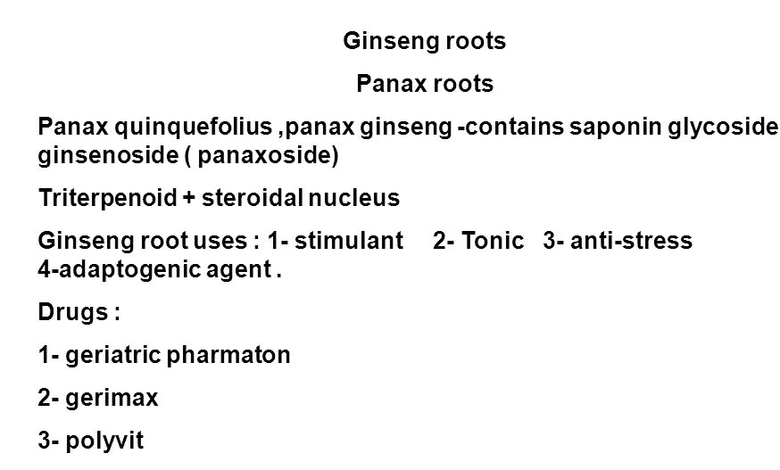

Cardiac glycosides

Glycosides that exert a prominent effect on heart muscle and heart rhythm are called cardiac glycosides example digitoxin from Digitalis purpurea. Their effect is specifically on myocardial contraction. They are commonly found in the genera Convallaria, Nerium and Digitalis. The aglycone portion is steroidal in nature and it is sometimes referred to as a cardenolide being cardioactive and possessing an alkene and olide (cyclic ester).
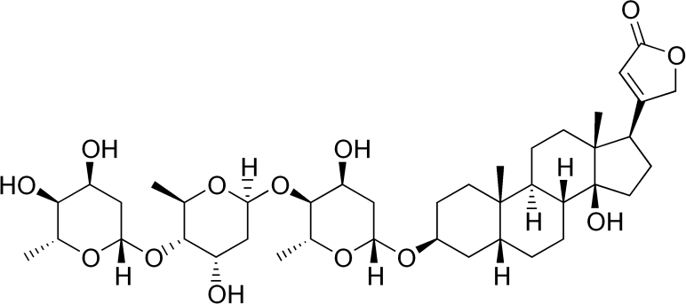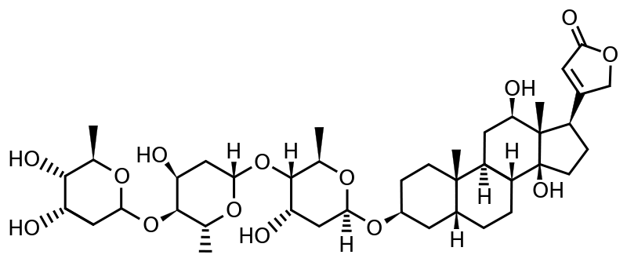

Digitoxin and digoxin

The most widely studied plant that contains these compounds is the foxglove (Digitalis purpurea) of the family Scrophulariaceae which is used from 18 century for the treatment of heart disease. The plant contains the medicinal agent's digoxin (which is more widely used) and digitoxin. Digoxin is also found in Digitalis lanata. Digitoxin yields one molecule of digitoxigenin and three of digitoxose. Digitoxin is insoluble in water and slightly soluble in alcohol. It is the most lipid soluble drug used in cardiac diseases.
Related glycosides which because they are very fast acting compounds are used in emergencies via IV routs are lanatoside C and diacetyl-lanatoside C.
Bufanolides (derived their name from the generic name of toad that produce bufalin) in which the lactone (cyclic ester) contains 6 member ring is less abundant in nature, for example proscillardin A, found in the plant squill (Scilla maritime). This glycoside is used as rodenticide due to sever toxicity

SAR
An unusual aspect of chemistry of both cardenolides and bufadienolide is that is the CD ring junction has the cis –configuration.
Both sugar and aglycone parts are responsible for activity. The sugar probably enhances the binding to heart muscle and the aglycone moiety has the desired effect on heart muscle. α- β unsaturated latone ring that is attached on the 17 position of the steroid nucleus is responsible for activity. Reduction of the double bond in the lactone ring results in inactive compound. For activity that is more prominent 3-OH should be on β- position. Oxygen substitution on the steroid nucleus influences the distribution and metabolism of the glycosides. In general the more hydroxyl groups in the molecule the more rapid the onset of action.

Drug interaction

Digoxin interacts with cation levels. Potassium depletion increase the susceptibility to cardiac glycoside toxicity, therefore patient on thiazide diuretics which cause potassium depletion should decrease the dose of digoxine or received a potassium therapy. Conversely high calcium level enhances the activity of digoxin, therefore, ingestion of high amount of milk or calcium gluconate should be avoided in patient on digoxin therapy.

Mechanism of action
The mechanism of action of the cardiac glycosides is still not completely known; however, observation has implicated Na⁺, K⁺ -ATPase as the receptor enzyme. This enzyme catalysis the active transport of Na⁺ out of the cell and subsequent transport of K⁺ into the cell. In myocardium the ion exchange is rapid because it is required after each heart beat; therefore an inhibition of ATPase has a great effect on heart tissues.
Page 116 in your text book for more details.
Biosynthesis of cardiac glycosides
The steroid nucleus is biosynthesized via acetate mevalonate pathway (polyketide). If we look to the side chain of cortisone we may suggest that the hydroxyl may oxidize to acid then lactonization occurs.

Physical and chemical properties
The glycosides are fairly soluble in water and slightly soluble in ethanol and chloroform: digitoxin is far more soluble in chloroform than digoxin, which is fairly soluble in dilute ethanol and in ethanol-chloroform mixtures. Both are sparingly soluble in ethyl acetate. Cardiac glycosides containing 3 or 4 monosaccharides are soluble in water. Aglycones of cardiac glycosides are soluble in organic solvents and practically insoluble in water. Cardiac glycosides easily hydrolyze. Upon hydrolysis, they yield the sugars and aglycone. Primary glycosides such as lanatoside C are water-soluble, soluble in dioxane, sparingly soluble in chloroform (1 g in 2 L), and virtually insoluble in methanol. The presence of the lactone renders the molecule labile, and likely to open in an alkaline medium.
Other cardioactive drugs
Oleander: The leaves of Nerium oleander, Fam; Apocyanaceae have been used to treat cardiac diseases. Oleandrin is a derivative of digoxin.
Strophanthus: Is the dried ripe seeds of strophanthus kombe, Fam; Apocyanaceae. K strophanthoside, also known as stroposide is the principle glycoside in the plant that has been used in Africa as arrow poisoning, when sent to Europe the effect on heart muscle was noticed.

Isothiocyanate glycosides (glucosinolates)

A group of glycosides which upon hydrolysis by the enzyme myrosinase yield a glucose and aglycon which undergo spontaneous rearrangement with the loss of sulphate to give an isothiocyanate as the major product. In this type of glycoside the sulphur atom is bonded to sugar (S-glycoside) and the second sulfur present in sulfonated oxime group (C=NOH)

Glucosinolates have a limited distribution in the plant families and are characteristic constituent of the mustard family (Brassicaceae), including rape seed, mustard, turnip, broccoli and cabbage. Mustard family vegetables have been found to have anticarcinogenic properties. For example indole-3 carbinol derived from indomethyl-glucosinolate which is widely distributed in mustard family has been shown to reduce risk of estradiol-linked cancer. Broccoli found to contain enzymes that have a protection against cancer (prevention).

Biosynthesis of glucosinolates
Biosynthetic pathway involves N-hydroxylation and oxidative decarboxylation to yield an aldoxime intermediate. The aglycones may be aliphatic (in black mustard) or aromatic (white mustard) derived from amino acid.

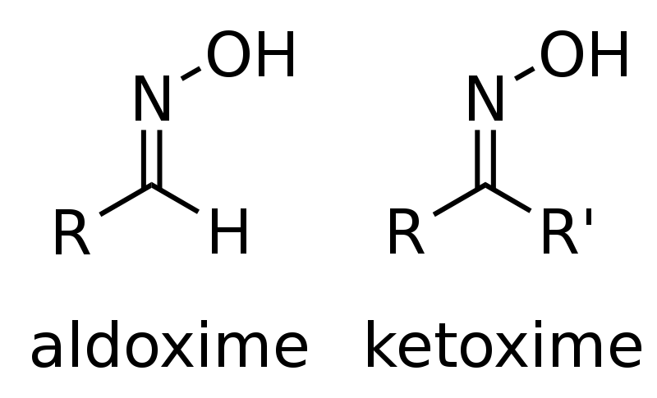

Uses
Black mustard is a local irritant and an emetic. Externally the drug is rubefacient. Commercially it is used as condiment.

Other organosulfur drugs
Garlic
Consist of the bulb of Allium sativum Fam; Lilicaeae. The plant was used as food and medicine from the time of Pharaohs. The intact cells of garlic contain the odorless sulfur containing amino acid derivative (+)-S-allyl-L- cysteine sulfoxide.(alliin). When the cell is crushed it comes into contact with the enzyme alliinase which convert it to allicin (bad smell, diallyl thiosulfinate). Allicin has a powerful antibacterial activity. Garlic also posse's antihyperlipedemic and inhibit platelets aggregation.

Measurement of the total activity of garlic is determined by the amount of bioactive allicin produced; therefore commercial garlic preparations have a great variation in their ability to produce allicin because the mode of preparation greatly influences the stability of alliin and alliinase. Enteric coated tablets or capsules have enhanced activity because stomach acid inactivates allinase.

Alcohol glycosides

Salicin
Is a glycoside obtained from Salix purpurea and Salix fragilis. Emulsin is the enzyme responsible for the hydrolysis of salicin to salicyl alcohol and glucose. It s action is similar to salicylic acid; probably it oxidized in the body to this acid. The glycoside populin (benzoylsalicin) is also found in with salicin in the barks of Salicaceae. Recognition of the properties of salicin clarifies many folkloric uses of poplar and willow barks.

Phenolic glycosides
Phenolic compounds are C-6-C3 metabolites derived from shikimic acid.

Coumarin glycosides
- R1 = OH, R2= O-glucose
- Acsulin used as Antidiarrhoea
- Fraxin opposite used as tonic

Apterin
- Is a furanocoumarin glucoside reported to dilate coronary arteries as well as block calcium channels. It can be found plants of the Apiaceae family.
It has been isolated from the root of plants in the genus Angelica

Flavonoid glycosides
- Among the important effects of flavonoids are their antioxidant effect.
- They are also known to decrease capillary fragility
- Flavonoid glycosides are a group of chemical compounds that occur in small but significant amounts in fruits and vegetables.
- More than 4,000 different flavonoids have been identified, some of which have been researched in detail and are believed to have beneficial effects on human health.
- Some of the health related benefits associated with this group of compounds include strengthening of the immune system, protection against cancer, and a reduction in capillary fragility.
- A variety of different foods contain these compounds. Fruits, vegetables, seeds, legumes and soy products are known to contain flavonoid glycosides.
- Onions, apples, green tea, and red wine are known to be rich in these nutrients, however.Known to have antioxidant properties, flavonoid glycosides are believed to help protect individuals from diseases, such as cancer.
- Antioxidants are known to stabilize unstable molecules, known as free radicals, which can potentially damage genetic materials and cells. Thus, this group of compounds can strengthen a person immune system.
- Although many types of flavonoid glycosides have been identified, few have been studied in any depth. The flavonoids that have been researched in detail include rutin, hesperedin, anthocyanaosides, and genistein.
Each of these has been found have specific benefits for human health.
Rutin:
is found in buckwheat and research has demonstrated that this particular
flavonoid glycoside may have several implications for human health.
Capillary fragility, or the weakening of delicate blood vessels, is common
in the elderly or those who suffer from a vitamin C deficiency.
Consumption of rutin is believed to strengthen weakened blood vessels
and also reduce the risk of heart disease.
Hemorrhoids are also often treated with rutin.

Hesperetin:
- is found in citrus fruits and is also a known antioxidant.
- Studies have indicated that it can reduce blood pressure and lower cholesterol.
- In addition, hesperetin has anti-inflammatory effects and, as such, is thought to reduce pain in the joints and muscles, particularly among those who suffer from arthritic conditions.

Anthrocyanosides:
are found in bilberries and known to have several positive health implications.
Anthocyanoside flavonoid glycosides are believed to help maintain healthy skin, teeth, eyes, and hair. In addition, anthocyanosides are thought to improve cardiovascular health and help to protect against conditions such as diabetes.
Since they are rich in antioxidants, flavonoid glycosides are believed to help boost a person s immune system. With such bolstered immune function, it is thought people can protect themselves from serious illnesses.
For this reason, a diet rich in foods that contain flavonoid glycosides may benefit many people. Those considering a major dietary change or taking supplements, however, should check with a physician or nutritionist to be sure of dosages and safety.

Lignan glycosides
Flaxseed (FS) is the richest source of the phytoestrogen secoisolariciresinol diglycoside (SDG), a plant lignan that can be metabolized by bacteria in the animal or human colon to the mammalian lignans enterodiol and enterolactone.
It is also a very rich source of α-linolenic acid Because these compounds have been suggested to have anticancer effects , FS is a food that has a very high potential to reduce cancer risk.
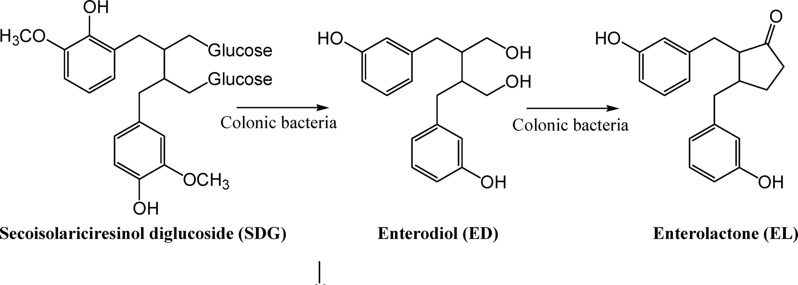

Aldehyde glycosides
Hydroquinol glycosides
- example on phenolic glycoside is arbutin.
- Arbutin is a glycoside; glycosylated hydroquinone extracted from the bearberry plant in the genus Arctostaphylos
inhibits tyrosinase and thus prevents the formation of melanin. Arbutin is therefore used as a skin-lightening agent

N- Glycosides

