**Pharmacognosy II 3rd stage**

**Phenylpropenses**

Are the simplest of shikimic-acid-derived biosynthetic subunit. These secondary metabolites are consist of purely of an aromatic ring (C6), with an unsaturated 3-carbon chain (C3), attached to the ring.



Simplest phenylpropene is the volatile oil example eugenol, saffrol and anethol which we will discuss in volatile oil chapter.



**LIGNANS**

Lignans are low molecular weight polymers formed by the coupling of two phenylpropene units and its polycyclic (possessing more than one ring).

A common precursor of lignans is cinnamyl alcohol, which can readily form free radicals and enzymatically dimerize to form aryltetralin-type lignans which is formed by the coupling of two phenylpropene units through their C3 side-chains and between the aromatic ring and the C3chain.

the compounds podophyllotoxin, 4'-demethylpodophyllotoxin and α- and β-peltatin (from Podophyllum peltatum and Podophyllum hexandrum, Berberidaceae) are examples for this type of compounds.

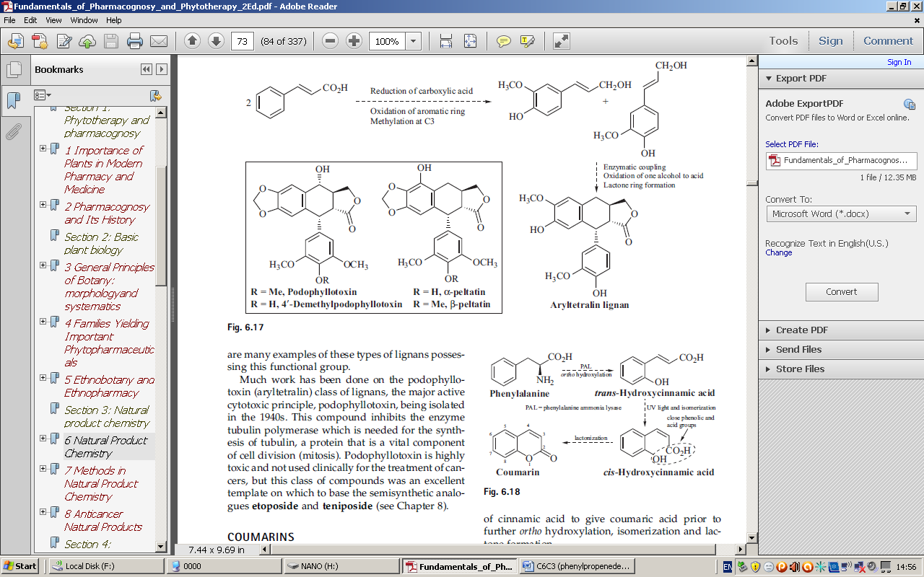

**Podophyllotoxin**

is the major compound found in podophyllum hexandrum (Indian podophyllum) is used in treatment of warts (abnormal cell growth). I t s cytotoxic effect was then demonstrated, the compound was found to be very toxic.

The major active cytotoxic principle, podophyllotoxin, being isolated in the 1940s and much work has been done on the podophyllotoxin (structure modification)) since that time.

This compound inhibits the enzyme tubulin polymerase which is needed for the synthesis of tubulin, a protein that is a vital component of cell division (mitosis). Podophyllotoxin is highly toxic and not used clinically for the treatment of cancers, but this class of compounds was an excellent template on which to base the semisynthetic analogue etoposide and tenoposide.

Ethanolic extract of podophyllum (podophyllin) contain anticancer lignan glycosides that are more water soluble and less toxic than podophyllotoxin but unfortunately had less antitumor activity.

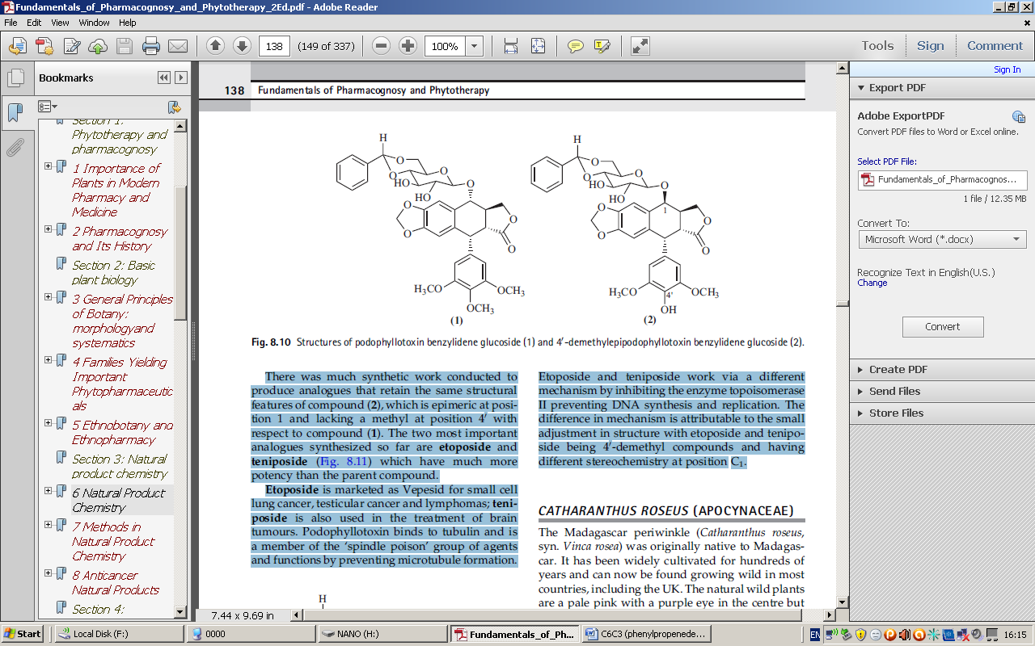

There was much synthetic work conducted to produce analogues that retain the same structural features of compound (2), which is epimeric at position 1 and lacking a methyl at position 4' with respect to podophyllotoxin.

The two most important analogues synthesized so far are etoposide and teniposide which have much more potency than the parent compound. Etoposide is marketed as Vepesid for small cell lung cancer, testicular cancer and lymphomas; teniposide is also used in the treatment of brain tumours.

Podophyllotoxin binds to tubulin and is a member of the ‘spindle poison’ group of agents and functions by preventing microtubule formation. Etoposide and teniposide work via a different mechanism by inhibiting the enzyme topoisomerase II preventing DNA synthesis and replication. The difference in mechanism is attributable to the small adjustment in structure with etoposide and teniposide being 4'-demethyl compounds and having different stereochemistry at position C1.

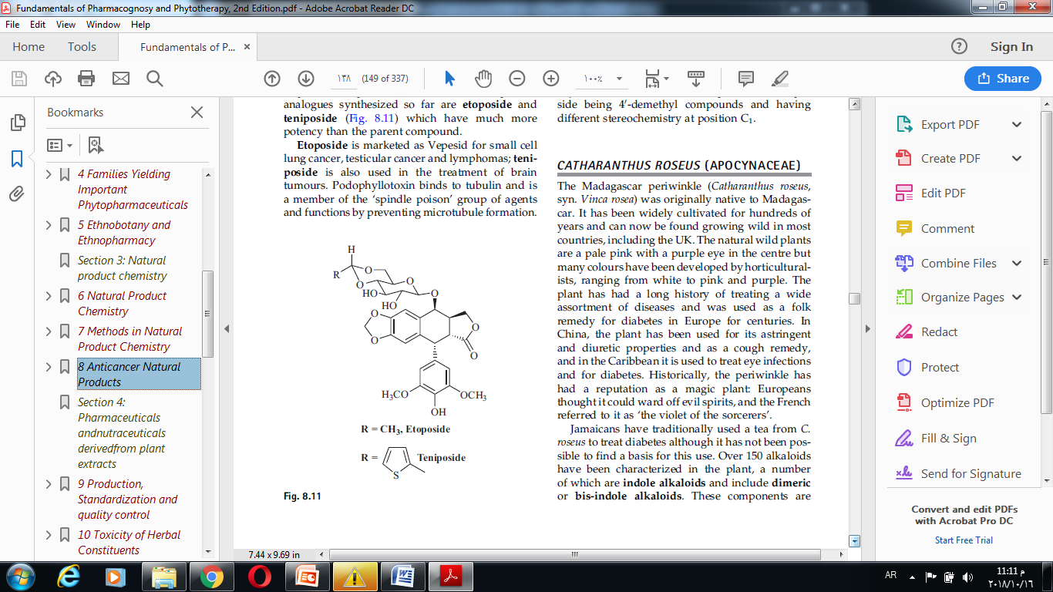

COUMARINS

The coumarins are shikimate-derived metabolites formed when phenylalanine is deaminated and hydroxylated to trans-hydroxycinnamic acid. The double bond of this acid is readily converted to the cis form by light-catalysed isomerization, resulting in the formation of a compound that has phenol and acidic groups in close proximity. These may then react intramolecularly to form a lactone and the basic coumarin nucleus, typified by the compound coumarin itself, which contributes to the smell of hay (Melilots).

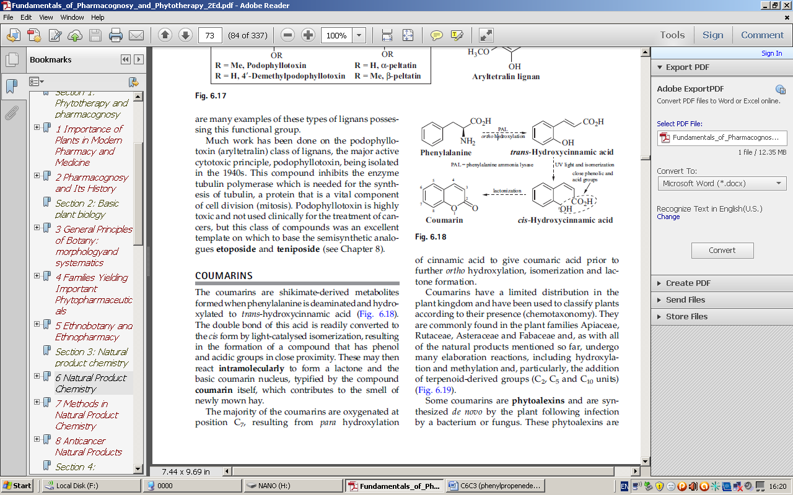

**Biosynthesis of coumarin**

Coumarins have a limited distribution in the plant kingdom and have been used to classify plants according to their presence (chemo-taxonomy). They are commonly found in the plant families Apiaceae, Rutaceae, Asteraceae and Fabaceae.

As with all of the natural products mentioned so far, undergo many elaboration reactions, including hydroxylation and methylation and, particularly, the addition of terpenoid-derived groups (C5 and C10 units)

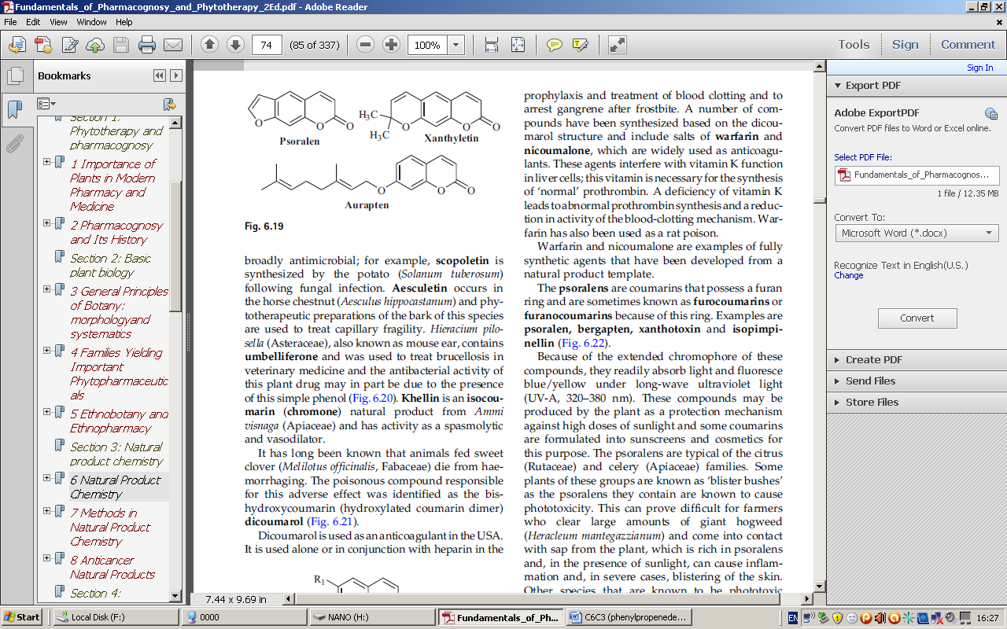

Coumarins act as antimicrobial; for example, scopoletin which is synthesized by the potato (Solanum tuberosum) following fungal infection.

Aesculetin occurs in the horse chestnut (Aesculus hippocastanum) and phytotherapeutic preparations of the bark of this species are used to treat capillary fragility.

Khellin is an isocoumarin (chromone) natural product from Ammi visnaga (Apiaceae) and has activity as a spasmolytic and vasodilator.

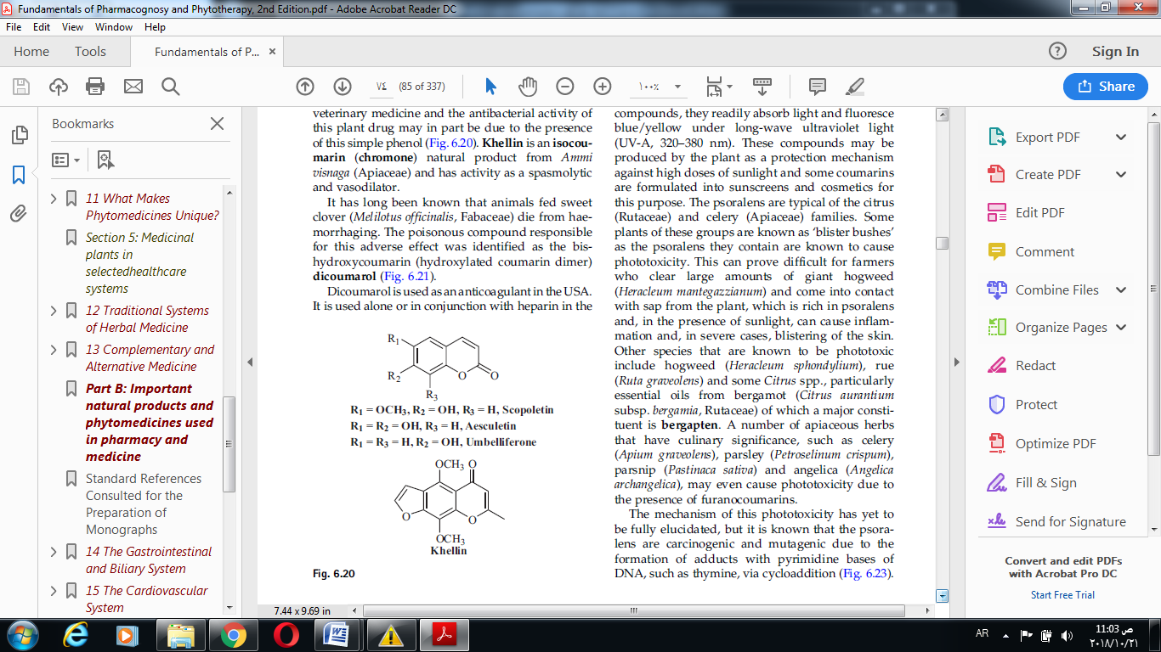

It has long been known that animals fed sweet clover (Melilotus officinalis, Fabaceae) die from hemorrhage. The poisonous compound responsible for this adverse effect was identified as the bishydroxycoumarin (hydroxylated coumarin dimer) dicoumarol.

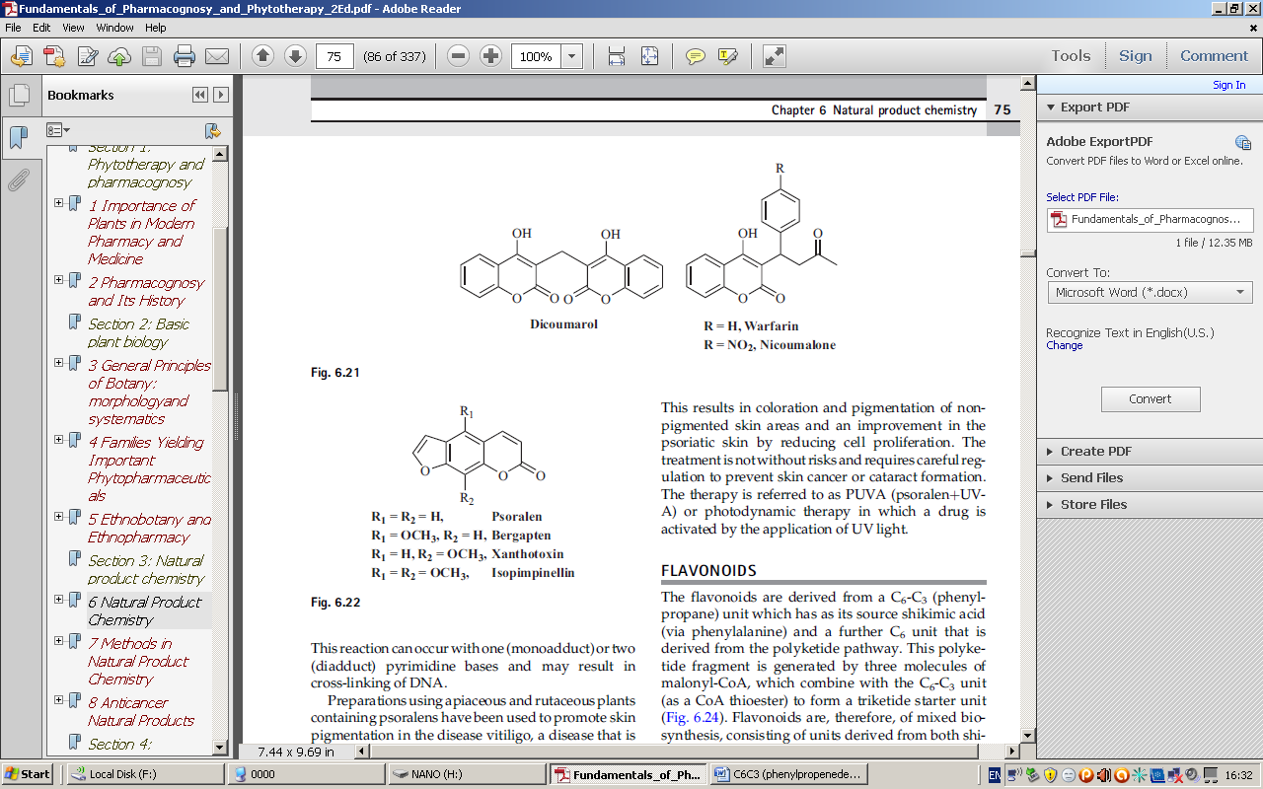

Coumarin derivatives Psoralen (furocoumain) promote repigmintation of leukoderma, therefore it is used to treat vitiligo. Example methoxsalen from *Ammi majus*.

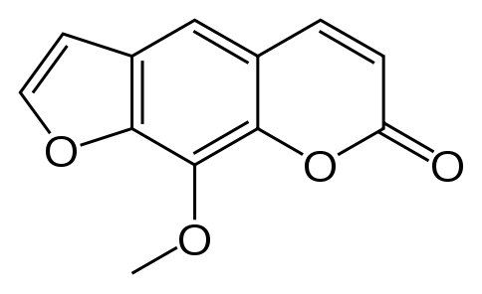

Methoxsalen (meladenine)

**FLAVONOIDS**

The flavonoids are derived from a C6-C3 (phenylpropane) unit which has its source from shikimic acid (via phenylalanine) and a further C6 unit that is derived from the polyketide pathway. This polyketide fragment is generated by three molecules of malonyl-CoA, which combine with the C6-C3 unit (as a CoA thioester) to form a triketide starter unit. Flavonoids are, therefore, of mixed biosynthesis, consisting of unit derived from shikimic acid and unit from polyketide pathway. The triketide starter unit undergoes cyclization by the enzyme chalcone synthase to generate the chalcone group of flavonoids.

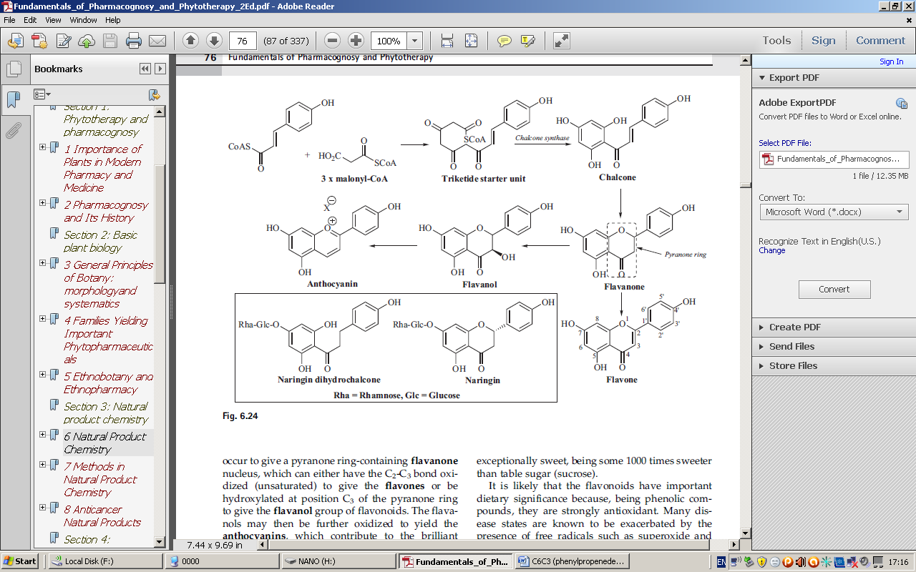

**Drugs and food containing flavonoids**

[Parsley](http://en.wikipedia.org/wiki/Parsley), both fresh and dried, contains [flavones](http://en.wikipedia.org/wiki/Flavones)

Blueberries contains anthocyanine

Tea contains flavan-3-ol

Citrus fruit contains hesperidine

Red grape and dark chocolate also contain flavonoids

|  |  |  |
| --- | --- | --- |
| **FLAVONOID** | **STRUCTURE** | **REPRESENTATIVE COMPOUNDS** |
| **Flavone** |  | **Apigenin**  Luteolin  Baicalein |
| **Flavonol** |  | **Quercetin**  **Kaempferol**  Myricetin |
| **Flavanone** |  | **Hesperetin**  **Naringenin** |
| **Isoflavonoid** |  | **Daidzein**  **Genistein** |
| **Flavon-3-ol** |  | **Catechin**  **Epicatechin**  **Epicatechin gallate**  Epigallocatechin gallate |
| **Anthocyanin** |  | **Cyanidin**  Malvidin  Perlagonidin |

**Flavonolignans**

Components of milk thistle (*Silybum marianum*), in particular silybin. are antihepatotoxins; extracts of milk thistle are generally known as silymarin and are used to reduce the effects of poisoning by fungi of the genus Amanita, which produces the deadly peptide toxins amanitins. Silymarin protect liver cells by reducing entry of the toxic peptides through the cell membrane and by acting as broad-spectrum antioxidants by scavenging the free radicals that can lead to hepatotoxicity.

Silybin is a flavanol that has an additional phenylpropane unit joined to it as a di-ether and it exists in the extract as a mixture of enantiomers.

