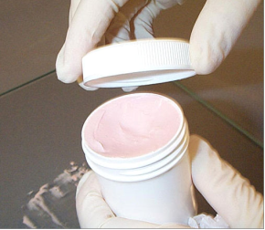
Creams

LAB. FOUR
Creams
Creams are semisolid preparations for external use, they are either o/w or w/o emulsion, medically divided into:-
1. Non-medicated creams which are used as emollient.
2. Medicated creams which are contain one or more medicinal agents. Medicated creams find primary application in topical skin products and in products used rectally and vaginally.

Note: Creams that containing less than 45% of water are w/o cream and those containing more than 45% of water are o/w cream.
Cold cream USP
R_{X}
Spermaceti 125g
White wax 120g
Mineral oil (liquid paraffin) 560g
Sodium borate 5g
Purified water 190g
Method of preparation:
- Reduce spermaceti and white wax to small pieces and melt them on steam bath with mineral oil (liquid paraffin) and raise temperature to 70C°.
- Dissolve borax (sodium borate) in water and heat to 73C°.
- Gradually add warm solution to the melted mixture and stir rapidly and continuously until congealed.
Note:
- Cold cream is emulsion of w/o type (water ˂ 45%).
- It is called cold cream because of the cooling effect that produced from the evaporation of water when this cream is applied to the skin.
- In cold cream the emulsifying agent is formed by reaction between the alkaline sodium borate and the free fatty acids in white wax.
- Cold cream is used as emollient.
Vanishing cream
R_{X}
Stearic acid 15g
White wax 2g
White petrolatum 8g
Potassium hydroxide 1.5g
Propylene glycol 8g
Purified water 65.5g
Method of preparation:
- Stearic acid is melted in water bath and heated up to 85Ċ.
- The oil soluble or miscible substances are added to melted stearic acid.
- Water containing the alkali or any other water soluble ingredient is also heated to 85Ċ then adds it to the oil with stirring.
- The temperature should be maintained 10-15 min.to ensure completion of reaction between stearic acid and alkali.
- Cool the cream slowly with stirring.
- Add perfume.
Note:
- Vanishing cream is o/w emulsion since:
- the alkali (KOH) is monovalent.
- the water contain is > 45 %.
- Since vanishing and cold creams are soap emulsions, they are incompatible with acidic substances because it destroys the soap and breaks the emulsion.

