Chronic heart failure
results from deficiency in the heart's function as a pump, where the delivery of blood, and therefore oxygen and nutrients, becomes inadequate for the needs of the tissues.
In chronic heart failure, the physiological mechanisms that aim to maintain adequate tissue perfusion become counterproductive and contribute to the progressive nature of the condition.
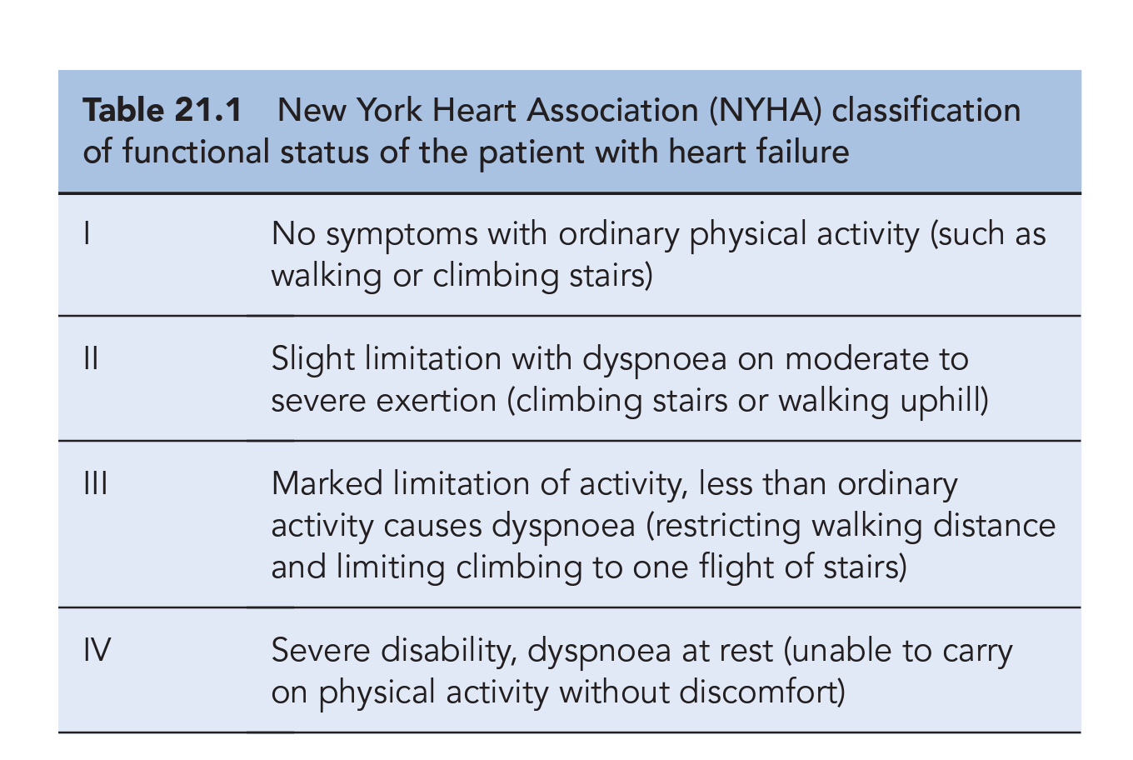
Patients with heart failure usually have their functional status assessed and categorised using the New York Heart Association (NYHA) classification system shown in Table 21.1.

Aetiology

The common underlying aetiologies in patients with heart failure are coronary artery disease and hypertension. The appropriate management of these predisposing conditions is also an important consideration in controlling heart failure in the community. Identifiable causes of heart failure include aortic stenosis, cardiomyopathy, mechanical defects such as cardiac valvular dysfunction, hyperthyroidism and severe anaemia. Conditions that place increased demands on the heart can create a shortfall in cardiac output and lead to intermittent exacerbation of symptoms. Cardiac output may also be compromised by bradycardia or tachycardia, or by a sustained arrhythmia such as that experienced by patients in atrial fibrillation. Improved management of the underlying causes, where appropriate, may alleviate the symptoms of heart failure, whereas the presence of mechanical defects may require the surgical insertion of prosthetic valve(s). While around 50% of patients with heart failure have significant left ventricular systolic dysfunction, the other half is comprised of patients who have either a normal or insignificantly reduced left ventricular ejection fraction (EF), although there is no consensus on the threshold for compromised EF and assessment of each patient relies mainly on clinical symptoms. These patients are referred to as having heart failure with preserved left ventricular ejection fraction (HFPEF). Clinical symptomatic description of chronic heart failure is mild, moderate, or severe heart failure. ‘Mild’ is used for patients who are mobile with no important limitations of dyspnoea or fatigue, ‘severe’ for patients who are markedly symptomatic in terms of exercise intolerance and ‘moderate’ for those with restrictions in between.

Pathophysiology
In health, cardiac output at rest is approximately 5 L/min with a mean heart rate of 70 beats per minute and stroke volume of 70 mL. Since the filled ventricle has a normal volume of 130 mL, the fraction ejected is over 50% of the ventricular contents, with the remaining (residual) volume being approximately 60 mL. In left ventricular systolic dysfunction, the EF is reduced to below 45%, and symptoms are common when the fraction is below 35%, although some patients with a low EF can remain asymptomatic. When the EF falls below 10%, patients have the added risk of thrombus formation within the left ventricle and in most cases anticoagulation with warfarin is indicated.

Co=HR(beat/min) * Sv(vol of blood/min )

Left ventricular systolic dysfunction arises from impaired contractility, and is reflected in a low EF and cardiac dilation. can result from cardiac injury, such as myocardial infarction, or by exposure of the heart muscle to mechanical stress such as long-standing hypertension. This may result in defects in systolic contraction, diastolic relaxation, or both. During systolic contraction, the tension on the ventricular wall is determined by the degree of resistance to outflow at the exit valve and that within the arterial tree, that is, the systemic vascular resistance. Arterial hypertension, aortic narrowing and disorders of the aortic valve increase the afterload on the heart by increasing the resistance against which the contraction of the ventricle must work.

Diastolic dysfunction arises from impairment of the filling process. Diastolic filling is affected by the rate of venous return, and normal filling requires active diastolic expansion of the ventricular volume. The tension on the ventricular wall at the end of diastole is called the preload, and is related to the volume of blood available to be pumped. That tension contributes to the degree of stretch on the myocardium. In diastolic dysfunction, there is impaired relaxation or reduced compliance of the left ventricle during diastole and, therefore, less additional blood is accommodated. In pure diastolic dysfunction, the EF can be normal but cardiac dilation is absent. Sustained diastolic dysfunction, which is a feature in a minority of patients with heart failure, may lead to systolic dysfunction associated with disease progression and left ventricular remodelling (structural changes and/or deterioration).

In the normal heart, a compensatory increase in performance occurs as the stretched myocardium responds through an increased elastic recoil. In the failing heart, this property of cardiac muscle recoiling under stretch is diminished, with the consequence that the heart dilates abnormally to accommodate the increased ventricular load. With continued dilation of the heart the elastic recoil property can become much reduced. Failure of the heart to handle the increasing ventricular load leads to pulmonary and systemic venous congestion. At the same time, the increased tension on the ventricular wall in heart failure raises myocardial oxygen requirements, which increases the risk of an episode of myocardial ischaemia or arrhythmias.
An irreversible increase in cardiac muscle mass, cardiac hypertrophy, occurs with progression of heart failure and is a consequence of long-standing hypertension.
A reflex sympathetic discharge caused by the diminished tissue perfusion in heart failure exposes the heart to catecholamines where positive inotropic and chronotropic effects help to sustain cardiac output and produce a tachycardia.
Reduced renal perfusion due to heart failure leads to increased renin release from the glomerulus in the kidney. Circulating renin raises blood pressure through the formation of angiotensin I and angiotensin II, a potent vasoconstrictor, and renin also prompts adrenal aldosterone release. Aldosterone retains salt and water at the distal renal tubule and so expands blood volume and increases preload. Arginine vasopressin released from the posterior pituitary in response to hypo perfusion adds to the systemic vasoconstriction and has an antidiuretic effect by retaining water at the renal collecting duct.
These secondary effects become increasingly detrimental to cardiac function as heart failure progresses, since the vasoconstriction adds to the afterload and the expanded blood volume adds to the preload. The expanded blood volume promotes the atrial myocytes to release a natural vasodilator, atrial natriuretic peptide (ANP), to attenuate the increased preload. The compensatory mechanisms for the maintenance of the circulation eventually become and are ultimately highly counterproductive, leading to the emergence and progression of clinical signs and symptoms of heart failure.

Clinical manifestations
The reduced cardiac output, impaired oxygenation and diminished blood supply to muscles cause fatigue. Shortness of breath occurs on exertion (dyspnoea) or on lying (orthopnoea). When the patient lies down, the postural change causes abdominal pressure on the diaphragm which redistributes oedema to the lungs, leading to breathlessness. At night the pulmonary symptoms give rise to cough and an increase in urine production prompts micturition (nocturia), which adds to the sleep disturbance. Patients with heart failure may appear pale and their hands cold and sweaty. Reduced blood supply to the brain and kidney can cause confusion and contribute to renal failure, respectively. Hepatomegaly occurs from congestion of the gastro-intestinal tract, which is accompanied by abdominal distension, anorexia, nausea and abdominal pain. In acute heart failure, symptoms of pulmonary oedema are prominent and may be life-threatening. The sputum may be frothy and tinged red from the leakage of fluid and blood from the capillaries.

Investigations
Patients with chronic heart failure are diagnosed and monitored on the basis of signs and symptoms from physical examination, history and an exercise tolerance test. Venous congestion can be demonstrated in the jugular vein of the upright reclining patient by an elevated jugular venous pressure (JVP), which reflects the central venous pressure.
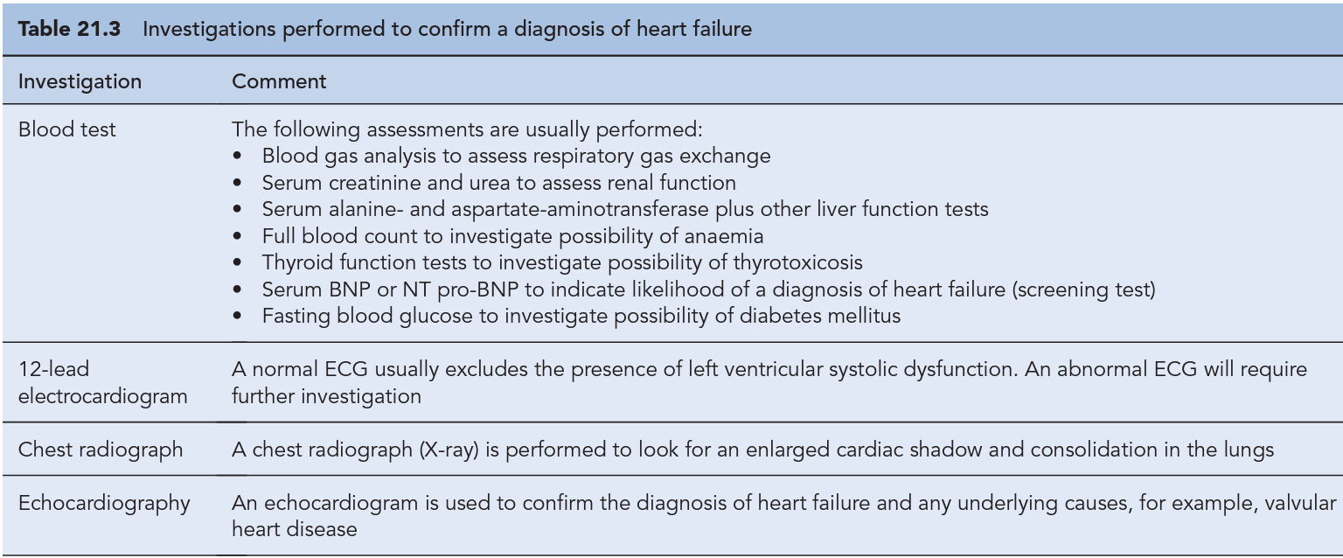

Treatment of heart failure

In heart failure patients with co-morbid conditions known to contribute to heart failure, such as hyperthyroidism, anaemia, atrial fibrillation and valvular heart disease, attention must be given to ensuring these underlying contributing factors are well controlled Tachycardia from atrial fibrillation usually requires control of the ventricular rate through the use of digoxin and/or β-blockers is recommended in such circumstances. In patients with heart failure and preserved EF, diuretics are commonly used for symptom control and there is some limited evidence to suggest that ACE inhibitors can reduce hospitalization. There is consensus that all patients with left ventricular systolic dysfunction should be treated with both an ACE inhibitor and a β-blocker in the absence of intolerance or contraindications. The evidence base for treatment clearly shows that use of an ACE inhibitor (or angiotensin receptor blocker) and β-blocker therapy in patients with heart failure due to left ventricular systolic dysfunction leads to an improvement in symptoms and reduction in mortality

Diuretics
In chronic heart failure, diuretics are used to relieve pulmonary and peripheral oedema by increasing sodium and chloride excretion through blockade of sodium re-absorption in the renal tubule. Thiazides are described as ‘low-ceiling agents’ because maximum diuresis occurs at low doses, and they act mainly on the cortical diluting segment (the point of merger of the ascending limb with the distal renal tubule) at which 5–10% of sodium is normally removed. Although thiazides have some action at this site, they fail to produce a marked diuresis since a compensatory increase in sodium re-absorption occurs in the loop of Henle, and consequently thiazides are ineffective in patients with moderate-to-severe renal impairment (eGFR <30 mL/min) or persisting symptoms. Additionally, doses above the equivalent of bendroflumethiazide 5 mg have an increased risk of adverse metabolic effects with no additional symptomatic benefit. Thiazides are, therefore, now rarely used as sole diuretic therapy and are reserved for cases where the degree of fluid retention is very mild, renal function is not compromised or as an adjunct to' loop diuretics (see below).
Loop diuretics are indicated in the majority of symptomatic patients and most patients will be prescribed one of either furosemide, bumetanide or torasemide in preference to a thiazide. These agents are known as ‘high-ceiling agents’ because their blockade of sodium re-absorption in the loop of Henle continues with increased dose. They have a shorter duration of action (average 4–6 h) compared to thiazides (average 12–24 h), and produce less hypokalaemia. In high doses, however, their intensity of action may produce hypovolaemia with risk of postural hypotension, worsening of symptoms and renal failure. In practice, high doses of furosemide (up to 500 mg/day) may be required to control oedema in patients with poor renal function. In the acute situation, doses of loop diuretics are titrated to produce a weight loss of 0.5–1 kg per day.
In longer term use, patients with heart failure frequently develop some resistance to the effects of loop diuretic due to a compensatory rebound in sodium retention. In this situation, a combination of thiazide and loop diuretics has been shown to have a synergistic effect, even in patients with reduced renal function. In the UK, metolazone is also used as an adjunct to augment the effects of loop diuretics. The potentially profound diuresis produced by such a combination poses serious risks, such as dehydration and hypotension, and patients who are prescribed metolazone in addition to an existing loop diuretic must be carefully monitored. Diuretics also have a mild vasodilator effect that helps improve cardiac function and the intravenous use of loop diuretics reduces preload acutely by locally relieving pulmonary congestion before the onset of the diuretic effect. Intravenous furosemide must be administered at a rate not exceeding 4 mg/min to patients with renal failure, since it can cause ototoxicity when administered more rapidly.

Potential problems with diuretic therapy
The increase in urine volume can worsen incontinence or precipitate urinary retention in the presence of an enlarged prostate, while overuse can lead to a loss of control of heart failure and worsening of symptoms. Rapid diuresis with a loop diuretic leading to more than a 1-kg loss in body weight per day may exacerbate heart failure due to an acute reduction in blood volume, hypotension and diminished renal perfusion, with a consequent increase in renin release. Prolonged and excessive doses of diuretics can also contribute to symptoms of fatigue as a consequence of electrolyte disturbance and dehydration. The adverse biochemical effects of excessive diuresis include uraemia, hypokalaemia and alkalosis. Diuretic-induced glucose intolerance may affect diabetic control in type 2 diabetes, but more commonly diuretics reveal glucose intolerance in patients who are not diagnosed as being diabetic. Diuretics also increase serum urate leading to hyperuricaemia, although this may not require a change in drug therapy if symptoms of gout are absent (estimated incidence of 2%).Hyponatraemia may occur with diuretics,

ACE inhibitors
ACE inhibitors are indicated as first-line treatment for all grades of heart failure due to left ventricular systolic dysfunction, including those patients who are asymptomatic. These agents exert their effects by reducing both the preload and afterload on the heart, thereby increasing cardiac output. ACE inhibitors act upon the renin–angiotensin–aldosterone system, and they reduce afterload by reducing the formation of angiotensin II, a potent vasoconstrictor in the arterial system. These drugs also have an indirect effect on sodium and water retention by inhibiting the release of aldosterone and vasopressin, thereby reducing venous congestion and preload. When an ACE inhibitor is prescribed, it is important to ensure that the dose is started low and increased gradually, paying close attention to renal function and electrolyte balance. The dose should be titrated to achieve the target dose that has been associated with long-term benefits shown in clinical trials or (if not possible) the maxi-mum tolerable dose. In patients at particular risk of hypotension, a test dose of the shorter-acting agent captopril can be given to assess suitability for treatment before commencing long-term treatment with a preferred ACE inhibitor. Once it has been established that the ACE inhibitor can be initiated safely, the preferred option would be to switch to a longer acting agent with once- or twice-daily dosing, starting with a low dose which would be gradually titrated upwards to the recommended target although careful monitoring of the patient should be under-taken during initiation and subsequent dose titration. If the increase in the patient's serum creatinine is >100% from baseline, the ACE inhibitor should be stopped, intolerance confirmed
and specialist advice sought. Where the increase from base-line is 50–100%, the ACE inhibitor dose should be halved and serum creatinine concentration rechecked after 1–2 weeks. ACE inhibitors are potentially hazardous in patients with pre-existing renal disease, as blockade of the renin-angiotensin system may lead to reversible deterioration of renal function. In particular, ACE inhibitors are contraindicated in patients with bilateral renal artery stenosis, in whom the renin- angiotensin system is highly activated to maintain renal perfusion. Fosinopril, which is partially excreted by metabolism, may be the preferred agent in patients with renal failure. ACE inhibitors are also contraindicated in patients with severe aortic stenosis because their use can result in a markedly reduced cardiac output due to decreased filling pressure within the left ventricle

Angiotensin II receptor blockers
Although comparisons of ACE inhibitors and ARBs have shown similar benefits on morbidity and heart failure mortality, only ACE inhibitors have been shown to have positive effects on all cause mortality. ARBs should, therefore, not be used instead of ACE inhibitors, unless the patient experiences intolerable side effects.

Potential problems with ACE inhibitor and ARB therapy
Both agents can predispose patients to hyperkalaemia through a reduction in circulating aldosterone; Heparin therapy has also been shown to increase the risk of hyperkalaemia When initiating ACE inhibitor or ARB therapy, volume depletion due to prior use of a diuretic increases the risk of a large drop in blood pressure occurring following the first dose. dry cough, which may be accompanied by a voice change, occurs in about 10% of patients receiving an ACE inhibitor.

b-Blockers
The use of β-blockers is, therefore, recommended for all patients with heart failure due to left ventricular systolic dysfunction, irrespective of age and the degree of dysfunction. However, due to their negative inotropic effects, β-blockers should only be initiated when the patient's condition is stable. There is insufficient evidence for a class effect to be assumed illustrated by the fact that in one trial, metoprolol tartrate was found to be inferior to carvedilol (COMET, 2003). Currently, nebivolol, bisoprolol and carvedilol are the only licensed β-blockers for the treatment of heart failure in the UK. It is likely that patients will experience a worsening of symptoms during initiation of therapy and, therefore, patients are started on very low doses of β-blocker (e.g. carvedilol 3.125 mg daily) with careful titration occurring over a number of weeks or months with careful monitoring. The goal is to titrate the dose towards those used in clinical trials that have been associated with morbidity and mortality benefits (carvedilol 25–50 mg daily). Table 21.6 summarises the activity and use of β-blockers in heart failure. There is now substantial evidence that β-blockers reduce mortality among patients with mild to-moderate symptomatic heart failure

Aldosterone antagonists
The use of aldosterone antagonists as an adjunct to standard treatment has been shown to have an effect on morbidity and mortality in patients with heart failure. Spironolactone has been shown to reduce mortality and hospitalisation rates in patients with moderate-to-severe heart failure Aldosterone can cause sodium and water retention, sympathetic activation and parasympathetic inhibition, all of which are associated with harmful effects in the patient with heart failure. Aldosterone antagonists counteract these effects by directly antagonising the activity of aldosterone, providing a more complete blockade of the renin–angiotensin– aldosterone system when used in conjunction with an ACE inhibitor. The use of spironolactone is, however, contraindicated in those patients with a serum potassium >5.5 mmol/L or serum creatinine >200 µmol/L. With eplerenone, similar contraindications exist and, therefore, close monitoring of blood biochemistry and renal function must be undertaken for use of either agent.

Digoxin
positive inotropic agent and acts by increasing the availability of calcium within the myocardial cell through an inhibition of sodium extrusion, thereby increasing sodium–calcium exchange and leading to enhanced contractility of cardiac muscle.
Although digoxin has an established role in the control of atrial fibrillation, While the use of digoxin in heart failure in patients in sinus rhythm has no measurable impact on mortality, it reduces the number of hospital admissions Consequently, digoxin is currently recommended for use as add-on therapy at low doses in patients with moderate-to-severe heart failure who remain symptomatic despite adequate doses of ACE inhibitor, β-blocker and diuretic treatment. Due to the lack of effect on mortality, it is unlikely that digoxin would be considered before the other adjunctive therapies available. In patients with atrial fibrillation, the serum digoxin concentration usually needs to be at the higher end of the reference range (0.8–2 µcg/L) or beyond to control the arrhythmia. symptoms associated with digoxin toxicity include nausea, vomiting, confusion and visual disturbances. Digoxin toxicity is more pronounced in the presence of metabolic or electrolyte disturbances and in patients with cardiac ischaemia. Those patients who develop hypokalaemia, hypomagnesaemia, hypercalcaemia, alkalosis, hypothyroidism or hypoxia are at particular risk of toxicity. Digoxin also has the potential to cause fatal arrhythmias. It slows atrioventricular conduction and produces bradycardia, but it may also cause various ventricular and supraventricular arrhythmias.

Nitrates/hydralazine
Nitrates exert their effects in heart failure predominantly on the venous system where they cause venodilation, thereby reducing the symptoms of pulmonary congestion. The preferred use of nitrates is in combination with an arterial vasodilator such as hydralazine, which reduces the afterload, to achieve a balanced effect on the venous and arterial circulation. The combined effects of these two drugs lead to an increase in cardiac output, and there is evidence to show the combination is effective and associated with a reduction in mortality in patients with heart failure

Inotropic agents
The use of inotropic agents (except digoxin) is almost exclusively limited to hospital practice, where acute heart failure may require the use of one or more inotropic agents, particularly the sympathomimetic agents dobutamine and dopamine, in an intravenous continuous infusion.
These agents have inotrope-vasodilator effects which differ according to their action on α, β1, β2 and dopamine receptors (β1-agonists increase cardiac contractility, β2-agonists produce arterial vasodilation, dopamine agonists enhance renal perfusion). With dopamine, low doses (0–2 µcg/kg/min) have a predominant effect on dopamine receptors within the kidneys to improve urine output, intermediate doses (2–5 µcg/kg/min) affect β1-receptors, producing an inotropic effect, and high doses (10 µcg/kg/min) have a predominant action on α-adrenoreceptors. Dobutamine has a predominantly inotropic and vasodilator action due to the action of the (+) isomer selectively on β-adrenoreceptors
Noradrenaline (norepinephrine) is an α-adrenoreceptor agonist where its vasoconstrictor action limits its usefulness in severely hypotensive patients such as those in septic shock. Adrenaline (epinephrine) has β1, β2 and α-adrenoreceptor agonist effects and is used in patients with low vascular resistance. However, it is more arrhythmogenic than dobutamine and should be used with caution.

Other agents
Direct-acting vasodilators such as sodium nitroprusside are rarely used except in the acute setting when they are given by continuous infusion. Vasodilation occurs as a result of the catalysis of nitroprusside in vascular smooth muscle cells to produce nitric oxide. diltiazem and verapamil, can exacerbate co-existing heart failure, since their negative inotropic effects offset the potentially beneficial arterial vasodilation. Second-generation dihydropyridines such as amlodipine and felodipine have a preferential action on the vasculature. They have less pronounced effects on cardiac contractility than other calcium antagonists, and this makes them the agents of choice where a limitation of the heart rate is not required.

Guidelines
All guidelines confirm that ACE inhibitors and β-blockers should be given to all patients with all grades of heart failure, whether symptomatic or asymptomatic, in the absence of contraindication or intolerance. In ACE inhibitor-intolerant patients, the preferred alternative is an ARB. If an ARB is an unsuitable alternative, the use of hydralazine/nitrate combination or digoxin could be considered, although the latter combination of agents has no effect on mortality. For patients with symptomatic heart failure, a loop diuretic is usually recommended to treat oedema and control symptoms. In heart failure patients who are still symptomatic despite being on optimum therapy (ACE inhibitor, β-blocker with/without a diuretic), the use of adjunctive therapies is recommended which can include ARB, aldosterone antagonists, hydralazine/nitrate combination and digoxin where the patient is still in sinus rhythm.

Patient care

See table 21.8 & 21.9

