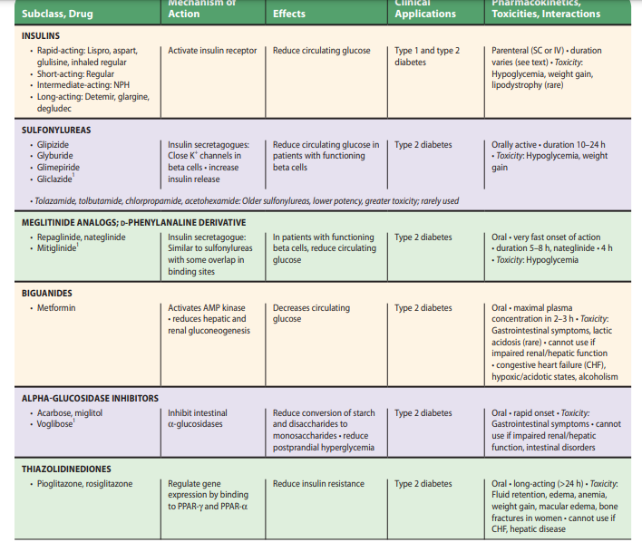

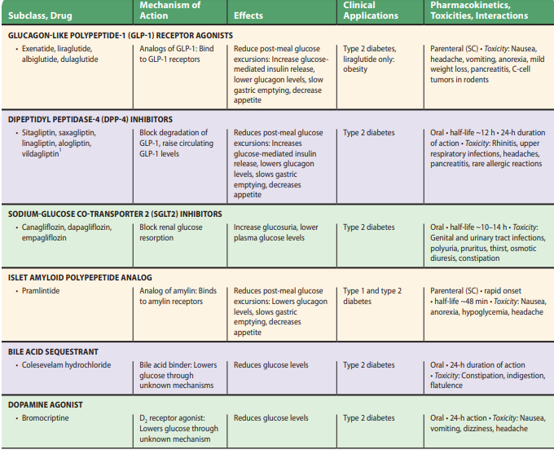

- If the A1C target is not achieved after approximately 3 months, metformin can be combined with any one of the preferred six treatment options: sulfonylurea, thiazolidinedione, DPP-4 inhibitor, SGLT2 inhibitor, GLP-1 RA, or basal insulin; the choice of which agent to add is based on drug-specific effects and patient factors.
- Drug choice is based on avoidance of side effects, particularly hypoglycemia and weight gain, cost, and patient preferences (48).

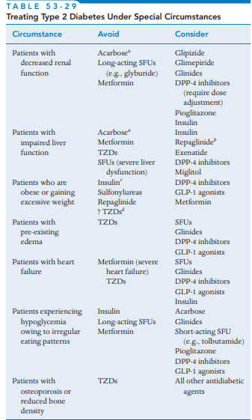

- Although most patients prefer oral medications to drugs that need to be injected, the eventual need for the greater potency of injectable medications is common, particularly in people with a longer duration of diabetes.
- The addition of basal insulin, either human NPH or one of the long-acting insulin analogs, to oral agent regimens is a well-established approach that is effective for many patients. In addition, recent evidence supports the utility of GLP-1 RAs in patients not reaching glycemic targets with use of non-GLP-1 RA oral agent regimens.
- While most GLP-1 RA products are injectable, an oral formulation of semaglutide is now commercially available (49). In trials comparing the addition of an injectable GLP-1 RAs or insulin in patients needing further glucose lowering, the efficacy of the two treatments was similar (50–52).
- However, GLP-1 RAs in these trials had a lower risk of hypoglycemia and beneficial effects on body weight compared with insulin, albeit with greater gastrointestinal side effects. Thus, trial results support injectable GLP-1 RAs as the preferred option for patients requiring the potency of an injectable therapy for glucose control (Fig. 9.2).
- However, high costs and tolerability issues are important barriers to the use of GLP-1 RAs.

