College of Pharmacy
Fourth year. Clinical Pharmacy
Infectious Diseases
Infective Meningitis
Introduction
Central nervous system (CNS) infections include a wide variety of clinical conditions and etiologies: meningitis, meningoencephalitis, encephalitis, brain and meningeal abscesses, and shunt infections. The focus of this lecture is meningitis.

Pathophysiology
1-The critical first step in the acquisition of acute bacterial meningitis is nasopharyngeal colonization of the host by the bacterial pathogen.

2-Most cases of acute bacterial meningitis probably occur following bacteremia, but the high incidence of pneumococcal meningitis in patients with sinusitis and otitis media suggests that direct spread to the CNS can also occur.

3-CNS infections may be caused by a variety of bacteria, fungi, viruses, and parasites. The most common causes of bacterial meningitis are Streptococcus pneumoniae, group B Streptococcus, Neisseria meningitidis, Haemophilus influenzae, and Listeria monocytogenes.

4-The neurologic sequelae of meningitis occur due to the activation of host inflammatory pathways.

5-These events lead to cerebral edema, elevated intracranial pressure, cerebrospinal fluid (CSF) pleocytosis, decreased cerebral blood flow, cerebral ischemia, and death.

6-Passive and active exposure to cigarette smoke and the presence of a cochlear implant that includes a positioner both increase the risk of bacterial meningitis.

Clinical presentation
1-Signs and symptoms of acute bacterial meningitis include fever, nuchal rigidity, altered mental status, chills, vomiting, photophobia, and severe headache.

2-Up to 95% of patients exhibit at least two of the following symptoms: fever, nuchal rigidity, headache, and altered mental status.

3-Kernig and Brudzinski signs may be present but are poorly sensitive and frequently absent in children.

4-Clinical signs and symptoms in young children may include bulging fontanelle, apnea purpuric rash, and convulsions.

5-Purpuric and petechial skin lesions typically indicate meningococcal involvement, although the lesions may be present with H. influenza meningitis. Rashes rarely occur with pneumococcal meningitis.

6-Meningitis causes changes in CSF fluid, and these changes can be used as diagnostic markers of infection (Table1).

7-CSF culture is the gold standard for diagnosis of bacterial meningitis .

8-Gram stain is a rapid, inexpensive, and accurate method to assess the presence of bacteria in CSF. However, prior antibiotic therapy may cause the Gram stain and CSF culture to be negative, but the antibiotic therapy rarely affects CSF protein or glucose.

9-Polymerase chain reaction (PCR) techniques can rapidly diagnose CNS infections and may be particularly useful in patients who have received antimicrobial therapy before lumbar puncture, have negative cultures, or when the organism is fastidious or fails to grow in conventional culture.

Table 1: Mean Values of the Components of Normal and Abnormal Cerebrospinal Fluid
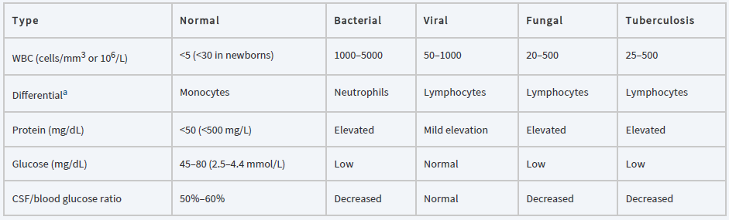
aInitial cerebrospinal fluid (CSF), white blood cell (WBC) count may reveal a predominance of polymorphonuclear neutrophils (PMNs). In CNS infection due to tuberculosis, “therapeutic paradox” may occur in which a lymphocytic predominance becomes neutrophilic during antituberculous treatment.

Treatment
1-Goals of Treatment: Eradication of infection with amelioration of signs and symptoms preventing morbidity and mortality.

2-Key elements include initiating appropriate antimicrobials, providing supportive care, and preventing disease through timely introduction of vaccination and chemoprophylaxis.

3-Administration of fluids, electrolytes, antipyretics, and analgesics may be indicated for patients presenting with a possible CNS infection.

4-Additionally, venous thromboembolism prophylaxis, antiepileptic therapy, and ICP monitoring may be needed.

Pharmacologic Therapy
1-Empiric antimicrobial therapy should be instituted as soon as possible to eradicate the causative organism (Table-2). Antimicrobial therapy should last at least 48–72 hours or until the diagnosis of bacterial meningitis can be ruled out.

2-The first dose of antibiotic should not be withheld even when lumbar puncture is delayed or neuroimaging is being performed. The time period from suspected diagnosis to initiation of antibiotic treatment should not exceed 1 hour.

Table 2: Bacterial Meningitis: Most Likely Etiologies and Empiric Therapy by Age Group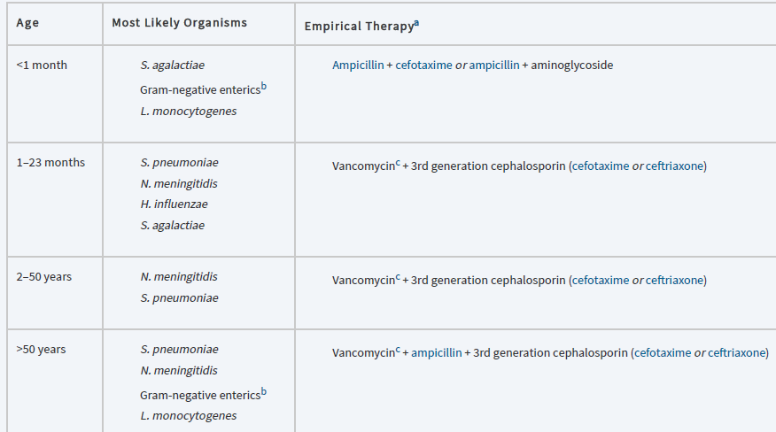

3-Continued therapy should be based on the assessment of clinical improvement, cultures, and susceptibility testing results. Once a pathogen is identified, antibiotic therapy should be tailored to the specific pathogen.

4-With increased meningeal inflammation, there will be greater antibiotic penetration (Table-3). Problems of CSF penetration can be overcome by direct instillation of antibiotics intrathecally or intraventricularly.

5-Advantages of direct instillation, however, must be weighed against the risks of invasive CNS procedures and adverse effects. Intraventricular delivery may be necessary in patients who have shunt infections that are difficult to eradicate or who cannot undergo the surgical components of therapy.

6-See (Table-4) for antimicrobial agents of first choice and alternatives for treatment of meningitis caused by gram-positive and gram-negative microorganisms.

Table 3: Penetration of Anti-infective Agents into the CSF
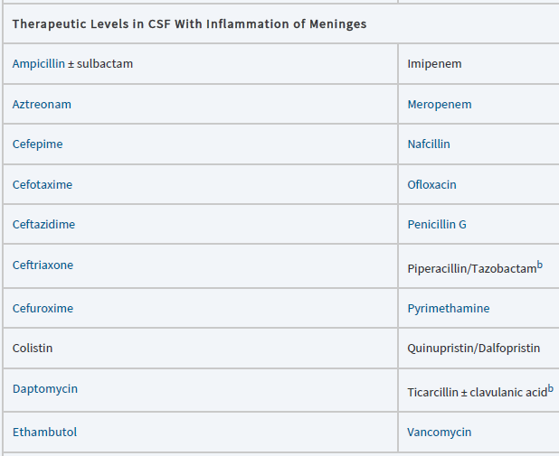
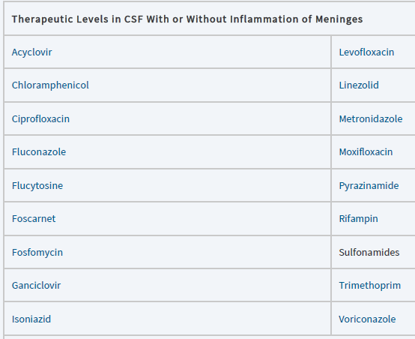
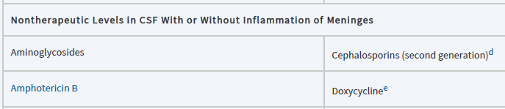
a Using recommended CNS dosing and compared to MIC of target pathogens. b May not achieve therapeutic levels against organisms with higher MIC, as in P. aeruginosa. Tazobactam does not penetrate the blood-brain barrier. c Includes clavulanic acid, sulbactam, and tazobactam. d Cefuroxime is an exception. e Documented effectiveness for B. burgdorferi. f Achieves therapeutic concentrations for Cryptococcus neoformans therapy.

7-Meningitis caused by S. pneumoniae has been treated successfully with 10–14 days of antibiotic therapy, while cases caused by N. meningitidis or H. influenzae usually can be treated with a 7-day course.

8-In contrast, a longer duration (21 days or more) has been recommended for patients with L. monocytogenes, Gram-negative or pseudomonal meningitis. Nonetheless, antibiotic treatments for bacterial meningitis should be individualized, and some patients may require enduring courses.

Table 4: Antimicrobial Agents of First Choice and Alternative Choice for Treating Meningitis Caused by Gram-Positive and Gram-Negative Microorganisms
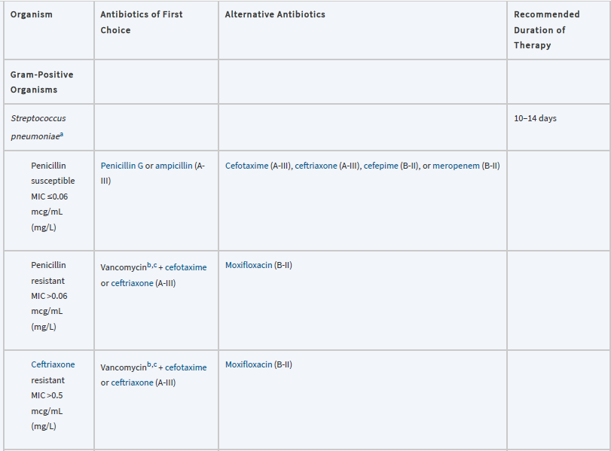
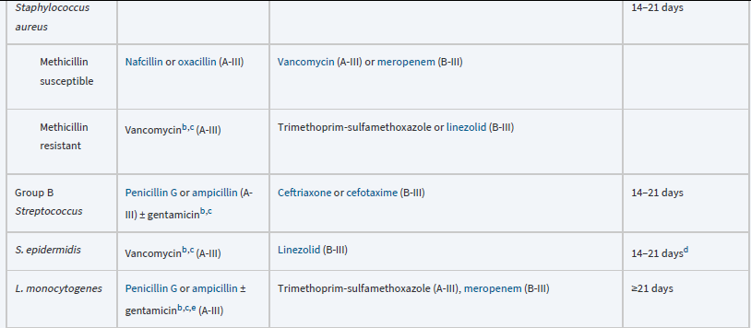
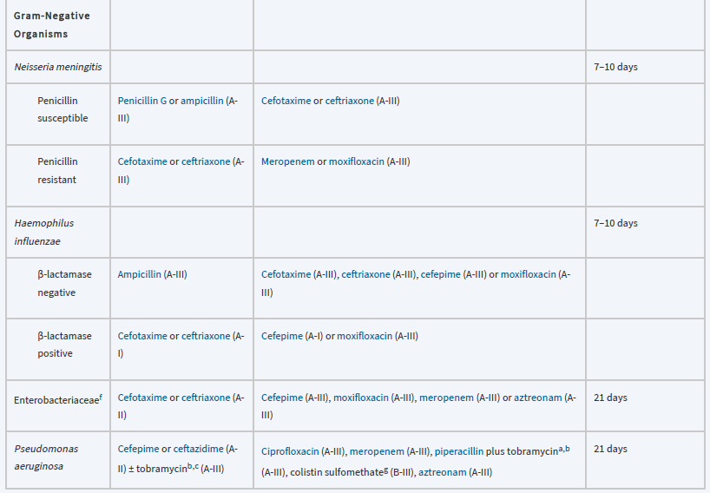
Dexamethasone as an Adjunctive Treatment for Meningitis
1-In addition to antibiotics, dexamethasone is a commonly used adjunctive therapy in the treatment of acute bacterial meningitis to immunomodulate the inflammatory response.

2-Recommendations call for the use of adjunctive dexamethasone in infants and children (6 weeks of age and older) with H. influenzae meningitis. The recommended intravenous dose is 0.15 mg/kg every 6 hours for 2–4 days, initiated 10–20 minutes prior to or concomitant with the first dose of antibiotics.

3-In infants and children with pneumococcal meningitis, adjunctive dexamethasone may be considered after weighing the potential benefits and possible risks.

4-If pneumococcal meningitis is suspected or proven, adults should receive dexamethasone 0.15 mg/kg (up to 10 mg) every 6 hours for 2–4 days with the first dose administered 10–20 minutes prior to first dose of antibiotics.

Neisseria meningitidis (Meningococcus)
1-N. meningitidis is a leading cause of bacterial meningitis among children and young adults around the world. It is spread by direct person-to-person close contact, including respiratory droplets and pharyngeal secretions.

2-The presence of petechiae may be the primary clue that the underlying pathogen is N. meningitidis. Patients may also have an obvious or subclinical picture of disseminated intravascular coagulation (DIC).

3-Deafness unilaterally, or more commonly bilaterally, may develop early or late in the disease course.

4-Third-generation cephalosporins (ie, cefotaxime and ceftriaxone) are the recommended empiric treatment for meningococcal meningitis.

5-Penicillin G or ampicillin is recommended for penicillin-susceptible isolates. The recommended duration of therapy is typically 7 days if there is good clinical response.

6-Antimicrobial chemoprophylaxis of close contacts should be started as soon as possible (ideally <24 hours after identification of the patient). In general, rifampin, ceftriaxone, and ciprofloxacin are recommended for prophylaxis; however, there is an increase in rifampin-resistant and ciprofloxacin-resistant isolates.

Streptococcus pneumoniae (Pneumococcus or Diplococcus)
1-Streptococcus group B (GBS) is a leading cause of neonatal meningitis around the world. Neurologic sequelae include sight or hearing loss and cerebral palsy.

2-Universal prenatal screening and intrapartum antimicrobial prophylaxis of GBS-colonized pregnant women decreases the rate of early onset invasive disease.

3-Recommended agents for intrapartum prophylaxis are penicillin or ampicillin, cefazolin (if penicillin allergy and not at high risk for anaphylaxis), or Vancomycin (if penicillin allergy and at high risk for anaphylaxis).

4-Ampicillin plus an aminoglycoside is the treatment of choice for a newborn infant with presumptive early-onset GBS meningitis. For empirical therapy of late-onset meningitis, ampicillin and an aminoglycoside or cefotaxime is recommended.

5-Ampicillin or penicillin G is the recommended agent in adults. Addition of an aminoglycoside could also be considered.

6-For infants with uncomplicated meningitis, 14 days of treatment is satisfactory, but longer periods of treatment may be necessary for patients with prolonged or complicated courses. For adults, the recommended duration of antibiotics is 14–21 days.

Haemophilus influenzae
1-Widespread vaccination of infants and children has effectively decreased the incidence of bacterial meningitis due to Hib in children between the ages of 1 month and 5 years, resulting in a significant decline in all cases of bacterial meningitis.

2-Third-generation cephalosporins (cefotaxime and ceftriaxone) are the drugs of choice for empirical therapy for H. influenzae type b meningitis as they are active against β-lactamase–producing and non-β-lactamase–producing strains. Cefepime and fluoroquinolones are suitable alternatives regardless of β-lactamase activity.

3-Recommended duration of treatment is 7 days (adults) or 7–10 days (children).

4-Dexamethasone is beneficial for treatment of infants and children with Hib meningitis to diminish the risk of hearing loss, if given before or concurrently with the first dose of antimicrobial agent(s).

5-Chemoprophylaxis with rifampin is indicated to reduce the risk of secondary invasive Hib disease in close contacts by eliminating nasopharyngeal and oropharyngeal carriages of H. influenzae.

6-Rifampin should be administered orally, once a day for 4 days (20 mg/kg/dose; maximum, 600 mg).

Listeria monocytogenes
1-L. monocytogenes is implicated in approximately 10% of meningitis cases in patients older than 65 years of age and carries a case-fatality rate of approximately 18% in the United States.

2-Treatment of L. monocytogenes meningitis should consist of penicillin G or ampicillin. The addition of aminoglycoside is also recommended in proven infection in both children and adults.

3-Patients should be treated a minimum of 21 days. Trimethoprim–sulfamethoxazole and meropenem may be effective alternatives because adequate CSF penetration is achieved with these agents.

Reference
Joseph T. DiPiro, Robert L. Pharmacotherapy: A Pathophysiologic Approach,
11th Edition. 2021.

