Generating Power Station
What is a power generating station?
Power generating station (i.e. power plants) is special plants with a set of components that have the ability to generate bulk electric power.
A generating station ( fig.1) essentially employs a prime mover coupled to an alternator for the production of electric power.
- The prime mover (e.g., steam turbine, water turbine etc.) converts energy from some other form into mechanical energy.
- Alternator converts mechanical energy of the prime mover into electrical energy.
- The electrical energy produced by the generating station is transmitted and distributed with the help of conductors to various consumers.

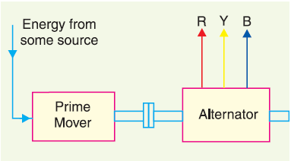

Fig.1schdual of A generating station
What are the sources of electric energy?
Since electrical energy is produced from energy available in various forms in nature, it is desirable to look into the various sources of energy. These sources of energy are:

- The Sun (ii) The Wind (iii) Water……( Renewable energy)
(iv) Fuels (v) Nuclear energy……….. (Classical energy)

Depending upon the form of energy converted into electrical energy, the generating stations are classified as under:
- Steam power stations
- Hydroelectric power stations
- Diesel power stations
- Gas station
- Nuclear power stations
- Wind power station
- Solar cell (Photovoltage cell)
Types of generating stations:

- Steam Power Station (Thermal Station): A generating station which converts heat energy of coal combustion into electrical energy is known as a steam power station.

A steam power station basically works on the Rankine cycle. Steam is produced in the boiler by utilizing the heat of coal combustion. The steam is then expanded in the prime mover (i.e., steam turbine) and is condensed in a condenser to be fed into the boiler again. The steam turbine drives the alternator which converts mechanical energy of the turbine into electrical energy.

1.1 Schematic Arrangement of Steam Power Station

Although steam power station simply involves the conversion of heat of coal combustion into electrical energy, yet it embraces many arrangements for proper working and efficiency.
The schematic arrangement of a modern steam power station can be divided into the following stages for the sake of simplicity:
1. Coal and ash handling arrangement
2. Steam generating plant
3. Steam turbine
4. Alternator
5. Feed water
6. Cooling arrangement

1. Coal and ash handling arrangement

- From the coal storage plant, coal is delivered to the coal handling plant where it is pulverized (i.e., crushed into small pieces) in order to rapid combustion without using large quantity of excess air.
- The coal is burnt in the boiler.
- Ash handling then delivered to the ash storage plant
- in a thermal station, about 50% to 60% of the total operating cost consists of fuel
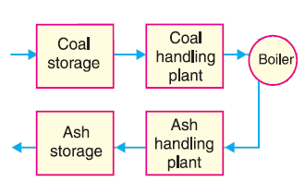
purchasing and its handling.

- Steam generating plant, it is consists of Boiler with Other auxiliary equipment :

Boiler: Place of burning coal, the heat of combustion of coal in the boiler is utilized to
convert water into steam at high temperature and pressure.

Other auxiliary equipment for the utilization of flue gases are:

- Superheater. The steam produced in the boiler is wet and is passed through a superheater where it is dried and superheated (i.e., steam temperature increased above that of boiling point of water) by the flue gases on their way to chimney.

Superheating provides two principal benefits:
* Firstly, the overall efficiency is increased.
*Secondly, avoided blade corrosion of steam turbine

- Economiser. used for extracts a part of heat of flue gases to increase the feed water
temperature before supplying to the boiler.

- Air preheater. The air preheater extracts heat from flue gases and increases the
temperature of air used for coal combustion.

The principal benefits of preheating the air are:
- Increased thermal efficiency
- Increased steam capacity per square meter of boiler surface.
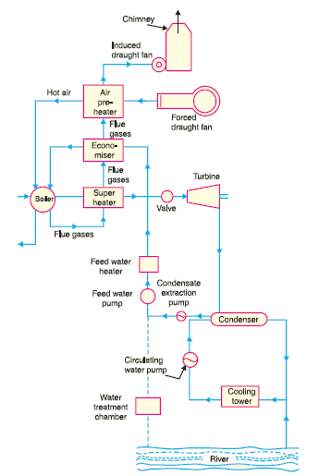
3. Steam turbine. The dry and superheated steam from the super heater is fed to
the steam turbine through main valve. The heat energy of steam when passing over the blades of turbine is converted into mechanical energy.

4. Alternator. The steam turbine is coupled to an alternator. The alternator converts mechanical energy of turbine into electrical energy. The electrical output from the alternator is delivered to the bus bars through transformer, circuit breakers and isolators.

5. Feed water. The condensate from the condenser is used as feed water to the boiler. Some
water may be lost in the cycle which is suitably made up from external source.

6. Cooling arrangement. In order to improve the efficiency of the plant, the steam exhausted from the turbine is condensed* by means of a condenser.

1.3 Efficiency of Steam Power Station
The overall efficiency of a steam power station is quite low (about 29%) due mainly to two reasons.
*Firstly, a huge amount of heat is lost in the condenser.
*Secondly heat losses occur at various stages of the plant.

- Thermal efficiency. The ratio of heat equivalent of mechanical energy transmitted to the turbine shaft to the heat of combustion of coal is known as thermal efficiency of steam power station.
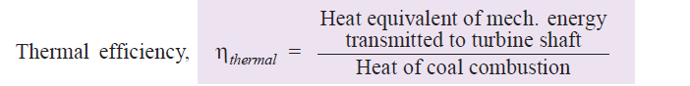

The thermal efficiency of a modern steam power station is about 30%. It means that if
100 calories of heat is supplied by coal combustion, then mechanical energy equivalent of 30 calories will be available at the turbine shaft and rest is lost. It may be important to note that more than 50% of total heat of combustion is lost in the condenser. The other heat losses occur in flue gases, radiation, ash etc.

- Overall efficiency. The ratio of heat equivalent of electrical output to the heat of combustion of coal is known as overall efficiency of steam power station i.e. Overall efficiency,

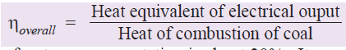

The overall efficiency of a steam power station is about 29%. It may be seen that overall efficiency is less than the thermal efficiency. This is expected since some losses (about 1%) occur in the alternator. The following relation exists among the various efficiencies.

Overall efficiency = Thermal efficiency . Electrical efficiency

- Hydro-electric Power Station
A generating station which utilises the potential energy of water at a high level for the generation of electrical energy is known as a hydro-electric power station.

Constituents of Hydro-electric Plant
The constituents of a hydro-electric plant are
(1) Hydraulic structures
(2) Water turbines and
(3) Electrical equipment. We shall discuss these items in turn.

1. Hydraulic structures. Hydraulic structures in a hydro-electric power station include dam, spillways, headworks, surge tank, penstock and accessory works

- Dam. A dam is a barrier which stores water and creates water head.
- spillways are constructed of concrete piers on the top of the dam, used to discharge
the surplus water from the storage reservoir into the river on the down-
stream side of the dam.
- Headworks. The headworks consists of the diversion structures at the head of an intake. They generally include valves for controlling the flow of water to the turbine.
- Surge tank. Open conduits leading water to the turbine
require no* protection. However, when closed conduits are used, protection becomes necessary to limit the abnormal pressure in the conduit. For this reason, closed conduits are always provided with a surge tank. A surge tank is a small reservoir or tank (open at the top) in which water level rises or falls to reduce the
pressure swings in the conduit

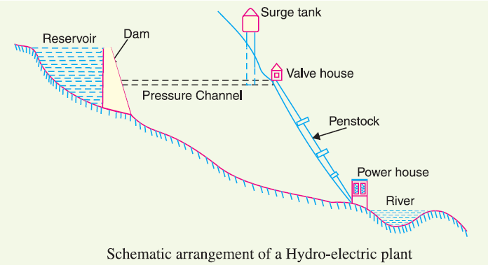

2. Water turbines. Water turbines are used to convert the energy of falling water into mechanical energy. The principal types of water turbines are :
(i) Impulse turbines (ii) Reaction turbines
(i) Impulse turbines. Such turbines are used for high heads.

- Reaction turbines. Reaction turbines are used for low and medium heads.
The important types of reaction turbines are :
(a) Francis turbines is used for low to medium heads.
(b) Kaplan turbines is used for low heads and large quantities of water.

3. Electrical equipment. The electrical equipment of a hydro-electric power station includes alternators, transformers, circuit breakers and other switching and protective devices.

- Diesel Power Station
A generating station in which diesel engine is used as the prime mover for the generation of electrical energy is known as diesel power station.
In a diesel power station, diesel engine is used as the prime mover. The diesel burns inside the engine and the products of this combustion act as the “working fluid” to produce mechanical energy.
The diesel engine drives the alternator which converts mechanical energy into electrical energy. These plants are also used as standby sets for continuity of supply to important points such as hospitals, radio stations, cinema houses and telephone exchanges.

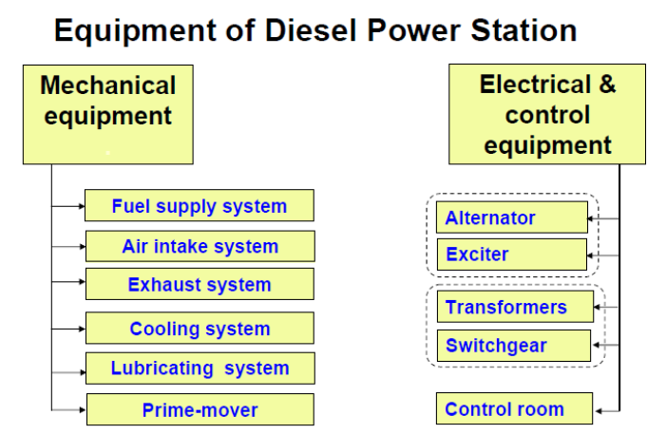

- Nuclear Power Station
A generating station in which nuclear energy is converted into electrical energy is known as a nuclear power station.
In nuclear power station, heavy elements such as Uranium (U235) or Thorium (Th232) are subjected to nuclear fission* in a special apparatus known as a reactor. The heat energy thus released is utilised in raising steam at high temperature and pressure. The steam runs the steam turbine which converts steam energy into mechanical energy. The turbine drives the alternator which converts mechanical energy into electrical energy.

Schematic Arrangement of Nuclear Power Station
The schematic arrangement of a nuclear power station is shown in Fig.. The whole arrangement can be divided into the following main stages :
- Nuclear reactor (ii) Heat exchanger (iii) Steam turbine (iv) Alternator.
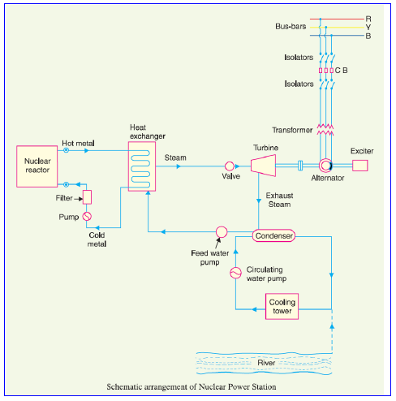

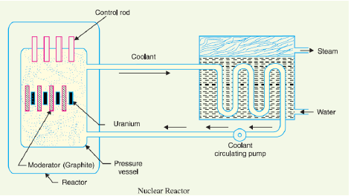

Q. what are the difference between the composition of steam and nuclear plants?

Steam plants | Nuclear plants
- Thermal station | 1.Thermal station
- A boiler is closed vessel in which water is converted into steam by utilising the heat of coal combustion.  - Using speed governor to make  pm = pe | 2. Nuclear reactor is a special apparatus in which water is converted into steam by utilising the heat of Uranium (U235)) fission.  - Using moderator & control rods to make pm = pe

Q. what are the moderator & control rods in Nuclear reactor?
1. The moderator consists of graphite rods . The moderator slows down the neutrons
before they bombard the fuel rods.
2.The control rods are of cadmium is strong neutron absorber and thus regulates the supply of neutrons for fission.

When the control rods are pushed in deep enough, they absorb most of fission neutrons and hence few are available for chain reaction which, therefore, stops.

However, as they are being withdrawn, more and more of these fission neutrons cause fission and hence the intensity of chain reaction (or heat produced) is increased.

Therefore, by pulling out the control rods, power of the nuclear reactor is increased, whereas by pushing them in, it is reduced. In actual practice, the lowering or raising of control rods is accomplished automatically according to the requirement of load. Q. what are the mechanisms that used to cover instantaneously variable load demand in Steam , Hydro station , Nuclear station

- Steam station using speed governor valve.
- Hydro station using gate of turbine that controlled by governor.
- Nuclear station using moderator & control rods.

5. Gas Turbine Power Plant
A generating station which employs gas turbine as the prime mover for the generation of electrical energy is known as a gas turbine power plant

Turbine
Compressed
air
Exhust (500)ºc
(700-1100)ºc
Pressure & hot

Combustion
Chamber
˜
Combustion
Chamber
Fuel

*In a gas turbine power plant, air is used as the working fluid.

*Gas turbine power plants are being used as standby plants for hydro-electric stations,
as a starting plant for driving auxiliaries in power plants etc.

6. WIND POWER GENERATION TECHNOLOGY
Due to rapid increase in the population and standard of living, we are faced with energy crisis. Conventional sources of energy are increasingly depleted. Hence, non-conventional Energy Sources have emerged as potential source of energy in world at large.
Among the various non-conventional energy sources, wind energy is emerging as the potential major source of energy for growth.

WIND POWER
Wind possesses energy by virtue of its motion .Any device capable of slowing down the mass of moving air can extract part of the energy and convert into useful work.
Following factors control the output of wind energy converter: -
 The wind speed
 Cross-section of the wind swept by rotor
 Conversion efficiently of rotor
 Generator
 Transmission system

PRINCIPLE OF ENERGY CONVERSION
Wind mills or turbines works on the principle of converting kinetic energy of the wind in to mechanical energy.
Power available from wind mill}= ½ ρA V³
Where, ρ – air density = 1.225 Kg. / m³ at sea level.(changes by 10-15% due to
temperature and pressure variations)
A – area swept by windmill rotor = ΠD² sq-m. (D – diameter )
V – wind speed m/sec.
Air density, which linearly affects the power output at a given speed, is a function of altitude, temperature and barometric pressure. Variation in temperature and pressure can affect air density up to 10 % in either direction. Warm climate reduces air density.
This equation tells us that maximum power available depends on rotor diameter. The combined effects of wind speed and rotor diameter can be observed by the following graph
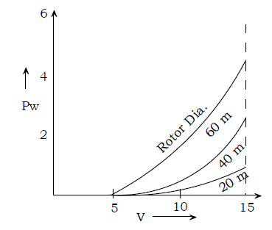

This graph indicates that wind machines should have large rotors and should be located in areas of high wind speeds. Practically, wind turbines are able to convert only a fraction of available wind power into useful power.

GENERATING SYSTEM
Wind - electric conversion system consists of the following components:-
1) Wind Turbine(WT)- Converts wind energy into rotational(mechanical) energy

2) Gear system and coupling (G/C)- It steps up the speed and transmits it to the generator rotor

3) Generator(G)- Converts rotational energy into electrical energy.

Types of generators used:-
- For Small rating systems - P.M.type d.c. generators
- Medium rating systems - P.M.type d.c. generators
- Induction generators
- Synchronous Generators
- Large rating systems - Induction generators (3-phase )
- Synchronous Generators (3 phase)

4) Controller(C)-Senses wind direction, wind speed generator output and temperature and initiates appropriate control signals to take control action.

5) Yaw motor gear- The area of the wind stream swept by the wind turbine is maximum when blades face into the wind. Alignment of the blade angle with respect to the wind direction to get maximum wind energy can be achieved with the help of yaw control that rotates wind turbine about the vertical axis.

In smaller wind turbines, yaw action is controlled by tail vane whereas, in larger turbines, it is operated by servomechanism.
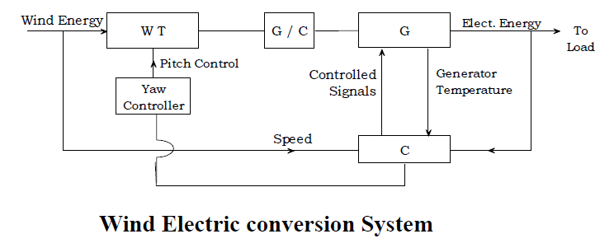

Practically, Wind power generating system ratings are divided into three groups:-
- Small up to 1KW
- Medium 1 KW to 50 KW
- Large 200KW to Megawatts

ENERGY STORAGE
Wind power turbines have operational limitations over very high and very low
speeds. When the power generated exceeds the demand, excess energy can be
stored to be used at other times.
- Excess energy can be conveniently stored in storage batteries in the form of
chemical energy.
- Excess energy can also be stored in water power storage in the form of
mechanical energy. Wind power plant (WPP) along with Hydroelectric power
plant (HPP), when generated power (Pg) exceeds the power demand (Pd), helps
to partly divert hydro power plant output to Pumping motor (PM) to pump water
from an auxiliary reservoir at the bottom of the dam to main reservoir.
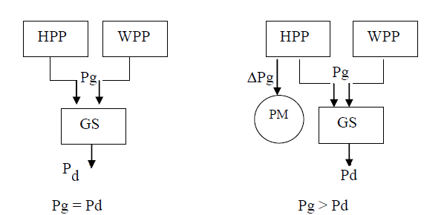

- Excess energy can also be stored in the form of compressed air.

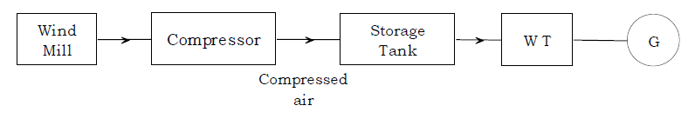

When wind is not blowing, energy stored in compressed air could be used to drive wind turbine whose shaft would then drive a generator, thus supplying the needed power.

7. Photovoltaic (PV) cells.

Photovoltaic (PV) systems convert sunlight directly into electricity, and are potentially one of the most useful of the renewable energy technologies.
The heart of a photovoltaic system is a solid-state device called a solar cell.
Groups of solar cells can be packaged into modules, panels and arrays to provide useful output voltages and currents to provide a specific power output.

Construction of Solar cells
- They are constructed by layering special materials called semiconductors into thin, flat sandwiches.
- These are linked by electrical wires and arranged on a panel of a stiff, non-conducting material such as glass. The panel itself is called a module.
- Modules are then interconnected, in series or parallel, or both, to create an array with the desired peak DC voltage and current.
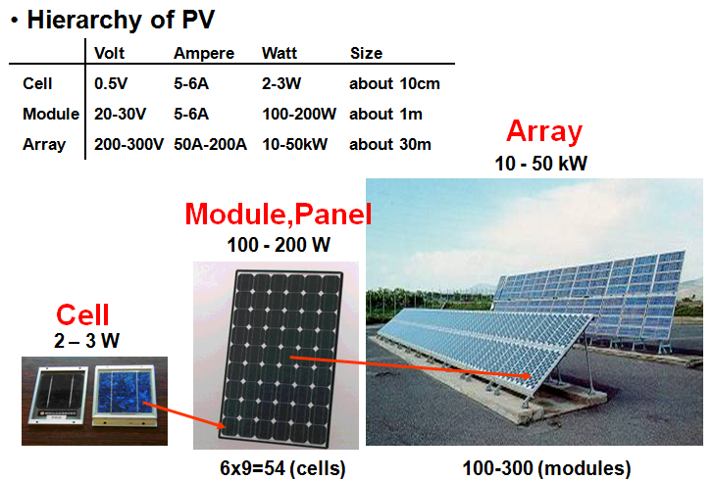
Q. How much PV can we install in this conference room?
Please remember that 1 kw PV need 10 m2

How Solar cells work
1. A solar cell is a sandwich of n-type silicon (blue) and p-type silicon (red).
2. When sunlight shines on the cell, photons (light particles) bombard the upper surface.
3. The photons (yellow dot) carry their energy down through the cell.
4. The photons give up their energy to electrons (green dot) in the lower, p-type layer.
5. The electrons use this energy to jump across the barrier into the upper, n-type layer and escape out into the circuit.
6. Flowing around the circuit, the electrons make the lamp light up.
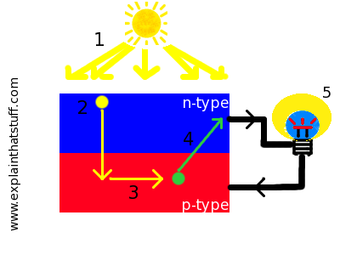

1. Theory of I-V Characterization
PV cells can be modeled as a current source in parallel with a diode. When there is no light present to generate any current, the PV cell behaves like a diode. As the intensity of incident light increases, current is generated by the PV cell, as illustrated in Figure 1.

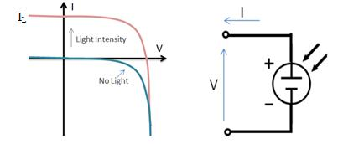
I-V Curve of PV Cell and Associated Electrical Diagram
In an ideal cell, the total current I is equal to the current Iℓ generated by the photoelectric effect minus the diode current ID, according to the equation:
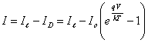
where I₀ is the saturation current of the diode
q is the elementary charge 1.6x10⁻¹⁹ Coulombs
k is a constant of value 1.38x10⁻²³J/K
T is the cell temperature in Kelvin
and V is the measured cell voltage that is either produced (power quadrant) or applied (voltage bias).
Expanding the equation gives the simplified circuit model shown below and the following associated equation, where n is the diode ideality factor (typically between 1 and 2), and R_{S} and R_{SH} represents the series and shunt resistances that are described the dissipation of power across internal resistances.
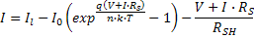

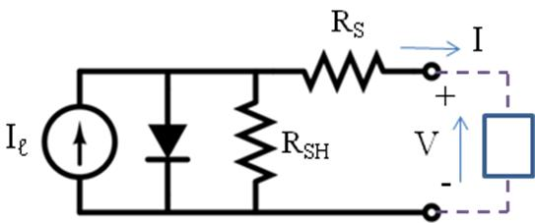
Simplified Equivalent Circuit Model for a Photovoltaic Cell
Solar Cell I-V Characteristic Curve
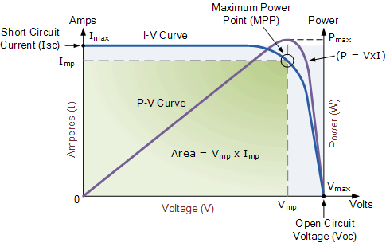
The above graph shows the current-voltage ( I-V ) characteristics of a typical silicon PV cell operating under normal conditions. The power delivered by a solar cell is the product of current and voltage ( I x V ). If the multiplication is done, point for point, for all voltages from short-circuit to open-circuit conditions, the power curve above is obtained for a given radiation level.
With the solar cell open-circuited, that is not connected to any load, the current will be at its minimum (zero) and the voltage across the cell is at its maximum, known as the solar cells open circuit voltage, or Voc. At the other extreme, when the solar cell is short circuited, that is the positive and negative leads connected together, the voltage across the cell is at its minimum (zero) but the current flowing out of the cell reaches its maximum, known as the solar cells short circuit current, or Isc.
Then the span of the solar cell I-V characteristics curve ranges from the short circuit current ( Isc ) at zero output volts, to zero current at the full open circuit voltage ( Voc ). In other words, the maximum voltage available from a cell is at open circuit, and the maximum current at closed circuit. Of course, neither of these two conditions generates any electrical power, but there must be a point somewhere in between were the solar cell generates maximum power.
However, there is one particular combination of current and voltage for which the power reaches its maximum value, at Imp and Vmp. In other words, the point at which the cell generates maximum electrical power and this is shown at the top right area of the green rectangle. This is the "maximum power point"
or MPP. Therefore the ideal operation of a photovoltaic cell (or panel) is defined to be at the maximum power point.
The maximum power point (MPP) of a solar cell is positioned near the bend in the I-V characteristics curve. The corresponding values ofVmp and Imp can be estimated from the open circuit voltage and the short circuit current: Vmp ≅ (0.8–0.90)Voc and Imp ≅ (0.85–0.95)Isc. Since solar cell output voltage and current both depend on temperature, the actual output power will vary with changes in ambient temperature.
Thus far we have looked at Solar Cell I-V Characteristic Curve for a single solar cell or panel. But many photovoltaic arrays are made up of smaller PV panels connected together. Then the I-V curve of a PV array is just a scaled up version of the single solar cell I-V characteristic curve as shown.

Solar Panel I-V Characteristic Curves
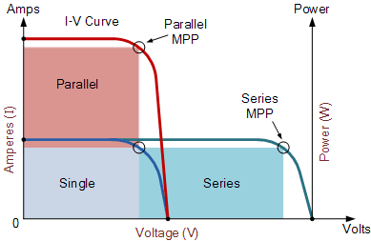

Photovoltaic panels can be wired or connected together in either series or parallel combinations, or both to increase the voltage or current capacity of the solar array. If the array panels are connected together in a series combination, then the voltage increases and if connected together in parallel then the current increases. The electrical power in Watts, generated by these different photovoltaic combinations will still be the product of the voltage times the current, ( P = V x I ). However the solar panels are connected together, the upper right hand corner will always be the maximum power point (MPP) of the array.

Solar Array Parameters
- V_{OC} = open-circuit voltage: – This is the maximum voltage that the array provides when the terminals are not connected to any load (an open circuit condition). This value is much higher than Vmp which relates to the operation of the PV array which is fixed by the load. This value depends upon the number of PV panels connected together in series.
- I_{SC} = short-circuit current – The maximum current provided by the PV array when the output connectors are shorted together (a short circuit condition). This value is much higher than Imp which relates to the normal operating circuit current.
- MPP = maximum power point – This relates to the point where the power supplied by the array that is connected to the load (batteries, inverters) is at its maximum value, where MPP = Imp x Vmp. The maximum power point of a photovoltaic array is measured in Watts (W) or peak Watts (Wp).
- FF = fill factor – The fill factor is the relationship between the maximum power that the array can actually provide under normal operating conditions and the product of the open-circuit voltage times the short-circuit current, ( Voc x Isc ) This fill factor value gives an idea of the quality of the array and the closer the fill factor is to 1 (unity), the more power the array can provide. Typical values are between 0.7 and 0.8.
- percent efficiency – The efficiency of a photovoltaic array is the ratio between the maximum electrical power that the array can produce compared to the amount of solar irradiance hitting the array. The efficiency of a typical solar array is normally low at around 10-12%, depending on the type of cells (monocrystalline, polycrystalline, amorphous or thin film) used.

