**Variable Load on Power Stations**

On one hand, the power engineer would like that the alternators in the power station should run at their rated capacity for maximum efficiency and on the other hand, the demands of the consumers have wide variations from time to time due to uncertain demands of the consumers. This makes the design of a power station highly complex. We shall focus our attention on the problems of variable load on power stations.

**Q. What are the effects of variable load on power station?**

(i) Need of additional equipment.

(ii) Increase in production cost.

**Load Curves:**

The curve showing the variation of load on the power station with respect to (w.r.t) time is known as a **load curve**.

There are different types of load curve:

1. Daily load curve.
2. Monthly load curve.
3. Yearly load curve.

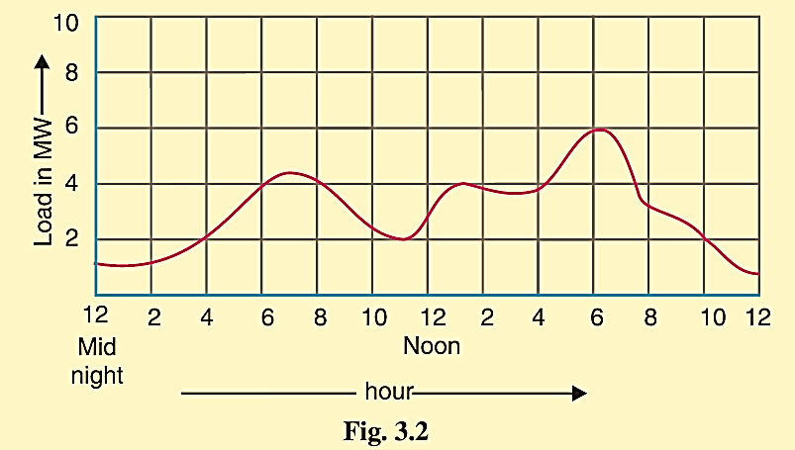

Figure (3-1) shows the typical daily load curve

***Q. What is the importance*** **of the daily load curves**?

* The daily load curve shows the variations of load on the power station during different hours of the day.
* The area under the daily load curve gives the number of units generated in the day**.**
* The highest point represents the maximum demand on the station on that day.
* The area under the daily load curve divided by the total number of hours gives

**the average load** on the station in the day

$$avarage load= \frac{Area (in kWh) under daily load curve}{24 hours}$$

* The ratio of the area under the load curve to the total area of rectangle in which it is contained gives the **load factor** i.e.
$$load factor=\frac{Average load}{Max. demand}= \frac{Average load 24}{Max. demand 24}$$

$$=\frac{Area (in kWh) under daily load curve}{Total area of rectangle in which the load curve is contained}$$

* The load curve helps in selecting* the size and number of generating units.
* The load curve helps in preparing the operation schedule** of the station.

**Notes**

**\*** The number and size of the generating units are selected to fit the load curve. This helps in operating the generating units at or near the point of maximum efficiency.

** It is the sequence and time for which the various generating units (*i.e.,* alternators) in the plant will be put in operation.

***Important Terms and Factors:***

***(i) Connected load.*** It is the sum of continuous ratings of all the equipment's connected to supply system. For instance, if a consumer has connections of five 100-watt lamps and a power point of 500 watts, then connected load of the consumer is (5 × 100 + 500 = 1000) watts. The sum of the connected loads of all the consumers is the connected load to the power station.

***(ii) Maximum demand:*** It is the greatest demand of load on the power station during a given period.

Referring back to the load curve of Fig. 3.1, the maximum demand on the power station during the day is 6 MW and it occurs at 6 P.M. Maximum demand is generally less than the connected load because all the consumers do not switch on their connected load to the system at a time.

**Q. What is the importance of the maximum demand** **knowledge?**

It is very important as it helps in determining the installed capacity of the station,

the station must be capable of meeting the maximum demand.

***(iii) Demand factor***. It is the ratio of maximum demand on the power station to its

connected load i.e.,

$$Demand Factor=\frac{Max. Demand}{Connected Load}……(usually less than 1$$

The knowledge of demand factor is vital in determining the capacity of the plant equipment.

***(iv) Average load***. The average of loads occurring on the power station in a given period (day or month or year) is known as average load or average demand.

$$Daily average Load=\frac{No. of units (kWh) generated in a day}{24 hours}$$

$$Monthly average Load= \frac{No. of units (kWh) generated in a month}{Number of hours in a month}$$

$$Yearly average Load= \frac{No. of units (kWh) generated in a year}{8760 hours}$$

***(v) Load factor***: The ratio of average load to the maximum demand during a given period is known as load factor i.e.,

$Load Factor=\frac{Average load}{Max. demand}$

If the plant is in operation for T hours then:

$Load Factor=\frac{Average load×T}{Max. demand×T}=\frac{Units generated in T hours}{Max. demand ×T hours}……..($ less than 1)

**Q. What is the relation between the load factor of the power station and the cost per unit generated?**

Higher load factor means lesser maximum demand. The station capacity is so selected

that it must meet the maximum demand. Now, lower maximum demand means lower capacity of the plant which, therefore, reduces the cost of the plant.

1. ***Diversity factor***. The ratio of the sum of individual maximum demands to the maximum demand on power station is known as diversity factor i.e.,

$$Diversity factor= \frac{Sum of individual max. demands}{Max. demand on power station}$$

diversity factor will always be greater than 1. The greater the diversity factor, the lesser is the cost of generation of power.

**Q. What is the effect of increasing diversity factor between generating units?**

Greater diversity factor means lesser maximum demand. This in turn means that lesser

plant capacity is required. Thus, the capital investment on the plant is reduced.

1. ***Plant capacity factor***. It is the ratio of actual energy produced to the maximum possible energy that could have been produced during a given period i.e.

$$Plant capacity factor=\frac{Actual energy produced}{Max. energy that could have been produced}$$

$$=\frac{Average demand ×T^{**}}{Plant capacity ×T}= \frac{Average demand}{Plant capacity}$$

**T in hours, If T for one year then:

$$Annual plant capacity factor=\frac{Annual KWh output}{Plant capacity*8760}$$

The plant capacity factor is an indication of the reserve capacity of the plant. A power station is so designed that it has some reserve capacity for meeting the increased load demand in future. Therefore, the installed capacity of the plant is always somewhat greater than the maximum demand on the plant.

Reserve capacity = Plant capacity − Max. Demand

The plant will have no reserve capacity when plant capacity equal to max. Demand.

1. ***Plant use factor***. It is ratio of kWh generated to the product of plant capacity and the number of hours for which the plant was in operation i.e.

$$Plant use factor= \frac{Station output in kWh}{Plant capacity ×Hours of use }$$

Suppose a plant having installed capacity of 20 MW produces annual output of 7·35 × 106 kWh and remains in operation for 2190 hours in a year. Then,

$$Plant use factor= \frac{7·35 × {10}^{6}}{(20×{10}^{6} )×2190}=0.167=16.7\%$$

***Units Generated per Annum***

It is often required to find the kWh generated per annum from maximum demand and load factor. The procedure is as follows:

$$Load Factor=\frac{Average load}{Max. demand}$$

Average load = Max. Demand × L.F.

Units generated/annum = Average load (in kW) × Hours in a year.

= Max. Demand (in kW) × L.F. × 8760.

***Load Duration Curve:***

When the load elements of a load curve are arranged in the order of descending magnitudes, the curve thus obtained is called a load duration curve.

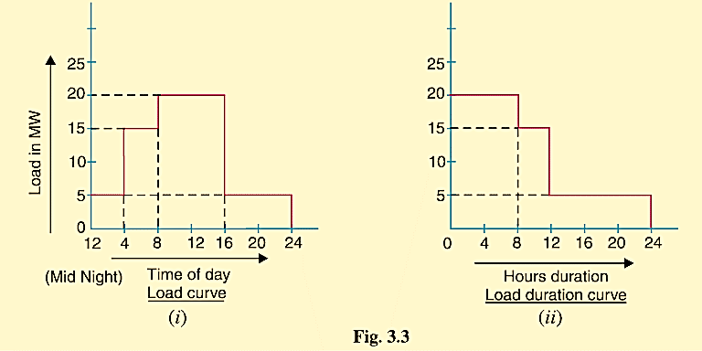

***Types of Loads:*** A device which taps electrical energy from the electric power system is called a load on the system. The load may be resistive (e.g., electric lamp), inductive (e.g., induction motor), capacitive or some combination of them. The various types of loads on the power system are:

1. **Domestic load.**
2. **Commercial load.**
3. **Industrial load.**
4. **Municipal load.**
5. **Irrigation load.**
6. **Traction load.**

***Typical Demand and Diversity Factors***

The demand factor and diversity factor depend on the type of load and its magnitude are tabulate as below:

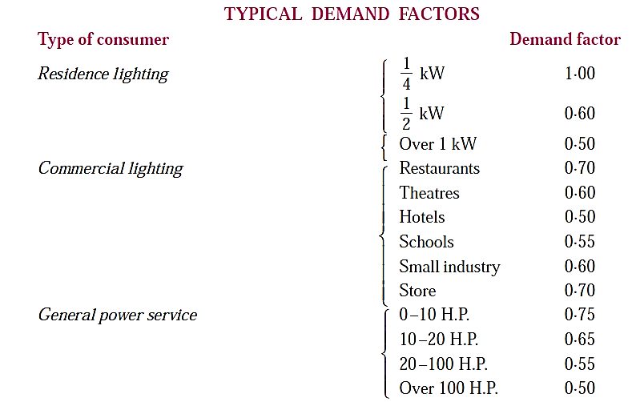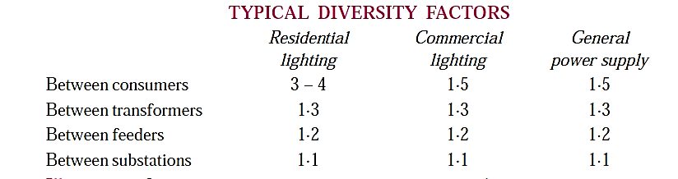

***Illustration:*** Load and demand factors are always less than 1 while diversity factors are more than unity. High load and diversity factors are the desirable qualities of the power system. Indeed, these factors are used to predict the load.

Fig. 3.4 shows a Small part of electric power system where a distribution transformer is supplying power to the consumers. For simplicity, only three consumers a, b, and c are shown in the figure.

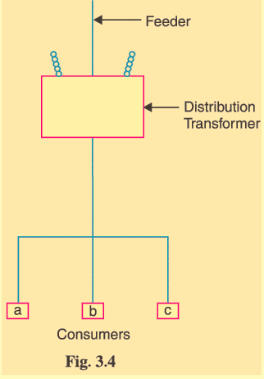

* Maximum demand of consumer a = connected load * the appropriate demand factor
* Maximum demand of consumer b = connected load * the appropriate demand factor
* Maximum demand of consumer c = connected load * the appropriate demand factor
* The diversity factors between the consumers= $\frac{\sum{maximum demands of a,b,c}}{The maximum demand on the transformer }$
* The maximum demand on the transformer = $\frac{\sum{maximum demands of a,b,c}}{ diversity factors between the consumers}$

Similarly,

* The maximum demand on the feeder =

$$\frac{\sum{maximum demands of distribution transformers connected to feeder}}{ diversity factors between the transformers}$$

Likewise diversification between feeders is recognized when obtaining substation maximum demands and substation diversification when predicting maximum load on the power station.

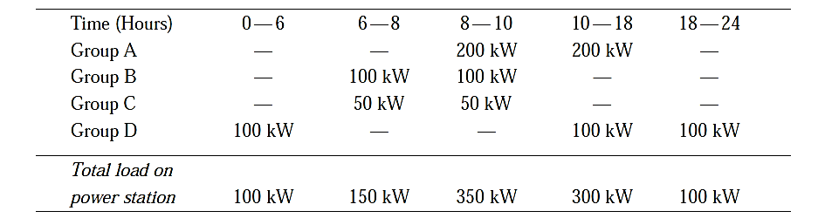The above curve put in this table:

The final results in this curve as shown below:

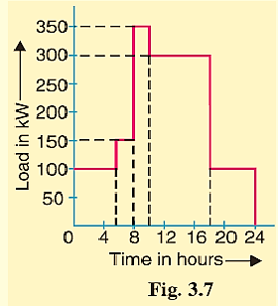

***Load Curves and Selection of Generating Units***

The principle of selection of number and sizes of generating units with the help of load curve is illustrated in Fig. 3.11.

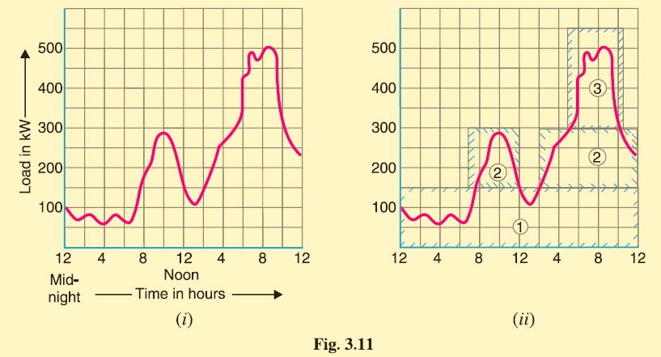

In Fig. 3.11 (i), the annual load curve of the station is shown. It is clear from the curve that

* load on the station has wide variations; the minimum load being somewhat near 50 kW

and maximum load reaching the value of 500 kW.

* the use of a single unit to meet this varying load will be highly uneconomical.
* The total plant capacity is divided into several generating units of different sizes to fit

the load curve. This is illustrated in Fig. 3.11(ii) where the plant capacity is divided into

three* units numbered as 1, 2 and 3. The cyan color outline shows the unit's capacity

being used.

* The three units employed have different capacities and are used according to the

demand on the station. The operating schedule can be as under:

|  |  |
| --- | --- |
| ***Time*** | ***Units in operation*** |
| From 12 midnight to 7 A.M. | Only unit no.1 is put in operation. |
| From 7 A.M. to 12.00 noon | Unit no. 2 is also started so that both units 1 and 2 are in operation. |
| From 12.00 noon to 2 P.M. | Unit no. 2 is stopped and only unit 1operates. |
| From 2 P.M. to 5 P.M. | Unit no. 2 is again started. Now units 1 and 2 are in operation. |
| From 5 P.M. to 10.30 P.M. | Units 1, 2 and 3 are put in operation. |
| From 10. 30 P.M. to 12.00 midnight | Units 1 and 2 are put in operation. |

Thus by selecting the proper number and sizes of units, the generating units can be made to operate near maximum efficiency. This results in the overall reduction in the cost of production of electrical energy.

***Important Points in the Selection of Units:***

While making the selection of number and sizes of the generating units, the following points should be kept in view:

1. The number and sizes of the units should be so selected that they approximately fit the annual load curve of the station.
2. The units should be preferably of different capacities to meet the load requirements. Although use of identical units (i.e., having same capacity) ensures saving (Due to duplication of sizes and dimensions of pipes, foundations etc.)
3. The capacity of the plant should be made 15% to 20% more than the maximum demand to meet the future load requirements.
4. There should be a spare generating unit so that repairs and overhauling of the working units can be carried out.
5. The tendency to select a large number of units of smaller capacity in order to fit the load curve very accurately should be avoided. It is because the investment cost per kW of capacity increases as the size of the units decreases.

***Base Load and Peak Load on Power Station:***

A close look at the load curve reveals that load on the power station can be considered in two parts, namely;  **(*i*)** Base load  **(*ii*)** Peak load

1. **Base load.** *The unvarying load which occurs almost the whole day on the station is known as* base load. Referring to the load curve of Fig. 3.13, it is clear that 20 MW of load has to be supplied by the station throughout 24 hours. Therefore, 20 MW is the base load of the station.
2. **(*ii*) Peak load.** *The various peak demands of load over and above the base load of the station is known as* peak load.

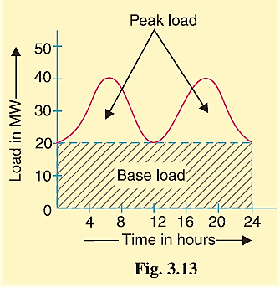

**Method of Meeting the Load**

In order to achieve overall economy, *the best method to meet load is to interconnect two different power stations*. The more efficient plant is used to supply the base load and is known *as base load power station*. The less efficient plant is used to supply the peak loads and is known as *peak load power station*.

**Illustration.**

The interconnection of steam and hydro plants is a beautiful illustration to meet the load. When water is available in sufficient quantity as in summer and rainy season, the hydroelectric plant is used to carry the base load and the steam plant supplies the peak load as shown in Fig 3.14 (i). However, when the water is not available in sufficient quantity as in winter, the steam plant carries the base load, whereas the hydro-electric plant carries the peak load as shown in Fig. 3.14 (ii).



Interconnected Grid System:

*The connection of several generating stations in parallel is known as* **interconnected grid system.** Some of the advantages of interconnected system are listed below:

1. *Exchange of peak loads,*
2. *Use of older plants,*
3. *Ensures economical operation*,

**(*iv*)**  *Increases diversity factor*,

1. *Reduces plant reserve capacity*,

**(*vi*)**  *Increases reliability of supply*.