**Chapter-8**

**Mechanical Design of**

**Overhead Lines**

**Introduction**

**E**lectric power can be transmitted or distributed either by means of

1. Overhead lines (almost used in transmission system)
2. Underground cables (used in distribution system & rarely in transmission system )

Q. The underground cables are rarely used for power transmission

**Firstly**, power is generally transmitted over long distances to load centers. Obviously, the installation costs for underground transmission will be very heavy.

**Secondly**, electric power has to be transmitted at high voltages for economic reasons. It is very difficult to provide proper insulationto the cables to withstand such higher pressures.

***8.1 Main Components of Overhead Lines***

In general, the main components of an overhead line are:

**(*i*)** *Conductors* which carry electric power from the sending end station to the receiving end station.

**(*ii*)** *Supports* which may be poles or towers and keep the conductors at a suitable level above the ground.

**(*iii*)** *Insulators* which are attached to supports and insulate the conductors from the ground.

**(*iv*)** *Cross arms* which provide support to the insulators.

**(*v*)** *Miscellaneous items* such as phase plates, danger plates, lightning arrestors, anti-climbing wires etc.

**Q. Name the important components of an overhead transmission line?**

***8.2 Insulators***

The overhead lines conductors should be supported on the poles or towers in such a way that currents from conductors do not flow to earth through supports. The insulators provide necessary insulation between line conductors and supports and thus prevent any leakage current from conductors to earth.

***Q. Why are insulators used with overhead lines?***

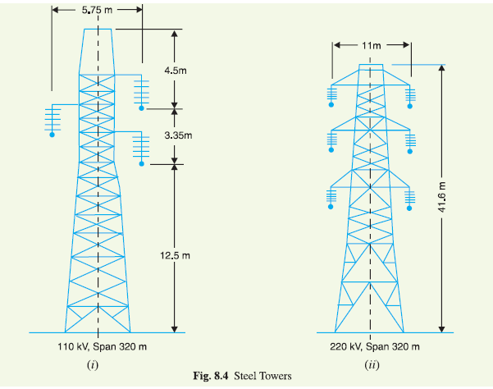

In general, the insulators should have the following desirable properties:

(i) High mechanical strength in order to withstand conductor weight, wind etc.

(ii) High electrical resistance of insulator material in order to avoid leakage currents to earth.

(iii) High relative permittivity of insulator material in order that dielectric strength is high.

(iv) The insulator material should be non-porous, free from impurities and cracks otherwise

the permittivity will be lowered.

(v) High ratio of puncture strength to flashover.

The most commonly used material for insulators of overhead line are porcelain and glass, Porcelain is stronger mechanically than glass, gives less trouble from leakage and is less affected by changes of temperature.

**Q. Discuss the desirable properties of insulators.**

***8.3 Types of Insulators***

The successful operation of an overhead line depends to a considerable extent upon the proper selection of insulators.

There are several types of insulators but the most commonly used are

1. pin type,
2. suspension type,
3. strain insulator and
4. shackle insulator.
5. ***Pin type insulators***. The part section of a pin type insulator is shown in Fig. 8.5 (i).

As the name suggests, the pin type insulator is secured to the cross-arm on the pole.



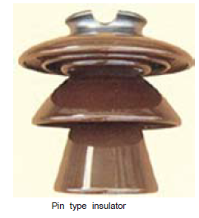

There is a groove on the upper end of the insulator for housing the conductor. The conductor passes through this groove and is bound by the annealed wire of the same material as the conductor [See Fig. 8.5 (*ii*)].

**Pin type insulators are used for transmission and distribution of electric power at voltages upto 33 kV. Beyond operating voltage of 33 kV, the pin type insulators become too bulky and hence uneconomical.**

***Causes of insulator failure.***

Insulators are required to withstand both mechanical and electrical stresses. The latter type is primarily due to line voltage and may cause the breakdown of the insulator. The electrical breakdown of the insulator can occur either by *flash-over* or *puncture.*

**In flashover**, an arc occurs between the line conductor and insulator pin (*i.e*., earth) and the discharge jumps across the *air gaps, following shortest distance. Fig. 8.6i shows the arcing distance (*i.e. a* + *b* + *c*) for the insulator.

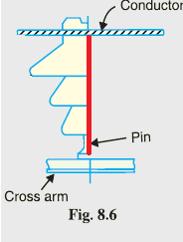

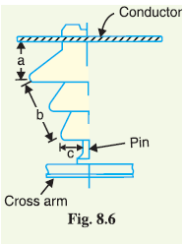

Fig 8.6i

Fig 8.6ii

In case of flash-over, the insulator will continue to act in its proper capacity unless extreme heat produced by the arc destroys the insulator.

**In case of puncture**, Fig. 8.6ii shows the discharge occurs from conductor to pin through the body of the insulator (red line). When such breakdown is involved, the insulator is permanently destroyed due to excessive heat. In practice, sufficient thickness of porcelain is provided in the insulator to avoid puncture by the line voltage. The ratio of puncture strength to flashover voltage is known as safety factor *i.e.,*

$$Safety factor of insulator== \frac{Puncture strength}{Flash over voltage}$$

It is desirable that the value of safety factor is high so that flash-over takes place before the insulator gets punctured. For pin type insulators, the value of safety factor is about 10.

**2. Suspension type insulators**

The cost of pin type insulator increases rapidly as the working voltage is increased. Therefore, this type of insulator is not economical beyond 33 kV. For high voltages (>33 kV), it is a usual practice to use suspension type insulators shown in Fig. 8.7.

They consist of a number of porcelain discs connected in series by metal links in the form of a string. The conductor is suspended at the bottom end of this string while the other end of the string is secured to the cross-arm of the tower. Each unit or disc is designed for low voltage, say 11 kV. The number of discs in series would obviously depend upon the working voltage. For instance, if the working g voltage is 66 kV, then six discs in series will be provided on the string.

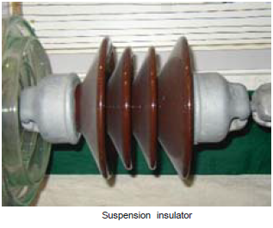

|  |  |
| --- | --- |
| Pin type insulators | Suspension type insulators |
| used for transmission and distribution of electric power at voltages up to 33 kV | used for transmission and distribution of electric power For high voltages (>33 kV) |
| The cost of pin type insulator increases rapidly as the working voltage is increased. | Cheaper than pin type insulators for voltages beyond 33 kV. |
| They consist of one porcelain disc. | They consist of a number of porcelain discs connected in series by metal links in the form of a string |
| If the disc is damaged, the Pin type insulators become useless**.** | If anyone disc is damaged, the whole string does not become useless because the damaged disc can be replaced by the sound one. |
| Does not provides flexibility to the line | provides greater flexibility to the line |
| Cannot be used for higher voltages | It can be used for higher voltages by adding a new discs |

**Q. Compare between Pin & Suspension type insulators**

**8.4 Potential Distribution over Suspension Insulator String**

A string of suspension insulators consists of a number of porcelain discs connected in series through metallic links. Fig. 8.10 (*i*) shows 3-disc string of suspension insulators.

1. The porcelain portion of each disc is in between two metal links. Therefore, each disc forms a capacitor *C* (**known as *mutual capacitance* or *self-capacitance***) 8.10 (*ii*).
2. If there were mutual capacitance alone, then charging current would have been the same through all the discs and consequently voltage across each unit would have been the same *i.e., V*/3 as shown in Fig. 8.10 (*ii*).

$I_{1}=I_{2}=I_{3}……=I_{N}=I_{phase}$ Where N is the number of discs in suspension insulator

$$V_{1}=V_{2}=V_{3}……V_{N }=\frac{V_{phase}}{3}$$

1. However, in actual practice, capacitance also exists between metal fitting of each disc and tower or earth. This is known as ***shunt capacitance******C*1**. Due to shunt capacitance, charging current is not the same through all the discs of the string [See Fig. 8.10 (*iii*)]. Therefore, voltage across each disc will be different.

$I_{1}≠I_{2}≠I_{3}……≠I_{N}≠I_{phase}$

$$V_{1}≠V_{2}≠V_{3}……V_{N }≠\frac{V_{phase}}{3}$$

1. Obviously, the disc nearest to the line conductor will have the maximum* voltage. Thus referring to Fig. 8.10 (*iii*), *V*3 will be much more than *V*2 or *V*1.

${i.e. V}_{3}>V_{2}>V_{1}$

***metal fitting***

***Mutual or self-capacitance***

***Shunt capacitance***

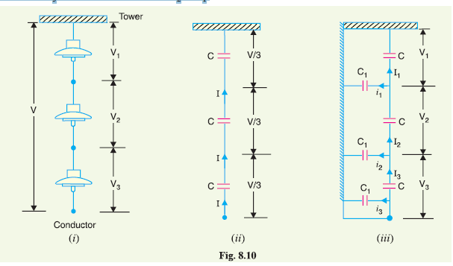

**Q. Give the reasons for unequal potential distribution over a string insulators.**

**8.5 String Efficiency**

As stated above, the voltage applied across the string of suspension insulators is not uniformly distributed across various units or discs. The disc nearest to the conductor has much higher potential than the other discs. This unequal potential distribution is undesirable and is usually expressed in terms of string efficiency.

The ratio of voltage across the whole string to the product of number of discs and the voltage across the disc nearest to the conductor is known as string efficiency i.e.,

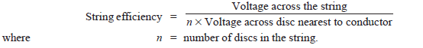

**Q. under any condition the efficiency of suspension insulator reach to100%?**

$$V_{1}=V_{2}=V_{3}……V_{N }=\frac{V_{phase}}{3}$$

$Ƞ=\frac{V_{phase}}{n*Vn}*100\% = \frac{V_{phase}}{V_{phase}}*100\% =100\%$

**8.6 Mathematical expression.** Fig. 8.11 shows the equivalent circuit for a 3-disc string.

Let us suppose that self-capacitance of each disc is *C*.

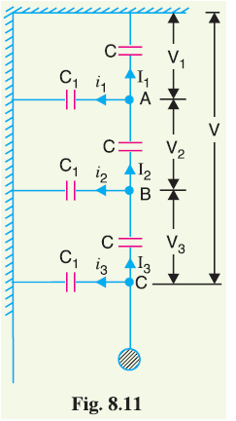

Cross-arm

Conductor

cross-arm

And shunt capacitance is *C*1 = *KC*.

Starting from the cross-arm or tower, the voltage across

each unit is *V*1,*V*2 and *V*3 respectively as shown.

Applying Kirchhoff’s current law to node *A*, we get,

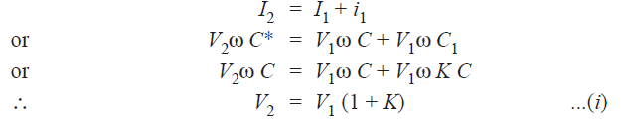

Applying Kirchhoff’s current law to node B, we get,

conductor

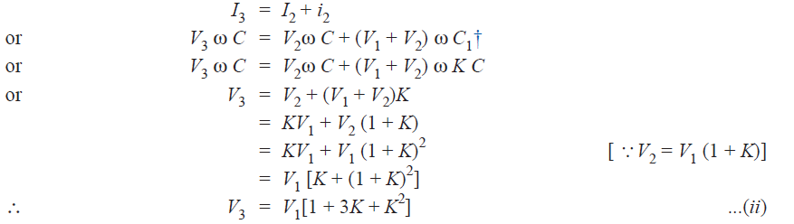

Voltage between conductor and earth (i.e., tower) is

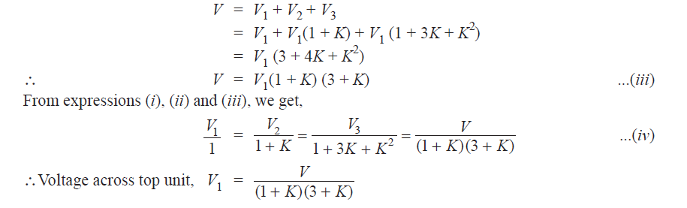

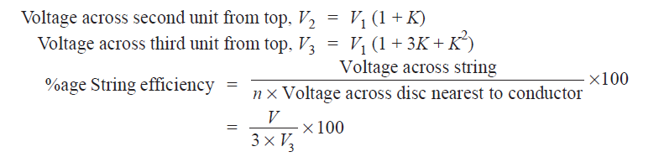

***8.7 Methods of Improving String Efficiency***

It has been seen above that potential distribution in a string of suspension insulators is not uniform. The maximum voltage appears across the insulator nearest to the line conductor and decreases progressively as the cross arm is approached. If the insulation of the highest stressed insulator (*i.e.* nearest to conductor) breaks down or flash over takes place, the breakdown of other units will take place in succession. This necessitates equalizing the potential across the various units of the string *i.e.* to improve the string efficiency.

The various methods for this purpose are :

1. . By using longer cross-arms

Longer cross-arms

increased the distance of conductor from tower

Lesser C1

Lesser K

Improving String Efficiency

**Q**

**C**

**V**

1. *By grading the insulators.*

From triangle Q = C * V

If Q is constant, voltage is inversely proportional to capacitance

The insulators of capacitance graded *i.e.* they are assembled in the string in such a way that

C1< C2 < C3 then, V1> V2 > V3>

This method tends to equalize the potential distribution across the units in the string and improve string efficiency.

1. *By using a guard ring*. The potential across each unit in a string can be equalized by using a guard ring which is a metal ring electrically connected to the conductor and surrounding the bottom insulator as shown in the Fig. 8.13.

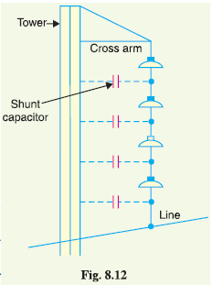

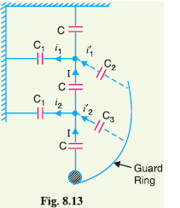

The guard ring introduces capacitance between metal fittings and the line conductor. The guard ring contoured in such a way that shunt capacitance currents *i*1, *i*2 etc. are equal to metal fitting line capacitance currents *i*′1, *i*′2 etc.

The result is that same charging current *I* flows through each unit of string. Consequently, there will be uniform potential distribution across the units.