= + 

Sketch  against *y* result the following figure:

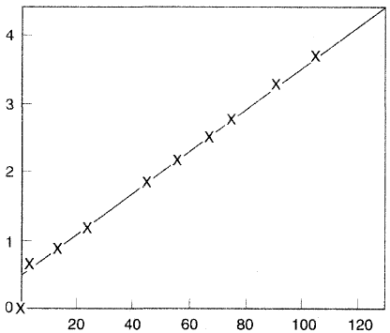

*y* (mm)

Slope: *s* = 

→ *DAB* =  …(*)

From the figure: *s* = 0.031 ks/mm2

*xA*2 = 0 , *xA*1 = 37.6/101.3 = 0.37

*CT* = 1/*V*

  but *P*1 = *P*2

→ *V*2 = = 22.4  = 26.34 m3/kmol

→ *CT* = 1/26.34 = 0.038 kmol/m3 , *MA* = 154 Substitute the above parameters in the Eq. (*)

→ *DAB* =  = 9.12×10-6 m2/s

**Mass transfer theories**

CA or pA

Interface

NA

Ci

Pi

δ1

δ2

CA

Liquid

Gas

1. The two films theory (Whitman, 1923)

This assumes: (1) steady state mass transfer.

i.e.  …..(1)

(2) resistance to mass transfer lies in two films on both sides of the interface.

→Eq.1:  (in gas phase)

Also:  (in liquid phase)

It can rewrite the above equations in the general form:

*NA = kg ∆P*  in gas phase

*NA = kl ∆C* in liquid phase

Note: *∆C = NA. ,* *V = I.R ,* OR *NA = k. ∆C , I = V.*

2. The penetration theory (Higbie, 1935)

This assumes: (1) unsteady state diffusion i.e.  ……(2)

(2) There are clumps of solute molecules arrive at the interface. Some penetrate

interface and more away, others mix back again with the bulk of the original

phase.

The solution of equation (2) for this case:

 interface

Liquid

Gas

I.C. : At t = 0 ; CA = CAo= 0

B.C.(1) : At y = 0 ; CA = Ci

CA=CAo=0

B.C.(2) : At y = ∞ ; CA = CAo = 0 y = ∞

y=0

CA=CAi

This gives the final solution:  For the liquid side

3. Surface Renewal theory (Danckwerts, 1951)

4. The film-penetration theory (Toor & Marchello, 1958)

**Gas-Liquid mass transfer**

(e.g. gas absorption, stripping and transfer of oxygen from air bubble to liquid broth fermentation)

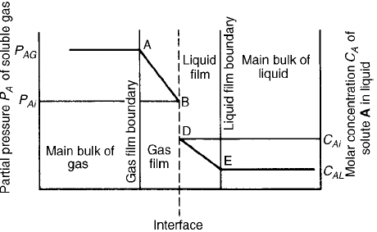

The mole flux of *A* through the gas boundary layer is

*NA = kg* (*CAg - CAgi*) *or NA = kg* (*PA- PAi*) …….(1)

and mole flux of *A* through the liquid boundary layer is

*NA = kl* (*CAli – CAl*) ……..(2)

Now define the over all mass transfer coefficient

*NA = KG* (*PA- *) …(3) used when the resistance to transfer in the gas phase

is larger than in the liquid phase

And

*NA = KL* ( *- CAl*) …(4) used when the resistance to transfer in the liquid phase

is larger than in the gas phase

And Henry’s law *PAi = H.CAli*and *= H.CAl*

From (1) & (3) *kg* (*PA- PAi*) *= KG* (*PA-* )

Or from Eqn 3:

 →

*P*A = H.CAl , PAi = H.CAli*

→

=

→ 

And 















but from eqs 1 & 2





Similarly 

*kg* = gas film mass transfer coefficient (m/s) or (kmol/kN.s)

*kl* = liquid film mass transfer coefficient (m/s)

*KG* = over all mass transfer coefficient on gas basis (kmol/kN.s)

*KL* = over all mass transfer coefficient on liquid basis (m/s)

*CAg* = concentration of A in the bulk gas (kmol/m3)

*CAl* = concentration of A in the bulk liquid (kmol/m3)

*CAgi* = concentration of A at the interface of the gas side (kmol/m3)

*CAli* = concentration of A at the interface of the liquid side (kmol/m3)

*H* = Henry’s constant (find from tables)

= saturation concentration (maximum possible concentration or called solubility of gas in liquid)

*PA*= partial pressure of component A (N/m2)

** = vapor pressure of component A (N/m2)

Note: *CAgi* and *CAli* are difficult to measure so Eqns. 3 & 4 are commonly used.

**Liquid-Liquid mass transfer (e.g. liq.-liq. Extraction)**

The mole flux of *A* in each liquid phase can be obtained as follows:

Film of liquid2

interface

*CA*1*i*

*CA2i*

Film of liquid1

*NA*1 *= kl*1 (*CA1 – CA1i*) ………(1) NA

CA1

Liquid2

*NA2 = kl*2(*CA2i – CA2*) ………(2)

Liquid1

*kl1*= liquid phase mass transfer coefficient in liquid1 CA2

*kl2* = liquid phase mass transfer coefficient in liquid2

*CAi* is the concentration of *A* at the interface and it is difficult to measure it, so assume steady state transport and no accumulation of *A* at the interface. i.e.

*NA1 = NA2 = NA*

Assume no resistance to mass transfer at the interface and the phases are in equilibrium:

 ……..(3)

*m* = equilibrium constant (distribution coefficient or partition coefficient)

From (1) , (2) & (3)



And



*KL*1 = over all liquid phase mass transfer coefficient based on liquid 1 (m/s)

*KL2* = over all liquid phase mass transfer coefficient based on liquid 2 (m/s)

And



= conc. of A in liq.1 which would be in eqlm. with *CA*2 in liq. 2

**Liquid – Solid mass transfer**

(e.g. Catalytic reaction, Leaching, Adsorption of molecules onto surface, Crystallization)

From liquid to solid transfer *NA* = *kl* (*CAo* – *CAi*)

From solid to liquid transfer *NA* = *KL* (– *CAo*)

[if the surface is non porous the transfer is up to surface] Liq-solid interface

*CAo* = concentration of A in the bulk liquid (Kmol/m3 ) *CAo CAi*

*CAi* = concentration of A at the interface ″ ″

= saturation concentration of A ″ ″

Liq

film

**Oxygen uptake in the cell culture**

*= kl a* (*- CAl* )

a: interfacial specific surface area (m2/m3).

**: mass transfer rate per unit volume (kmol/m3s).

*CAl*: O2 conc. in the broth

: O2 conc. in the broth in eqlm. with gas phase (kmol/m3)

(- CA*l*): concentration difference driving force for mass transfer

(- CA*l*) in large scale (e.g. >10 m3 ) is expressed in logarithmic mean conc. difference



Subscript *i* & *o* represent the gas inlet and outlet ends of the vessel, respectively.

O2 solubility in aqueous solution ≈ 10 ppm in ambient temp. & press.

For yeast population with *ρ* = 109 cell/ml, O2 content must be replaced about 12 times/min to keep up with cellular O2 demand.

**The factors affecting cellular O2 demand:**

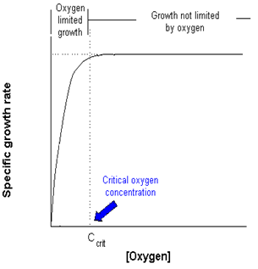

1. Cell species (complex morphology

lead to lower transfer rate)

2. Culture growth phase

3. Nature of carbon source [rate of O2 are

higher when glucose is used than other carbon

containing substrate (lactose or sucrose)]

4. O2 conc. in liq.

**Specific O2 uptake rate:**

Rate of O2 consumption per cell is *q*o (g/g.s):

*Qo = qo x*

*Qo*: O2 uptake per volume (g/l.s)

*x*: cell conc. (g/l)

**The steps for transfer of O2 from gas bubble to cell in fermenter**