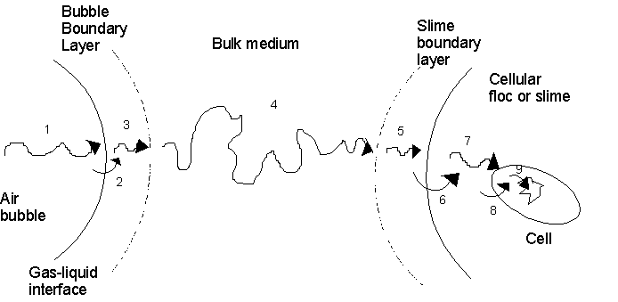

(liq. Film) (liq. Film)

1. Transfer from the interior of the bubble to the gas-liquid interface.

2. Movement across the gas-liquid interface.

3. Diffusion through the bubble boundary layer.

4. Movement through the bulk liquid.

5. Diffusion through the stagnant layer film surrounding the cells.

6. Movement across the liquid-cell interface.

7. If the cells are in floc, clump or solid particle, diffusion through the solid to the individual cell.

8. Transport through the cytoplasm to the site of reaction.

*At steady state*:  *O2 transfer rate from bubbles = O2 consumption rate by cells*

*kl a* (**- *CAl*) = *qo* *x*

[note **or CA*l* are mass conc. (kg/m3)or (g/l)]

For constant cell metabolism (O2 consumption), if *kla* is increased (such as by stirrer speed to reduce the δ around the bubbles), *CAl* must be rise in order to balance the eqn. above.

Maximum cell conc. *x*max is obtained when (**- *CAl*) is maximum i.e. when CA*l* = 0



*Note:* The maximum cell concentration obtained by heat transfer 

= ,

*TF*=fermenter Temp. , *TCi* = cooling water Temp., *U* = over all heat transfer coefficient

*A* = heat transfer area, *V* = fermenter volume,

If *x*max estimated is less than *x*required , *kl a* must be improved

If *x*max is small and *x*'max is large → mass transfer operations are more limit biomass growth.

If *x*max and *x*'max > *x*required  → mass and heat are adequate.

Note: It is undesirable for cell density to be limited by rate of mass transfer.

Minimum (k*l* a) or ( k*l* a )crit is estimated as

 (minimum *kl a* required to maintain CA*l* > Ccrit )

Notes:

* O2 transfer in fermenter depends on *kl* or (and) on (- CA*l*) where

*kl* = 3 – 4×10-4 m/s for bubble size ≥ 2 – 3 mm

*kl* = 1×10-4 m/s for bubble size < 2 mm , bubble size << 1 mm is avoided.

In production scale fermenter. *kl a* = ( 0.02 – 0.25 1/s ), to increase *NA* it must be increased *a* , where bubble characteristics affect on *kl* & *a* . Hence the goal bioreactor design is a high level of gas dispersion to provide many small bubbles which they have low velocity → large *a*.

Gas hold up (gas fraction of the fluid volume in the reactor) is

 , *ε* = gas hold up , *VG* = gas volume , *VL* = liquid volume

Where high *NA*is achieved with high *ε* . *ε* is difficult to predict ( 0.01 - 0.2 ).

* *kl a*  is increased if the speed stirrer and gas sparging are increased.

* *kl a* is decrease when antifoam is added (cell cultures produce foam agent such as protein, polysaccharides and fatty acids). So mechanical methods are preferred upon chemical methods of disrupting foam , but chemical antifoam agents unavoidable.

* increasing Temp. (10 – 40oC) cause increase *D* & then *kl* but decrease in solubility of O2 (C*A*l*). i.e. increase *T* → increase *NA* of O2.

but above 40oC C*A*l* drops significantly and then reduce *NA*.

C*A*l* can be estimated from the Eq.

C*A*l* (mmol/*l*) = 2.18- 0.055*T*- 0.85×10-3*T*2- 0.48×10-5*T*3 , *T* in oC & in range (0 – 40oC ).

* Increasing total pressure or conc. of O2 in the gas (*yA*),  will increase and therefore *NA* will increase according Henry’s law: *PA = yA PT* = H .

* Presence of cells, proteins and other molecules which adsorb at gas-liquid interface cause interfacial blanketing which reduce contact area and then reduce *kl a*.

The combined mass transfer coefficient (k*l* a) can be estimated by the eqn:

*kl a* = 2×10-3(*P/V* )0.7 *uG*0.2

Where: *P*: is the power disspated by the stirrer (*W*).

*V*: is the liquid volume in the fermenter (m3)

*UG*: is the superficial gas velocity (*m/s*), [is the volumetric gas flow rate divided by the cross section area of the fermenter]

**Ex:** A strain of *Azotobacter vinelandii* is cultured in a 15 m3 stirred fermenter for alginate production. Under current operating conditions *kLa* is 0.17 s-1. Oxygen solubility in the broth is approximately 8x10-3 kg m -3.

(a) The specific rate of oxygen uptake is 12.5 mmol g-1h-1. What is the maximum possible cell concentration?

(b) The bacteria suffer growth inhibition after copper sulphate is accidently added to the fermentation broth. This causes a reduction in oxygen uptake rate to 3 mmol g-1h-1. What maximum cell concentration can now be supported by the fermenter?

Solution: (a) 

*qo* = 12.5×= 1.11×10-4 g/g.s

**= 8×10-3 kg/m3 = 8×10-3 g/l

→ *xmax* = = 12 g/l

(b) Assume that addition of copper sulphate does not affect **or *kLa.*

*qo* = 3 mmol/g.h = 0.2664 g/g.s

→ *xmax* = = 51 g/l

**Measurement of *kl a***

(1) Oxygen balance method

The rate of O2 transferred is

 ……..(1)

Where:

 = molar flowrate of *A* (koml/m3s)

*VL* = liquid volume in the fermenter (m3),

*Fg* = gas flow rate ( m3/s ),

*CAg* = gas conc. (kmol/m3), and

*i, o* referred to in and out respectively.

Or Eqn (1) can be expressed in terms of partial pressures

 …….(2)

Where *R* is the universal gas constant, and

*T* is absolute temp. (K).

Then after calculate  from eqn (1) or (2) , *CAl*is measured by oxygen probe and  = *PA/H* , *kl a* is estimated by the eqn. *= kl a* (- *CAl*)

(2) Dynamic method

(*kl a*) measured by this method is based on an unsteady-state mass balance for O2

 …….(1)

time t1 t2

Air on

Where [*kl a* (- *CAl*)] is the transfer of O2  Air off

from gas to liquid, qo*x* is the O2 uptake and CA*l*2

d*CAl* /dt is the change of O2 during period of time. CA*l*1

At steady state d*CAl* /dt = 0 and *CAl*= 

Ccrit

→ *qox = kl a* (-) …………(2)

Substitute eqn (2) in (1)

→ ………...(3)

Integrating eqn (3) from *t1* to *t2*

→  slope = *kl*a



For more accurate several points are considered and plotting

 against (*t2 – t1*) and the slope is (k*l* a) .

(*t2-t1*)

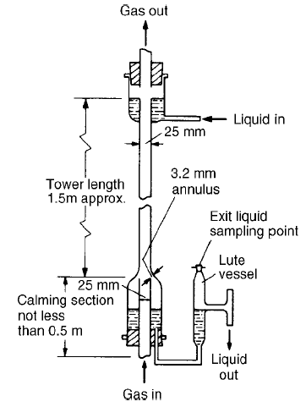

**1**

**2**

**Determine the over all mass transfer**

**coefficient, *KOG* , using the wetted wall column**

The equation for mass transfer:

*JA = KOG.A.P.∆ylm*kmol/s



*A* = mass transfer area = *π d L*

*KOG* = over all mass transfer coefficient (kmol/kN.s)

*JA* = rate of mass transfer (kmol/s) = *G* (*y1-y2*)

*G* = gas flow rate (kmol/s)

*y* = mole fraction

*y\** = 

*y\**: mole fraction of *A* in gas phase which in eqlm with liq. Phase.

**Ex:** A 20*lit* stirred fermenter containing a *Bacillus thuringiensis* culture at 30oC is used for production of microbial insecticide, *kLa* is determined using the dynamic method. Air flow is shut off for a few minutes and the dissolved-oxygen level drops; the air supply is then re-connected. When steady state is established, the dissolved-oxygen tension is 78% air saturation. The following results are obtained.

*Time*(*s*)5 15

*Oxygen tension* 50 66

(% air saturation)

(a) Estimate *kLa.*

(b) An error is made determining the steady-state oxygen level which, instead of 78%, is taken as 70%. What is the percentage error in *kLa* resulting from this 10% error in *CAL*?

Solution: (a) =  = 0.085 s-1

(b) *kl a* = = 0.16 s-1

The error in *kLa* is almost 88% for 10% error in *CAL*.