Fluid in motion
The behavior of fluid in motion is very complex due to the large number of variable involved. Since viscosity introduces a great complexity to fluid flow behavior, we assume the fluid is an ideal one, this mean no viscosity and no shear stress as it flow. We also assume incompressible flow which mean that the density of fluid does not change throughout the system.
Properties of flow:
Steady flow: when there is no change in flow properties(Q,v,h) with time.
Unsteady flow: when there is change in flow properties with time.
Uniform flow :when there is no change in fluid properties with distance.
Non-uniform flow(2D):flow with two directions (x,y) and velocity distribution become parabola section with maximum value at the center and minimum at the wall of pipe.
Three-dimensions flow(3D): flow with 3 diractions (x, y, z)as flow through orifice.

The continuity equation
This theorem state that the mass can neither be created nor destroyed . For steady flow the rate which mass enters a control volume equals the rate at which mass leaves this volume . in fig.1, fluid is flowing from left to right the pipe has two different size (A1 and A2) the volume between 1 and 2 is the control volume (CV), the rate at which the mass enter equals the rate at which the mass leaves CV.
Maas flow rate
From fig.1 let M represent the rate at which mass enter or leave the CV , we have M1=M2, thus for steady flow the mass flow rate at the inlet to the CV equals mass flow rate at the exit from the CV.
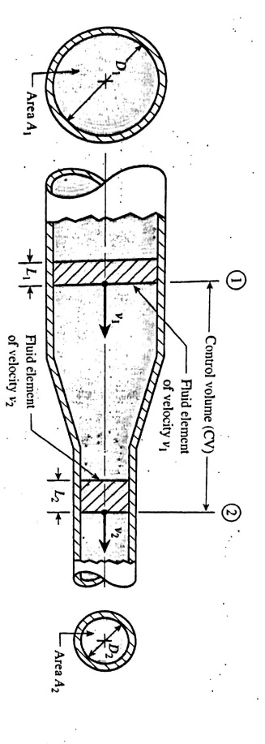
Fig.1

$M _{1}=\frac{m _{1}}{t}=\frac{Ƿ _{1}A _{1}L _{1}}{t}=Ƿ _{1}A _{1}v _{1}$ and
$$M _{2}=\frac{m _{2}}{t}=\frac{Ƿ _{2}A _{2}L _{2}}{t}=Ƿ _{2}A _{2}v _{2}$$
So $Ƿ _{1}A _{1}v _{1}M _{2}= Ƿ _{2}A _{2}v _{2}$
Weight flow rate
Since specific weight equals times the acceleration of gravity(γ=Ƿ*g)
The continuity equation shows that we also have equality of weight flow rates entering and leaving the CV, W1=W2
γ ₁A ₁v₁=γ ₁A ₁v ₁
volume flow rate
for steady incompressible flow the volume flow rate is also constant represented by Q(flow), because flow =volume per time.
$\frac{vol _{1}}{vol _{2}}=\frac{A _{2}}{A _{1 _{ }}}$=($\frac{D _{2}}{D _{1}}) ^{2}$
D is the diameter for circular section.
Or Q= v*A (v is velocity)
Examples:
Ex1:
For the fig.1 the following data are given:D₁=4 in. D₂=2in. v₁=4ft/s
Find the volume flow rate, fluid velocity at sec. 2 , weight flow rate and mass flow rate?
Fig.1
Q=Q₁=A₁v₁
A₁=$\frac{π}{4}$D²=$\frac{π}{4}$(4/12)²=0.0873 ft²
Q=(0.0873)(4)=0.349 ft³/s
b-v₁₌v₂(D₁/D₂)²
=4(4/2)²=16ft/s
c-W=W₁=γ A₁ v₁=γ Q₁=62.4*0.349=21.8 lb/s
d-M=M₁=ǷA₁v₁=ǷQ₁=1.94*0.349=0.677 slug/s

Ex2: A pipe line of 300 mm diameter carrying water at an average velocity 4.5 m/s branches into two pipes of 150 mm , 200mm dia., if the average velocity in the 150mm is 5/8 of the velocity in the main pipe, find the average velocity of flow in 200 mm, and the total flow rate in the system by l/s?
Q=AV=Q1+Q2
AV=A1VA+A2V2
$\frac{1}{4}$π(0.3)²*4.5=$\frac{1}{4}$π(0.15)²*$\frac{5}{8}$*4.5+$\frac{1}{4}π$(0.2)²*V2
V2=8.54 m/s
Total flow Q=$\frac{1}{4}$π(0.3)²*4.5
=0.318 m³/s
=318 l/s
Ex3:
The velocity of a liquid (s.g)=1.4, in 150mm pipeline is 0.8 m/s. Calculate the rate of flow in l/s , m³/s, kg/s and KN/s?
Q=VA=0.8($\frac{π}{4})(\frac{150}{1000}) ^{2}$=0.01414 m³/s= 14.141 l/s
M=Ƿ*Q=(1.4*1000)*0.01414=19.79 kg/s
W=γ*Q=(1.4*9.8)*0.01414=0.194 KN/s

Bernoullis equation
Bernoullis equation is based on the conservation of energy law, which states that energy can be neither created nor destroyed. The total energy possessed by a given mass of fluid can be considered to consist of three type :potential, kinetic and flow energy.
Fig.2 shows fluid flowing from left to right, the total energy by a given weight w of fluid entering CV at sta.1 and the same weight of fluid leaving CV at sta.2.
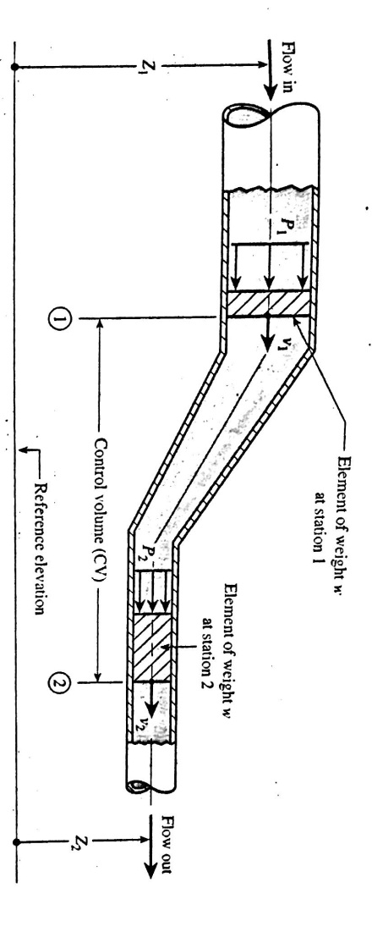
Fig.2
Potential energy:
The fluid element of weight w has a potential energy due to its elevation Z related to a reference plane.
PE= wz
Kinetic energy:
The fluid element of weight w moving with a velocity
KE=$\frac{1}{2}$ mv²
Flow energy;
It is the amount of work that pressure accomplishes by pushing the element of weight w at sta.1 into the CV or pushing the element of weight w at sta.2 out of CV.
FE= $\frac{Pw}{γ}$
Statement of Bernoullis equation:
Daniel Bernoulli an eighteen century Swiss scientist, formulated his equation by noting that the total energy possessed by the fluid in CV does not change with respect to time.
Total energy in element at 1 = total energy in element at 2
(PE+KE+FE)1=(PE+KE+FE)2
wZ₁+$\frac{1}{2}\frac{w}{g}$v₁²+$\frac{P _{1 W}}{γ}$= wZ₂ +$\frac{1}{2}\frac{w}{g}v{ _{2}}^{2}+\frac{P _{2}}{γ}w$ divide by w
Z₁+$\frac{v _{1} ^{2}}{2g}+\frac{P _{1}}{γ}$ = Z₂ +$\frac{v{ _{2}}^{2}}{2g}+\frac{P _{2}}{γ}$
Z: elevation head.
$\frac{P}{γ}$: pressure head.
$$\frac{v{ _{2}}^{2}}{2g}:velocity head$$
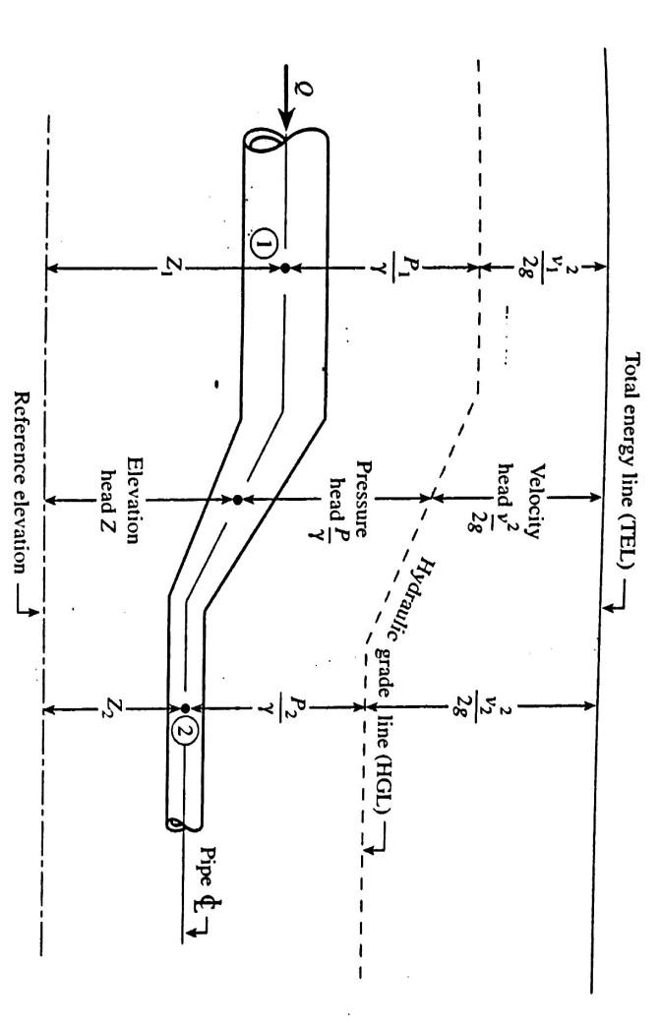
Fig.3
Examples:
Ex1:For the pipe of fig.4 find P2 if the following data are given:p1= 20 psi, D2 =2 in and D2=1.5 in , Q=200 gpm of water?
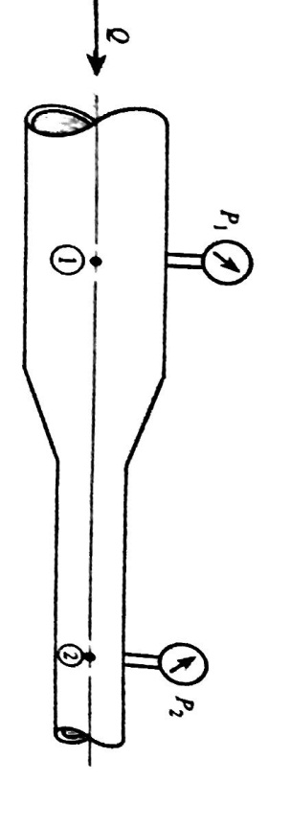
Fig.4

Z₁+$\frac{v _{1} ^{2}}{2g}+\frac{P _{1}}{γ}$ = Z₂ +$\frac{v{ _{2}}^{2}}{2g}+\frac{P _{2}}{γ}$
V1= $\frac{Q}{A1}$=$\frac{200*1*231*1}{\frac{π}{4}\left(\frac{2}{12}\right)*60*1*1728}$
=20.4 ft/s
v2=v1(D1/D2)²
$\frac{20*144}{62.4}$+$\frac{20.4}{2(32.2)}$ =$\frac{P2}{62.4}$ +$\frac{36.2 ^{2}}{2(32.2)}$ +46.2+6.46 = $\frac{P2}{62.4}$ +20.3
Solving for P at 2 yields :
P2= 2020 lb/ft² gage=14 psig.

Torricillis theorem:
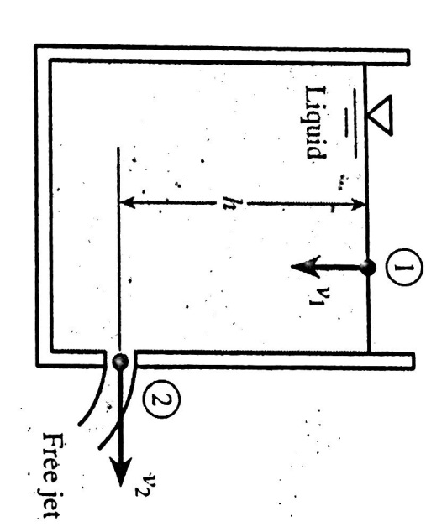
Fig.5
The velocity of free jet of fluid is equal to:
V=$\sqrt{2gh}$
Because:
1-P1=P2 atmosphere pressure
2-v1 negligible cross sec. A1 very large compared with A2 so
v1=$\frac{A2}{A1}$ v2 (very small number)
3-Z2 can be taken as a zero number.

EX2:for the system in fig.5, 198 h=36 ft and diameter of side opening is 2 in find the jet velocity and the volume flow rate in gpm?
V2=$\sqrt{2gh}$
=$\sqrt{ 2*32.2*36 }$=48.3 ft/s
Q=A2v2=$\frac{π}{4}$ (2)²*48.3*12*$\frac{1}{231 in ^{3}}$*60
=473gpm

The siphon:
It is a device that is used to cause a liquid to flow from one container in an upward direction downward in to a second . as shown in fig.6,
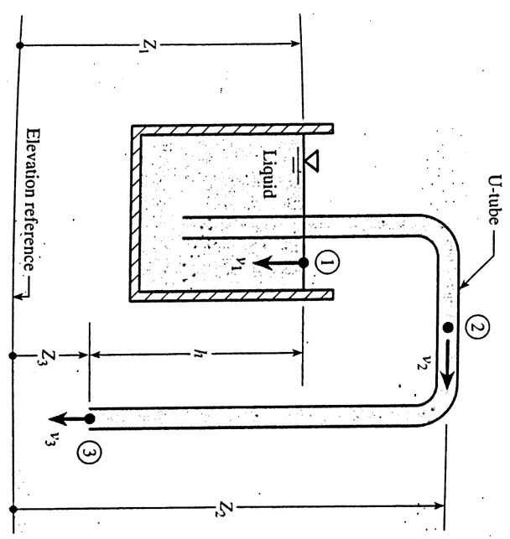
Fig.6

Point 1 lies in the free surface in the container.
Point 2 lies in the U-tube at its highest elevation.
Point 3 lies in the U-tube at the lowest elevation
The output at 3 is a free jet.
If we apply Bernoullis eq. for pointe 1 &3
P1=P3, v1$≈0$ , Z1-Z3=h, so
V3=$\sqrt{2gh}$
So Q3 =A3v3
P2=γ(Z1-Z2)+γ(-v²₂/2g)
EX3:
Water is siphoned from a large storage tank through 50 mm diameter hose(fig.7). Find the maximum height H of a building over which the water can be siphoned?
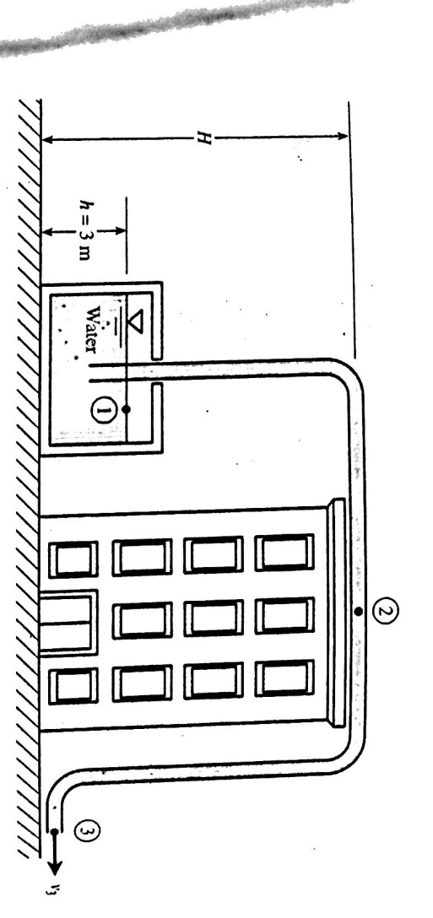
Fig.7
V3=$\sqrt{2gh}$
V3=$\sqrt{ 2*9.8*3}$ =7.67 m/s
V2=v3
P2=γ (Z1-Z2)-γ (v²₂/2g)
2.34-101) KPa =9800 N/m³(3-H)-9800*$\frac{7.67}{2*9.81}$
-98700=29400 – 9800 H -29380
H=10.1 m
Ex4: Water is flowing upward through the pipeline (fig.8) ,a manometer measures the pressure difference p1-p1. Find the volume of flow rate?
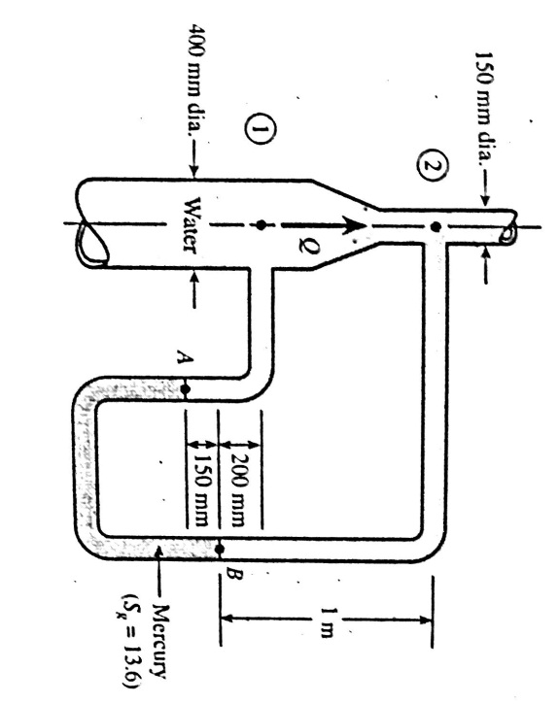
Fig.8

P_{B}=P₂+9800*1=P₂+9800
Pa=Pb+9800*13.6*0.15
Pa=Pb +20000P=P2+29800
P1=Pa-3430=P2+ 26370
P1-P2=26370 pa
Z₁+$\frac{v _{1} ^{2}}{2g}+\frac{P _{1}}{γ}$ = Z₂ +$\frac{v{ _{2}}^{2}}{2g}+\frac{P _{2}}{γ}$
A1v1=A2v2
V2=A1v1/A2
=$(\frac{400}{150}) ^{2}$*v1=7.11 v1
$\frac{v ^{2 _{2}}-v{ _{1} }^{2}}{2g}$=(Z1-Z2)+(P1-P2)/γ
$\frac{\left(7.11v _{1 }\right) ^{2}-v _{1 ^{2}}}{2*9.81}$ =-(1-0.2)+$\frac{26370}{9800}$
$\frac{49.6v _{1 ^{2}}}{19.6}$=-0.8+2.69=1.89 m
V1=0.89 m/s
Q1=A1v1=$\frac{π}{4}$(0.4)²*0.86=0.108 m³/s
The pitot-static tube:
Fig.9, shows a pitot tube installed in a pipeline along with piezometer , both are pressure measuring device. Unlike, piezometer , pitot continues inward toward the centerline of the pipe. As a result the fluid that inters the inside of the pitot tube comes to a stop (stagnates), in contrast the piezometer tube allows the fluid to travel past without any change of velocity.
Fig.9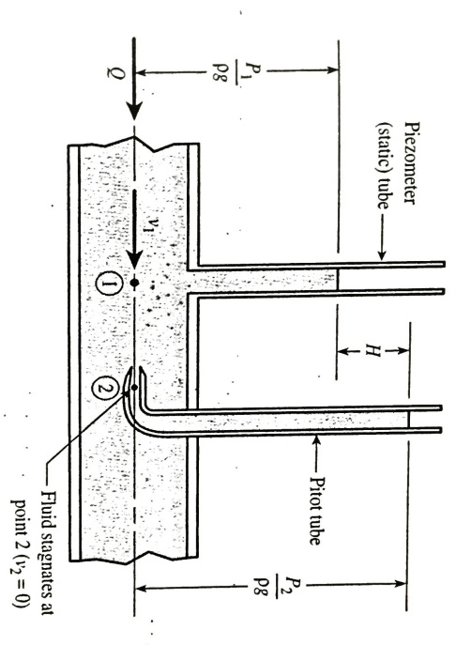

Z₁+$\frac{v _{1} ^{2}}{2g}+\frac{P _{1}}{γ}$ = Z₂ +$\frac{v{ _{2}}^{2}}{2g}+\frac{P _{2}}{γ}$
Z1=Z2 and v2=0 (stagnation point)
H=$\frac{v _{1} ^{2}}{2g}$
Ex5:
Determine the flow rate through the pipe?
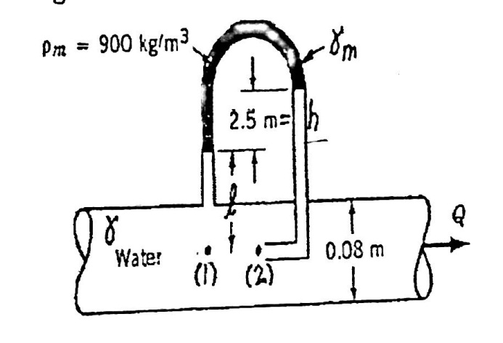
Fig. 10
Z1=Z2 v2=0
$\frac{v _{1} ^{2}}{2g}+\frac{P _{1}}{γ}$ = $\frac{P _{2}}{γ}$
V1=$\sqrt{\frac{2g (P2-P1)}{γ}}$
P1-γ L-γ _{m}h+γ(L+h)=P2
So v1= $\sqrt{\frac{2g \left(1-\frac{γm}{γ}\right)h}{ }}$
=(2(9.81)(1-900/999)(2.5))^{0.5}
=2.2m/s
Q=A1V1=$\frac{π}{4}$(0.08)² (2.2)=0.0111 m³/s.

Verturi, nozzle and orifice flow meters:
Three additional used flow meters measuring that operate on the principles of Bernoullis eq. , venture, nozzle and orifice flow meters. They based on the principle that as the velocity of flow increases, a drop in pressure occurred. The measurement of the pressure drop can be used to indicate the flow rate.
Fig. 11, shows the venturi meter, it is installed to the pipeline whose flow rate is measured , venture meter consist of a converging section followed by a constant diameter section (throat) followed by a diverging section.
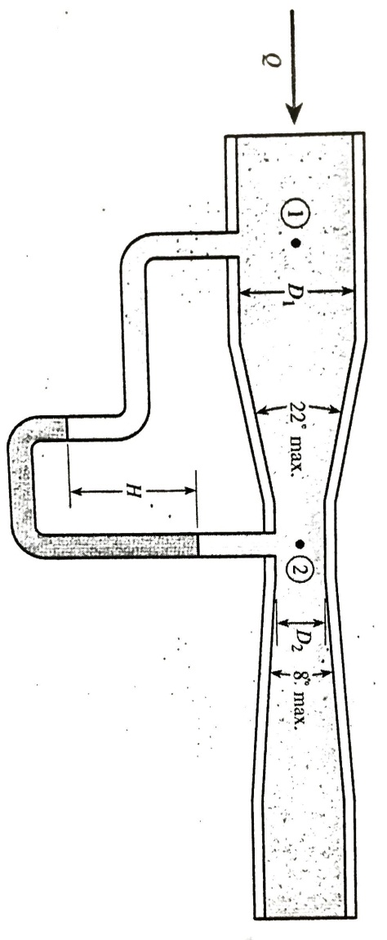
Fig. 11

Z₁+$\frac{v _{1} ^{2}}{2g}+\frac{P _{1}}{γ}$ = Z₂ +$\frac{v{ _{2}}^{2}}{2g}+\frac{P _{2}}{γ}$
Z1=Z2
A1v1=A2v2
So $Cv ideal=\sqrt{\frac{2(P1-P2)}{ρ( 1-\left(\frac{A2}{A1}\right) ^{2 })}}$
To calculate the flow coefficient Cv=$\frac{V2 actual}{V2 ideal}$
Q=v2 actual A2= Cv ideal A2
Q=$Cv A2\sqrt{\frac{2(P1-P2)}{ρ( 1-\left(\frac{A2}{A1}\right) ^{2 })}}$=$Cv A2\sqrt{\frac{2(P1-P2)}{ρ( 1-\left(\frac{D2}{D1}\right) ^{2 })}}$

Fig.12, shows the nozzle meter contain a nozzle has a flange on its upstream face.
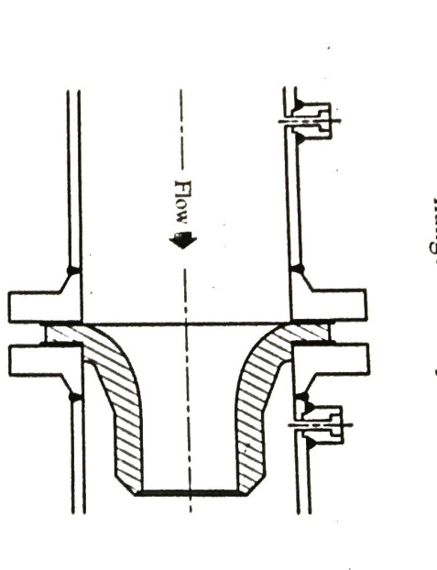
Fig.12

Q=$Cn A2\sqrt{\frac{2(P1-P2)}{ρ( 1-\left(\frac{D2}{D1}\right) ^{2 })}}$ Cn discharge coefficient.

Fig.13, shows the orifice meter it is a simple flow meter consist of a circular plate containing a sharp edge , the upstream fluid approach the orifice it must turn inward to inter the orifice. The fluid jet cannot immediately change directions as its flow, thus the jet area continues to contract until its minimum value is obtained downstream :
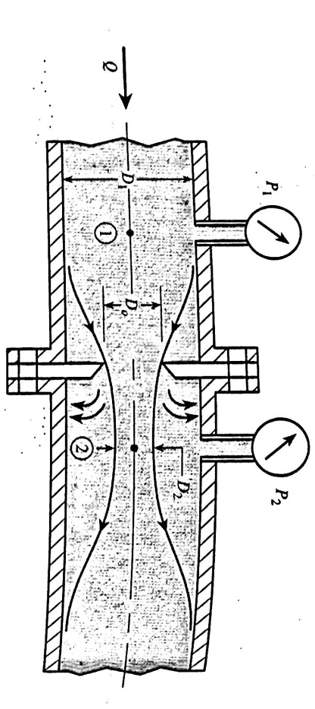
Fig.13
Q=$C0 A0\sqrt{\frac{2(P1-P2)}{ρ( 1-\left(\frac{D0}{D1}\right) ^{2 })}}$ A0:area of the hole in the orifice plate.

Ex6:
Venture meter of fig.11, has the following data:D1 3in, D20.75 in, Cv 0.98, fluid in manometer is mercury, P2-P1=10 psi, H=20 in Hg, find the flow rate in gallons per minute ?
Q=$Cv A2\sqrt{\frac{2(P1-P2)}{ρ( 1-\left(\frac{A2}{A1}\right) ^{2 })}}$
A2=$\frac{π}{4}$($\frac{0.75}{12}) ^{2}$=0.00307 ft²
Ƿwater =1.94 slugs/ft³
P1-P2=10*144=1440 lb/ft²
$\left(\frac{A2}{A1}\right) ^{2 }$=$(\frac{0.75}{3}) ^{4}$=0.00391
Q=0.98* 0.00307*$\sqrt{\frac{2*1440}{1.94(1-0.00391)}}$=0.116 ft³/s
Q= 0.116*1728*$\frac{1}{231}$*60=52.1 gpm
P2-P1 =H(γHg- γwater)=20*1/12*(847-62.4)=1308 ib/ft²
Q $∝\sqrt{P1-P2}$ Q=52.1 *$\sqrt{\frac{1308}{1440}}$= 49.7 gpm .

