Flow of viscous fluids in pipeline
In this lecture we take into account that the fluids possess viscosity that results in creation of shear stress under flow conditions. These shear stresses create frictional forces that transform useful pressure energy and kinetic energy into thermal energy. This action produces losses in pressure and flow rate that can cause a fluid flow system to malfunction unless the frictional energy losses are held to an applicable level. Frictional energy losses require that system to use more prime mover energy. It is very important to keep frictional losses to a minimum level. The proper selection of diameter, valves and fittings make up fluid system is required.
Laminar and turbulent flow:
In fig. 1 we assumed a constant velocity profile, this assumption was a direct result of assuming an ideal flow having no viscosity. When a real fluid flows through a pipe the layer of fluid at the pipe wall has zero velocity due to viscosity which causes fluid particles in constant with the wall. The maximum velocity occurs at the center.
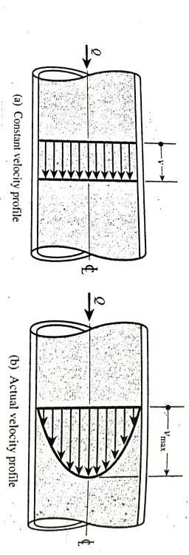
Fig.1
If the flow rate is increased so that the average velocity reaches a high enough value the flow ceases to remain laminar and starts to become turbulent (fig.2) the moving of each particle is become random and fluctuates up and down, this cause considerably more resistance to flow and energy losses
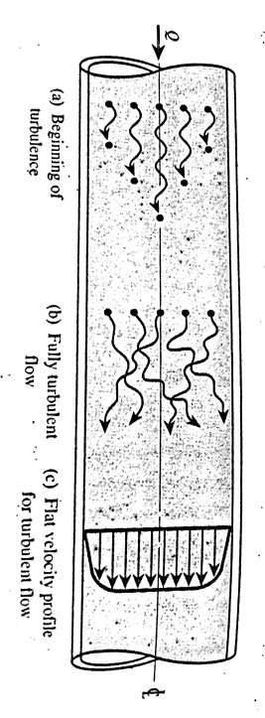
Fig.2
Reynolds number:
A classic experiment is done by Osborne Reynolds to determine the conditions governing the transition form laminar to turbulent. Fig.3.
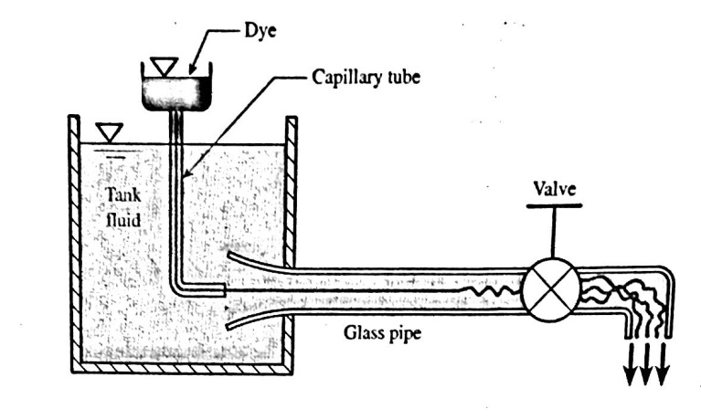
Fig.3
Conclusions of Reynolds experiment :
1-floe depends on dimensionless parameter ǷvD/µ
2-This parameter has the following significance:
If Re$≤$ 2000 the flow is laminar
If Re$≥$ 4000 the flow is turbulent
If 2000 $<$ Re $<$ 4000 the floe is either laminar or turbulent.
Re =$\frac{ρv D}{μ}$
Type of losses
a-Major losses (h_{f}):
It means the friction losses or energy losses due to friction, it is also called the pressure losses, Hagen-Poiseuille equation shows the flow rate variable Q
ΔP_{f}=$\frac{128 μ Q L}{π D^{2}}$
Solving for head loss:
H _{f}=$\frac{32 μ v L}{γ D^{2}}$
But R_{e}= $\frac{ρv D}{μ}$
So H _{f}=$\frac{64}{Re }\frac{L}{D}\frac{v^{2}}{2g}$

Darcy-Weisbach equation
If the expression 64/Re is replaced by the symbol f ( friction factor), the equation results :
H _{f}=$f\frac{L}{D}\frac{v^{2}}{2g}$ (for laminar and turbulent flow)
flow
turbulent |  |  | laminar
rough | smooth |  | 64/Re
$$\frac{1}{\sqrt{f}}=2log\frac{3.7}{ε/D}$$ | Re ˃10⁵  $$\frac{1}{\sqrt{f}}=2log\frac{Re\sqrt{f}}{2.51}$$ | Re ˂ 10⁵  f=0.316/Re^{0.25}

General formula:
$$\frac{1}{\sqrt{f}}= -2\log{ [\frac{\frac{ε}{D}}{3.7}}+\frac{2.51}{Re \sqrt{f}}]$$
Moody diagram:
To determine the friction factor from diagram, we can use Moody diagram (fig. 4), the following characteristics should be noted:
1-It is plotted on logarithmic paper.
2-At the left end Reynolds no. less than 2000, the straight line curve for laminar flow (f=64/Re).
3-No curves are drawn in the critical zone, we cant predict the flow (laminar or not).
4-For Reynolds no. ˃ 4000, each curve represents a particular value of $ε/D$, for the intermediate value of $\frac{ε}{D}$ interpolation is required.
5-The bottommost curve is for smooth pipe $\frac{ε}{D}=0$.
6-Region to the right of dashed line, increasing value of Re no. have no effect on the value of f for a given value of $\frac{ε}{D}.$
7-The region from Re=4000tothe location where complete turbulence is initially achieved is called transition zone.

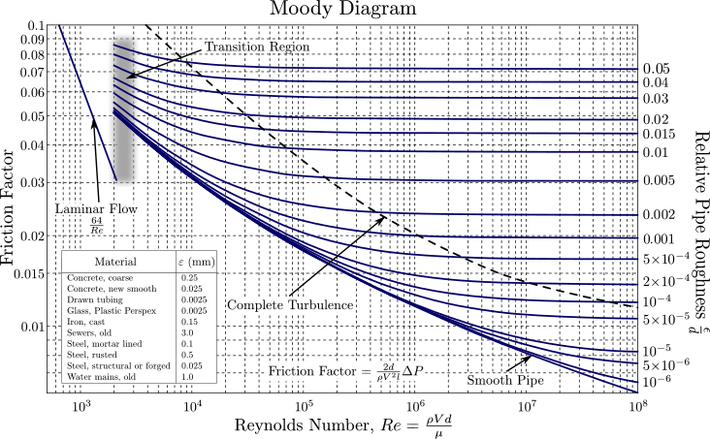

b- Minor losses:
there are energy losses in valves and pipe fittings, they are smaller than major losses, sometimes they are greater than major losses.
Due to change in flow direction, cross section and flow path fittings and valves(fig.5)
$$H _{L}=K_{L}\frac{v^{2}}{2g}$$
K_{L} is loss coefficient . table 1 gives K_{L} values.
Table 1
Valve or fitting | Loss coefficient
Globe valve | 10
Gate valve | 0.9
Swing check valve | 2
tee | 0.4
elbow | 0.75
Return bend | 2.2
Pipe entrance from a reservoir | 0.5
Pipe exit from a reservoir | 1
Sudden contraction | 0.1- 0.5
Sudden expansion | 0.2- 1

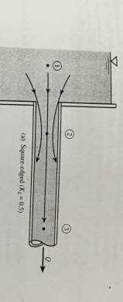
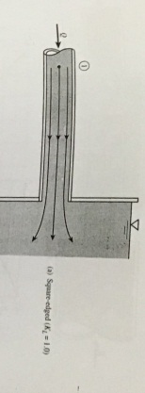
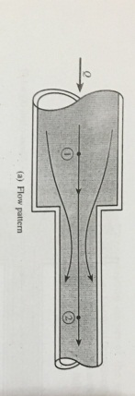
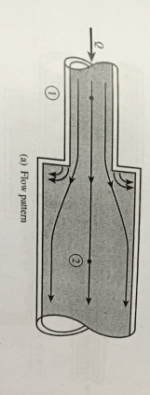
Fig.5
So the total losses will added to the right of Bernoullis eq., and if there is a pump through the pipe system, the energy head will become higher and the pump head H_{p} will be at the left side of the equation with (+) sign, however the turbine will cause the energy head become low and will add to the left side of the equation with (-) sign.
Z₁+$\frac{v _{1} ^{2}}{2g}+\frac{P _{1}}{γ}$ + H_{p} – H_{T} = Z₂ +$\frac{v{ _{2}}^{2}}{2g}+\frac{P _{2}}{γ}$ +H_{f} + H_{L}

Examples:
Ex1:Oil with µ= 0.38 N.s/m², Ƿ= 912 kg/m³, flows through a horizontal 100 mm dia. and 500 m length, pipe at flow rate = 0.01 m³/s. Determine the pressure drop in the pipe?
ΔP_{f}=$\frac{128 μ Q L}{π D^{2}}$
=$\frac{128*0.38*500*0.01}{π({0.1)}^{4}}$= 774000 pa =772 kpa.
To find Re:
V=v avg.=Q/A=$\frac{0.01}{\frac{π}{4}*{(0.1)}^{2}}$= 1.27 m/s
Re =$\frac{ρv D}{μ}$= $\frac{912*1.27*0.1}{0.38}$= 306 ˂ 2000 laminar flow and the analysis is valid.

Ex2'; Oil (µ=4*10⁻³)lb.s/ft², Ƿ=1.8 slugs/ft³,flows through an inclined pipe (fig. 6) dia.=3 in, find the slope of the pipe that will cause the pressure to be constant along the pipe? ($ε=0.00026)$
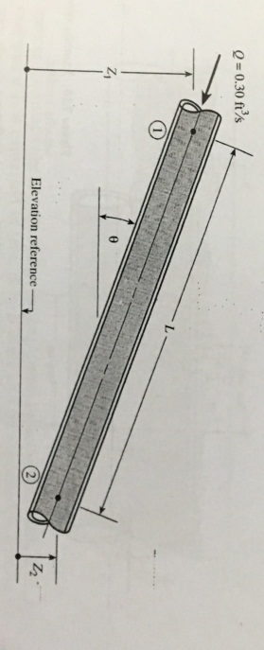
Fig.6
Z₁+$\frac{v _{1} ^{2}}{2g}+\frac{P _{1}}{γ}$ ₋ $\frac{32 μ v L}{γ D^{2}}$= Z₂ +$\frac{v{ _{2}}^{2}}{2g}+\frac{P _{2}}{γ}$
P1= p2 and v1=v2
$\frac{Z1-Z2}{L}$ = $\frac{32 μ v L}{γ D^{2}}$=$\frac{32 μv}{ρgD ^{2}}$
v=vavg.=Q/A=$\frac{0.3}{\frac{π}{4}(\frac{3}{12}) ^{2}}$ =6.11 ft/s
sin$θ=\frac{Z1-Z2}{L}$
sin$θ$= $\frac{32 μv}{ρgD ^{2}}$=$\frac{(32)(4*10 ^{-3})(6.11)}{1.8*32.2*(\frac{3}{12})}=0.216 ft/ft$
$$θ=12.5°$$
Re=$\frac{6.11*\left(\frac{3}{12}\right)*1.8}{4*10 ^{-3}}$ = 687 ˂ 2000 laminar flow

Ex3: The pump (fig.7) delivers 0.03 m³/s water from lake to the top of a hill. The cast iron pipe has a diameter of 80 mm and a length of 200 m , find the required power the pump must be deliver to the water?
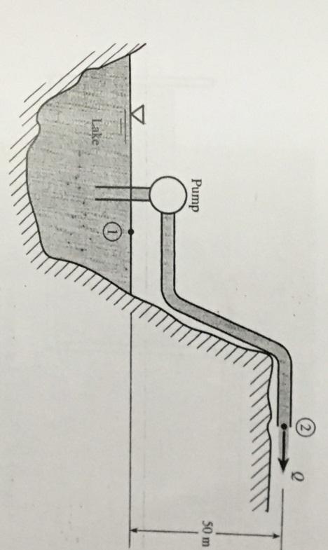
Fig.7
Z₁+$\frac{v _{1} ^{2}}{2g}+\frac{P _{1}}{γ}$ ₊ Hp - $f\frac{L}{D}\frac{v^{2}}{2g}$ = Z₂ +$\frac{v{ _{2}}^{2}}{2g}+\frac{P _{2}}{γ}$
P1=p2 $\frac{v _{1} ^{2}}{2g}=0$
Hp = $\frac{v{ _{2}}^{2}}{2g}$ (Z2-Z1) + $f\frac{L}{D}\frac{v^{2}}{2g}$
V2=Q/A=$\frac{0.03}{π/4(0.08) ^{2}}$ =5.97 m/s
Solve for Re v=1.12 *10⁻⁶ m²/s
Re= $\frac{VD}{v}$=$\frac{5.97*0.08}{1.12}$ =4.26 *10⁵
$\frac{ε}{D}=\frac{0.00026}{0.08}=0.00325$from Moody diagram f=0.026
Hp=$\frac{5.97}{2*9.81}+50+0.026*\frac{200}{0.08}*\frac{(5.97) ^{2}}{2*9.81}$ =169.8 m
Pump power =γ Hp Q
=9800* 169.8*0.03
=49900 watt= 49.9 kwatt
Note:Pump efficiency = $\frac{power out}{power in}*100\%$
For example: A pump have an efficiency 60% lift water to height 50 m at flow rate 0.1 m³/s, what is the required pump power in KW?
Pump power =γ Hp Q
Power out= 9.8 * 50* 0.1 =49 KW
Efficiency =$\frac{power out}{power in}*100\%$
Pin = ( Pout/ eff.)*100% =82 KW

Ex4: The pump (fig.8) add a 15 ft head to water being pumped when the flow rate is 1.5 ft³/s. Determine the friction factor for the pipe?
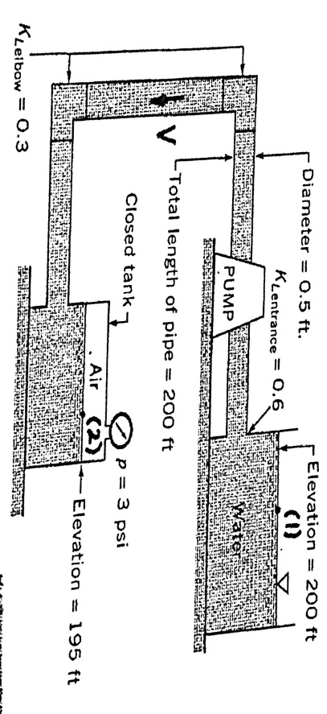
Fig.8
Z₁+$\frac{v _{1} ^{2}}{2g}+\frac{P _{1}}{γ}$ ₊ Hp - $f\frac{L}{D}\frac{v^{2}}{2g}+K _{L}\frac{v ^{2}}{2g}$ = Z₂ +$\frac{v{ _{2}}^{2}}{2g}+\frac{P _{2}}{γ}$
P1=0 V1=0 Z1=0 Hp=15 Z2=195m V2=0
∑K_{L}= Kent +K elbow +Kexit
=0.6+ 2(0.3) + 1=2.2
200 +15=$\frac{3*144}{62.4}$ +195 + $f\frac{200}{0.5}+2.2*\frac{v^{2}}{2*32.2}$
V=Q/A=$\frac{1.5}{\frac{π}{4}*0.5 ^{2}}$ = 7.64 ft/s f=0.0306

Ex5: When water flows from the tank shown if fig.9, find the water velocity if the water depth in tank is h= 1.5 ft , the total length of 0.6 in dia. pipe is 20 ft, and the friction factor is 0.03. The loss coefficients are 0.5 for entrance, 1.5 for each elbow and 10 for valve?
Fig.9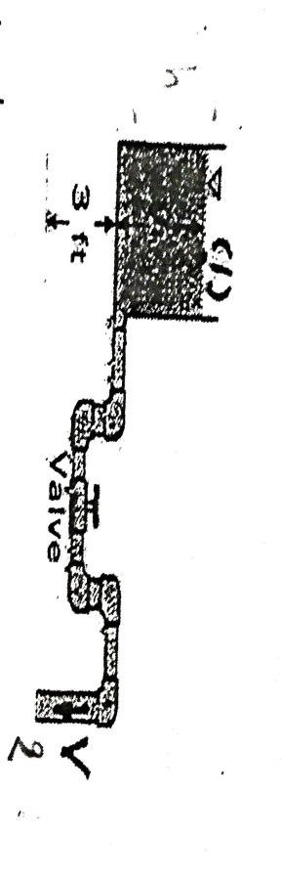
Z₁+$\frac{v _{1} ^{2}}{2g}+\frac{P _{1}}{γ}$ ₊ HL = Z₂ +$\frac{v{ _{2}}^{2}}{2g}+\frac{P _{2}}{γ}$
P1=P2 Z1=0 Z2=3 ft+h V1=0 V2=V AND
H_{L}=$f\frac{L}{D}\frac{v^{2}}{2g}+K _{L}\frac{v ^{2}}{2g}$
Z1=4.5 ft
4.5 = (0.3 $\frac{20}{0.6/12}+18+1)$ $\frac{v^{2}}{2*32.2}$
V=3.06 ft/s Q=AV= $\frac{π}{4}(\frac{0.6}{12}) ^{2}(3.06)$ = 0.00601 ft ³/s

