Anionic and Cationic polymerization

(5)
Dr. Raouf Mahmood

Anionic vinyl polymerization
Anionic vinyl polymerization is a method of making polymers from small molecules containing carbon-carbon double bonds. It is a type of vinyl polymerization. In anionic polymerization, the process is begun by an initiator. In this case, the initiator is an anion; that is, an ion with a negative electrical charge.
There are a lot of different initiators used in anionic vinyl polymerization, but the most often used is an unassuming little molecule called butyl lithium.
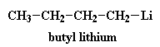
Now a little bit of the butyl lithium will always fall apart. Not a lot, but some. It falls apart to form a positive lithium cation and a negative butyl anion. We call an anion like this where the negative charge is on a carbon atom a carbanion
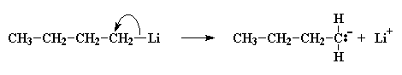
A pair of electrons from the butyl anion will be donated to one of the double bond carbon atoms of the monomer. Now this carbon atom already has eight electrons in its outer shell which it shares with the atoms to which it is bonded, so one pair of these electrons, specifically a pair in the carbon-carbon double bond, will leave the carbon atom, and settle on the other carbon atom of the carbon-carbon double bond. This forms a new carbanion, with the negative charge resting on that carbon. The process in which the butyl lithium falls apart, and the butyl anion reacts with a monomer molecule is called initiation.
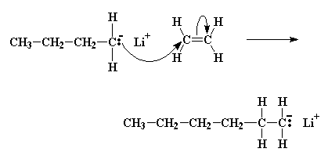
The carbanion now reacts with another monomer molecule in just the same manner as the initiator reacted with the first monomer molecule; another carbanion is generated. This keeps happening, and each time another monomer is added to the growing chain, a new anion is generated allowing another monomer to be added. In this way the polymer chain grows. This adding of monomer after monomer is called propagation.
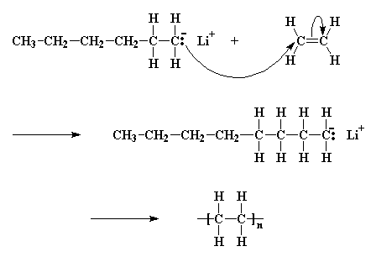
Now, while you may get this nagging feeling that this can't go on forever, that something has to put a stop to this convenient process. Funny thing, though: it doesn't stop! In many cases, the only thing that stops monomers from adding to the growing chain, is that finally there are no more monomer molecules in the beaker left to add! And even then, if someone came along some time later and discarded more monomer into the beaker, they would add to the chain and the chain would grow some more! Some chains of polystyrene have been known to stay active like this for years. In order to stop them, something like water, which reacts with the carbanions, has to be added to the polymer. Systems like this are called living anionic polymerizations. This allows us to do some interesting tricks…
Modular Chemistry
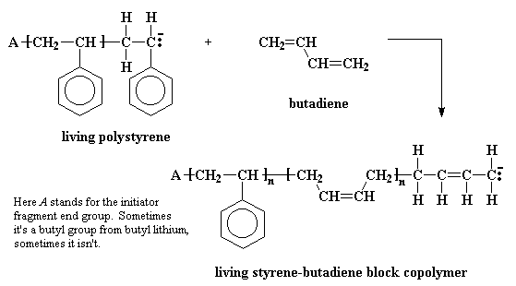
Some time ago someone was pondering this beaker full of polymer which would stay active for years; and how if one added additional monomer, this new monomer would add to the living polymer chains, and came up with an idea. Instead of adding the same monomer to the solution filled with living polymer, why not add a different monomer? The result was a polymer whose chains consisted of a long stretch of one type of polymer, and a second long stretch of another polymer. Polymers like this are called block copolymers. For example, a solution of living polystyrene chains will react with butadiene to give a styrene-butadiene block copolymer.

Cationic vinyl polymerization
Cationic vinyl polymerization is a way of making polymers from small molecules, or monomers, which contain carbon-carbon double bonds. Its primary commercial use is for making polyisobutylene.
In cationic vinyl polymerization, the initiator is a cation, which is an ion with a positive electrical charge. It is shown as A+ in the picture. A pair of electrons, negatively charged, from the carbon-carbon double bond will be attracted to this cation, and will leave the carbon-carbon double bond to form a single bond with the initiator, as shown. This leaves one of the previous double bond carbons at a loss for electrons, and carrying a positive charge. This new cation will react with a second monomer molecule in the same manner as the initiator reacted with the first monomer molecule. This happens over and over until a high molecular weight is reached, that is, a molecular weight at which the polymer is useful for something.
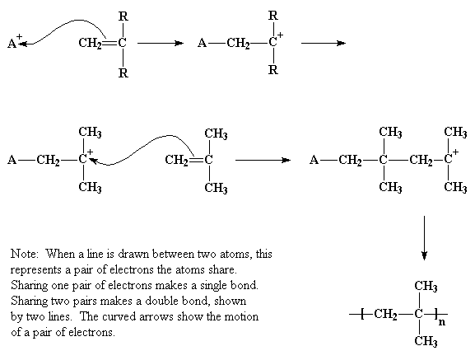
Many times, though, it starts off in a little bit more complicated manner than that. Normally, the initiator used is something like aluminum trichloride, or AlCl₃. If you know the octet rule, you'll know that all atoms on the second row of the periodic table like to have eight electrons in their outermost shell, or level. The aluminum atom in AlCl₃ is sharing electron pairs with only three other atoms, leaving it with only six electrons, two short of the magical octet. As it sits, it has a whole orbital (that is, a vacant slot where a pair of electrons should be) empty and ready for something to come along and fill it. It just so happens, much to the delight of that aluminum atom, that a very small amount of water is usually present in the system. Now the oxygen atom in water has two unshared pairs of electrons, and it has most graciously donate a pair to the aluminum atom, forming an AlCl₃ and H₂O complex.
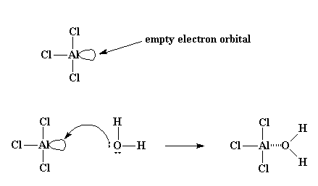
Oxygen, being very electronegative, will tend to pull the electrons it shares with the hydrogen atoms toward itself, leaving the hydrogen atoms with a slight positive charge. This leaves them ripe for attack by a pair of electrons from the double bond of a monomer molecule. The monomer in this way can swipe the hydrogen, making it self a cation, and the AlCl₃/H₂O complex becomes its compliment anion, AlCl₃OH⁻. This whole process by which the AlCl₃/H₂O complex forms and reacts with the first monomer molecule are called initiation.
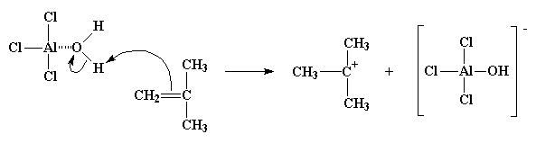
You can see we've got a new cation after all this is done. Not just a cation, a carbocation. That's what we call a cation where the positive charge is on a carbon atom (duh!). Carbocations are very unstable. They're unstable because the carbon atom in a carbocation only has six electrons in its outermost shell. Six! That's two electrons short of the eight that all carbon atoms want to have in their outermost shells. So a carbocation will do just about anything to get two more electrons and reach the magic octet.
So the carbocation looks around, and finds a pair of electrons in the double bond of a nearby monomer molecule. (Remember, there are two pairs of electrons in a double bond.) So the carbocation swipes those electrons, and in doing so forms a single bond with the monomer molecule. It also generates another carbocation, as you can see in the picture below. This can react with another monomer, and then another, and so on. Eventually we get a long polymer chain.
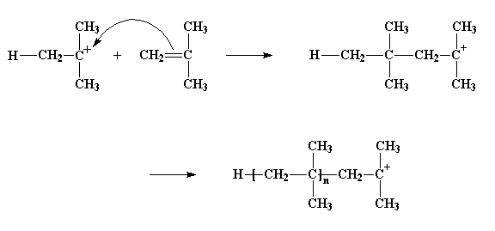
This process, by which monomer after monomer is added to form a polymer, is called propagation.
But how does it end? How does this cycle of adding more monomer molecules to the growing polymer stop? The most common way goes something like this... Imagine the growing chain of polyisobutylene. The methyl groups attached to the cationic carbon atom have a little problem: they've got hydrogen trouble. The hydrogens on these methyl groups will, without a whole lot of persuasion, break away and join other molecules. This is just what can happen when they come close to a molecule of monomeric isobutylene. Starved for electrons as they are, being part of a cation, these hydrogens are easily attacked by a pair of electrons from the carbon-carbon bond in the isobutylene molecule. When all the electrons are through rearranging themselves, as shown by the arrows, we're left with a neutral polymer chain with a double bond at its end, and a new cation, formed from the isobutylene molecule. The polymer chain end is now neutral, and can no longer react and grow. But the new cation can start a new chain growing, in the same way as our initiator molecule did. This process is called a chain transfer. It also happens in free radical polymerization, and other kinds of polymerization as well.
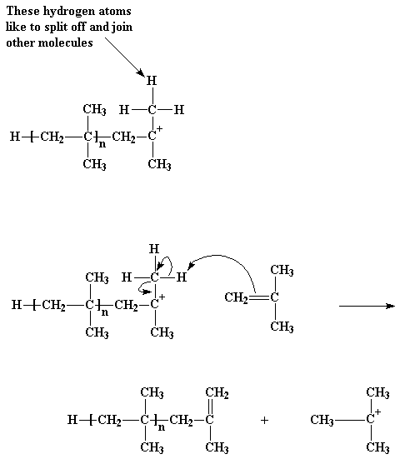
That particular kind of chain transfer is called a chain transfer to monomer. But there's another kind of chain transfer. To understand, it helps to remember that for every cation, there is an anion waiting somewhere in the same beaker. Remember that AlCl₃OH⁻ ion? As we all know, cations and anions have this nasty tendency to react with each other, which can be troublesome when we want our cation to react with something else, like a monomer molecule. Let's take a look at how this happens.
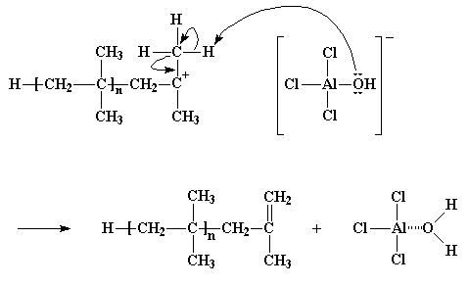
When the cationic initiator reacts, and forms a growing cationic chain, the old anion of the initiating cation becomes the anion of the growing polymeric cation. Remember that anions tend to have pairs of electrons floating around with nothing to do, and, what did mother always say, idle hands do the devil's work? That's just what happens here. The electrons of the anion will, from time to time, attack the hydrogen atoms on the methyl groups adjacent to the cationic carbon. Remember these hydrogen atoms? They're the ones that were so eager to be snatched away by a nearby monomer molecule. Sometimes, not often, but sometimes, these hydrogens will very easily react with the unshared electrons of the oxygen atom in the anion in the exact same manner, leaving the same dead polymer chain with a double bond at its end. But on the bright side, the AlCl₃/H₂O complex is regenerated, and it can start new polymers growing just as it did earlier. Yet another case of the villainous chain transfer.
Of course, it doesn't always turn out so well. At times it is the unshared pairs of electrons from a chlorine atom which will react, not with one of the hydrogen atoms, but with the cationic carbon atom itself. It leaves the container, and joins the polymer. We're then left with a different kind of dead polymer, ending in a chlorine atom, and AlCl₂OH, which won't start a new polymer chain growing.
