**Chapter One**

**Introduction to the Insulation Materials**

There are many benefits of home insulation. Insulating will add the comfort to the building, create a healthier home environment, reduce the energy bills and have a positive environmental impact. Adding home insulation to an existing home will regulate the temperature, making the living environment more enjoyable, especially in places of extreme weather. With insulation the home will become more energy efficient. Insulation will keep the home cooler in the summer and warmer in the winter. This will reduce the amount of heating and cooling appliances that is needed to keep the house comfortable. Because of this, home insulation will reduce the energy bills and the costs of cooling and heating. Adding acoustic insulation will also enhance the sound control. Insulation creates a sound barrier, keeping unwanted sounds out and protecting the privacy by keeping the sounds inside from being audible outside. Insulating the home also creates a moisture barrier, keeping undesirable moisture out and offers much comfortable living environment inside. Insulating the electrical outlets and the corresponding components will protect home against any electrical shock. The benefit of home insulation is not related to the occupants inside the house only but it is also extended to keep the environment out of pollutants. The insulated building will contribute to use less energy for air-conditioning. This will reduce the carbon footprint, and also reduce the amount of chemicals released into the environment from air-conditioning units. Therefore, insulation is a key element in the so-called "green home policy".

**Insulators:** Materials that made to maintain the building components and facilities as long as possible. There are many types of insulation materials according to the purpose and the structure.

**Types of Insulators**

**1- Thermal Insulators**

**2- Acoustic Insulators**

**3- Waterproofing Insulators**

**4- Radiation Insulators**

**5- Electrical Insulators**

**6- Fireproofing Insulators**

**1- Thermal Insulators**

Thermal insulators are those materials that prevent or reduce various forms of heat transfer (conduction, convection and radiation). Insulator resists the heat transfer from the out to in or the opposite direction whether the environment temperature is high or low. There are many advantages of thermal insulation that isolates the building from the heat and reduces the energy consumption as well as the costs of air-conditioning operation. Also, it makes the indoor temperature of the building stable and non-volatile. To reduce the transmission of the heat, buildings must be isolated in order to protect it from heat loss in winter and heat gained in the summer. It is found that about 50% of heat losses directly through the ceilings and walls of the building and that about 25% of other seeps through the glass and about 25% of the heat infiltrates through cracks, openings and doors.

**To make the thermal insulation of the building an economical process, the following factors should be chosen carefully:**

- The amount of insulation material and thickness

- The cost of insulation material and labor costs for installation.

- The amount of energy saving and the reduction in green house emissions.

**Location of Thermal Insulation**

It is used to choose a quality of insulation material that satisfies the balance between the economic saving and the energy saving. Buildings are divided in terms of thermal insulation location into two types, buildings in warm climates and buildings in cold climates. Most of the heat that is gained in hot climates come through the outer shell of the building due to high solar intensity and the temperature differences between indoor and outdoor environment. The heat gained from external sources is higher than that comes from the internal heat generated by the various activities. The increase in thermal insulation in the outer shell of the building will lead necessarily to reduce the amount of heat gained and this consequently leads to reduce the energy needed for cooling. The U-value is a dominant factor to find the optimal thickness of the insulator in building. The amount of the total cost is equal to the total cost of insulating material plus the cost of energy saved in the building for a certain period. In cold climates, heat is transferred from inside to out, so the insulating layer should be located in the internal face of the surfaces in order to reduce the heat losses.

**Types of Thermal Insulators**

The thermal insulation refers to all isolators systems that reduce the heat transfer. Thermal insulation in buildings prevents the heat loss in winter and resists the heat from out in summer. It is looked to use best thermal insulation materials that reduces all types of heat transfer modes like conduction, convection and radiation. Glass wool is one of the most common thermal insulators as well as polyurethane, cork, polymers and many other materials.

**2- Acoustic Insulators**

Acoustic isolators prevent the permeability of sound and absorb it or try to disperse it. Sounds transmit through the air so we can distinguish the different types of voices as well as the noise. Sounds also travel as a waves through solid objects of the building specially the concrete bodies, so it should be isolated to prevent the transmission of sound from out to the inside or from one place to another.

**Objective of Acoustic Insulation**

1. Prevent transmission of sound from the outside and between the partitions through walls and ceilings.

2. Prevent the transmission of sounds and vibrations of machines.

3. Absorption of sound inside.

**Architectural Procedures to Control the Acoustics**

1. Planning methods of determining the home position relative to sources of external sounds such as streets, markets and factories as well as the correct orientation of windows, doors, etc.

2. Design methods for internal spaces of the building.

3. Methods of choosing perfect soundproof material.

**Types of Acoustic Insulators**

1. Acoustic tiles and sound-absorbing tiles, made up of two sides often be grainy and of colored quartz and assembled by resin. it is characterized by its ability of durability and easy cleaning.

2. Glass wool panels which could be covered by aluminum foil to absorb sound and reject heat. It could be installed on the walls, floors and ceilings

3. Plastic layers that might be perforated or grainy face.

4 Sheets of cellulose compressed and perforated face.

5. Slabs of gypsum with the possibility of adding glass fibers.

6. Rubber

7. Cork

8. Light foam

9. Perlite

**3- Waterproofing Insulators**

All buildings need insulation from moisture, rain, groundwater and surface water because the moisture helps to damage the elements of construction and there materials and release undesired smells with the breeding of insects and mice and bring diseases. The walls that exposed to the rain without sufficient amount of sunlight are more susceptible to moisture.

**Effect of Dampness**

- Damage of building materials and elements of the house

- Efflorescence of the walls, floors and ceilings.

- Damaging the paint.

- The failure in the timber used and wooden decor

- Corrosion of metallic parts.

- Proliferation of fungi and unhealthy situation for users in the building.

**Causes of Dampness**

**1. Rain water:** The rain water has the ability to penetrate the roof of the building, especially for poor surfaces and absence of gutters. Rain could penetrate the external walls in absence of overhangs.

**2. Surface water:** This means river, sea or pond, where the water mixes with the soil close to the building and be clay near the foundations then moisture seeps to the foundations or inside through the capillary action.

**3. Underground water:** which formed by the accumulated water under the earth's surface. Water drops transmit through the pores of the soil through the osmosis phenomenon and ascend to the foundations or inside hence damage the structural materials used in the building. it could even overflowing into the building.

**4. Condensation:** it noticed in winter days a layer of dew formed on the window or even wall, and this phenomenon is called "condensation". The accumulated moisture on windows, walls, ceilings and floors seeps into parts of the house after a period of time and leads to the fragility of construction materials and the appearance of rust, mildew and odors.

**5. Poor sewage drainage:** When wastewater gathers under the building and it was hard to flow downstream because of some restrictions then dampness could be occurred in the nearby elements of the building.

**6. Modern construction:** the walls newly constructed remain in the wet state for a certain period.

**Types of Waterproofing Insulators**

It is advised to use and install barriers to prevent water leakage into the different parts of building elements. The common waterproofing materials are: asphalt, flancoat, bitumen, polyethylene White cement, asbestos and acrylic

**4- Radiation Insulators**

Radiation energy is released in the form of electromagnetic waves such as light, UV, infrared, x-ray and Gamma or small particles such as Alpha and Beta, as shown in the figure below.

Radiation could come from cosmos, sun, earth, nuclear reactors, and various devices or even inside the body. Radiations that come from sun like (Gamma, UV, light and IR) have short wave lengths. Radiation with a long wavelength called microwaves or radio waves.

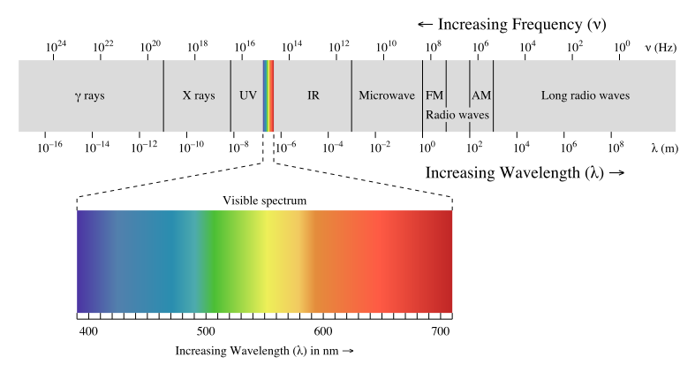

**How dangerous exposure to radiation**

When the radiation passes through a medium, it helps to detach electrons from atoms or molecules, and this is called "ionization". If the ionizing radiation is higher than the threshold level, then serious effects occur such as skin redness, hair loss, burns, radiation syndrome and in some cases cancer.

**Means to minimize the risk of radiation:**

There are three aspects to reduce the risk of radiation which are:

1. **Time:** it is advised to reduce the exposure time (time spent by the person next to the radiation source).

2. **Distance:** the greater the distance between the person and the radioactive source the less the proportion of exposure (by inverse-square law)

3- **Shields:** barriers around the radioactive source will reduce exposure.

**Types of radiation insulators:**

There is appropriate shield for each type of radiation, as shown in the figure.

[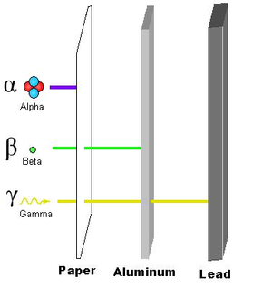](https://ar.wikipedia.org/wiki/%D9%85%D9%84%D9%81:RadiationPenetration2-pn.png)

**5- Electrical Insulators**

There are some materials do not allow the flow of electric current through them called insulators such as: wood, plastic and ceramic. The main reason of the ability of these materials to restrict the electrical flow is that the atomic structure contains a very small number of free electrons midwife to move. It is known that any substance contains a number of molecules and atoms. These atoms have some electrons in the outer orbit called "free electrons".

Due to the ease expelled of the free electrons from the external orbit and make it move easily to another atom, then to another atom, and so on, so that flow of electrons called "electrical current".

The electric field still active even in an insulating material, where an imbalance occurs and the positive charges attract to the electric field while the negative charges displace away. This separation between electrical charges generates the so-called "dipole" and the corresponding process called "polarization".



**Conductor Insulator**

**It may understand the following from the figure:**

• Material that contains a plenty of free electrons becomes a "conductor".

• Material that contains few of free electrons becomes an "insulator".

**Properties of Electrical Insulators**

1. **Resistance**: which is the ability of the material to repel the electrical current.

2. **Permittivity:** which increases the ability of the insulation to absorb more amounts of electrical charges and avoid the transfer of energy. The best insulator is that which has a large permittivity.

3. **Polarization**: which is the ability of insulating material to undergo the separation between electrical charges and its strength.

**Types of Electrical Insulators**

There are many types of insulators in electrical systems for various purposes and uses. For example, plastic is used to cover the electrical wires to protect against electrical shock. Many other examples of electrical insulation materials like: rubber, wood, ceramics, paper, glass and oils.

**6- Fireproofing Insulators**

Practical Fireproofing building can help prevent fires by using materials that are relatively fire-resistant. The key is to construct a building in which a fire would take effect slowly, allowing the occupants plenty of time to escape. Recently, many fireproofing mixtures and solution have been used and it is available and affordable commercially. Fireproofing materials could be classified to:

1. Fire-resistant materials (used in building parts) like: glasswool and gypsum.

2. Fire-retardant materials (used in textiles manufacturing) like polymers.