**Chapter Three**

**Acoustic Insulation**

**Acoustic Insulators**

Some materials prevent sound transmission or absorb it. Sound is transmitted in form of pressure waves through the air where we can distinguish various voices as well as the noise. Sound travels also through solid objects. The continuous sounds surrounding mankind may lead to nervous tension and affect the behavior and action of people. Therefore, environmental engineering identified appropriate sound levels for living and working. Since, it is easy of sound transmission through concrete parts, thus, it should always control the design of the building and select the most appropriate soundproofing materials. The insulation of building prevents the transmission of sound outside or inside and from room to another.

**Architectural Procedures to Control the Acoustics**

1. Planning methods of determining the home position relative to sources of external sounds such as streets, markets and factories as well as the correct orientation of windows, doors, etc.

2. Design methods for internal spaces of the building.

3. Methods of choosing perfect soundproofing material.

**Objective of Acoustic Insulation**

1. Prevent transmission of sound from the outside.

2. Prevent transmission of sound between the partitions through walls and ceilings.

3. Prevent the transmission of sounds and vibrations of machines.

4. Absorption of sound inside.

**Procedures of acoustic insulation**

1. Walls: Using wall tiles and insulating materials such as cork, glass wool and polyurethane foam.

2. Roof: using insulators such as plastic sheets, secondary or ceiling panels, perlite and vermiculite.

3. Dampers: some rubbers, fiberglass or certain panels could be placed under vibrating machines or inside the room. The pieces of furniture help to absorb amount of sounds.

4. Avoid acoustic bridge: it is a term describes the region that allows the transmission of sound a result of the damage in insulator or in case of absence it basically. One of these areas is the joint link between the walls and the ceiling or between the walls and floor slabs.

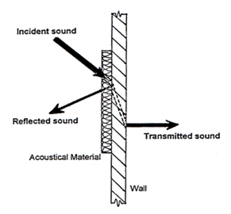**Classification of acoustic insulators**

The incident sound upon a surface could be distributed into three main parts. The first part is reflected from the surface, the second part is absorbed by the surface while the last part is transmitted across the surface to inside. So it could say that the sound-proofing materials are divided into:

1. Reflective materials

2. Absorbing material

**Commercial Insulators**

1. Acoustic tiles, these tiles have the capability of sound absorption, durability and ease of cleaning. Often, they are made of composite materials such as quartz mixed with granular resin, as well as the fiberglass, that results from the mixing of glass wool with epoxy. These tiles are used for the absorption of sounds of machines.

2. Glass wool or rock wool, they are characterized by the ability to absorb sound and thermal insulation, and can be mounted on the walls and ceiling. These could be used in commercial and industrial buildings.

3. Polyurethane foam which are available in the form of spray, layers and tiles.

4. Cellulose panels which are compressed and perforated face.

5. Gypsum boards with the addition of fibers to the surface.

6. Rubber it is available in many forms like: natural rubber, industrial chloroprene (neoprene or polychloroprene) and Mass Loaded Vinyl (MLV). These are available as panels, layers and rolls. They usually use to absorb sound and vibrations.

7. Natural cork or synthetic cork (EPS).

8. Plastic packaging sheets: these layers fit for ceilings in factories where large dimensions. These are resistant to dust as well as the moisture.

9. Perlite, a white color substance taken from the volcanic rocks, and it is a good insulator of sound and heat. It gives the surface a reliable fire-resistant. It is used to insulate ceiling and walls.

10. Viscoelastic damping compound (VDC), a viscous resin fast to dry, used in flooring damping, absorption of the noise as well as to absorb the vibrations of machinery and ducts.

11. Fabrics, leather, carpet and sponge materials.

12. Metallic panel, it is similar in work to the silencer where it dissipates the undesired sounds and then absorbs it by acoustic insulation inside (fiberglass).



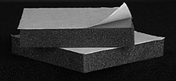

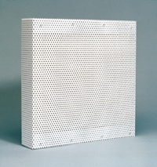Polyurethane, 5 cm, 32 kg/m3, NRC=0.9 Rock wool, 5 cm, 60 kg/m3, NRC=0.7

Acoustic tiles (Quartz, 1250 kg/m3) Metallic panel

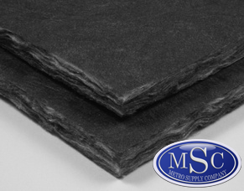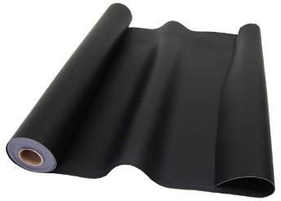

Fiberglass (48 kg/m3) Mass Loaded Vinyl (16 kg/m3)

**Acoustical Engineering**

**Sound:** It is one modes of mechanical energy. Sound travels from one place to another in the form of pressure waves occurring vibrations in the air or building materials. And it can distinguish between sounds by ear or audio devices. The sound does not move in a vacuum but only in a medium. The science of acoustics describes the source of the sound, its transmission and measuring.

**There are some basic definitions in acoustics science, including:**

**Type of sound**: it is the property that distinguishes between different types of sounds. For example, the voice of a man, an animal, a machine, etc.

**Quality of sound:** it is the property that characterized the pitch change to the same source. It depends on the frequency of sound waves which characterized the loudness of sounds, such as the difference between the sound of men and women and the difference between mature and young voices, as well as sound in joy and sorrow.

**Sound intensity:** It is the property that differentiates between sounds in terms of being high or low.

**Sound frequency**: It is the number of times that air particles fluctuate per second as a result of sound energy passed. It is expressed in the unit of Hertz (Hz). Most of the sounds that we hear are a mixture of frequencies.

**Classification of sound waves:**

1. Infrasonic: waves that have less than 20 Hz frequency.

2. Sonic: waves that have frequencies between 20 Hz and 20,000 Hz.

3. Ultrasonic: waves that have frequencies above 20,000 Hz.

**Sound power**: It is the energy carried by the acoustic wave in a period of time. And it is measured in watts.

**Sound intensity**: Mathematically, it is the amount of acoustic energy on a unit area. Human ear can feel a sound has 10-12 W/m2 intensity as minimum. The highest intensity of sound within earshot is 1 W/m2.

**Iref = 10-12 W/m2**

**Sound Intensity Level (SIL)**: The sound intensity value is too small and it is difficult to compare with, so it is looking for a value more acceptable like (Decibel) which is symbolized by (dB). The lowest sound level value is zero dB. The sound level could be accounted from the relation:

**SIL = 10 log (I/Iref)**

**Based on that, the sound is classified in terms of the level of intensity to:**

* 0 - 40 dB : Quiet
* 40 - 80 dB : Noisy
* 80 - 120 dB : Very noisy
* > 120 db : Intolerable

**Sound pressure:** It is the change of atmospheric pressure in a region as a result of the passage of sound. The less sound pressure feeling by human ear is about 2x10-5 Pa and this is called the hearing threshold. At a pressure of about 20 Pa the ear starts feeling of pain.

**Pref = 2x10-5 Pa**

**Sound Pressure Level (SPL):**

It is a value similar to the sound intensity level, and also measured in decibels. It is calculated from the relation:

**SPL = 20 log (P/Pref)**

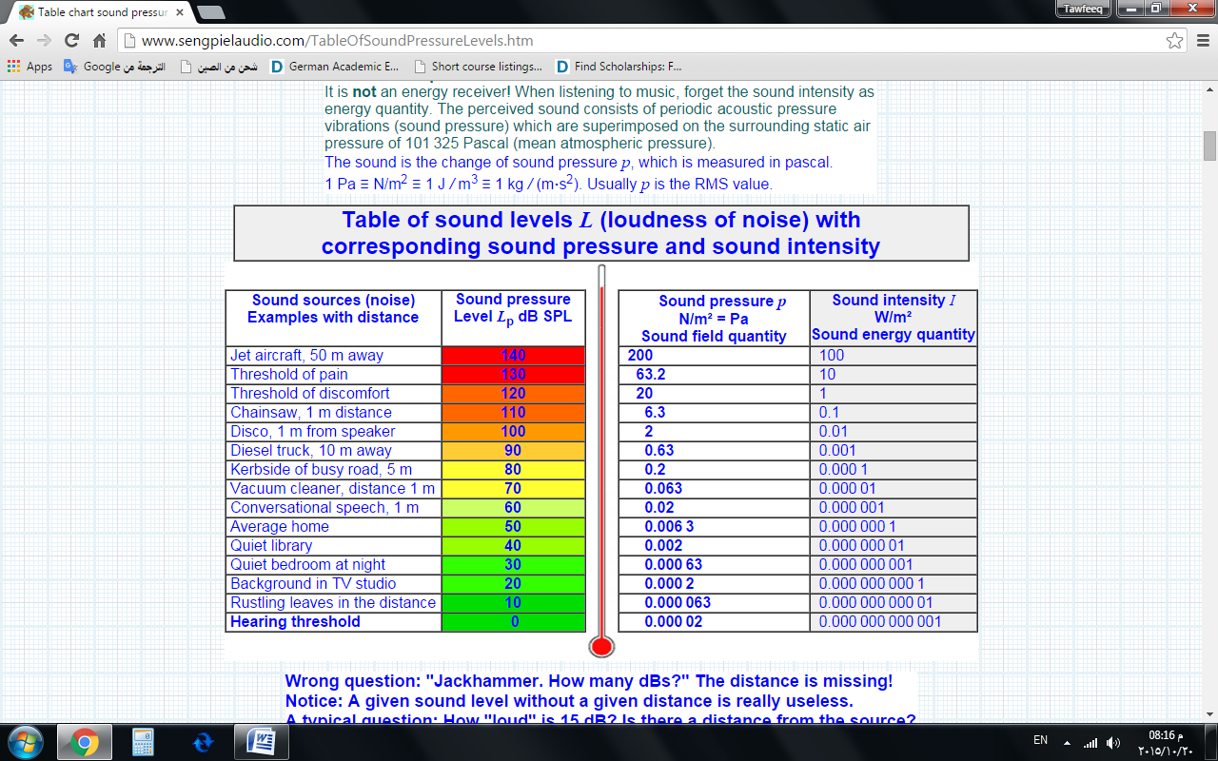**Properties of some sound sources.**

**Acoustic transmission**: It means the ability of sound to move across the building from one part to another. There are several ways for sound moving which are:

- Airborne transmission: it referred to the sound transmitted through windows and openings. These can be processed by good sealing.

- Impact transmission: It means the voices of people movement as well as of the machines on the upper floor. These can be treated by absorbing layers and dampers such as carpet and rubber.

- Flanking transmission: It means the sound transmission through the parts of the building (concrete, metal, wood or glass). These are processed using insulating materials. Any part of the building has a number represents the amount of resistance to the permeability of sound which is called (Transmission Loss).

**Transmission loss**:

It is a measure of the sound difference in decibels through the barrier. For example, if we have a sound of 100 decibels on a side of the wall. Then we measured this sound on the other side and we found it is 55 dB. Then we say that the wall has 45 dB transmission loss. The higher value indicates good resistance and good acoustic insulation. This value varies depending on the frequency of the sound source.

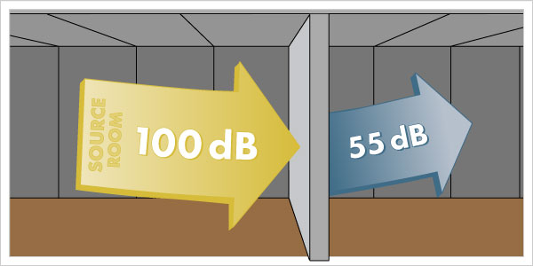

**Sound Transmission Class (STC)**

It is the amount of transmission loss through a barrier or a wall at a sound frequency of 500 Hz. Sound transmission class is a key factor in the design and represents an indication of the building element performance to resistance the sound transmission through it.

**Table represents the STC of some building elements**

|  |  |
| --- | --- |
| **Partition type** | **STC** |
| Single glass window | 27 |
| Double glass window | 30 |
| Single layer of 1 cm drywall on each side, wood studs, no insulation (typical interior wall) | 33 |
| Single layer of 1 cm drywall on each side, wood studs, fiberglass insulation | 39 |
| 10 cm hollow CMU (Concrete Masonry Unit) | 44 |
| 20 cm thermostone wall with plastering for both sides | 44 |
| Double layer of 1 cm drywall on each side, wood studs, batt insulation in wall | 45 |
| Single layer of 1 cm drywall, glued to 15 cm lightweight concrete block wall, painted both sides | 46 |
| 15 cm Hollow CMU (Concrete Masonry Unit) | 46 |
| 20 cm hollow CMU (Concrete Masonry Unit) | 48 |
| 25 cm hollow CMU (Concrete Masonry Unit) | 50 |
| 20 cm hollow CMU (Concrete Masonry Unit) with 5 cm Z-Bars and 1 cm drywall on each side | 52 |
| 20 cm concrete floor with plastering for both sides | 53 |
| Single layer of 1 cm drywall, glued to 20 cm dense concrete block wall, painted both sides | 54 |
| 20 cm hollow CMU with 5 cm wood Furring, 5 cm fiberglass insulation and 1 cm drywall on each side | 54 |
| 24 cm brick wall with plastering for both sides | 54 |
| Double layer of 1 cm drywall on each side, on staggered wood stud wall, batt insulation in wall | 55 |
| Double layer of 1 cm drywall on each side, on wood stud wall, batt insulation | 59 |
| Double layer of 1 cm drywall on each side, on wood/metal stud walls (1 cm space), double batt insulation | 63 |
| 20 cm Hollow CMU with 8 cm Steel Studs, fiberglass Insulation and 1 cm drywall on each side | 64 |
| 20 cm concrete block wall with 1 cm drywall on steel stud walls, each side, insulation in cavities | 72 |

**Sound absorption**

Any substance has the ability to absorb sound in addition to its ability to reflect the sound. The energy absorbed is converted into heat. Sound absorption factor is a value describes the ability of sound absorption. The absorbance in porous materials is more than in dense solids.

**Coefficient of sound absorption:** It is the ratio between the energy absorbed by the surface to the total energy incident up on the surface. The parameter is denoted by the symbol (α).

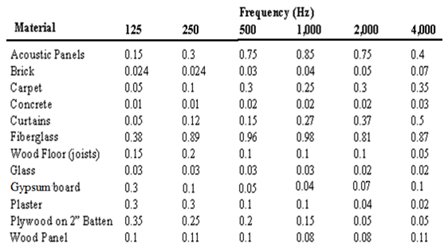**Coefficients of sound absorption at differente frequences**

**Note:** It can be seen from the table above that the absorption coefficient of the material varies with the source frequency. In some cases, taking the average of these values is preferred and this is what so-called Noise Reduction Coefficient (NRC) which is commonly used to describe the value of the absorbance of the insulating material.

**Noise reduction coefficient of some insulating materials**

| **Material** | **NRC** |
| --- | --- |
| Acoustic tiles | 0.8-0.9 |
| Polyurethane | 0.8-0.9 |
| Mass vinyl | 0.75 |
| Glass wool | 0.7 |
| Asbestos | 0.6 |
| Mineral wool | 0.65 |
| EPS, XPS | 0.3-0.4 |
| Rubber | 0.2 |

**Absorption capacity:** it represents the amount of acoustic units that can be absorbed by the barrier or the wall. Sound absorption unit is called (Sabin). The absorption capacity depends on the space area and absorption coefficient according to the relationship:

**C = α x A**

**Noise attenuation**

The total amount of reduction in the acoustic energy as a result of reflection and absorption when moving from a room to another or abroad is called the noise reduction. This amount is expressed in the relationship:

**NR = TL + 10 Log (C/A)**

Where: TL is the loss transmission of the walls

C is the absorption capacity of the room

A is the area of the separation wall

**Note**: in the design usually suppose a sound frequency value of 500 Hz which isstill within the range of the voices of people and cars, as shown in the figure below.

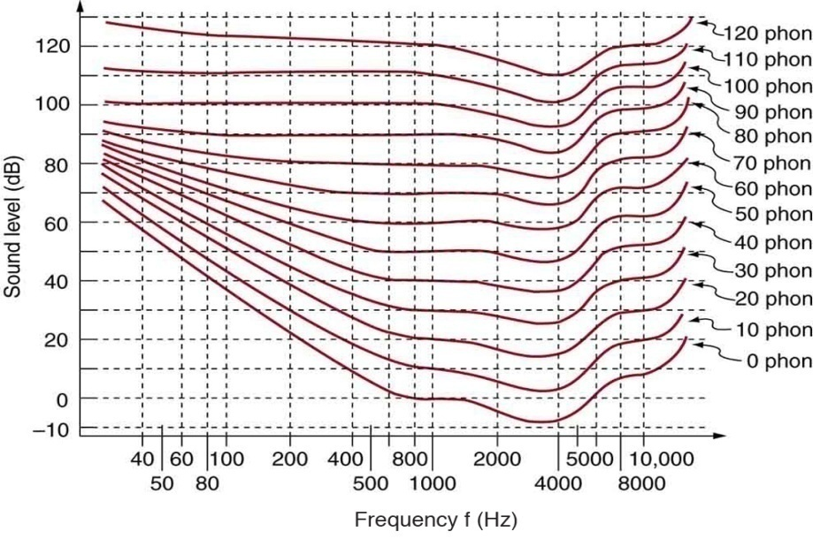

* So it could say that:

**TL = STC**

* 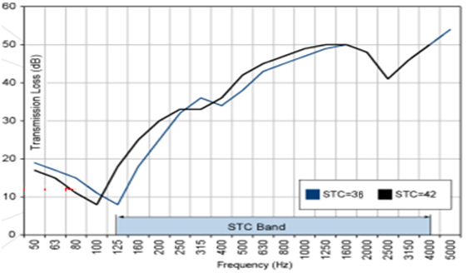In case of high ranges of frequencies, then it is acceptable to use the correction chart as shown in the figure below.

**Ex. (1)** A conference hall of 10 m x 6 m x 3.5 m, has 3 walls of gypsum (α=0.05), one facade of glass (α=0.03), ceiling of plastic tiles (α=0.1) and floor of carpet (α=0.3). An office is located next door to the hall, as shown in the figure.

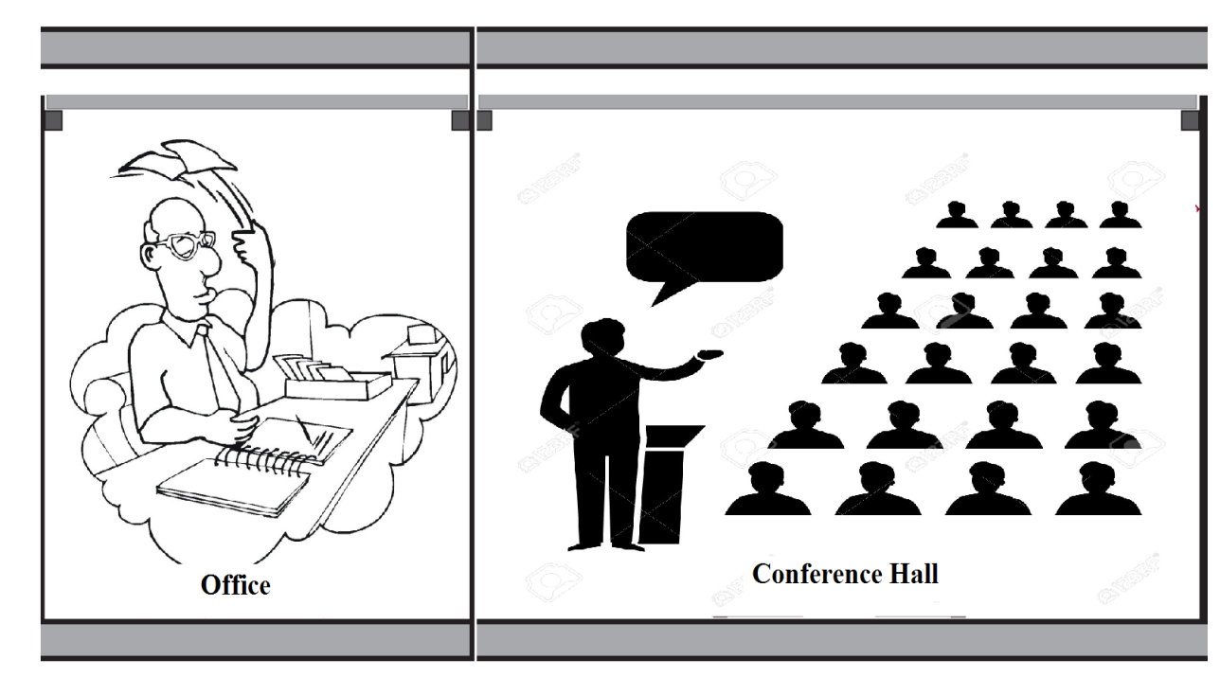

Find:

a) Total absorption for the conference hall. (Absorption of furniture=20 Sabins)

b) Noise reduction for the office room. (STC of the separated wall is 48)

c) Total absorption for the conference hall if the separated wall is covered by acoustic tiles (NRC=0.9)

d) Noise reduction for the office room after insulation. (STC of the separated wall becomes 54)

**Solution**

a)

- Walls (gypsum) A = 10*3.5+6*3.5*2 = 77 m2

C = α x A = 0.05*77 = 4 Sabins

- Wall (glass) A = 10*3.5 = 35 m2

C = α x A = 0.03*35 = 1 Sabin

- Ceiling (plastic tiles) A = 10*6 = 60 m2

C = α x A = 0.1*60 = 6 Sabins

- Floor (carpet) A = 10*6 = 60 m2

C = α x A = 0.3*60 = 18 Sabins

Ctotal = Cwalls + Cceiling + Cfloor + Cfurniture =4+1+6+18+20 = 49 Sabins

b) NR = TL + 10 Log (C/A) = 48 + 10 Log (49/21) = 52 dB

c) Acoustic tiles A = 6*3.5 = 21 m2

C = NRC x A = 0.9*21 = 19 Sabins

Ctotal = 49+19 = 68 Sabins

d) NR = TL + 10 Log (C/A) = 54 + 10 Log (68/21) = 60 dB Excellent insulation.

**Ex. (2)** A living room of 6 m x 5 m x 3 m has the following features:

Bed Room

Element Material α

Walls Plywood 0.2

Living Room

Ceiling Gypsum 0.05

Floor Carpet 0.3

What would be the noise attenuation with respect to the upper bed room for both cases:

1- Before insulation.

2- After insulating the ceiling by 5 cm glasswool (NRC=0.7).

Take into account that STC of the roof without insulation is (48) and with insulation is (54). There is an additional absorption due to the furniture which is 15 Sabins.

**Solution**

1-Befor insulation

- Walls (plywood) A = 6*3*2+5*3*2 = 66 m2

C = α x A = 0.2*66 = 14 Sabins

- Ceiling (gypsum) A = 6*5 = 30 m2

C = α x A = 0.05*30 = 2 Sabins

- Floor (carpet) A = 6*5 = 30 m2

C = α x A = 0.3*30 = 9 Sabins

Ctotal = Cwalls + Cceiling + Cfloor + Cfurniture =14+2+9+15 = 40 Sabins

NR = TL + 10 Log (C/A) = 48 + 10 Log (40/30) = 50 dB

2-After insulation

- Glasswool A = 6*5 = 30 m2

C = NRC x A = 0.7*30 = 21 Sabins

Ctotal = 40+21 = 61 Sabins

NR = TL + 10 Log (C/A) = 54 + 10 Log (61/30) = 57 dB Very good insulation.

**Noise pollution in industrial**

 The steady increase in the noise level leads to permanent damage in the auditory system, as well as some attendant symptoms like: reducing the heart rate, changing in blood pressure and difficulty of breathing. As the psychological impact on the individual worker, protrudes through the change the style of his sleep, thus accompanying fatigue in the body which will affect the production efficiency of the working. If the worker is exposed to a continuous noise (80 dB) during the period of his work, then that will lead to loss 15 dB approximately in his hearing threshold during several years (i.e., he loses the level of whisper). Sound level is measured using a device called sound level meter, as shown in the figure.

It must follow the following steps to prevent the noise and satisfy safety conditions:

1. Use suitable damper for high-vibration machines.

2. Use soundproofing for the purpose of absorption and dispersion of sounds.

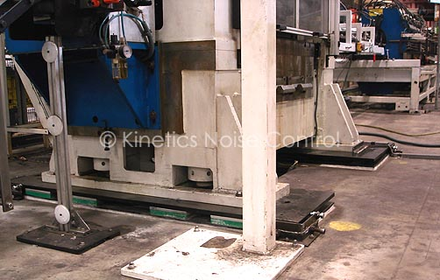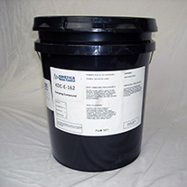3. Use of ear protectors as a prerequisite for workers.

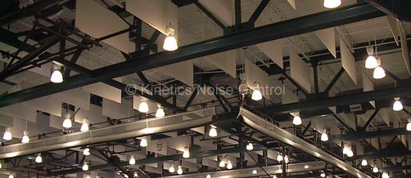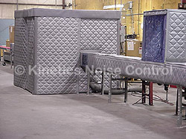Vibration pad (Neoprene or vinyl) Viscoelastic compound (Polymer)

Noise Control Baffles (fiberglass) Curtain