Low Density Polyethylene LDPE 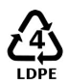
Low Density Polyethylene is manufactured using a free radical mechanism (initiated with a peroxide initiator) under high pressure.
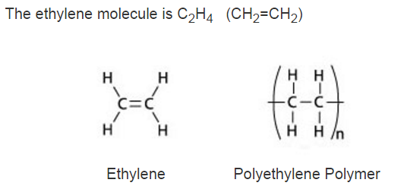

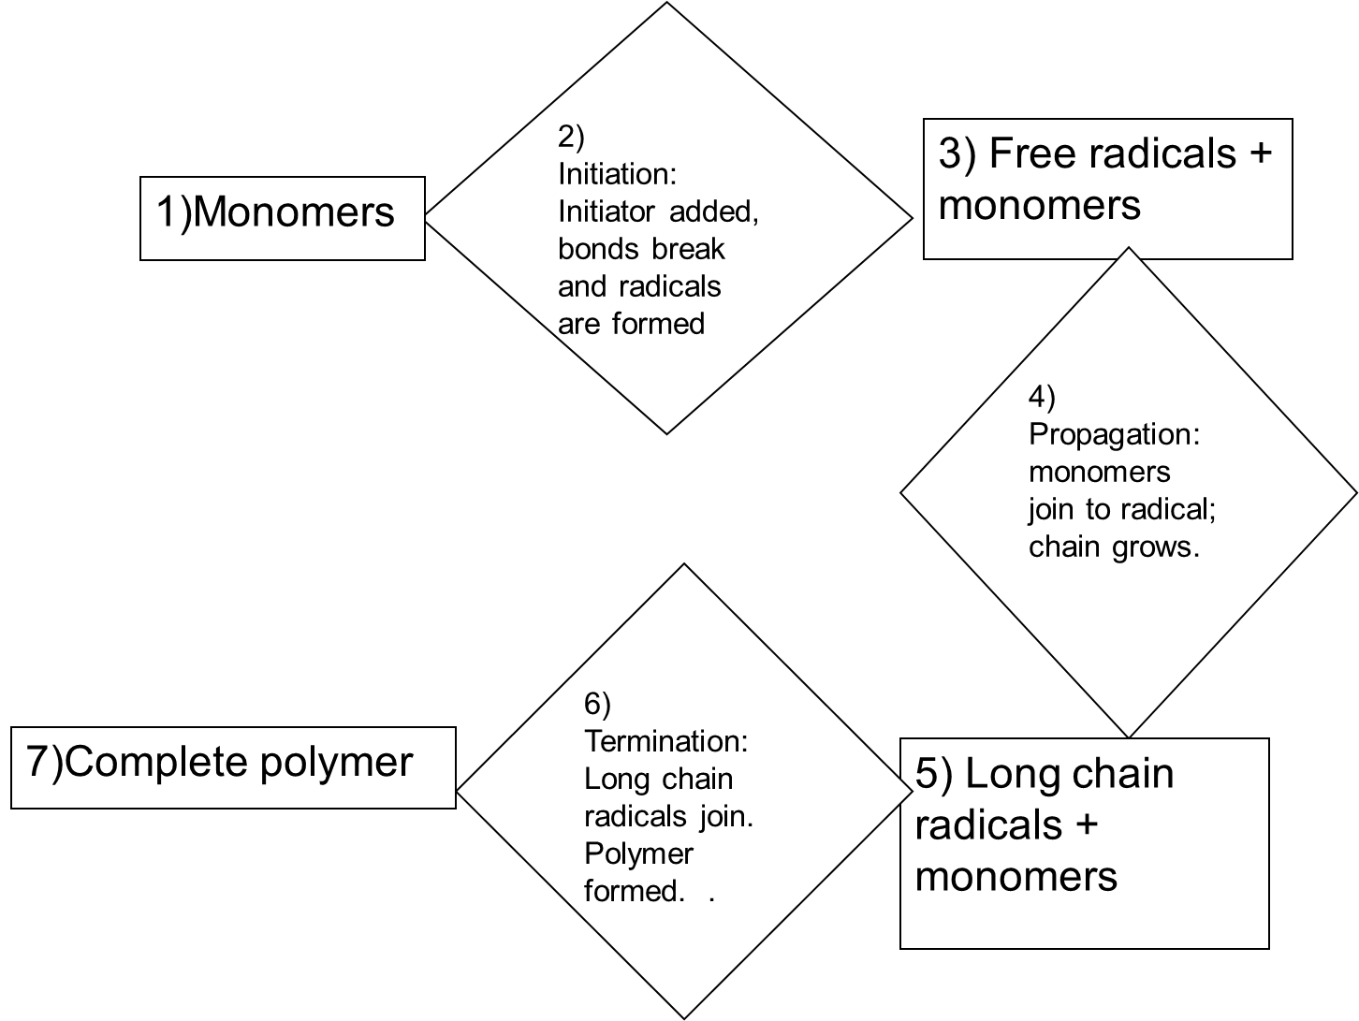
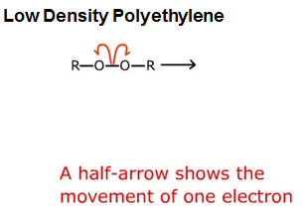
1. Initiation: The O–O bond is weak and breaks to make R–O radicals (alkoxy radicals).

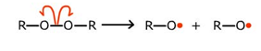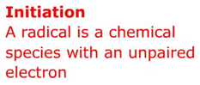
2. Combination An alkoxy radical combines with one of the electrons from the double bond in ethylene.
3. Propagation: An alkoxy radical combines with one of the electrons from the double bond in
ethylene.
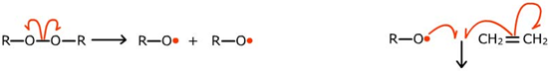
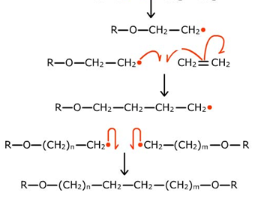
The new radical reacts with another ethylene molecule.

This forms another new radical, longer than before.
The chain grows longer until two radicals react with each other.

This is called the termination step.
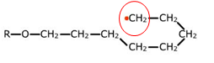
A growing chain may curl around and attack itself by back-biting.

The radical moves to another part of the chain, and allows branched chains to
grow from the side.

Properties
LDPE is defined by a density range of 0.910 - 0.940 g/cm3. It has a high degree of short and long chain branching, which means that the chains do not pack into the crystal structure as well. It has therefore less strong intermolecular forces as the instantaneous-dipole induced-dipole attraction is less. This results in a lower tensile strength and increased ductility. LDPE is created by free radical polymerization. The high degree of branches with long chains gives molten LDPE unique and desirable flow properties.
ADVANTAGES:
- Low cost
- Impact resistant from -40 C to 90 C
- Moisture resistance
- Good chemical resistance
- Food grades available
- Readily processed by all thermoplastic methods
DISADVANTAGES AND LIMITATIONS:
- High thermal expansion
- Poor weathering resistance
- Subject to stress cracking
- Difficult to bond
- Flammable
- Poor temperature capability
Low Density Polyethylene (LDPE) Ve High Density Polyethylene (HDPE):
Property | Low Density Polyethylene  (LDPE) | High Density Polyethylene  (HDPE)
Melting Point | ~115ºC | ~135ºC
Crystallinity | low crystallinity (50-60% crystalline)  Main chain contains many side chains of 2-4 carbon atoms leading to irregular packing and low crystallinity (amorphous) | highly crystalline (>90% crystalline)  contains less than 1 side chain per 200 carbon atoms in the main chain leading to long linear chains that result in regular packing and high crystallinity
Flexibility | more flexible than HDPE due to lower crystallinity | more rigid than LDPE due to higher crystallinity
Strength | not as strong as HDPE due to irregular packing of polymer chains | strong as a result of regular packing of polymer chains
Heat Resistance | retains toughness & pliabilty over a wide temperature range, but density drops off dramatically above room temperature. | useful above 100ºC
Transparency | good transparency since it is more amorphous (has non-crystalline regions) than HDPE | less transparent than LDPE because it is more crystalline
Density | 0.91-0.94 g/cm³  lower density than HDPE | 0.95-0.97 g/cm³  higher density than LDPE
Chemical Properties | chemically inert  Insolvent at room temperature in most solvents.  Good resistance to acids and alkalis.  Exposure to light and oxygen results in loss of strength and loss of tear resistance. | chemically inert
Schematic diagram | 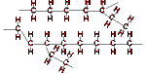 | 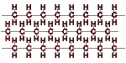
Uses | sandwich bags, cling wrap, car covers, squeeze bottles, liners for tanks and ponds, moisture barriers in construction | freezer bags, water pipes, wire and cable insulation, extrusion coating

