LECTURE NO.1
A. Measuring Units

The international system ϑ units (SI)
1.1.Length : meter (m)
1 m = 100 cm = 1000 mm
1.2. Mass: kilogram (kg)
1 kg = 1000 g
1.3. Force: N/m² = 1 Pascal (Pa)
Mega Pascal M = 1 * 10⁶ Pa
1 bar = 50 MN / m² or 50 MPa
1.4. To convert the following:
N (Newton) = kgf * 9.8066
Pascal (Pa) = kgf / m² * 9.8066

B. Introduction To Strength Θ Materials
The field ϑ mechanics covers the relations between forces acting on rigid bodies, in statics, the bodies are in equilibrium, where as in dynamics, they are accelerated but can be put in equilibrium by applying correctly placed ……. Forces.
The field ϑ strength ϑ materials (or mechanics ϑ materials) deal with the relations between externally applied loads and their internal effects on bodies.
Thus the properties ϑ the material ϑ which a structure or machine is made affect both its choice and the dimensions that will satisfy the requirements ϑ strength and stiffness rigidity other properties ϑ materials.

LECTURE NO. 2
Simple Stress

2.1. Tension & Compression Stress
Stress is expressed symbolically as
σ = P / A N / m²
Where: σ (sigma): is stress or per unit area N/m²
P: is applied load N (network)
A: cross- selection at area over a section normal to the load in m².

Examples:
- The bar shown in the fig. Below has a constant width ϑ 35 mm and a thickness ϑ 10 mm. Determine the maximum average normal stress in the bar when it is subjected to the loading shown :

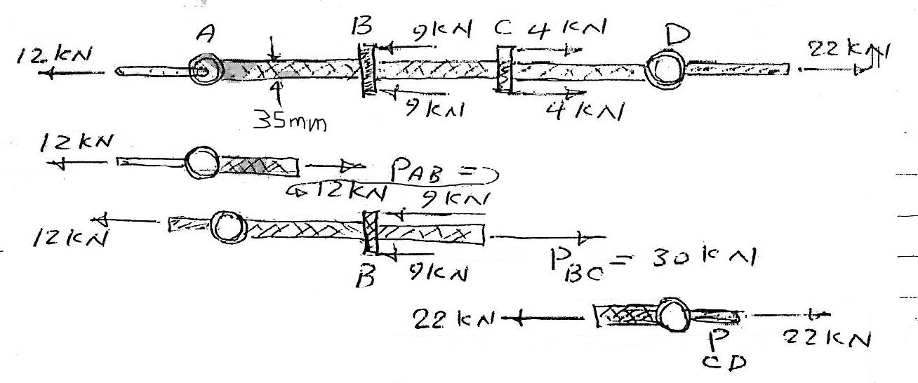

Solution :
By inspection the internal axial forces in regions AB, BC, and CD are all constant let have different magnitudes, the largest loading is in region BC, where P_{BC} = 30 kn thus the largest average normal stress occurs with in this region ϑ the bar
σ_{BC} = P_{BC} /A = $\frac{( 30 * {10}^{3} ) }{(0.035 * 0.01 }$ = 85.7 Mpa

B.. the 80 kg lamp is supported by two rods AB & BC as shown in fig. if AB has a diameter ϑ 10 mm, and BC has a diameter ϑ = 8 mm, determine which rad is subjected to the greater average normal stress

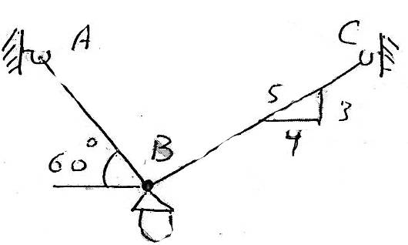
Solution :
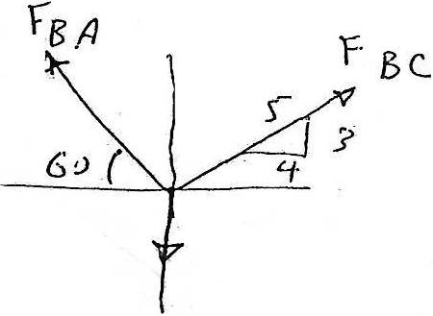

∑ F_{x} =0 or F_{BC} * (4/5) – F_{BA} cos 60 = 0 ……(1) +

∑ F_{y} =0 or F_{BC} * (3/5) + F_{BA} sin 60 – 784.8 = 0 ……(2) +

From equations 1&2
F_{BC =} 395.2 N , F_{BA} = 632.4 N
By Newton's third law ϑ action, equal but opposite reaction, these forces subject the rods to tension throughout their length.
Average normal stress:
σ_{BC} = $\frac{F_{BC}}{A_{BC}}$ = $\frac{395.2}{π {(0.004)}^{2} }$ = 7.86 MPa
σ_{BA} =$\frac{F_{BA}}{A_{BA}}$= $\frac{632.4}{π {(0.005)}^{2} }$ = 8.05 MPa
Thus rod BA is subjected to max. Stress.

2.2. Shearing Stress:
Shearing stress differs from both tensile & compression stress in that it is caused by forces acting along or parallel to the area resisting the forces, whereas tensile and compressive stresses are caused by forces perpendiculars to the areas on which they act. For this reason tensile and compressive stresses are frequently called normal stress, whereas a shearing stress may be called a tangential stress.
The shear stress may be:
*Direct shear (simple shear) : this occurs over an area parallel to the applied load.
*Induced shear: this occurs over sections inclined with the resultant load.
Example ϑ the above types are:
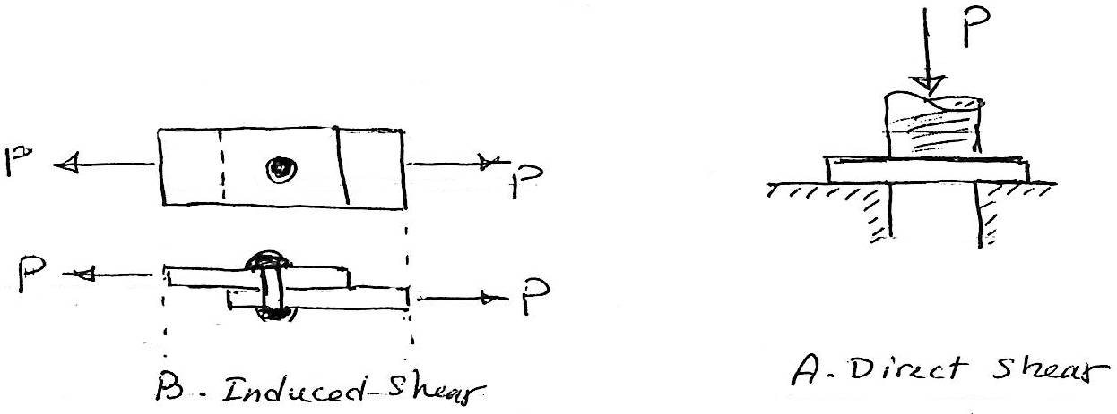
Both direct shear and induced shear may be:
1. Single shear:
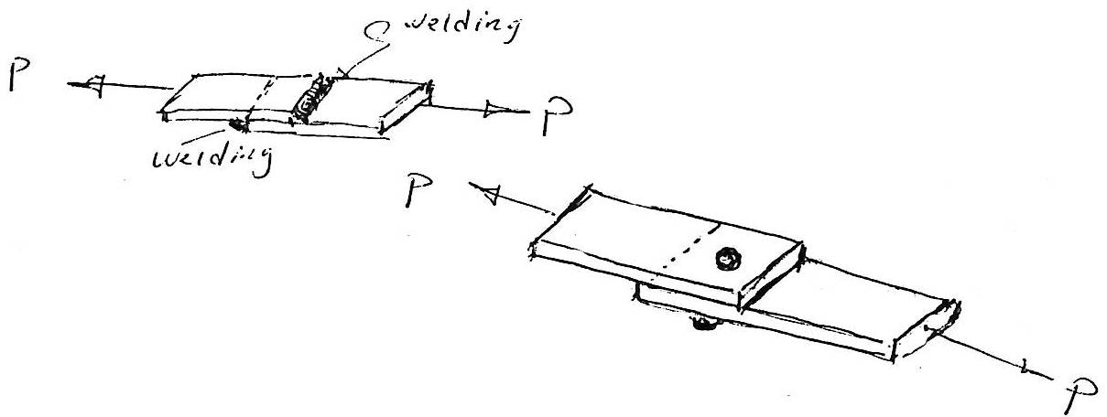
2. Double shear:
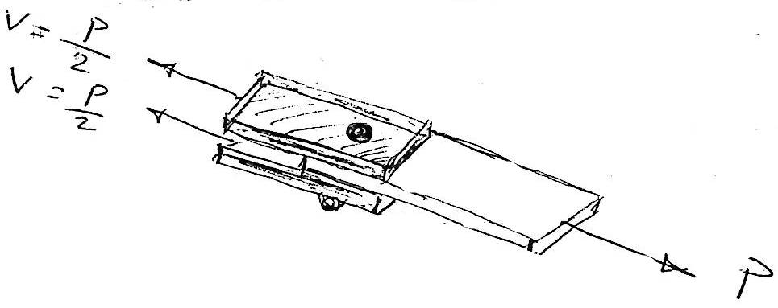
τ_{avg} = $\frac{V}{A}$
Where:
: Average shear stress at the section. τ_{avg}
V: internal resultant force at the section determined from the equation ϑ equilibrium.
A: area at the section.
Examples:
A. A hole is to be punched out ϑ a plate having an ultimate shearing stress ϑ 300 MPa. (a) if the compressive stress in the punch is limited to 400 MPa determine the maximum thickness ϑ plate from which a hole 100 mm in diameter can be punched. (b) it the plate is 10 mm thick compute the smallest diameter hole which can be punched?
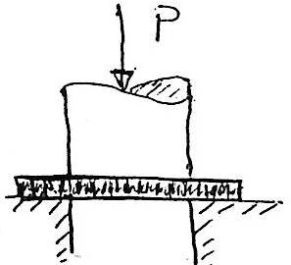
a.
σ = $\frac{P}{A}$
400= $\frac{P}{{(\frac{0.1}{2})}^{2}π}$
P = 3.14159 MPa
τ= $\frac{P}{A}$ or A= $\frac{3.14159}{300}$ = 0.01047 M²
A = t * d * π or
t= $\frac{A}{(d*π) }$ = $\frac{0.01047}{0.1*π}$ = 0.0333 m = 33.3 mm
b.
τ= $\frac{P}{A}$
A = t * d * π
Or P = 300 * 0.01 * d * π …… (1)
σ= $\frac{P}{A}$or
P = 400 * π * $\frac{d^{2}}{4}$…… (2)
From equation 1 & 2
300 * 0.01 * d * π = 400 * π * (d²/4)
So d = 0.03 m = 30 mm
B. A bar has a square cross-section for which depth and thickness are 40 mm. if an axial force ϑ 800 N is applied along the centroidal axis ϑ the bar's cross-sectional area, determine the average normal stress and average shear stress acting on the material along(a) section plane a-a and (b) section plane b-b.
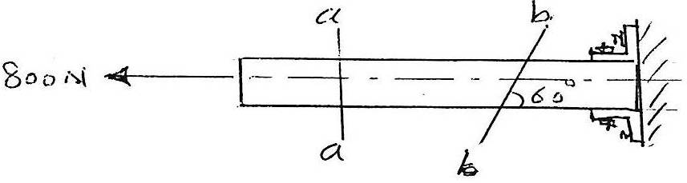
Solution:
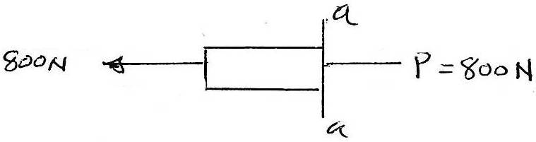
The loading consists only an axial force for which p= 800 N
The average normal stress is determined from:
σ= $\frac{P}{A}$= $\frac{800}{0.04* 0.04}$ = 500 kPa
No stress exits on this section, since the shear force at the section is zero.
τ_{avg}= 0
b.
Free body diagram shows a normal force (N) and shear force (V)
+ ∑ F_{x} = 0 , -800+N sin60 + V cos60 = 0 ……(1)
F_{y} = 0, V sin60 – N cos60 = 0 ……..(2) ∑ +
From equation 1 & 2
N = 692.8 N
V = 400 N
At section b-b the area has a thickness = 40 mm & depth ϑ 40/sin60 = 46.19 mm
Average normal stress σ = $\frac{N}{A}$= $\frac{692.8 }{0.04*0.04619}$ = 375 kPa
Average shear stress τ_{avg}= $\frac{V}{A}$ = $\frac{400}{0.04*0.04619}$ = 217 kPa

2-3. Bearing Stress:
Bearing stress differs from compressive stress in that the latter is the internal stress caused by a compressive force whereas the former is a contact pressure between separate bodies.
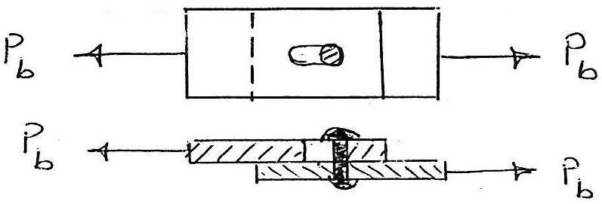
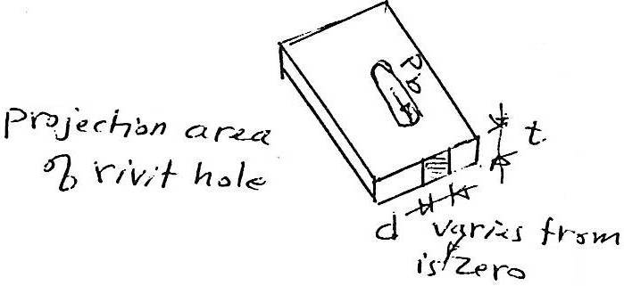
P_{b} = A_{b} σ_{b}
= ( t d ) σ_{b}

Note: bearing stress at is various from zero ϑ the hole to max. Directly in back ϑ the rivet.
Examples:
The lap joint shown in the fig. fastened by three 20 mm diameter rivet , determine the maximum safe load p which may be applied if the shearing stress in the rivets is limited to 60 MPa, the bearing stress in the plates is 110 MPa, and the average tensile stress in the plate to 140 MPa.
Solution:
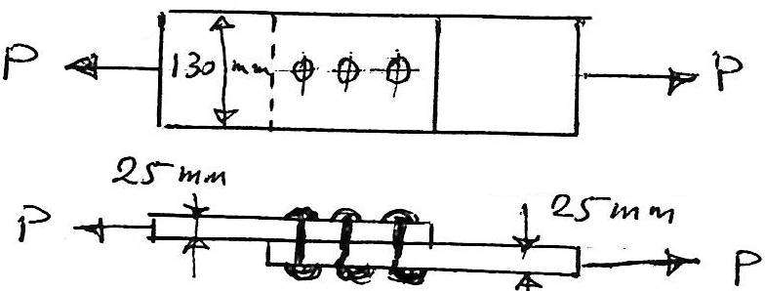
We must check the tensile force, shearing force in the rivets, and in the plate.
Bearing force in the plate, and then taking the min. force:
σ_{p}= $\frac{P}{A}$ or P = σ_{p} * A
P = 140 * 10³ * ( 0.13*0.025)
= 459 kN
τ_{p}= $\frac{V}{A}$ or V= τ_{p} * A
V = 60 * 10³ * (0.01)² * 3
= 56.5 kN
P_{b} = A_{b} * σ_{b}
= ( 0.02 * 0.025) * 3 * 110 * 10³
165 kN
So the min. P is 56.5 kN

LECTURE NO. 3
Thin Walled Cylinders
Cylinders or spherical vessels are commonly used in industry to serve as boilers or tanks.
When under pressure, the material ϑ which they are made is subjected to a loading from all directions.
Although this is the case, the vessel can be analyzed in a simpler manner provided it has a thin wall.
In general, "thin wall" refers to a vessel having an inner radius-to-wall thickness ratio of 10 or more ( r/t ≥ 10).
A cylindrical tank carrying a gas or fluid under pressure of P N/m² is subjected to tensile force which resists the bursting forces developed across longitudinal and transverse section.
Consider atypical longitudinal section A-A through the pressure-loaded cylinder in the following figure:
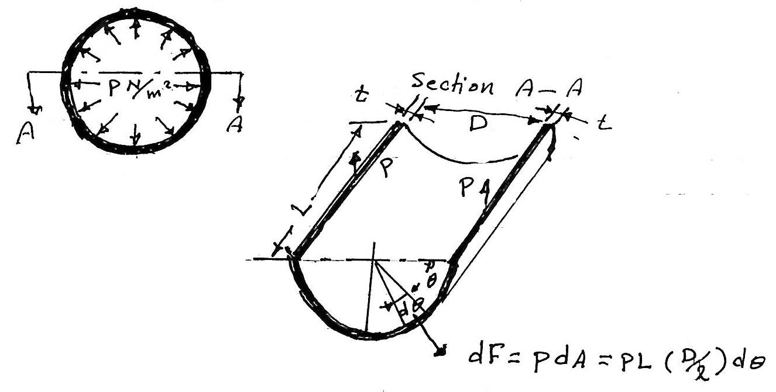
The elementary force acting normal to an element ϑ the cylinder located at angle θ from the horizontal is :
d F = p d A = p L $\frac{D}{2}$dθ
A similar force (not shown) acts on the symmetrically placed element on the other side ϑ the vertical center since the horizontal components of such pairs ϑ forces cancel out the bursting force. F is the summation ϑ the vertical component ϑ these elementary forces:
F = $\int_{0}^{π}{\left(PL \left(\frac{D}{2}\right)dθ \right)sinθ}$
= P L $\frac{D}{2}{[-cosθ]}_{0}^{π}$
∴ F = P D L
∴ The stress in the longitudinal section that resists the bursting force is:
σ= $\frac{F}{A }$or σ₁= $\frac{PDL}{2tL}$ = $\frac{P D }{2t }$ …….(1)
Where
P: is the applied pressure inside the cylinder in N/m^{2 .}
D: diameter ϑ the cylinder m.
t : thickness ϑ the cylinder m.
σ₁ : normal stress.
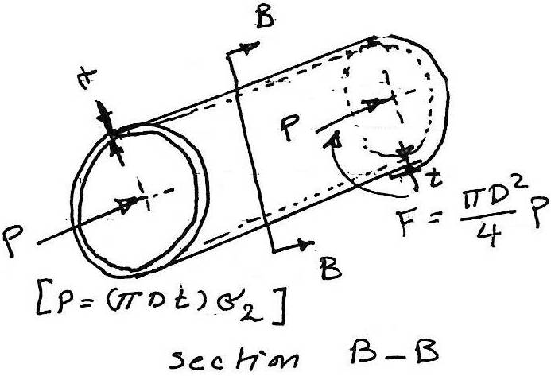
Note: the normal, stress could be called tangential stress because it acts tangent to the surface ϑ the cylinder. Others common names are circumferential stress, hoop stress and girth stress.
If we consider the free-body diagram ϑ a transverse section.

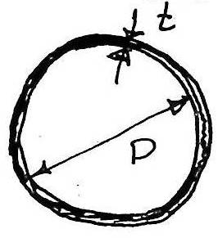
The bursting force acting over the end of the cylinder is resisted by the resultant p ϑ the tearing forces acting over the transverse section.
The transverse area:
Π ( D + t) t
If t small compared to D
∴ A= π D t
P = F or π D t σ₂ = $\frac{π D^{2}}{4} P$
∴ σ₂ = $\frac{P D }{4 t}$ ………..(2)
Where
σ₂: longitudinal stress (because it acts parallel to the longitudinal axis ϑ the cylinder) N/ m²
P: is the pressure inside the cylinder N / m²
D: inside diameter ϑ the cylinder m
t: thickness ϑ the cylinder m
Comparing equations 1 and 2
σ₁ = 2 σ₂ .......... (3) or σ₂ = $\frac{1}{2}$ σ₁
Longitudinal stress is one half the value ϑ the normal.
Stress or tangential stress.
For spherical tanks or vessels
σ = $\frac{P r}{2 t}$ .......(4)
Where:
σ = stress
P = pressure inside the spherical vessels
r = radius ϑ the vessel
t = thickness ϑ material used.
Example:
A cylindrical pressure vessel is fabricated from steel plates which have a thickness ϑ 20 mm. The diameter ϑ the pressure vessel is 500 mm and its length is 3m. Determine the max. Internal pressure which can be applied if the stress in the steal is limited to 140 MPa.
Solution:
σ₁ = $\frac{P D}{2 t}$ or P = $\frac{2 t σ_{1}}{D}$
Or P = $\frac{2 * 140 * {10}^{3}* 0.02}{0.5}$
= 11.2 MPa
σ₂ = $\frac{P D}{4 t}$ or P = $\frac{4 t σ_{2}}{D}$
Or P = $\frac{4 * 140 * {10}^{3} * 0.02}{0.5}$
= 22.4 MPa
∴ The max. Internal pressure = 11.2 MPa
Example:
A cylindrical pressure vessel has an inner diameter ϑ 150 cm and a thickness ϑ 13 mm. determine the maximum internal pressure it can sustain so that neither it circumferential nor its longitudinal stress component exceeds 138 MPa. Under the same conditions, what is the max. internal pressure that a similar-size spherical vessel can sustain?
Solution:
The max. stress occurs in the circumferential direction ( tangential stress):
σ₁ = $\frac{P D}{2 t}$ or P = $\frac{2 t σ_{1}}{D}$
= $\frac{2 * 0.013 * 138 * }{1.5}$
= 23920 kPa
= 23.92 MPa
For spherical vessel:
σ = $\frac{P r}{2 t}$
Or P = $\frac{2 t σ}{r}$
= $\frac{2 * 0.013 *138}{\frac{1.5}{2}}$
= 47.84 MPa
The spherical pressure vessel will carry twice as much internal pressure as a cylindrical vessel.

LECTURE NO. 4
Simple Strain
4.1. Stress Strain Diagram .
The properties ϑ materials such as stiffness, hardness, toughness and ductility are determined by making tests on materials and comparing the results with established standards.
One ϑ these tests → the tension test for steal.
For example:
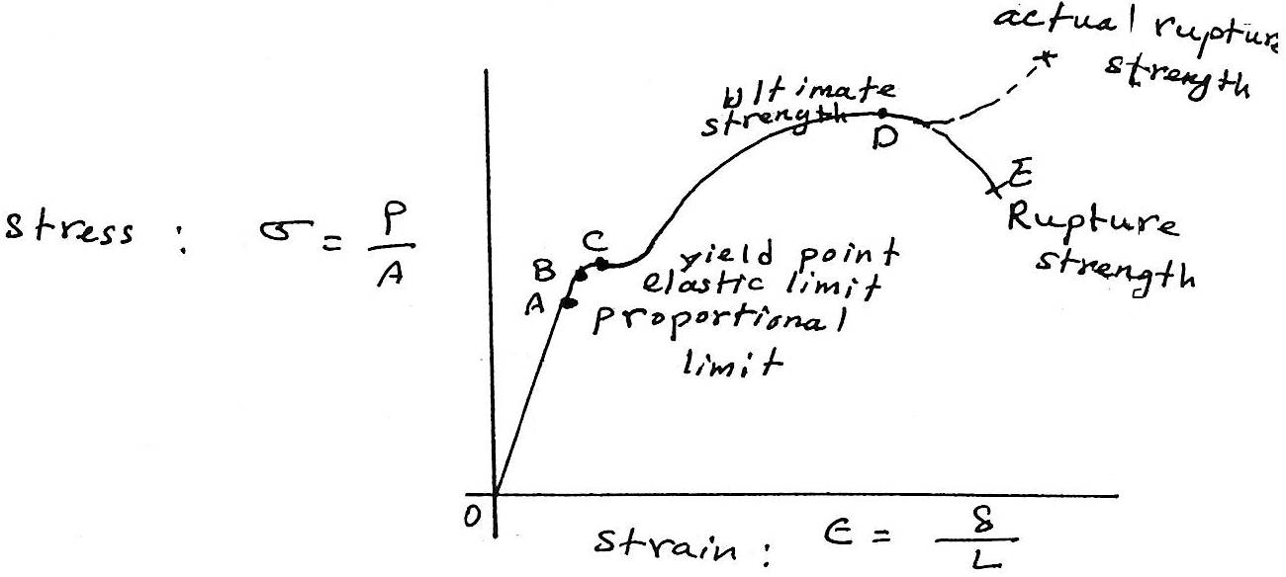
[The curve or relation is first postulated by Robert Hooke in 1678]
A. Proportional Limit:
The stress stain diagram to be a straight line ( i.e. from zero up to this point ), beyond this limit or point, the stress in no longer proportional to the strain. The proportional limit is important because all subsequent theory involving the behavior ϑ elastic bodies is based upon a stress-strain proportionality. Also this limit indicates the max. stress to which a material may be subjected.
B. The elastic limit, that is, the stress beyond which the material will not return to its original shape when unloaded but will retain a permanent deformation called permanent set.
C. Yield point, at which there is an appreciable elongation or yielding ϑ loads, the load may actually decrease while the yielding occurs.
D. Ultimate strength: or ultimate stress, is the highest ordinates on the stress-strain curve.
E. Rupture strength, the stress at failure.
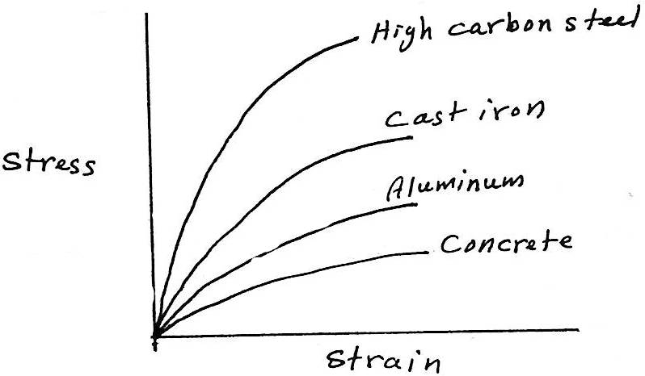
Comparative stress-strain diagram for different materials.
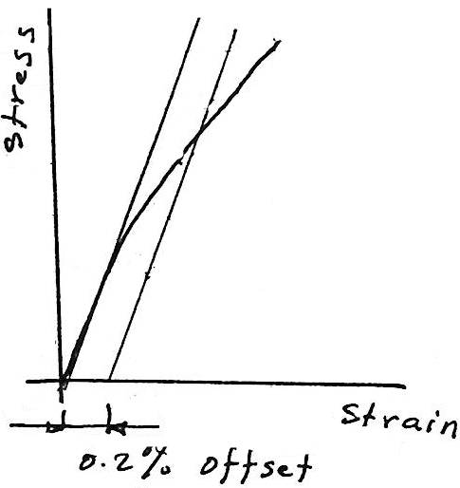
Yield strength; closely associated yield point. For materials which do not have a well defined yield point, yield strength is determined by the offset method. This consists ϑ drawing a line parallel to the initial tangent ϑ the stress-strain curve, this line being started at an arbitrary offset strain, usually ϑ 0.2 % or 0.002 m/m, the intersection ϑ this line with stress strain curve is called the yield strength, see the figure.

E = δ / L ……….. (1)
Where
E : strain , δ : elongation , L : length
Equation (1) determines the average strain in a length; the strain must be constant over the length. However, under certain conditions the strain may be assumed constant and its value computed from equation (1) under the following conditions:
1.The specimen must be ϑ constant cross section.
2.The material must be homogeneous.
3.The load must axial that is, produce uniform stress.
Allowable stress : is the maximum safe stress a material may carry.
σ_{W} = $\frac{σ_{YP}}{N_{YP}}$ or σ_{w} = $\frac{σ_{ult}}{N_{ult}}$ …….. (2)
Where N: factor ϑ safety.
N = 4 for materials that are known to be quite uniform and homogeneous.
For other materials, like wood, in which unpredictable no uniformities may occur, larger factor ϑ safety are desirable.
4.2. Hooke's Law: Axial Deformation
The slop ϑ the line (i.e. the straight-line portion ϑ the stress-strain diagram) is the ratio ϑ stress to strain is called the modulus ϑ elasticity (E):
E = σ / ϵ or σ = E ϵ ……… (3) Hooke's Law
Where :
E: modulus ϑ elasticity or young modulus
ϵ for steel = 200 * N/m² (Pa)
= 200 GPa GPa = 10⁹ Pa G (giga)
σ = E ϵ
$\frac{P}{A}$ = E $\frac{δ}{L}$
δ = $\frac{P L}{A E}$ ……….. (4)
where:
δ : total deformation
P : applied load
A : cross-sectional area
E : modulus ϑ elasticity
Example:
Compute the total elongation caused by an axial load ϑ 100 kN applied to a flat bar 20 mm thick, tapering from a width ϑ 120 mm in a length of 10 m as shown below, assume E=200*10⁹ N/m².
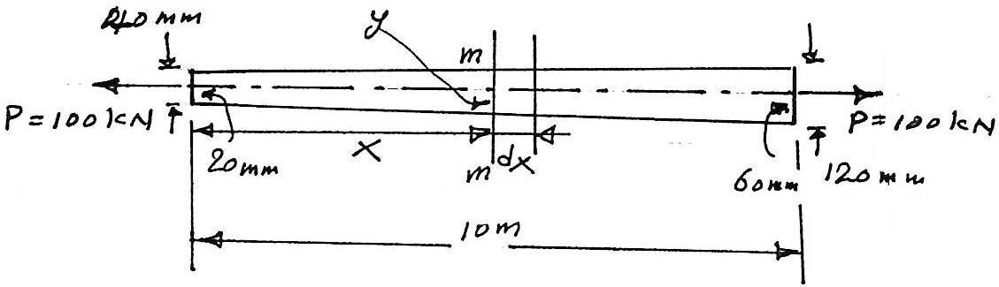
Solution:
Since the cross-sectional area is not constant, therefore, it may be used to find the elongation in a differential length for which the cross-sectional area is constant. Then the total elongation is the sum ϑ these infinitesimal elongation.
$\frac{y-20}{x}$ = $\frac{60-20}{10}$ or y= (4x+20)………(1)
The area at the section is
A= 20 * 2y
∴ A= 160x + 800
δ = $\frac{P L}{A E}$ PL /AE
dδ = $\frac{100*{10}^{3} dx}{(160x+800)(200*{10}^{9}}$
= $\frac{0.5dx}{160x+800}$
∴ The total elongation is
δ = 0.5 $\int_{0}^{10}{\frac{dx}{160x+800 }}$
= $\frac{0.5}{160} {[ln(160x+800)]}_{0}^{10}$
= (3.13*10⁻³) ln $\frac{2400}{800}$ (2400/800)
= 3.44 mm ans
H.W (singer)
205, 211, 213
4.3. Shearing Deformation:
Shearing forces cause a shearing deformation, just as axial forces cause elongations, but with an important difference: an element subject to tension undergoes an increase in length; an element subject to shear does not change the length ϑ its sides, but undergoes a change in shape from rectangle to parallelogram.
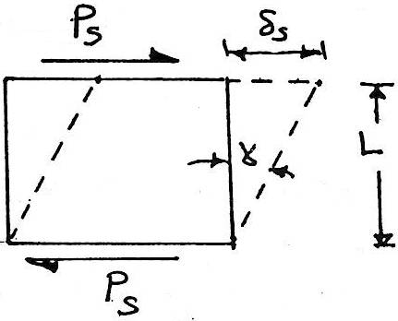
The average shear
Strain ɣ = $\frac{δ s }{L}$
Applied Hooke's law
τ = G ɣ
Where :
G: modulus ϑ elasticity in shear (modulus ϑ rigidity)
∴ δ_{s} = $\frac{V L}{A_{s} G}$V L/ A_{s} G ……. (5)
Where:
V: shearing force
A_{s}: shearing area
Example:
The plate shown in the fig. below is held in the rigid horizontal guides at its top and bottom, AD and B. if the right side CD is given a uniform horizontal displacement ϑ 2 mm, determine:
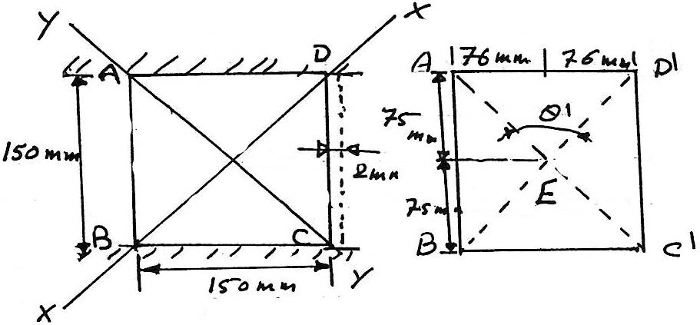
A. The normal strain along the diagonal AC.
B.The shear strain at E relative to the x-y axes.
a.When the plate is deformed, the diagonal AC becomes AC', the length ϑ diagonals AC & AC' can be computed from the Pythagorean Theorem:
AC=$\sqrt{{(0.15)}^{2}+{ (0.15)}^{2}}$
= 0.21213m
AC'=$\sqrt{{(0.15)}^{2}+{ (0.152)}^{2 }}$
= 0.21355m
The average normal strain along the diagonal is ∴
(E_{AC}) _{avg}= $\frac{AC'-AC}{A C}$
= $\frac{0.21355-0.21213}{0.21213}$
= 0.00669 mm/mm
To find the shear strain at E relative to x & y axes, it is necessary to find the angle θ':
tan $\frac{∅'}{2}$ = $\frac{76}{75}$
∴θ'= 90.759° = $\frac{π}{180}$ (90.759)
= 1.58404 rad.
ɣ= $\frac{π}{2}-$θ'
∴ɣ_{xy} = $\frac{π}{2}-$1.58404
= -0.0132 rad.
The negative sign indicates that the angle θ' is greater than90°.
4.4. Poisson's Ratio; Biaxial & Triaxal Deformation:
Another type ϑ elastic deformation is the change in transverse dimensions accompanying axial tension or compression.
Experiments show that if a bar is lengthened by axial tension, there is a reduction in the transverse dimensions.
Simeon D. Poisson showed in 1811 that the ratio ϑ the unit dimensions or strain in these directions is constant for stresses within the proportional limit.
V= - $\frac{ϵ_{y}}{ϵ_{x}}$ = $\frac{ϵ_{z}}{ϵ_{x}}$ …………. (6)
Where:
V: Poisson ratio
ϵ_{x} = strain in x-direction
ϵ_{y} = strain in y-direction
ϵ_{z} = strain in z-direction
Note; minus sign indicates a decrease in transverse dimension positive as in the case ϑ tensile elongation.
Tensile stress in x and y direction thus; (biaxial)
ϵ_{x} = $\frac{σ_{x}}{E}$ – V $\frac{σ_{y}}{E}$ ……... (7)
ϵ_{y} = $\frac{σ_{y}}{E}$ – V $\frac{σ_{x}}{E}$ ……… (8)
or
σ_{x} = $\frac{\left(ϵ_{x}+Vϵ_{y }\right)E}{1- V^{2}}$ ;
σ_{y} = $\frac{\left(ϵ_{y}+Vϵ_{x }\right)E}{1- V^{2}}$ ; ……(9)
Tensile stress in x, y, and z (triaxial tension stress);
ϵ_{x} = $\frac{1}{E}$ [σ_{x} – V (σ_{y}+σ_{z})]
ϵ_{y} = $\frac{1}{E}$ [σ_{y –} V (σ_{z}+σ_{x})]
ϵ_{z} = $\frac{1}{E}$ [σ_{z} – V (σ_{x}+σ_{y})] ……… (10)
G = $\frac{E}{2(1-V) }$…… (11) for a given material
Where:
G: modulus ϑ elasticity in shear
E: modulus ϑ elasticity
V: Poisson's ratio
V for steel from 0.25 to 0.3
V for most material ≅ 0.33
V for concrete ≅ 0.2
Example:
A solid aluminum shaft 80 mm diameter fits concentrically in hollow steel tube. Compute the minimum internal diameter ϑ the steel tube so that no contact pressure exists when the aluminum shaft carries an axial compressive load ϑ400 KN. Assume V=1/3 and E_{a}=70*10⁹ N/m²
Solution:
The axial compressive stress in the aluminum is
G = $\frac{P}{A}$= $\frac{400* {10}^{-3}}{\frac{π}{4} ({0.08)}^{2}}$ = - 79.6 Mn/m²
For uniaxial stress, the transverse strain is
ϵ_{y} = -V ϵ_{x} = - V $\frac{σ_{x}}{E}$ or
ϵ_{y} = - $\frac{1}{3}$ $(\frac{(-79.6*{10}^{6}) }{70*{10}^{9}}$)
= 379*10⁻⁶ m/m
δ_{y} = ϵ L = 379* 10⁻⁶ * 80
= 0.0303 mm
The internal diameter required for steel tube is
D = 80 + 0.0303 = 80.0303 mm ANS.
4.5. Thermal Stresses:
The change in temperature cause bodies to expand or contract, the amount of the linear deformation, δ_{T} , being expressed by the relation
δ_{T} = α L ∆ T ……….(12)
Where:
δ_{T:} linear deformation due to heat
α: the coefficient ϑ linear expression m/m.T
L: length m
∆T: temperature change
The result ϑ temperature deformation is internal forces which the material resists them. The stresses caused by these internal forces are known as internal forces are known as thermal stresses.
A general procedure for computing the loads and stresses caused when temperature deformation is prevented is outlined in these steps;
1. Imagine the structure relieved ϑ all applied loads and constraints so that temperature deformations can occur freely.
Represent these deformations on a sketch, and exaggerate their effect.
2. Now imagine sufficient load applied to the structure to restore it to the specified conditions ϑ restraint. Represent these loads and corresponding load deformations on the sketch for step1.
3. The geometric relations between the temperature and load deformations on the sketch give equations which, together with the equations ϑ static equilibrium, may be solved for all unknown quantities.
Example:
A steel rod 2.5 m long is secured between two walls. If the load is zero at 20° C, compute the stress when the temperature drops to -20°. The cross-sectional area ϑ the rod is 1200 mm², α=11.7μm/m.C° and E=200GN/m². Solve, assuming:
a. That the walls are rigid
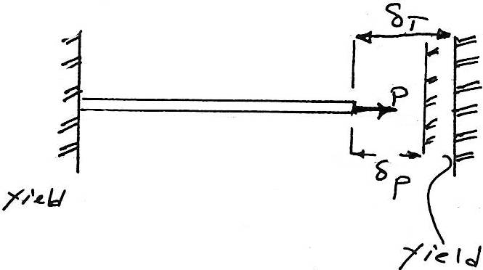
b. That the walls spring together a total distance ϑ 0.5mm as the temperature drops.
Solution:
Part (a)
Imagine the rod is disconnected from the right wall. Temperature deformations can then freely occur. A temperature drop cause the contraction represented by δ_{T}. To reattach the rod to the wall will evidently require a pull p to produce the load deformation δ_{P}.
∴ δ_{T} = δ_{P}
α(∆T)L = $\frac{P L}{A E}$ = $\frac{σ L}{E}$
∴σ = E α (∆ T)
σ= (200*10⁹)*(11.7*10⁻⁶)*40
= 93.6*10⁶ N/m²
= 93.6 MN/m² ANS.
Part (b)
When the walls spring together, the free temperature contraction is equal to the sum ϑ the load deformation and the yield ϑ the walls. Hence:
δ_{T} = δ_{P} +yield
αL (∆T) = $\frac{σ L}{E}$ + yield or
(11.7*10⁻⁶)*2.5*40 = $\frac{6*2.5}{200* {10}^{6}}$ +0.5*10⁻³
∴σ = 53.6 MN/m² Ans.
Example:
A rigid block having a mass ϑ 5 Mg is supported by three rods symmetrically placed as shown in figure below.
Determine the stress in each rod after a temperature rise ϑ 40°C.
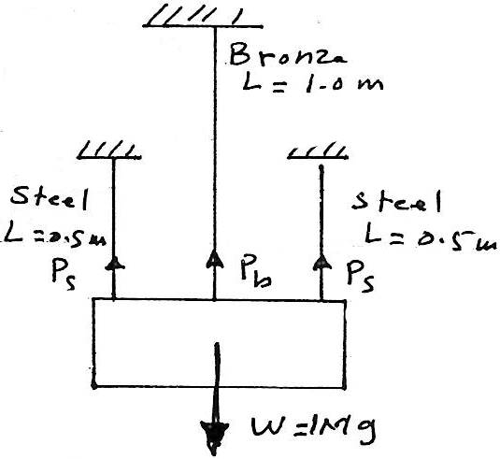
The lower ends ϑ the rods are assumed to have been at the same level before the block was attached and the temperature changed.

Bronze rod | Each steel rod
900 | 500 | Area (mm²)
83*10⁹ | 200*10⁹ | E (N/m²)
18.9 | 11.7 | α (μm/m.°C)

The free-body diagram ϑ the block represents the equal and opposite effects ϑ the force exerted by the rods upon the block.
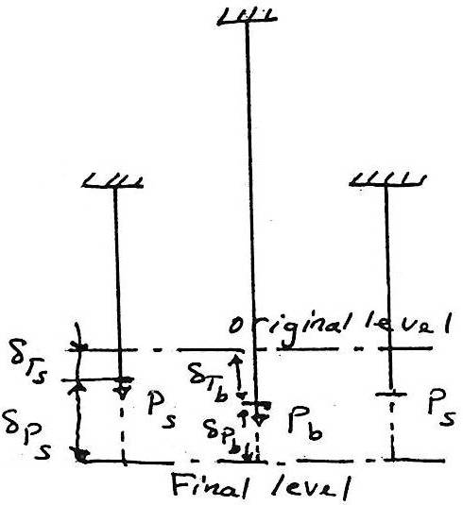
δ_{Ts} + δ_{Ps} = δ_{Tb} + δ_{Pb}

(α L ∆ T)_{s} + (${\frac{P L}{A E})}_{s}$ = (α L ∆ T)_{b} + (${\frac{P L}{A E})}_{b}$
(11.7*10⁻⁶)*0.5*40+ $\frac{P_{s }*0.5}{(500*{10}^{-6})*(200*{10}^{9})}$
= (18.9*10⁻⁶)(1)*40+ $\frac{P_{b}*1}{\left(900*{10}^{-6}\right)*(83*{10}^{9})}$
P_{s} - 2.68P_{b} = 104 * 10³ N ……(1)
From free-body diagram εY=0
2P_{s} + P_{b} = 5000*9.81 = 49.05*10³ N ……(2)
From equations 1 & 2
P_{s} = 37kn & P_{b} = -25kn
The stresses are:
σ_{s} = $\frac{37*{10}^{3}}{500*{10}^{-6}}$ = 74 MN/m² (tension)
σ_{b} = $\frac{25*{10}^{3}}{900*{10}^{-6}}$ = 27.8 MN/m² (compression)

LECTURE NO. 5
TORSION
Torque is a moment that tends to twist a member about its longitudinal axis. Its effect is of primary concern in the design of axles or drive shafts used in vehicles and machinery.
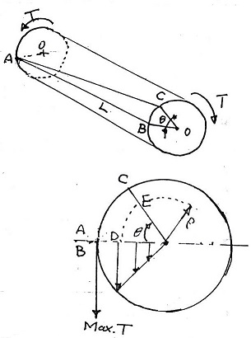
5.1. Torsion ϑ Circular Members:
In driving the torsion formulas the following assumption must be taking in consideration:
1. Circular section remain circular
2. Plane sections remain plane and do not warp.
3. The projection upon a transverse section of straight radial line in the section remains straight
4. Shaft is loaded by twisting couples in planes that are perpendicular to the axis ϑ the shaft
5. Stresses do not exceed the proportional limit. Thus the length ϑ deformation due to torque (T) is the arc ϑ a circle whose radius 𝒮 and which is subtended by the angle of θ radius; the length is given by
δ_{s} = D E = P θ ……..(a)
the unit deformation is:
ɣ = $\frac{δ_{s}}{L}$ = $\frac{P θ }{L}$ …….(b)
the shearing stress is:
τ = G ɣ = ($\frac{G θ}{L}$ ) P ……(c)
∑ M = 0 (to satisfy the condition ϑ static equilibrium)
M = T_{r} = δ dp where p is the load
∴ T = T_{r} = ∫ δ dp = ∫ p (τ dA)
Sub-equation c in the above equation gives:
T = $\frac{G θ}{L}$ ∫ δ² dA
Since ∫ δ² dA = J, the polar moment ϑ interia ϑ the cross section,
∴ T = $\frac{G θ }{L}$ J or
Θ = $\frac{T L}{J G}$ ……..(1)
Where:
Θ: angle ϑ twist
T: torque
L: length ϑ shaft
J: polar moment ϑ interia ϑ cross-section
G: modulus ϑ elasticity in shear
τ = $\frac{T r}{J}$ ……(2) torsion formula (shear stress)
Max. Shearing stress:
Max τ = $\frac{T r}{J}$ …….. 2a
Where r: shaft radius
Using the values ϑ J from the following figure, we can obtain the following modification ϑ the torsion formula:
Shold shaft: max.τ = $\frac{2 T}{π r^{3}}$ = $\frac{16 T}{π d^{3}}$ ……. 2b
Hollow shaft: max.τ = $\frac{2 T R}{π \left(R^{4}- r^{4}\right)}= \frac{2 T R}{π(D^{4}-d^{4})}$ ....... 2c
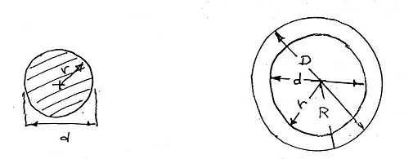

J = $\frac{πr^{4}}{2}$ = $\frac{πd^{4}}{32}$ J = $\frac{π}{2}$(R⁴ - r⁴) = $\frac{π}{32}$(D⁴ - d⁴)
P = T W
Where:
P: power (transmit power)
T: torque
W: angular speed
But w = 2πf
Where f: shaft rotation revolution /unit time
∴ P = T2πF
T = $\frac{P}{2 π f}$ ……. (3)
For equation no.3 if P measured in watts (1w =1 N.m/sec) and f in revol./s or (r/s) this equation will determine the torque T in Newton-meters.
Example:
A solid shaft in a rolling mill transmits 20 kw at 2 r/s. Determine the diameter ϑ the shaft if the shearing stress is not to exceed 40 MN/m² and the angle of twist is limited to 6° in a length ϑ 3m.
Use G=83 GN/m².
Solution:
T = $\frac{Q}{2πf}$ ∴ T = $\frac{20*{10}^{3}}{2π*2}$ = 1590 N-m
= 58.7mm τ = $\frac{16 T}{π d^{3}}$ or d= $\sqrt[3]{\frac{16*1590}{π*40*{10}^{6}}}$
Check for angle ϑ twist:
Θ = $\frac{T L}{J G}$* 57.3 or J = $\frac{T L}{θ G}*$57.3
Where:
$\frac{π d^{2}}{32}$= $\frac{1590*3*57.3}{6*83*{10}^{9}}$
Or d = 48.6 mm
∴ The larger diameter, d=58.7 mm. will satisfy both strength & rigidity.
Note:
1 degree = 1.74539*10⁻² = 1 rad.
Or 1 degree = 57.29378 = 57.3 rad.
Example:
Two solid shafts ϑ different materials are rigidly fastened together and attached to rigid supports as shown in the figure. The aluminum segment is 75 mm in diameter, and G_{a}= 28*10⁹ N/m². The steel segment has a diameter ϑ 50 mm and G_{s}=83*10⁹ N/m².
The torque, T=1000N-M, is applied to the junction ϑ the two segments-compute the max. shearing stress developed in the assembly.
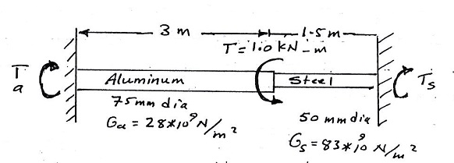
Static equilibrium:
∑ M =0 T_{s} + T_{a} = 1000 ……..(1)
each segment has the same angular deformation, i.e:
θ_{s} = θ_{a}
$({\frac{T L}{J G})}_{s}$= (${\frac{T L}{J G})}_{a}$
$\frac{T_{s}*1.5}{\frac{π({0.05)}^{4}}{32}*83*{10}^{9}}$= $\frac{T_{a*3}}{\frac{π ({0.075)}^{4}}{32}*28*{10}^{9}}$
From which T_{s} = 1.17 T_{a} ……. (2)
From equation 1&2
∴ T_{a} = 461 N-m & T_{s} = 539 N-m
Τ = $\frac{16 T}{π d^{3}}$
∴ τ_{a} = $\frac{16*461}{π ({0.075)}^{3}}$ = 5.57 MN/m²
τ_{s} = $\frac{16*539}{π ({0.05)}^{3}}$ = 22 MN/m²
5.2. Flanged Bolt Coupling
A commonly used connection between two shafts is a flanged bolt coupling. It consists of flanges rigidly attached to the ends ϑ the shafts and bolted together, the torque is transmitted by the shearing force (p) created in the bolts.
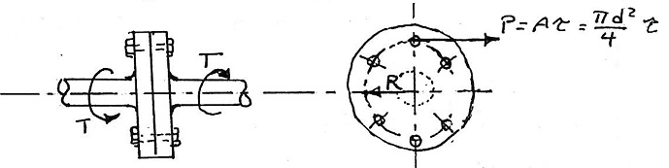
Assuming that the stress is uniformly distributed, the load in any bolt is given by:
P =Aτ = $\frac{π d^{2}}{4}$ τRn …….(4)
Where:
P: load on a bolt.
R: radius ϑ the bolt circle
n: number ϑ bolt
d: bolt diameter
5.3. Torsion Of Thin-Walled Tubes
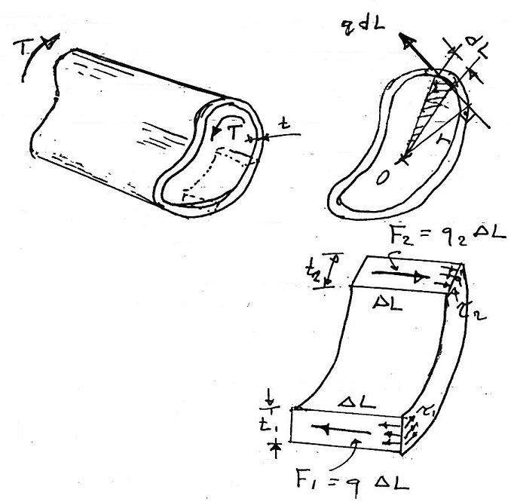
Where:
t: wall thickness
τ: tensional stress
q: shear follow
F₁ = q₁∆L & F₂ =q₂∆L ……(a)
q₁∆L = q₂∆L or q₁ = q₂ ……(b)
T = ∫ rqdL …… (c)
From a,b&c
T = 2Aq …….(5)
The average shearing stress across any thickness t is given by:
τ = $\frac{q}{t}$ = $\frac{T}{2 A t}$ ……(6)
Where A: area ϑ the section

Example:
A tube has a semicircular shape. If stress concentration at the corners is neglected, what torque will cause a shearing stress ϑ 40 MN/m²?
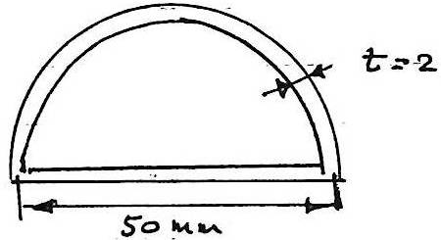
T = 2Atr
= 2$\frac{πr^{2}}{2}$tτ
= 2[$\frac{π}{2}$ (0.025)²]*0.002 *40*10⁶
= 157 N.m

5.4. Helical Spring
Where:
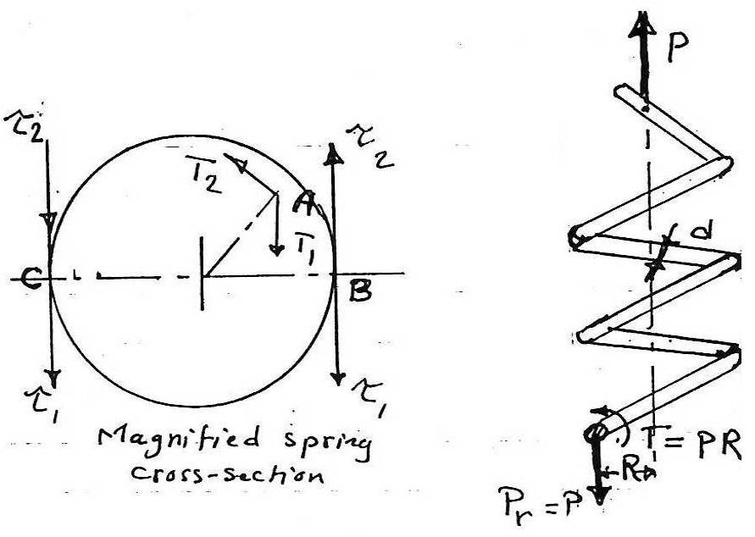
d: wire diameter
P: load
R: helix main radius
P_{r}: spring resistance = P
T: torque
τ₁: direct shearing stress
τ₂: max. torsional shearing stress.
The magnified view ϑ the cross-section shows the stress distribution that created the resisting force. Two types ϑ shearing stress are produce:
1. Direct shearing stress like τ₁, uniformly distributed over the spring section and creating the resisting load P_{r} that passes through the centroid ϑ the section.
2. Variable torsional shearing stress like τ₂ caused by the twisting couple T=PR.
The torsional stresses τ₂ vary in magnitude with their radial distance from the centroid and are directly perpendicular to the radius, as at A. the result shearing stress is the vector sum ϑ the direct and torsional shearing stresses. At B. the stresses are oppositely directed, and the resultant stress is the difference between τ₂&τ₁.
At the inside fiber c, however, the two stresses are collinear and in the same scene; their sum produces the maximum stress in the section.
T = PR
τ₁ = P/A
τ₂ = Tr/J
τ = τ₁ + τ₂ = $\frac{4 P}{π d^{2}}$ + $\frac{16 P R}{π d^{3}}$ …….(7)
τ = $\frac{16 P R}{π d^{3}}$ ($\frac{d}{4 R}$+1) …….(7a)
The ratio d/4r is small for a spring composed of a wire ϑ relatively small diameter wound on spring ϑ large radius.
Wahl has developed the following formula:
Max. τ = $\frac{16PR}{πd^{3}}$ $\left(\frac{4m-1}{4m-4}+\frac{0.615}{m}\right)$
Where m=2r/d = D/d, the ratio of the mean diameter ϑ the spring to the diameter ϑ the spring wire. In light springs, where the ratio m is large, the first term in the parentheses approaches unity.
Compare with equation(7), which may be rewritten in the following form:
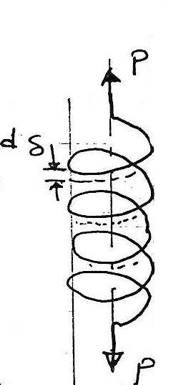
Max τ = $\frac{16PR}{πd^{3}}\left(1+\frac{0.5}{m}\right)$ (9)
5.4. Spring Deflection:
δ = $\frac{64PR^{3}n}{Gd4}$ ……(10)
Where:
n: number ϑ coils
δ = $\frac{8PRn}{Gd^{2}}$ …….(11)
Notes:
Equation (10) is the general for computing spring deflection with direct shear and torsional shear stresses while equation (11) neglected the deformations caused by direct shear.
Example:
A load P is supported by two steel springs arranged in series as shown in the figure. The upper spring has 20 turns ϑ 20 mm diameter wire on a mean diameter of 150 mm. the lower spring consists ϑ is turns of 10 mm diameter wire on a mean diameter of 130 mm. determine the max. Shearing stress in each spring if the total deflection is 80 mm and G=83GN/m^{2.}
Solution:
The total deflection is the sum ϑ the deflection in each spring;
δ =$\sum{\frac{64 PR^{3}n}{Gd4}}$
0.08 = $\frac{64P}{83*{10}^{9 }}$ $\left[\frac{({0.075)}^{3}*20}{\left(0.02\right)*4}+ \frac{{(0.065)}^{3}*15}{\left(0.01\right)*4}\right]$
P = 233 N
The stress for upper spring, m=2 R/d =2(0.075)/0.02
= 7.5 ; 4 m = 30 .
Applying Wahl's formula:
Max.τ = $\frac{16PR}{πd^{3}} \left[\frac{4m-1}{4m-4}+ \frac{0.615}{m}\right]$
Or
Max.τ = $\frac{16\left(223\right)(0.075)}{π{(0.02)}^{3}} \left[\frac{30-1}{30-4}+ \frac{0.615}{7.5}\right]$
= 12.7 MN/m² …. Ans
Similarly for lower spring where m=2(0.065)/0.01
= 13 & 4m =52
∴ max.τ = $\frac{16\left(223\right)(0.065)}{π({0.01)}^{3}} \left[\frac{52-1}{52-4}+ \frac{0.615}{13}\right]$
= 81.9 MN/m²
If we used equation(7a) to compute these max shearing stresses, the result would have been 11.4 MN/m² in the upper spring and 76.7 MN/m² in the lower spring. Thus the approximate formula gives results that are ∓10.2 %, thus the Wahl formula gives more precise result.
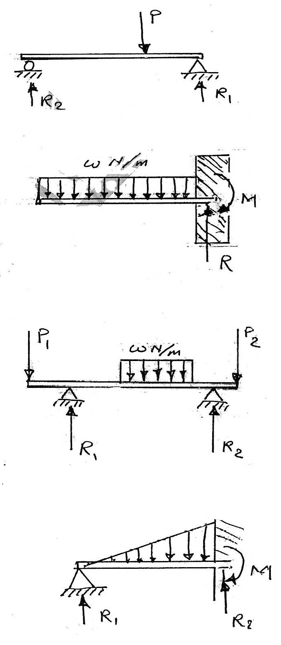
H.W. (singer) ; 343,346,348

LECTURE NO. 6
Shear & Moment In Beams
6.1. Methods & beam supporting:
1. Simple beam:
A simple beam is supported by a hinged reaction at one end and a roller support at the other end.
2. Cantilever beam:
This type is supported at one end only, with a suitable restrained to prevent rotation of that end.
3. Overhanging beam:
The overhanging beam is supported by a hinge and a roller reaction. With either or both ends extending beyond the supports.

Note:
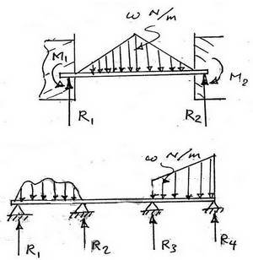
The above beams are all statically determinate their reactions can be determined directly from the equations ϑ static equilibrium.
4. Propped beam:
5. Fixed or restrained beam:
6. Statically indeterminate beams

6.2. Shear & Moment:
The figure shows a simple beam that carries a concentrated load P and held in equilibrium by reactions R₁ & R₂ neglect the mass of the beam itself and consider only the effect ϑ the load P.
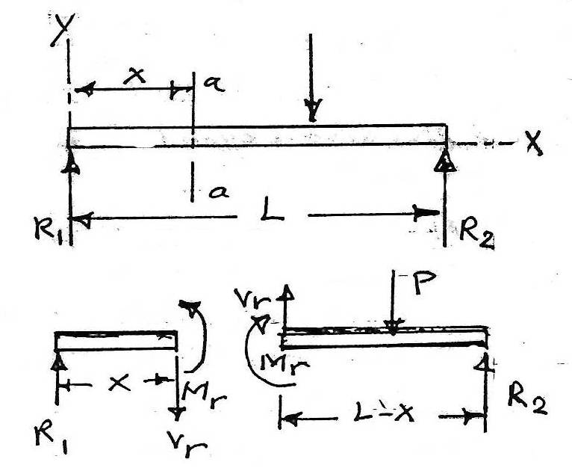
Assume that a cutting plane a-a at a distance x from R₁ divided the beam into two segments.
For left segment;
$\sum{Fx=0}$ ….. No forces in x- direction.
$\sum{Fy=0}$ ,
the vertical unbalance caused by R₁ requires a resisting force V_{r}(also called the resisting shearing force), opposite in direction to R₁;
R₁ = V_{r} or v= (∑Fy)_{L} …….(1)
Note; V_{r} is determined from the summation ϑ the vertical components ϑ the external load acting on either side ϑ the section.
M_{r} = R₁ * X
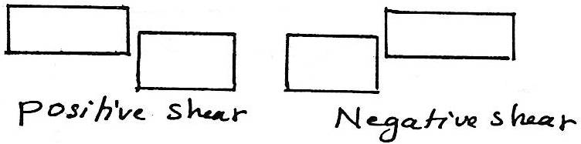
Bending moment is defined as the summation ϑ moments about the centroidal axis ϑ any selected section ϑ all the load acting either to the left or to the right side ϑ the section, and is expressed as;
M =(∑M)_{L} = (∑M_{R}) …….(2)
Where:
L: moment acting to the left ϑ the section.
R: moment acting to the right ϑ the section.
Up-ward acting external forces cause positive bending moments with respect to any section; down-ward forces cause negative bending moments as shown in the figures below:
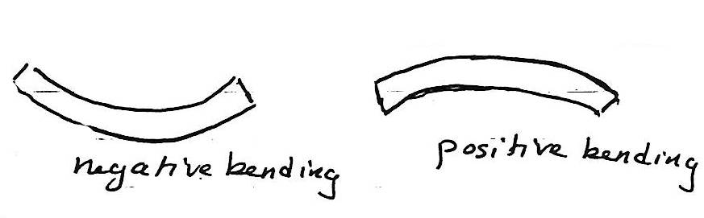
Example 6.1:
Write shear and moment equations for the beam loaded as shown in the figure and sketch the shear and moment diagrams:
Solution:
Calculation the reaction at A & B;
↱+ ∑M_{c} = 0
R₁*10-20*5*7.5+30*4=0
∴ R₁ = 63 kN
+↑∑ Fy = 0; 63+R₂-30-20*5=0
∴ R₂ = 67 kN
The section ϑ zero shears between A & B occurs because the downward force due to x meter ϑ load applied at 20 kN/m must balance the vertical shear ϑ 63 kN at A. hence;
63 = 20x or x = 3.15 m
Force at (∵ shearing force) point B=5*20-63=37kN↓
Shearing force at c=67-37=30↑ kN
Shearing force at D=30kN↓
Moment at; A=0 kN-m
Max. Moment at zero shear i.e. at point E=
↱+∑M_{E} = 63*3.15-20*3.15* $\frac{3.15}{2}$
= 99.225 kN-m
Or calculating the shear force area i.e.;
63*3.15* $\frac{1}{2}$ = 99.225 kN-m
↱+∑M_{B} = 63*5-20*5*2.5 = 65kN.m
Or calculating from the summation ϑ shearing force area i.e.;
63* $\frac{3.15}{2}$- 37 * $\frac{(5-3.15)}{2}$ = 65 kN-m
↱+∑M_{c} = 63*10 – 5*20*7.5 = -120 kN-m
Or 63* $\frac{3.15}{2}$ - 37* $\frac{1.85}{2}$ - 5*37 = -120kN-m
↱+∑M_{D} = 63*14-20*11.5+67*4
= 0 KN-m.
Example 6.2:
Write the shear and moment equation for the cantilever beam carrying the uniformly varying load and concentrated load show in the figure. Also sketch the shear and moment diagrams.
Solution:
For the region AB
$$\frac{y}{6} = \frac{x}{6}$$
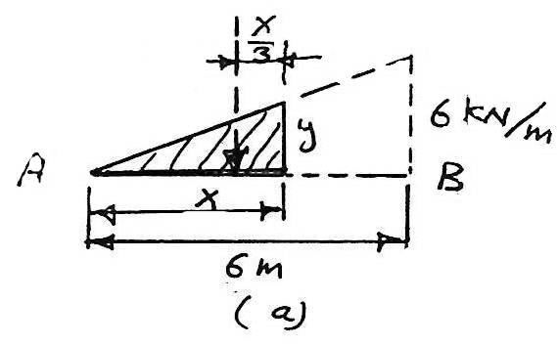
y= x
[ V = ∑Fy ]_{L} ,
V_{AB} = - $\frac{x^{2}}{2} kN$
= - $\frac{36}{2}$ = -18 kN = 18 ↓kN
[ M = ∑ M ]_{L} ,
M_{AB} = - $\frac{x^{2}}{2}$ * $\frac{x}{3}$ = - $\frac{x^{3}}{6} kN-m$
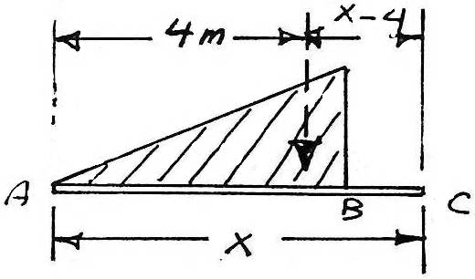
For the region BC
[ v = ∑ Fy ]
For the region BC; in which x varies between 6 and 8
[ V =∑ Fy ]
V_{BC} = - 18 kN = 18 kN↓
[ M = ∑ M ]_{L}
M_{BC} = - 18(x-4) = -18x+72 kN
For the region C & D in which x varies from 8 to 10, we obtain.
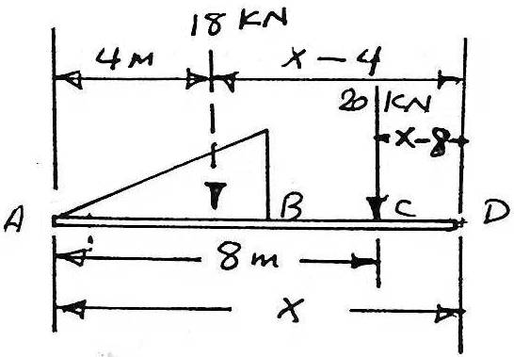
0 [ V = ∑ Fy ]
V_{CD} = -18-20 = -38 kN
[ M = ∑ M ]_{L}
M_{CD} = -18(x-4)-20(x-8)
= -18(x-4)-20(x-8)
= (-38x+232) kN-m
The direct solution:
Shearing force at B = - $\frac{6*6}{2}$ = -18 kN
=18 kN ↓
Shearing force at c = -18-20 = -38 kN
= 38 kN ↓
↳+∑ M_{B} = -18*2 = - 36 kN-m
↳+∑ M_{c} = -18*4 = - 72 kN-m
↳+∑ M_{D} = -18*6-20*2 = -148 kN-m
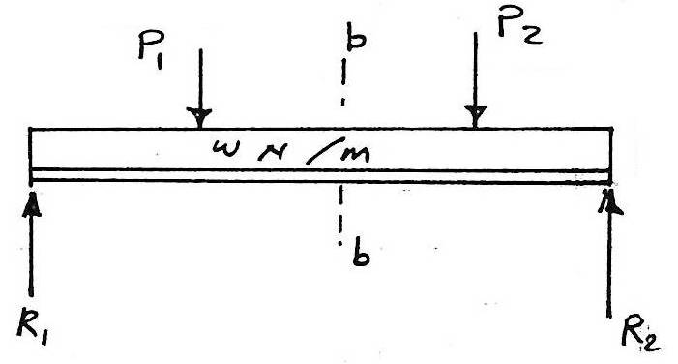
6.3. Interpretation Of Vertical Shear & Bending Moment
The beam in the figure carries a uniformly distributed load as well as concentrated load.
The external effects ϑ each load acting to the left or right ϑ section b-b could be reduced to a single force and a moment at that section. See the fig. below;
For example the moment at section c-c
M_{c} = M_{b} + V_{b} z – $\frac{w z^{2}}{2}$
6.4. Relations Between Load, Shear And Moment:
Consider the beam shown above, which is assumed to carry any general loading. The force-body diagram ϑ a segment ϑ this beam ϑ length dx is shown with shearing forces & moments. Applying the condition ϑ static equilibrium to the segments:
[ ∑ F_{y} = 0]
V+ wdx - (v+dv) = 0
dv =wdx …..(a)
[ ∑ M_{B} = 0]
M + vdx + (wdx)$\frac{dx}{2}$ - (M + dm) = 0
dM = V dx ……(b)
Note: (wdx)$\frac{dx}{2}$ is negligible compare with the other term because it is a square ϑ a differential integrating equation(a), we obtain
$\int_{v1}^{v2}{dv}$ = $\int_{x1}^{x2}{w dx}$
Yield to
v2 –v1 = ∆ v = (Area)_{load} ……..(3)
i.e. shaded area in the _______ integration ϑ equation b yield
$$\int_{M1}^{M2}{dM} = \int_{x1}^{x2}{v dx}$$
M2 – M1 = ∆ M = (Area) _{shear} …..(4)
Equation (4) shows that the change in bending moment ∆M between any two sections is equal to the area ϑ the shear diagram for this in terval.
The following principles suggest the following procedure for construction ϑ shear and moment diagrams:
1. Compute the reactions.
2. Compute values & shear at the change of load points, using either v = (∑ F_{yL}) or ∆v = (area) _{load}
3. Sketch the shear diagram
4. Locate the point's ϑ zero shear
5. Compute values ϑ bending moment at the change ϑ load points and at the point's ϑ zero shear
6. Sketch the moment diagram through the ordinates ϑ the bending moments computed in step.5
Example 6.3:
Using the semi graphical method, sketch shear and moment diagrams for the beam shown in the fig. computing the values at all change ϑ loading points and the maximum shear and maximum moment.
Solution:
↱+∑M_{D} = 0
-(2*12)*9+R₁*12-8*3=0
R₁ = 20 kN ↑
↑∑ Fy = 0
20-2*12-8+R₂ = 0
R₂ = 12 kN
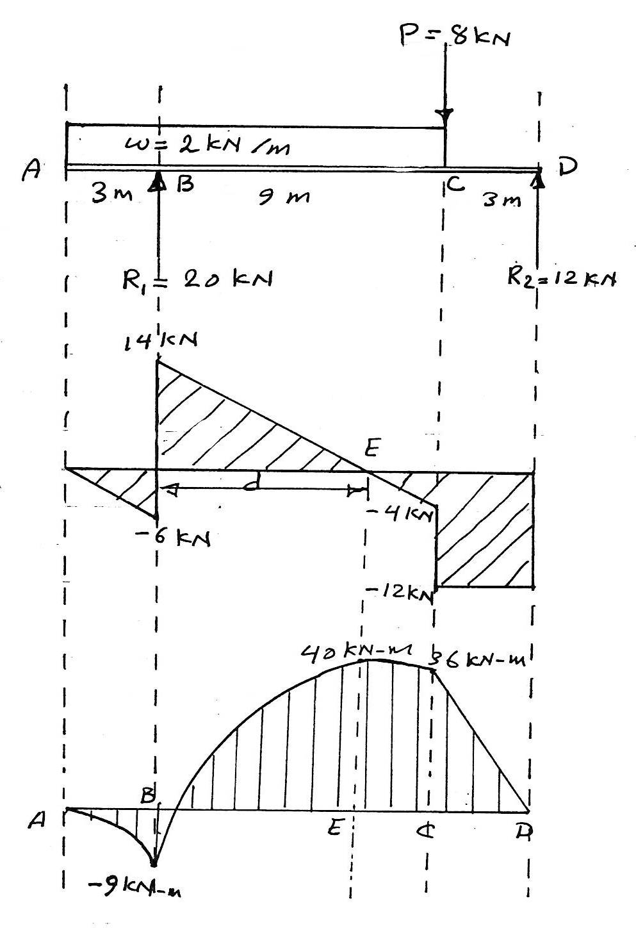
Calculation the moment by shear area method
14 = 2 * d
d = $\frac{14}{2}$ = 7 m
$$\sum{M_{B}= - \frac{6*3}{2}}$$
= - 9 kN-m
$$\sum{M_{E}= -\frac{6*3}{2}+\frac{14*7}{2}}$$
= 40 kN-m
$$\sum{M_{c} = - \frac{6*3}{2}+ \frac{14*7}{2}- \frac{4*2}{2}}$$
=36 kN-m

Example 6.4:
Sketch shear and moment diagrams for the beam shown in the fig. :
Solution:
↱₊ M_{a} = 0
-2+1-10*R_{c}+0.5*3^11.5
R_{c} = 1.625 kN
↑$\sum{F_{y}}$ = 0
R_{A}+1.625-0.5*3=0
R_{A} = - 0.125kN

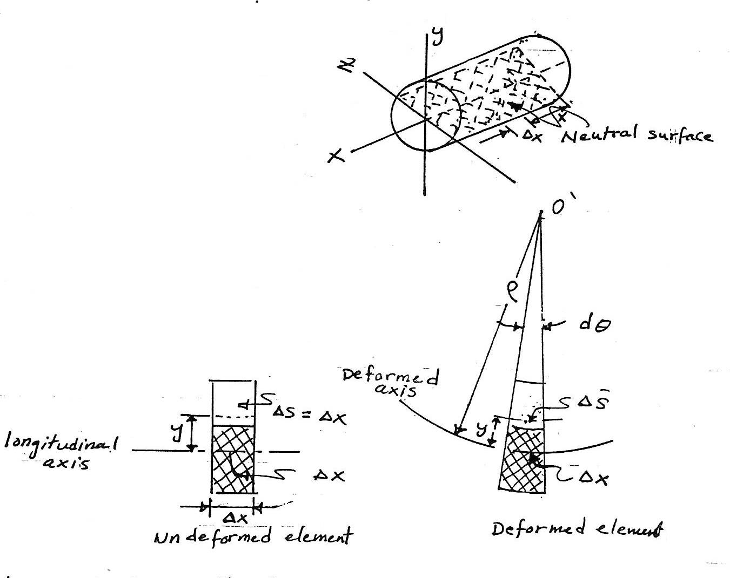
LECTURE NO. 7
Bending Stress In Beams
The behavior ϑ any deformable bar subjected to a bending moment causes the material within the bottom portion ϑ the bar to stretch and the material within the top portion to compress. Consequently, between these two regions there must be a surface, called the neutrals surface, in which longitudinal fibers ϑ the material will not undergo a change in length.
Assume an isolate segment ∆x located at distance x along the beam's length. This segment was taken to study the effect ϑ bending on the material ϑ the beam.
∆x is located on the neutral surface,
Does not change its length, whereas any line segment ∆s, located at the arbitrary distance y above the neutral surface, will contract and become ∆s' after deformation.
By definition, the normal strain along ∆s is determined from
ϵ = $\lim_{∆s→0}{\frac{∆s^{'}- ∆s}{∆s}} ……\left(1\right)$
Before deformation ∆s=∆x. After deformation ∆x has a radius ϑ curvature P, with center curvature at point o'.
∆x = ∆s = P∆θ …..(2)
∆s' = (P-y) ∆θ …..(3)
Sub. Equations (2) & (3) into (1)
ϵ = $\lim_{∆θ→0}{\frac{\left(P-y\right)∆θ-P∆θ}{P∆θ}}$
or
ϵ = - $\frac{y}{P} …….$(4)
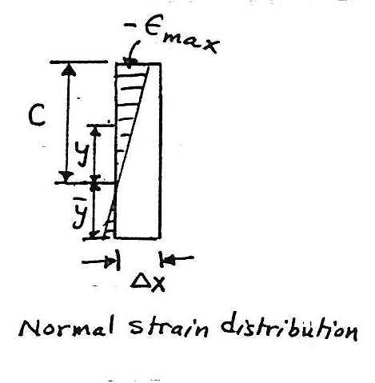
This result indicates that the longitudinal normal strain will vary linearly with y from the neutral axis.
A contraction (-ϵ) will occur in fibers located above the neutral axis (+y) whereas elongation (+ϵ) will occur in fibers located below the axis (-y). The maximum strain occurs at the outermost fiber, located at distance c from the neutral axis.
Since
ϵ_{max} = $\frac{c}{p}$
∴ $\frac{ϵ}{ϵ_{max}}= \frac{-y/p}{c/p}$
Then
ϵ = - ($\frac{y}{c}$) ϵ_{max} ……(5)
According to Hooke's Law σ = E ϵ equation (6) can be written as:
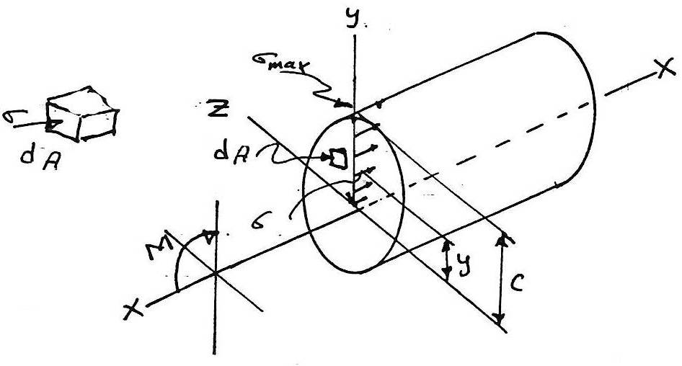
σ = - ($\frac{y}{c})$ σ_{max} …..(7)
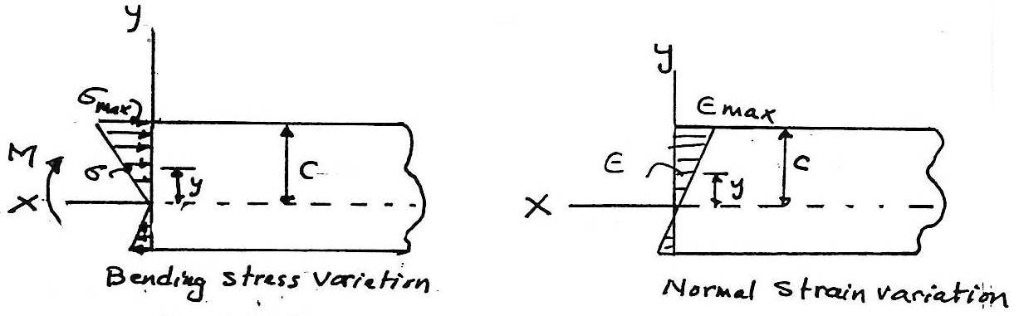

dF acts on the arbitrary element dA
dF = σ dA
F_{R} = ∑ Fx; 0=$\int_{A}{dF}$
= $\int_{A}{σ dA}$
= $\int_{A}{-\left(\frac{y}{c}\right) σ_{max} dA}$
= - $\frac{σ_{max}}{c}$ $\int_{A}{y dA}$
Since $\frac{σ_{max}}{c} is not equal to zero, then$
$\int_{A}{y dA=0 …….(8)}$
This means that the first moment ϑ the member's cross-sectional area about the neutral axis must be zero. This condition can only be satisfied if the neutral axis is also the horizontal centroidal axis for the cross section.
M = moment produced by the stress distribution about the neutral ↑ axis
For internal moment
(M_{R})_{z} = ∑ M_{z} ;
M = $\int_{A}{y dF}$
= $\int_{A}{y \left(σ dA\right)= \int_{A}{y \left(– \frac{y}{c} σ_{max} \right)dA}}$
Or
M = $\frac{σ_{max}}{c}$ $\int{y^{2}}$ dA ……(9)
σ_{max} = $\frac{M C}{I}$ (flexure formula) ….(10)
Where
y² dA: moment ϑ ineria ϑ the beam's cross-sectional area, computed about the neutral axis. (I)
σ_{max} : the maximum normal stress in the member, which occurs at a point on the cross sectional area farthest way from the neutral axis.
M: moment about the neutral axis.
C: the perpendicular distance from the neutral axis to the point farthest away from a neutral axis, where σ_{max} acts.
Also we can prove that (from equation 7)
σ = - $\frac{M y}{I}$ (fexure formula) ……(11)
Example 7.1:
A beam 150 mm wide by 250mm deep supports the loads shown in fig. determine the maximum flexural stress.
Solution:
↱+∑M_{A} = 0
15*2+6*3*1.5-R_{C}*3=0
R_{C}=19 kN
∑ F_{y} = 0
R_{A} +19-15-18=0
R_{A}= 14 kN
The S.F.D shows that zero shear occurs at x = 2 m, at this point the maximum bending moment.
M_{max} = $\frac{12*2}{2}$ + 2*2 = 16 kN-m
I = I_{y} = $\frac{1}{12}$ b h³ = $\frac{1}{2}$ * 0.15 *(0.25)³ = 0.195312*10⁻³ m⁴
σ_{max} = $\frac{M C}{I }$ = $\frac{16*0.125}{0.195312*{10}^{-3}}$
= 10.24 MP_{a}
Note:
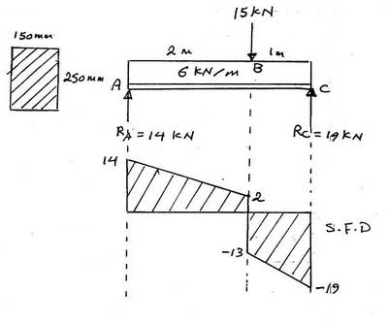
σ_{max} = $\frac{M C}{I }$ can be put in this way:
σ_{max} = $\frac{M}{S}$
Where S is the section modulus =$\frac{I}{C}$
Example 7.2:
A beam 100 mm wide by 300 mm height and 8 m long carries the loading show in fig. if the maximum flexural stress is 9 MP_{a} , for what maximum value ϑ w will the shear be zero under P. and what is the value ϑP?
Solution:

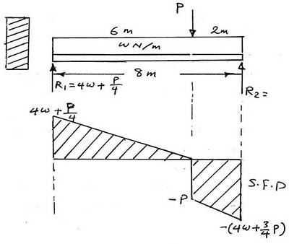
↱+∑ M_{R2} =0
R₁ *8-P*2-8w*4=0
R₁ = 4w+ $\frac{P}{4}$
The maximum value ϑ w to reduce the shear to zero is:
4w+$\frac{P}{4}$ = 6 w
P = 8 w
The maximum bending moment occurs under p or at zero shear:
M. max. = 1/2 (4w+$\frac{P}{4})$ * 6 = $\frac{1}{2}$ * 6w*6 =18 w N-m
I = $\frac{1}{12}$ b h³ = $\frac{1}{12}$ *0.1*(0.3)³ = 0.225*10⁻³ m⁴
σ_{max} = $\frac{M C}{I}$ or M = $\frac{σmax*I}{C}$
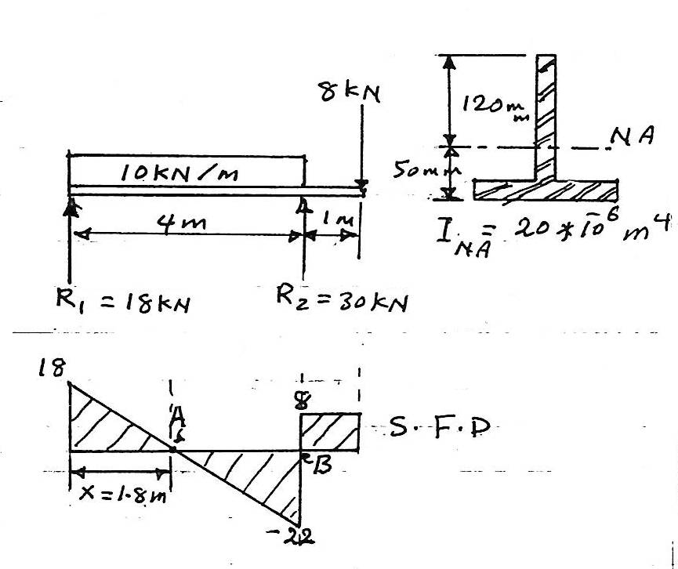
18 w = $\frac{9*{10}^{6}*0.225*{10}^{-3}}{0.15}$
W = 750 N/m
P = 8 w = 8 * 750 = 6000 N
Example 7.3:
Compute the maximum tensile and compressive stresses developed in the beam that is loaded and has the cross-sectional prosperities shown in the fig.
Solution:
↱+∑ M_{R1} =0
10*4*2+8*5-R₂*4=0
R₂ = 30 kN
∑ F_{y} = 0
30+R₁-40-8=0
R₁ = 18 kN
Sections ϑ zero shears are:
x = 1.8 and x = 4 m
M_{x=1.8} = $\frac{18*1.8}{2}$ = 16.2 kN-m positive moment the curvature concave upwards the upper fiber in compressive and the lower fiber in tension.
M_{x=4} = -$\frac{22*2.2}{2}$ + 16.2 = -8 kN-m negative bending moment the curvature concave downward, so that the upper fibers are in tension and the lower ones in compression.
σ_{A} = $\frac{M y}{I }$ ;
At A
σ_{c} = $\frac{\left(16.2*{10}^{3}\right)*0.12}{20*{10}^{-6}}$ = 97.2 MP_{a}
σ_{t} = $\frac{\left(16.2*{10}^{3}\right)*0.05}{20*{10}^{-6}}$ = 40.5 MP_{a}
At B
D_{B} = $\frac{M y}{I }$
D_{t} = $\frac{\left(8*{10}^{3}\right)*0.12}{20*{10}^{-6}}$ = 48 MPa
D_{c} = $\frac{\left(8*{10}^{3}\right)*0.05}{20*{10}^{-6}}$ = 20 MPa
Hence the max. Compressive stress is 97.2 MPa occurring at x =1.8 m, and the max. Tensile stress is 48 MPa occurring at x=4 m.
Example 7.4:
A cast-iron beam carries a uniformly distributed load on a simple span. Compute the flange width b ϑ the inverted T section so that the allowable stresses σ_{t} = 30 MPa and σ_{c} = 90 MPa reach their limits simultaneously.
Solution:
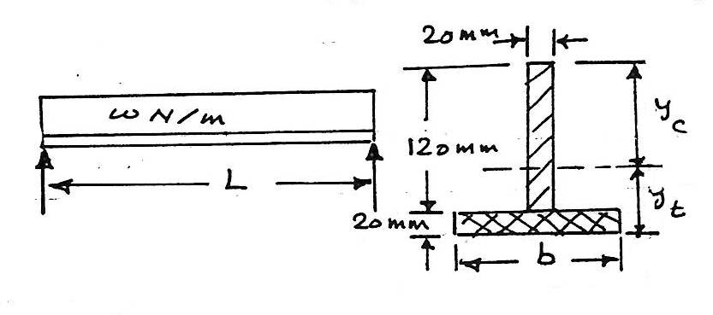
The beam concave upward so that the upper most fibers are in compression the lower most fiber in tension.
Flexure stresses vary directly with their distance from the neutral axis. i.e.
$\frac{y_{t}}{y_{c}}= \frac{σ_{t}}{σ_{c}}$ or $\frac{y_{t}}{y_{c}}= \frac{30}{90}= \frac{1}{3}$ ….(1)
y_{t} + y_{c} = 140 mm ……(2)
Consider the T section to consist ϑ two shaded rectangles. Since the neutral axis coincide with the centroidal axis. Take the moment ϑ area with respect to x axis through the base ϑ flange:
from equation 1&2:
y_{t} = 35 mm & y_{c} = 105 mm
A $\overline{y}$ = ∑ a y
(120*20+b*20) y_{t} = (120*20)(20+60)+(b*20)(10)
But y_{t} = $\overline{y}$ = 35 mm sub this value in the above equation gives:
b = 216 mm
Example 7.5:
A beam has a rectangular cross-section and is subjected to the stress distribution shown in the fig. determine the internal moment M at the section caused by the stress distribution
a. Using the flexure formula.
b. By finding the resultant ϑ the stress distribution using basic principles.
Solution:
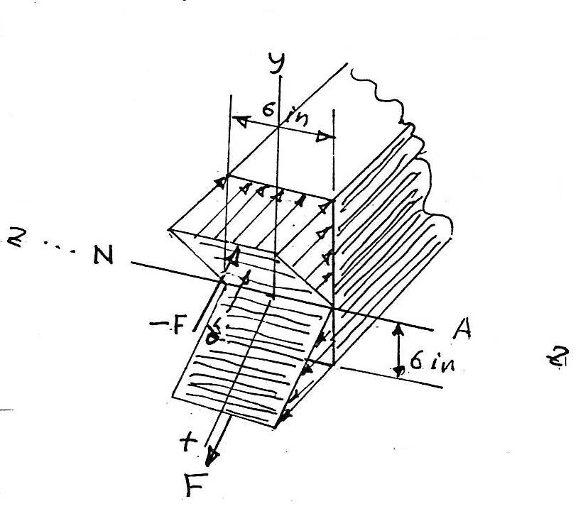
The neutral axis is N-A
C = 6 in
σ_{max} = 2 ksi
a. I = $\frac{1}{12}$ b h³
= $\frac{1}{12}*6*({12)}^{3}$ = 864 in⁴
σ_{max} = $\frac{M C}{I}$
2= $\frac{M*6}{864}$ or
M = 288 kip.in = 24 kip.ft
First we will show the resultant force ϑ the stress distribution is zero.
The stress on the arbitrary element strip dA= 6 dy located y from the neutral axis is:
σ = ($\frac{-y}{6})$ * 2
but dF = σ dA and thus:
F_{r} = $\int_{A}{σ dA}$ = $\int_{-6}^{6}{\left[\left(\frac{-y}{6}\right)*2\right]*6*dy}$
F_{r} = (${\left.-1*y2 \right]}_{-6}^{6}$
= 0
The result moment ϑ the stress distribution about neutral axis (z axis) must equal M.
The magnitude ϑ the moment of dF about axis is
dM = y dF dM is always positive.
M = $\int_{A}{σ dA}$ = $\int_{-6}^{6}{y\left[\left(\frac{y}{6}\right)*2\right]*6*dy}$
= ${\frac{2}{3} y^{3}]}_{-6}^{6}$
= 288 kip.in = 24 kip.ft
Example 7.6:
The simply supported beam shown in the fig. determine the absolute maximum bending stress in the beam and draw the stress distribution over the cross section at this location.
Solution:

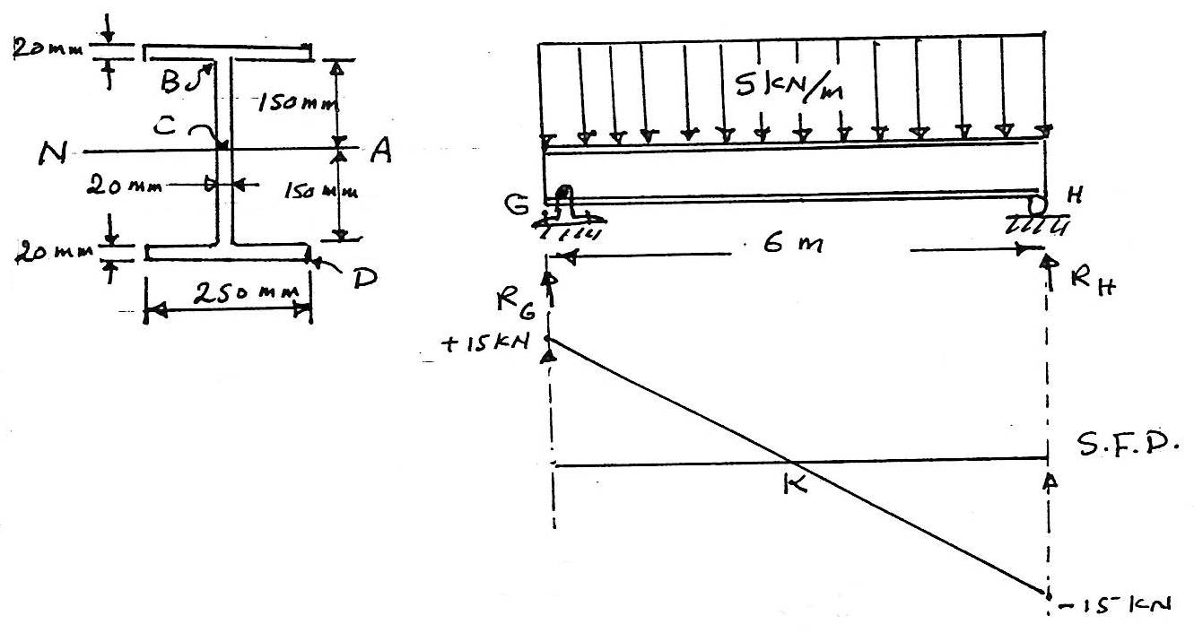
↱ $\sum{M_{G}}$ = 0
+$\sum{R_{H }*6-5*6*3}$
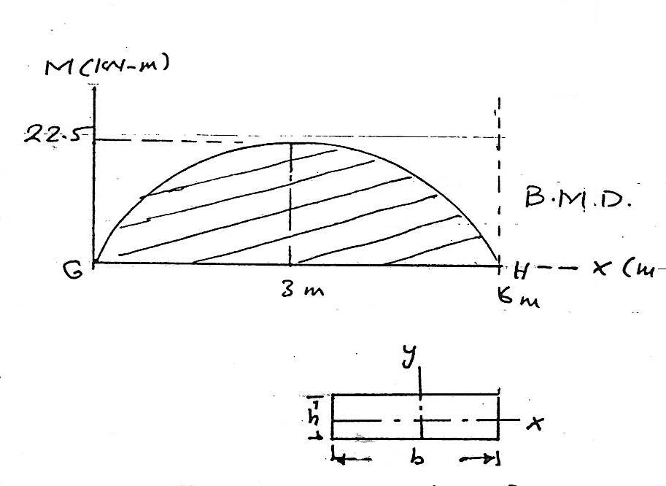
R_{H} = 15 kN
∑ Fy = 0
15 + R_{G} – 5*6 =0
R_{G} = 15 kN
Max. B. M. at point k = $\frac{15*3}{2}$ = 22.5 kN-m
I = ∑ (? + Ad²)
= 2$\left[\frac{1}{12} (0.25){(0.02)}^{3}+(0.25)(0.02){(0.16)}^{2}\right]+\left[\frac{1}{12} (0.02)({0.3)}^{3}\right]$
= 301.3 *10⁻⁶ m⁴
Applying the flexure formula, with c = 170 mm
σ_{max} = $\frac{M C}{I}$
σd_{max} = $\frac{22.5*0.17}{301.3*{10}^{-6}}$ = 12.7 MPa
σ_{B} = $\frac{M y_{B}}{I}$
σ_{B} = $\frac{22.5*0.15}{3011.3*{10}^{-6}}$ = 11.2 MPa
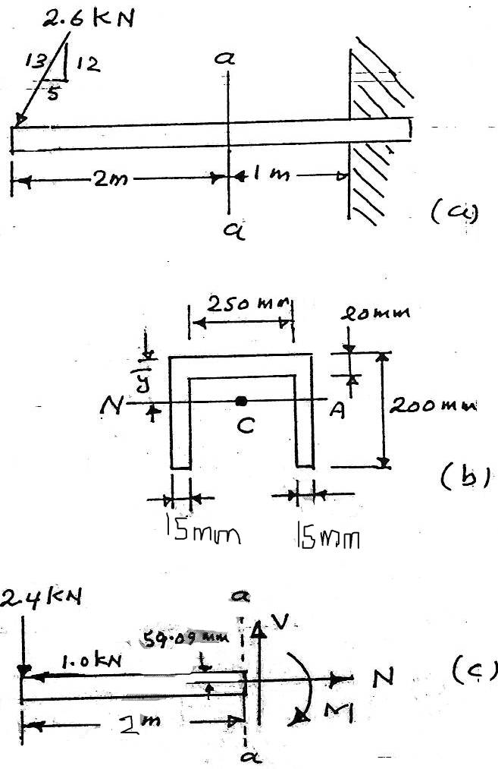
stress distribution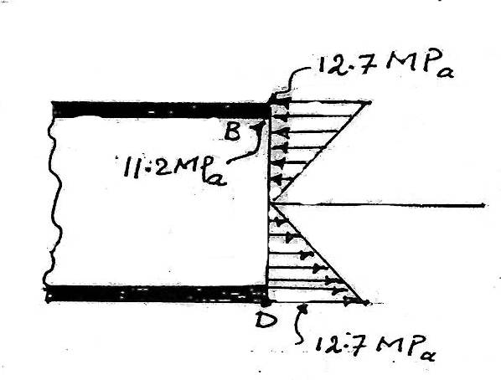
Example 7.7:
The beam has a cross-sectional area in the shape ϑ a channel as shown in the figure. Determine the maximum bending stress that occurs in the beam at section a_a.
Solution:
To find the location ϑ the neutral axis, the cross-sectional area is subdivided into three composite parts as shown in fig. b, since the neutral axis passes through the centroid.

I = ∑ ( $\overline{I}$ + A d² )
$\overline{y}$ = $\frac{\sum{\overline{y}} A}{\sum{A}}$
= $\frac{2\left(0.1\right)\left(0.2\right)\left(0.015\right)+\left(0.01\right)\left(0.02\right)(0.25)}{2\left(0.2\right)\left(0.15\right)+\left(0.02\right)(0.25)}$
= 0.05909 m = 59.09 mm
↳∑ M_{N_A} = 2.4*2+1*0.05909 –M =0
= 4.859 kN-m
The moment ϑ inertia about neutral axis is determined using the parallel axis the ?
I = $\left[\frac{1}{12} (0.25){(0.02)}^{3}+(0.25){(0.02)(0.05909-0.01)}^{2}\right]+2\left[\frac{1}{12} (0.015)({0.2)}^{3}+(0.015)(0.2){(0.1-0.05909)}^{2}\right]$
= 42.26(10⁻⁶) m⁴
Maximum bending stress occurs at points farthest away from N-A
C = 0.2 - $\overline{y}$ = 0.2 – 0.05909 = 0.1409 m thus
σ_{max} = $\frac{M C}{I}$ = $\frac{4.859*0.1409}{42.26*{10}^{-6}}$ = 16.2 MPa

LECTURE NO. 8
A – Composite Beams
Beams constructed of two or more different materials are referred to as composite beams. Examples include these made of wood with straps ϑ steel at the bottom or top, or more commonly, concrete beams reinforced with steel rods. Engineers purposely design beams in this manner in order to develop a more efficient means for carrying applied loads. For example, concretes are excellent in resisting compressive stress but are very poor in resisting tensile stress. Hence, the steel reinforcing rods shown in fig. have been placed in the tension zone of the beams cross-section so that they resist the tensile stresses that result from the moment M.
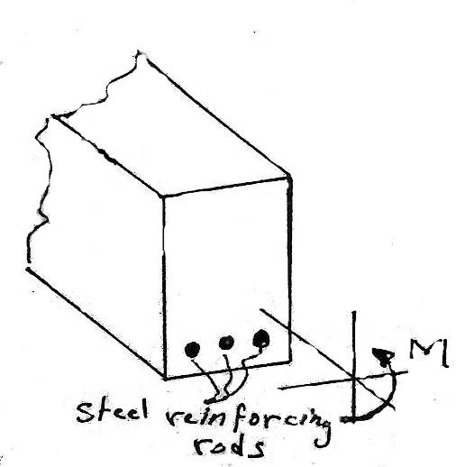
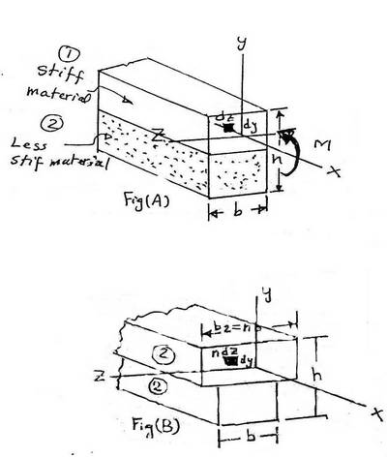
Since the flexure formula was developed for beams whose material is homogeneous ((lecture no. 7)) this formula cannot be applied directly to determine the normal stress in a composite beam. However a develop method for modifying or "transforming" the beams cross-section into one made ϑ a single material.
Once this has been dine, the flexure formula can then be used for the stress analysis.
Consider the composite beam to be made ϑ two material; (1) and (2), which have the cross-sectional area shown in the fig. if a bending moment is applied to this beam, a simpler to calculate the normal stresses, is to transform the beam into one made ϑ single material.
For example, if the beam is thought to consist entirely ϑ the less shift material (2), then the cross-section would have to look like the shown in fig. below.
Here the height (h) ϑ the beam remains the same, the upper portion ϑ the beam must be widened in order to carry a load equivalent to that carried by the stiffer material (1).
If dF acting on the area dA = dz dy , ϑ the beam (fig. A)
∴ dF = σ dA = (E₁ϵ)dz dy
For (fig. B) dF' =σ' dA' = (E₂ ϵ) n dz dy
But the moment is the same.
∴ dF' = dF and E₁ϵ dz dy = E₂ϵ n dz dy
Or
n = $\frac{E_{1}}{E_{2}}$ …….(1)
Where n = transformation factor.
In the same manner, if the less stiff material (2) is transformed into the stiffer material (1) then
n' = $\frac{E_{2}}{E_{1}}$ …….(2)
where n' must be less than one since E₁ > E₂ and the cross section ϑ the beam will look like shown in fig. (c).
once the beam has been transformed into one having a single material, the normal stress distribution over the transformed cross-section will be linear, consequently, the centroid(neutral axis) and moment ϑ inertia the transformed area can be determined and the flexure formula applied in the usual manner to determine the stress at each point on the transformed beam. Thus;
dF = σ dA = σ' dA'
σ dz dy = σ' n dz dy
σ = n σ' ……..(3)
Example 8.1:
A composite beam is made ϑ wood and reinforced with steel strap located on its bottom side. It has the cross-sectional area shown in the fig. if the beam is subjected to a bending moment ϑ M= 2 kN-m, determine the normal stress at points B and C. take E_{w} = 12 GPa and E_{st} = 200 GPa.
Solution:
Transform the section into one made entirely of steel. Since steel has a greater stiffness than wood (E_{st} > E_{w}), the width ϑ the wood must be reduced to an equivalent width for steel.
n = $\frac{E_{w}}{E_{st}}$
= $\frac{12}{200}$ = 0.06
b_{st} = n b_{w} = 0.06*150 = 9 mm
$\overline{y}$ = $\frac{\sum{\overline{y} A}}{\sum{A}}$
= $\frac{\left(0.01\right)\left(0.02\right)\left(0.15\right)+\left(0.095\right)\left(0.009\right)(0.15)}{\left(0.02\right)\left(0.15\right)+\left(0.009\right)(0.15)}$
= 0.03638 m
I = $\sum{( \overline{I}}+ A d^{2})$
I_{NA} = $\left[\frac{1}{12}\left(0.15\right)({0.02)}^{3}+(0.15)(0.02)({0.03638-0.01)}^{2}\right]+\left[\frac{1}{12}\left(0.009\right)({0.15)}^{3}(+(0.009)(0.15)({0.095-0.03638)}^{2}\right]$
= 9.36*10⁻⁶ m⁴
σ_{b'} = $\frac{M C}{I}$ = $\frac{2*(0.17-0.03638)}{9.36*{10}^{-6}}$ = 28.6 MPa
d_{c} = $\frac{M C}{I}$ = $\frac{2*0.03638}{9.36*{10}^{-6}}$ = 7.77 MPa
The normal stress in the wood located at in fig. (b)
σ_{B} = n σ_{B'}
= $\frac{12}{200}*(28.6)$ = 1.71 MPa

B. Reinforced concrete beams
All beams subjected to pure bending must resist both tensile and compressive stresses. Concrete, however is very susceptible to cracking when it is in tension and therefore by itself would not be suitable for resisting a bending moment. In order to circumvent this shortcoming engineer place steel reinforcing rods within a concrete beam at a location where the concrete is in tension.
The stress analysis requires locating the neutral axis and determining the maximum stress in the steel and concrete. To do this, the area ϑ steel a_{s} is first transformed into an equivalent area ϑ concrete using the transformation factor n = e_{s}/e_{c} . This ratio, which gives n>1, is chosen since, a" greater" amount ϑ concrete is needed to replace the steel. The transformed area is na_{s} and the transformed section looks like the shown in fig. (b).
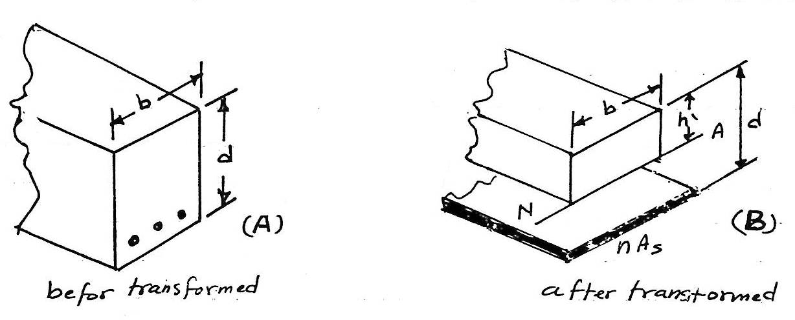
h' = is unknown distance from the top ϑ the beam to the neutral axis. h' can be obtained using the fact that the centroid C of the cross-sectional area ϑ the transformed section lies on the neutral axis, with the reference to the neutral axis, therefore, the moment ϑ the areas, $\sum{\tilde{y} A }$ must be zero, since
$\overline{y}= \frac{\sum{\tilde{y} A}}{\sum{A}}$ = 0
thus,
b h' ($\frac{h'}{2})-n A_{s} \left(d-h^{'}\right)=0$
or
$\frac{b}{2}$h'² + n A_{s} h' - n A_{s} d = 0 ......(4)
once h' is obtained from this quadratic equation, the solution proceeds in the usual manner for obtaining the stress in the beam.
Example 8.2:
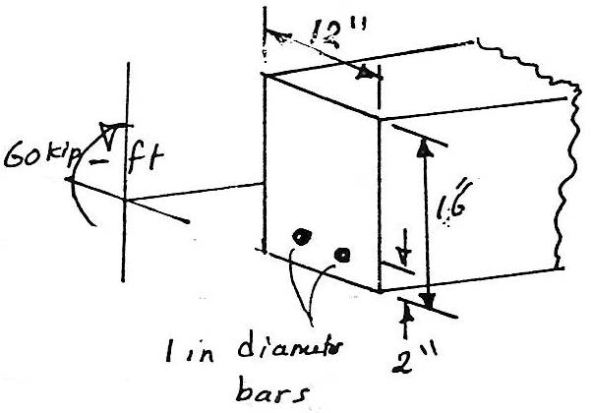
The reinforced concrete beam has the cross sectional area shown in the fig. If it subjected to a bending moment ϑ m = 60 kips.ft, determine the normal stress in each ϑ the steel reinforcing rods and the maximum normal stress in concrete. Take e_{st} = 29*10³ ksi and e_{c} = 3.6*10³ ksi.
Solution:
Neglect the tensile stress ϑ concrete.
A_{s} = 2 ( π (0.5)²)
= 1.571 in²
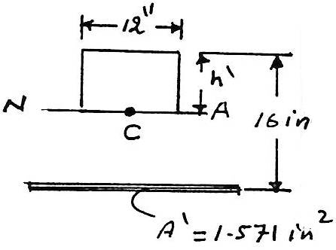
A' = n A_{s} = $\frac{29*{10}^{3}}{3.6*{10}^{3}}*1.571$ = 12.65 in²
We require the centroid to lie on the neutral axis. Thus $\sum{\tilde{y} a=0 }$, or
12 (h') $\frac{h'}{2}$ - 12.65 ( 16 - h' ) = 0
h'² - 2.1 h' - 33.7 = 0
h' = 4.85 in (solving for the positive root)
The moment ϑ inertia of the transformed section, computed about the neutral axis, is
I = $\left[\frac{1}{12} (12)({4.85)}^{3}+12*4.85*({\frac{4.85}{2})}^{2}\right]+ 12.65*({16-4.85)}^{2}$ = 2029 in⁴
The normal stress (max.) In the concrete is
( σ_{conc})_{max.} = $\frac{M C }{I}$ = $\frac{60*12*4.85}{2029}$
= 1.72 ksi
The normal stress resisted by the "concrete" strop, which replaced the steel, is
σ'_{conc.} = $\frac{60*12*(16-4.85)}{2029}$ = 3.96 ksi
The normal stress in each ϑ the two reinforcing rods is therefore:
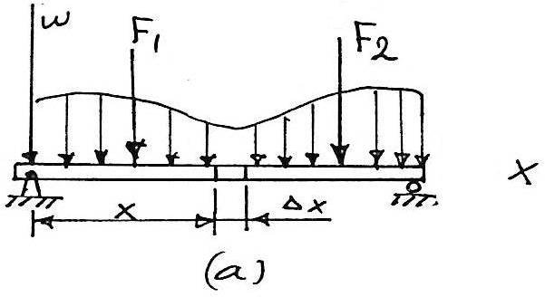
σ_{st.} = n σ'_{conc.} = $\frac{29*{10}^{3}}{3.6*{10}^{3}}*3.96$
= 31.9 ksi

LECTURE NO. 9

Shear Stress In Beams
In this lecture we will developed a method for finding the shear stress in beam having a prismatic cross section and mode from homogeneous material that be haves in a linear elastic manner.
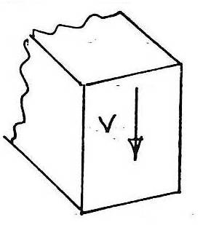
if a beam is generally subjected to transfer loadings, these loading not only cause an internal moment in the beam but also an internal shear force, cause a transverse shear stress distribution that acts over the beams cross section. as a result ϑ the shear stress, shear strain will be developed and these will tend to distort the cross section in a rather complex manner.
9.1. The Shear Formula
Consider the shaded top segment ϑ the element that has been sectioned a $\overline{y}$ from the neutral axis fig.(b). This segment has a width t at the section, and the cross sectional sides each have an area A' .

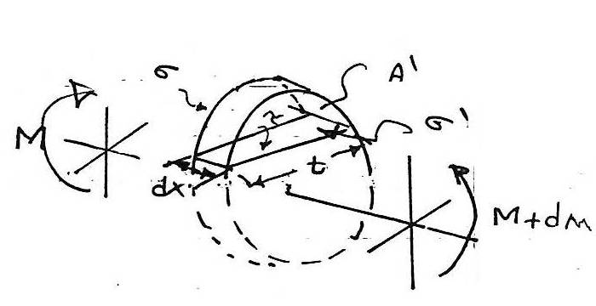
←+$\sum{F_{x}}$ i = 0 ;
$$\int_{A'}{σ^{'}dA- \int_{A'}{σ dA- τ\left(t dx\right)=0}}$$
$$\int_{A'}{(\frac{M+dM}{I})}y dA- \int_{A'}{\left(\frac{M}{I}\right)y dA- τ\left(td\right)=0 }$$
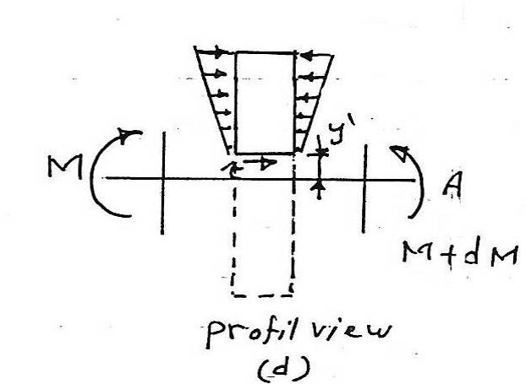
$\left(\frac{dM}{I}\right)\int_{A'}{y dA= τ (t dx)}$ .....(1)
solving for τ (t dx), we get:
τ = $\frac{1}{I t}\left(\frac{dM}{dx}\right)\int_{A}{y dA}$
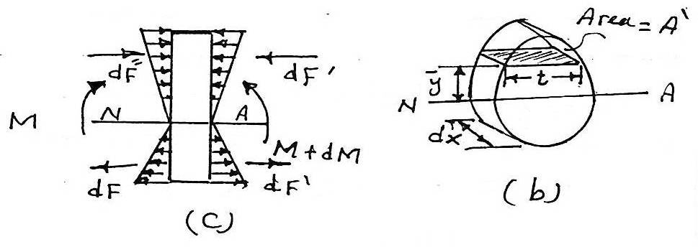
This equation can be simplified as:
V = $\frac{dM}{dx}$ and the integral represent the first moment of the area A' about the neutral axis. we will denote it by Q.
Q = $\int_{A'}{y dA= \overline{y'}} A^{'}$ ......(2)
and thus:
τ = $\frac{V Q}{I t}$ .......(3)
Where:
τ: the shear stress in the member at the point located a distance y' from the neutral axis fig. (b). this stress is assumed to be constant and therefore averaged across the width t ϑ the member fig(d).
V: the internal resultant shear force, determined from the method ϑ sections and equilibrium equations.
I: the moment ϑ inertia ϑ the member's cross-sectional area, measured or computed about the neutral axis .
t: the width ϑ the member's cross-sectional area, measured at the point where τ is to be determined.
Q = $\int{A^{'}y {dA}^{'}= \overline{y'} A^{'}}$,
where A' is the top (or bottom) portion ϑ the member's cross-sectional area, defined from the section where t is measured, and $\overline{y'}$ is the distance to the centroid ϑ A', measured from the neutral axis.
7.2. Shear Stresses In Beams:
In order to develop some insight as to the method ϑ applying the shear formula and also its limitations on some ϑ common types ϑ beam cross-section:
A. Rectangular cross-section beam.
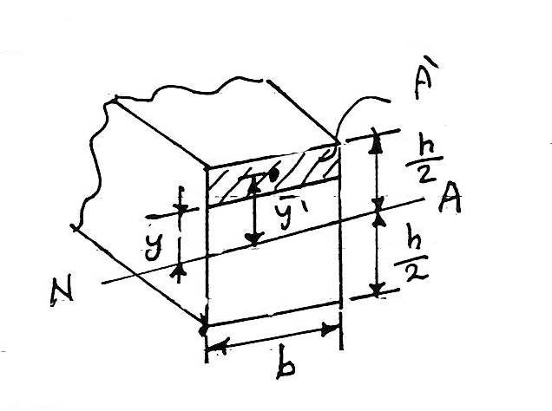
Q = $\overline{y'}$ A'
= $\left[y+\frac{1}{2}\left(\frac{h}{2}- y\right)\right]\left[\left(\frac{h}{2}-y\right)b\right]$
= $\frac{1}{2}(\frac{h^{2}}{4} - y^{2})b$
τ = $\frac{V Q}{I t}$ = $\frac{V(1/2)(\frac{h^{4}}{4} - y^{2})b}{(\frac{1}{12}b h^{3})(b)}$
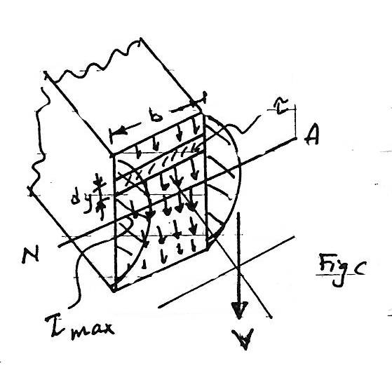
or
τ = $\frac{6 V}{b h^{3}} (\frac{h^{2}}{4} - y^{2})$ ......(4)
This result indicates that the shear stress distribution over the cross section is parabolic see fig. C, the intensity varies from zero at the top and bottom, y = ± h/2, to a maximum value at the neutral axis y=0, since the area ϑ the cross section is a= bh, then at y = 0 we have, from equation 4:
τ_{max} = 1.5 $\frac{V}{A}$ ......(5)
For other cross section see the following examples:
Example 9.1:
The beam shown in the fig. is made ϑ wood and is subjected to resultant internal vertical shear force ϑ V = 3 kip.
a. determine the shear stress in the beam at point P.
b. compute the maximum shear stress in beam.
Solution:
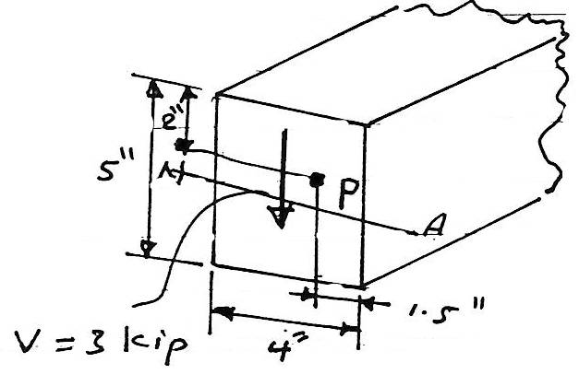
The moment ϑ the inertia ϑ the cross-sectional area computed about the neutral axis is:
(a)
I = $\frac{1}{12}$ b h³ = $\frac{1}{12}$ (4)(5)² = 41.7 in⁴
Q = $\overline{y'}$ A'
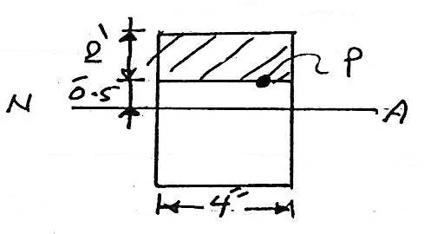
= [ 0.5+$\frac{1}{2}$ (2) ] 2*4
= 12 in²
τ_{p} = $\frac{V Q}{I t}$ = $\frac{3*12}{41.7*4}$
= 0.216 ksi
(b)
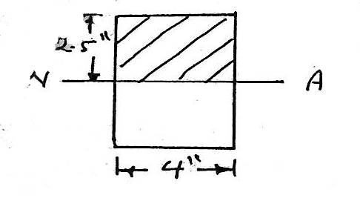
the max. shear stress occurs at the neutral axis.
Q = $\overline{y'}$ A'
= ($\frac{2.5}{2})$ *4*2.5
= 12.5 in²
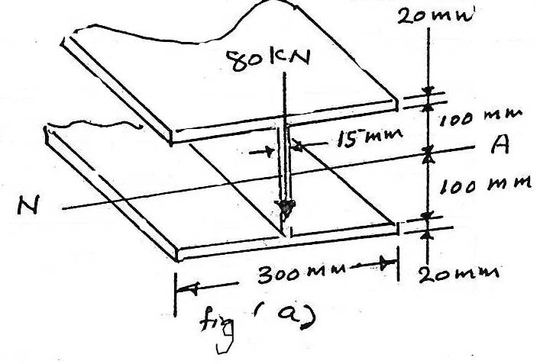
τ_{max} = $\frac{V Q}{I t}$= $\frac{3*12.5}{41.7*4}$
= 0.225 ksi
or it could be calculated from:
τ_{max} = 1.5 $\frac{V}{A}$ = 1.5*$\frac{3}{4*5}$
= 0.225 ksi
Example 9.2:
A steel wide flange beam has the dimension shown in the figure, if it is subjected to a shear-stress distribution acting over the beams cross-sectional area, and B determine the shear force resisted by the web.
Solutions:
(a)
The stress (shear-stress)distribution will be parabolic and varies in the manner show in fig.
(b)
Due to symmetry, only stresses at points B', B, & c have to be computed.
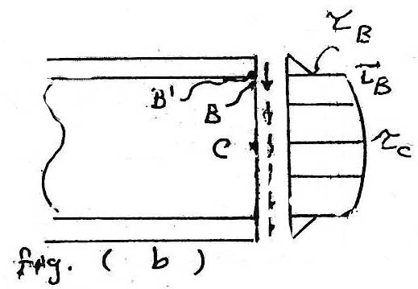
I = [ $\frac{1}{12}$(0.015)(0.2)³ ] + 2[ $\frac{1}{12}$ (0.3)(0.02)³+(0.3)(0.02)(0.11)²]
= 155.6*10⁻⁶ m⁴
For point B', t_{b'} =0.3, and A' is the dark shaded area shown in fig. C . Thus.
Q_{B'} = $\overline{y'}$ A'
= [0.11][(0.3)(0.02)]
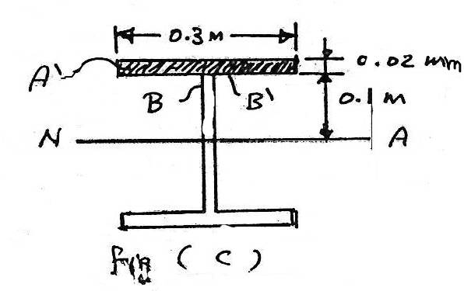
= 0.66*10⁻³ m³
τ_{B'} = $\frac{V Q_{B'}}{I t_{B'}}$
= $\frac{80*0.66*{10}^{-3}}{155.6*{10}^{-3}*0.3}$ = 1.13 MPa
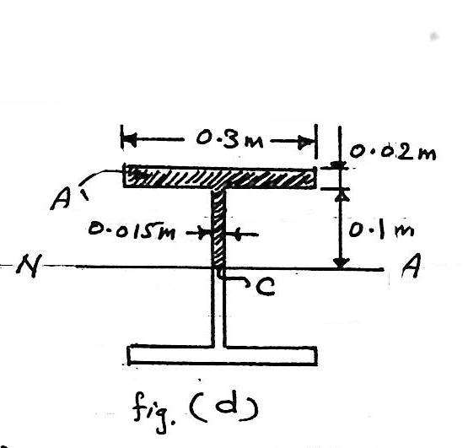
for point B, t_{B} = 0.015 and Q_{B} = Q_{B'}
τ_{B} = $\frac{V Q_{B}}{I t_{B}}$
= $\frac{80*0.66*{10}^{-3}}{155.6*{10}^{-6}*0.015}$= 22.6 MPa
For point c, t_{c} = 0.015 m and A' is the dark shaded area shown in fig.(d). Considering this area to be composed of two rectangles we have:
Q_{c} = $\sum{\overline{y'}} A'$ = (0.11)(0.3)(0.02)+(0.05)(0.015)(0.1)
= 0.735 * 10⁻³ m³
τ_{c} = τ_{max} = $\frac{V Q_{c}}{I t_{c}}$
= $\frac{80*0.735*{10}^{-3}}{155.6*{10}^{-6}*0.015}$ = 25.2 MPa
(B)
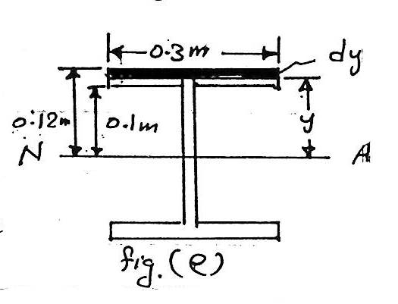
The shear force in the web will be determined by first computing the shear force in each flange and then subtracting this result from v= 80 kn. To obtain the shear force in a flange, we must first determine the shear stress at the arbitrary location y, fig. e:
I = 155*10⁻⁶ m⁴
t = 0.3 m
A' = (0.3)(0.12-y) m²
$\overline{y'}$ = y+$\frac{1}{2}$(0.12-y)
= $\frac{1}{2}$(0.12+y)m
Q = $\overline{y'}$ A' = (0.15)[ (0.12)² _ y²]
τ = $\frac{V Q}{I t}$ = $\frac{\left(80\right)\left[0.15\right][({0.12)}^{2}-({y)}^{2}]}{155.6*{10}^{-6}*0.3}$
= 257((0.12)² _ y² ) MPa
This shear acts on the area strip da=0.3*y show in fig. e, and therefore the shear force resisted by the top flange is:
V_{f} = $\int_{A_{f}}{τ dA}$ = $\int_{0.1}^{0.12}{257\left({10}^{6}\right)[\left({0.12)}^{2}- y^{2}\right]300 dy}$
= 3.496 kN
By symmetry, this force also acts in the bottom flange. Thus the shear force in the web is.
V_{w} = V - 2V_{f} = 80-2(3.496) = 73 kN
Example 9.3:
The beam shown in the figure (a) is made from two boards. Determine the maximum shear stress in the glue necessary to hold the boards together along the seam where they are joined. The supports at b and c exert only vertical reactions on the beam.
Solution:
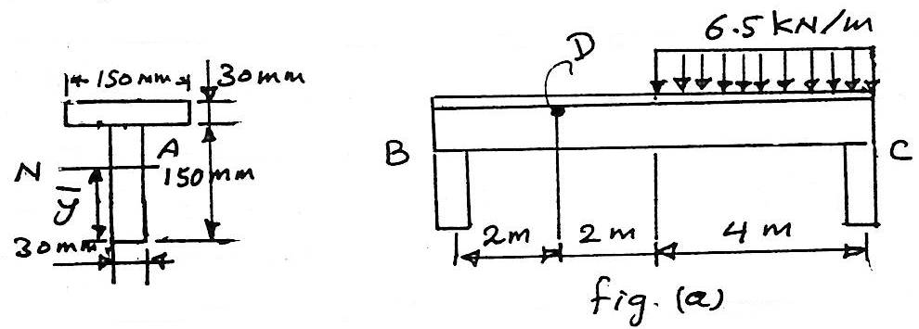
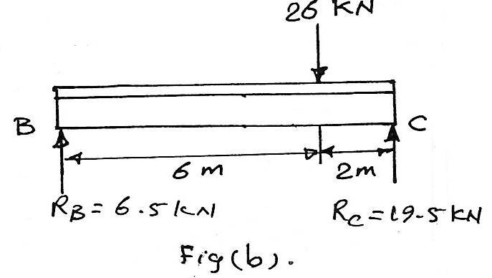
↱+$\sum{M_{B}}=0$
26*6 - R_{c} *8 = 0
R_{c} = 19.5 kN
$$\sum{Fy}=0$$
R^{B} = 26-29.5 = 6.5 kN
The centroid and therefore the neutral axis will be determined from the reference axis placed at the bottom ϑ the cross-sectional area see fig. a :
$\overline{y}$ = $\frac{\sum{\tilde{y} A}}{\sum{A}}$
= $\frac{\left(0.075\right)\left(0.15\right)\left(0.03\right)+\left(0.165\right)\left(0.03\right)(0.15)}{\left(0.15\right)\left(0.03\right)+\left(0.03\right)(0.15)}$
= 0.12 m
The moment ϑ inertia, computed about the neutral axis:
I = [ $\frac{1}{12}$(0.03)(0.15)³+(0.03)(0.15)(0.12-0.075)² ]+[$\frac{1}{12}$(0.15)(0.03)³+(0.03)(0.15)(0.165-0.12)² ]
= 27*10⁻⁶ m⁴
A' : is top board area
Q = $\overline{y'}$A'
= (0.18-0.12-0.015)(0.03*0.15)S.F.D
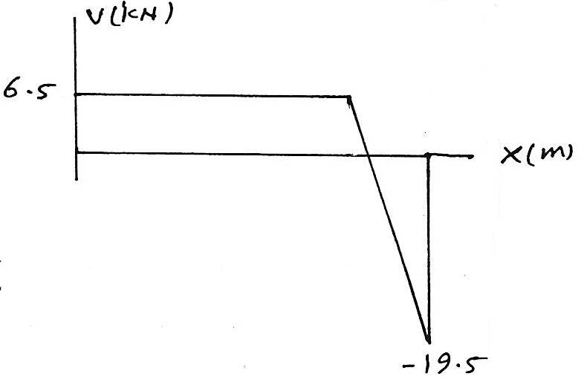
= 0.2025*10⁻³ m³
τ_{max} = $\frac{V Q}{I t}$
= $\frac{19.5*0.2025*{10}^{-3}}{27*{10}^{-6}*0.03}$
= 4.88 MPa

LECTURE NO.10
Beam Deflection
Several methods are available for determining beam deflections. Although based on the same principle, they differ in technique and in their immediate objective.
10.1 The Elastic Curve
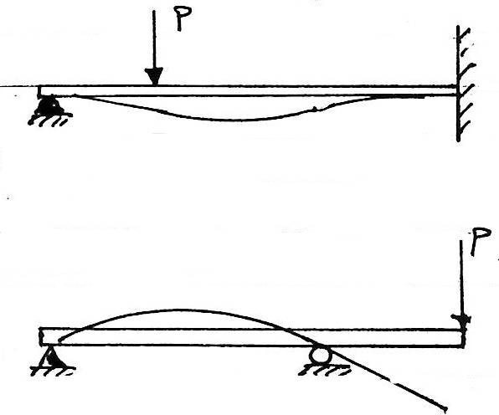
The deflection diagram of the longitudinal axis that passes through the centroid ϑ each cross-sectional area ϑ the beam is called the elastic curve. For most beams the elastic curve can be sketched without much difficulty. After that it is necessary to know how the slope or displacement is restricted at various types of supports. In general, supports that resist a force, such as a pin, restrict displacement and those that resist a moment, such as a fixed wall, restrict rotation or slope.
With this in mind, two typical examples of the elastic for loaded beams (or shafts) shown in fig. (1)
If the elastic curve for a beam seems difficult to establish, it is suggested that the moment diagram for the beam be drawn first. Using the beam sign, a positive internal moment tends to bend the beam concave upward, like wise a negative moment tends to bend the beam concave downwards see fig(2). Therefore, if the moment diagram is known, it will be easy to construct the elastic curve.
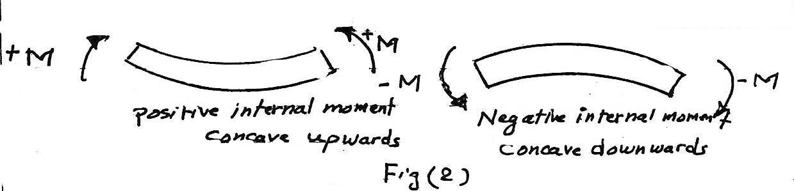
10.2. Double Integration Method
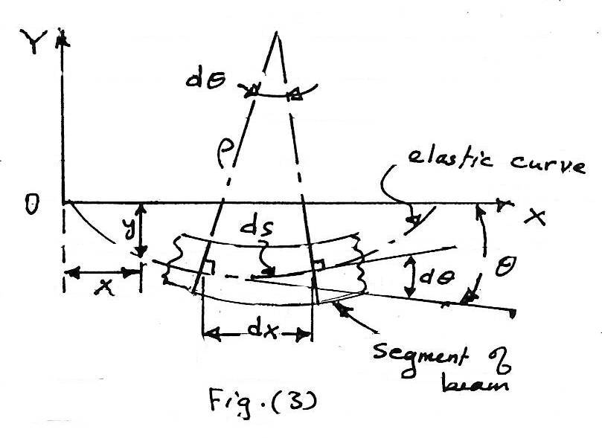
the elastic curve ϑ a beam is shown in fig. (3), to determine the equation ϑ this curve, i.e., how to determine the vertical displacement y ϑ any point in term of it x coordinate.
select the left end ϑ the beam. the deflection are assumed to be so small that there is no appreciable difference between the original length ϑ the beam and the projection of deflected length.
thus the elastic curve is very flat and its slope at any point is very small.
$\tan{θ= \frac{dy}{dx}}$and hence
θ = $\frac{dy}{dx}$ ......(a) and
$\frac{dθ}{dx}$ = $\frac{d^{2}y}{{dx}^{2}}$ ......(b)
ds = p dθ ......(c)
where p is the radius ϑ curvature over the length ds.
because the elastic curve is very flat, ds is practically equivalent to dx , so from eqs. (c)&(b) we obtain
$\frac{1}{p}$ = $\frac{dθ}{dx} ≅ \frac{dθ}{ds}$ or
$\frac{1}{p}$ = $\frac{d^{2}y}{{dx}^{2}}$ .......(d)
but $\frac{1}{p}$ = $\frac{M}{E I}$ .......(e)
from eqs. (e)&(d)
E I $\frac{d^{2}y}{{dx}^{2}}$ = M ....(1)
This is know as the differential equation ϑ the elastic curve ϑ a beam.
E I; called the flexural rigidity ϑ the beam, it is usually constant along the beam.
E I $\frac{dy}{dx}$ = $\int{M dx+c }$ ......(2) by integration ϑ eq.(1)
E I y = ∬ M dx + c₁ x + c₂ .....(3)
Equation (3) is the deflection equation ϑ the elastic curve specifying the value ϑ y for any value ϑ x.
c₁ and c₂ are constant ϑ integration which must evaluated from a given boundary conditions ϑ the beam and its loading.
Example 10.1:
The cantilevered beam shown in fig. a is subjected to a vertical load p at its end. determine the equation ϑ elastic curve. E I is constant.
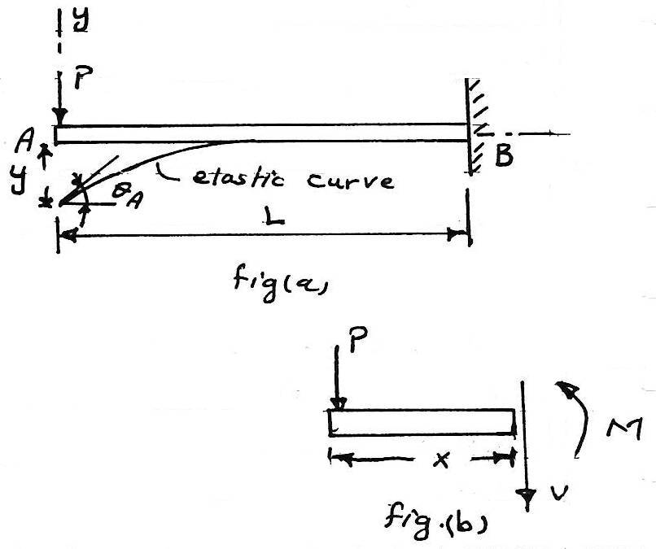
Solution:
The load tends to deflect the beam as show in fig. a . by inspection. the internal moment can be represented throughout the beam using a single x coordinate. from the free-body diagram, with M acting in the positive direction fig. b,
M = - P x
E I $\frac{d^{2}y}{{dx}^{2}}$ = M or E I $\frac{d^{2}y}{{dx}^{2}}$ = - P x ....(a)
E I $\frac{dy}{dx}$ = - $\frac{P x^{2}}{2}$ + c₁ .......(b)
E I y = - $\frac{P x^{3}}{6}$ + c₁ x + c₂ .......(c)
using the boundary condition $\frac{dy}{dx}$ =0 at x=L and y=0 at x=L, equations b&c become:
0 = - $\frac{P L^{2}}{2}$ + c₁
0 = - $\frac{P L^{3}}{6}$ + c₁ L + c₂
thus, c₁ = $\frac{p L^{2}}{2}$ and c₂ = $\frac{- PL^{3}}{3}$ sub. these values into eqs. b&c with θ = $\frac{dy}{dx}$, we get
θ = $\frac{P}{2 E I}$ (L² - x² )
y = $\frac{P}{6 E I}$ (- x³ +3 L² x - 2 L³ )
max. slope and displacement occur at A when x=0 for which:
θ_{A} = $\frac{P L^{2}}{2 E I}$ .......(d)
y_{A} = - $\frac{P L^{3}}{3 E I}$ ........(e)
The positive result for θ_{A} indicates counter clockwise rotation and negative result for y_{A} indicates that y_{A} is downward.
Example 10.2:
For the same beam in example 10.2 , consider the beam have a length (L) ϑ 15 ft support a load p ϑ 6 kip, and be made ϑ A-36 steel having E_{st} = 29*10³ ksi, assuming the allowable normal stress is equal to the yield stress σ_{allow} = 36 ksi, I = 204 in⁴. calculate max. slop and displacement.
θ_{A} = $\frac{P L^{2}}{2 E I}$ = $\frac{6*({15*12)}^{2}}{2*\left(19*{10}^{3}\right)(204)}$ = 0.0164 rad.
y_{A} = - $\frac{P L^{3}}{3 E I}$ = - $\frac{6*({15*12)}^{3}}{3\left(29*{10}^{3}\right)(204)}$ = -1.97 in
Example 10.3:
The simply supported beam shown in fig.(a) supports the triangular distributed loading. determine its ma. deflection. E I is constant.
Solution:
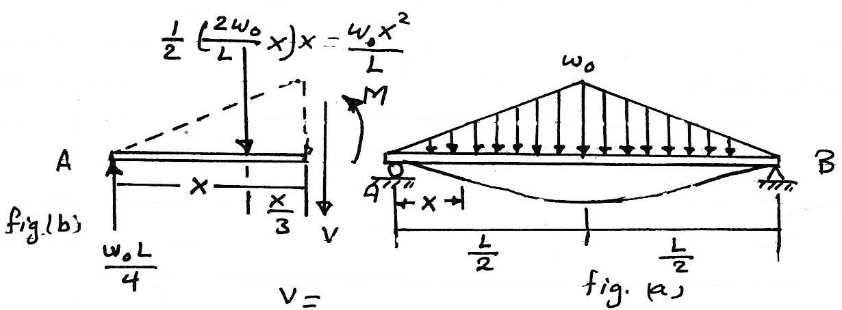
Due to symmetry, only one x coordinate is needed for solution.
0 ≤ x ≤ $\frac{L}{2}$
from fig.(b)
R_{A} = $\frac{w_{o}*L/2}{2}$ = $\frac{w_{o L}}{4}$
The distribution load at any point is :
w = $\frac{2 w_{o} x}{L}$
note غير مفهومة
hence,
+↳$\sum{M_{NA}}=0;$
M + $\frac{ w_{o} x^{2}}{L}$ ($\frac{x}{3})$ - $\frac{ w_{o} L}{4}$ (x) = 0
M = $\frac{- w_{o} x^{3}}{3L}$ + $\frac{ w_{o} L}{4}$ x
E I $\frac{d^{2}y}{{dx}^{2}}$= M
E I $\frac{d^{2}y}{{dx}^{2}}$ = $\frac{- w_{o} }{3L}x^{3}$ + $\frac{ w_{o} L}{4}$ x
E I $\frac{dy}{dx}$ = $\frac{- w_{o} }{12L}x^{4}$ + $\frac{ w_{o} L}{8}$ x² + c₁
E I y = $\frac{- w_{o} }{60L}x^{5}$ + $\frac{ w_{o} L}{24}$ x³ +c₁ x +c₂
Apply the boundary conditions:
when y=0 at x=0 also due to symmetry $\frac{dy}{dx}$ = 0when x = L/2 . this leads to
c₁ = $\frac{- 5 w_{o} L^{3}}{192}$ & c₂ =0
hence,
E I $\frac{dy}{dx}$ = $\frac{- w_{o}}{12L}$ $x^{4}$ + $\frac{ w_{o} L}{8}$ x² - $\frac{ 5 w_{o} L^{3}}{192}$
E I y = $\frac{- w_{o} }{60L}$ $x^{5}$+ $\frac{ w_{o} L}{24}$ x³ - $\frac{ 5 w_{o} L^{3}}{192}$ x
The max. Deflection at x = l/2 sub. This value in equation (a).
y = $\frac{1}{E I}$ [ - $\frac{W_{o}}{60 L}*({\frac{L}{2})}^{5}+ \frac{w_{o}L}{24}*({\frac{L}{2})}^{3}- \frac{5 w_{o}L^{3}}{192}*\frac{L}{2}]$
y = $\frac{1}{E I}$ [ - $\frac{w_{o}L^{4}}{1920}+ \frac{w_{o}L^{4}}{192}- \frac{5 w_{o}L^{5}}{384}]$
$\frac{5 w_{o}L^{5}}{120 E I}$ = -
Example 10.4:
The beam in fig. (a) is subjected to a load p at its end. Determine the displacement at c. Ei is constant.
Solution:
Due to the loading, two x coordinates will be considered,
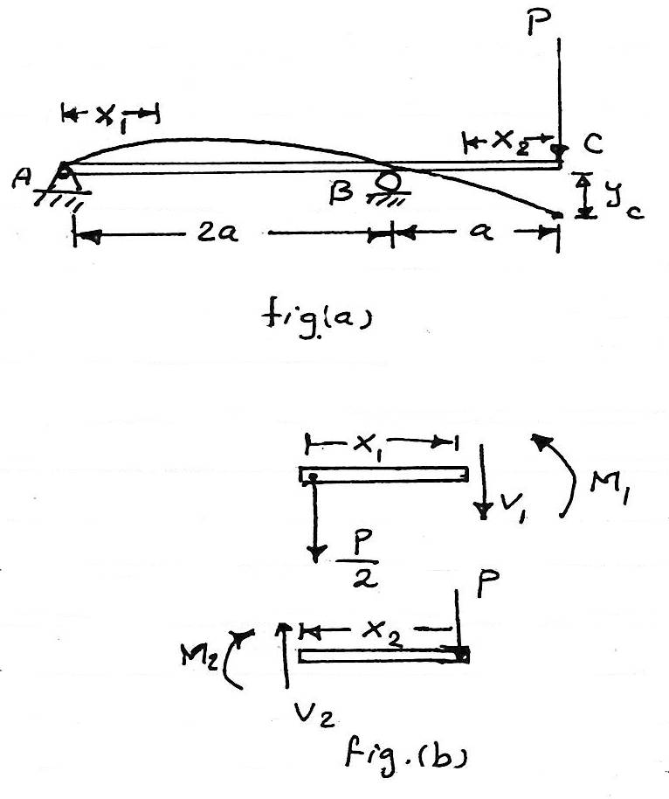
0 ≤ x₁ < 2a
0 ≤ x₂ < a
from fig. (b)
M₁ = - $\frac{P}{2}$ x₁
M₂ = - p x₂
E I $\frac{d^{2}y}{{dx}^{2}}$= M
for 0 ≤ x₁ < 2a
E I $\frac{d^{2}y_{1}}{dx_{1}^{2}}$= - $\frac{P}{2}$ x₁
E I $\frac{dy_{1}}{dx_{1}}$ = - $\frac{P}{4} x_{1}^{2}+c_{1}$ .......(1)
E I y₁ = - $\frac{P}{12} x_{1}^{3}+c_{1}$x₁+c₂ ......(2)
for 0 ≤ x₂ < a
E I $\frac{d^{2}y_{2}}{dx_{2}^{2}}$= - P x₂
E I $\frac{dy_{2}}{dx_{2}}$ = - $\frac{P}{2} x_{2}^{2}+c_{3}$ .......(3)
E I y₂ = - $\frac{P}{6} x_{2}^{3}+c_{3}$x₂+c₄ ......(2)
boundary conditions:
y₁ = 0 at x₁ = 0
y₁ = 0 at x₁ = 2a
y₂ = 0 at x₂ = a
Also the continuity ϑ the slope at roller requires :
$\frac{dy_{1}}{dx_{1}}$ = -$\frac{dy_{2}}{dx_{2}}$ at x₁ = 2a and x₂ = a
applying these four conditions yields:
y₁ = 0 at x₁ = 0 → to equation(2)
0=0+0+c₂
∴ c₂ = 0
y₁ = 0 at x₁ = 2a → to equation (2)
0 = - $\frac{P}{12}$ (2a)³ + 2c₁ a +c₂
∴c₁ = $\frac{P a^{2}}{3}$
y₂ = 0 at x₂ = a → to equation (4)
0 = -$\frac{P}{6}$ a³ + c₃ a + c₄ ........(5)
also $\frac{dy_{1}}{dx_{1}}$ = -$\frac{dy_{2}}{dx_{2}}$ at x₁ = 2a and x₂ = a apply this condition into equations 1&3 yield
- $\frac{P}{4}$ (2a)² + $\frac{Pa^{2}}{3}$ = -(-$\frac{P}{2}$(a)² + c₃ )
∴ c₃ = $\frac{7}{6}$ p a² sub this value into eq. 5
c₄ = - P a³
sub the values ϑ c₃ & c₄ into equation (4) gives,
y₂ = - $\frac{P}{6 E I}$ $x_{2}^{3}$ + $\frac{7 P a^{2}}{6 E I}$ $x_{2}^{2}$ - $\frac{P A^{3}}{E I}$
the value ϑ y₂ at point c is determining by setting x₂ = 0
∴ y₂ = - $\frac{P a^{3}}{E I}$
10.3 Superposition Method.
The deflection for a series ϑ separate loadings acting on a beam may be superimposed. for example, if y, is the deflection for one load and y₂ is the deflection for another load, the total deflection for both loads acting together is the algebraic sum y₁+y₂. using tabulated results for various beam loadings found in various engineering handbooks.
Example 10.5:
Determine the displacement at point c and the slope at support A of the beam shown in fig. a. EI is constant.
Solution:
The loading can be separated into two component parts as shown in figures a&b.
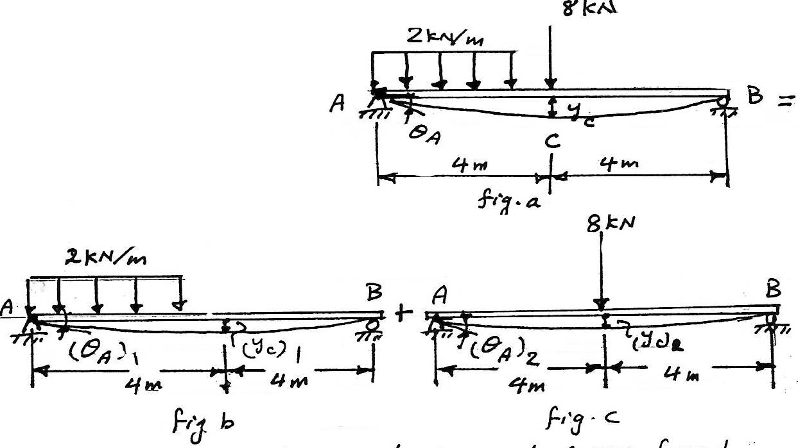
The displacement at c and slope at A are found using tables. For the distributed loading.
(θ_{A})₁ = $\frac{3 w L^{3}}{128 E I}$ = $\frac{3 \left(2\right)({8)}^{3}}{128 EI}$ = $\frac{24 kN.m^{2}}{EI}$
(yc)₁ = $\frac{5 w L^{4}}{768 EI}$ = $\frac{5 (2)({8)}^{4}}{768 EI}$ = $\frac{53.33 kN.m^{3}}{E I}$ ↓
for the 8 kN concentrated force.
(θ_{A})₂ = $\frac{ P L^{2}}{16 E I}$ = $\frac{8 ({8)}^{2}}{16 EI}$ = $\frac{32 kN.m^{2}}{EI}$ ↲
(y_{c})₂ = $\frac{P L^{3}}{48 E I}$ = $\frac{8 ({8)}^{3}}{48 E I}$ = $\frac{85.33 kN}{E I}$ ↓
The total displacement at c and the slope at A are the algebraic sums ϑ these components. Hence
θ_{A} = (θ_{A})₁ + (θ_{A})₂ = $\frac{56 kN.m^{2}}{E I}$ ↲
y_{c} = (y_{c})₁ + (y_{c})₂ = $\frac{138.66 kN.m^{3}}{E I}$ ↓
Example 10.6:
Determine the displacement at the end c ϑ the cantilever beam shown in fig.
Solution:
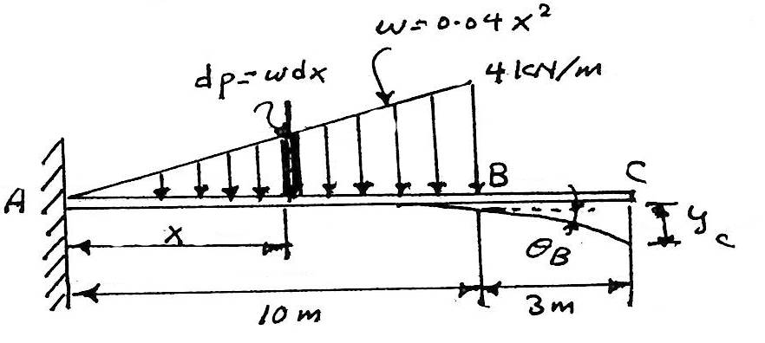
Distributed loadings that are parabolic are not included in the table, in order to solve this problem we can consider the load as an infinite series ϑ concentrated forces dp, and then integrate the result over the region where the loading acts.
dp = wdx = 0.04 x² dx act at a distance x from A. from the table for single concentrated force dp.
θ_{B} = ∫ $\frac{d px^{2}}{2 E I}$ = $\int_{0}^{10}{\frac{\left(0.04x^{2}\right)x^{2}}{2 E I}} dx$ = $\frac{400 kN-m^{2}}{E I}$
y_{B} = $\int{\frac{dpx^{2}}{6 EI}(3L-x)}$ = $\int_{0}^{10}{\frac{\left(0.04x^{2}\right)x^{2}(3*10-x)}{6 E I}} dx$
= $\frac{2888.9 kN.m^{3}}{E I}$
The unloaded region BC ϑ the beam remains straight, as shown in fig. Since θ_{b} is small, the displacement at c becomes:
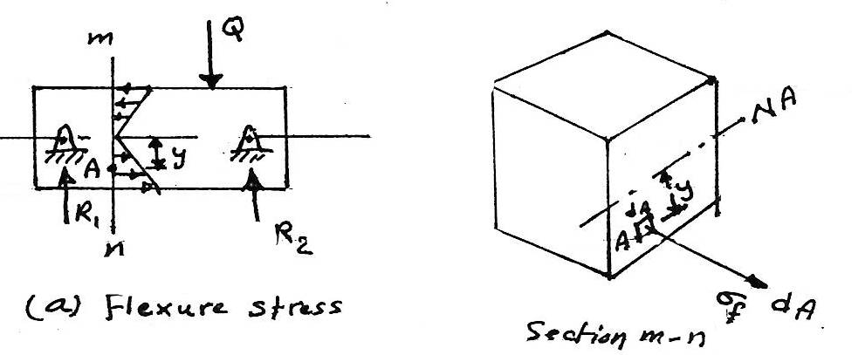
y_{c} = y_{B} + θ_{B} *3
= $\frac{2888.9}{E I}$ + $\frac{400*3}{E I}$
= $\frac{4098 kN.m^{3}}{E I}$ ↓

LECTURE NO. 11
Combined Stresses
In preceding lectures we studied three basic types ϑ loading: axial, torsional, and flexural. Each ϑ these types was discussed on the assumption that only one ϑ these loadings was acting on a structure at a time, the present lecture is concerned with cases in which two or more ϑ these loading act simultaneously upon a structure. The three basic types ϑ loading may be summarized as follows:
Axial loading σ_{a} = $\frac{P}{A}$
Torsional loading τ = $\frac{T P}{J}$
Flexure loading σ_{f} = $\frac{M y}{I}$
There are four possible combinations ϑ these loadings:
1. Axial and flexure
2. Axial and torsional
3. Torsional and flexure
4. Axial, torsional, and flexural, acting simultaneously.
11.1 Combined Axial & Flexural Loads
Consider a simply supports beam (the supports are hinged to the beam at its centroidal surface) carries a concentrated load Q. The flexure stress at point A:
σ_{f} = $\frac{M y }{I}$
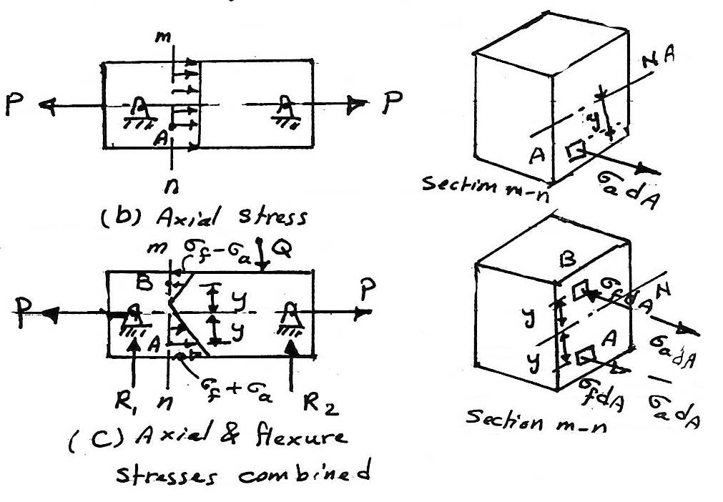
It is tensile and is directed normal to the surface ϑ the cross-section, as shown. The force exerted on the element at a is σ_{f} da.
From fig. (b) axial loading σ_{a} = P/A
From fig. (c) combined stress result force on point A is the vector sum ϑ a the collinear forces σ_{a} dA & σ_{f} dA.
the stresses σ = σ_{a} + σ_{f} directed normal to the cross section similarly, at a point B in the same section. thus the result stress at any point ϑ the beam is given by the algebraic sum ϑ the flexural and axial stresses at that point.
σ = σ_{a} ± σ_{f}
σ = $\frac{⨁{P }}{⊖A}$ ± $\frac{M y}{I}$ .........(1)
Note: tensile stress denoted by positive sign compressive stress denoted by negative sign
⨁ or ⊖ uniform stress
+ or − vary with position
Example 11.1:
A cantilever beam has a profile shown so that it will provide sufficient clearance for large pulleys mounted on the line shaft it supports. The reaction ϑ the line shaft is a load P= 25 kn. Determine the resultant normal stresses at A and B at the wall.
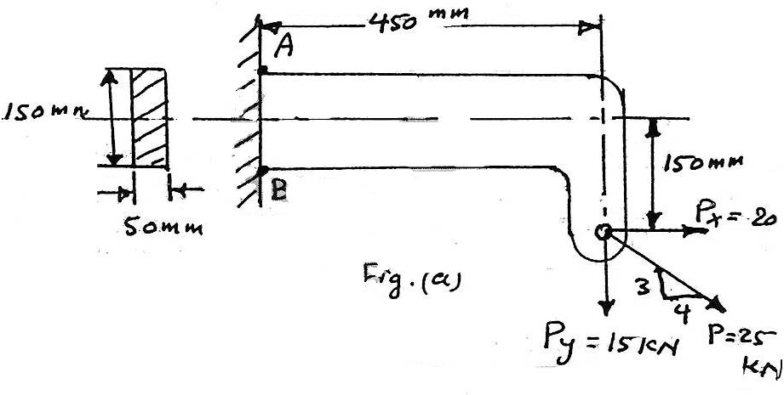
Solution:
Taking moment (B.M) about the centroidal axis ϑ section A B :
[ M = (${\sum{M_{cg})}}_{R}]$
+↳ M = - 15*10³*0.45+20*10³*0.15
= - 3750 N.m
The negative sign ϑ the bending moment at AB indicates that the beam curvature at section A-B is concave downward, thereby causing tension at A and compression at B.
Add a pair ϑ collinear forces each equal to p_{x} as shown in fig. (b), thereby reducing the system tb that shown in fig. (c).
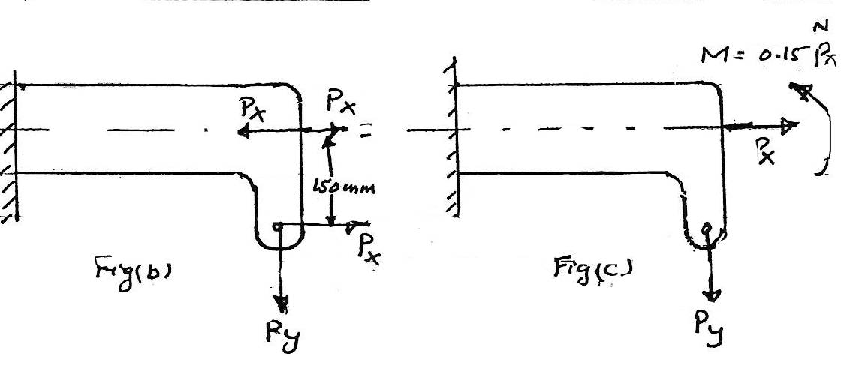
The stress at A:
σ = $\frac{P}{A}$ + $\frac{MC}{I}$ = $\frac{P}{A}$ + $\frac{6 M}{bh^{2}}$
note : c= $\frac{1}{2}$h , I=$\frac{bh^{3}}{12}$
σ_{A} = $\frac{20* {10}^{3}}{\left(0.05\right)(0.15)}+ \frac{6*3750}{\left(0.05\right)({0.15)}^{2}}$
= (2.67*10⁶)+(20*10⁶)= 22.67 MPa
at B the flexural stress is compressive:
σ = $\frac{P}{S}- \frac{6 M}{bh^{2}}$
σ_{B} = $\frac{20*{10}^{3}}{\left(0.05\right)\left(0.15\right)}- \frac{6*3750}{\left(0.05\right)({0.15)}^{2}}$
= (27.67*10⁶ ) - (20*10⁶) = - 17.33 MPa
11.2 Kern Θ A Section, Loads Applied Off Axes Of Symmetry
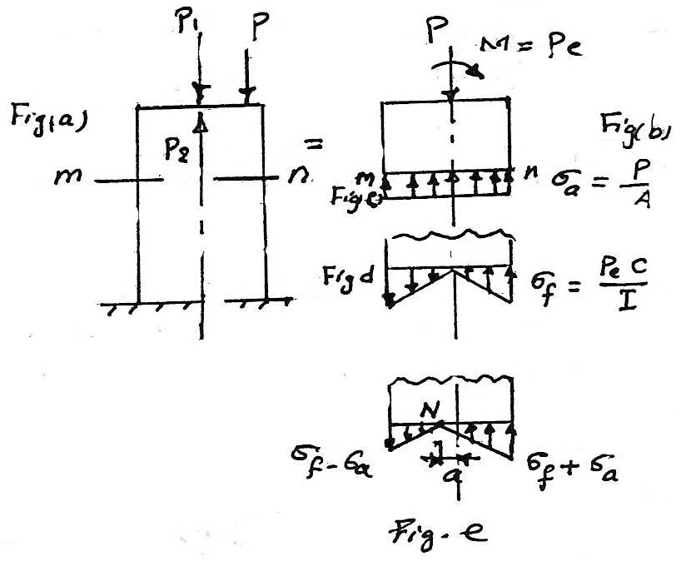
A special case ϑ combined axial and flexural load in fig. (a), in which a short strut carries a compressive load p applied with eccentricity e along one ϑ the principle axis ϑ the section. P₁ & P₂ each ϑ magnitude P and acting at the centroid ϑ the section, causes the equivalent loading see fig. (b).
σ_{a} = $\frac{P}{A}$ see fig. (c)
σ_{f} = $\frac{M C }{I}$ = $\frac{\left(P_{e}\right)C}{I}$ see fig. (d)
if σ_{f} > σ_{a} as shown in fig. (e) the point ϑ zero.
N is the new location ϑ the neutral axis and is easily found by computing the distance a at which the tensile flexural stress equal the direct compressive stress.
$$\frac{P}{A} = \frac{M y}{I} = \frac{\left(P_{e}\right)a}{I}$$
when c,e
a = $\frac{I }{A e}$ . .........(2)
It is evident that there will be no tensile stress any where over the section if the direct compressive stress equal or exceeds the maximum flexure stress.
Thus, for a rectangular section ϑ dimension b & h, with p applied at an eccentricity e (fig below), we obtain:
$$\frac{P}{A}= \frac{M C }{I}=\frac{P_{e (\frac{h}{2})}}{\frac{b h^{3}}{12}}$$
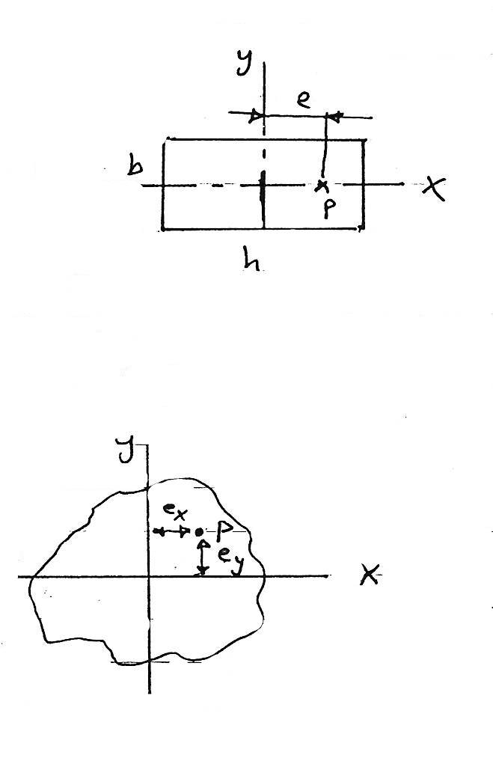
The max. Eccentricity to avoid tension is thus
e = $\frac{h}{6}$ ........(3)
For general case in which the load P is applied at any point with respect to the principle axis x & y as shown in fig. if e_{x} and e_{y} represent the eccentricities ϑ P.
The moment, ϑ P with respect to the x & y are respectively P e_{x} and P e_{y}, the stress at any point ϑ the cross section is :
σ = - $\frac{P}{A}- \frac{\left(P e_{x}\right)x}{I y}- \frac{\left(P e_{y}\right)y }{I x}$ ......(4)
11.3 Variation Θ Stress At A Point.
The stress acting at a point is represented by the stresses acting on the faces ϑ the element enclosing the point, the stresses on the faces ϑ the element vary as the regular position ϑ the element changes.
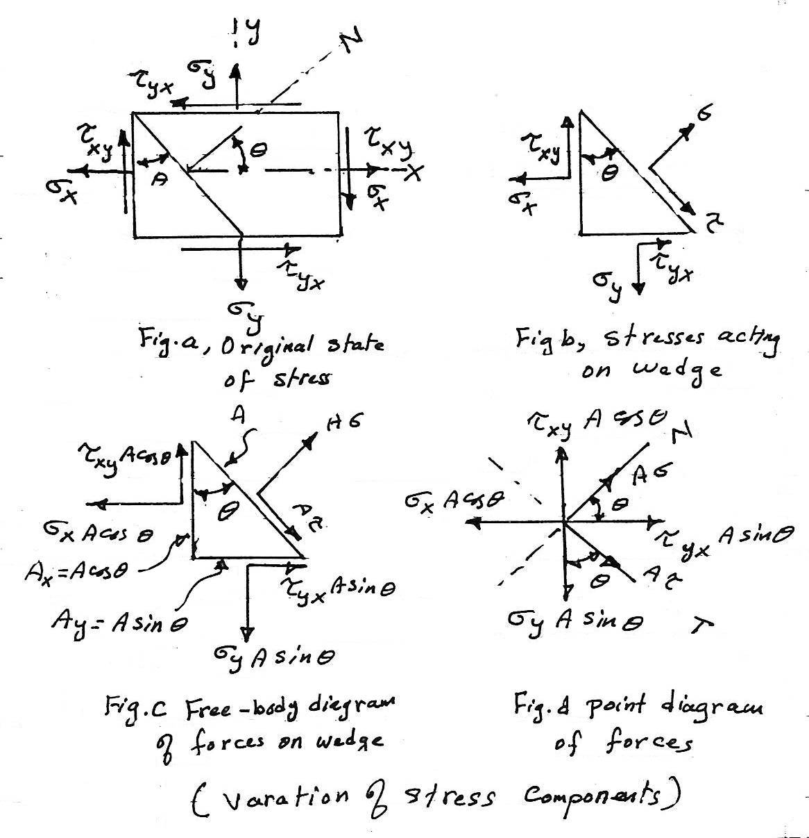
From the figure ϑ variation ϑ stress components, applying the conditions ϑ equilibrium to axis chosen as in figure (d) we obtain:

A σ = (σ_{x} A cosθ)cosθ + (σ_{y} A sinθ)sinθ - (τ_{xy} A cosθ)sinθ - (τ_{yx} A sinθ)cosθ ......(a)
$$\sum{T=0}$$
A τ = (σ_{x} A cosθ)sinθ - (σ_{y} A sinθ)cosθ + (τ_{xy} A cosθ)cosθ - (τ_{yx} A sinθ)sinθ .....(b)
since the common term A can be canceled and since τ_{yx} is numerically equal to $τ_{xy}$, we use the relations
cos² θ = $\frac{1+cos2θ}{2}$ ,
sin² θ = $\frac{1-cos2θ}{2}$ also
sinθ cosθ = $\frac{1}{2}$ sin2θ
sub. the above into equations a&b
σ = $\frac{σ_{x}+σ_{y}}{2}+\frac{σ_{x}- σ_{y}}{2}$ cos2θ - τ_{xy} sin2θ .......(5)
and
τ = $\frac{σ_{x}- σ_{y}}{2 }$ sin2θ + τ_{xy} cos2θ ......(6)
the planes defining max. or min. normal stresses:
tan2θ = - $-\frac{2τ_{xy}}{σ_{x}-σ_{y}}$ .......(7)
the planes ϑ max. shearing stress is:
tan2θ_{s} = $\frac{σ_{x}-σ_{y}}{2 τ_{xy}}$ ........(8)
the max stresses:
(σ)_{max,min} = $\frac{σ_{x}+σ_{y}}{2} ± \sqrt{({\frac{σ_{x}-σ_{y}}{2})}^{2}+ ({τ_{xy })}^{2}}$ .......(9)
(τ)_{max} = ± $\sqrt{({\frac{σ_{x}-σ_{y}}{2})}^{2}+({τ_{xy})}^{2}}$ .........................(10)
11.4 Mohr's Circle
The formula developed in the preceding article may used for any case ϑ two-dimensional stress. A visual interpretation ϑ them, devised by the German engineers Otto Mohr in 1882. in this interpretation a circle is used; according, the construction is called Mohr's circle.
If the construction is plotted to scale, the results can be obtained graphically.
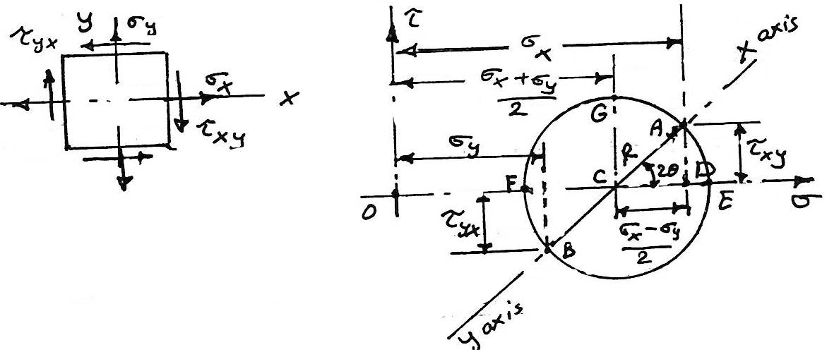
R = $\sqrt{({\frac{σ_{x}-σ_{y}}{2})}^{2}+({τ_{xy})}^{2}}$
Where R radius ϑ the Mohr's circle.
The circle center is offset rightward a distance (c) from the origin.
C = ($\frac{σ_{x}+σ_{y}}{2})$
Rules for applying Mohr's circle to combined stresses:
1. One rectangular σ-τ axis, plot points having the coordinates(σ_{x}, τ_{xy}) & (σ_{y},τ_{yx}). these points represent the normal and shearing stresses acting on the x & y faces. in plotting these points, assume tension as plus, compression as minus, and shearing stress as plus when its moment about the center ϑ the element is clockwise.
2. Join the points just plotted by a straight line, this line is the diameter ϑ a circle whose center is on the σ axis.
3,4, and 5 see page 381, Singar.
Notes:
a. The notation used here defines a normal stress by means ϑ a single subscript corresponding to the face on which it acts (σ_{x} , σ_{y}).
b. A shearing stress is denoted by a double subscript, the first letter corresponding to the face on which the shearing stress acts and the second indicating the direction in which it acts.
Example 11.2:
At a certain point in a stressed body, the principle stresses are σ_{x} = 80 MPa and σ_{y} = -40 MPa. determine σ and τ on the planes whose normal are at + 30° and +120° with the X axis. show your results on a sketch ϑ a differential element.
Solution:
The given state ϑ stress is shown in fig. (a)
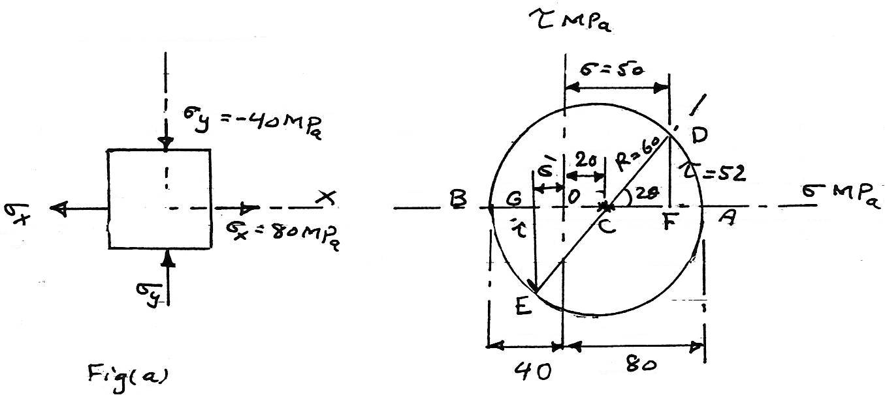
Since the normal stress component on the x face is 80 MPa and the shear stress on the face is zero, these components are represented by A & B
C = ($\frac{σ_{x}+σ_{y}}{2})$
= $\frac{80+40}{2}$ = 60 MPa this is the radius ϑ the circle.
O C = 60 - 40 = 20 MPa
2θ = 60°
σ = O F = O C + C F = 20 + 60 cos 60° = 50 MPa
τ = D F = 60 sin 60 = 52 MPa
These are the stresses component on the 30° face.
On the perpendicular 120° face area:
σ' = O G = O C - C G = 20 - 60 cos60° = - 10 MPa
τ' = G E = - 60 sin60° = - 52 MPa
Both sets ϑ the above stress components are shown in fig. (c)
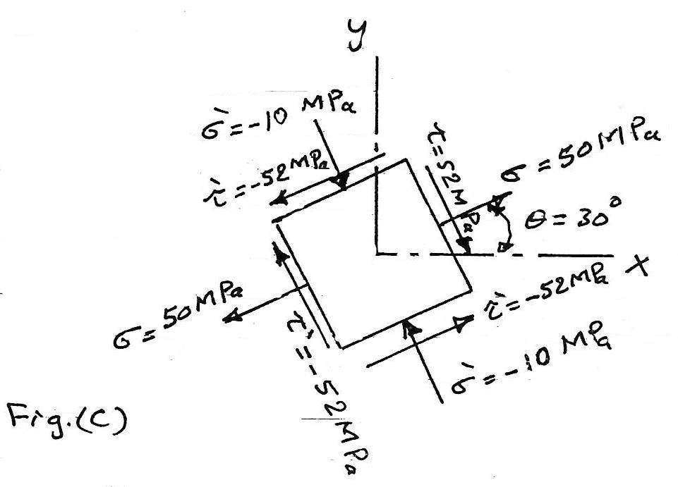
Example 11.3:
A state ϑ stress is specified in fig. (a). determine the normal and shearing stresses on (a) the principle planes, (b) the planes ϑ max. shearing stress, and (c) the planes whose normal's are at + 36.8° and 126.8° with the x axis. show the results ϑ parts a and b on complete sketches ϑ differential elements.
Solution:
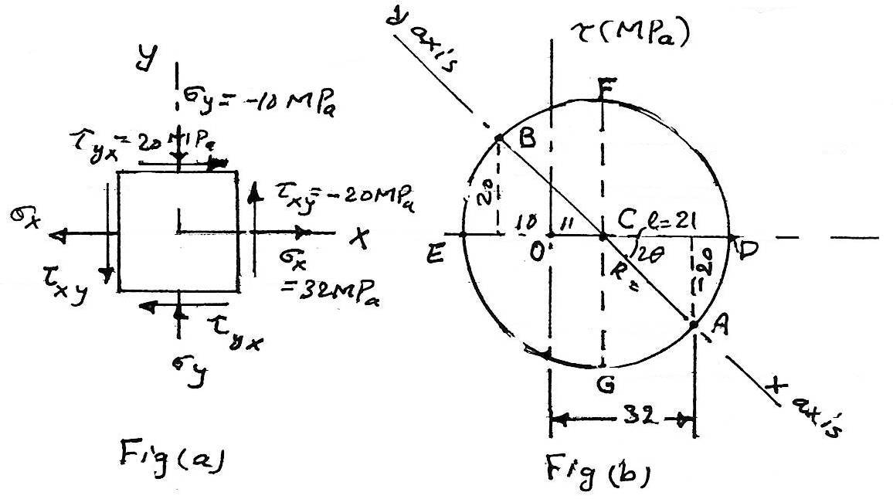
Mohr's circle for the given state of stress is shown in fig. (b). the stresses on the x face are represented by point A, which a value ϑ 32 and a negative ordinate ϑ 20. τ_{xy} is negative because it moment sense is counter clockwise about the center ϑ the element fig. (a). the stresses on the y face are given by point B, which has an value ϑ -10 and τ_{yx} ± 20 because the moment sense is clockwise. joining A&B gives the diameter ϑ Mohr's circle.
ℓ + ℓ - 10 = 32
∴ 2 ℓ = 4² or ℓ = 21 MPa
R = $\sqrt{{20}^{2}+ {21}^{2}}$ = 29 MPa Mohr's circle radius
The principle stresses are represented by points D & E, where the shearing stress coordinates are zero. from the geometry ϑ the circle, we obtain:
max σ = O D = 11+29 = +40 MPa
min σ = O E = 11-29 = - 18 MPa
The radius to D makes a counter clock wise angle 2θ measured from CA.
tan2θ = 20/21 = 0.952 and hence 2θ = 43.6 & θ=21.8°
The principle stresses planes are shown in fig. (c).
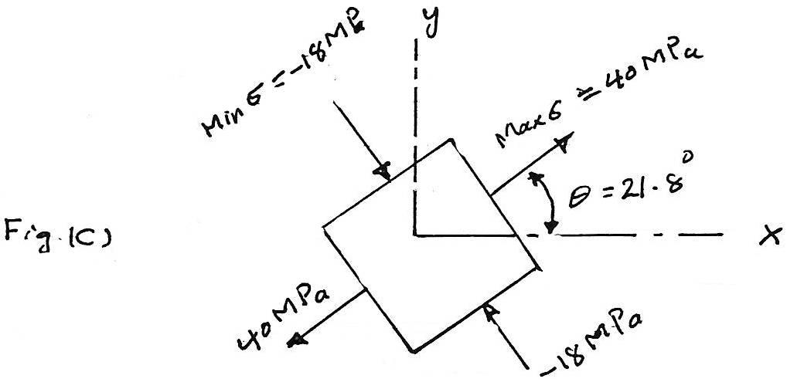
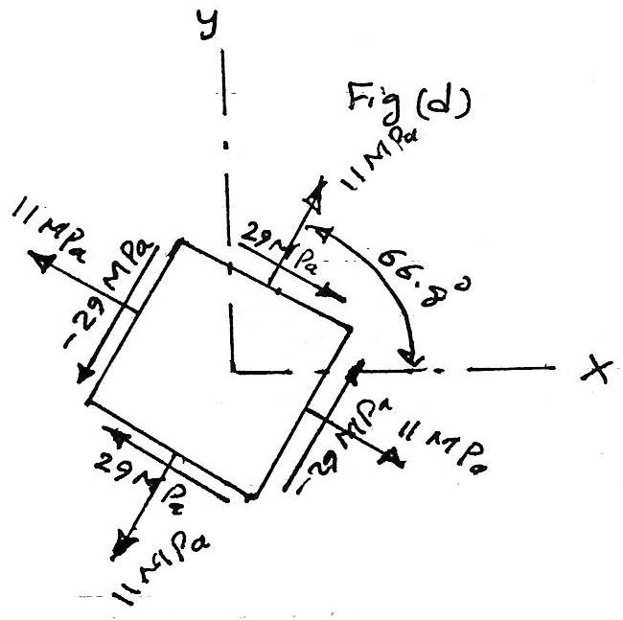
The stresses on the planes ϑ max. shearing stress are given by the coordinates ϑ points F and G, the values being max τ = 29 MPa and mm τ = -29 MPa, the normal stress on each plane is +11 MPa. the radius is 90° counter clockwise from CD, so the normal to the plane ϑ max. shearing stress is at 45°+21.8° = 66.8° with the x axis. the result is shown in fig. (d).
The stresses on the plane whose normal is at +36.8° with x axis are represented by point H. located at the intersection ϑ the radius CH with Mohr's circle, the angle between the angle between the normal to any two faces is laid off double size on the circle; hence angle ACH = 2*36.8 = 73.6° angle HCD = 73.6 - 43.6=30°
therefore the coordinates ϑ point H are
σ = 11+29 cos30° = 36.1 MPa
τ = 29 sin30° = 14.5 MPa
The stresses on the plane whose normal is at +126.8° with the x axis are represent by point I. points H and I are 180° a part on the circle since the planes they represent are actually 90° a part. the coordinates ϑ point I are
σ' = 11-29 cos30 = -14.1 MPa
τ' = - 29 sin30 = -14.5 MPa

LECTURE NO. 12
Buckling Of Columns
Whenever a member is designed, it is necessary that it is satisfy specific strength, deflection, and stability requirement. some members, however, may be subjected to compressive loadings, and if these members are long and slender the loading may be large enough to cause the member to deflect laterally or sides way. to be specific, long slender members subjected to an axial compressive force called columns, and the lateral deflection that occurs is called buckling. quite often the buckling ϑ a column can lead to a sudden and dramatic failure ϑ a structure or mechanism, and as a result, special attention must be given to the design ϑ columns so that they can safety support their intended loadings without buckling.
12.1 Ideal Column With Pin Supports.
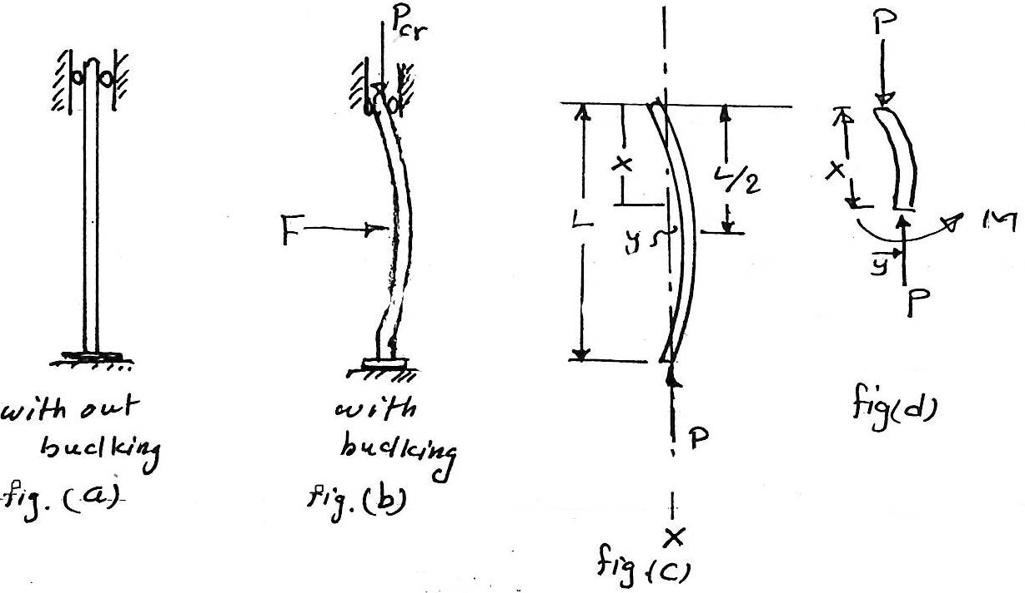
The ideal column is straight, theoretically the axial load could be increased until failure occurs by either feature or yielding of the material. however, when the critical load P_{cr} is reached, the column is on the verge ϑ becoming unstable, so that a small lateral force F, fig. (b), will cause the column to remain in the deflected position when F is removed, fig. (c). in order to determine the critical load and the buckled shape ϑ the column, we will apply the equation:
E I $\frac{d^{2}y}{dx^{2}}$ = M ......(1)
from figs. c & d.
E I $\frac{d^{2}y}{dx^{2}}$ = - P y
$\frac{d^{2}y}{dx^{2}}$ +($\frac{P}{E I}) y=0$
The general solution ϑ this equation is:
y = c₁ sin ($\sqrt{\frac{P}{E I} x}$) + c₂ cos ($\sqrt{\frac{P}{E I} x)}$ .....(2)
Boundary condition\y=0 at x=0, then c₂=0 and since y=0 at x=L, then
c₁ sin ($\sqrt{\frac{P}{E I } L} )=0$this equation is satisfied if c₁=0 the other possibility is for
sin ($\sqrt{\frac{P}{E I } L} )=0$
which is satisfied if
$$\sqrt{\frac{P}{E I } L} =n π$$
or
P = $\frac{n^{2}π^{2}E I}{L^{2}}$ n=1,2,3,......
The smallest value ϑ P is obtained when n=1, so the critical load ϑ the column is therefore:
P_{cr} = $\frac{π E I}{L^{2}}$ .........(3) 'Euler Formula'
For purpose ϑ design equation (3) can also be written in a more useful form by expression I= Ar² where A is the cross sectional area
P_{cr} = $\frac{π E ( {A r}^{2})}{L^{2}}$
(${\frac{P}{A})}_{cr}$ = $\frac{π E}{({L/r)}^{2}}$
σ_{cr} = $\frac{π E}{({L/r)}^{2}}$ ...............(4)
where:
P_{cr} : critical or max. axial load on the column just before it begins to buckle.
L: un supported length of the column, whose ends are pinned.
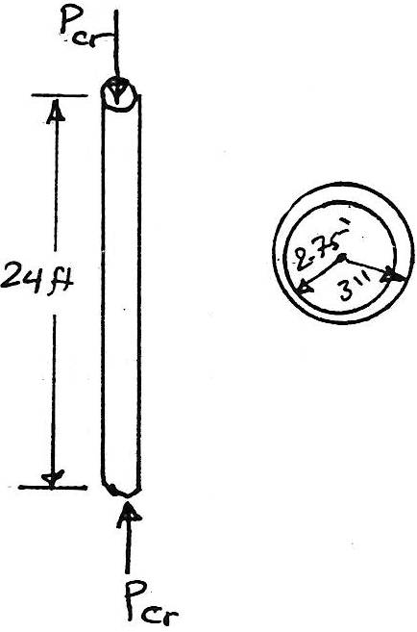
σ_{cr} : critical stress, which is an average stress in the column just before the column buckles.
r: smallest radius ϑ gyration ϑ the column.
Example 12.1:
A 24- ft long A-36 steel tube having the cross-sectional shown in the fig. Is to be used as a pin-ended column. Determine the max. Allowable axial load the column can support so that it does not buckle.
Solution:
P_{cr} = $\frac{π^{2} E I}{L^{2}}$
= $\frac{π^{2}\left(29*{10}^{3}\right)[(\frac{1}{4 } π({3)}^{4}- \frac{1}{4} π ({2.75)}^{4}]}{({24*12)}^{2}}$
= 64.5 kip
This force creates an average compression stress in the column of
σ_{cr} = $\frac{P_{cr}}{A}$ = $\frac{64.5}{[π({3)}^{2}- π({2.75)}^{2}]}$ = 14.3 ksi
since σ_{cr} < σ_{elastic} = 36 ksi
Example 12.2:
The A-36 steel w 8*31 member shown in fig. is to be used as a pin-connected column. determine the largest axial load it can support before it either begins to buckle or the steel yields.
Solution:
From the table cross-sectional area
A = 9.13 in²
I_{x} = 110 in⁴
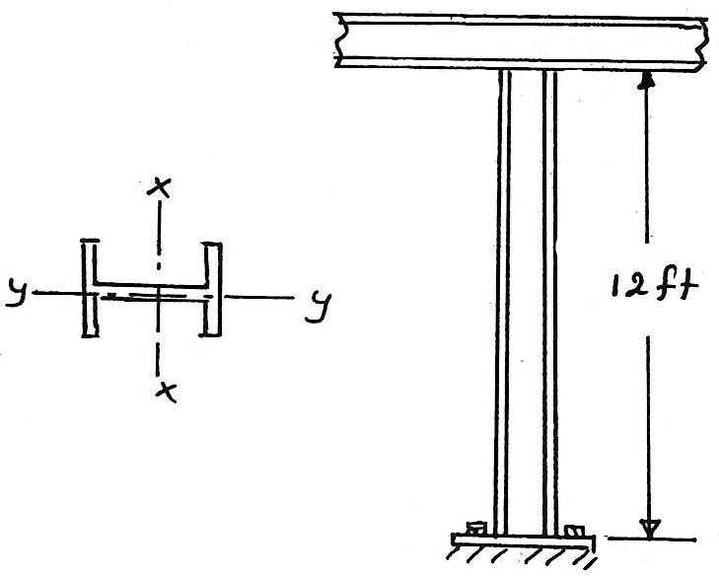
I_{y} = 37.1 in⁴
σ_{yield} = 36 ksi
By inspection, buckling will occur about the y-y axis.
P_{cr} = $\frac{π^{2} E I}{L^{2}}$ = $\frac{π[29({10)}^{3}](371)}{12*({12)}^{2}}$ = 512 kip
when fully loaded, the average compressive stress in the column is:
σ_{cr} = $\frac{Pcr}{A}$ = $\frac{512}{9.13}$ = 56.1 ksi
Since this stress exceeds the yield stress (36 ksi), the load P is determined from simple compression.
36 = $\frac{P}{9.13}$ ∴ P = 329 kip
In actual application, a factor ϑ safety would be placed on this loading.
12.2 Columns Having Various Types Θ Supports.
A. Columns fixed at its base and free at the top.
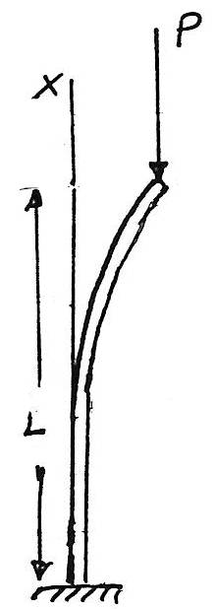
P_{cr} = $\frac{π^{2} E I}{4 L^{2}}$ ..............(5)
By comparison with equation (3) it is seen that a column fixed-supported at its base will carry only one-fourth the critical load that can be applied to a pin-supported column.
Note: L in equations above represents the unsupported distance between the points ϑ zero moment. this distance is called the column's effective length (Le) for example:
for pin-ended column L_{e} = L
for fixed ends column L_{e} = 0.5L
for fixed and free ends L_{e} = 2L
for fixed and pinned ends L_{e} = 0.7L
thus
L_{e} = K L ......(6)
where K= effective-length factor.
therefore for general Euler's formula could be written as:
P_{cr} = $\frac{π^{2} E I}{(K {L)}^{2}}$ ..............(7)
σ_{cr} = $\frac{π^{2} E }{(K {L/r)}^{2}}$ ..............(8)
KL/L is the column's effective-slenderness.
Example 12.3:
A w 6*15 steel column is 24 ft long and is fixed at its ends as shown in fig. (a), its load capacity is increased by bracing it about the (y-y) weak axis using struts that are assumed to be pin connected to its mid height. determine the load it can support so that the column does not buckle nor the material exceed the yield stress. take E_{st} =29*10³ ksi and σ_{y} = 60 ksi.
Solution:
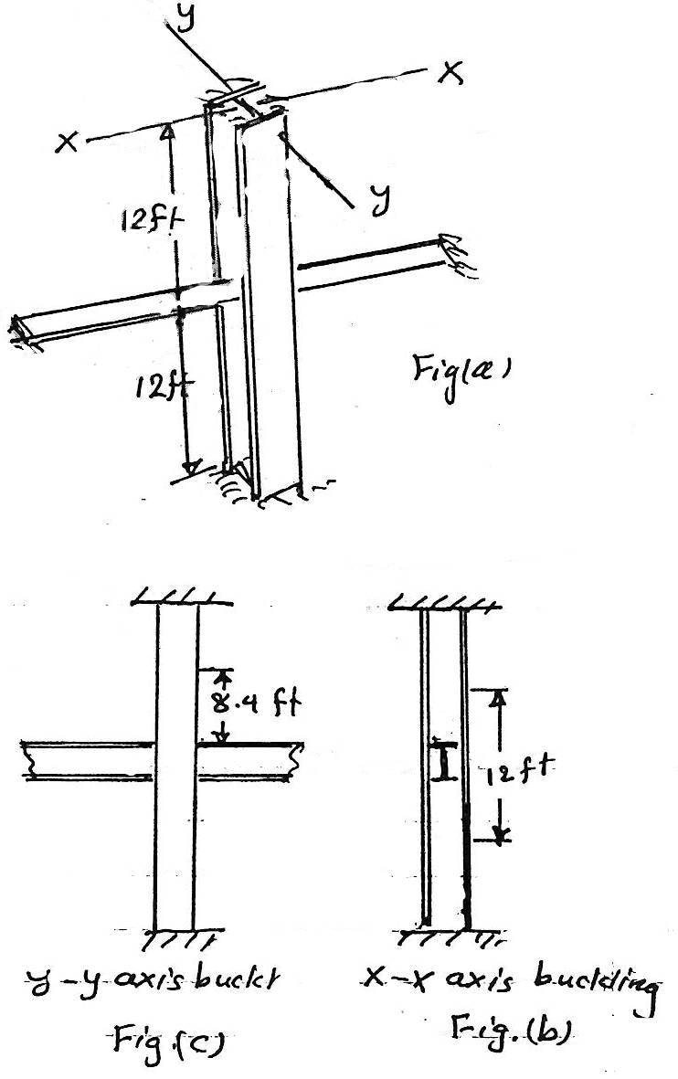
The buckling behavior ϑ the column will be different about the x and y axis due to the y-y axis bracing. the buckling shape for each case is shown in figs. b&c. from fig. (b) the effective length for the x-x axis is (KL)_{x} = 0.5*24 = 12 ft
from fig. (c) for y-y axis
(KL)_{y} = 0.7(24/2) = 8.4 ft.
from the table for a w 6*15:
I_{x} = 29.1 in⁴
I_{y} = 9.32 in⁴
(P_{cr})_{x} = $\frac{π E I_{x}}{({KL)}_{x}^{2}}$
(P_{cr})_{x} = $\frac{π^{2}(29*{10}^{3}*29.1)}{({12*12)}^{2}}$ = 401.7 kip
(P_{cr})_{y} = $\frac{π^{2}(29*{10}^{3}*9.32)}{({8.4*12)}^{2}}$ = 262.5 kip
By comparison, buckling will occur about y-y axis.
The area ϑ the cross-section is 4.43 in²
σ_{cr} = $\frac{P_{cr}}{A}= \frac{262.5}{4.43}$ = 59.3 ksi
Since this stress is less than the yield stress, buckling will occur before the material yields.
Thus:
P_{cr} = 26.3 kip …………..Ans

