Cumulative Curves

1. Definition
The function Nx(t) is defined as the number of vehicles that have passed a point x at time t and is only used for traffic into one direction. Hence, this function only increases over time. Strictly speaking, this function is a step function increasing by one every time a vehicle passes. However, for larger time spans and higher flow rates, the function is often smoothed into a continuous differentiable function.
The increase rate of this function equals the flow:

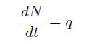

Hence from the flow, we can construct the cumulative curve:

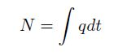

2. Vertical queuing model

A vertical queuing model is a model which assumes an unlimited inflow and and an outflow which is restricted to capacity. The vehicles which cannot pass the bottleneck are stacked “vertically” and do not occupy any space. Figure below illustrates this principle.

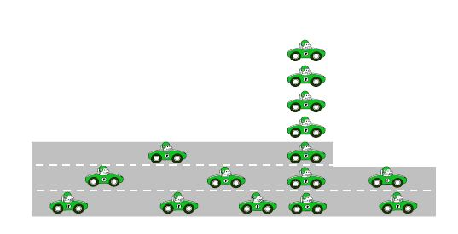
Figure: Illustration of a vertical queue.

Let us now study the dynamics of such a queue. We discretize time in steps of duration $∆$t, referred to by index t. The demand is externally given, and indicated by D. At time steps t we compute the flow into and out of the stack (the number of vehicles in the stack indicated as S). In between the time steps, indicated here as t + 1/2, the number of vehicles in the stack is updated based on the flows q. Then, the stack provide the basis for the flows in the next time
step.
The stack starts at zero. Then, for each time step first the inflow to the stack is computed.
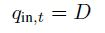
and the stack is updated accordingly, going to an intermediate state at time step t+1/2. This intermediate step is the number of vehicles in the queue if there were no outflow, so the original queue plus the inflow:
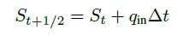
Then, the outflow out of the stack (qout) is the minimum of the number of vehicles in this intermediate queue and the maximum outflow determined by the capacity C:
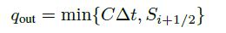
The stack after the time step is then computed as follows
Let us consider a situation as depicted in figure 3.1, and we are interested in the delays due to the bottleneck with a constant capacity of 4000 veh/h. The demand curve is plotted in figure below (a). The flows are determined using the vertical queuing model . The flows are also show in figure below (a). Note that the area between the flow and demand curve where the demand is higher than the flow (between approximately 90 to 160 seconds), is the same as the area between the curves where the flow is higher than the demand (between approximately 160 and 200 seconds). The reasoning is that the area represents a number of vehicles (a flow times a time). From 90 to 160 seconds the demand is higher than the flow, i.e., the inflow is higher than the outflow. The area represents the number of vehicles that cannot pass the bottleneck, and hence the number of queued vehicles. From 160 seconds, the outflow of the queue is larger than the inflow. That area represents the number of vehicles that has left the queue, and cannot be larger than the number of vehicles queued. Moreover, the flows remains at capacity until the stack is empty, so both areas must be equal.

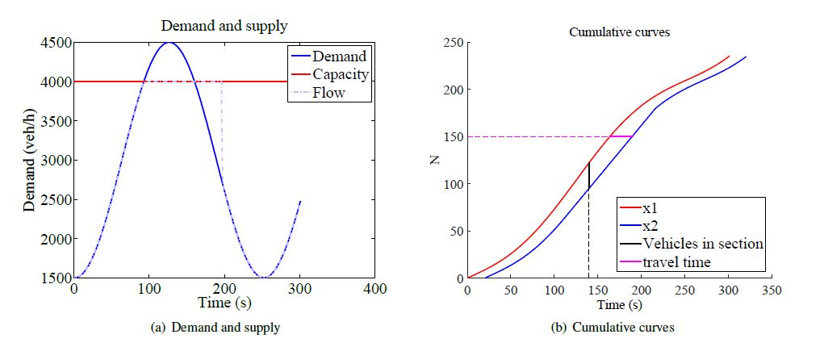
Figure : Demand and cumulative curves.

3. Travel times, densities and delays
3.1 Construction of cumulative curves

Travel times and delays. Delay can be computed using cumulative curves. Note that this methodology does not take spillback effects into account.

The cumulative curves for the above situation is shown in figure above(b). The curves show the flows as determined by the vertical queuing model. The for the inflow we hence use equation
and for the outflow we use
; for both, the cumulative curves are constructed using equation.

3.2 Travel times, number of vehicles in the section

A black line is drawn at t = 140s in figure above (b) . The figure shows by intersection of this line with the graphs how many vehicles have passed the upstream point x1 and how many vehicles have passed the downstream point x2.
Consequently, it can be determined how many vehicles are in the section between x1 and x2. This number can also be found in the graph, by taking the difference between the inflow and the outflow at that moment. This is indicated in the graph by the bold vertical black line.

Similarly, we can take a horizontal line; consider for instance the line at N = 150. The intersection with the inflow line shows when the 150th vehicle enters the section, and the intersection with the outflow line shows when this vehicle leaves the section. So, the horizontal distance between the two lines is the travel time of the 150th vehicle. At times where the demand is lower than the capacity, the vehicles have a free flow travel time. So without congestion, the outflow curve is the inflow curve which is translated to the right by the free flow travel time.

The vertical distance is the number of vehicles in the section (_N)at a moment t. In a time period dt this adds $∆$Ndt to the total travel time (each vehicle contributes dt). To get the total travel time, we integrate over all infinitesimal intervals dt:

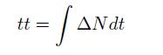

The horizontal distance between the two lines is the travel time for one vehicle, and vertically we find the number of vehicles. Adding up the travel times for all vehicles gives the total travel time:

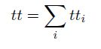

In a continuous approach, this changes into

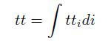

Both calculation methods lead to the same interpretation: the total time spent can be determined by the area between the inflow and outflow curve.

3.3 Delays

Delays for a vehicle are the extra time it needs compared to the free flow travel time. so to calculate delay, one subtracts the free flow travel time from the actual travel time. To subtract the free flow travel time from the travel time, we can graphically move the outflow curve to the left, as is shown in figure below (a). For illustration purposes, the figure is zoomed at figure below (b). The figure shows that if the travel time equals the free flow travel time, both curves are the same, leading to 0 delay.
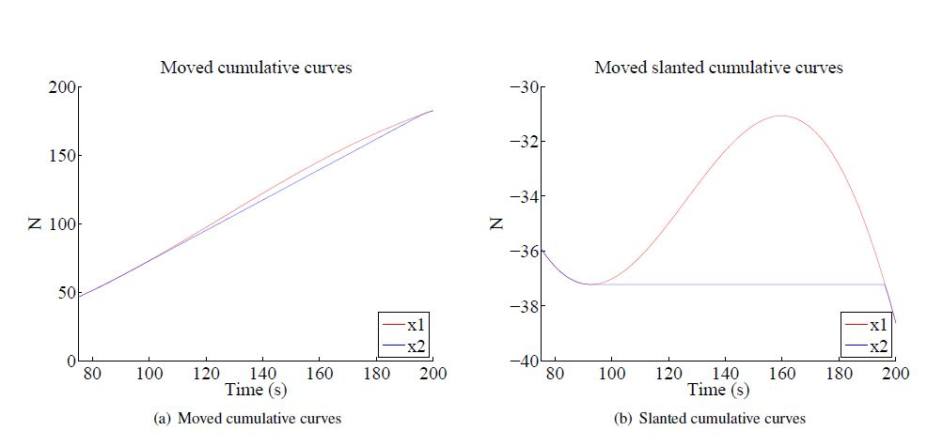
Figure : Determining the delay and the flows from cumulative curves.

Similar to how the cumulative curves can be used to determine the travel time, the moved cumulative curves can be used to determine the delay. The delay for an individual vehicle can be found by the horizontal distance between the two lines. The vertical distance between the two lines can be interpreted as the number of vehicles queuing. The total delay is the area between the two lines:
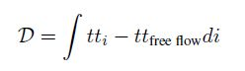
This is the area between the two lines. If we define Nqueue as the number of vehicles in the queue at moment t, we can also rewrite the total delay as:

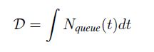

4. Slanted cumulative curves

Slanted cumulative curves or oblique cumulative curves is a very powerful yet simple tool to analyses traffic streams. These are cumulative curves which are offset by a constant flow:
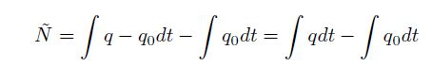
This means that differences with the freely chosen reference flow q0 are amplified: in fact, only the difference with the reference flow are counted. The best choice for the reference flow q0 is a capacity flow.

Previous Figure (b) shows the slanted cumulative curves for the same situation as in previous figure (a). The figure is off set by q0 = 4000 veh/h. Because the demand is initially lower than the capacity, ~N reaches a negative value. From the moment outflow equals capacity, the slanted cumulative outflow curve is constant. Since the demand is higher than the capacity, this increases. At the moment both curves intersect again, the queue is dissolved. The vertical distance between the two lines still shows the length of the queue, Nqueue. That means that equation
still can be applied in the same way for the slanted cumulative curves, and the delay is the area between the two lines.
Slanted cumulative curves are also particularly useful to determine capacity, and to study changes of capacity, for instance the capacity drop . In that case, for one detector the slanted cumulative curves are drawn. By a change of the slope of the line a change of capacity is detected.

5. Practical limitations

Cumulative curves are very useful for models where the blocking of traffic does not play a role. For calculating the delay in practice, the method is not very suitable due to failing detectors. Any error in the detection (a missed or double counted observation), will change one of the curves and will offset the cumulative flow, and this is never corrected; this is called cumulative drift. Recently, an algorithm has been proposed to check the offsets by cross checking the cumulative curves with observed travel times (Van Lint et al., 2014).

This is work under development. Moreover ,some types of detectors will systematically miscount vehicles, which makes the above-mentioned error larger. Apart from their use in models, slanted cumulative curves are very powerful to show changes in capacity in practice.

Example application

Consider a road with a demand of:

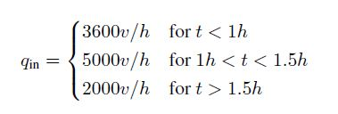
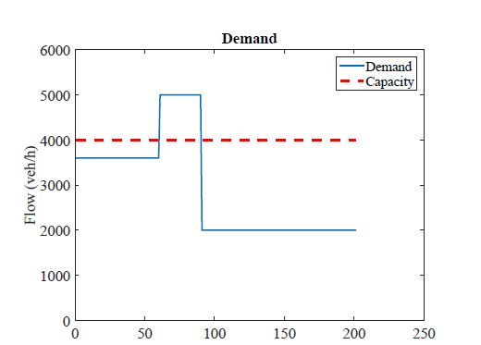
Figure : Demand and capacity.

The capacity of the road is 4000 veh/h. A graph of the demand and capacity is shown in figure above.
1. Construct the (translated=moved) cumulative curves
2. Calculate the first vehicle which encounters delay (N)
3. Calculate the time at which the delay is largest
4. Calculate the maximum number of vehicles in the queue
5. Calculate the vehicle number (N) with the largest delay
6. Calculate the delay this vehicle encounters (in h, or mins)
7. Calculate the time the queue is solved
8. Calculate the last vehicle (N) which encounters delay
9. Calculate the total delay (veh-h)
10. Calculate the average delay of the vehicles which are delayed (h)

