Transit Concept Introduction

Transit Characteristics
Several characteristics differentiate transit from the automobile in terms of availability and capacity. Although the automobile has widespread access to roadway facilities, transit service is available only in certain locations during certain times.
Roadway capacity is available 24 hr/day once constructed, but transit capacity is limited by the number of transit vehicles operated at a given time. transit passengers relay on other modes to gain access to transit. Transit use is greatest where population densities are highest and pedestrian access is good. A typical transit user does not have transit service available at the door and must walk, bike or derive to a transit stop and then must walk or bike from transit discharge point to the destination, transit is not an option.
Transit goals is to move large numbers of people rather than large numbers of vehicles. transit modes include buses , streetcars, and light rail. Streetcars can share a lane with other traffic; light rail trains are almost always separated from other traffic, even when running on street. light rail provides higher speeds and somewhat higher capacity than streetcars.
The classification of modes can be done for transit based on three characteristics: right of way (R/W), technology and type of service. The right of way (R/W) is the strip of lane in which transit vehicle operates. There are three basic R/W categories, distinguished by the degree of separation from other traffic:
Category A: grade separation or exclusive. It is a fully controlled R/W without grade crossings or any legal access by other vehicles. In some ways, this category resembles a freeway system.
Category B: includes R/W types that are longitudinally physically separated from other traffic, but with goals crossing for vehicles and pedestrians, including regular street intersections. A light rail system that cross a few streets at the surface falls into this category.
Category C: surface streets with mixed traffic. Most bus systems and streetcars systems fall into this category.

Right of Ways
Based on degree of segregation:
- Surface with mixed traffic: buses, light rail: with/without preferential treatment
• Longitudinal separation but at-grade crossing interference: light rail, bus rapid transit
- Full separation: at grade, tunnel, elevated.

Technologies
Key technological characteristics:
(a) Support -contact between vehicle and surface
    - rubber tire on concrete.
    - steel wheel on steel rail.
• others.
(b) Guidance -lateral control:
• steered by driver.
•guided by track.
• others.
(c) propulsion
• diesel.
• electronic.
• hybrid.
(d) Control
• manual/ visual.
• automatic.

Transit Modes

A brief description of the various transit modes follows:
1. Taxis: automobiles operated by a driver and hired by users for individual trips, tailored entirely to the user's desire.
2. Dial- a- ride -a - bus: minibus or vans directed from a central dispatching office. Passengers call the office and gave their origin, destination and desired time of travel. the office plans the bus routing to maximize the number of passengers on single trip.
3. Carpools: prearranged ride sharing services where parties of two or more people travel together in a car on regular basis. It is privet transport and therefore cannot be organized, scheduled, or regulated by an agency, but it can be encouraged by employers.
4. Vanpools: privately or publicly provided vans (7-15 seat) transporting groups of persons to and from work on daily basis. They need a somewhat formal organization for vehicle purchase, maintenance, and driving.
5. Regular buses: buses operating along fixed schedules. Vehicles vary from minibuses (20 to 35) to articulated buses (up to 130 spaces).
6. Express buses: provide fast, comfortable travel on long routes with widely spaced stops.
7. Trolley buses: same as regular buses except that they are propelled by electronic power, and therefore constrained to operate only where power lines exist.
8. Semi rapid buses: regular or right -performance buses on routes that include substantial sections of R/W categories A and B. Buses on busway consist of an exclusive busway on the freeway or in the median utilized by a great number of bus routes. They typically represent commuter transit.
9. Light- rail transit: mode utilizing predominantly reserved, but not necessarily grade- separated R/W. It is electrically propelled.
10. Rapid transit: includes the following:
a) Light rail rapid transit consisting of light rail vehicles operating on R/W category A only.
b) Rubber-tired rapid transit consisting of moderately large vehicles, supported or guided by rubber tires running on wooden, steel, or concrete surface.
c) Rail rapid transit, typically having four-axle rail vehicles operating in trains of up to 10 cars on fully controlled R/W category A with high speed, reliability and capacity.
d) Regional rail operated on long route with few stations at high speed on exclusive R/W category A.

Transit System Operations, Service and Characteristics
Transit operations include such activities as scheduling, crew restoring, running and supervisions of vehicles, fare collection, and system maintenance. They produce transportation that is offered to potential users. Transit system characteristics are classified in four categories:

1. System Performance: refers to the entire set of performance elements, the most important of which are:
a) Service frequency (f), number of transit unit departures per hour.
b) Operating speed ($v_{0}$), speed of travel on the line that passengers experience.
c) Reliability, expressed as percentage of vehicle arrivals with less than a fixed- time deviation from schedule (e.g. 4 minutes).
d) Safety, measured by the number of fatalities, injuries, and property damage per 100 million passenger-km(passenger -mi) or similar unit.
e) Line capacity (c), the maximum number of persons that transit vehicles can carry past a point along the line.

f) Productive capacity ($P_{c}$), the product of operating speed and line capacity.
g) Productivity, the quantity of output per unit of resource (e.g. vehicle-km(-mi), space-km(-mi) per unit of labor, operating cost, fuel, R/W width, etc.).
h) Utilization, also the ratio of output to input, but of the same unit, for example, person-km/ space -km (person-mi/space-mi) offered.

2. Level of Service (LOS): is the overall measure of all service characteristics that affect users. LOS is a basic element in attracting potential users to the system. Major factors comprising LOS can be divided into two groups:
a) Performance elements that affect users, such as operating speed, reliability, and safety.
b) Service quality (SQ), consisting of qualitative elements of service, such as convenience and simplicity of using the system, riding comfort, aesthetics, clean lines, and behavior of passengers.

3. Impacts: are the effects that transit service has on its surroundings and the entire area it serves. They may be positive or negative. Short-run impacts include reduced street congestion, changes in air line pollution, noise new line. Long- run impacts consist of changes in land values, economic activities, physical form, and social environment of the city.

4. Costs: are usually divided into two major categories; investment costs (or capital costs) are those required to construct or later make permanent changes in the physical plant of the transit system. Operating costs are costs incurred by regular operation of the system.

Evaluation and comparative analysis of transit systems must include all four categories: Performance, LOS, impacts, and costs of each system. The preferred mode is usually not the one of one with the highest performance or lowest costs, but the one with most advantageous 'package' or combination of the four.

General Transit Capacity Concept
Transit capacity is different from highway capacity. It deals with the movement of both people and vehicles; it depends on the size of the transit vehicles and how often they operate; and it reflects the interaction of passenger traffic and vehicle flow. Transit capacity depends on the operating policy of the transit agency, which specifies service frequencies and allowable passenger loadings.
Figure (1) illustrates the two-dimensional nature of on-street urban transit capacity, using buses. It is possible to operate many buses, each carrying only a few passengers. Whether the buses are full or empty, a larger number of buses can have a negative impact on LOS in terms of highway capacity. Alternatively, a few vehicles could operate, each overcrowded.
This represents a poor quality of service from the passenger perspective, and long waiting times would detract from user convenience.

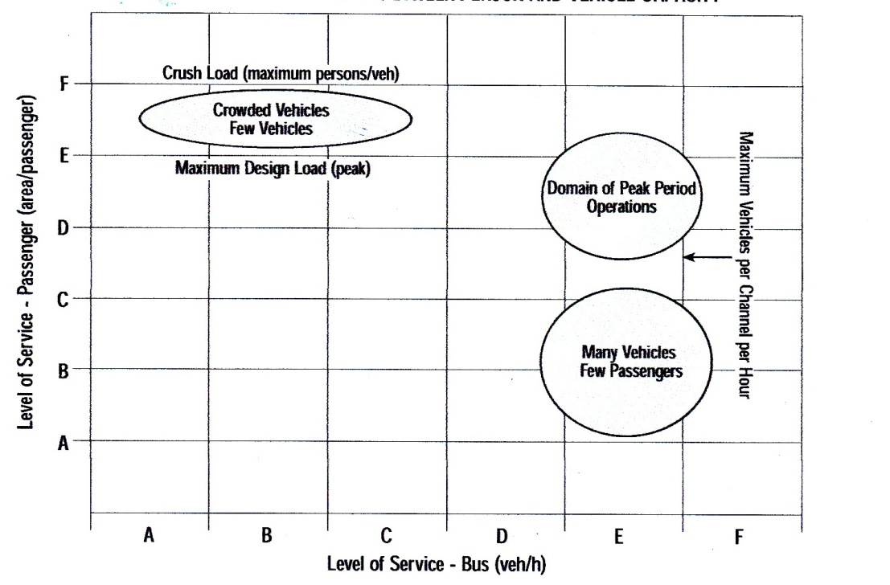
Figure (1): Relation between Person and vehicle Capacity.

Vehicle capacity: reflects the number of transit units (buses or trains) that can be served by a loading area, transit stop, or route during a specified period of time.
Transit vehicle is commonly determined for three locations:
-loading areas
-berths
- bus lanes and transit routes
each location directly influences the next. the vehicle capacity of a bus atop or rail station is controlled by the vehicle capacities of the loading areas, and the vehicle capacity of a bus lane or transit route is controlled by the vehicle capacity of the critical stops along the lane or more.
The two greatest influences on loading area vehicle capacity are the dwell time and the ratio of the green time to the cycle length (g/c ratio) for the street on which the transit operates. Dwell time and g/c ratio also have major influences on the vehicle capacity of transit stops and routes. Dwell time ( the time required to serve passengers at the busiest door plus the time required to open and close the doors) has the greater influence on loading area vehicle capacity. The amount of green time provided to a street controls the number of transit vehicles that theoretically can arrive at a loading area during an hour. In addition, the length of red in relation to a vehicle's dwell time also affects vehicle capacity: if passenger movement have finished, but the vehicle must wait for a traffic signal to run green, vehicle capacity will be less than if the vehicle can leave immediately, so that another vehicle can use the loading area.
Person capacity: reflects the number of people that can be carried past a given location during a given time period under specified operating conditions without unreasonable delay, hazard, or restriction and with reasonable certainty.
Person capacity typically is calculated for transit stops and stations and for the maximum load point of a transit route or bus lane; its calculated for three locations:
- Transit stops and stations
- Transit routes at their maximum load point.
- Bus lanes at their maximum load points.

Operator Policy
A transit operator directly controls the maximum passenger load allowed on transit vehicles and the service frequency. An operator with a policy requiring all passengers to be seated will have a lower potential person capacity for a given number of vehicles than an operator with a policy allowing standees. However, passengers experience a higher quality of service with the first operator.
The service frequency determines how many passengers actually can be carried, even though a transit stop, transit route, or bus lane can serve more vehicles than actually are scheduled.
Passenger Demand Characteristics
How passenger demand is distributed spatially along a route and how it is distributed over time during the analysis period affects the number of boarding passengers that can be carried. Because of the spatial aspect of passenger demand, person capacity must be stated for a location (typically the maximum load point), not for a route or a street as a whole.
Passenger demand fluctuates during the peak hour. the peak-hour factor (PHF) reflects peak demand volumes typically over a 15-min. period during the hour. A transit system should provide sufficient capacity to accommodate peak passenger demand.

However, since peak demand is not sustained over the entire hour, and since every transit vehicle will not experience the same peak loadings, actual person capacity during the hour will not less than the peak 15 min. demand volumes.
The average passengers trip length affects how many passengers can board a transit vehicle as it travels its route. If trips tend to be long with passengers boarding near the start of the route and alighting near the end, vehicles will not board as many passengers as when passengers board and alight at many locations. However, the total number of passengers onboard at the maximum load points may similar for each route.
The distribution of boarding passengers among transit stops affects the dwell time of vehicles at each stop. if passenger boarding's are concentrated at each stop, the vehicle capacity of a transit route or bus lane will be lower, since the dwell time at the stop will control the vehicle capacity (and, in turn, the person capacity) of the entire route or lane. Vehicle capacity (and person capacity at the maximum load point) is greater when passenger boarding volumes ( and dwell times) are evenly distributed among stops. The relationship between vehicle capacity of transit facilities and the elements of person capacity is illustrated in Figure (2) below;

Figure(2): Influences on Transit Person Capacity.

Vehicle Capacity
The vehicle capacity of various transit facilities—loading areas, stops and stations, and bus lanes—sets an upper limit to the number of passengers that may use a transit stop or that may be carried past the maximum load point. The relationship between the vehicle capacity of transit facilities and the elements of person capacity is illustrated in Figure (3) below:

Figure (3): Calculating Transit Person Capacity.
Dwell Time
There are six main influences on dwell time. Two relate to passenger demand and the others relate to passenger service time:
1. Passenger demand and loading: the number of people boarding and alighting through the highest -volume door determines how long it will take to serve all passengers. If standees are present on a transit vehicle as it arrives at a stop, or if all seats are filled as passengers board, service times will be higher than normal because of congestion in the vehicle.
2. Stop and station spacing: the fewer the stops along a route, the greater the number of passengers boarding at each stop. A balance must be found between few stops and too many. Too few stops increase both the distance riders must walk to gain access to transit and the amount of time a vehicle occupies a loading area. Too many stops reduce overall travel speeds due to the time lost in accelerating and decelerating as well as waiting at traffic signals because stops were made.
3. Fare payment procedures: the amount of time passengers spend paying fares is a major factor in the total time for passenger boarding. This time can reduced by minimizing the number of bills and coins required to pay a fare; encouraging the use of prepaid tickets, tokens, passes or smart cards; using a proof-of-payment fare collection system; or collecting fares before boarding. Besides eliminating the time required for each passenger to pay a fare onboard, proof-of-payment and paid- fare waiting area collection systems allow an even distribution of boarding passengers among the vehicle doors, rather than concentrating them at a single door.
4. Vehicle types: low -floors buses decrease passenger service time by eliminating the need to ascend and descend steps. This particularly applies to routes frequently used by the elderly, persons with facilities, or persons with strollers or bulky carry- on items. Wide doors also allow more passengers to board and alight simultaneously.
5. On- Board circulation: Encouraging people to exit via the rear doors of buses with more than one door decrease passenger congestion at the front door and reduces passenger service times.
6. Wheelchair and bicycle boarding: Dwell time also can be affected by the time to board and disembark passengers in wheelchairs and for bicyclists to load and unload bicycles onto a bus-mounted bicycle rack.

