Classifications of Nanomaterials

1. Classifications of nanomaterials

On the basis of particle size the nanomaterials are classified into following

major types :

1.1 Nanoparticles

1.2 Nanocapsules

1.3 Fullerenes

1.4 Dendrimers

1.5 Quantum dots

1.6 Nanostructures

1.7 Nanopores

1.1 Nanoparticles

Nanoparticles are particles which are 1 to 100 nanometers in size. In

nanotechnology, a particle is defined as a small object that behaves as a whole unit

with respect to its transport and properties. The particles are further classified

according to diameter, ultrafine particles are the same as nanoparticles and between

1 and 100 nanometers in size. Coarse particles cover a range between 2,500 and

10,000 nanometers. Fine particles are sized between 100 and 2,500 nanometers.

Nanoparticle research is currently an area of intense scientific interest due to a wide

variety of potential applications in biomedical, optical and electronic fields [14].
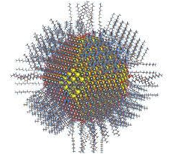

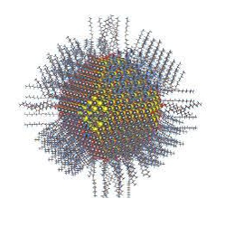

Fig1: Semiconductor nanoparticles 1

Classifications of nanomaterials

1.2 Nanocapsules

The nanocapsules are nanoscale shells made of a nontoxic polymer. They are

vesicular systems that are made up of a polymeric membrane which encapsulates an

inner liquid core at the nanoscale level. It has a myriad of uses, which include

medical promising applications for drug delivery, food enhancement, nutraceuticals,

and for the self-healing of materials. These beneficial of encapsulation methods are

protect in the adverse environment, for controlled release, and for precision

targeting [15].

Fig. 2: Nanocapsules for artificial photosynthesis

1.3 Fullerene nanomaterials

Fullerene is a molecule with total carbon composition and it is available in

the different forms like ellipsoid, tube and hollow sphere. There are several types of

fullerene such as buckyball clusters, mega tubes, polymers nano-onions and linked

ball and chain dimers. The cylindrical features are called as carbon nanotubes. The

spherical fullerenes are called as bucky ball. The megatubes are larger in diameter

than nanotubes and prepared with walls of different thickness. The polymers are

chain, two dimensional and three dimensional polymers are formed under the high

2
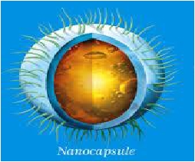

temperature and high pressure conditions. The nano-onions are spherical particles

based on multiple carbon layers surrounding a bucky ball core proposed for

lubricants. The linked ball and chain dimers are two bucky balls linked by carbon

chain. The fullerenes are used in various fields such as optical devices, as photo

resistant in certain photo is tho graphic processes, in microelectronics devices and

also used as anti-oxidants. They are also acts as HIV- protease and inhibit the

catalytic activity of enzymes [16].

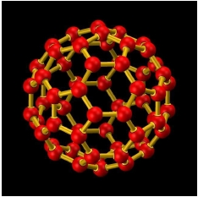

Fig.3: Fullerene nanomaterials

1.4 Dendrimers

The dendrimer is another most important type of nanomaterial. Dendrimers

are continually branched molecule. The dendrimers are polymers and it contains the

several types of branches. The shape of the dendrimer nanomaterials are chain like

and also have numerous chain ends that can be made to have exact functions

normally recycled for chemical reactions. Some types of dendrimer have three

dimensional structures and have an interior cavity into which other molecules can

3

Classifications of nanomaterials

fit. The drug supply is one use of this internal cavity found in dendrimers. They are

also used in gene therapy as well as in medical diagnosis.

Dendrimer is typically symmetric around the core, and often adopts a

spherical three-dimensional morphology. A dendron usually contains a single

chemically addressable group called the focal point. The difference between

dendrons and dendrimers is illustrated in figure below, but the terms are typically

encountered interchangeably [17-19].

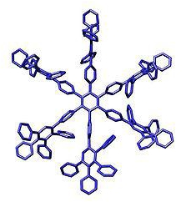

Fig 1.4: Polyphenylene Dendrimer
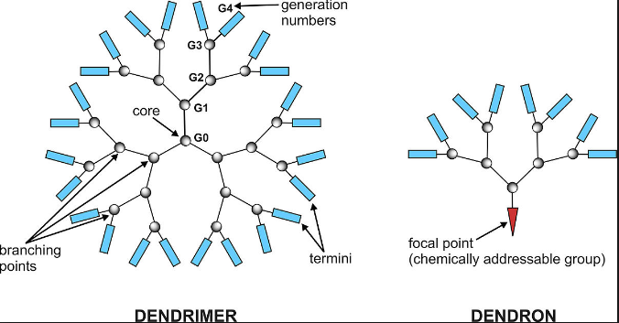

etc.[26-27].

References

[1] G. John, G. Mary, R. Feynman: A Life Sci. Dutton., 1997, ISBN-0-525-94124-X.

[2] R. Feynman, P. Richard, Rev. Mod. Phys., 1945, 17, 157–181.

[3] J. Kreuter, Int. J. Pharm., 2007, 331, 1, 1–10.

[4] (a) D.Ali, M. Sasikala, M. Gunasekaran, N. Thajuddin, Dig.J.

NanomaterBios.,2011, 6, 385-390.; (b) M. Rai, A. Yadav, A. Gade, Crit. Rev.

Biotechnol., 2008, 28, 277-284.

[5] Handbook on Nanoscience, Engineeering and Technology, 2nd Ed., Taylor and

Francis.

[6] J. M. Siegel, J. of Pers., 1990, 18, 151-156.

[7] F. Rocco, Elect. Telegraph, 1996, 14, 422-570.

[8] A. Posischil, M. F. Furchi, T. Muller, Nature Nanotech., 2014, 9, 257-261.

9

[9] Q. H. Wang, K. K. Zadeh,A.Kis,J.N.Coleman,M.S.StranoNat.Nanotechnol., 2012, 7, 699–712

[10] A. R. Taylor, P. T. Otanicar, Y. Herukerrupu, F. Bremond, G. Rosengarten, R.

E. Hawkes, X. Jiang, S. Coulombe, Appl.Opt., 2013, 52 , 1413-1422.

[11] M. Ormsby, British Columbia, A History, Toronto: Macmillan Company of

Canada Ltd., 1976, 174.

[12] I. Freestone, N. Meeks, M. Sax and C. Higgitt, 'The Lycurgus Cup: A Roman
nanotechnology', Gold Bulletin, 2007, 4, 270–277.; (b) Commons. wikimedia. org.

[13] (a) Webmineral, Retrieved 2011, 10-08; (b) www. glasscanadamog.com

[14] T. Robert, C. Sylvain, O. Todd, P. Patrick, G. Andrey, L, Wei, R. Gary, P.,

Ravi, T. Himanshu, J. Appl. Phy., 2013, 113, 011301.; (b) en. wikipedia.org.

[15] (a) P. N. Ezhilarasi, P. Karthik, N. Chhanwal, C. Anandharamakrishnan, Food
Bioprocess Techn., 2012, 6, 628–647.; (b) www. icbpharmapl / techno slow html.
[16] (a) R. Bakry, R. M. Vallant, M. Najam-ul-Haq, M. Raines, Z. Szabo, C. W.

Huck, G. K. Bonn, Int. J. Nano Med., 2007, 2, 639-649. ; (b) S. Deguchi, S. Mukai,

T. Yamazaki, M. Tsudome, K. Horikoshi, J. Phys. Chem., 2009, 114, 849-856.; (c)

www. jcrystal. com.
[17] D. Astruc, E. Boisselier, C. Ornelas, Chem. Rev., 2010, 110, 1857–1959.

[18] B.K. Nanjwade, M. B. Hiren, K. Ganesh K. F. V. Derkara, V. Manvia, V. K.
Nanjwade, Eur. J. Pharm., Sci., 2009, 38, 185–196.

[19] (a) R. E. Bauer, V. Enkelmann, U. M. Wiesler, A. J. Berresheim, K. Müllen,

Chem. Eur.J.,2002, 8, 3858 ; (b) R. E. Bauer, V. Emelman, U. M. Wiesler, A. J.

Berresheim, K. Mullen, Chem. Eur. J., 2002, 17, 3858-3864.; (c) en. Wikipedia.org.

[20] (a) L.E. Brus, Chem.andPhy. SmiconductorNanocrystals,2007, 4; (b) H.

Milkert , 2014, 3d. print.com.
[21] (a) M. Strong Protein Nanomachine, PLoS Biol., 2004,2, 73–74 ; (b) A. Alam,
S.Sachar,R.KSNanotexicology,2013,8,1351-1360.;(c)www.adventureillustratedmagazine.com.

[22] (a) M. Akeson D. Branton, J. J. Kasianowicz, E.Brandin, D. W.
DeamerBiophys. J., 1999, 77, 3227–3233. ;(b) Labs. Mcb. Harvard.edu.

[23] V. V. Mody, R. Siwale, A. Singh, H. R. Mody, J. Pharm. Bioallied. Sci. 2010,

2, 282-289.

[24] B. V. Nagavama, H. K. Yadav, A. AYaz, L. S. Vasudha, H. G. Shivkumar,
10

Asian J. Pharm. Clin. Res., 2012, 3, 16-23.

[25] S. Bose, T. Kuila, A. K. Mishra, R. Rajasekar, N. H. Kim, J. H. Lee, J. Mater.

Chem., 2012, 22, 767-784.

[26]C. Noguera, Phycics and Chemistry at Oxides Surfaces, Cambridge University,

Cambridge, UK, 1996.

[27] H. H. Kung, Transition Metal Oxides: Surface Chemistry and Catalysis,

Elsevier Amsterdam, 1989

11

