Lecture 4

Unique Properties of Nanomaterials

Atoms are the building blocks of all matter. They can be assembled in many ways to obtain the desired product. Both the chemistry and the geometric arrangement of atoms can influence the properties of the material. Hence, if we have the ability to construct matter, atom by atom, we would be able to perform wonders. For example, we know that both graphite and diamond are made of pure carbon. Thus, in principle, if we are able to rearrange the atoms (carbon) in graphite at our discretion, it would be possible to make diamond! Or, if we could rearrange the atoms (silicon and oxygen) in sand (and add a few other trace elements), it should be possible to make a computer chip! Engineering at the nano-level can bring about large changes in the properties of the products. In Chapter 1, we saw how the high defect concentration in nanomaterials results in novel and unique physical, chemical, elastic and mechanical properties of this class of materials.
MICROSTRUCTURE AND DEFECTS IN NANOCRYSTALLINE MATERIALS
In order to understand the novel properties of nanostructured materials, we need to understand the structure and its interrelationship with properties. The microstructural features of importance in nanomaterials include:
• Grain size, distribution and morphology
• The nature of grain boundaries and interphase interfaces
• Nature of intragrain defects
• Composition profiles across grains and interfaces
• Residual impurities from processing
Crystal lattice imperfections, such as point, linear, planar and volume defects, lead to the structure-sensitive properties of materials. The atomic structure of nanostructured materials
DEFECTS IN CRYSTALLINE MATERIALS
Crystals are three-dimensional, periodic arrangements of atoms/molecules in space.
Any imperfection leading to disruption of periodicity is referred to as a ‘crystalline defect’. These defects are usually classified based on their dimensionality, namely, point defects (0D), line defects (1D), surface defects (2D) and volume defects (3D).
Vacancies and substitutional and interstitial solutes are the common point defects observed in metals and alloys. In case of ionic solids, Schottky (anion–cation vacancy pairs) and Frenkel (vacancy-interstitial pairs of the same ions) defects may also be observed. Dislocations are the most commonly observed line defects and refer to a missing plane of atoms. Among the surface defects, grain boundaries, twins, stacking faults and free surfaces are the most common. Inclusions, voids and microcracks constitute the volume defects.
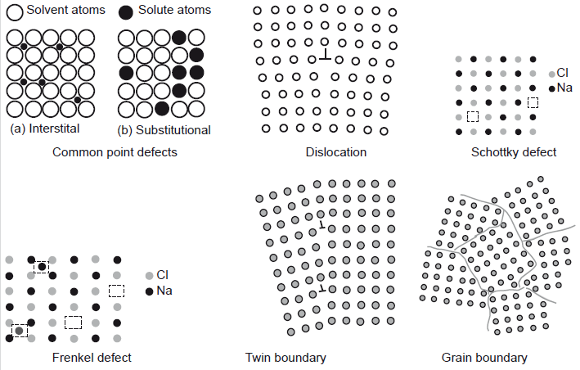
Unlike that seen in glass or conventional crystalline materials, because of the large volume fraction of grain boundaries and interfaces. Hence, in nanocrystalline materials, a substantial fraction of atoms lies at the grain boundaries and interfaces. It is not surprising that the behaviour of nanocrystalline materials is decided to a large extent by these defects, and as such, nanomaterials exhibit vastly different properties compared to bulk materials. The main defect types observed in nanocrystals are vacancies, grain boundaries, dislocations, twins, stacking faults and triple junctions.
Dislocations
Missing rows of atoms in a crystal are regions of high energy and stress due to disruption of the atomic bonds in the plane. This provides a heavy force for dislocations to be done at surfaces or grain boundaries to minimize the strain energy of the crystal.
In effect, this may be treated as equivalent to an attractive force applied by the surface on dislocations in the crystal. This force is inversely proportional to the distance of separation and hence becomes negligible for dislocations farther than a critical distance. However, for dislocations close to the surface or grain boundary, the attractive force can be large enough to result in applying the dislocations. Hence, for a small distance from the surface and grain boundaries, one would not expect to find any dislocations.
In order to treat this attractive force of surfaces and grain boundaries mathematically, a virtual image-dislocation of opposite sign is imagined to be existing at the surface. This problem can then be solved by considering the virtual force of attraction between the two dislocations of opposite sign. The force exerted by this virtual imaginary image dislocation on the dislocation defect in bulk is referred to as image force (Fimage).
Dislocations are, in general, stable in conventional microcrystalline materials, though not thermodynamically stable defects. However, when the magnitude of the critical distance becomes comparable with that of the grain size, as in nanomaterials, the stability of dislocations is altered significantly. Hence, with decreasing grain size of nanograined materials, dislocation stability is reduced, due to the large grain boundary area. It is well known that dislocation mobility and interactions play a large role in determining the deformation and plastic flow behaviour of conventional crystalline materials. Hence, it is expected that the deformation behaviour of nanocrystalline materials is significantly different from that of conventional microcrystalline materials.
The typical dislocation density in annealed (hardened) crystalline materials is about 10¹⁰/cm. As the grain size is reduced to about 10 nm, the dislocation density can reduce by 2–3 orders or more and finally, below a critical grain size, dislocations are no longer stable, i.e., there will be no dislocations in the nanocrystalline materials below the critical grain size. However, in contrast to whiskers (single crystals without dislocations), nanomaterials have a large number of grain boundaries as defects. Hence, the plastic deformation behaviour of the material cannot be governed by dislocation mechanisms. This can result in significantly different mechanical properties in nanomaterials below the critical sizes. The effect of decreasing dislocation density on the deformation mechanism is an area of significant scientific curiosity.
Twins, stacking faults and voids
Although thermodynamically metastable, planar defects are often observed, even after annealing, in many faceted nanomaterials, including Nano rods and nanowires. These planar defects include twins and stacking faults (intrinsic or extrinsic), and are usually neglected by most analytical models. For example, many bulk metals have the face-centred cubic structure, but nanocrystals and nanorods of the same material often exhibit various structural modifications such as single or multiple symmetric twinning, as well as five-fold cyclic twinning, resulting in decahedral and truncated decahedral nanostructures below critical siges (see box). The Figure demonstrates the nano-twins in nanocrystalline Cu particles that are embedded in an amorphous Fe–Zr–B alloy.
Twins are generally observed in crystals subjected to deformation under high strain rate or at low temperatures. During crystallization of liquid metal, it is expected that volume misfit strains can be easily accommodated in the liquid phase, and hence one does not anticipate the formation of twins in the nucleating crystals. Thus, the origin of such twins during the growth of nanoparticles from liquid is a subject of immense interest.
Voids in nanocrystallites may be situated at either triple junctions or as large porosities due to insufficient compaction and sintering of nanocrystallites synthesized from the powder method.
Although both types of voids influence the behaviour of the nanocrystallites, the former is structurally more important. It is suggested that triple junction voids arise as a result of relaxation of nanocrystalline grain boundaries.
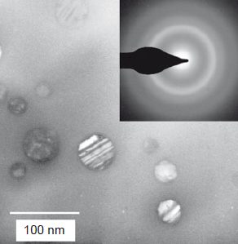
Twins in nanocrystalline Cu
particles embedded in amorphous Fe-Zr-B
alloy. The twins formation is possibly due
to strains developed at the amorphous Cu
interface during solidification.
Grain boundaries, triple junctions and disclinations
A schematic representation of a hard-sphere mode of an equiaxed nanocrystalline metal as shown in Figure.
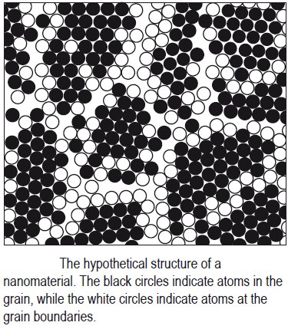
Two types of atoms can be distinguished: crystal atoms with nearest-neighbour configurations corresponding to the lattice (black circles) and boundary atoms with a variety of interatomic spacings (white circles). Nanocrystalline materials typically contain a high number of interfaces with random orientation relationships, and consequently, a substantial fraction of atoms lies in the interfaces. Assuming that the grains have the shape of spheres or cubes, the volume fraction of nanocrystalline materials associated with the boundaries (V_{i}) is estimated to be:
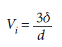
where δ is the average interface thickness and d is the average grain diameter. Thus, the volume fraction of interfaces can be as much as 60% for 5 nm grains, 30% for 10 nm grains, and about 3% for 100 nm grains, for a grain boundary thickness of 1 nm.
According to the phase mixture model, many properties of nanocrystalline materials can be estimated by a simple rule of mixtures,
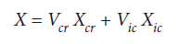
where subscripts cr and ic refer to the crystalline and intercrystalline components of nanocrystalline materials, and X and V denote the property and volume fraction of the respective components. Intercrystalline components include the grain boundaries, triple lines and quadruple nodes. Taking a cubic unit cell or a regular polyhedron unit cell of nanocrystalline materials, the volume fraction of each component can be expressed as follows:
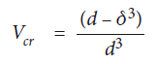
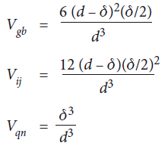
and quadruple nodes, respectively; d and δ represent the grain size and grain boundary thickness.
When the grain size is smaller than about 20 nm, the total volume of the intercrystalline region (grain boundary and triple junctions) becomes significant. The density of grain boundaries in nanocrystals is very large (~ 10¹⁹ cm^{–3}) and there is wide distribution of interatomic spacing at these grain boundaries.
It has been suggested that the triple junctions can be described based on the disclination defect model. Disclinations (Figure) are line defects characterised by a rotation vector ω in contrast to the translational vector b for dislocations. For example, consider a solid rubber ball. If you cut a slit in it of width only as thick as a blade and then try to forcefully bring together the ends of the cut portion, the resultant defect is a dislocation. Instead, if you cut a wedge in the ball and now try to bring the cut ends together, the resultant defect is a disclination. Unlike dislocations, the elastic stress fields of disclinations diverge with distance.
The triple junctions may be considered to form a network of disclinations. Theoretical calculations have shown that triple junction energies are comparable to dislocation energies, and that compensating disclinations play a significant role in the properties of nanocrystalline metals with
grain size less than about 10 nm. These triple junctions are linear defects that play a significant role in the mechanical, thermodynamic and kinetic properties of polycrystals. This role may be particularly important in nanocrystalline materials, where the grain boundaries are short and contain a small number of structural units.
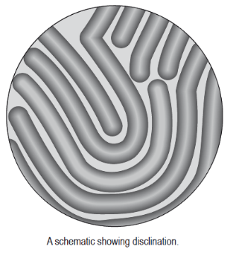

MULTIPLY TWINNED NANOPARTICLES
Multiply twinned particles (MTP) with a pseudo five-fold symmetry are observed frequently in nanocrystalline particles and thin films (deposited on crystalline substrates) of cubic face-centred metals, diamond-type semiconductors (C, Si, Ge) and alloys. MTP are formed by sequential cyclic five-fold twinning, with each twin sharing a common twin plane boundary with the adjacent twin. It is known, for example, that twinning in FCC occurs along the plane. The angle between two {111} planes is 70.53 degrees. Thus, repeated twinning five times will still not result in 360 degrees, but will result in an annular gap of about 7.35 degrees. Thus, the fivefold symmetry formed from an FCC structure should have a distortion due to the geometrical arrangements along the five-fold axis. This results in a typical rotational defect, similar to disclination defects in such multiply twinned particles. The maximum size of these particles without distortion has been reported to be ~ 40 nm because the internal stresses of the crystals increase as they grow.
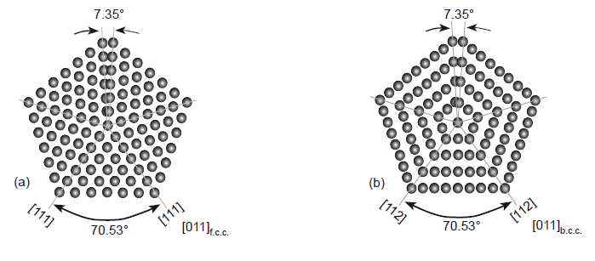
Schematic of five-fold twinned cubic
lattice showing the annular mismatch created by
repetitive twinning.

Physical and chemical properties of materials assembled from five-fold twinned no particles may differ from materials consisting of untwined nanoparticles in a variety of aspects, according to their respective structural characteristics. These differences concern properties sensitive to the surface energy, lattice symmetry, internal structure and surface structure, and they may cause changes in melting point, magnetic moment, electronic transition and chemical reactivity. For MTPs embedded
in a matrix of foreign material, the interface structure has to be considered, which via particle–matrix interaction may influence the elastic properties of the composite. The appearance of natural ferromagnetic order in Pd nanoparticles of about 6.8 nm size has been explained by a transition from single crystalline to multiply twinned structure with decreasing size.

