Polymorphism and Allotropy
Some metals, as well as nonmetals, may have more than one crystal structure, a phenomenon known as polymorphism. When found in elemental solids, the condition is often termed allotropy. The prevailing crystal structure depends on both the temperature and the external pressure.

One familiar example is found in carbon, graphite is the stable polymorph at ambient conditions, whereas diamond is formed at extremely high pressures. Also, pure iron has a BCC crystal structure at room temperature, which changes to FCC iron at 912⁰C (1674⁰F). Most often a modification of the density and other physical properties accompanies a polymorphic transformation.

Crystal Systems
Because there are many different possible crystal structures, it is sometimes convenient to divide them into groups according to unit cell configurations and/or atomic arrangements. One such scheme is based on the unit cell geometry, that is, the shape of the appropriate unit cell parallelepiped without regard to the atomic positions in the cell. Within this framework, a (xyz) coordinate system is established with its origin at one of the unit cell corners; each of the x, y, and z axes coincides with one of the three parallelepiped edges that extend from this corner, as illustrated in Figure (1).
The unit cell geometry is completely defined in terms of six parameters: the three edge lengths a, b, and c and the three interaxial angles α, ᴃ and ɣ. These are indicated in Figure (1) and are sometimes termed the lattice parameters of a crystal structure.

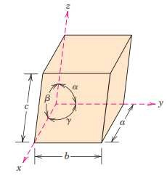

Figure (1): A unit cell with x, y, and z coordinate axes, showing axial lengths (a, b, and c) and interaxial angles (α, ᴃ and ɣ).

On this basis there are seven different possible combinations of a, b, and c and α, ᴃ and ɣ, each of which represents a distinct crystal system. The main seven crystal systems are cubic, tetragonal, hexagonal, orthorhombic, rhombohedral, monoclinic, and triclinic. The lattice parameter relationships and unit cell sketches for each are represented in Table (1). The cubic system, for which (a = b = c) and (α=ᴃ = ɣ =90⁰), has the greatest degree of symmetry. The least symmetry is displayed by the triclinic system because (a ≠ b ≠c) and (α≠ᴃ ≠ ɣ ≠90⁰). From the discussion of metallic crystal structures, it should be apparent that both FCC and BCC structures belong to the cubic crystal system, whereas HCP falls within the hexagonal system.

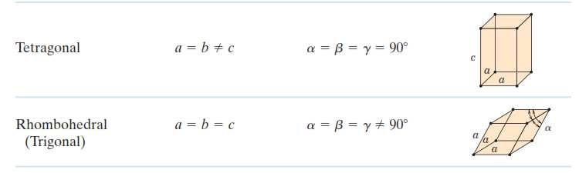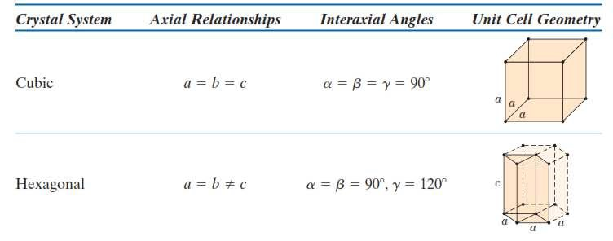

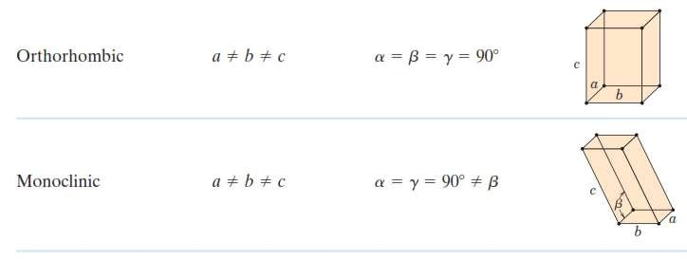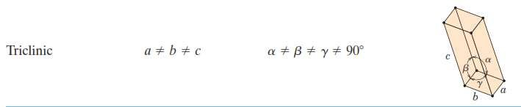

Table (1): Lattice Parameter Relationships and Figures Showing Unit Cell Geometries for the Seven Crystal Systems.

Crystallographic Points, Directions, and Planes

When dealing with crystalline materials, it often becomes necessary to specify a particular point within a unit cell, a crystallographic direction, or some crystallographic plane of atoms.

A. Point Coordinates
The position of any point located within a unit cell may be specified in terms of its coordinates as fractional multiples of the unit cell edge lengths (i.e., in terms of a, b, and c). To illustrate, consider the unit cell and the point (P) situated therein as shown below. We specify the position of (P) in terms of the generalized coordinates q, r, and s, where (q) is some fractional length of (a) along the x axis, (r) is some fractional length of (b) along the y axis, and similarly for (s). Thus, the position of (P) is designated using coordinates (q r s) with values that are less than or equal to unity. Furthermore, we have chosen not to separate these coordinates by commas or any other punctuation marks.
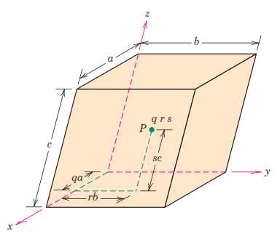
EX.1

Sol.1
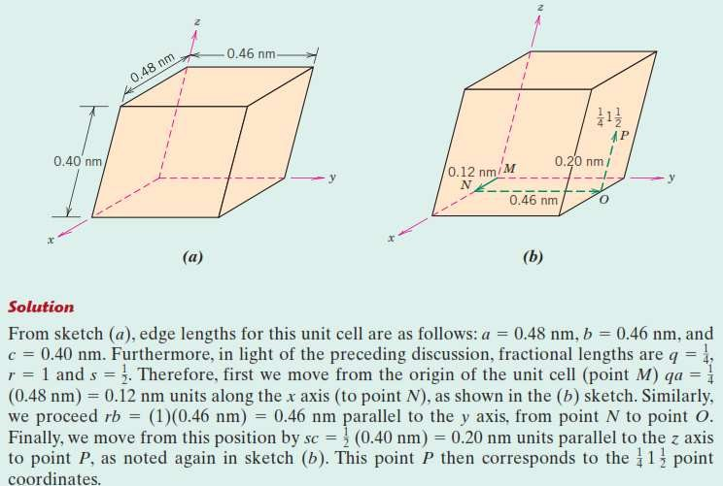

H.W.1
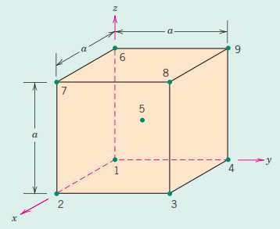

B. Crystallographic Directions
A crystallographic direction is defined as a line directed between two points, or a vector. The following steps are used to determine the three directional indices:

- A vector of convenient length is positioned such that it passes through the origin of the coordinate system.
- The length of the vector projection on each of the three axes is determined; these are measured in terms of the unit cell dimensions a, b, and c.
- These three numbers are multiplied or divided by a common factor to reduce them to the smallest integer values.
- The three indices, not separated by commas, are enclosed in square brackets, thus: [uvw]. The u, v and w integers correspond to the reduced projections along the x, y, and z axes, respectively.

For each of the three axes, there will exist both positive and negative coordinates. Thus negative indices are also possible, which are represented by a bar over the appropriate index.
For example, the [111] direction has a component in the (-y) direction. Also, changing the signs of all indices produces an antiparallel direction; that is, is [111] is directly opposite to [111]. The [100], [110], and [111] directions are common ones; they are drawn in the unit cell shown below.
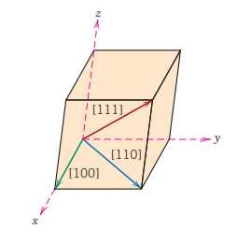

----------------------------------------------------------------------------------------------

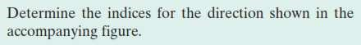
EX.2

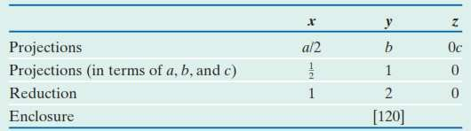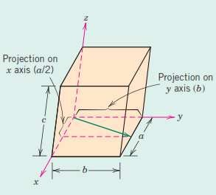
Sol.2

--------------------------------------------------------------------------------------------

C. Crystallographic Planes
The orientations of planes for a crystal structure are represented in a similar manner. Again, the unit cell is the basis, with the three-axis coordinate system. The crystallographic planes are specified by three Miller indices as (hkl). An intercept on the negative side of the origin is indicated by a bar or minus sign positioned over the appropriate index. The procedure used to determine the h, k, and l index numbers is as follows:

- If the plane passes through the selected origin, either another parallel plane must be constructed within the unit cell by an appropriate translation, or a new origin must be established at the corner of another unit cell.
- At this point the crystallographic plane either intersects or parallels each of the three axes; the length of the planar intercept for each axis is determined in terms of the lattice parameters a, b, and c.
- The reciprocals of these numbers are taken. A plane that parallels an axis may be considered to have an infinite intercept and therefore a zero index.
- If necessary, these three numbers are changed to the set of smallest integers by multiplication or division by a common factor.
- Finally, the integer indices, not separated by commas, are enclosed within parentheses, thus: (hkl).

One interesting and unique characteristic of cubic crystals is that planes and directions having the same indices are perpendicular to one another; however, for other crystal systems there are no simple geometrical relationships between planes and directions having the same indices. Several low-index planes are shown below:

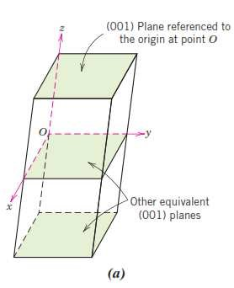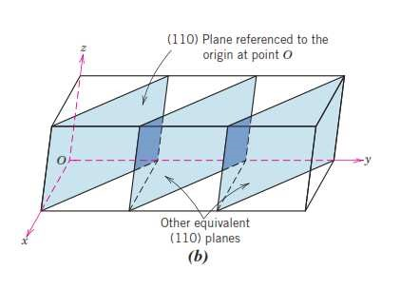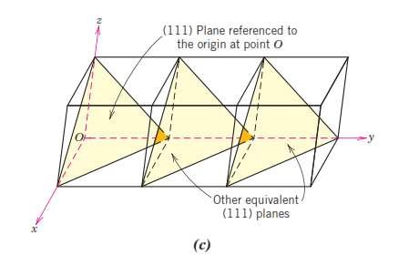

---------------------------------------------------------------------------------------------- EX.3
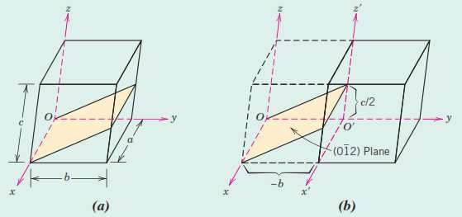

Sol.3
Because the plane passes through the selected origin O, a new origin must be chosen at the corner of an adjacent unit cell, taken as O\ and shown in sketch (b). This plane is parallel to the x axis, and the intercept may be taken as (∞a). The y- and z-axis intersections, referenced to the new origin O\, are -b and c/2, respecDvely. Thus, in terms of the laEce parameters a, b, and c, these intersections are ∞, -1, and 1/2. The reciprocals of these numbers are 0, 1, and 2; because all are integers, no further reduction is necessary. Finally, enclosure in parentheses yields (01\2) .These steps are briefly summarized here:

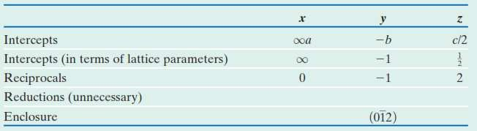

----------------------------------------------------------------------------------------------
Definition of Miller Index:
Description of a plane found by taking reciprocals of the intercepts of the plane on the x, y and z axes and clearing fractions. Miller Index are enclosed in parentheses.

