Crystalline and Non-crystalline Materials A. Crystalline solids:
There are two principle types of crystalline solids, one of them termed single crystal solids and the others is termed polycrystalline solids. For a crystalline solid, when the periodic and repeated arrangement of atoms is perfect or extends throughout the entirety of the specimen without interruption, the result is a single crystal. All unit cells interlock in the same way and have the same orientation. Single crystals exist in nature, but they can also be produced artificially. They are ordinarily difficult to grow because the environment must be carefully controlled.

Polycrystalline solids:
Most crystalline solids are composed of a collection of many small crystals or grains; such materials are termed polycrystalline. Various stages in the solidification of a polycrystalline specimen are represented schematically in Figure (1). Ini&ally, small crystals or nuclei form at various positions. These have random crystallographic orientations, as indicated by the square grids. The small grains grow by the successive addition from the surrounding liquid of atoms to the structure of each. The extremities of adjacent grains impinge on one another as the solidification process approaches completion. As indicated in Figure (1), the crystallographic orientation varies from grain to grain. Also, there exists some atomic mismatch within the region where two grains meet; this area, called a grain boundary,
As a result, polycrystalline solids can define as the materials that composed of a collection of many small crystals or grains separated by grain boundary.

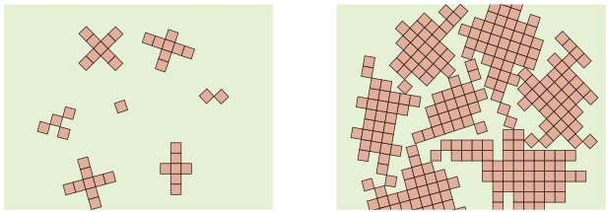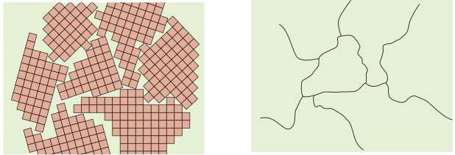

Figure (1): Schematic diagrams of the various stages in the solidification of a polycrystalline material.

Anisotropy and Isotropy
The physical properties of crystals of some substances depend on the crystallographic direction in which measurements are taken. For example, the elastic modulus, strength, the electrical conductivity, and the index of refrac&on may have different values in the [100] and [111] directions. This directionality of properties is termed anisotropy, which have different properties in different direction, and it is associated with the variance of atomic with crystallographic direction. Substances in which measured properties are independent of the direction of measurement are called isotropic which have similar properties in different direction.

Determination of crystal structures: (X-ray diffraction)
Much of our understanding regarding the atomic and molecular arrangements in the solids has resulted from the x-ray diffraction investigations; furthermore, x-rays are still very important in developing new materials. Diffraction occurs when a wave encounters a series of regularly spaced obstacles that (1) are capable of scattering the wave and (2) have spacings that are comparable in magnitude to the wavelength.

X-rays are a form of electromagnetic radiation that have high energies and short wavelengths—wavelengths on the order of the atomic spacings for solids. When a beam of x-rays impinges on a solid material, a portion of this beam is scattered in all directions by the electrons associated with each atom or ion that lies within the beam’s path.

X-ray diffraction is a technique using the interaction between X-ray radiation and planes of atoms in a crystal to obtain information about the identity and characteristics of a material. This method measures the distances between planes of atoms. The principle that used in this technique is known as Bragg's law, and is written as: 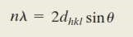
Where (n) is order of reflection, (λ) is wave length, (d_{hkl}) is inter planar spacing, (Ɵ) is the diffraction angle. Figure (2) shown the diffraction of x-rays by planes of atoms.

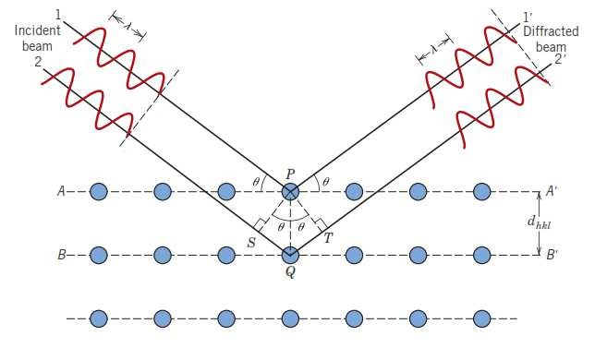

Figure (2): the diffraction of x-rays by planes of atoms.
The magnitude of the distance between two adjacent and parallel planes of atoms (d_{hkl}) is a function of the miller indices (h,k,l) as well as the lattice parameter (a). For example, for crystal structures that have cubic symmetry, (d_{hkl}) can be calculated as:

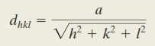

Where (a) is lattice parameter and (h,k,l) are miller indices.
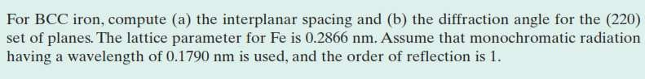
EX.1

Sol.1
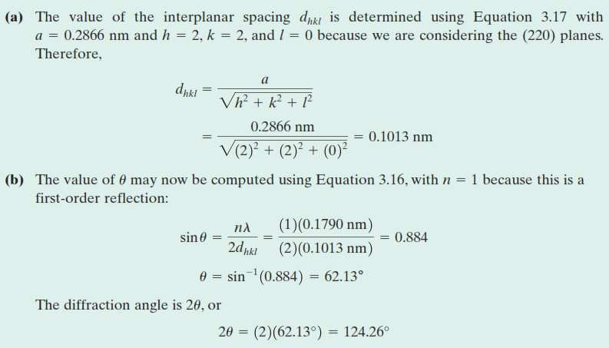

B. Noncrystalline solids:
Noncrystalline solids lack a systematic and regular arrangement of atoms over relatively large atomic distances. Sometimes such materials are also called amorphous. An amorphous condition may be illustrated by comparison of the crystalline and noncrystalline structures of the ceramic compound silicon dioxide (SiO₂), which may exist in both states.

Figure (3) present two-dimensional schematic diagrams for both the structures of SiO₂, the structure is much more disordered and irregular for the noncrystalline structure. Whether a crystalline or amorphous solid forms depends on the ease with which a random atomic structure in the liquid can transform to an ordered state during solidification.

Furthermore, rapidly cooling through the freezing temperature favors the formation of a noncrystalline solid because little time is allowed for the ordering process. Metals normally form crystalline solids, but some ceramic materials are crystalline, whereas the others are amorphous. Polymers materials may be completely noncrystalline or semicrystalline consisting of varying degrees of crystallinity.
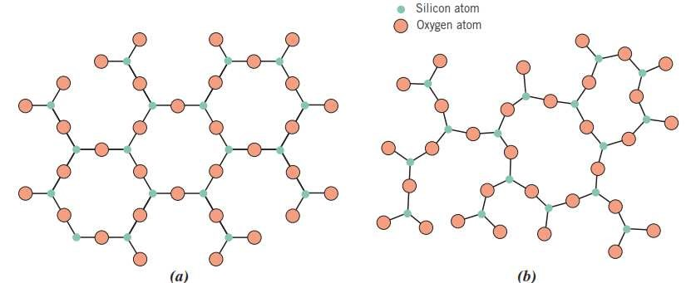

Figure (3): Two-dimensional schemes of the structure of (a) crystalline
silicon dioxide and (b) noncrystalline silicon dioxide.

Imperfections in Solids
The perfect order that exists throughout crystalline materials has been tacitly assumed. However, such an idealized solid does not exist; all contain large numbers of various defects or imperfections. As a matter of fact, many of the properties of materials are profoundly sensitive to deviations from crystalline perfection. A crystalline defect refers to a lattice irregularity, several different imperfections are discussed in this subject, including point defects, linear defects, and interfacial defects.

A. Point defects
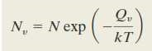
The simplest of the point defects is a vacancy, which occur as a result of an atom missing from the normal site as shown in Figure (4). All crystalline solids contain vacancies, and, in fact, it is not possible to create such a material that is free of these defects. The presence of vacancies increases the entropy of the crystal. The equilibrium number of vacancies (N_{v}) for a given quantity of material depends on and increases with temperature according to:

Where (N) is the total number of atomic sites, (Q_{v}) is the energy required for the formation of a vacancy, (T) is the absolute temperature in kelvins, and (k) is the gas or Boltzmann’s constant. The value of k is 1.38 x 10⁻²³ J/atom K, or 8.62 x10⁻⁵ eV/atom, depending on the units of (Q_{v}).
A self-interstitial is an atom from the crystal that is crowded into an interstitial site. This kind of defect is also represented in Figure (4).1. In metals, a self-interstitial introduces relatively large distortions in the surrounding lattice because the atom is substantially larger than the interstitial position in which it is situated. Consequently, the formation of this defect is not highly probable, and it exists in very small concentrations, which are significantly lower than for vacancies.

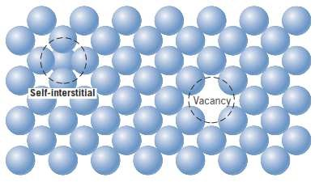

Figure (4): vacancy and a self-interstitial defects.

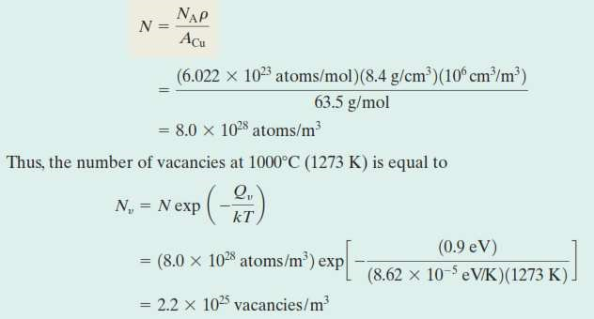
EX.2

Sol.2

Impurities in solids
In fact, even with relatively sophisticated techniques, it is difficult to refine metals to a purity in excess of 99.9999%. Most familiar metals are not highly pure; rather, they are alloys, in which impurity atoms have been added intentionally to impart specific characteristics to the material. Ordinarily, alloying is used in metals to improve mechanical strength and corrosion resistance. For example, sterling silver is a 92.5% silver–7.5% copper alloy.

In normal ambient environments, the pure silver is highly corrosion resistant but also very soft. Alloying with copper significantly enhances the mechanical strength without depreciating the corrosion resistance appreciably. The addition of impurity atoms to a metal will result in the formation of a solid solution, depending on the kinds of impurity, their concentrations, and the temperature of the alloy.

Several terms relating to impurities and solid solutions. With regard to alloys, solute and solvent are terms that are commonly employed. Solvent is the element or compound that is present in the greatest amount; on occasion, the solvent atoms are also called host atoms. Solute is used to denote an element or compound present in a minor concentration. A solid solution forms when the solute atoms are added to the host material and it's compositionally homogeneous; the impurity atoms are randomly and uniformly dispersed within the solid.
Impurity point defects are found in solid solutions, of which there are two types: substitutional and interstitial. For the substitutional type, solute or impurity atoms replace or substitute for the host atoms as shown in figure (5). Several features of the solute and solvent atoms determine the degree to which the former dissolves in the latter, as follows:

- Atomic size factor: the difference in atomic radii between the two atom types is less than about 15%.
- Crystal structure: For the appreciable solid solubility, the crystal structures of both atom types must be the same.
- Electronegativity: The more electropositive one element and the more electronegative the other must be approximately equal.
- Valences: a metal will have a stronger tendency to dissolve another metal of higher valency than one of a lower valency.

An example of a substitutional solid solution is found for copper and nickel. These two elements are completely soluble in one another at all proportions. The atomic radii for copper and nickel are (0.128) and (0.125) nm, respectively; both have the FCC crystal structure; and their electronegativities are (1.9) and (1.8). Finally, most common valences are (+1) for copper and (+2) for nickel. For interstitial solid solutions, impurity atoms fill the voids or interstices among the host atoms (see Figure 5). For metallic materials that have relatively high atomic packing factors, these interstitial positions are relatively small. Consequently, the atomic diameter of an interstitial impurity must be substantially smaller than that of the host atoms. Normally, the maximum allowable concentration of interstitial impurity atoms is low (less than 10%). Carbon forms an interstitial solid solution when added to iron; the maximum concentration of carbon is about (2%).The atomic radius of carbon atom is much less than that of iron: (0.071) versus (0.124) nm.

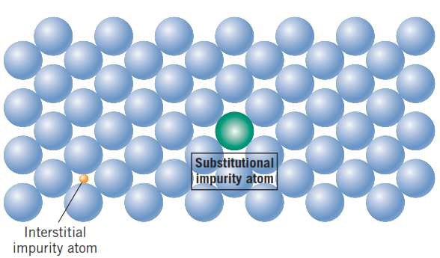

Figure (5): substitutional and interstitial impurity atoms.

B. Linear defects (dislocations)
A dislocation is a linear or one-dimensional defect around which some of the atoms are misaligned. One type of dislocation is represented in Figure (6): an extra por&on of a plane of atoms, or half-plane, the edge of which terminates within the crystal. This is termed an edge dislocation; it is a linear defect that centers on the line that is defined along the end of the extra half-plane of atoms. This is sometimes termed the dislocation line. Within the region around the dislocation line there is some localized lattice distortion. The magnitude of this distortion decreases with distance away from the dislocation line; sometimes the edge dislocation is represented by the symbol ().

Another type of dislocation, called a screw dislocation, may be thought of as being formed by a shear stress that is applied to produce the distortion as shown in Figure (7), the upper front region of the crystal is shifted one atomic distance to the right relative to the bottom portion. The atomic distortion associated with a screw dislocation is also linear and along a dislocation line. Most dislocations found in crystalline materials are probably neither pure edge nor pure screw but exhibit components of both types; these are termed mixed dislocations.

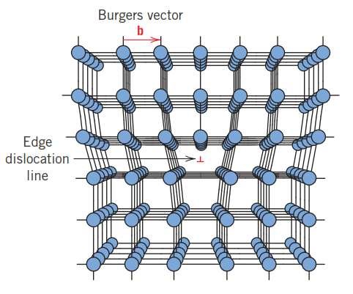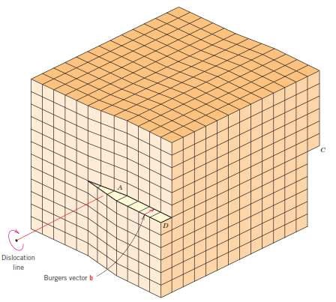

Figure (6): Edge disloca&on. Figure (7): Screw disloca&on.
The magnitude and direction of the lattice distortion associated with a dislocation are expressed in terms of a Burgers vector, denoted by (b). Furthermore, the nature of a dislocation (i.e., edge, screw, or mixed) is defined by the orientations of dislocation line and Burgers vector.

C. Interfacial defects
Interfacial defects are boundaries that have two dimensions and normally separate regions of the materials that have different crystal structures and/or crystallographic orientations. These imperfections include external surfaces, grain boundaries and twin boundaries.
- External Surfaces:
One of the most obvious boundaries is the external surface, along which the crystal structure terminates. Surface atoms are not bonded to the maximum number of nearest neighbors and are therefore in a higher energy state than the atoms at interior positions.

- Grain Boundaries:

Another interfacial defect, the grain boundary, which defined as the boundary separating two small grains or crystals having different crystallographic orientations in the polycrystalline materials. A grain boundary is represented schematically in the Figure (8). Within the boundary region, which is probably just several atom distances wide, there is some atomic mismatch in a transition from the crystalline orientation of one grain to that of an adjacent one. Various degrees of crystallographic misalignment between adjacent grains are possible Figure (8). When this orientation mismatch is slight, on the order of a few degrees, then the term small (or low) angle grain boundary is used. On the contrary, when orientation mismatch is wide, on the order of a many degrees, then the term high angle grain boundary is used.

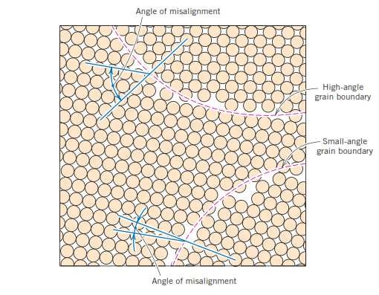

Figure (8): Schematic diagram showing small- and high-angle grain boundaries.

- Twin boundaries

A twin boundary is a special type of grain boundary across which there is a specific mirror lattice symmetry; that is, atoms on one side of the boundary are located in mirror image positions to those of the atoms on the other side Figure (9). The region of material between these boundaries is appropriately termed a twin. Twins result from atomic displacements that are produced from applied mechanical shear forces and also during annealing heat treatments. Twinning occurs on a definite crystallographic plane and in a specific direction, both of which depend on the crystal structure.
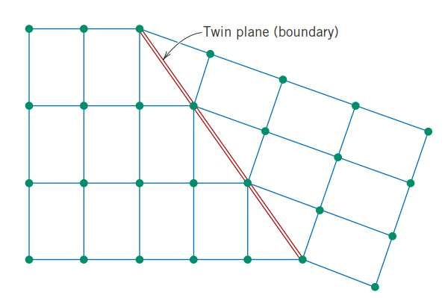

Figure (9): Schematic diagram showing twin boundaries.

