Diffusion
Many reactions and processes that are important in the treatment of materials rely on the transfer of mass either within a specific solid or from a liquid, a gas, or another solid phase. This is necessarily accomplished by diffusion, the phenomenon of material transport by atomic motion.

Diffusion mechanism
From an atomic perspective, diffusion is the stepwise migration of atoms from lattice site to lattice site. For an atom to make such a move, two conditions must be met:

- There must be an empty adjacent site, and
- The atom must have sufficient energy to break bonds with its neighbor atoms and then cause some lattice distortion during the displacement.

This energy is vibrational in nature. At a specific temperature some small fraction of the total number of atoms is capable of diffusive motion by virtue of the magnitudes of their vibrational energies. This fraction increases with rising temperature.

Types of diffusion
Two types of diffusion are observed in materials, one is named vacancy diffusion and the other named interstitial diffusion.

A. Vacancy diffusion
This mechanism involves the interchange of an atom from a normal lattice position to an adjacent vacant lattice site or vacancy, as represented schematically in Figure (1). This mechanism is aptly termed vacancy diffusion.

This process necessitates the presence of vacancies, and the extent to which vacancy diffusion can occur is a function of the number of these defects that are present; significant concentrations of vacancies may exist in metals at elevated temperatures. Because diffusing atoms and vacancies exchange positions, the diffusion of atoms in one direction corresponds to the motion of vacancies in the opposite direction.

. 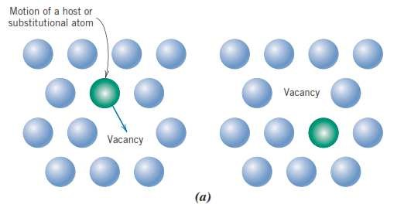

Figure (1): Vacancy diffusion.

B. Interstitial Diffusion
The second type of diffusion involves atoms that migrate from an interstitial position to a neighboring one that is empty. This mechanism is found for interdiffusion of impurities such as hydrogen, carbon, nitrogen, and oxygen, which have atoms that are small enough to fit into the interstitial positions. Host or substitutional impurity atoms rarely form interstitials and do not normally diffuse via this mechanism. This phenomenon is appropriately termed interstitial diffusion as shown in Figure (2).

In most metal alloys, interstitial diffusion occurs much more rapidly than diffusion by the vacancy mode because the interstitial atoms are smaller and thus more mobile. Furthermore, there are more empty interstitial positions than vacancies; hence, the probability of interstitial atomic movement is greater than for vacancy diffusion.

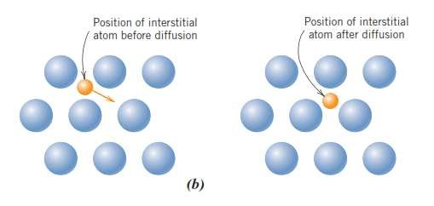

Figure (2): Interstitial diffusion.

Steady-state diffusion (Fick’s first law).
Diffusion is a time-dependent process and the quantity of an element that is transported within another is a function of time. Often it is necessary to know the rate of mass transfer. This rate is frequently expressed as a diffusion flux (J), defined as the mass (or, equivalently, the number of atoms) M diffusing through and perpendicular to a unit cross-sectional area of solid per unit of time. In mathematical form, this may be represented as:
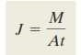

Where (A) denotes the area across which diffusion is occurring and t is the elapsed diffusion time. The units for (J) are kilograms or atoms per meter squared per second (kg/m².s) or (atoms/m².s).

If the diffusion flux does not change with time, a steady-state condition exists. One common example of steady-state diffusion is the diffusion of atoms of a gas through a plate of metal for which the concentrations (or pressures) of the diffusing species on both surfaces of the plate are held constant. This is represented schematically in figure (3.a).

When concentration (C) is plotted versus position (or distance) within the solid (x), the resulting curve is termed the concentration profile; the slope at a particular point on this curve is the concentration gradient:
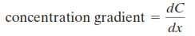

The concentration profile is assumed to be linear, as shown in the figure (3.b) where:
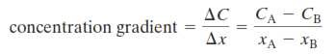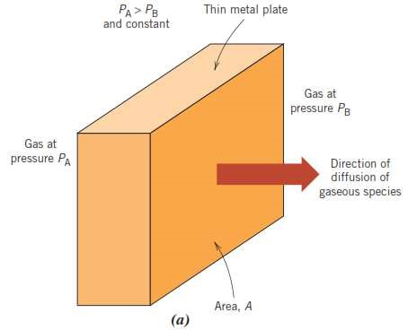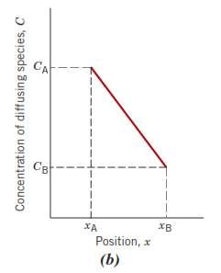

Figure (3): steady state diffusion.

For diffusion problems, it is sometimes convenient to express concentration in terms of mass of diffusing species per unit volume of solid (kg/m³ or g/cm³). The mathematics of steady-state diffusion in a single (x) direction is relatively simple, in that the flux is proportional to the concentration gradient through the expression:

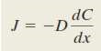
The constant of proportionality (D) is called the diffusion coefficient, which is expressed in square meters per second. The negative sign in this expression indicates that the direction of diffusion is down the concentration gradient, from a high to a low concentration. The above equation called Fick’s first law.
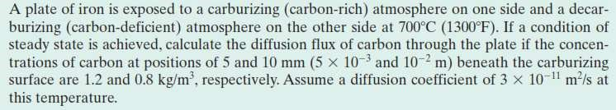
---------------------------------------------------------------------------------------------- Ex.1

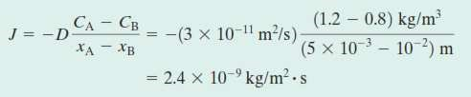
Sol.1

Non-steady-state diffusion (Fick’s second law)
Most practical diffusion situations are nonsteady-state ones. That is, the diffusion flux and the concentration gradient at some particular point in a solid vary with time. Under conditions of nonsteady state, use of previous equation is no longer convenient; instead, the partial differential equation (in which concentration in terms of both position and time) known as Fick’s second law is used.
Fick’s second law may be represented as the following expressing:

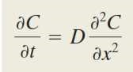

Furthermore, the following assumptions are made:

- Before diffusion, any of the diffusing solute atoms in the solid are uniformly distributed with concentration of (C₀).
- The value of x at the surface is zero and increases with distance into the solid.
- The ;me is taken to be zero before the diffusion process begins.
- For t > 0, C = Cs (the surface concentration).
Application of these boundary conditions to this equation yields the solution:
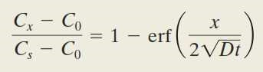

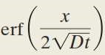
Where (C_{x}) represents the concentration at depth (x) after time t. The expression i s t h e G a u s s i a n error function. This equation demonstrates the relationship between concentration, position and time.
Ex.2

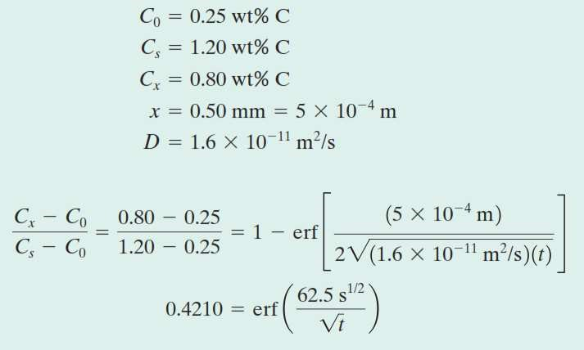
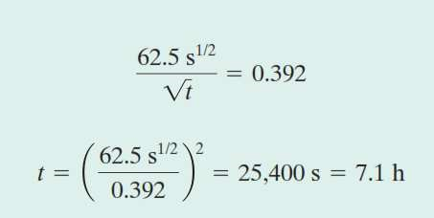
Sol.2

Factors that influence diffusion A. Diffusing Species:
There is a significant difference in magnitude between self-diffusion and carbon interdiffusion in iron at 500⁰C, the (D) value being greater for the carbon interdiffusion. This comparison also provides a contrast between the rates of diffusion via vacancy and interstitial modes as discussed earlier. The self-diffusion occurs by a vacancy mechanism, whereas carbon diffusion in iron is interstitial.

B. Temperature:
Temperature has a profound influence on the coefficients and diffusion rates. For example, for the self-diffusion of Fe in α-Fe, the diffusion coefficient increases approximately six orders of magnitude in rising temperature from 500⁰C to 900⁰C. The temperature dependence of the diffusion coefficients is:

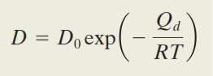

Where:
(D₀): constant (m²/s), (Q): the activation energy for diffusion (J/mol or eV/atom), (R): the gas constant, 8.31 J/mol.K or 8.62 x 10⁻⁵ eV/atom.K T: absolute temperature (K).
The activation energy may be thought of as that energy required to produce the diffusive motion of one mole of atoms. A large activation energy results in a relatively small diffusion coefficient. Taking natural logarithms of above equation yields:

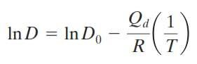

Or, in terms of logarithms to the base 10,
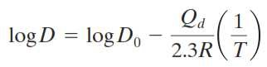

Because D₀, Q_{d}, and R are all constants, the equation takes on the form of an equation of a straight line: y=b+mx, where y and x are analogous, respec;vely, to the variables log D and 1/T. Thus, if log D is plotted versus the reciprocal of the absolute temperature, a straight line should result.
---------------------------------------------------------------------------------------------- Ex.3
Compute the diffusion coefficient for magnesium in aluminum at 550⁰C, where the values of (D₀) and (Q_{d}) are 1.2 x 10⁻⁴ m²/s and 131 KJ/mol respectively.
Sol.3 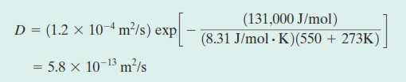

--------------------------------------------------------------------------------------------------------------------------------------------------------------------------------------------

H.W.1
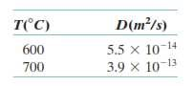
The diffusion coefficients for carbon in nickel are given at two temperatures, determine:
(a): Determine the values of (D₀) and (Q_{d}).
(b): What is the magnitude of D at 850 ⁰C.
----------------------------------------------------------------------------------------------

