Computer Basics
Syllabus
Chapter One: The Essentials: Hardware, Software, and Information Technology (IT), Computer Overview, The Front of a Computer and Peripheral Devices, The Inside of a Computer, Memory Cache, Computer Performance, Upgrading a Computer.
Chapter Two: Understanding Hardware, Central Processing Unit (CPU), Memory , RAM and ROM, Input Devices, Monitor, Graphics Card, Input/ Output Devices , Hard Drive, Hard Drive Maintenance, Types of Drives, Formatting a Disk.
Chapter Three: Understanding Software, Understanding Graphical User Interfaces , Types of Software , Operating Systems, Word Processing, Spreadsheets, Databases, Presentation Software, Accounting, Web Browsing and Authoring, Programming Languages, Systems Development.
Chapter Four: Information Networks , The Internet, Intranets and Extranets, Telephones and Networks
Chapter Five: Introduction to Windows XP, Starting and Logging On to Windows XP Home and XP Professional, Understanding the Windows XP Screen, A Look at the New Windows XP Start Menu, Using the Mouse and Keyboard
Chapter Six: Working with a Window, Understanding the Parts of a Window, Learning how to deal with all the parts of the window.
Chapter Seven: Working with Programs, Using Menus, Using Toolbars , Filling Out a Dialog Box, Entering Text in the WordPad Program, Editing Text, learning how to deal with the text, Getting Help by Contents or by Help Index and Search, Saving and Opening Files in Different Locations.
Chapter Eight: Working with Files and Folders, Understanding Storage Devices, Using My Computer , Dealing with files and folders, Changing How Information is Displayed, Managing the Search Companion, Using Windows Explorer, Using MS-DOS, Creating and Using a Compressed Folder.
Chapter Nine: Exploring the Internet, Connecting to the Internet, Displaying a Specific Web Page, Browsing and searching the Web, Adding a Web Page to Favorites and Changing Your Home Page, Displaying or clearing the History of Visited Web Pages, Downloading Pictures and Files, Understanding the Information Bar, Using the Pop-up Blocker, Understanding Information Security and Windows Firewall, Introduction to E-mail, learning how to deal with e-mails.
Chapter One
The Essentials
Hardware, Software, and Information Technology (IT)
A computer is an equipment that can do a number of things. Two basic components make up a computer: hardware and software.
Hardware: represents all computer parts that you can physically see or touch which includes the computer’s monitor, case, keyboard, mouse, and printer.
Software: represents computer programs that tell hardware how to operate such as Microsoft Excel, word or any other program. you don’t have to know how to program a computer to use one. A computer programmer has already done the work for you by writing the program (software). All you have to do is tell the software what you’re trying to do, and the software then directs the work of the hardware.
IT, short for Information Technology, is the broad subject related to computers and managing and processing information, especially within large organizations. Many large companies have departments full of computer experts called IT departments.

Computer Overview
Computers are not really as complicated as they initially seem. You just have to learn the basic functions of the various parts, and then you can separate them into three categories:
- Input: Any device that lets you talk to the computer (such as a mouse or keyboard).
- Process/Storage: Main functions of a computer, which happen inside the computer case, the Central Processing Unit (CPU) does all the processing; the storage function is handled by any number of drives (hard, floppy, Zip, tape-backup, CD/DVD-ROM) or disks (compact discs or floppy diskettes).
- Output: Any device that lets the computer talk to you (such as a monitor or speakers).

Types of Computers: There are several different types of computer systems out there. Here's a very brief description of the most common ones:
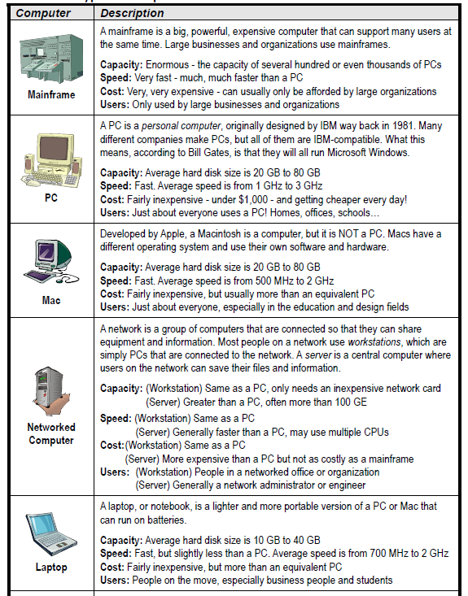

The Front of a Computer and Peripheral Devices:
System Unit or Computer Case: A plastic or metal case with slots, buttons, and lights in the front and holes in the back. This is the most important part of a computer because it contains the Central Processing Unit (CPU). The system unit directs the computer, performs calculations, and stores information.
Hard Drive: The computer‘s main, long-term storing device. Unlike CD-ROMs, you typically cannot remove a hard disk.
CD-ROM or DVD Drive: CD-ROMs and DVDs for computer can store lots of information. The only real difference between a CD-ROM and a DVD is how much information they can store. A CD-ROM can store at least 700 MB (megabytes) of information, while a DVD can store much more—up to 4.7 GB (gigabytes) or 9.4 GB on a dual-layer DVD.
Most CD-ROMs and DVD are read-only, meaning you can‘t write information to them. You can buy special CD-ROM and DVD drives that can write or burn information to special CD-R, CD-RW, DVD-R, and DVD-RW discs.
Tape Backup: A device that you can use to store backups, or copies, of the information on a computer‘s hard drive.
Keyboard and Mouse: are input devices. You can use to communicate with your computer.
Scanner: is an input device. Scanners work like photocopiers, except the image is translated into a digital image in your computer rather than copied onto paper.
Monitor: is an output device resembles a television set, and is where the computer displays information.
Speakers: are an output device similar to those on a stereo system. They allow your computer to play sounds.
Printer: is an output device where a computer writes down information or output, onto paper, or a hardcopy.
The Inside of a Computer:
Motherboard: The main piece of circuitry in a computer. Everything connects to or is wired to the motherboard.
Central Processing Unit (CPU): The computer‘s brain or heart, the CPU is a computer‘s main chip. The CPU is really nothing more than an incredibly fast and powerful calculator.
Random Access Memory (RAM): A computer‘s temporary storage place, where it gets its work done. For example, when you use a word processor to type a letter, the letter is stored in the computer‘s memory.
ROM-BIOS: A computer‘s ROM-BIOS (stands for Read Only Memory – Basic Input/Output System) is a special chip with instructions for the computer to communicate with other hardware parts.
Expansion Slot: An expansion slot lets you add more features and capabilities to a computer by plugging in expansion cards.
Expansion Card: A card that allows you to expand your computer‘s capabilities, such as a modem card, a network card, a video card, or a sound card.
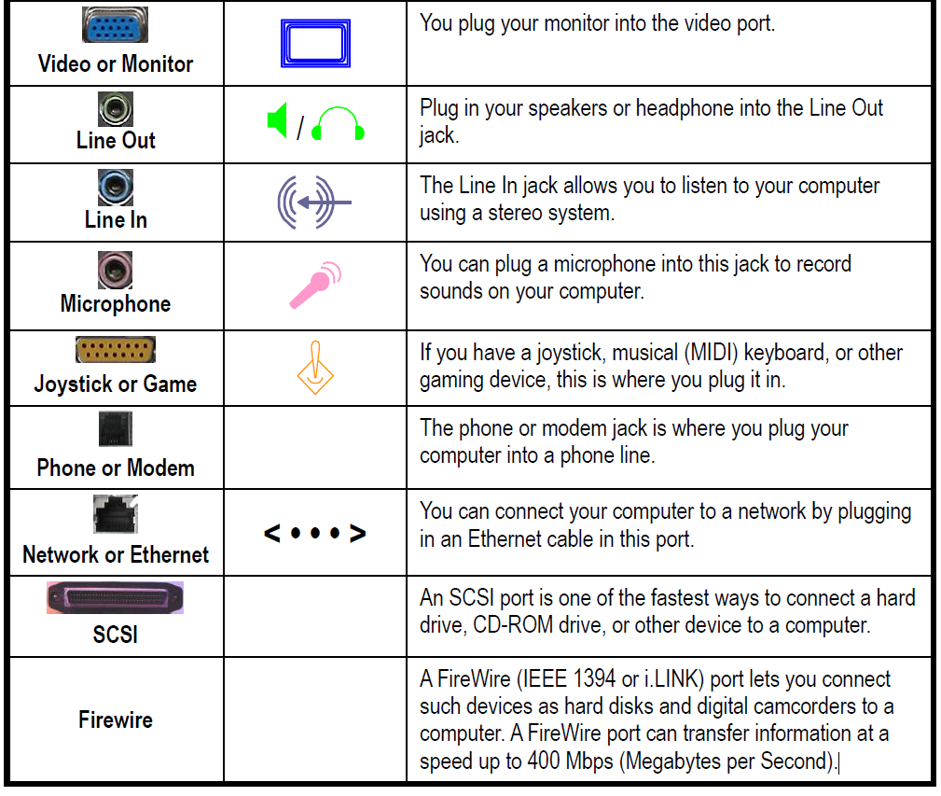
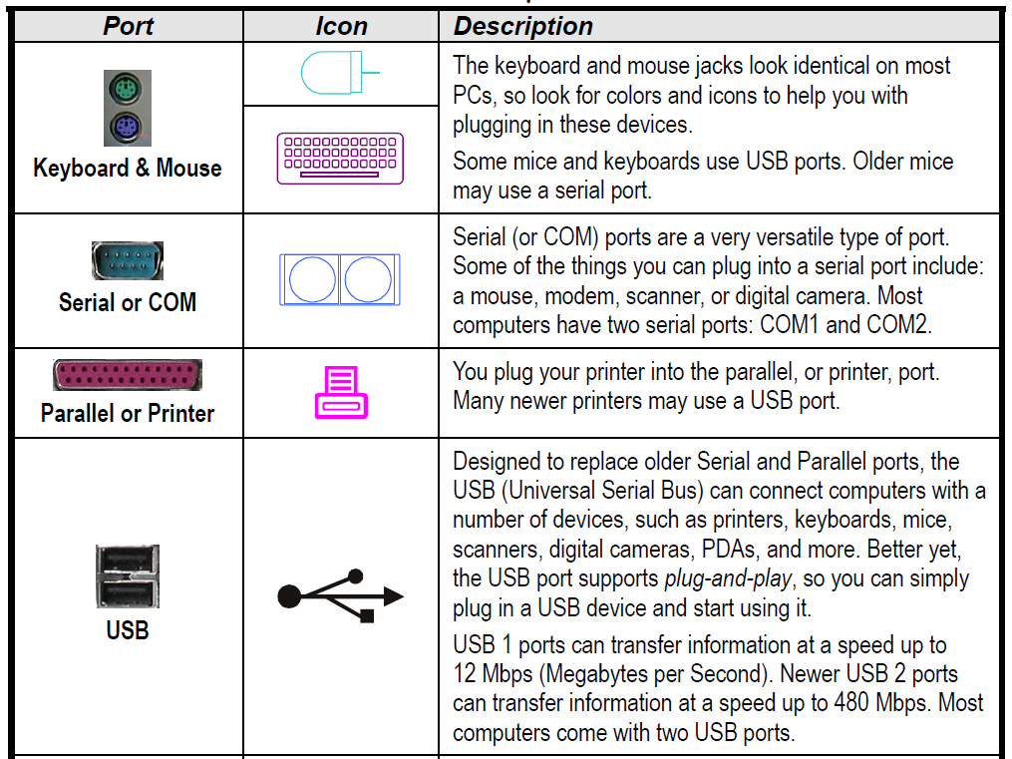
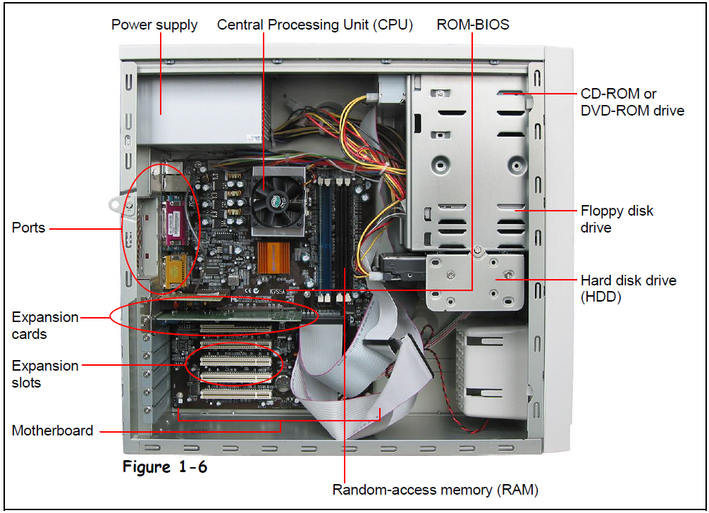The Back of a Computer Case:
Memory Cache : A memory cache increases a computer’s performance by storing the most recently used data. There are two types of cache:
• Internal Cache (also called primary or L1 cache) When the computer needs data it first looks in the internal cache. The internal cache is inside the CPU and is the fastest possible way for the computer to get information. The internal cache can normally only contain a very small amount of information.
• External Cache (also called secondary or L2 cache) If the computer doesn’t find the data in the internal cache, it then looks in the external cache. The external cache is slower than the internal cache, but much faster than the normal RAM memory. The external cache normally holds much more information than the internal cache, but still not as much as the main memory (RAM).

Computer Performance: the computer performance is the speed of the computer to do processes. Factors that affect computer performance are:
CPU Speed: Arguably the single most important factor that determines a computer‘s performance is the speed of its CPU. The speed of the CPU is measured in megahertz (MHz) and gigahertz (GHz). The faster the CPU, the faster the computer. The first PC in 1981 ran at 4.77 MHz, while today‘s computers can run at speeds exceeding 3,000 MHz, or 3 GHz.
Amount of RAM or Memory: is another very important factor in a computer‘s performance. Generally, the more RAM a computer has the better its performance. However, you usually won‘t see much of an improvement after 1 GB of RAM.
Type of Video Card: Video cards have their own processor and memory, just like the computer does. The faster the processor and the more memory a video card has, the faster it can draw images on the monitor. Video card performance is especially important if you‘re interested in playing newer, 3D computer games.
Hard Drive Speed: A hard drive‘s average access time is how fast it can find information. Average access time is measured in milliseconds (ms), or 1/1000 of a second. The lower the access speed, the faster the hard drive. Most newer computers have an average access time of 8 to 15 ms. Another factor that determines hard drive performance is how fast it spins, in revolutions per minute (rpms). Faster IDE hard drives may have speeds as fast as 7,200 rpm, while high-end SCSI hard drives have speeds of 15,000 rpm.
Free Hard Disk Space: Not only do you need a fast hard drive, you have to make sure that is has plenty of free storage space. Microsoft Windows uses this hard disk space to create a cache on the hard drive where it stores temporary information.
Hard Disk Fragmentation: Normally a computer stores a file in the same location on a hard drive. Over time, a hard drive can become fragmented, and instead of storing a file in the same location it begins storing parts of it all over. When the computer needs to read a fragmented file, it must read several different parts of the hard drive instead of just one. Defragmenting a hard drive puts the fragmented files back together in one place. You should defragment your computer‘s hard drive about once a month.
Multitasking Considerations: Microsoft Windows can multitask, or run more than one program or task at a time—probably no different than your job. And, just like your job, the more programs or tasks you throw at Windows, the longer it takes to complete each one, and hence a drop in computer performance.
Upgrading a Computer: The following list some of the more common upgrades:
Memory (RAM): the amount of memory in a computer is probably the most effective and inexpensive upgrades you can make. More memory can significantly increase the performance of your computer. 512MB to 1GB of memory is all you should ever need—for the next year or so anyway.
Hard Disk: The hard drives in newer computers have become so huge that you may never need to buy another one. If you do somehow run out of room on your hard drive, you can buy a second one, since most computer can handle two internal hard drives.
CPU and Motherboard: It‘s often better to buy a whole new computer than to upgrade the CPU and motherboard. That way you get all new components all once—which is a lot cheaper than buying them all individually.
Add Devices and Peripherals: There are an endless variety of devices that you can add to a computer. You can add CD-ROM, DVD, and Zip drives, graphics cards, tape backups, and more.

