Chapter Four

Information Network
Network: A network is several computers, printers, and other devices that are connected together. The benefits of a network are:
- Share Information: Networks allow you to share files and programs.
- Share Equipment: Computers connected to a network can share equipment to reduce costs.
- Use Network Software: Software designed for networks lets people send and receive
electronic mail (e-mail) with other users on the network.
Types of Networks: There are two basic types of networks:
- Local Area Networks (LAN): A network that connects computers in the same area or building, using cables.
- Wide Area Networks (WAN): A network that connects computers across a large area. The Internet is actually a huge Wide Area Network.
Local Area Networks (LANs) are subdivided into two types of network subcategories:
peer-to-peer and client/server:
1- Peer-to-Peer Network or Workgroup: In a peer-to-peer network, everyone stores their files on their own computer, and anyone on the network can access files stored on any other computer. Peer-to-peer networking is an inexpensive way to connect computers in a small office or home. The disadvantages of a peer-to-peer network are that it doesn’t offer as much security as client/server networks, and it can be difficult to find files that are stored on many different computers.
2- Client/Server Network: In a client/server network, everyone stores their files and can access the files on a central computer called a server. Client/server networks are more secure, easier to administer, and much more powerful than peer-to-peer networks. That’s why they are used to connect computers in most businesses. The disadvantages of client/server networks are that they require special, expensive software, such as Windows XP Server or NetWare, and they are more complicated to install than peer-to-peer networks.

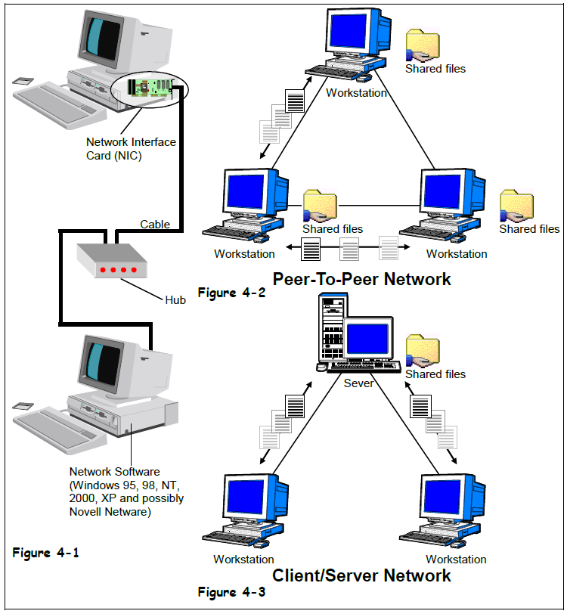
Network Components:
1- Network Interface Card (NIC): A network interface card is a device that plugs into your computer and connects each computer to the network.
2- Cables: are the wires that connect the computers, printers, and other equipment on a network.
3- Hub: A hub is a device where all the cables on a network connect.
4- Network Operating Software: Your operating system must provide networking capabilities.

The Internet: The Internet is the largest computer network in the world. It consists of millions of computers all over the planet, all connected to each other. The World Wide Web (WWW) is simply one way to communicate and share information over the Internet. The World Wide Web consists of millions of documents that are stored on thousands of computers that are always connected to the Internet. These documents are called Web pages. Web pages are stored on Web servers. A Web server is a computer, not unlike your own computer, only bigger and faster. So, what can you do with internet?
- Send and Receive Electronic Mail (E-mail).
- Browse the World Wide Web: The World Wide Web is an enormous collection of interconnected documents stored on Web servers all over the world.
- Join online discussions with newsgroups: Newsgroups are discussion groups on the Internet that you can join to read and post messages to and from people with similar interests such as computers, education, hobbies, politics, religion, and more.
- Chat with other online users: Chatting lets you communicate with people on the Internet instantly. Chats are text-based also have voice and even video capabilities.
- Download software: You can download pictures, programs, and many other types of files and save them to your computer.
- Listen to music and watch videos.

Intranets and Extranets:
An Intranet is a miniature version of the Internet that works within a company or organization. Web sites on an Intranet act like any other Web sites, but can only be viewed by users within the company or organization.
An Extranet is similar to an Intranet, but an Extranet is accessible by authorized outside users. Business partners use Extranets to share information.
So what are the advantages of Intranets and Extranets? Both Intranets and Extranets can:
- Share Information: Intranets and Extranets offer a very simple and inexpensive way to make internal company documents available to employees.
- Connect Documents: Documents on an Intranet or Extranet can be connected by hyperlinks, so users can easily jump from one related document to another.
- Use Special Software: Some software can only be used on an Intranet or Extranet, such as Web based e-mail programs.

