Classifying Nanostructured Materials Lecture Two

Dr. Raouf Mahmood Raouf
Lecture Two
Classifying Nanostructured Materials
There are several ways to classify nanomaterials. This depends very much on the applications and philosophy which are adopted. We shall just present here one extreme classification which can be found in the literature. The focus is done on the macroscopic dimensions of the material. Nanomaterials are then defined as materials containing structures having at least one dimension less than about 100 nm.
In this classification this no reference to the structure of the material. The classification, which might be more related as far as the nanostructure of a material is concerned, is to consider the dimensionality of the nanoscale component with which the material is made. A nanostructure is said to have one dimension, for example, if it has a length larger than 100 nm in one direction only. According to this definition, a nanoparticles is considered to have zero dimension (it has no dimension with a length larger than 100 nm). A wire or a fiber is a 1-dimensional object and a thin film a 2-dimension nanostructure. To summarize, 0D nanomaterials contain spheres or clusters which are considered as point-like particles. 1D nanomaterials contain nano fibers, wires, rods, etc., 2D use films, plates, multilayers, or networks. 3D nanomaterials are Nano phase materials consisting of equiaxed nanometer-sized grains. This is shown schematically in figure 1.
Bulk nanomaterials are larger objects made from structures having well-identified domains with an average size less than 100 nm, for instance the grain size in ceramics. For comparison, the diameter of a human hair is about 100,000 nm and the size of a single particle of smoke is around 1,000 nm. In this case a nanoparticle is considered to have zero dimension, a wire, 1 dimension. There are several ways to classify nanostructured nanomaterials, but this depends, to some extent, on the applications under consideration. As sketched in figure 1, a nanomaterial can be classified according to the dimension of the nanostructure used to make it: zero dimensional (0D), one dimensional (1D), two dimensional (2D) and three dimensional (3D).
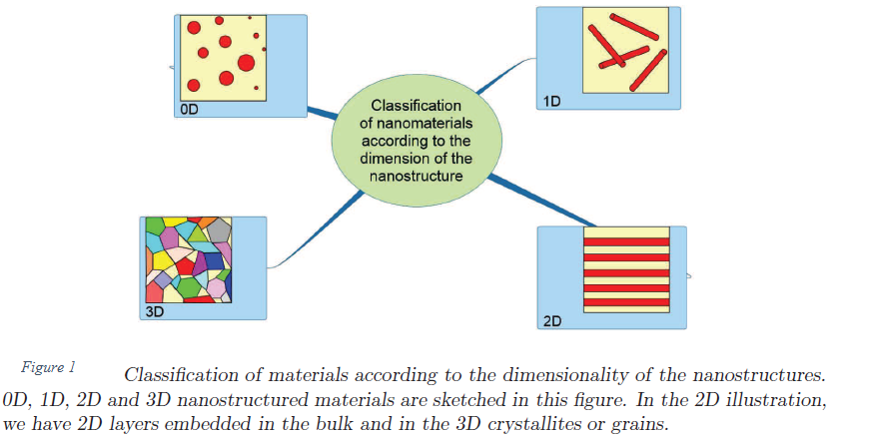
It is also possible to classify nanomaterials in families reflecting their composition. This gives, as a possibility, the classification shown in figure 2. It is possible to distinguish the four types of nanomaterials as indicated in figure 2.
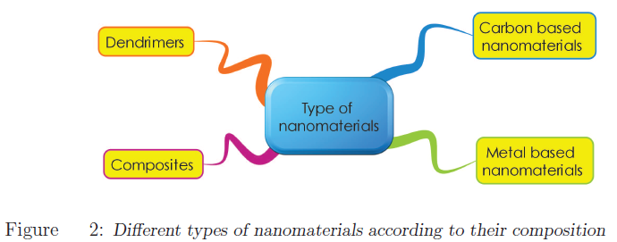
Carbon-based nanomaterials are composed mostly of carbon. They play such an important role in applications as well as in the historical development of the nanotechnology domain. This classification includes fullerenes, carbon nanotubes, graphene and the like.
Metal-based nanomaterials are materials made of metallic nanoparticles like gold, silver, metal oxides, etc. For example, titanium dioxide (TiO₂) nanoparticles are extensively used in applications such as paint, sunscreen, and toothpaste.
Dendrimers are Nano sized polymers built from branched units. They can be functionalized at the surface and can hide molecules in their cavities. A direct application of dendrimers is for drug delivery. Composite nanomaterials contain a mixture of simple nanoparticles or compounds such as Nano sized clays within a bulk material. The nanoparticles give better physical, mechanical, and/or chemical properties to the initial bulk material.

Nanostructured materials
Nanostructured materials are materials with structures in the nanoscale range (1-100 nm). The properties of the nanostructured materials depend on the size and nature of their microstructure. If the characteristic length scale of the microstructure is comparable to the lengths associated with fundamental physical phenomena, large changes in the properties of the material compared to a non-nanostructured material can be observed. The whole structure – like for many materials - can be in or out of thermodynamic equilibrium.
Using crystallites of nanometer size of elements like gold or sodium chloride, for instance, can produce a great variety of nano structuration depending on the crystallographic orientation, the chemical composition of the mixture and the possibility to have non-equilibrium structures which provides certain property advantages.
Nanoparticles are of course often used as building blocks to make nanostructured materials. They can be of various natures: fullerenes, nanotubes, nanocrystallites, nano fibers, etc. If the simplest building blocks of nanostructured nanomaterials are nanoparticles, more complicated elementary structures can be used as well, as in nanocomposites, for example. Nano-intermediates are the building blocks of nanostructured materials. Nanoparticles are the simplest objects we may think of from which to build nanomaterials. However, it is not always easy to align nanoparticles according to a given template by self-assembly. There are only few examples (mainly sulphides or selenides [is a chemical compound containing a selenium anion with oxidation number of −2 (Se⁻²)]) combining with success soft templates, self-alignment of nanoparticles by dipolar interactions and oriented attachment resulting in 1D structures or hierarchical structures. Hard nanotemplates can be designed using different techniques such as electron lithography, for example, or anodization as for alumina membranes. Soft nanotemplates (such as mesophases and micellar systems) may also be used in the synthesis of nanoparticles with controlled size and shape, or mesoporous materials.
Films with a thickness less than 100 nm, supramolecular assemblies, dispersions of nanoparticles, etc. are nano-intermediates currently used to improve different technologies such as solar cells, batteries, catalysts, and drug delivery systems.
Nanostructured materials can be ordered into different families indicated in figure 4.

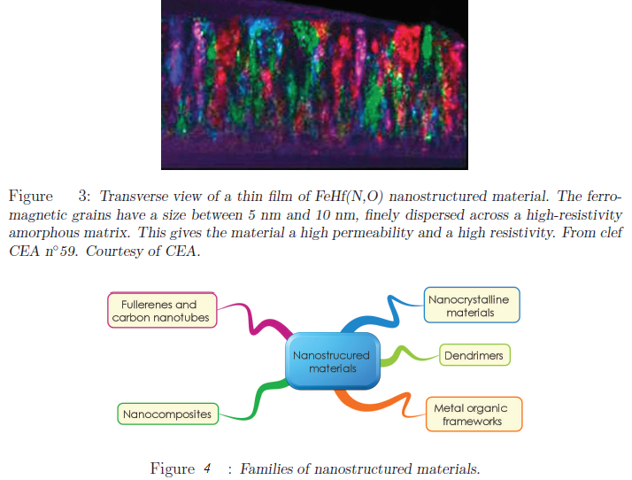
Example of a nanostructured film
An illustration is shown in figure 3. The picture shows a transverse section observed with a transmission electron microscope of a nanostructured FeHf(NO) film. The horizontal length of figure 3 is about 750 nm. Ferromagnetic grains of a size between 5 and 10 nm are dispersed inside a high resistivity amorphous matrix. The resulting nanostructured film has both high resistivity and high saturation magnetization value. These properties, obtained at the CEA, are interesting because they allow integrating this material in circuits close to inductive components, while minimizing parasitic capacities at high frequency operation (up to more than 2 GHz).
Zero Dimension (0D) nanostructured materials (NSMs):
A major feature that discriminates various types of nanostructures is their dimensionality. The word ‘‘nano’’ stems from the Greek word ‘‘nanos’’, which means dwarf. This word ‘‘nano’’ has been assigned to indicate the number 10⁻⁹, i.e., one billionth of any unit. In the past 10 years, significant progress has been made in the field of 0D NSMs. A rich variety of physical and chemical methods have been developed for fabricating 0D NMSs with well-controlled dimensions. Recently, 0D NSMs such as uniform particles arrays (quantum dots), heterogeneous particles arrays, core–shell quantum dots, onions, hollow spheres and nanolenses have been synthesized by several research groups. Fig. 1 shows the images of different types of 0D NSMs. Moreover, 0D NSMs, such as quantum dots has been extensively studied in light emitting diodes (LEDs), solar cells, single-electron transistors, and lasers.
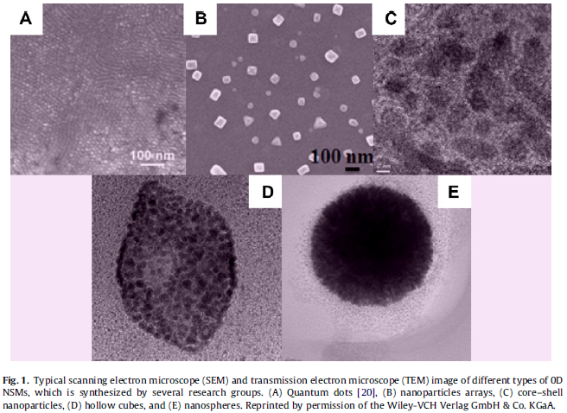
One Dimension (1D) Nanostructured materials NSMs:
1D NSMs have stimulated an increasing interest due to their importance in research and developments and have a wide range of potential applications. It is generally accepted that 1D NSMs are ideal systems for exploring a large number of novel phenomena at the nanoscale and investigating the size and dimensionality dependence of functional properties. They are also expected to play an important role as both interconnects and the key units in fabricating electronic, optoelectronic, and EEDs with nanoscale dimensions. The field of 1D NSMs such as nanotubes has attained a significant attention. 1D NSMs have a profound impact in nanoelectronics, nanodevices and systems, nanocomposite materials, alternative energy resources and national security. Fig. 2 show the 1D NSMs, such as nanowires, nanorods, nanotubes, nanobelts, nanoribbons, and hierarchical nanostructures, which have been synthesized in our and other laboratories.
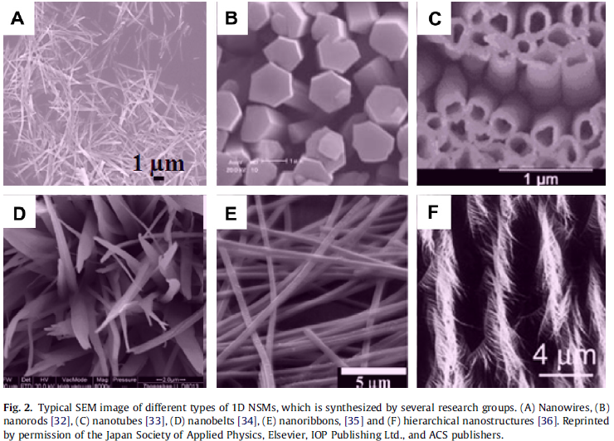
Two Dimension (2D) Nanostructured materials NSMs:
2D nanostructures have two dimensions outside of the nanometric size range. In recent years, a synthesis 2D NSMs have become a focal area in materials research, owing to their many low dimensional characteristics different from the bulk properties. In the quest of 2D NSMs, considerable research attention has been focused over the past few years on the development of 2D NSMs. 2D NSMs with certain geometries exhibit unique shape-dependent characteristics and subsequent utilization as building blocks for the key components of nanodevices. In addition, a 2D NSMs are particularly interesting not only for basic understanding of the mechanism of nanostructure growth, but also for investigation and developing novel applications in sensors, photocatalysts, nanocontainers, nanoreactors, and templates for 2D structures of other materials. Fig. 3 show the 2D NSMs, such as junctions (continuous islands), branched structures, nanoprisms, nanoplates, nanosheets, nanowalls, and nanodisks.
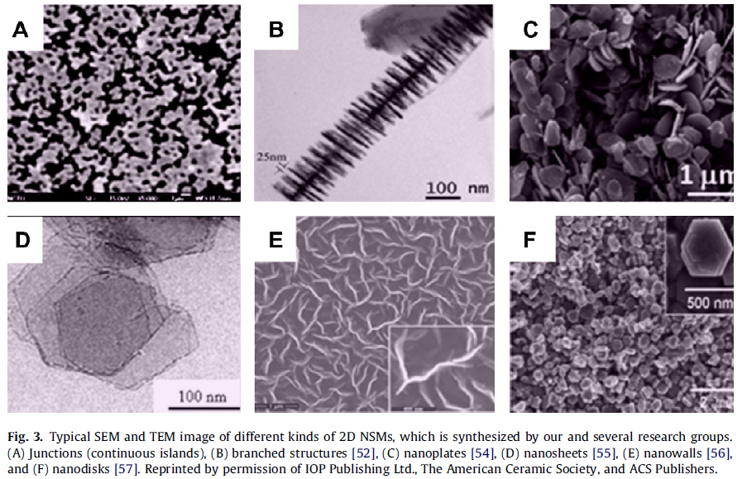
Three Dimension (3D) Nanostructured materials NSMs:
Owing to the large specific surface area and other superior properties over their bulk counterparts arising from quantum size effect, 3D NSMs have attracted considerable research interest and many 3D NSMs have been synthesized in the past 10 years. It is well known that the behaviours of NSMs strongly depend on the sizes, shapes, dimensionality and morphologies, which are thus the key factors to their ultimate performance and applications. Therefore it is of great interest to synthesize 3D NSMs with a controlled structure and morphology. In addition, 3D nanostructures are an important material due to its wide range of applications in the area of catalysis, magnetic material and electrode material for batteries. Moreover, the 3D NSMs have recently attracted intensive research interests because the nanostructures have higher surface area and supply enough absorption sites for all involved molecules in a small space. On the other hand, such materials with porosity in three dimensions could lead to a better transport of the molecules. Fig. 4 show the typical 3D NMSs, such as nanoballs (dendritic structures), nanocoils, nanocones, nanopillers and nanoflowers. 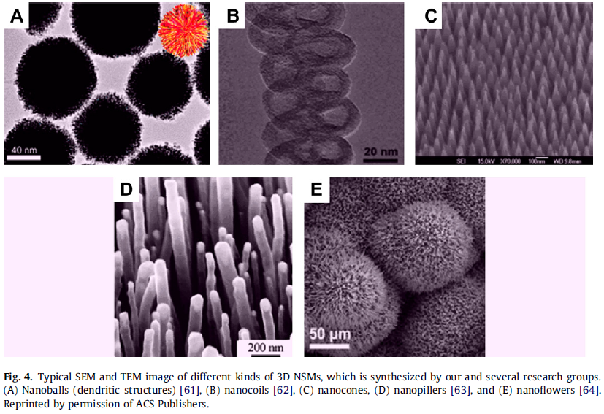
Zero Dimension Fabrication Method
Nanoparticles make up one of the most important nanomaterials subgroups because nanoparticle manufacturing is an essential component of nanotechnology. Also, assembling of nanoparticles and related structures is the most generic route to generate nanostructured materials and to build up bulk nanomaterials.

Lithography processes
Lithography is more versatile and easy to implement process for producing the self-assembled of 0D, 1D, 2D and 3D NSMs on different types of substrates. Lithography is also a rapid and effective method for surface patterning, which is compatible with a large variety of materials. Lithography includes many different kinds of surface preparation in which a design is transferred from a photo mask or reticle onto a substrate surface that would allow multiple copies to be made from one exposure.
Lithography techniques can be divided in two categories on the basis of the nanofabrication approaches:
(1) Unconventional approaches such as soft nano-imprint lithography, Nanosphere lithography, colloidal lithography, nano-imprint lithography, and solution-phase synthesis.
(2) Conventional approaches like e-beam lithography and focused ion beam lithography.
Unconventional approaches are more preferable to conventional approaches. Lithographic patterning is achieved by various moulding processes, for instance Nano imprint lithography, hot embossing, and elastomer moulding. Lithography has become a widely used technique by many researchers in fields of physics, chemistry, and biology.
Problems in lithography
Though the concept of photolithography is simple, the actual implementation is very complex and expensive. This is because
(1) Nanostructures significantly smaller than 100 nm are difficult to produce due to diffraction effects.
(2) Masks need to be perfectly aligned with the pattern on the wafer.
(3) The density of defects needs to be carefully controlled, and
(4) Photolithographic tools are very costly, ranging in price from tens to hundreds of millions of dollars.
Electron-beam lithography
Electron-beam lithography and X-ray lithography techniques have been developed as alternatives to photolithography. In the case of electron beam lithography, the pattern is written in a polymer film with a beam of electrons. Since diffraction effects are largely reduced due to the wavelength of electrons, there is no blurring of features, and thus the resolution is greatly improved. However, the electron beam technique is very expensive and very slow.
In the case of X-ray lithography, diffraction effects are also minimized due to the short wavelength of X-rays, but conventional lenses are not capable of focusing X-rays and the radiation damages most of the materials used for masks and lenses.

