Chapter Six
Working with a Window
Starting a Program:
A program is a complex set of instructions that tells your computer how to do something. The easiest way to start a program is by clicking the Windows Start button and then selecting the program from the All Programs menu.

Understanding the Parts of a Window:
Located in every window are several little buttons, menus, and controls that you use to control the program and window. We will use the parts of word processing window for illustration:
Title bar
Minimize button
Maximize button
close button
Menu bar
Toolbars
Main window or document area
Status bar

- Title bar: Displays the name of the program or window.
- Minimize button: Minimizes a window, hiding it from your screen but keeping it running in your computer’s memory, ready for quick use.
- Maximize/Restore button: One of the benefits of Windows XP is that it enables you to open and work with several programs at the same time. To make working with several programs at once easier, you can change the size of the windows. You can maximize a window so it takes up the entire screen; minimize a window so that it only appears as a button in the Windows taskbar. Depending on the size of the window, this button toggles between maximize and restore. Here’s what each one does:
Maximize: Enlarges the window so that it fills the entire screen.
Restore: When a window is maximized (fills the entire screen), clicking the Restore button returns the window to its previous size.
- Close button: Closes the window or program when you’re finished working with it.
- Menu bar: Controls what the program does.
- Toolbar: Contain buttons you point and/or click to access frequently used commands.
- Main Window or Document Area: This is where all the action takes place.
- Status bar: Displays information such as instructions, messages about the state of the computer, or your location in the window.

Moving a Window:
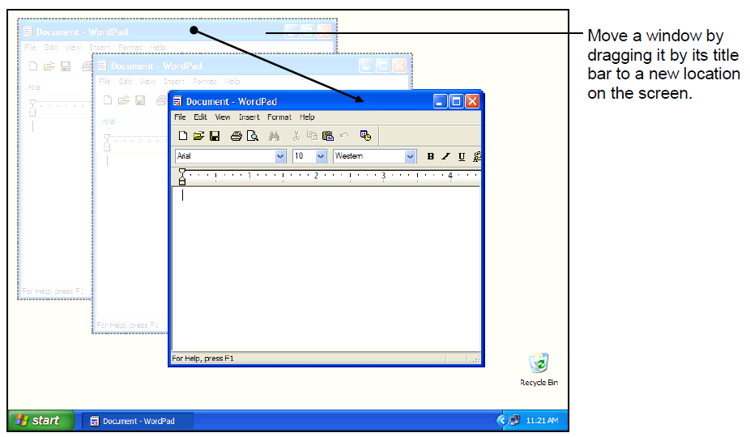
When you have several programs or windows open, you may find that one window covers the other windows or other items on your screen. When this happens, you can simply move a window to a new location on the screen by doing the following steps:
1. Position the mouse pointer over the title bar of the program.
2. Click the title bar and move the mouse while still holding down the mouse button.
3. Release the mouse button to drop the window to a new location.
Sizing a Window:
If a window doesn’t have to be maximized (fill up the entire screen) or minimized (appear only as a button on the Taskbar) you can manually size it by following these steps:
1. Point at the border of the window until the pointer changes to a .
2. Click and hold the left mouse button and drag the border of the window.
3. Release the mouse button when the window is the size you want.

Switching Between Windows:
You can have several programs or windows open and running simultaneously, but you can only work in one window at a time. The window you’re working with is called the active window and always appears on top of any other windows that you have open. Actually, there are several ways to switch between the programs you’re running. These ways are:
1. When you open several programs at once, the programs appear in the taskbar, so you can switch between the programs by clicking its icon on the taskbar.
2. You can make another open window the active window by clicking on any visible part of the window.
3. Another method of switching between windows is by press and hold down the <Alt> key, press and release the <Tab> key, but don’t release the <Alt> key.

