LAB 3: THE SUPERPOSITION PRINCIPLE AND THE THEVENIN EQUIVALENT CIRCUIT
OBJECTIVES
- Verifying experimentally the superposition principle for a circuit with two voltage sources.
- Designing and testing the Thevenin equivalent circuit.
PRELAB
- Make a brief plan of measurements to demonstrate the superposition principle for a circuit shown in Fig. 3.
- Draw a Thevenin equivalent circuit of the circuit in Fig. 3 without R_{L}, which is an external "load" resistor. Express the voltage of the source and the resistance in the Thevenin circuit in terms of R₁ and R₂.
LABORATORY
Equipment needed: ECE 291 parts kit, a proto-board, a resistance substitution box, leads.
1. THE SUPERPOSITION PRINCIPLE
Assemble the circuit shown in Fig. 3. Choose different values for R₁ and R₂ from resistors in 1k to 30k range such that their ratio is no more than 5. At first, do not connect the load resistor R_{L}.
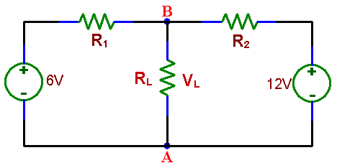
Measure V_{L}, between:
a) Points A and B, with R_{L} infinite (open circuit) and compare it with the calculated value.
b) Find V_{L} from superposition principle after making two voltage measurements.

c) Repeat a) and b) after connecting a resistor R_{L} (in 3k to 20k range) between points A and B. After the measurements put aside this resistor; you will need it again in part 2.
d) Replace the 6 V dc source with an ac source and, using an oscilloscope, verify that the superposition principle applies also to ac. You may use the ac of the same amplitude as the replaced dc source for easier comparison with measurements 1. b).

